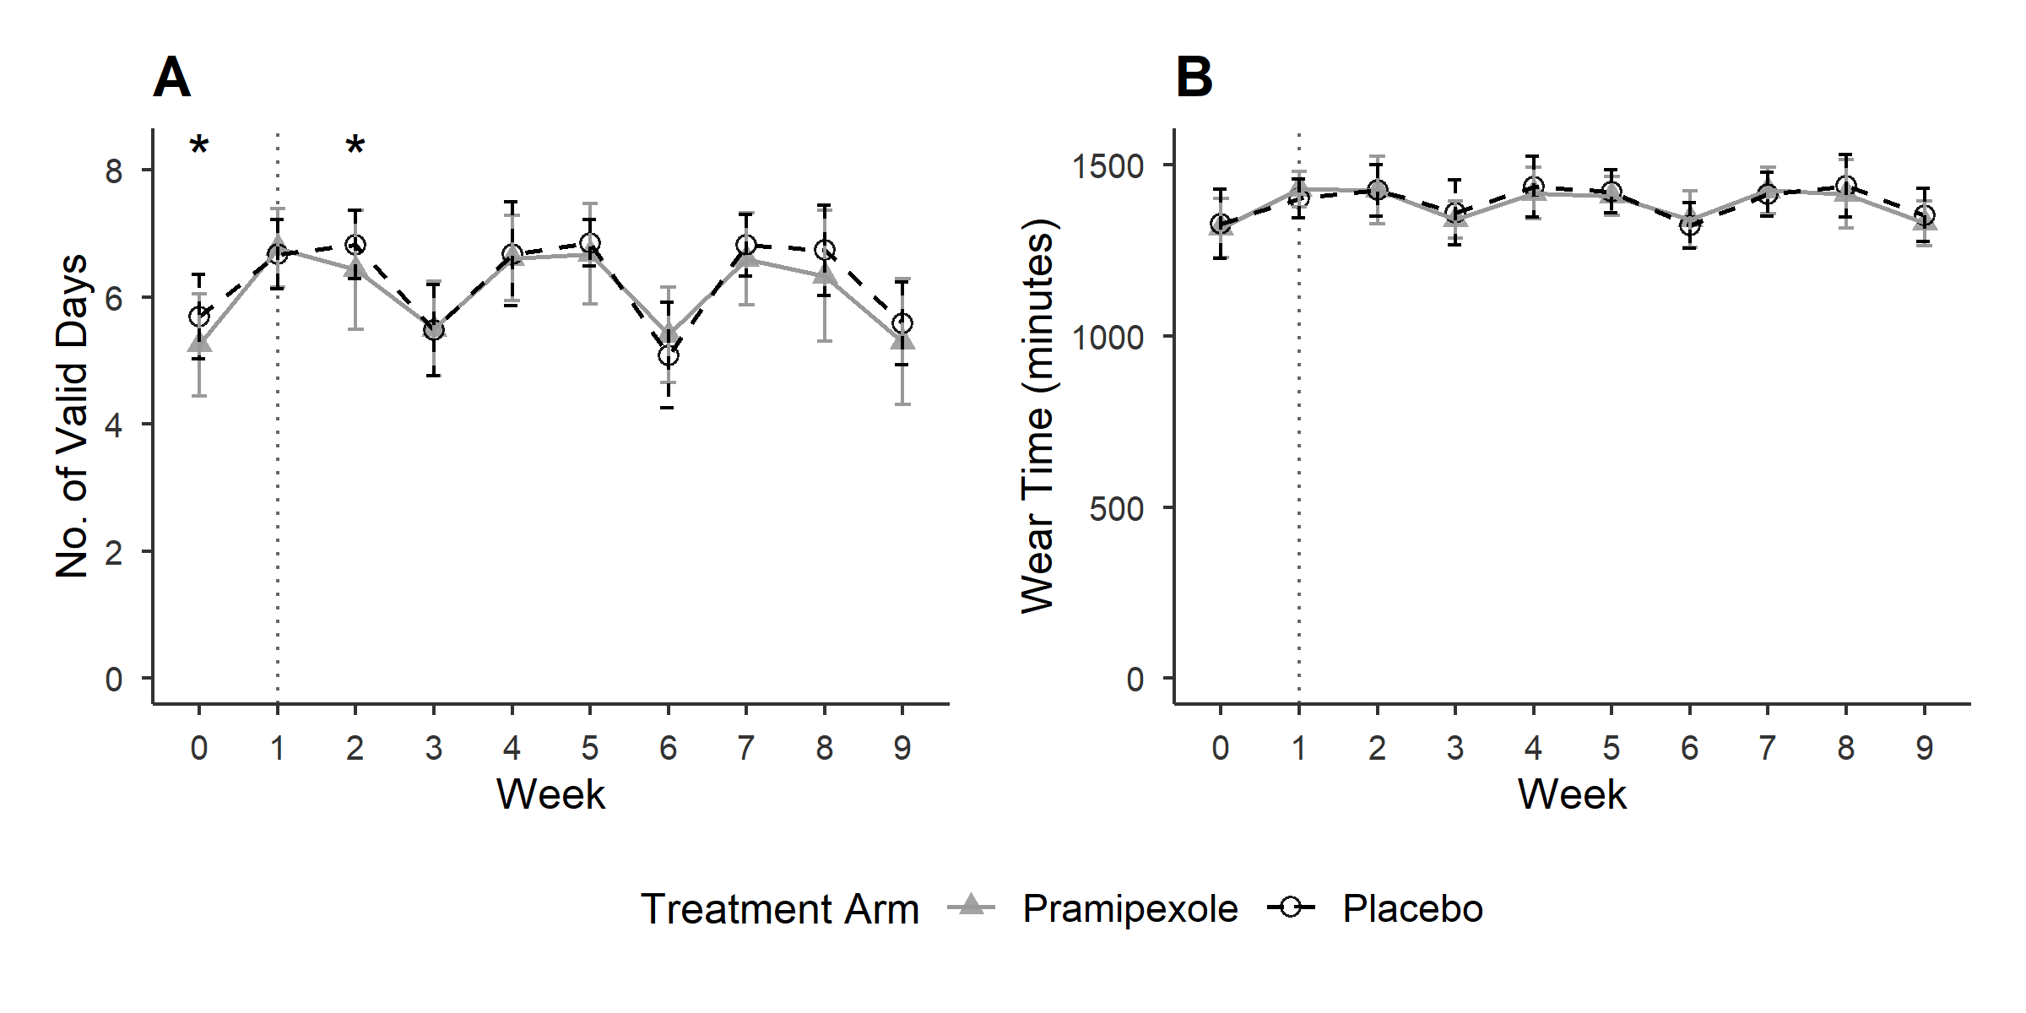
Supplementary Fig. 1 | Validation analysis of accelerometer data.
Physical activity data only includes participants with a valid baseline measurement (week 0; n = 61). Vertical dotted lines indicate the start of the intervention at week 1. Following the start of the intervention, participants wore accelerometers during three distinct measurement periods: weeks 1–3 (w1–3), weeks 4–6 (w4–6), and weeks 7–9 (w7–9). Each period was separated by a follow-up clinic visit for data collection. Data from an individual was considered missing during the weeks not reaching the validity threshold of at least four valid days. A, Mean number of valid measurement days per week for each treatment group (± 1 SD). B, Mean weekly wear time during the full 24-hour period (wake-up to wake-up the next day), calculated across all valid days for each treatment group (± 1 SD). Analysis revealed a consistent reduction in valid wear time during the final week of each measurement period across both treatment groups. Pairwise comparisons between the final week and either the first or second week of the same period revealed statistically significant reductions, with p-values ranging from < 0.05 to < 0.001. No significant differences in average wear time were observed between the groups. However, the number of valid days differed significantly between the groups during two time points (p < 0.05).

