Extended Data

Table E1
Descriptive statistics of primary and secondary outcome rating scales in the intention to treat sample. Total scores are summarized as mean values with standard deviations in parentheses.
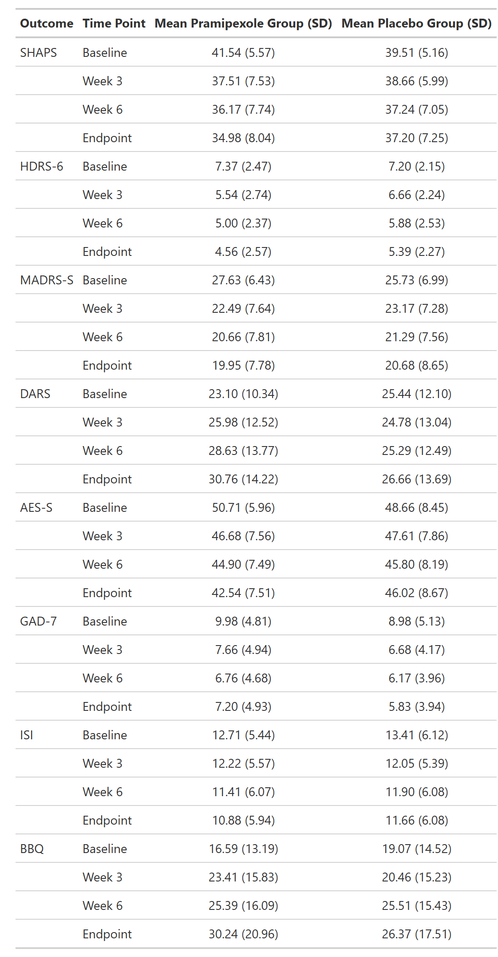

Table E2
Summary of statistical analyses for primary and secondary outcome rating scales. Adjusted means (least-squares means), 95% confidence intervals, model estimates, p-values, and effect sizes (Hedges’ g) are reported. Group differences were analyzed using pairwise comparisons of the estimated means from the mixed models. Complete remission of anhedonia symptoms (SHAPS≤2) was achieved by 22.95% of participants in the pramipexole group compared with 12.82% in the placebo group. A treatment response, defined as a ≥50% reduction in anhedonia symptoms, was observed in 39.02% of participants receiving pramipexole and 30.77% receiving placebo when the scale was scored according to the original authors’ instructions (0 or 1 point per item). However, when using the Likert scoring method (1–4 points per item), only one participant in the pramipexole group met the response criterion. According to the MADRS-S, 21.95% percent in the pramipexole group and 17.07% in the placebo group were responders and 14.63% in each group were remitters.

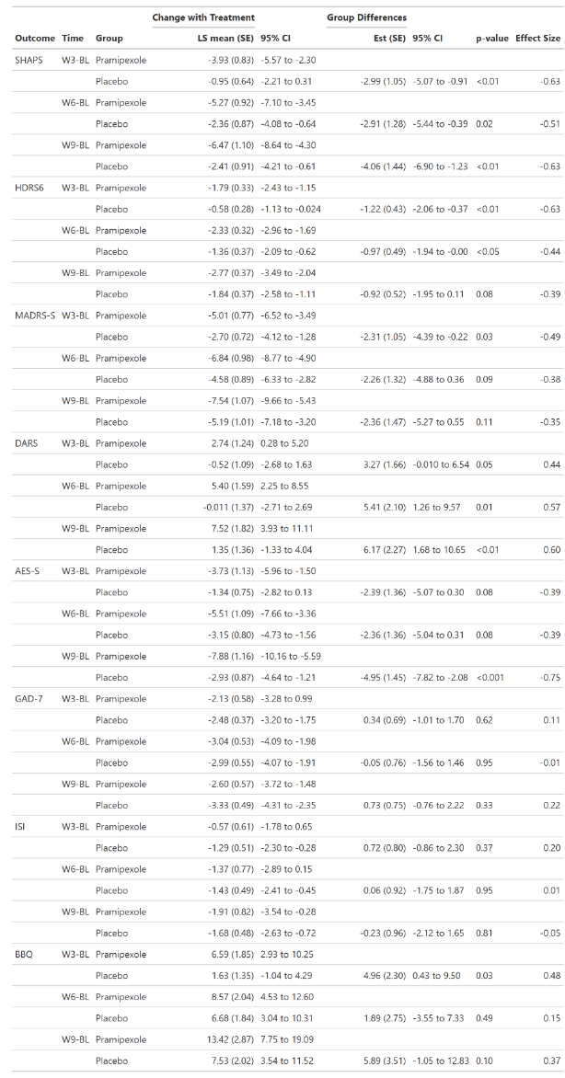

Figure E1
Change in awake time, sedentary time (SED) and moderate to vigorous physical activity (MVPA) from baseline as mean minutes per day. Valid data were available for n=29 (placebo) and n=32 (pramipexole) participants per treatment arm across all time points (LOCF applied). Lines represent group means with shaded ribbons indicating ± standard error. A dashed horizontal line marks zero change from baseline. Purple line represents pramipexole group and black line placebo group. Asterisks indicate timepoints where pairwise comparisons from mixed models revealed statistically significant differences (p<0.05).
Pramipexole consistently increased awake time relative to placebo, with a robust main effect of treatment (p=0.0083) and significant differences observed at Weeks 1 and 3 through 9 (p< 0.05). The largest effect was observed at Week 5 (Hedges’ g=0.31), indicating a moderate treatment impact. In contrast, there was no significant main effect of treatment on sedentary time (SED; p=0.11), suggesting that overall changes in SED did not differ between groups. However, pairwise comparisons revealed a significant difference at Week 8 (p=0.038, Hedges’ g=0.19).
For moderate-to-vigorous physical activity (MVPA), neither the main effect of treatment (p=0.10) nor the time-by-treatment interaction (p=0.47) reached significance. Nonetheless, pairwise contrasts showed statistically significant differences at Week 4 (p=0.047) and Week 5 (p=0.012), suggesting modest improvements in MVPA during mid-treatment.
Taken together with results from light physical activity (LPA, Fig 2), these findings indicate that pramipexole increased both awake time and LPA but did not consistently reduce SED or enhance MVPA. The observed increase in LPA without a corresponding decrease in SED may be explained by the overall extension of awake time.
