Table S1: Characteristics of sampled birds, including reference number, bird type, age, farm source, and vaccination status.
# | Reference No. | Bird type | Bird Age | Farm | Source | Immunization
1 | NA27 | Commercial | 35 | A | Boxing, Binzhou | Y
2 | NA28 | Commercial | 35 | A | Boxing, Binzhou | Y
3 | NA29 | Commercial | 35 | A | Boxing, Binzhou | Y
4 | NA30 | Commercial | 35 | A | Boxing, Binzhou | Y
5 | NA31 | Commercial | 35 | A | Boxing, Binzhou | Y
6 | NA32 | Commercial | 35 | A | Boxing, Binzhou | Y
7 | NA34 | Commercial | 35 | A | Boxing, Binzhou | Y
8 | NA35 | Commercial | 35 | A | Boxing, Binzhou | Y
9 | NA36 | Commercial | 35 | A | Boxing, Binzhou | Y
10 | NA38 | Commercial | 35 | A | Boxing, Binzhou | Y
11 | NA42 | Commercial | 35 | A | Boxing, Binzhou | Y
12 | NA43 | Commercial | 35 | A | Boxing, Binzhou | Y
13 | B7 | Commercial | 18 | B | Wudi, Binzhou | Y
14 | B8 | Commercial | 18 | B | Wudi, Binzhou | Y
15 | B12 | Commercial | 18 | B | Wudi, Binzhou | Y
16 | B16 | Commercial | 18 | B | Wudi, Binzhou | Y
17 | B40 | Commercial | 35 | B | Wudi, Binzhou | Y
18 | C2 | Commercial | 18 | C | Wudi, Binzhou | Y
19 | C6 | Commercial | 18 | C | Wudi, Binzhou | Y
20 | C14 | Commercial | 18 | C | Wudi, Binzhou | Y
21 | C31 | Commercial | 35 | C | Wudi, Binzhou | Y
22 | D11 | Commercial | 18 | D | Wudi, Binzhou | Y
23 | D13 | Commercial | 18 | D | Wudi, Binzhou | Y
24 | D26 | Commercial | 35 | D | Wudi, Binzhou | Y
25 | E4 | Commercial | 18 | E | Huimin, Binzhou | Y
26 | E7 | Commercial | 18 | E | Huimin, Binzhou | Y
27 | E17 | Commercial | 18 | E | Huimin, Binzhou | Y
28 | E29 | Commercial | 35 | E | Huimin, Binzhou | Y
29 | E38 | Commercial | 35 | E | Huimin, Binzhou | Y
30 | E39 | Commercial | 35 | E | Huimin, Binzhou | Y
31 | E41 | Commercial | 38 | E | Huimin, Binzhou | Y
32 | F2 | Commercial | 18 | F | Huimin, Binzhou | Y
33 | F3 | Commercial | 18 | F | Huimin, Binzhou | Y
34 | F5 | Commercial | 18 | F | Huimin, Binzhou | Y
35 | F6 | Commercial | 18 | F | Huimin, Binzhou | Y
36 | F11 | Commercial | 18 | F | Huimin, Binzhou | Y
37 | F18 | Commercial | 18 | F | Huimin, Binzhou | Y
38 | IBDV_GR-1 | Commercial | 35 | GR | Guangrao, Dongying | Y
39 | IBDV-GR-2 | Commercial | 35 | GR | Guangrao, Dongying | Y
40 | IBDV-GR-3 | Commercial | 35 | GR | Guangrao, Dongying | Y
41 | IBDV-GR-4 | Commercial | 35 | GR | Guangrao, Dongying | Y
42 | IBDV-GR-5 | Commercial | 35 | GR | Guangrao, Dongying | Y
43 | IBDV-GR-6 | Commercial | 35 | GR | Guangrao, Dongying | Y
44 | IBDV-GR-7 | Commercial | 35 | GR | Guangrao, Dongying | Y
45 | IBDV-NY-1 | Local | 35 | NY | Bincheng, Binzhou | Y
46 | IBDV-NY-2 | Local | 35 | NY | Bincheng, Binzhou | Y
47 | IBDV-NY-3 | Local | 35 | NY | Bincheng, Binzhou | Y
48 | IBDV-NY-4 | Local | 35 | NY | Bincheng, Binzhou | Y
49 | IBDV-NY-6 | Local | 35 | NY | Bincheng, Binzhou | Y
50 | IBDV-NY-8 | Local | 35 | NY | Bincheng, Binzhou | Y
51 | IBDV-NY-9 | Local | 35 | NY | Bincheng, Binzhou | Y
52 | IBDV-NY-10 | Local | 35 | NY | Bincheng, Binzhou | Y
53 | 20210604-6 | Commercial | 35 | SG | Shouguang, Dongying | Y
54 | 20210604-12 | Commercial | 35 | SG | Shouguang, Dongying | Y
55 | Huimin_Tianxi-201016 | Backyard | Unknown | Backyard | Huimin, Binzhou | Unknown
56 | NAB1 | Backyard | Unknown | Backyard | Boxing, Binzhou | Unknown
57 | NAB2 | Backyard | Unknown | Backyard | Boxing, Binzhou | Unknown
58 | NAB3 | Backyard | Unknown | Backyard | Boxing, Binzhou | Unknown
59 | NAB5 | Backyard | Unknown | Backyard | Boxing, Binzhou | Unknown
60 | NAB6 | Backyard | Unknown | Backyard | Boxing, Binzhou | Unknown
61 | NAB7 | Backyard | Unknown | Backyard | Boxing, Binzhou | Unknown
62 | IBDV-ZWT-1 | Backyard | Unknown | Backyard | Wudi, Binzhou | Unknown
63 | IBDV-ZWT-2 | Backyard | Unknown | Backyard | Huimin, Binzhou | Unknown
64 | IBDV-ZWT-3 | Backyard | Unknown | Backyard | Huimin, Binzhou | Unknown
65 | IBDV-ZWT-4 | Backyard | Unknown | Backyard | Huimin, Binzhou | Unknown
66 | Jinzhou-20211202 | Backyard | Unknown | Backyard | Jinzhou, Hebei | Unknown
67 | Jinzhou-20220219 | Backyard | Unknown | Backyard | Jinzhou, Hebei | Unknown
68 | Binzhou-20220210 | Backyard | Unknown | Backyard | Bincheng, Binzhou | Unknown

Table S2: GenBank accession numbers of the new VP2 sequences
# | IBDV Isolate | GenBank Accession # | Farm
1 | NA27 | PP886999 | A
2 | NA28 | PP887000 | A
3 | NA29 | PP887001 | A
4 | NA30 | PP887002 | A
5 | NA31 | PP887003 | A
6 | NA32 | PP887004 | A
7 | NA34 | PP887005 | A
8 | NA35 | PP887006 | A
9 | NA36 | PP887007 | A
10 | NA38 | PP887008 | A
11 | NA42 | PP887009 | A
12 | NA43 | PP887010 | A
13 | B7 | PP886951 | B
14 | B8 | PP886952 | B
15 | B12 | PP886953 | B
16 | B16 | PP886954 | B
17 | B40 | PP886955 | B
18 | C2 | PP886957 | C
19 | C6 | PP886958 | C
20 | C14 | PP886959 | C
21 | C31 | PP886960 | C
22 | D11 | PP886961 | D
23 | D13 | PP886962 | D
24 | D26 | PP886963 | D
25 | E4 | PP886964 | E
26 | E7 | PP886965 | E
27 | E17 | PP886966 | E
28 | E29 | PP886967 | E
29 | E38 | PP886968 | E
30 | E39 | PP886969 | E
31 | E41 | PP886970 | E
32 | F2 | PP886971 | F
33 | F3 | PP886972 | F
34 | F5 | PP886973 | F
35 | F6 | PP886974 | F
36 | F11 | PP886975 | F
37 | F18 | PP886976 | F
38 | IBDV-GR-1 | PP886978 | GR
39 | IBDV-GR-2 | PP886979 | GR
40 | IBDV-GR-3 | PP886980 | GR
41 | IBDV-GR-4 | PP886981 | GR
42 | IBDV-GR-5 | PP886982 | GR
43 | IBDV-GR-6 | PP886983 | GR
44 | IBDV-GR-7 | PP886984 | GR
45 | IBDV-NY-1 | PP886985 | NY
46 | IBDV-NY-2 | PP886986 | NY
47 | IBDV-NY-3 | PP886987 | NY
48 | IBDV-NY-4 | PP886988 | NY
49 | IBDV-NY-6 | PP886989 | NY
50 | IBDV-NY-8 | PP886990 | NY
51 | IBDV-NY-9 | PP886991 | NY
52 | IBDV-NY-10 | PP886992 | NY
53 | 20210604-6 | PP886949 | SG
54 | 20210604-12 | PP886950 | SG
55 | Huimin_Tianxi-201016 | PP886977 | Backyard
56 | NAB1 | PP887011 | Backyard
57 | NAB2 | PP887012 | Backyard
58 | NAB3 | PP887013 | Backyard
59 | NAB5 | PP887014 | Backyard
60 | NAB6 | PP887015 | Backyard
61 | NAB7 | PP887016 | Backyard
62 | IBDV-ZWT-1 | PP886993 | Backyard
63 | IBDV-ZWT-2 | PP886994 | Backyard
64 | IBDV-ZWT-3 | PP886995 | Backyard
65 | IBDV-ZWT-4 | PP886996 | Backyard
66 | Jinzhou-20211202 | PP886997 | Backyard
67 | Jinzhou-20220219 | PP886998 | Backyard
68 | Binzhou-20220210 | PP886956 | Backyard
69 | VIRGO7_Vaccine | PP887017 | Vaccine strain

Table S3: Immunohistochemistry analysis of the Bursa of Fabricius
Sample reference number | Negative control  (100×） | Diagnosed positive sample (100×）
NA27 | 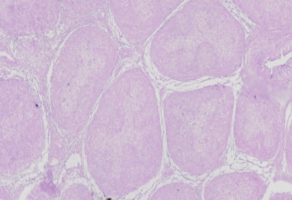  The negative control slide showed normal follicular architecture, with intact follicles, regular cortex, and no evidence of edema, cellular infiltration, or stromal changes. Intercellular spaces and boundaries appeared normal, and no pathological alterations observed. | 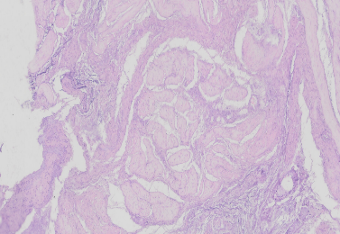  A trace of residual follicles observed, with partial follicle disappearance and associated bleeding.
NA28 |  | 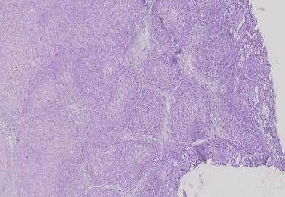  Macrophages observed within the follicles, and the follicles showed signs of denaturation.
NA29 |  | 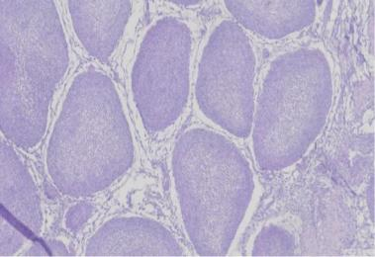  Interfollicular regions exhibited edema.
NA30 |  | 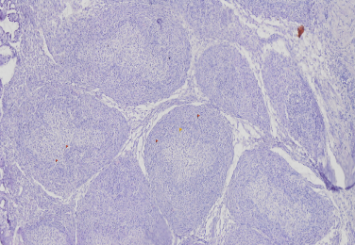  Edema began to appear between the follicles.
NA31 |  | 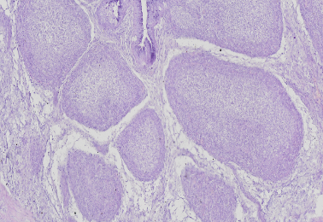  Macrophages appeared within the follicles.
NA32 |  | 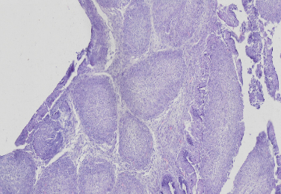  Macrophages appeared within the follicles.
NA34 |  | 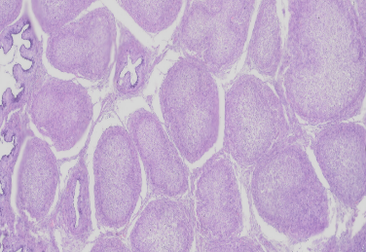  The interfollicular spaces widened and exhibited edema.
NA35 |  | 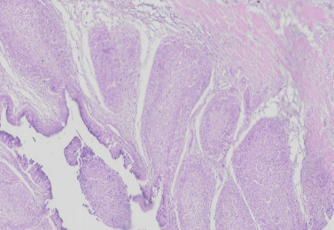  A single interfollicular region exhibited widening, edema, and bleeding.
NA36 |  | 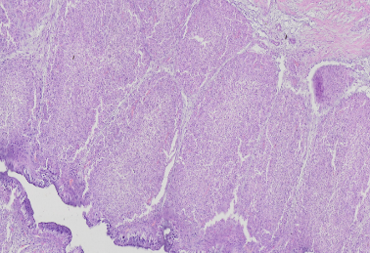  A large number of macrophages appeared within the follicles
NA38 |  | 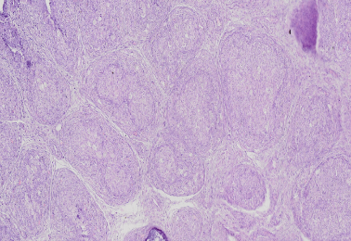  No edema observed between the follicles; however, the stromal tissue appeared increased.
NA42 |  | 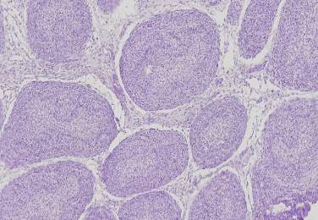  Edema started to appear in the interfollicular spaces.
C31 |  | 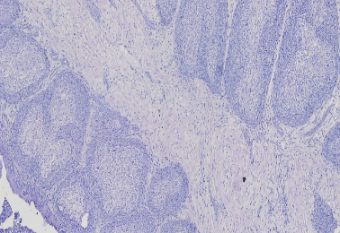  Single follicles observed in the lower left and upper right regions. The central portions of the follicles had disappeared, leaving only traces of individual follicles.
D26 |  | 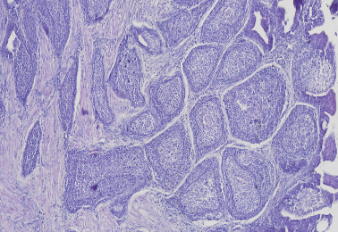  Edema observed between the follicles, accompanied by an increase in stromal tissue.
D42 |  | 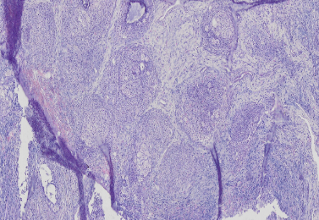  The intercellular spaces expanded, and the cellular boundaries appeared blurred.
E38 |  | 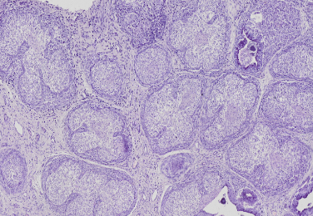  The follicular stroma increased, and the cortex appeared irregular.
E39 |  | 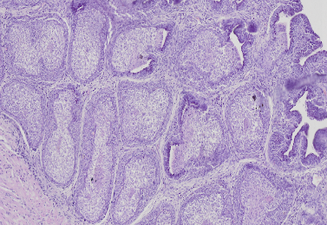  The follicular stroma increased, and the cortex appeared irregular.
E41 |  | 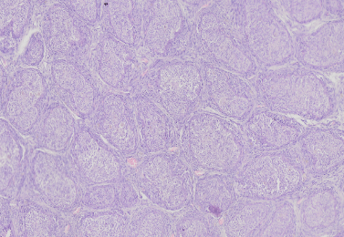  The intercellular space increased, and the boundaries appeared blurred.

