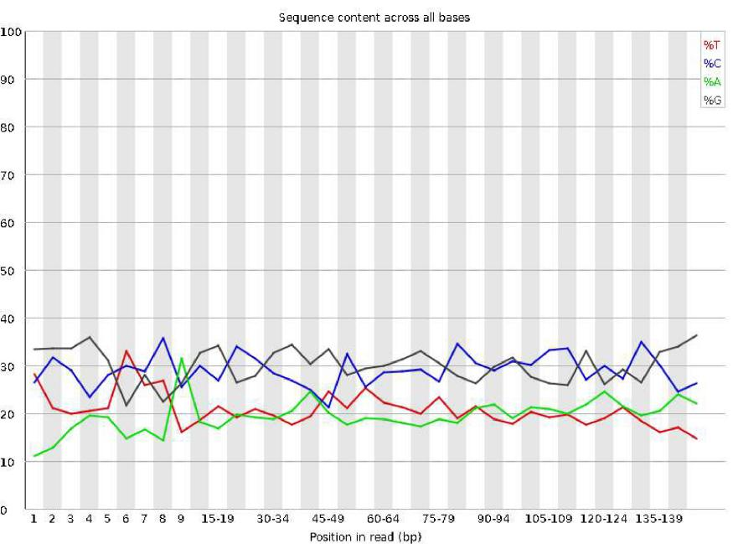
Supplementary Figure 1. Quality control of raw sequencing data using FastQC (v0.11.5) and base error rate estimation with Phred. Clean reads were obtained and aligned to the reference genome using HISAT2.

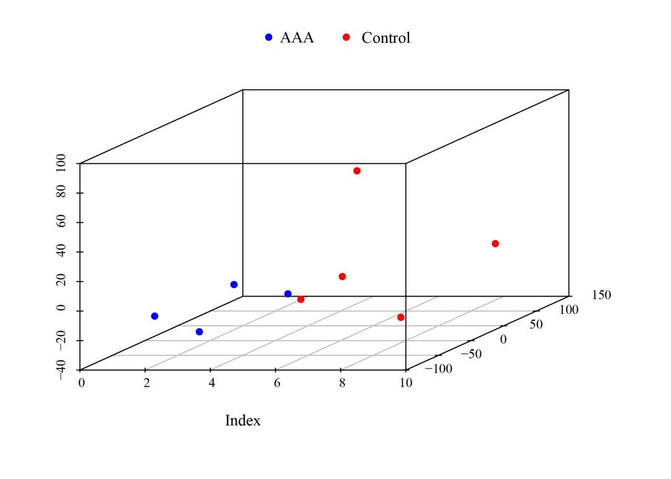
Supplementary Figure 2. Principal component analysis (PCA) performed using the scatterplot3d (v0.3-44) package to assess sample dispersion and intra-group repeatability.

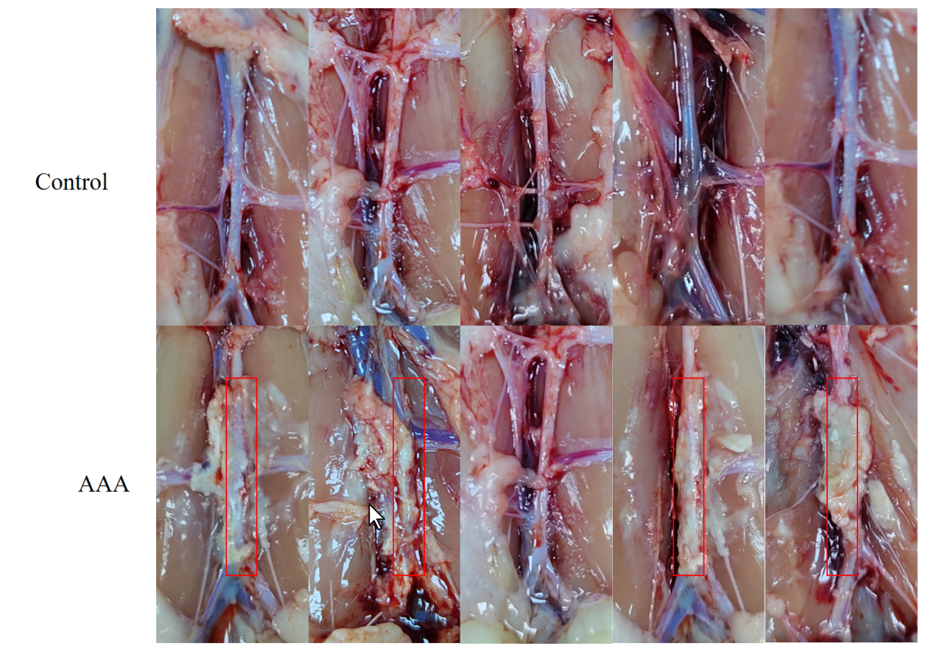

Supplementary Figure 3. Representative images from animal experiments.
Macroscopic photographs of abdominal aortic aneurysm (AAA) tissues in the rat model compared with normal control aortas. Obvious dilation of the abdominal aorta is visible in the AAA group.

RNA concentration detection results：
NO. | Sample | Group | Concentration  (ng/uL) | A260/A280 | A260/A230
1 | A1 | Control | 108.52 | 1.478 | 0.304
2 | A2 | Control | 336.88 | 1.86 | 0.917
3 | A3 | Control | 696.96 | 1.861 | 1.224
4 | A4 | Control | 55.4 | 1.527 | 0.27
5 | A5 | Control | 80.24 | 1.231 | 0.176
6 | B1 | AAA | 459.48 | 1.81 | 0.746
7 | B2 | AAA | 724.8 | 1.835 | 1.174
8 | B3 | AAA | 1825 | 1.97 | 1.606
9 | B4 | AAA | 2790.2 | 1.989 | 1.679
10 | B5 | AAA | 669.44 | 1.927 | 1.143

Fcgr2b：
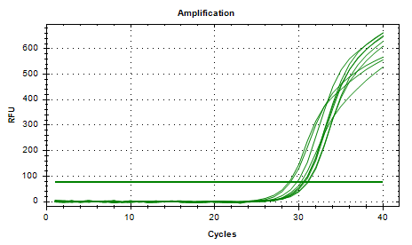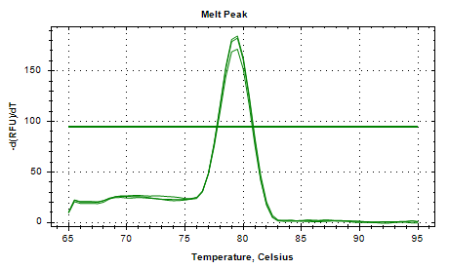

Tlr7：
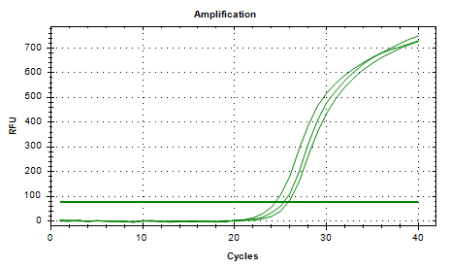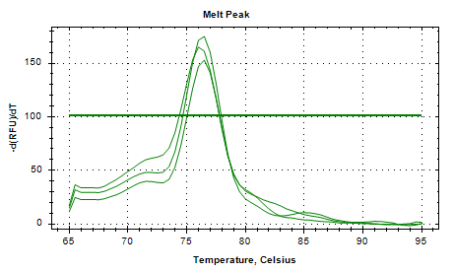

Clec7a：
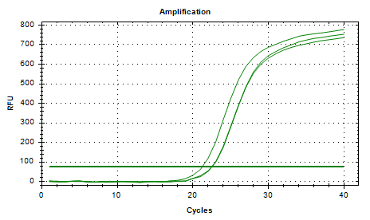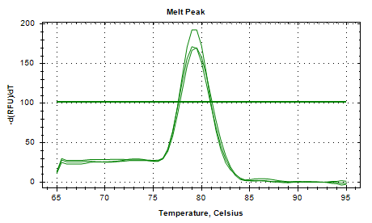
Tlr9：
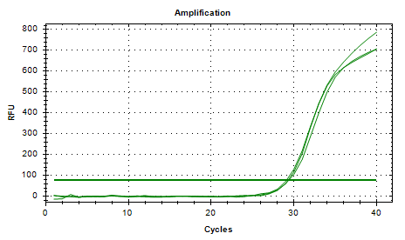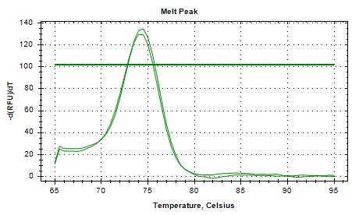

Cd53：
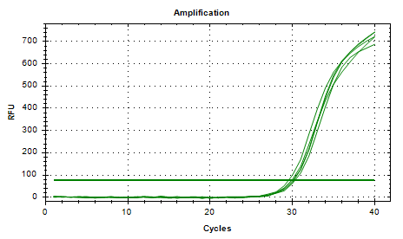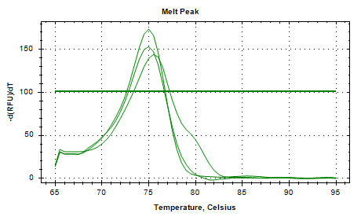
GAPDH：
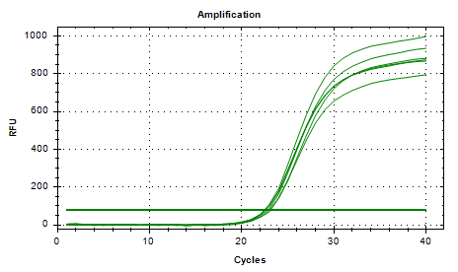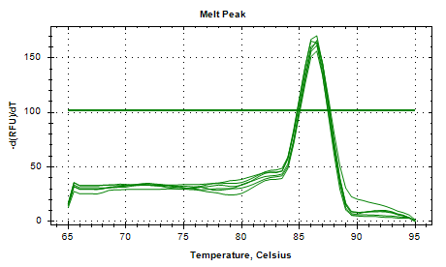

Supplementary Figure 4. Primer validation for RT-qPCR analysis.
Supplementary Table 1. Primer sequences for six genes used for RT-qPCR validation.
Primers | Sequences
Fcgr2b F | GGAATCCTGCCGTTCCTACTG
Fcgr2b R | ATGGCACAAAGTCCGTGAGAA
Tlr7 F | TCTTTGGGTTTCGATGGTTTCC
Tlr7 R | GCAGTCCACGATCACATGGG
Clec7a F | AAAGCCAAACATCGTCTCACC
Clec7a R | CGAGTTGGGGAAGAATGCTGAT
Tlr9 F | ATGGTTCTCCGTCGAAGGACT
Tlr9 R | GAGGCTTCAGCTCACAGGG
Cd53 F | GCCTGCTTATGTCGTTCTTTGT
Cd53 R | CCTCAGCCACTAAAGTGTTGAGT
GAPDH F | GGCCGGAGACGAATGGAAATTA
GAPDH R | CCAAATCCGTTCACACCGAC

Supplementary Table 2. Summary of alignment comparison rates (70%–90%) for 4 AAA and 5 control samples selected for downstream analysis after Cufflinks processing.

Sample | Valid reads | Mapped reads
A1 | 2180 | 932(42.75%)
A2 | 79623356 | 63782730(80.11%)
A3 | 86053768 | 80024237(92.99%)
A4 | 105530 | 88695(84.05%)
A5 | 84564292 | 79920380(94.51%)
B1 | 34374464 | 32032287(93.19%)
B2 | 80440246 | 75957429(94.43%)
B3 | 393262 | 357593(90.93%)
B4 | 82972418 | 77429589(93.32%)
B5 | 74677390 | 72203623(96.69%)

