Supplementary Material Santos et al., 2025

Supplementary Table 1- The primers information

Genes | Number NCBI | Forward Sequence | Reverse Sequence
Zea mays sucrose transporter 1 (LOC541615) | >NM_001111370.3 | GCCTCCCAAAGCTCTCTTGT | TGTGATCGAAATCGAAGGGGA
Zea mays plasma-membrane H+ATPase 2 (LOC542048) | NM_001305847.1 | TGGTTGGGTACCCGTCTTTC | AACGATTACAACACGCGCAC
Zea mays regulatory-associated prot of TOR 1  (LOC103640651) | XM_023301204.2 | GATGGTGTGAAGAGGCTCCC | GGAGGCGGCTAACGAATCTT
Zea mays high affinity nitrate transporter (LOC778437) NAR2.1 | >NM_001112459.2 | AAGTAGAACGAGTTGCGGCT | AGCAACGACAGCCACTCATC
Zea mays phosphate transporter protein1  (EU966504.1)  Zmpht1 | >NM001111799.2 | TTCCTTCCTGCACTGCACAT | ACACAGCCAGGGTTGACTTT
Zea mays actin 2 (LOC100281811) | >NM_001154731.2 | TGAAGCCATGTACAACTCCATCA | ATGCGGTCACCAATACCAGG
Zea mays GADPH (LOC542367) | >NM_001111943.1 | CCCAGTAGGGGTTTTTCCCC | CACGCGCCATCCACATTTAT
Zea mays nitrate reductase [NADH]-like (NNR1), mRNA | >NM_001305856.1 | ATAAACCAGCCGACTTGCCA | GCACAGTACAAGTGCAAACCT
Zea mays auxin transporter-like protein 3 (LOC103654551) | >NM_001346984.1 | AAGTGAGGCGACAGCTC | CATGTAGTTCCCTGCCACGA
Supplementary Figure 1- One-week bioassay with MCT-P. Morphological data of corn seedlings: Shoot fresh weight (A), shoot dry weight (B), root fresh weight (C), root dry weight (D), total root length (E), and root surface area. The error bars represent confidence intervals of 15 plants. The experiments were replicated at least 3 times. The second-degree polynomial regression, and the first derivative that revealed the best rate are shown.

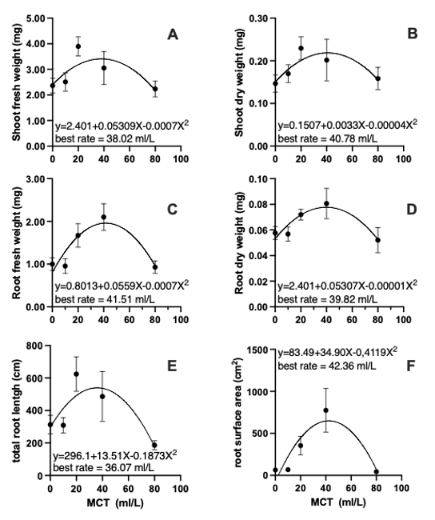
Supplementary Figure 2- Two-weeks bioassay with MCT-P. Morphological data of corn seedlings: root total length (A), root surface area (B), number of roots of class diameter 0<0.25 mm, and (C), root volume (D). The error bars represent confidence intervals of 15 plants. The experiments were replicated at least 2 times.

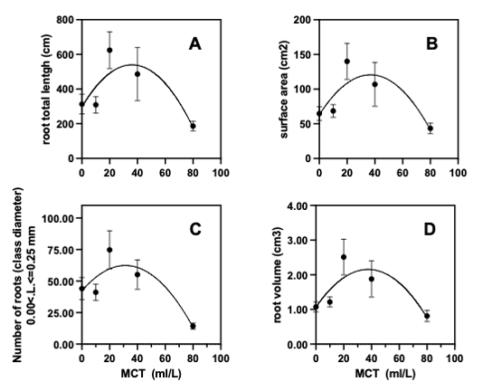

Supplementary Figure 3 - Two-weeks bioassay with MCT-P. Morphological data of lettuce: root surface area (A), total root length (B), root diameter (C), fresh root weight (D), root volume fresh shoot weight (E). The error bars represent confidence intervals of 12 plants. The experiments were replicated at least 2 times.

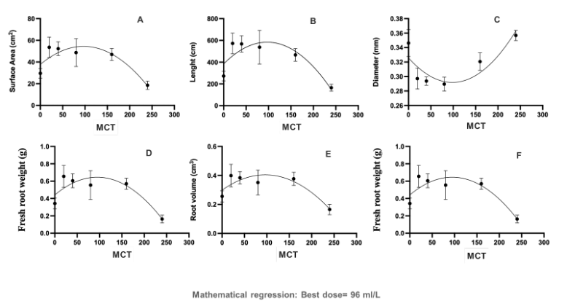

Supplementary Figure 4 - Representative image of the dose response curves in corn (A) and lettuce (B).
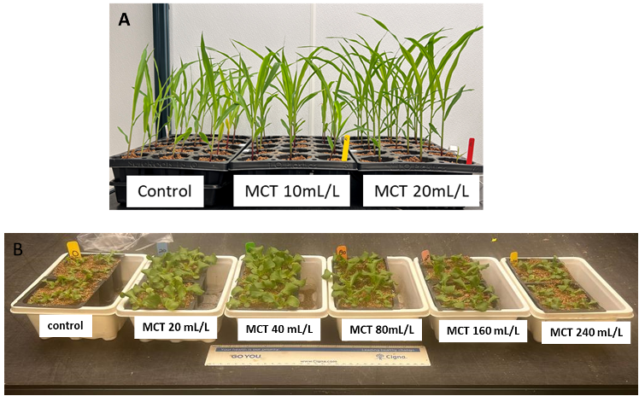

Supplementary Figure 5 - Representative image of the drought stress experiment carried out with corn. Photo (A) shows plants treated with MCT-P and control under drought stress; B to D show details of plants treated with MCT-P during stress where the leaves show curling and dark green color and without color changes in the veins; E to G show details of the control plants during stress, showing a darker color of the leaves and reddish veins. H- Plants 24 hours after re-irrigation.

