Supplementary information

Thermoresponsive and Xenon Triggered Gate-opening in Flexible Three-dimensional Covalent Organic Framework for Xenon/Krypton Separation
Yongzheng Wang,^{[a]} Shanshan Wang,^{[a]} Yinhui Li,^{[a]} Shizhen Liu,^{[a]} Qingxin Liang,^{[a]} Bin Chen,^{[a,b]} Wenxiang Zhang,^{[a]} Heping Ma*^{[a]}
^{[a]} State Key Laboratory of Fluorine & Nitrogen Chemicals, School of Chemical Engineering and Technology, Xi’an Jiaotong University, Xi’an, Shaanxi 710049, China.
^{[b]} Northwest Institute of Nuclear Technology, Xi’an, Shaanxi 710024, China.

Email: maheping@mail.xjtu.edu.cn

Table of contents
Section 1. Synthesis of FCOF-XJ 3
Section 2. Charaterization of FCOF-XJ 5
Section 3. Calculation procedures of isoteric adsorption enthalpy 10
Section 4. Calculation of selectivity using S(DIH) equation 12
Section 5. Crystal structure of FCOF-XJ 15
Section 6. Column Breakthrough Measurement Experiments 30
Section 7. References 36

Section 1. Synthesis of FCOF-XJ
FCOF-XJ was synthesized by the literature method.¹ Tetrakis[(4-formylphenoxy)methyl]methane (TFPM) (44.2 mg, 0.08 mmol) and tetra(p-aminophenyl)methane (TAPM) (30.4 mg, 0.08 mmol) were placed in a Pyrex tube with mesitylene (2.8 mL), chloroform (1.2 mL), and 12 M aqueous acetic acid (0.4 mL). The tube was flash frozen in a liquid nitrogen bath (77 K), degassed through three freeze−pump−thaw cycles, sealed under vacuum, and then heated at 120 °C for 7 days. The mixture was cooled to room temperature, and the resulting precipitate was filtered, exhaustively washed by Soxhlet extractions with tetrahydrofuran and dichloromethane, and dried at 90 °C under vacuum for 24 h. The activated FCOF-XJ was isolated as a violet powder (60 mg, 75% yield).
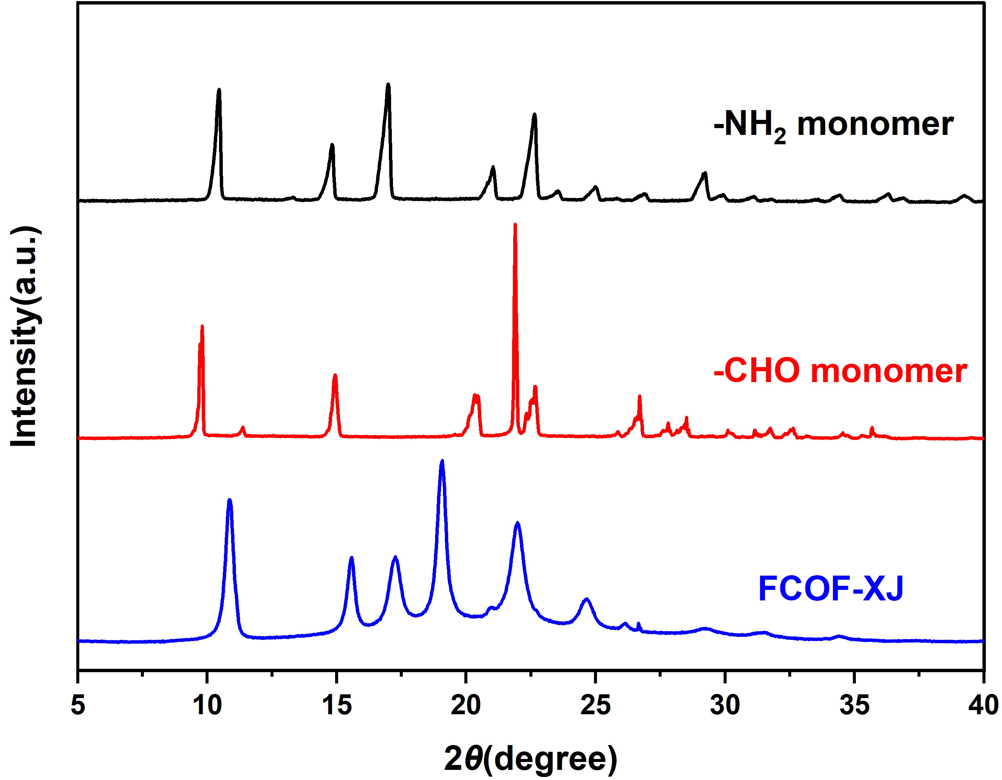
Figure S1. PXRD patterns of amino monomer (black), aldehyde monomer (red) and FCOF-XJ (blue).

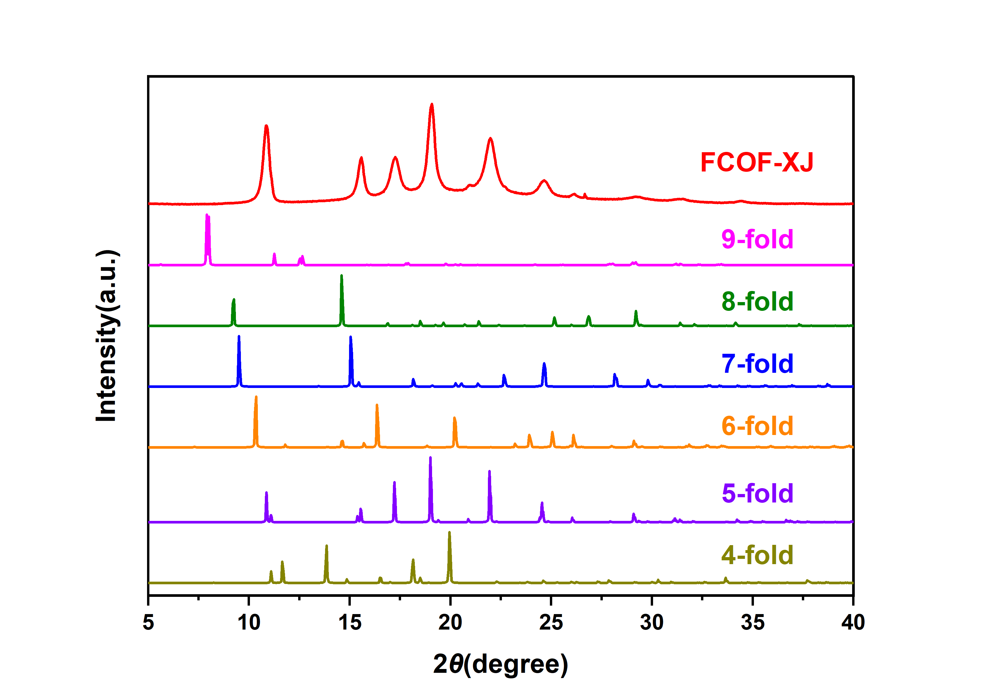
Figure S2. Simulated XRD curves of structures with different interpenetration degrees.

Section 2. Charaterization of FCOF-XJ
FI-TR Spectroscopy Analysis
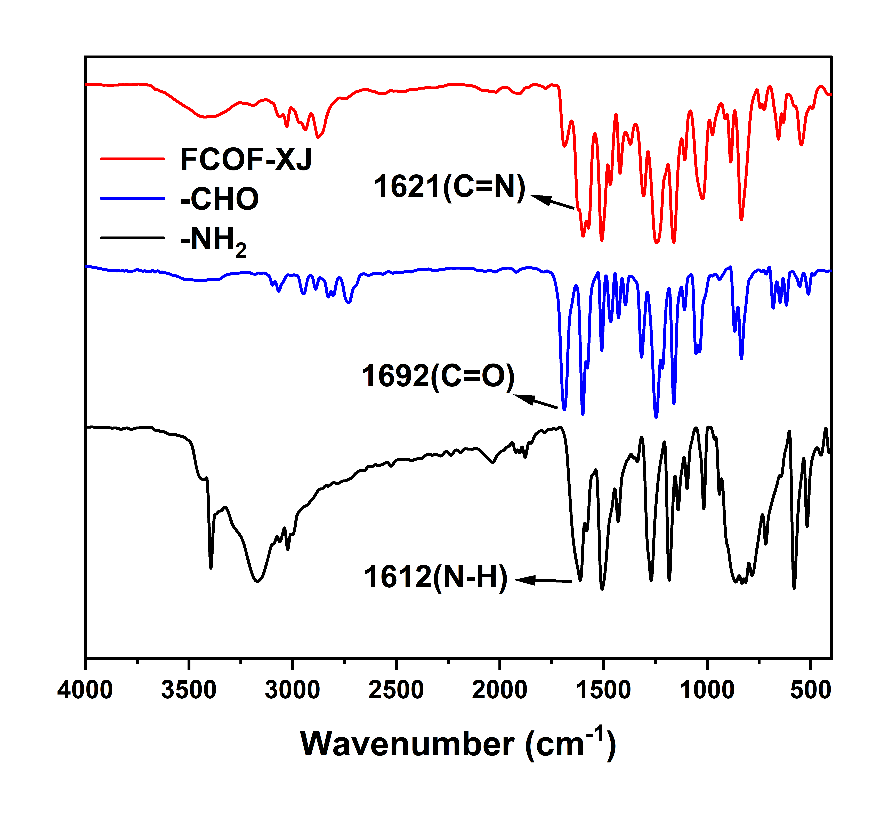
Figure S3. FI-TR spectra of FCOF-XJ, -CHO and -NH₂. The peak appearing at 1621 cm⁻¹ is attributed to the imine-linked C=N.

¹³C Solid-State NMR Spectroscopy
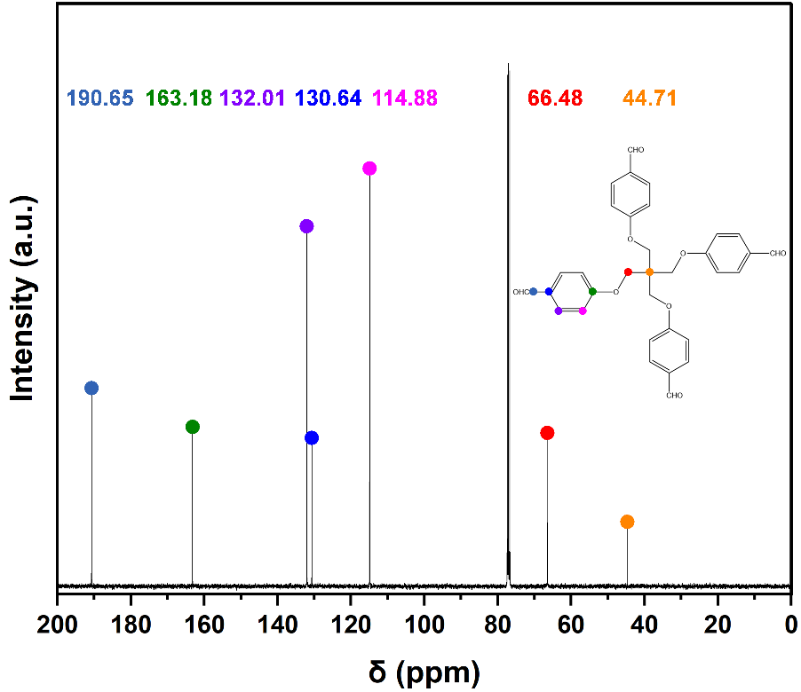
Figure S4. ¹³C NMR spectrum of TFPM.
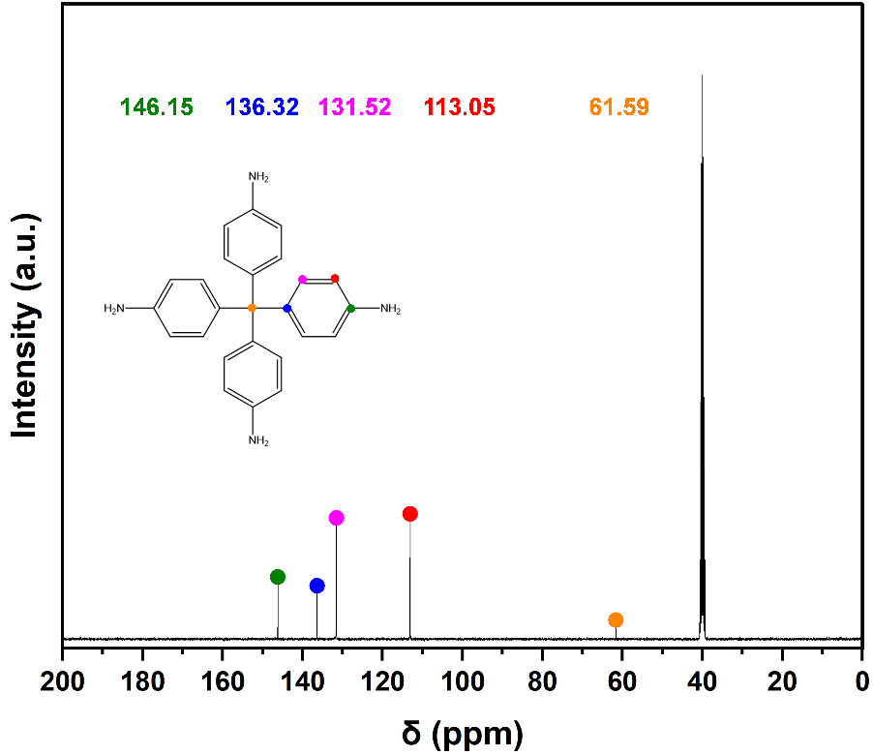
Figure S5. ¹³C NMR spectrum of TAPM.
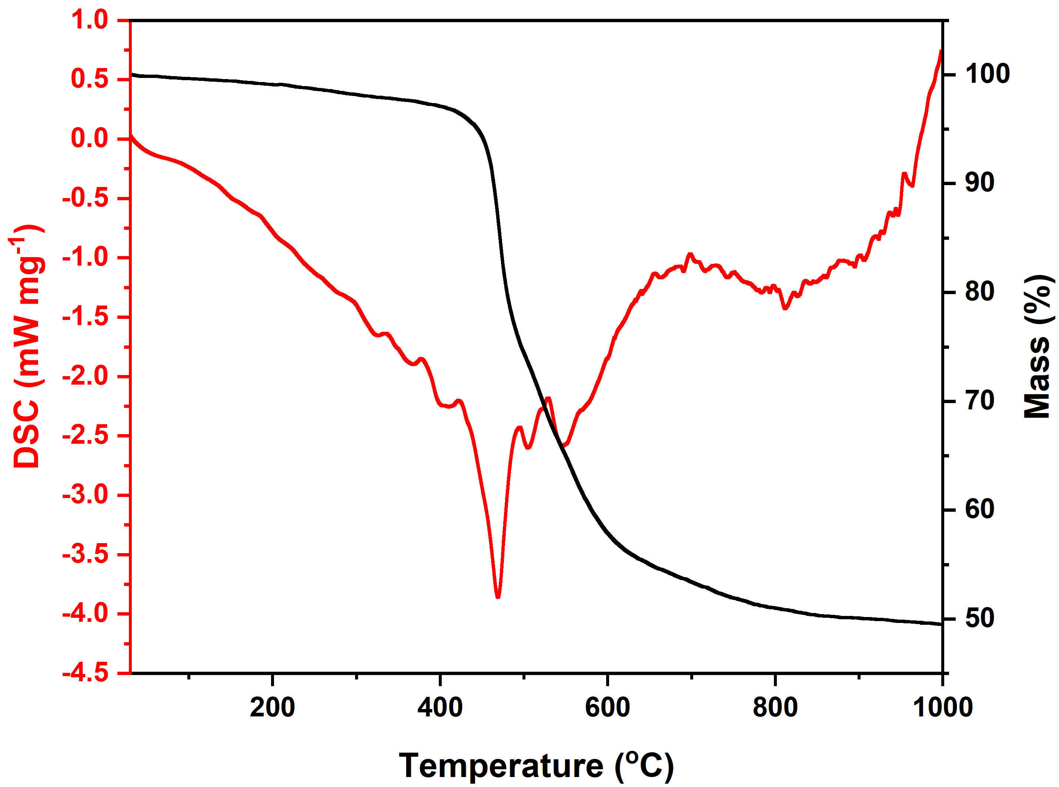
Figure S6. TG-DSC profile of FCOF-XJ.

Stability Test of FCOF-XJ
In a typical experiment, 50 mg of FCOF-XJ was immersed in 1 M NaOH and 1 M HCl at room temperature for 24 hours to test the stability of FCOF-XJ. The powder was then filtered and washed with tetrahydrofuran and dichloromethane, and then vacuum dried to measure gas adsorption data and FT-IR data.
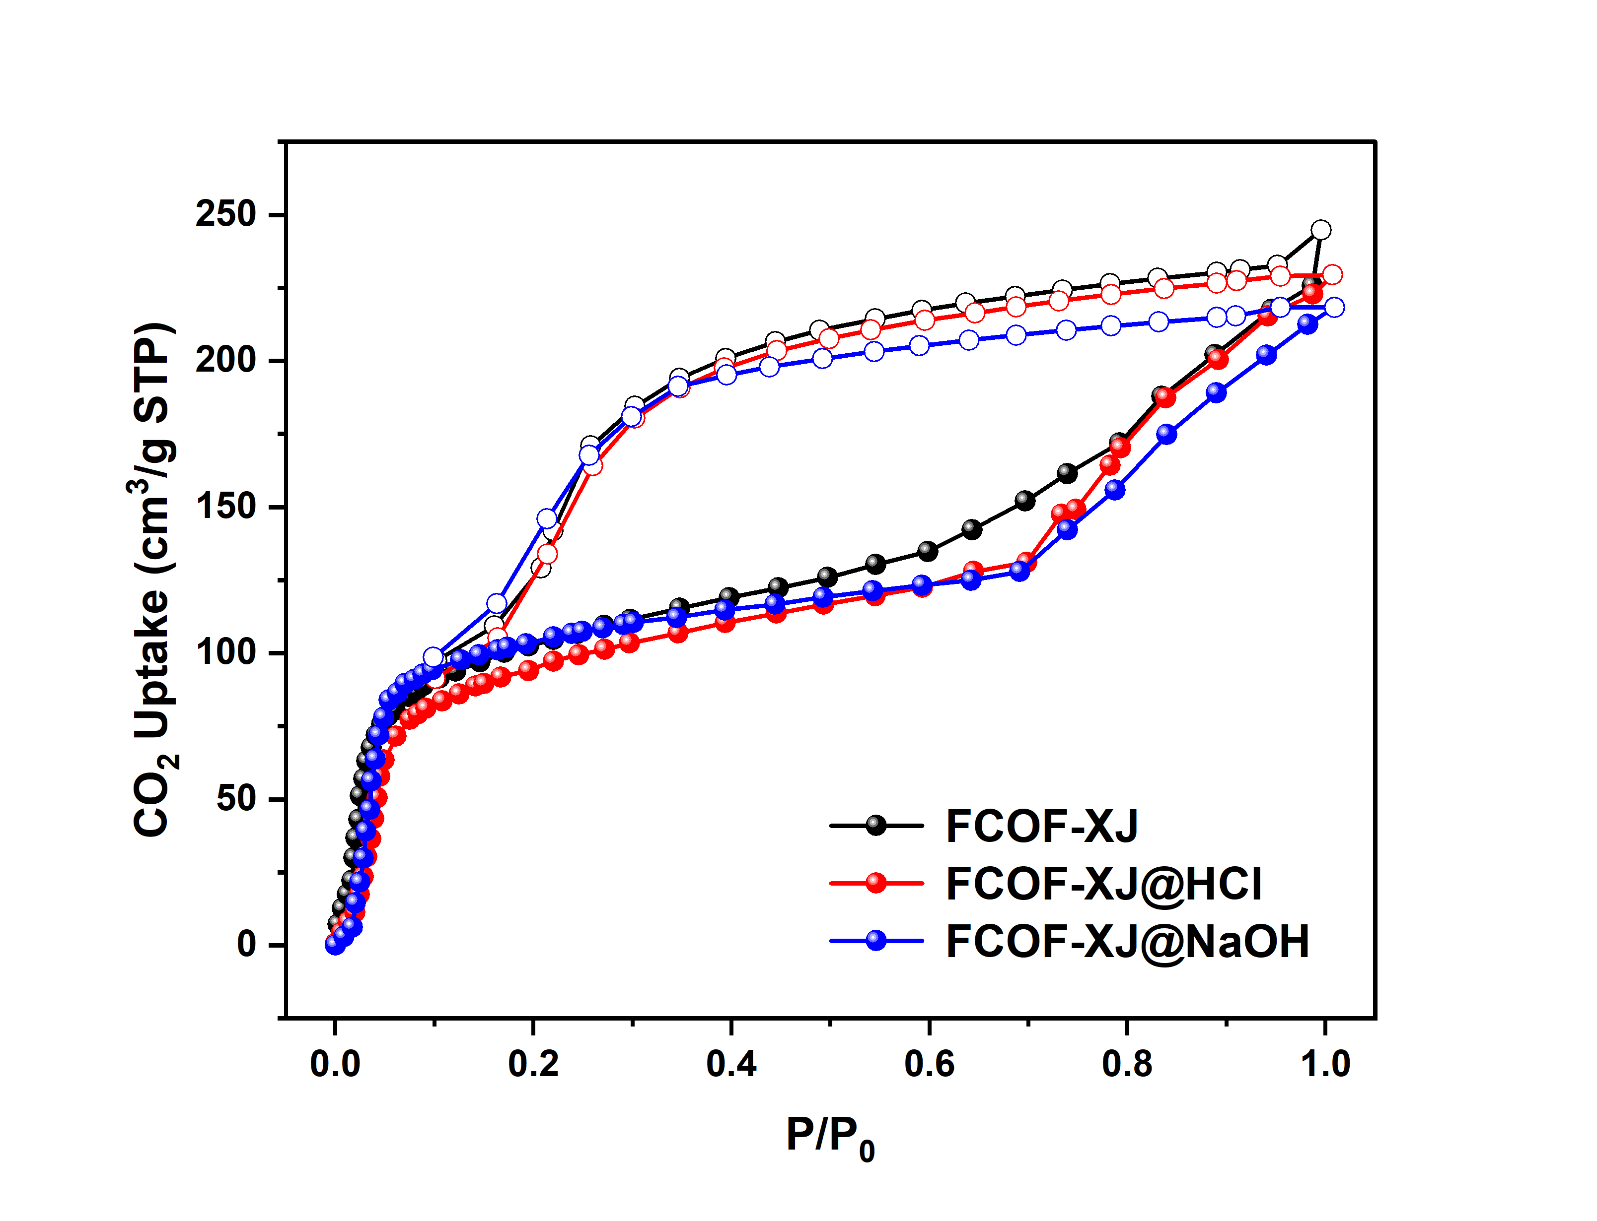
Figrue S7. CO₂ adsorption-desorption isotherm for FCOF-XJ. Untreated FCOF-XJ: black; FCOF-XJ after immersion in 1 M HCl: red; FCOF-XJ after immersion in 1M NaOH: blue.
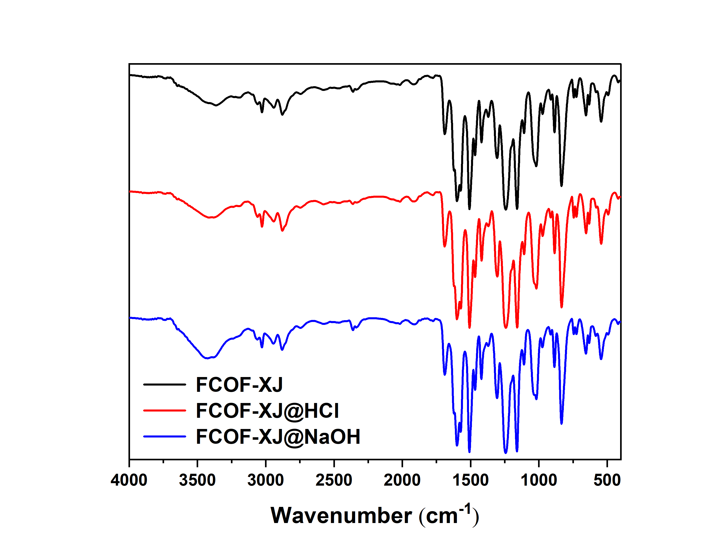
Figrue S8. FT-IR profile for FCOF-XJ. Untreated FCOF-XJ: black; FCOF-XJ after immersion in 1 M HCl: red; FCOF-XJ after immersion in 1M NaOH: blue.

Section 3. Single-component gas adsorption experiment
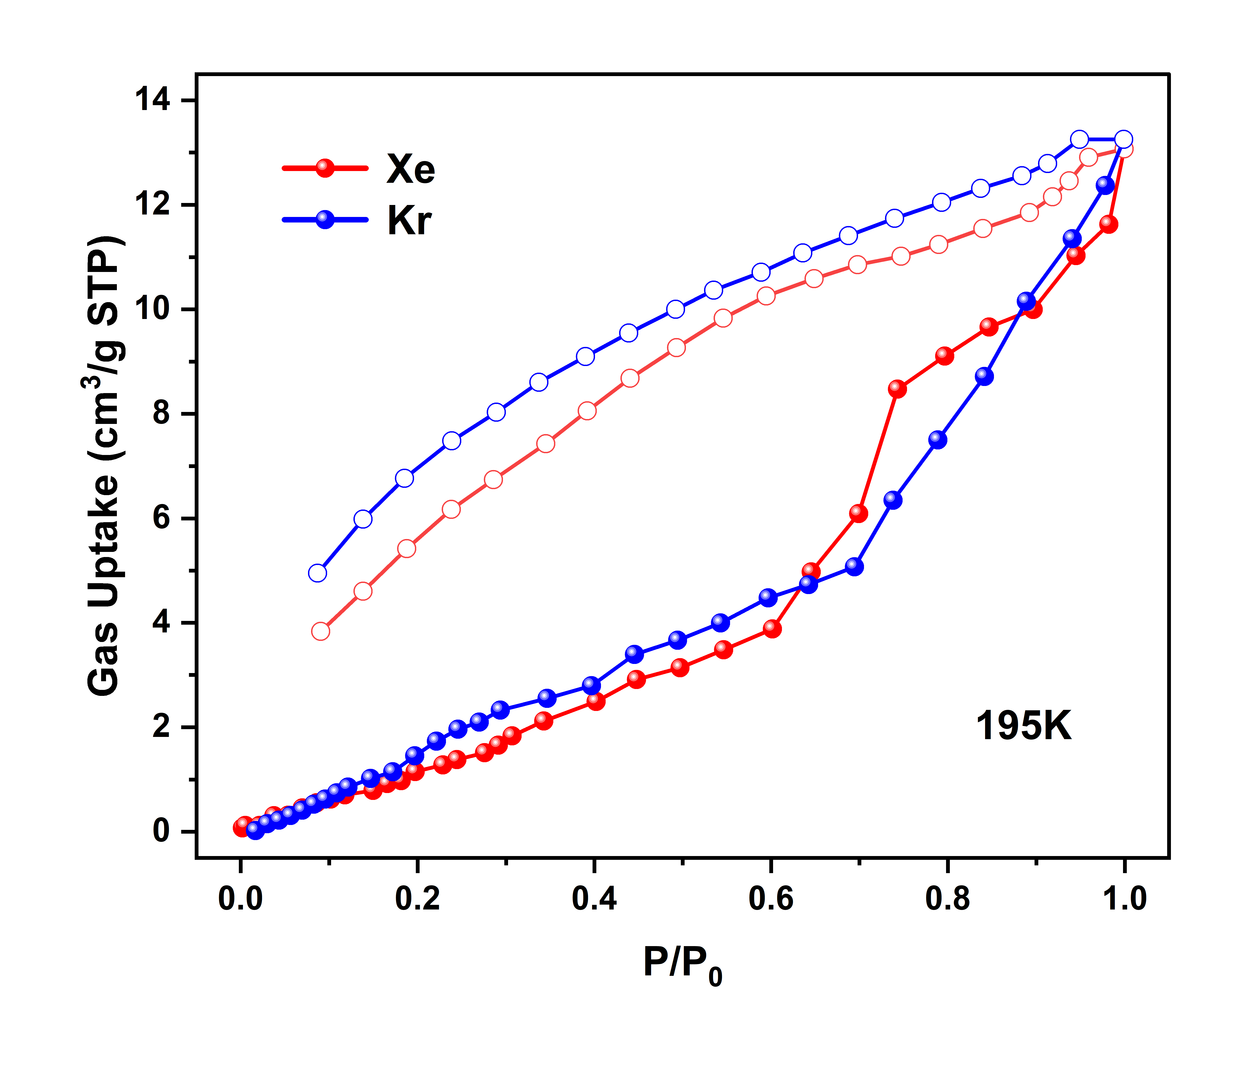
Figrue S9. Single-component adsorption isotherms for Xe and Kr at 195 K
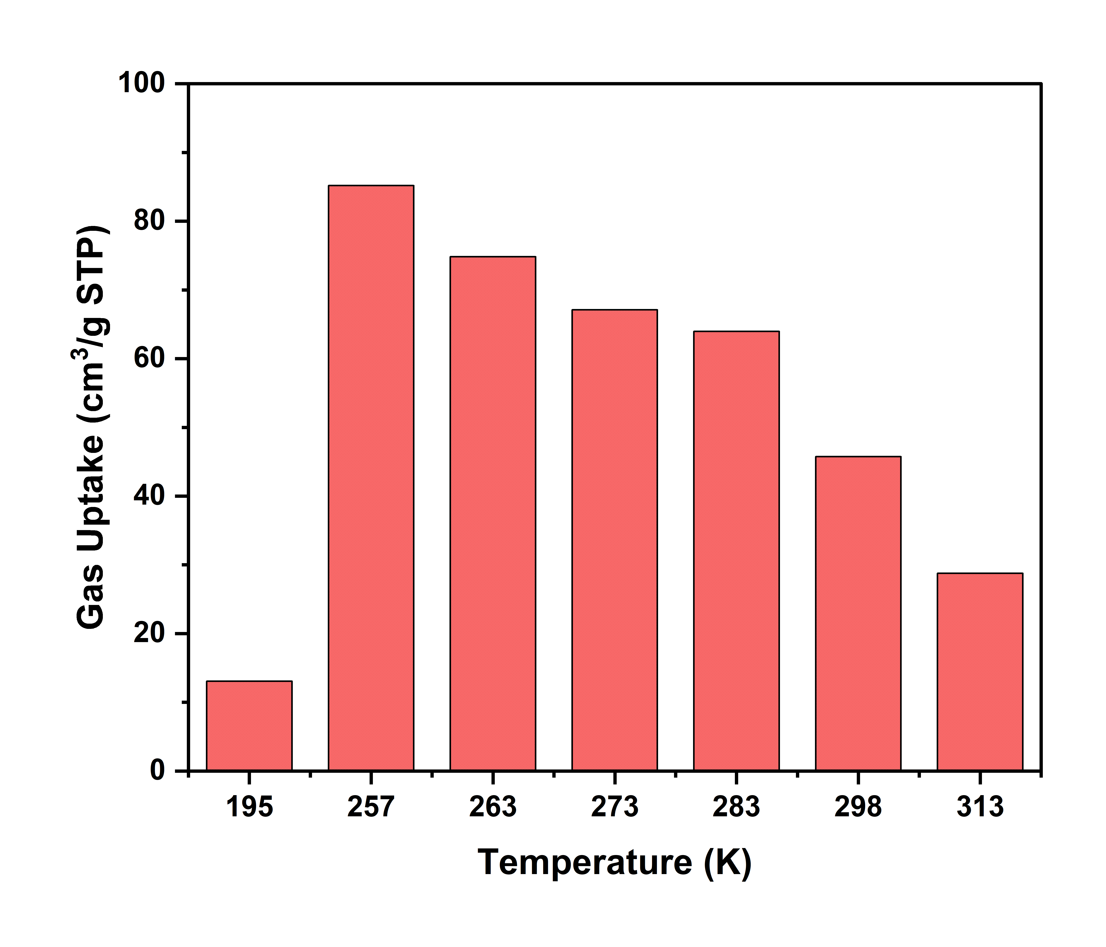
Figrue S10. Saturated adsorption capacity of Xe on FCOF-XJ at 195 K-313 K and atmospheric pressure.

Section 3. Calculation procedures of isoteric adsorption enthalpy
The isosteric enthalpy (Q_{st}) were calculated by the Clausius-Clapeyron equation¹:
$\frac{Q_{st}}{R}=\frac{d(lnP)}{d(1/T)}$ (1)
The modified dual-site Sips equation (Langmuir-Freundlich equation):
$q=a\frac{bP}{1+bP}+q_{m,a}\frac{{(b_{A}P)}^{1/n_{a}}}{1+{(b_{A}P)}^{1/n_{A}}}+q_{m,B}\frac{{(b_{B}P)}^{1/n_{B}}}{1+{(b_{B}P)}^{1/n_{B}}}$ (2)
where q is the adsorbed amount per unit mass of pure component (mmol g⁻¹); P is the pressure of the native gas at equilibrium (kPa); q_{m,A}, q_{m,B}, and a (mmol g⁻¹) are the maximum loading capacity of the adsorbent at the adsorption sites A, B, and C; b_{A}, b_{B}, and b (kPa⁻¹) are the affinity parameters of adsorption sites A, B, and C; and n_{A} and n_{B} are the solid heterogeneity parameters of adsorption sites A and B. n_{A} and n_{B} are the solid heterogeneity parameters of adsorption sites A and B.
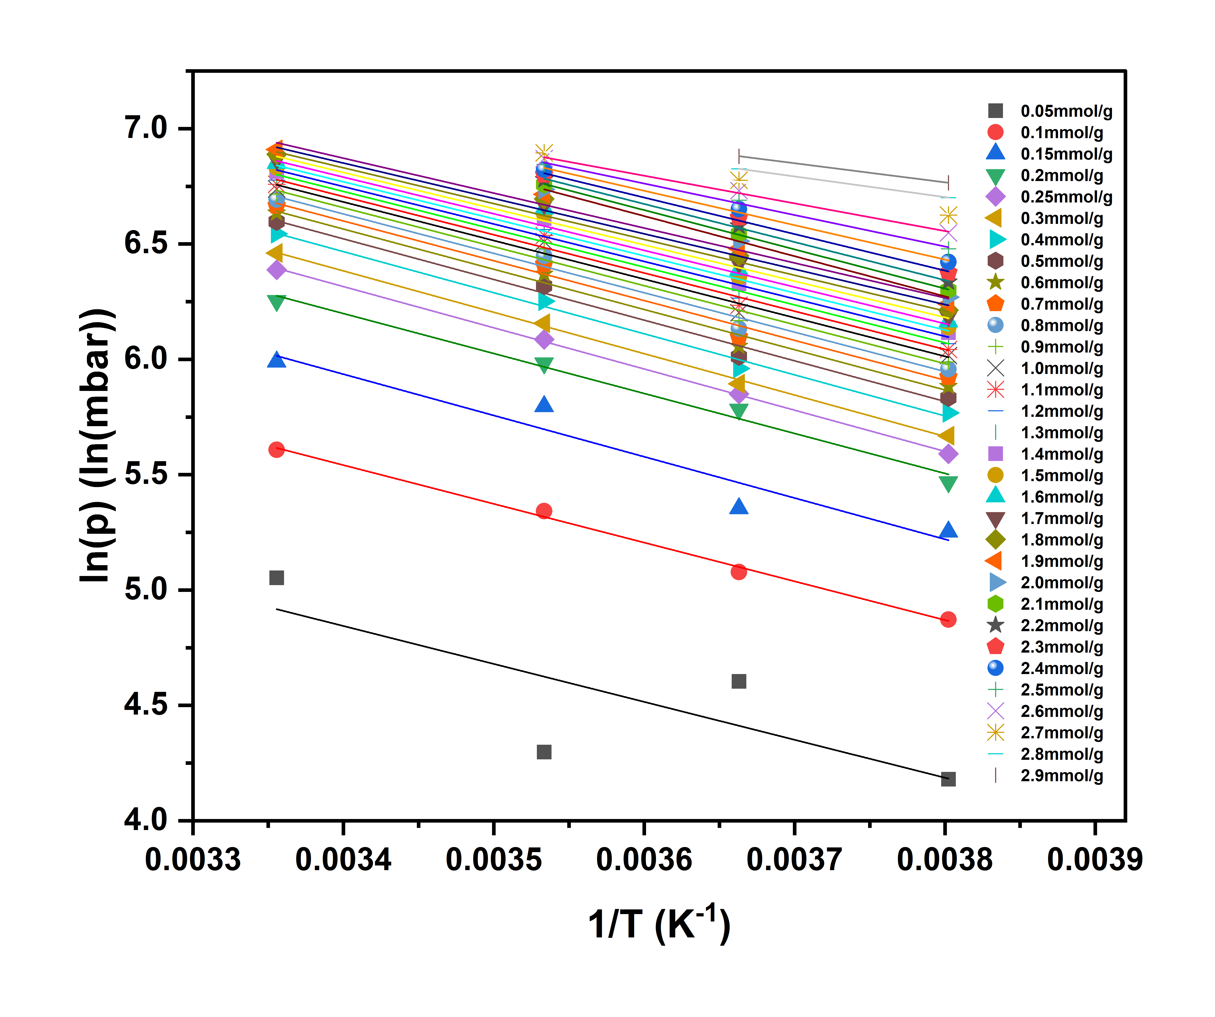
Figure S11. Van’t Hoff isochore graphs for Xe adsorption on FCOF-XJ for temperatures 263 K, 273 K, 283 K, 298 K, as a founction of the amount adsorbed ranging from 0.05-2.9 mmol g⁻¹.
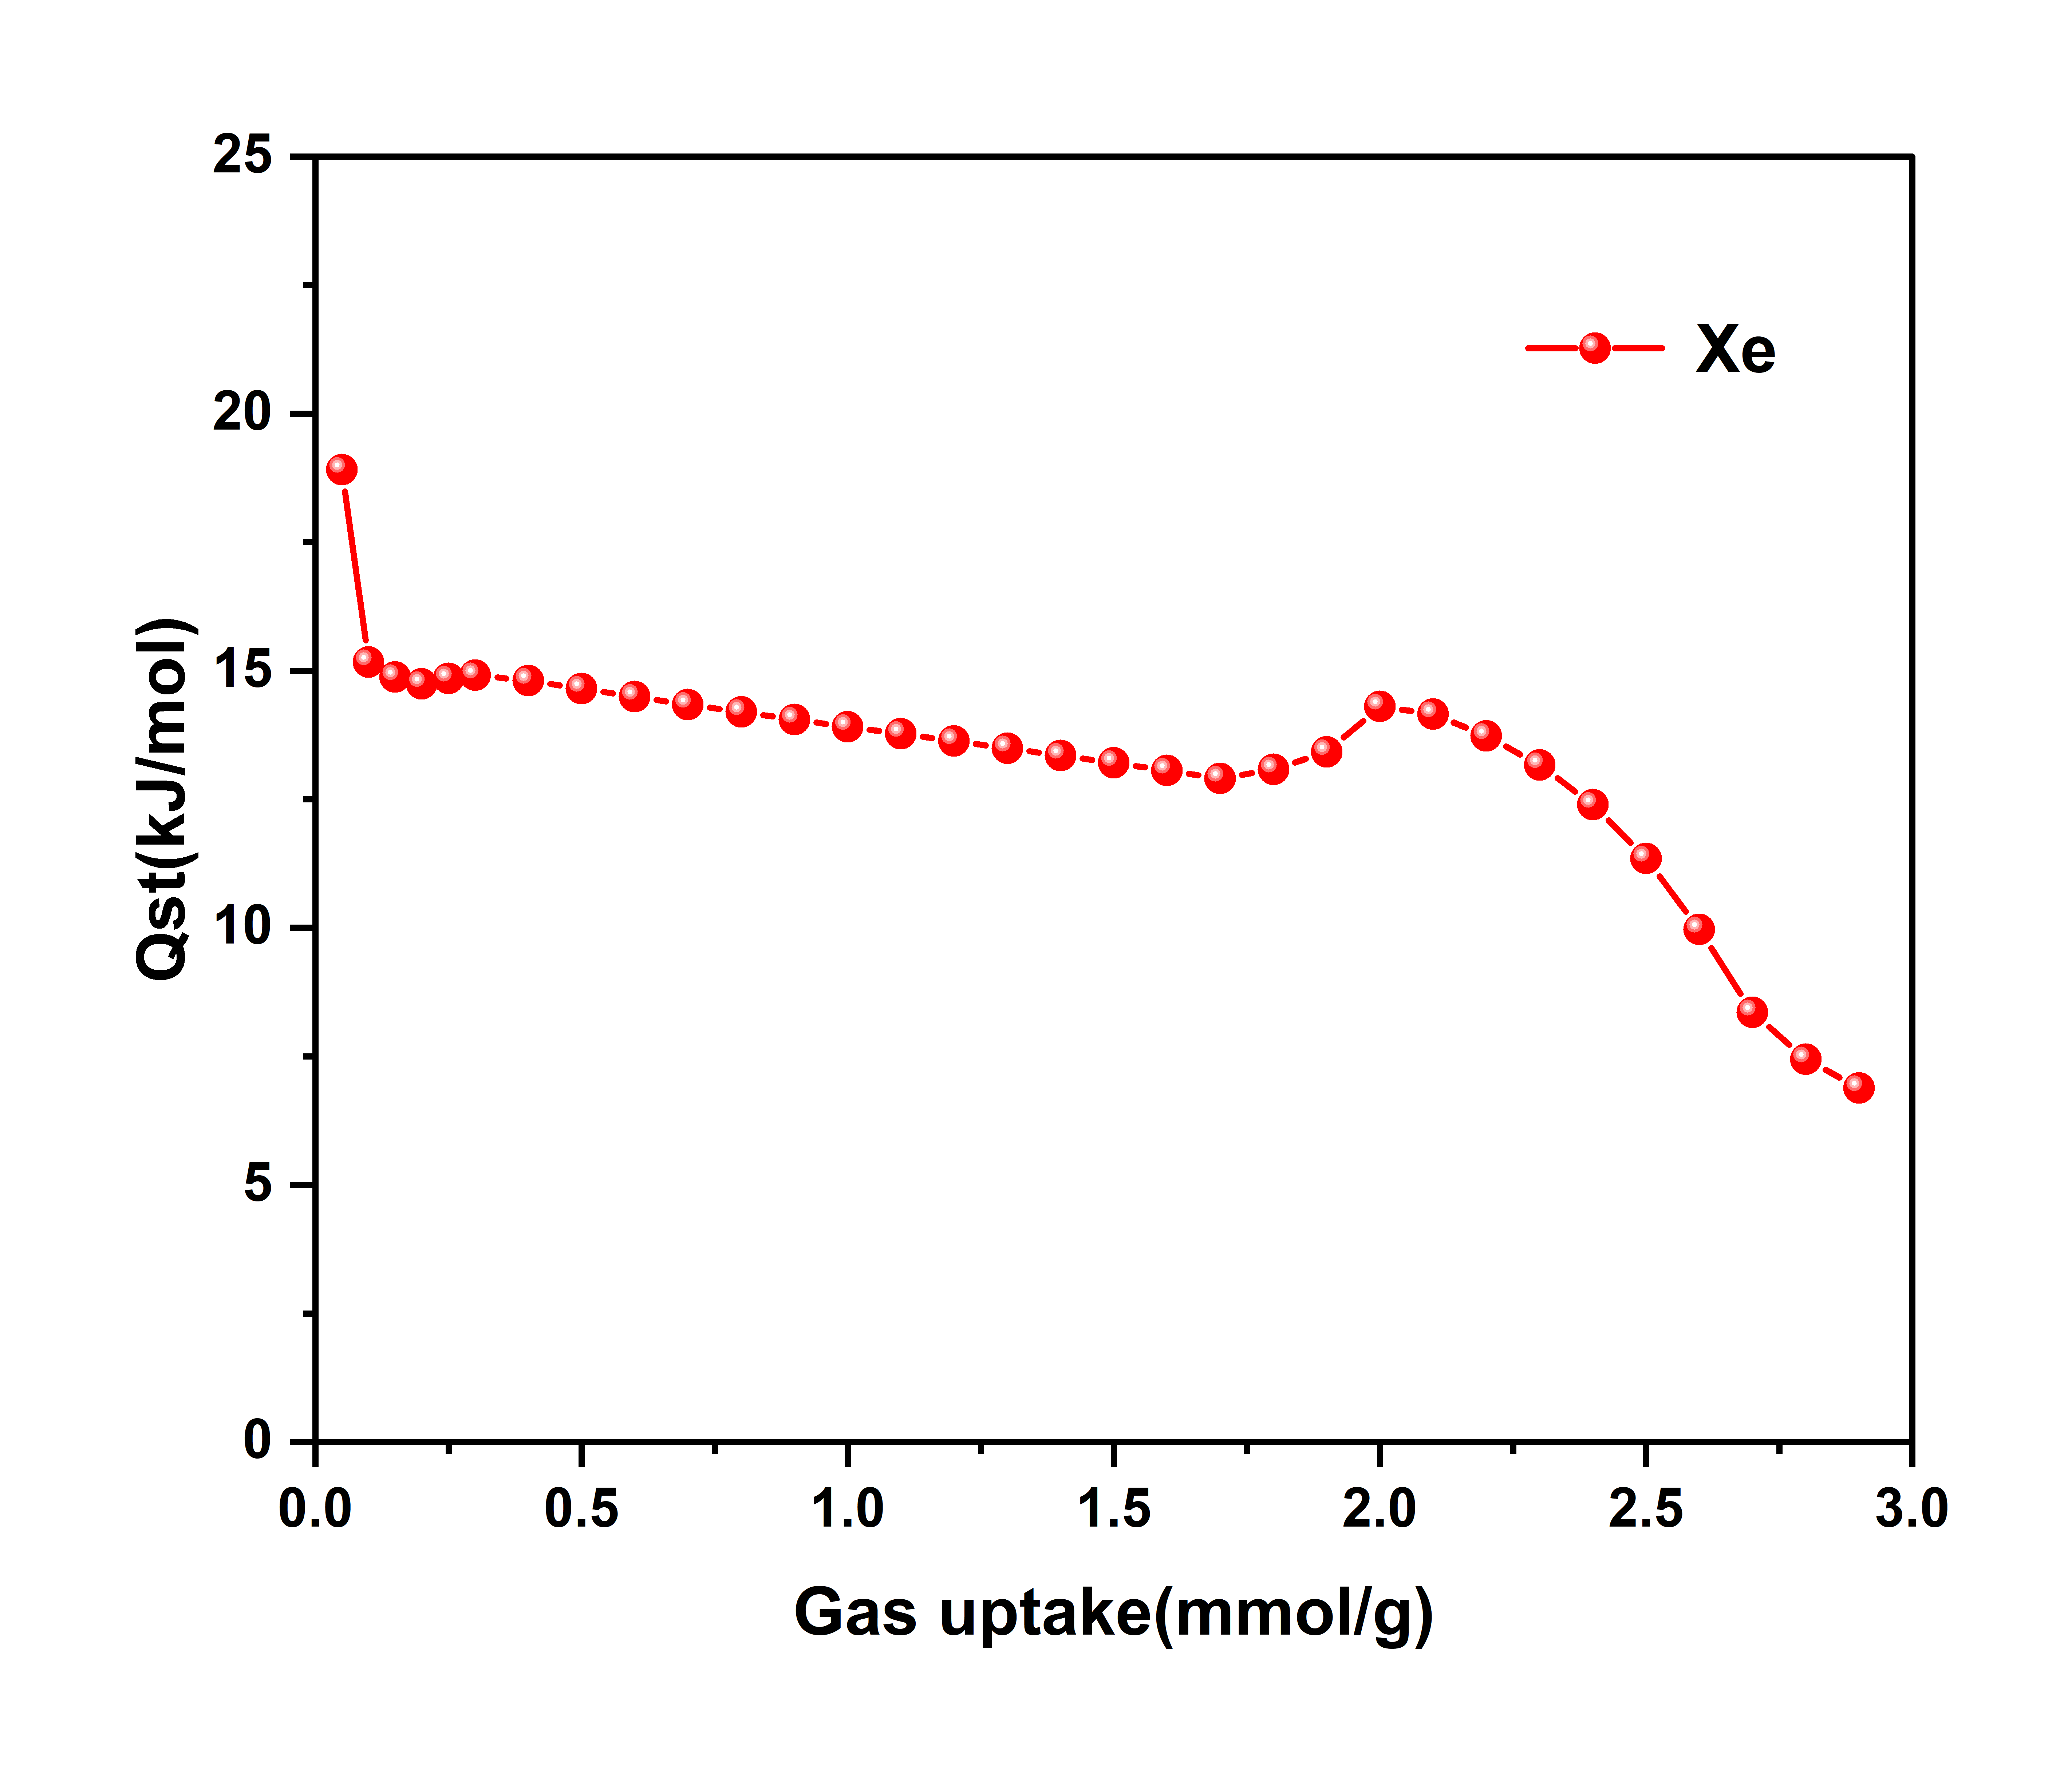
Figure S12 Isosteric heat (Q_{st}/ kJ mol⁻¹) of adsorption for Xe as a founction of amount adsorbed (mmol g⁻¹) for the temperature range 263-298 K.
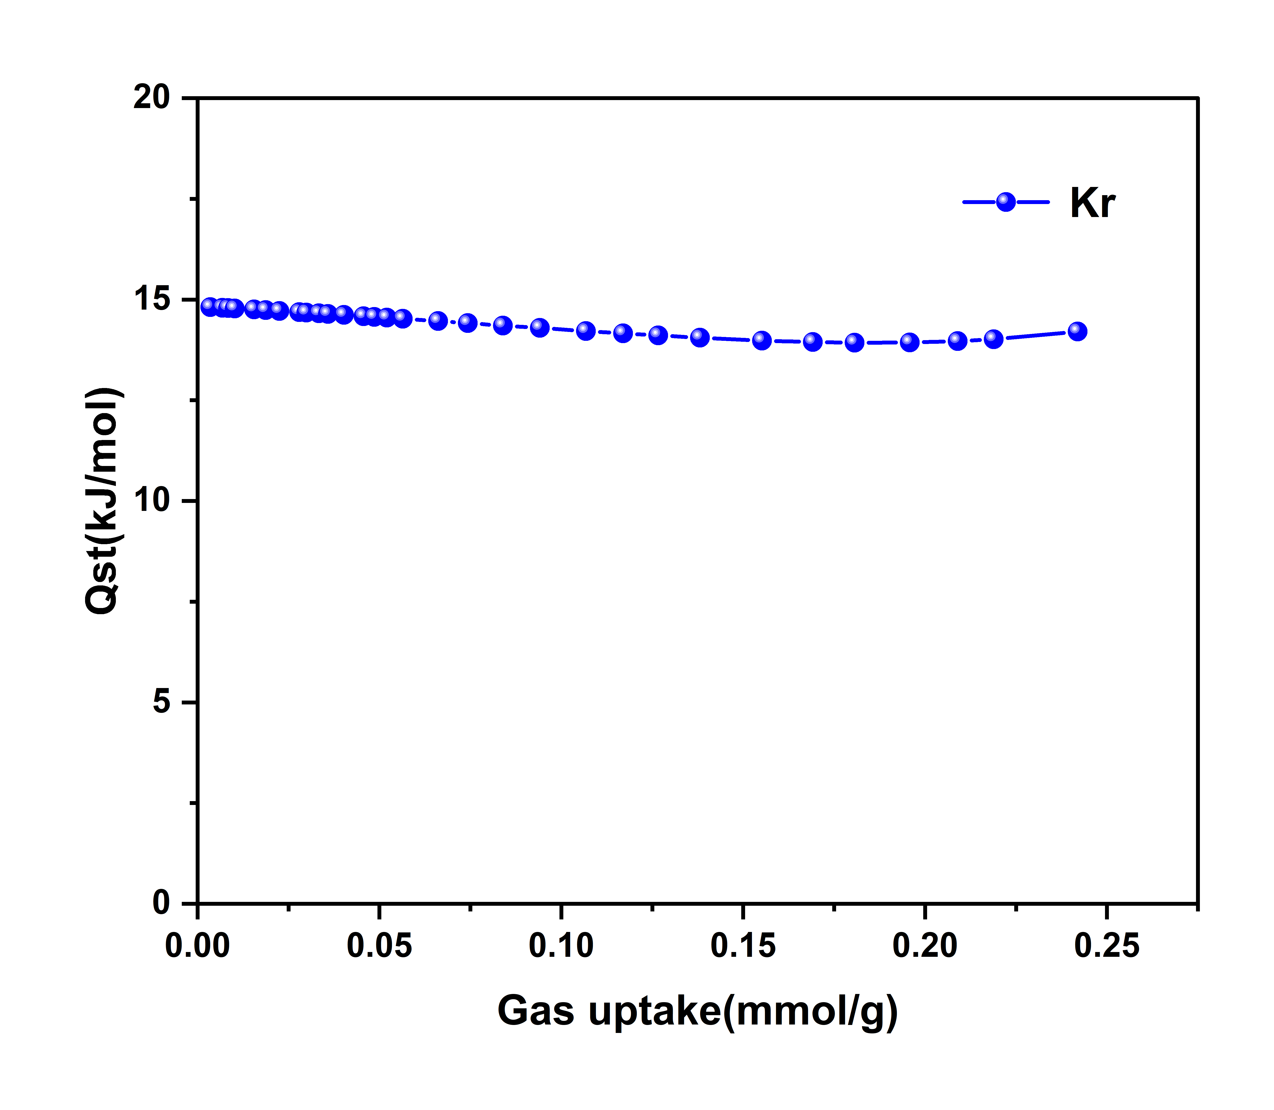
Figure S13. The isosteric heat (Q_{st}) with amountadsorbed for Kr.

Section 4. Calculation of selectivity using S(DIH) equation
The S(DIH) equation based on the difference in equivalent heat (DIH) has been shown to accurately predict the selectivity of two-component gas mixtures at low pressures (1~1 bar). The pressure-dependent selectivity can be calculated using the following equation²:
$S_{ads}\left(i/j\right)=\sqrt{S_{ideal}∙S_{0}}$ (3)
$S_{ideal}=\frac{N_{i}(p)}{N_{j}(p)}$ (4)
$lnS_{0}=0.716\frac{∆q_{st}^{o}}{RT}$ (5)
where N_{i}(p) and N_{j}(p) are the inspirations of the pure component at the pure component at the corresponding partial pressures, respectively. S₀ is only related to $∆q_{st}^{o}$, which is the difference in the strength of the interaction of the material with the two gases.
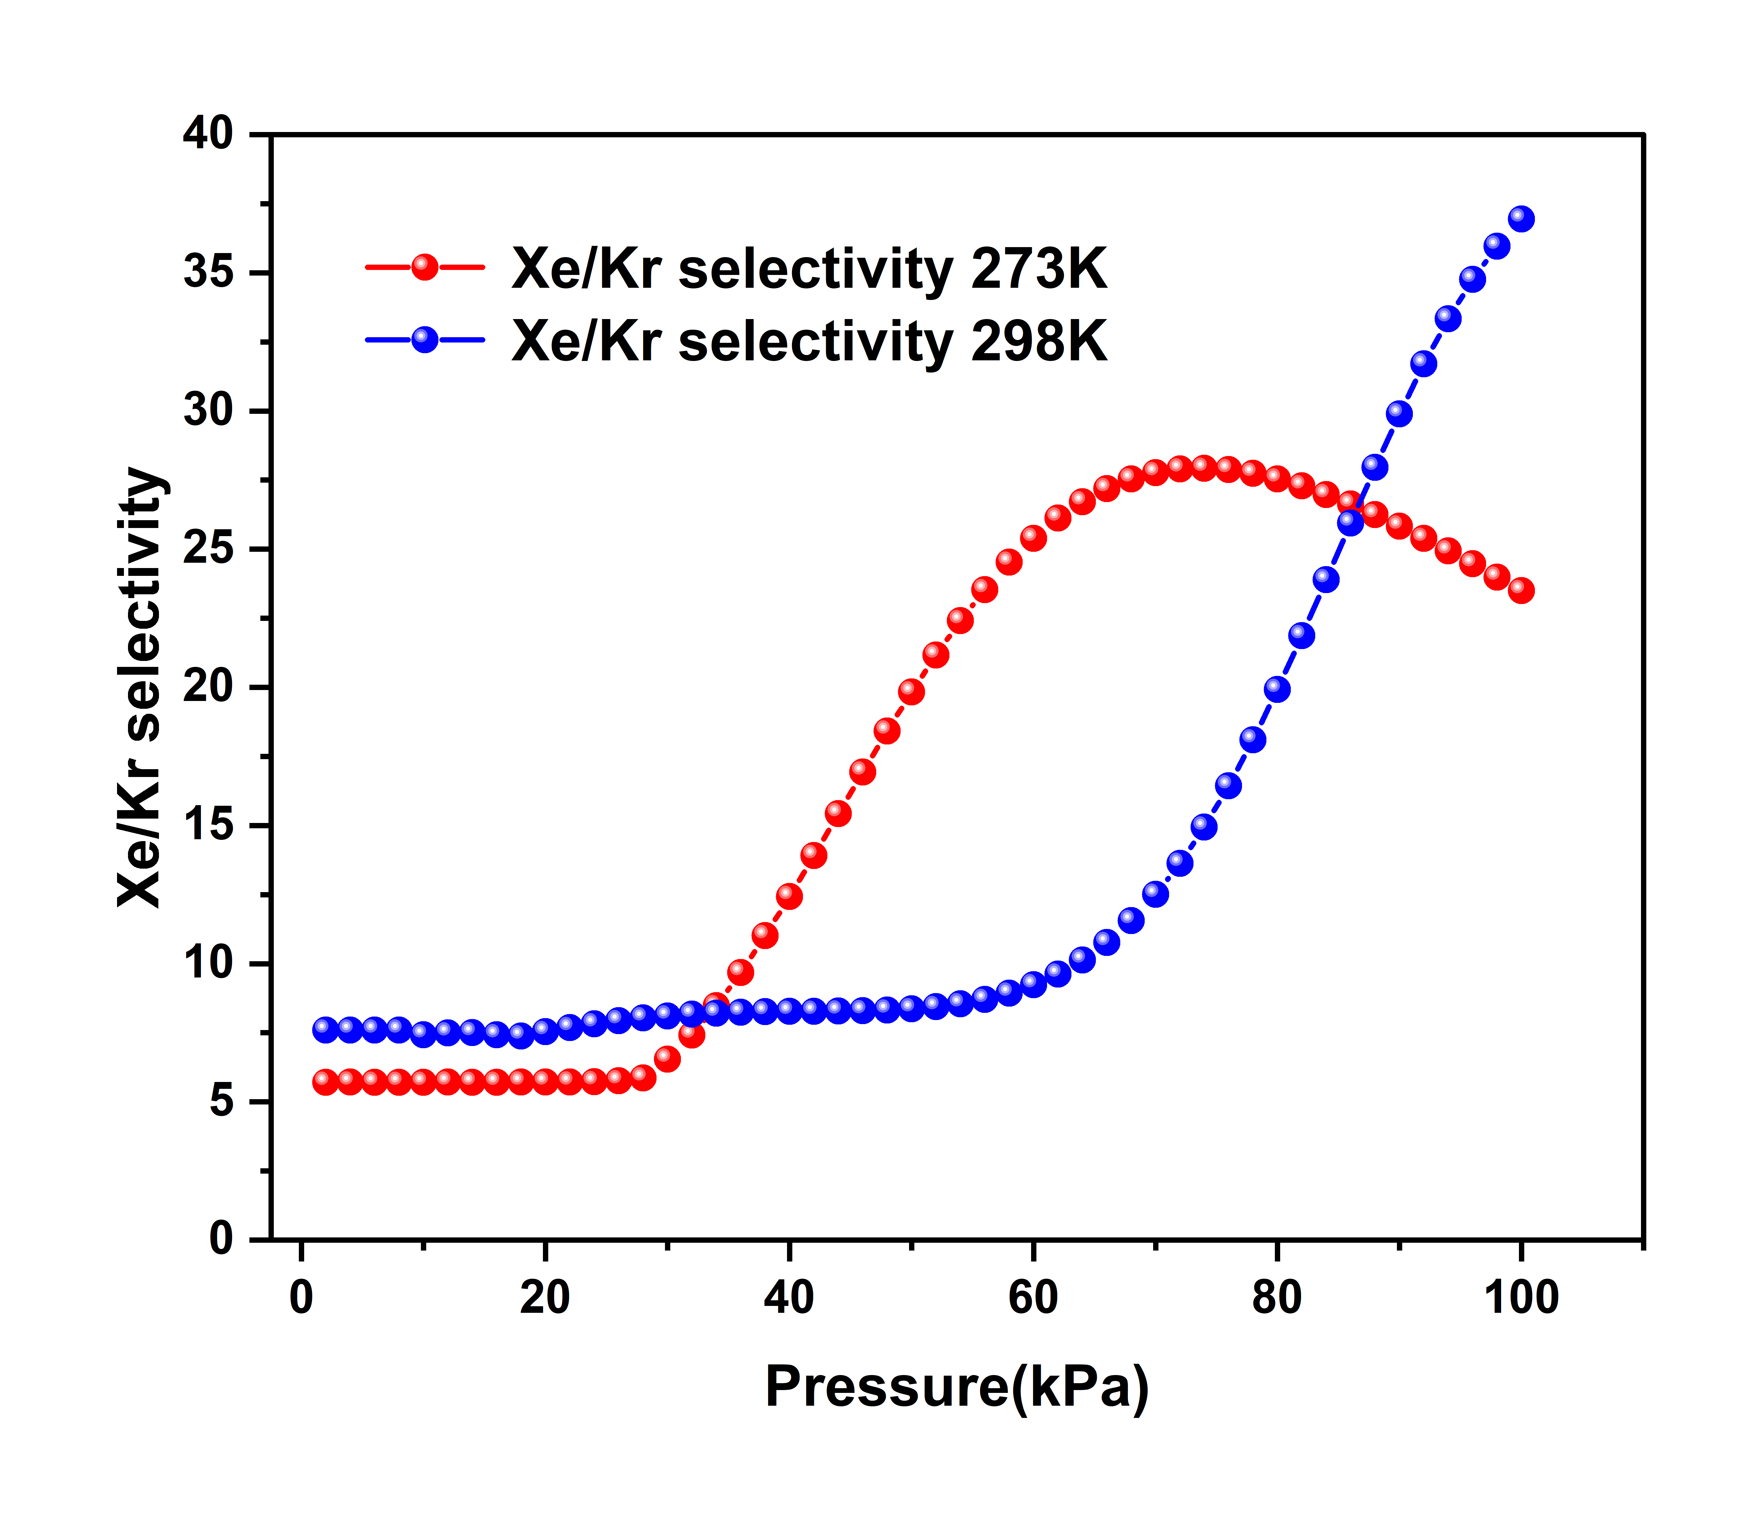
Figure S14. Xe/Kr selectivity at different temperatures (273 K: red; 298 K: blue).
Table S1. Comparison of Xe/Kr adsorption uptake, Qst and IAST selectivity in this work with some other reported porous materials
Materials | Xe Uptakeª  (cm³/g) | Kr Uptakeª  (cm³/g) | Xe/Kr selectivity | Material  Type | Ref.
FCOF-XJ | 45.8 | 2.0 | 36.9^{b} | COF | This work
ATFG-COF | 38.5 | 12.1 | ~6^{c} | COF | ³
TFB-TAPA | 34.9 | 10.2 | 8.9^{d} | COF | ⁴
TFB-TAPA-Bu | 36.7 | 14.4 | 5.7^{d} | COF | ⁴
TFP-TAPA | 37.5 | 12.0 | 9.8^{d} | COF | ⁴
TFP-TAPA-Bu | 85.6 | 28.5 | 9.7^{d} | COF | ⁴
Ppy-POF | 29.6 | 9.4 | 7.6^{c} | POP | ⁵
POP-ch-ET | 31.1 | 7.2 | 9.8^{b} | POP | ⁶
POP-ch-ME | 51.5 | 13.0 | 7.8^{b} | POP | ⁶
POP-ch-SP | 53.1 | 15.0 | 11.5^{b} | POP | ⁶
COP-14 | 53.8 | ~11.2 | ~6^{b} | POP | ⁷
IISERP-POF6 | 37.6 | ~9.9 | 6.7^{c} | POP | ⁸
IISERP-POF7 | 34.5 | ~12.1 | 6.3^{c} | POP | ⁸
IISERP-POF8 | 38.5 | ~11.0 | 6.3^{c} | POP | ⁸
CMP-PY-TBTP | 38.1 | ~12.1 | 11.9^{c} | POP | ⁹
CTF-0 | 25.2 | 8.4 | 5.2^{d} | POF | ¹⁰
PAF-45 | 49.6 | 24.2 | 8.1^{d} | POF | ¹⁰
PAF-67 | 62.8 | 37.3 | 6.6^{d} | POF | ¹⁰
PAF-45S | 41.5 | 12.2 | 16.7^{d} | POF | ¹¹
QS-PAF-1 | 40.3 | ~11.2 | 9.7^{d} | PAF | ¹²
QS-PAF-2 | 39.2 | ~11.2 | 9.7^{d} | PAF | ¹²
PAF-4F | 50.6 | 12.5 | 4.2^{c} | PAF | ¹³
PAF-8F | 39.0 | 9.4 | 3.1^{c} | PAF | ¹³
HOF-FJU-168 | 78.3 | 29.9 | 22.0^{c} | HOF | ¹⁴
HOF-FJU-46 | 56.2 | ~24.8 | 19.9^{c} | HOF | ¹⁵
HOF-FJU-8 | 40.5 | 17.2 | 12.1^{c} | HOF | ¹⁶
HOF-BTB | 45.0 | 9.4 | 6.1^{c} | HOF | ¹⁷
HOF-40 | 34.9 | 9.9 | 11.2^{c} | HOF | ¹⁸
HIAM-103 | 31.1 | 14.6 | 8.3^{c} | HOF | ¹⁹
ETTA-Cl | 32.0 | 15.2 | 9.7^{c} | HOF | ²⁰
ETTA-Br | 30.5 | 14.3 | 10.5^{c} | HOF | ²⁰
HOF-ZJU-201 | 67.4 | ~34.7 | 21.0^{c} | SMOF | ²¹
HOF-ZJU-202 | 63.2 | ~38.1 | 15.1^{c} | SMOF | ²¹
MOF-Cu-H | 71.5 | ~35.8 | 16.7^{c} | MOF | ²²
ZUL-C1 | ~64.7 | ~24.6 | 11.7^{c} | MOF | ²³
ZUL-C2 | ~58.2 | ~29.1 | 19.1^{c} | MOF | ²³
ZJU-74a-Ni | 73.7 | 30.9 | 74.1^{c} | MOF | ²⁴
ZJU-74a-Pd | 62.9 | 23.5 | 103.4^{c} | MOF | ²⁴
Co-squarate | 29.1 | ~13.6 | 69.7^{c} | MOF | ²⁵
Ni(4-DPDS)₂CrO₄ | 36.1 | ·20.2 | 23.7^{c} | MOF | ²⁶
Ni(4-DPDS)₂MoO₄ | 24.0 | ~14.6 | 20.3^{c} | MOF | ²⁶
Ni(4-DPDS)₂WO₄ | 24.9 | 13.9 | 30.2^{c} | MOF | ²⁶
ZUL-530 | 70.1 | 32.0 | 20.5^{c} | MOF | ²⁷
(a) At RT and 1 Bar; (b) From S(DIH) calculation; (c) From ISAT calculation; (d) From Henry calculation.

Section 5. Crystal structure of FCOF-XJ
Table S2. Fractional atomic coordinates and the unit cell of FCOF-XJ-CP.
FCOF-XJ-CP |  | Space group: I-4  a = 16.279(1) Å, b = 16.279(1) Å, c =9.148(2) Å, α = β= γ = 90º
C1 | C | 6.86485 | 8.57643 | 8.19212
C2 | C | 8.57643 | 9.41415 | 0.95608
C3 | C | 9.41415 | 7.70257 | 8.19212
C4 | C | 7.70257 | 6.86485 | 0.95608
C5 | C | 15.00435 | 0.43693 | 3.61802
C6 | C | 0.43693 | 1.27465 | 5.53018
C7 | C | 1.27465 | 15.84207 | 3.61802
C8 | C | 15.84207 | 15.00435 | 5.53018
O9 | O | 6.16535 | 7.31464 | 7.77432
O10 | O | 7.31464 | 10.11365 | 1.37388
O11 | O | 10.11365 | 8.96436 | 7.77432
O12 | O | 8.96436 | 6.16535 | 1.37388
O13 | O | 14.30485 | 15.45414 | 3.20022
O14 | O | 15.45414 | 1.97415 | 5.94798
O15 | O | 1.97415 | 0.82486 | 3.20022
O16 | O | 0.82486 | 14.30485 | 5.94798
C17 | C | 5.55798 | 7.13883 | 6.55231
C18 | C | 7.13883 | 10.72102 | 2.59589
C19 | C | 10.72102 | 9.14017 | 6.55231
C20 | C | 9.14017 | 5.55798 | 2.59589
C21 | C | 13.69748 | 15.27833 | 1.97821
C22 | C | 15.27833 | 2.58152 | 7.16999
C23 | C | 2.58152 | 1.00067 | 1.97821
C24 | C | 1.00067 | 13.69748 | 7.16999
C25 | C | 5.63888 | 8.13266 | 5.58946
C26 | C | 8.13266 | 10.64012 | 3.55874
C27 | C | 10.64012 | 8.14634 | 5.58946
C28 | C | 8.14634 | 5.63888 | 3.55874
C29 | C | 13.77838 | 16.27216 | 1.01536
C30 | C | 16.27216 | 2.50062 | 8.13284
C31 | C | 2.50062 | 0.00684 | 1.01536
C32 | C | 0.00684 | 13.77838 | 8.13284
C33 | C | 4.87686 | 5.89951 | 6.31354
C34 | C | 5.89951 | 11.40214 | 2.83466
C35 | C | 11.40214 | 10.37949 | 6.31354
C36 | C | 10.37949 | 4.87686 | 2.83466
C37 | C | 13.01636 | 14.03901 | 1.73944
C38 | C | 14.03901 | 3.26264 | 7.40876
C39 | C | 3.26264 | 2.23999 | 1.73944
C40 | C | 2.23999 | 13.01636 | 7.40876
C41 | C | 5.06472 | 7.86097 | 4.39534
C42 | C | 7.86097 | 11.21428 | 4.75286
C43 | C | 11.21428 | 8.41803 | 4.39534
C44 | C | 8.41803 | 5.06472 | 4.75286
C45 | C | 13.20422 | 16.00047 | 8.96944
C46 | C | 16.00047 | 3.07478 | 0.17876
C47 | C | 3.07478 | 0.27853 | 8.96944
C48 | C | 0.27853 | 13.20422 | 0.17876
C49 | C | 4.31328 | 5.63221 | 5.11494
C50 | C | 5.63221 | 11.96572 | 4.03326
C51 | C | 11.96572 | 10.64679 | 5.11494
C52 | C | 10.64679 | 4.31328 | 4.03326
C53 | C | 12.45278 | 13.77171 | 0.54084
C54 | C | 13.77171 | 3.82622 | 8.60736
C55 | C | 3.82622 | 2.50729 | 0.54084
C56 | C | 2.50729 | 12.45278 | 8.60736
C57 | C | 4.39761 | 6.60586 | 4.12666
C58 | C | 6.60586 | 11.88139 | 5.02154
C59 | C | 11.88139 | 9.67314 | 4.12666
C60 | C | 9.67314 | 4.39761 | 5.02154
C61 | C | 12.53711 | 14.74536 | 8.70076
C62 | C | 14.74536 | 3.74189 | 0.44744
C63 | C | 3.74189 | 1.53364 | 8.70076
C64 | C | 1.53364 | 12.53711 | 0.44744
C65 | C | 3.76729 | 6.29265 | 2.81353
C66 | C | 6.29265 | 12.51171 | 6.33467
C67 | C | 12.51171 | 9.98635 | 2.81353
C68 | C | 9.98635 | 3.76729 | 6.33467
C69 | C | 11.90679 | 14.43215 | 7.38763
C70 | C | 14.43215 | 4.37221 | 1.76057
C71 | C | 4.37221 | 1.84685 | 7.38763
C72 | C | 1.84685 | 11.90679 | 1.76057
N73 | N | 3.85780 | 7.26450 | 1.92259
N74 | N | 7.26450 | 12.42120 | 7.22561
N75 | N | 12.42120 | 9.01450 | 1.92259
N76 | N | 9.01450 | 3.85780 | 7.22561
N77 | N | 11.99730 | 15.40400 | 6.49669
N78 | N | 15.40400 | 4.28170 | 2.65151
N79 | N | 4.28170 | 0.87500 | 6.49669
N80 | N | 0.87500 | 11.99730 | 2.65151
C81 | C | 2.99371 | 7.36104 | 0.79580
C82 | C | 7.36104 | 13.28529 | 8.35240
C83 | C | 13.28529 | 8.91796 | 0.79580
C84 | C | 8.91796 | 2.99371 | 8.35240
C85 | C | 11.13321 | 15.50054 | 5.36990
C86 | C | 15.50054 | 5.14579 | 3.77830
C87 | C | 5.14579 | 0.77846 | 5.36990
C88 | C | 0.77846 | 11.13321 | 3.77830
C89 | C | 3.13322 | 8.52043 | 0.01592
C90 | C | 8.52043 | 13.14578 | 9.13228
C91 | C | 13.14578 | 7.75857 | 0.01592
C92 | C | 7.75857 | 3.13322 | 9.13228
C93 | C | 11.27272 | 0.38093 | 4.59002
C94 | C | 0.38093 | 5.00628 | 4.55818
C95 | C | 5.00628 | 15.89807 | 4.59002
C96 | C | 15.89807 | 11.27272 | 4.55818
C97 | C | 1.99190 | 6.37648 | 0.48714
C98 | C | 6.37648 | 14.28710 | 8.66106
C99 | C | 14.28710 | 9.90252 | 0.48714
C100 | C | 9.90252 | 1.99190 | 8.66106
C101 | C | 10.13140 | 14.51598 | 5.06124
C102 | C | 14.51598 | 6.14760 | 4.08696
C103 | C | 6.14760 | 1.76302 | 5.06124
C104 | C | 1.76302 | 10.13140 | 4.08696
C105 | C | 2.23918 | 8.73271 | 8.13998
C106 | C | 8.73271 | 14.03982 | 1.00822
C107 | C | 14.03982 | 7.54629 | 8.13998
C108 | C | 7.54629 | 2.23918 | 1.00822
C109 | C | 10.37868 | 0.59321 | 3.56588
C110 | C | 0.59321 | 5.90032 | 5.58232
C111 | C | 5.90032 | 15.68579 | 3.56588
C112 | C | 15.68579 | 10.37868 | 5.58232
C113 | C | 1.11137 | 6.59967 | 8.60416
C114 | C | 6.59967 | 15.16763 | 0.54404
C115 | C | 15.16763 | 9.67933 | 8.60416
C116 | C | 9.67933 | 1.11137 | 0.54404
C117 | C | 9.25087 | 14.73917 | 4.03006
C118 | C | 14.73917 | 7.02813 | 5.11814
C119 | C | 7.02813 | 1.53983 | 4.03006
C120 | C | 1.53983 | 9.25087 | 5.11814
C121 | C | 1.18820 | 7.79325 | 7.85410
C122 | C | 7.79325 | 15.09080 | 1.29410
C123 | C | 15.09080 | 8.48575 | 7.85410
C124 | C | 8.48575 | 1.18820 | 1.29410
C125 | C | 9.32770 | 15.93275 | 3.28000
C126 | C | 15.93275 | 6.95130 | 5.86820
C127 | C | 6.95130 | 0.34625 | 3.28000
C128 | C | 0.34625 | 9.32770 | 5.86820
C129 | C | 8.13950 | 8.13950 | 0.00000
C130 | C | 0.00000 | 0.00000 | 4.57410
C131 | C | 0.00000 | 8.13950 | 6.86115
C132 | C | 8.13950 | 0.00000 | 2.28705

Table S3. Fractional atomic coordinates and the unit cell of FCOF-XJ-OP.
FCOF-XJ-OP |  | Space group: I-4  a = 18.305(1) Å, b = 18.305(1) Å, c =9.592(2) Å, α = β= γ = 90º
C1 | C | 7.97892 | 9.61154 | 7.72748
O2 | O | 7.47206 | 8.43581 | 7.08968
C3 | C | 9.15245 | 9.15245 | 8.5922
C4 | C | 6.59946 | 8.52972 | 6.08165
C5 | C | 10.32598 | 8.69336 | 7.72748
C6 | C | 9.61154 | 10.32598 | 9.45692
C7 | C | 8.69336 | 7.97892 | 9.45692
C8 | C | 6.56524 | 9.58994 | 5.18514
C9 | C | 5.73383 | 7.42923 | 5.93154
O10 | O | 10.83284 | 9.86909 | 7.08968
O11 | O | 8.43581 | 10.83284 | 10.09472
O12 | O | 9.86909 | 7.47206 | 10.09472
O13 | C | 5.68898 | 9.52715 | 4.14256
C14 | C | 4.8422 | 7.39701 | 4.90726
C15 | C | 11.70543 | 9.77518 | 6.08165
C16 | C | 8.52972 | 11.70543 | 11.10275
C17 | C | 9.77518 | 6.59946 | 11.10275
C18 | C | 4.8076 | 8.43453 | 3.98902
C19 | C | 11.73966 | 8.71496 | 5.18514
C20 | C | 12.57107 | 10.87567 | 5.93154
C21 | C | 9.58994 | 11.73966 | 11.99927
C22 | C | 7.42923 | 12.57107 | 11.25286
C23 | C | 8.71496 | 6.56524 | 11.99927
C24 | C | 10.87567 | 5.73383 | 11.25286
C25 | C | 3.8627 | 8.33056 | 2.92367
C26 | C | 12.61592 | 8.77775 | 4.14256
C27 | C | 13.4627 | 10.90789 | 4.90726
C28 | C | 9.52715 | 12.61592 | 13.04184
C29 | C | 7.39701 | 13.4627 | 12.27714
C30 | C | 8.77775 | 5.68898 | 13.04184
C31 | C | 10.90789 | 4.8422 | 12.27714
N32 | N | 3.9566 | 9.06257 | 1.90317
C33 | C | 13.4973 | 9.87037 | 3.98902
C34 | C | 8.43453 | 13.4973 | 13.19539
C35 | C | 9.87037 | 4.8076 | 13.19539
C36 | C | 3.03715 | 8.94725 | 0.88732
C37 | C | 14.4422 | 9.97434 | 2.92367
C38 | C | 8.33056 | 14.4422 | 14.26073
C39 | C | 9.97434 | 3.8627 | 14.26073
C40 | C | 3.05344 | 9.98917 | -0.02208
C41 | C | 2.10708 | 7.89527 | 0.69794
N42 | N | 14.3483 | 9.24233 | 1.90317
N43 | N | 9.06257 | 14.3483 | 15.28123
N44 | N | 9.24233 | 3.9566 | 15.28123
C45 | C | 2.14716 | 10.03218 | -1.04395
C46 | C | 1.21453 | 7.9392 | -0.32668
C47 | C | 15.26775 | 9.35765 | 0.88732
C48 | C | 8.94725 | 15.26775 | 16.29708
C49 | C | 9.35765 | 3.03715 | 16.29708
C50 | C | 1.1922 | 9.01864 | -1.20592
C51 | C | 15.25146 | 8.31573 | -0.02208
C52 | C | 16.19782 | 10.40963 | 0.69794
C53 | C | 9.98917 | 15.25146 | 17.20648
C54 | C | 7.89527 | 16.19782 | 16.48646
C55 | C | 8.31573 | 3.05344 | 17.20648
C56 | C | 10.40963 | 2.10708 | 16.48646
C57 | C | 0 | 9.15245 | -2.14805
C58 | C | 16.15774 | 8.27272 | -1.04395
C59 | C | 17.09037 | 10.3657 | -0.32668
C60 | C | 10.03218 | 16.15774 | 18.22835
C61 | C | 7.9392 | 17.09037 | 17.51108
C62 | C | 8.27272 | 2.14716 | 18.22835
C63 | C | 10.3657 | 1.21453 | 17.51108
C64 | C | -1.1922 | 9.28626 | -1.20592
C65 | C | -0.13381 | 7.96025 | -3.09018
C66 | C | 0.13381 | 10.34465 | -3.09018
C67 | C | 9.01864 | 17.1127 | 18.39032
C68 | C | 9.28626 | 1.1922 | 18.39032
C69 | C | 0.87973 | 7.00528 | -3.25215
C70 | C | -1.21325 | 7.93792 | -3.96942
C71 | C | -0.87973 | 11.29961 | -3.25215
C72 | C | 1.21325 | 10.36698 | -3.96942
C73 | C | 9.15245 | 18.3049 | 19.33245
C74 | C | 0.83672 | 6.09901 | -4.27402
C75 | C | -1.25718 | 7.04537 | -4.99404
C76 | C | -0.83672 | 12.20589 | -4.27402
C77 | C | 1.25718 | 11.25953 | -4.99404
C78 | C | 10.34465 | 18.17109 | 20.27458
C79 | C | 7.96025 | 18.43871 | 20.27458
C80 | C | -0.2052 | 6.1153 | -5.18342
C81 | C | 0.2052 | 12.1896 | -5.18342
C82 | C | 11.29961 | 19.18463 | 20.43655
C83 | C | 10.36698 | 17.09165 | 21.15382
C84 | C | 7.00528 | 17.42517 | 20.43655
C85 | C | 7.93792 | 19.51815 | 21.15382
N86 | N | -0.08988 | 5.19585 | -6.19927
N87 | N | 0.08988 | 13.10905 | -6.19927
C88 | C | 12.20589 | 19.14161 | 21.45842
C89 | C | 11.25953 | 17.04772 | 22.17844
C90 | C | 6.09901 | 17.46818 | 21.45842
C91 | C | 7.04537 | 19.56208 | 22.17844
C92 | C | -0.82189 | 5.28975 | -7.21977
C93 | C | 0.82189 | 13.01515 | -7.21977
C94 | C | 12.1896 | 18.0997 | 22.36782
C95 | C | 6.1153 | 18.5101 | 22.36782
C96 | C | -0.71792 | 4.34485 | -8.28512
C97 | C | 0.71792 | 13.96005 | -8.28512
N98 | N | 13.10905 | 18.21502 | 23.38367
N99 | N | 5.19585 | 18.39478 | 23.38367
C100 | C | 0.3747 | 3.46347 | -8.43866
C101 | C | -1.75544 | 4.31025 | -9.20336
C102 | C | -0.3747 | 14.84143 | -8.43866
C103 | C | 1.75544 | 13.99465 | -9.20336
C104 | C | 13.01515 | 17.48301 | 24.40417
C105 | C | 5.28975 | 19.12679 | 24.40417
C106 | C | 0.43749 | 2.58721 | -9.48124
C107 | C | -1.72322 | 3.41862 | -10.2276
C108 | C | -0.43749 | 15.71768 | -9.48124
C109 | C | 1.72322 | 14.88628 | -10.2276
C110 | C | 13.96005 | 17.58698 | 25.46952
C111 | C | 4.34485 | 19.02282 | 25.46952
C112 | C | -0.62273 | 2.55298 | -10.3777
C113 | C | 0.62273 | 15.75191 | -10.3777
C114 | C | 14.84143 | 18.6796 | 25.62306
C115 | C | 13.99465 | 16.54946 | 26.38776
C116 | C | 3.46347 | 17.9302 | 25.62306
C117 | C | 4.31025 | 20.06034 | 26.38776
O118 | O | -0.71664 | 1.68039 | -11.3858
O119 | O | 0.71664 | 16.62451 | -11.3858
C120 | C | 15.71768 | 18.74239 | 26.66564
C121 | C | 14.88628 | 16.58168 | 27.41204
C122 | C | 2.58721 | 17.86741 | 26.66564
C123 | C | 3.41862 | 20.02812 | 27.41204
C124 | C | 0.45909 | 1.17353 | -12.0236
C125 | C | -0.45909 | 17.13137 | -12.0236
C126 | C | 15.75191 | 17.68217 | 27.56215
C127 | C | 2.55298 | 18.92763 | 27.56215
C128 | C | 0 | 0 | -12.8883
O129 | O | 16.62451 | 17.58826 | 28.57018
O130 | O | 1.68039 | 19.02154 | 28.57018
C131 | C | -1.17353 | 0.45909 | -13.753
C132 | C | 1.17353 | -0.45909 | -13.753

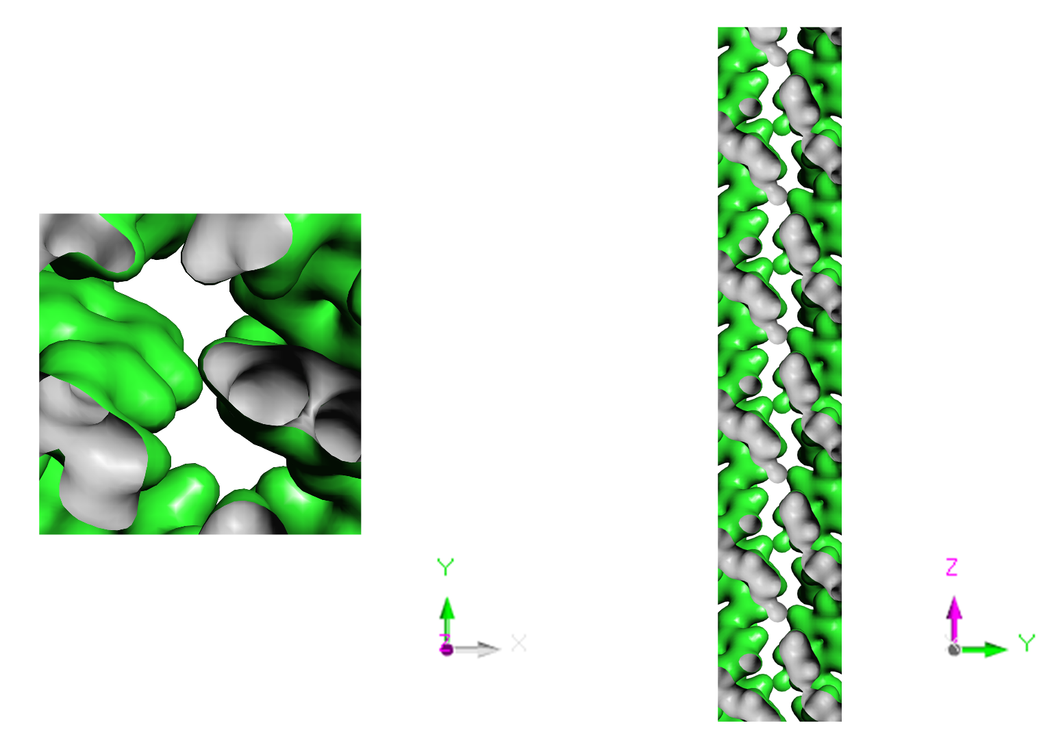
Figure S15. Electron density distribution along the Z-axis (left) and X-axis (right) of FCOF-XJ-CP.
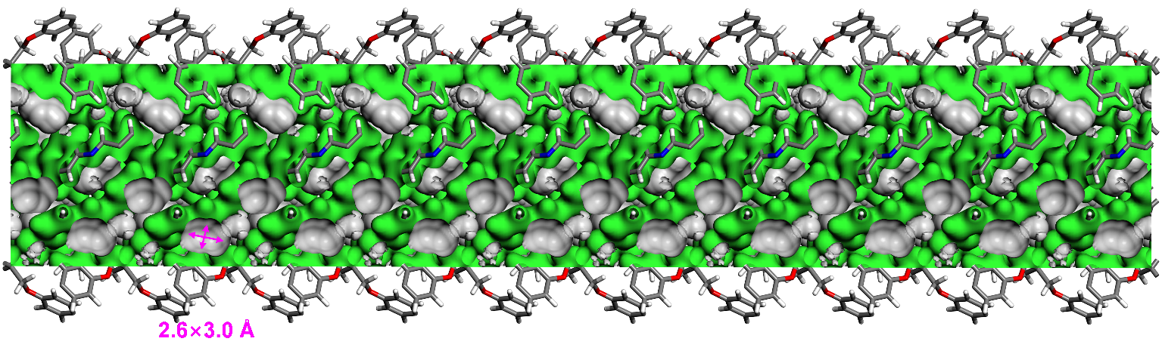
Figure S16. Pore diagram of FCOF-XJ-CP.
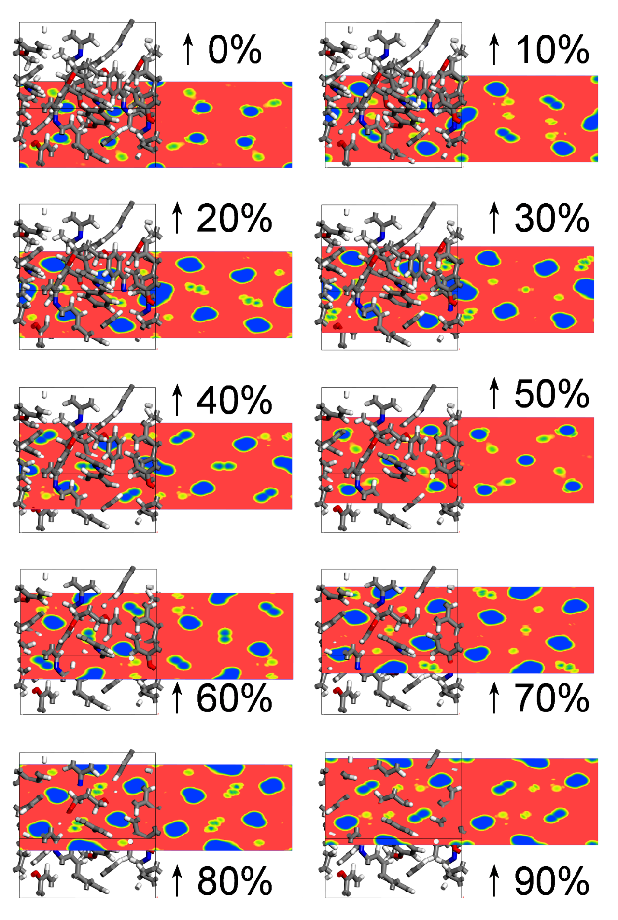
Figure S17. Distribution of pores and skeletons in the FCOF-XJ-CP unit cell from bottom to top (blue: pores; red: skeleton)
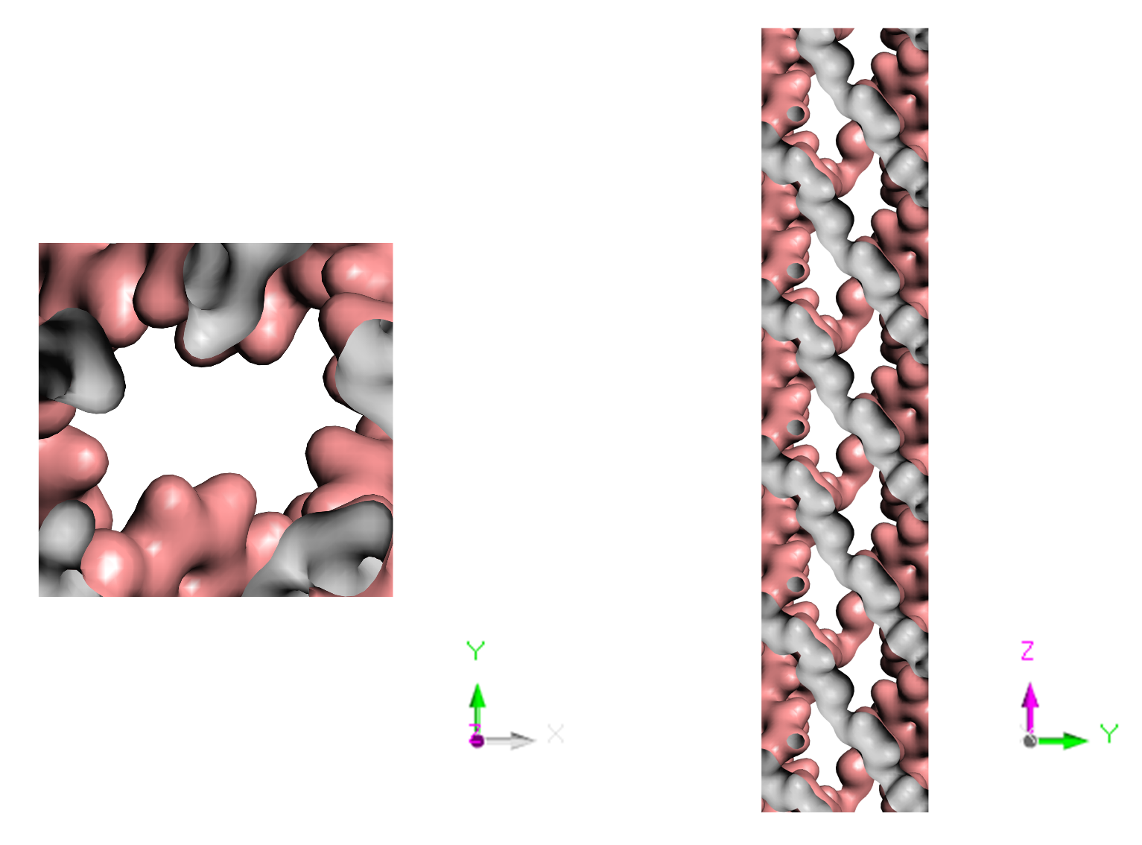
Figure S18. Electron density distribution along the Z-axis (left) and X-axis (right) of FCOF-XJ-OP
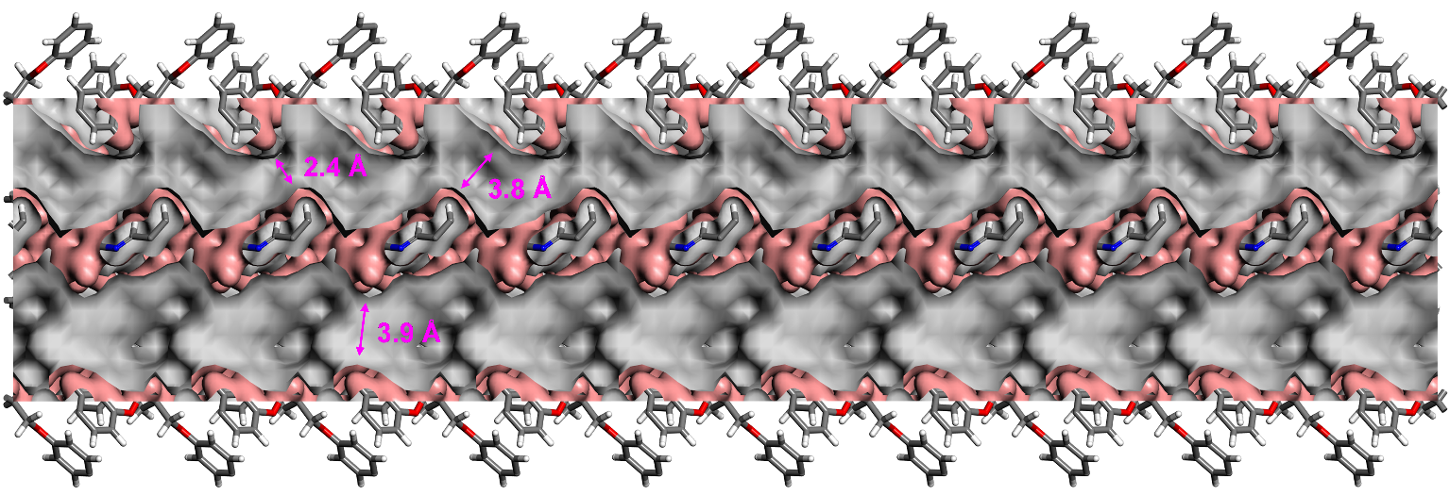
Figure S19. Pore diagram of FCOF-XJ-OP.
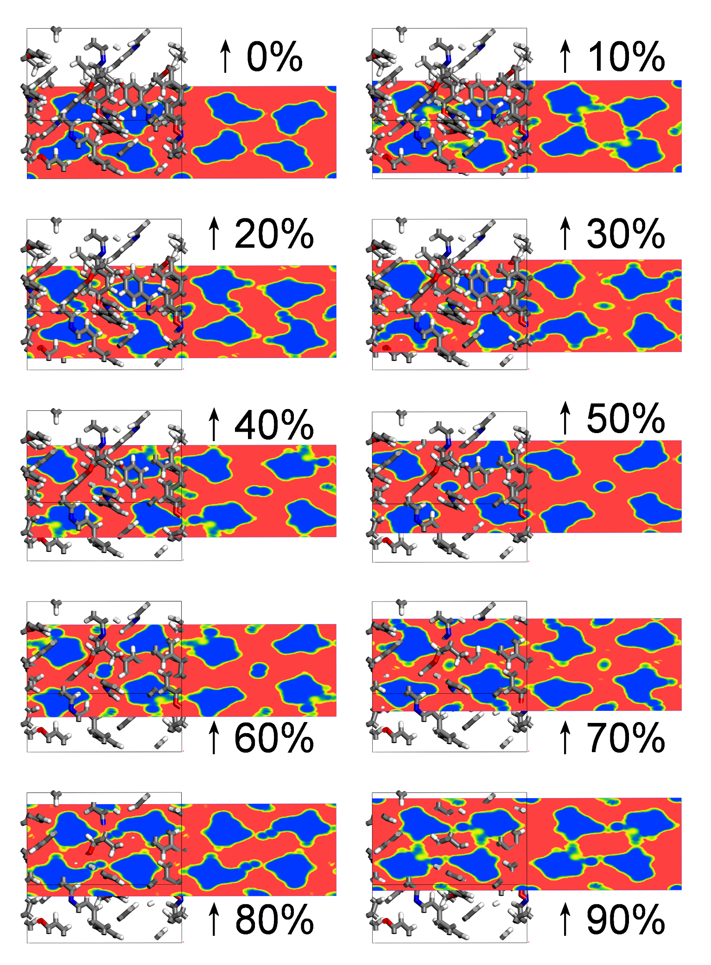
Figure S20. Distribution of pores and skeletons in the FCOF-XJ-OP unit cell from bottom to top (blue: pores; red: skeleton)
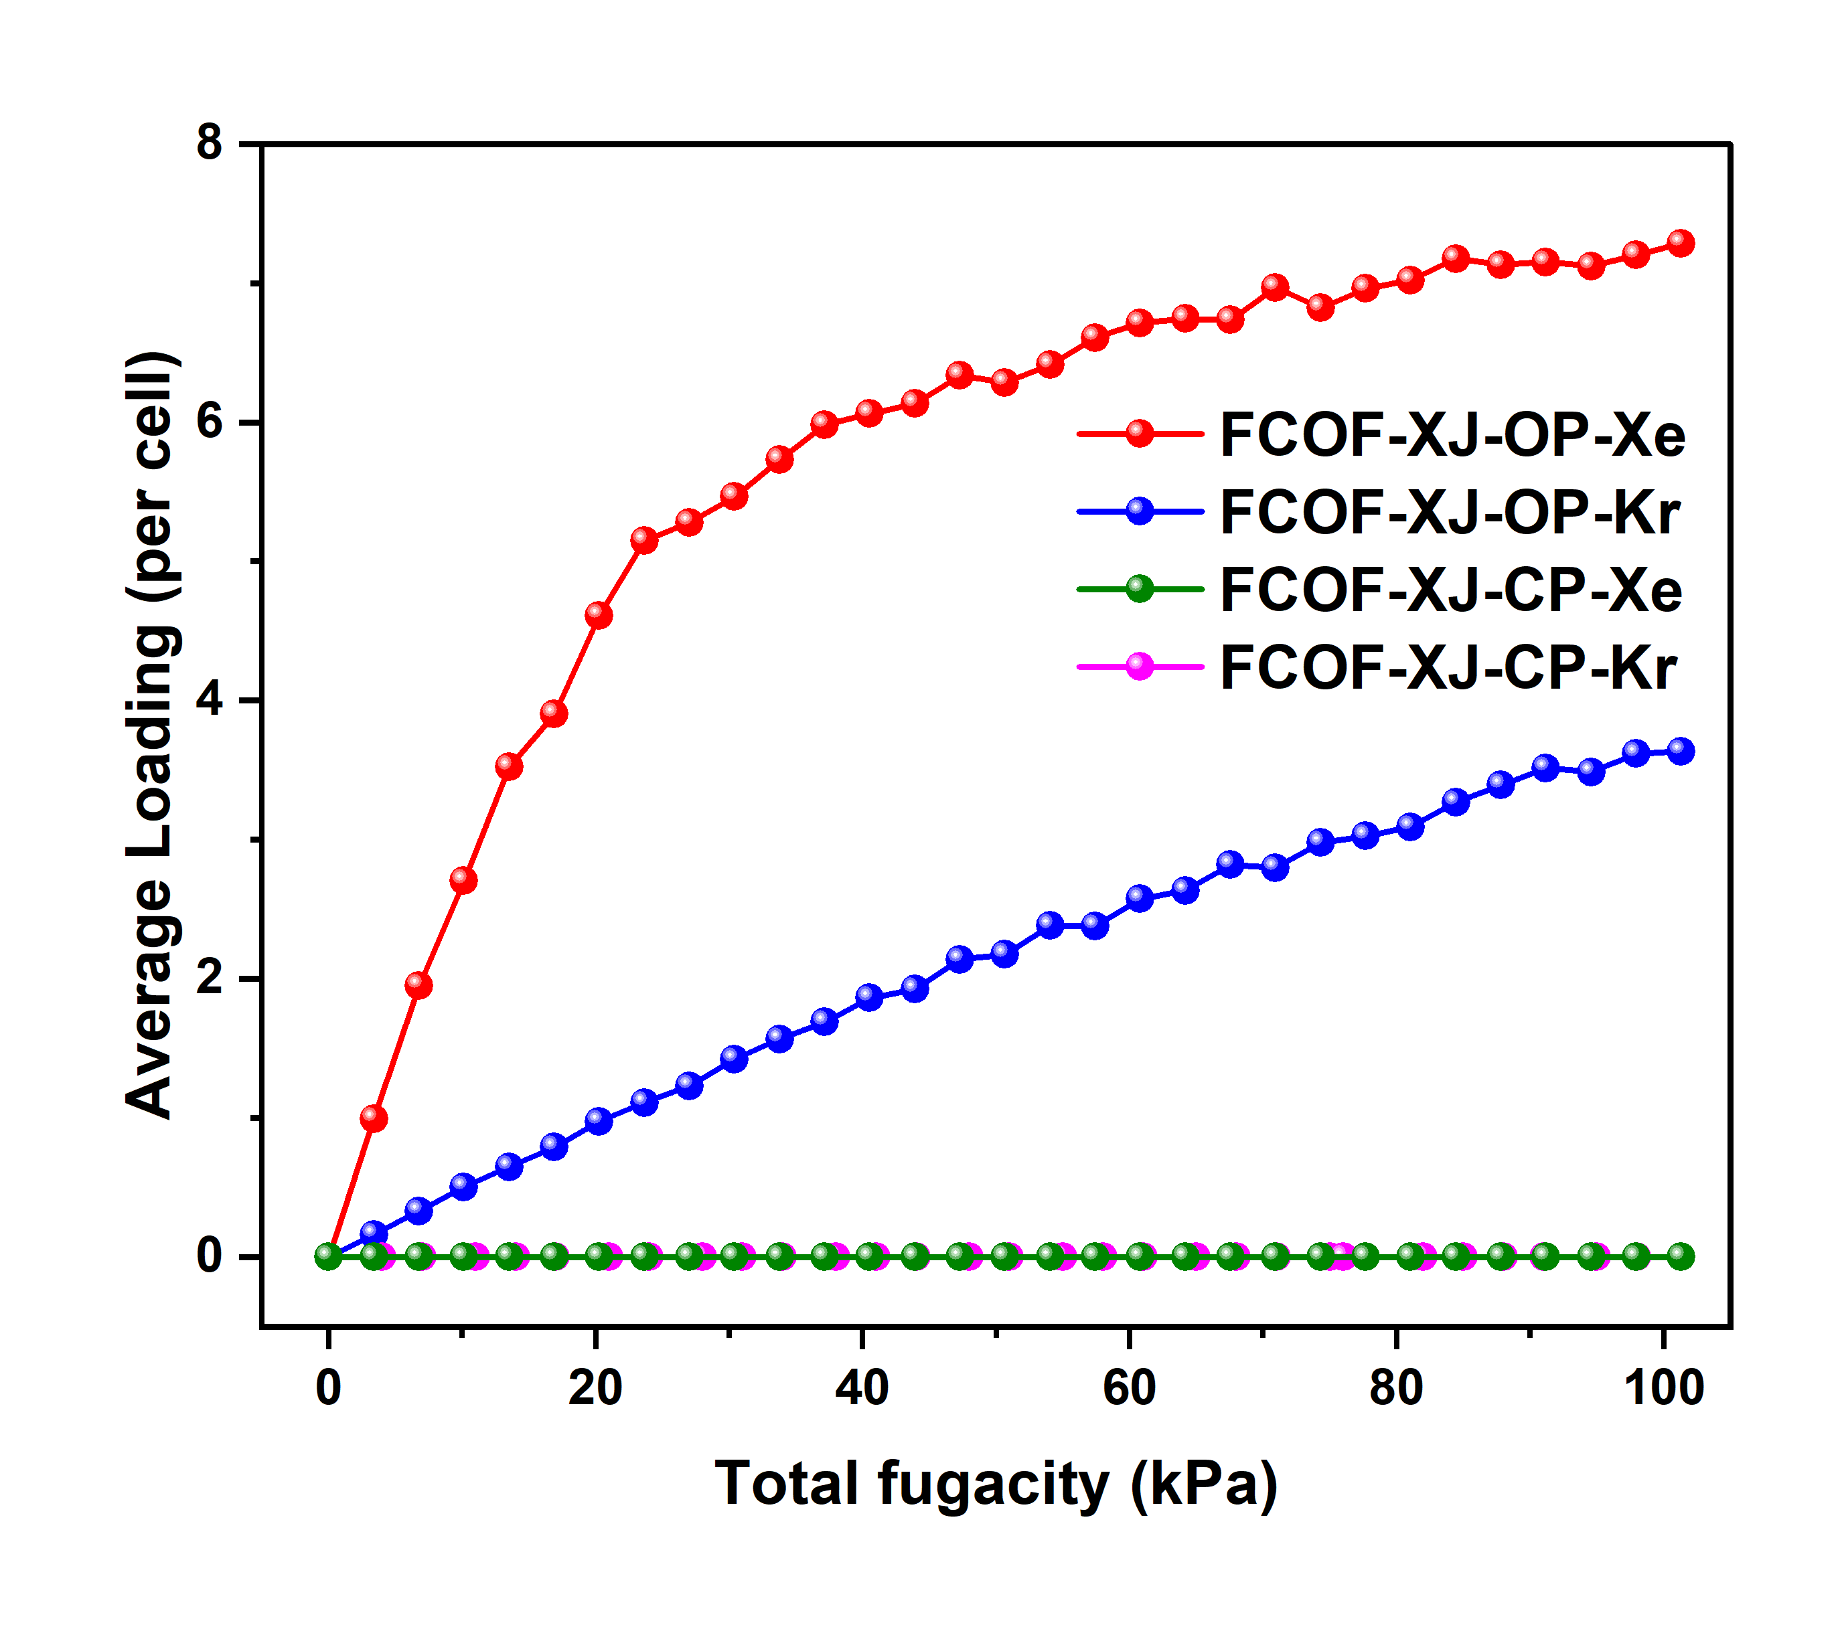
Figure S21. Simulated adsorption amount of Xe and Kr by FCOF-XJ-OP and FCOF-XJ-CP at 273 K.

Section 6. Column Breakthrough Measurement Experiments
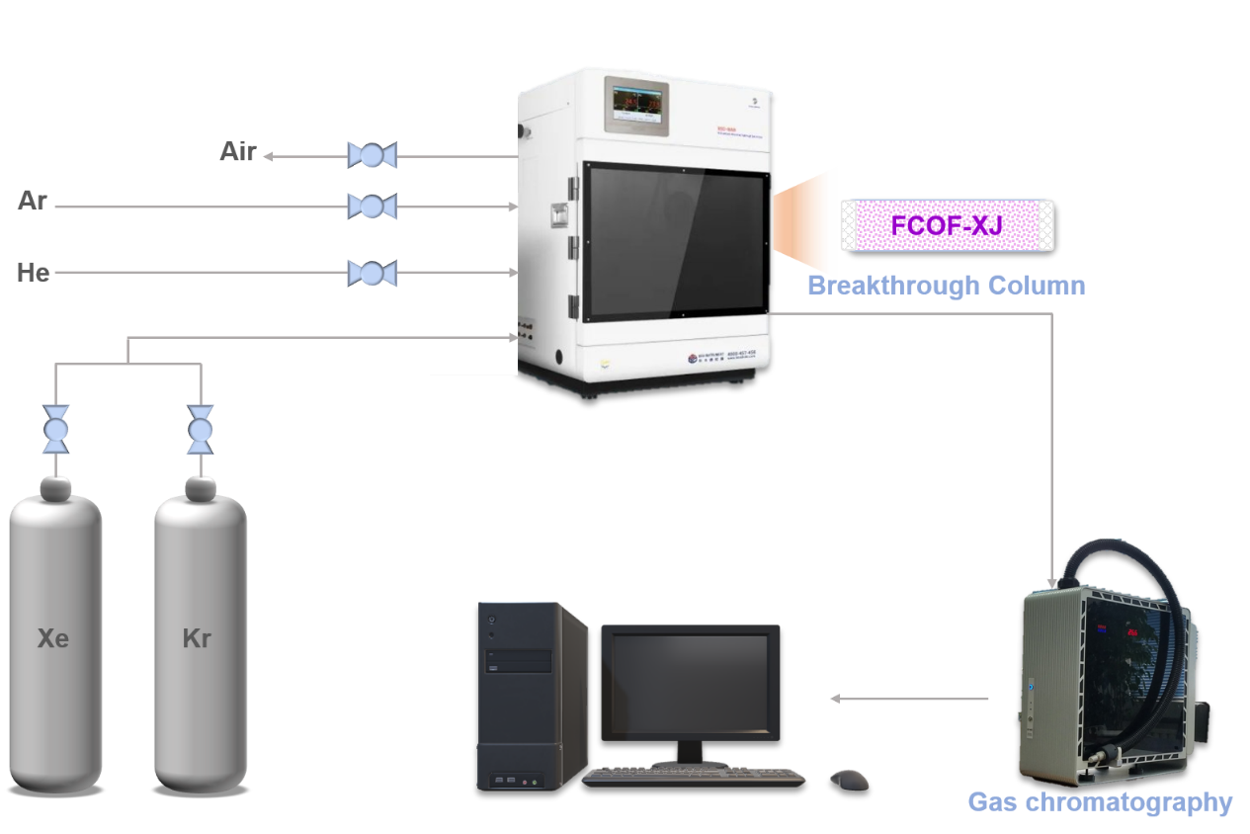
Figure S22. The apparatus of column breakthrough experimengts.
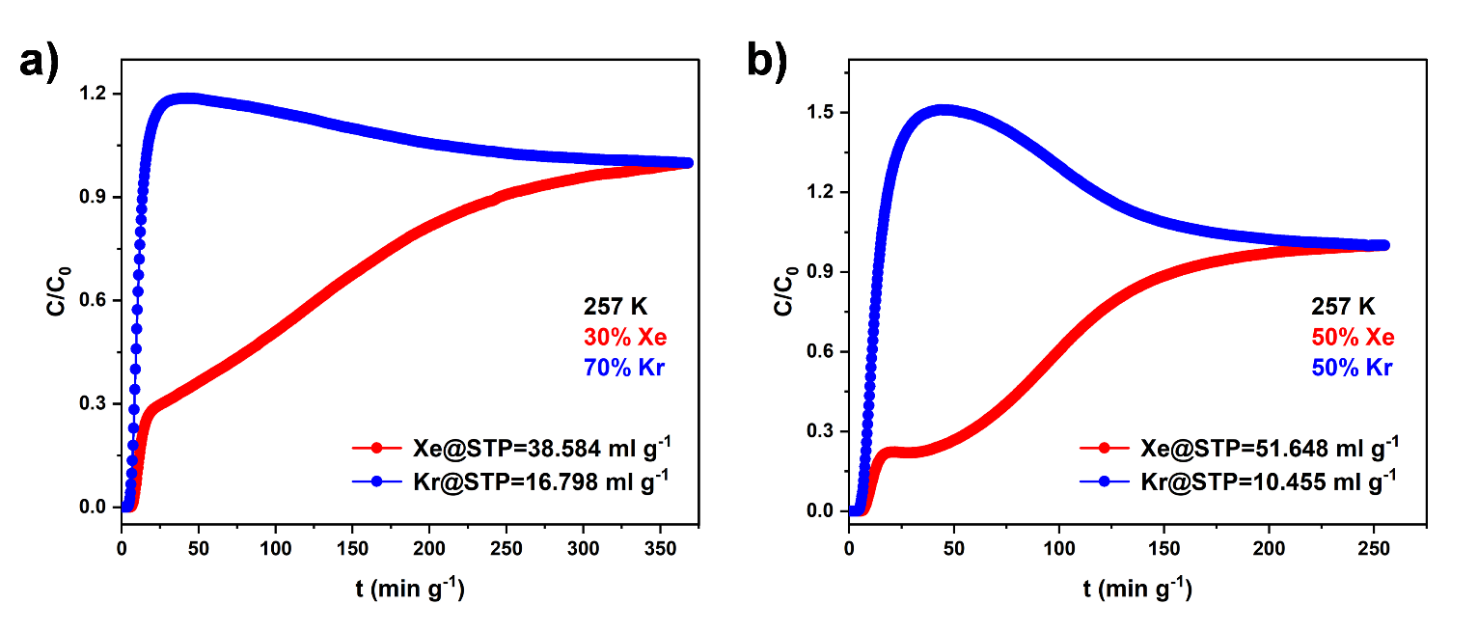
Figure S23. Dynamic breakthrough patterns of Xe/Kr at 257 K with different gas ratios. (a). 257K, Xe/Kr = 3:7; (b). 257 K, Xe/Kr = 5:5 (Xe flow rate: red; Kr flow rate: blue, total flow rate: 1.0 mL min⁻¹).
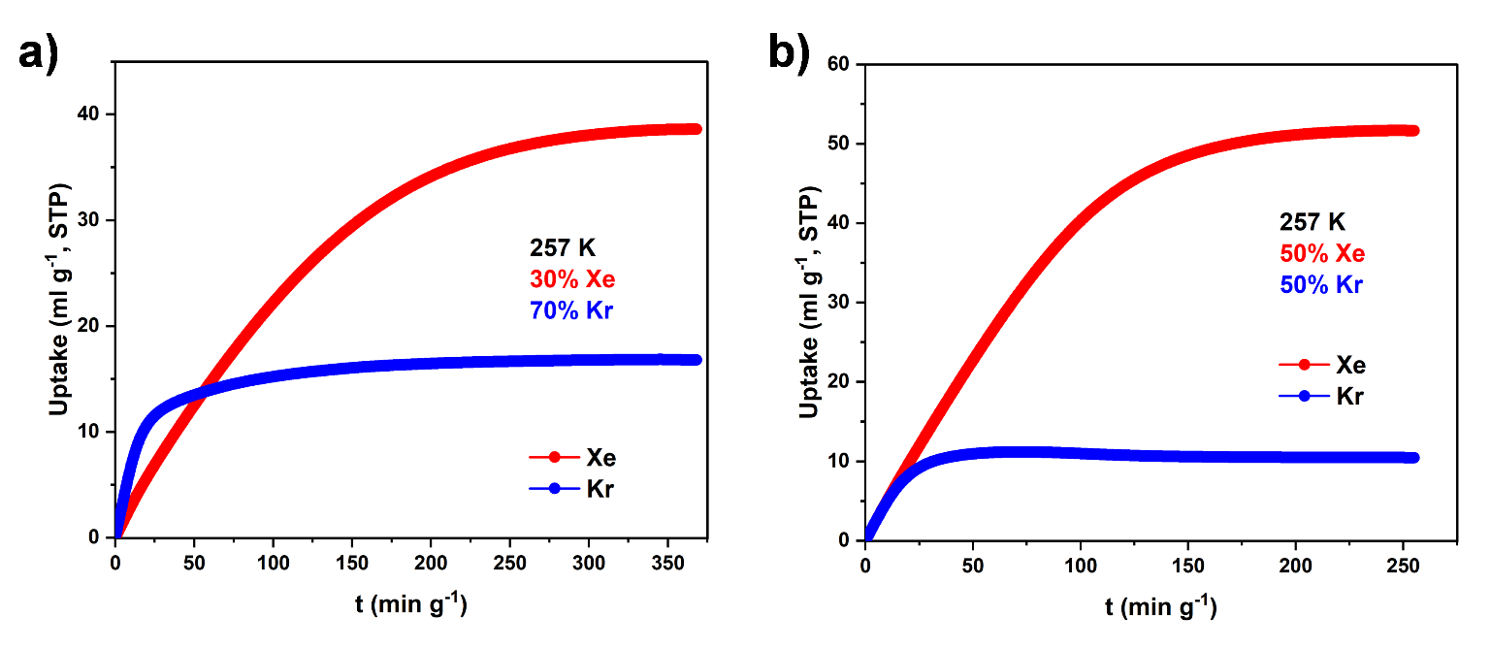
Figure S24. Dynamic breakthrough cumulative adsorption patterns of Xe/Kr at 257 K with different gas ratios. (a). 257 K, Xe/Kr = 3:7; (b). 257 K, Xe/Kr = 5:5 (Xe flow rate: red; Kr flow rate: blue, total flow rate: 1.0 mL min⁻¹).
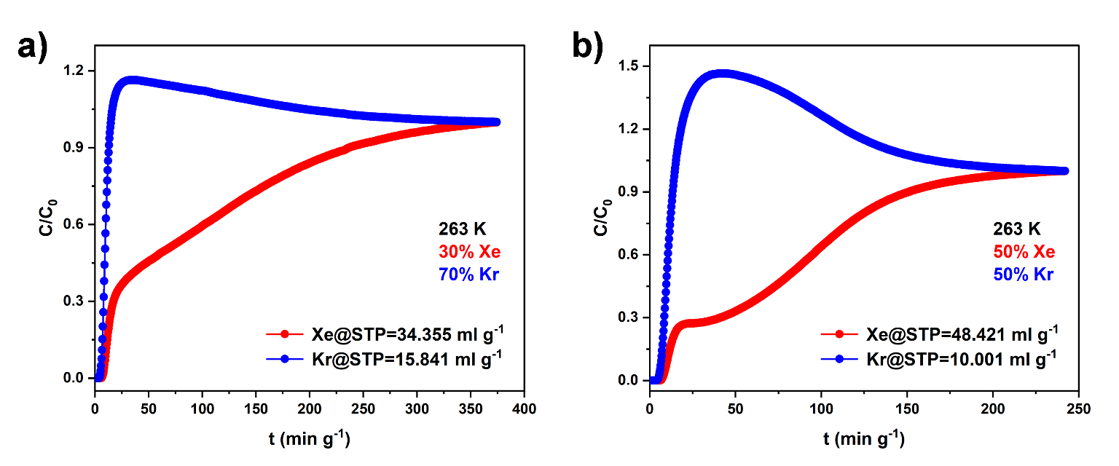
Figure S25.Dynamic breakthrough patterns of Xe/Kr at 263 K with different gas ratios. (a). 263 K, Xe/Kr = 3:7; (b). 263 K, Xe/Kr = 5:5 (Xe flow rate: red; Kr flow rate: blue, total flow rate: 1.0 mL min⁻¹).
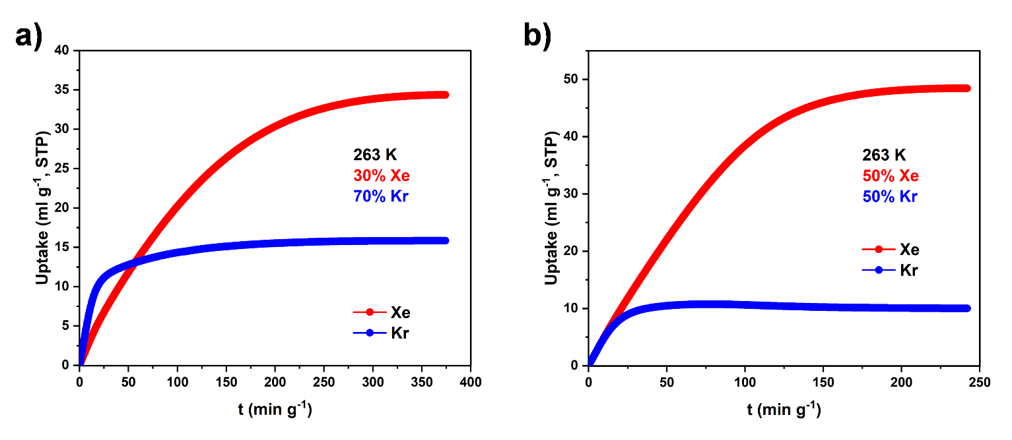
Figure S26. Dynamic breakthrough cumulative adsorption patterns of Xe/Kr at 263 K with different gas ratios. (a). 263 K, Xe/Kr = 3:7; (b). 263 K, Xe/Kr = 5:5 (Xe flow rate: red; Kr flow rate: blue, total flow rate: 1.0 mL min⁻¹).
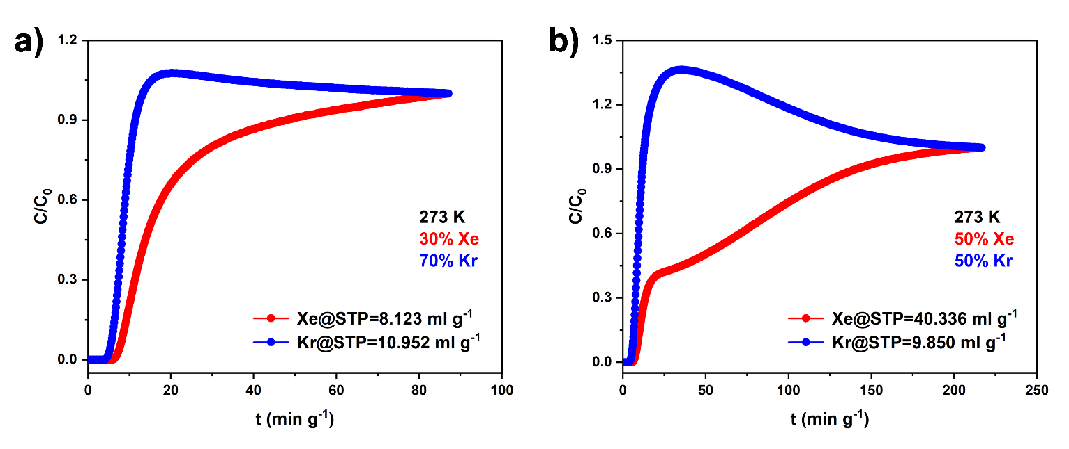
Figure S27. Dynamic breakthrough patterns of Xe/Kr at 273 K with different gas ratios. (a). 273 K, Xe/Kr = 3:7; (b). 273 K, Xe/Kr = 5:5 (Xe flow rate: red; Kr flow rate: blue, total flow rate: 1.0 mL min⁻¹).
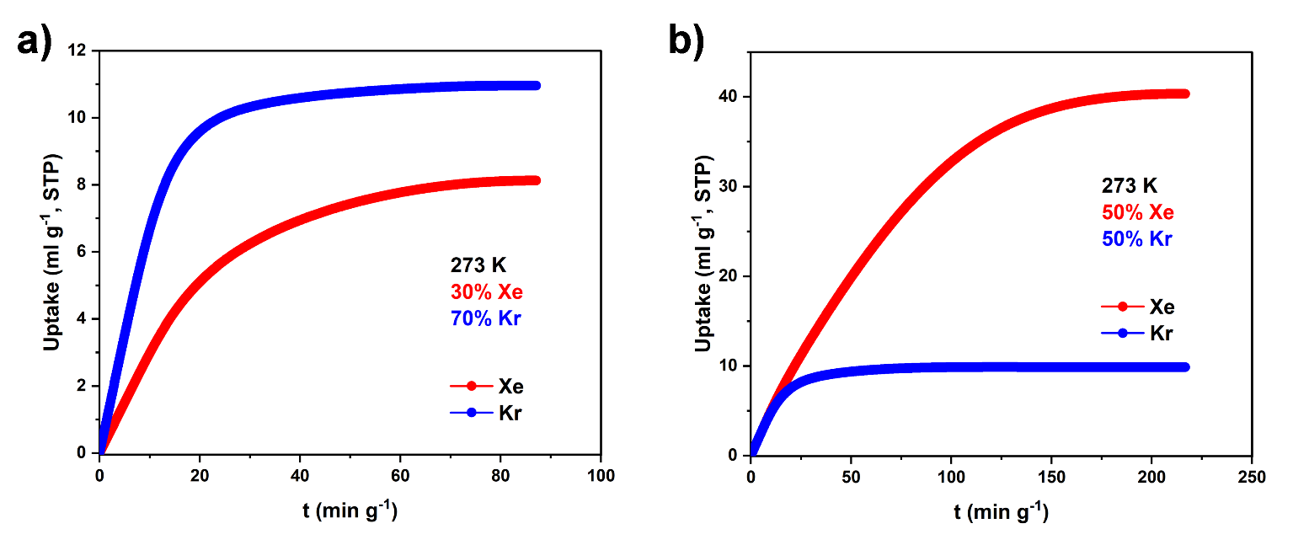
Figure S28. Dynamic breakthrough cumulative adsorption patterns of Xe/Kr at 273 K with different gas ratios. (a). 273 K, Xe/Kr = 3:7; (b). 273 K, Xe/Kr = 5:5 (Xe flow rate: red; Kr flow rate: blue, total flow rate: 1.0 mL min⁻¹).
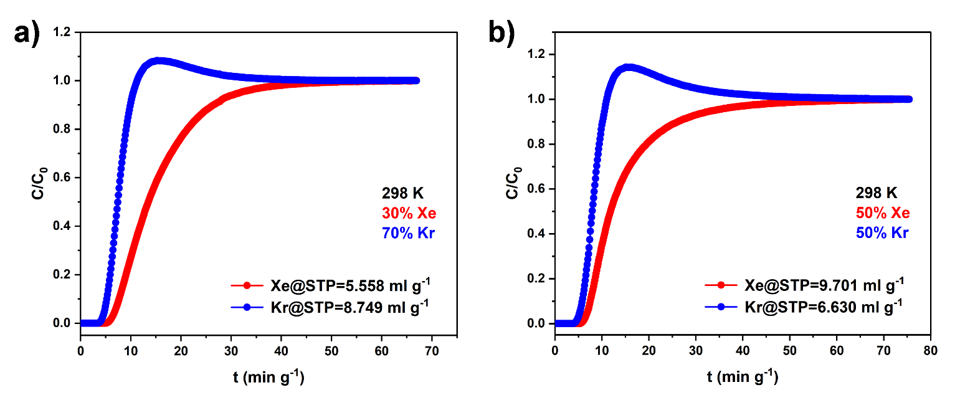
Figure S29. Dynamic breakthrough patterns at 298 K with different gas ratios. (a). 298 K, Xe/Kr = 3:7; (b). 298 K, Xe/Kr = 5:5 (Xe flow rate: red; Kr flow rate: blue, total flow rate: 1.0 mL min⁻¹).
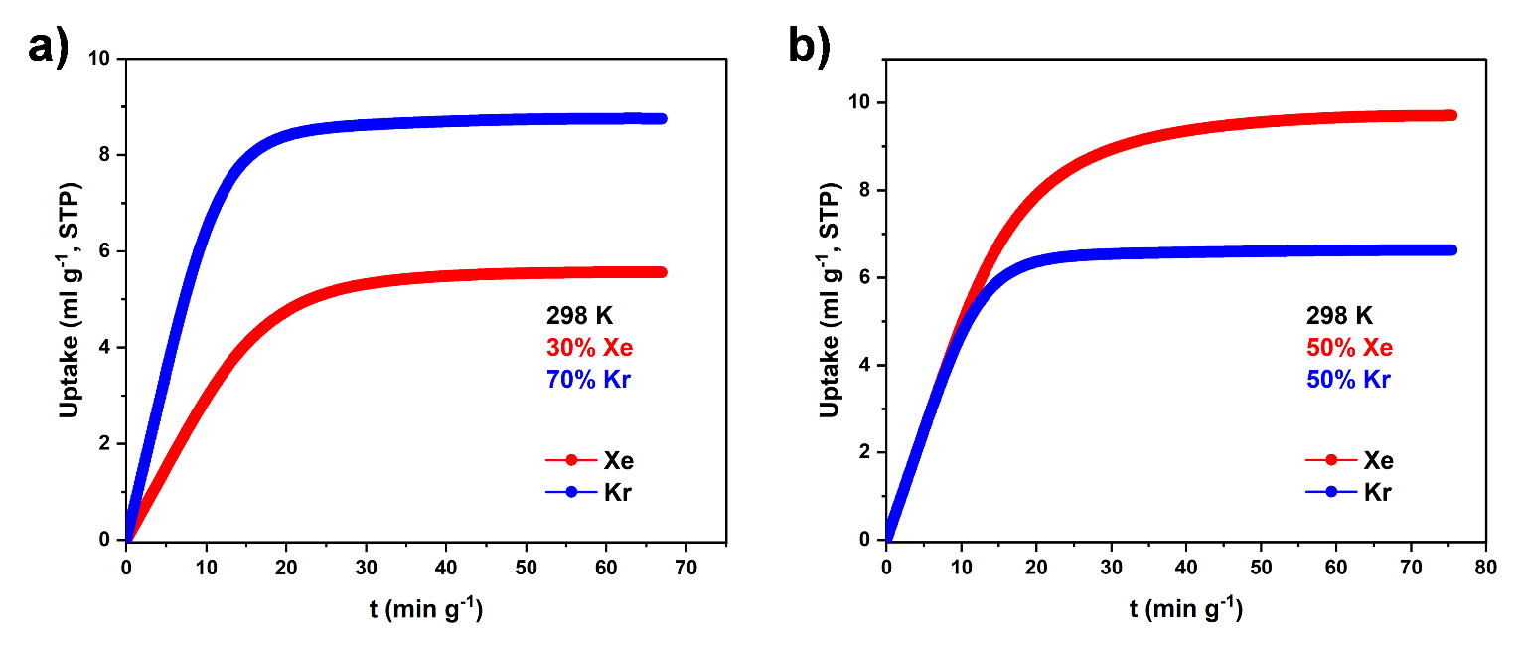
Figure S30. Dynamic breakthrough cumulative adsorption patterns at 298 K with different gas ratios. (a). 298 K, Xe/Kr = 3:7; (b). 298 K, Xe/Kr = 5:5 (Xe flow rate: red; Kr flow rate: blue, total flow rate: 1.0 mL min⁻¹).
Desorption experiments
Xenon captured during breakthrough experiments can be recovered by a desorption process at 353 K. Upon completion of the breakthrough experiment, the xenon krypton gas flow was shut off, argon was introduced at a flow rate of 2.5 ml/min, and when the krypton gas flow was reduced to zero, the penetration column was heated to 353 K. The exit gas from the penetration column was monitored using mass spectrometry
The cumulative purity p of Xe obtained during the resolution process is calculated using the following equation:
$$p=\frac{n_{Xe}}{n_{Xe}+n_{Kr}}×100\%$$
Where n_{Xe} and n_{Kr} are calculated from the desorption curve with the following equations:
$$n_{i}=\int_{t1}^{t2}{FC_{i}dt}$$
where n_{i} is the capacity of the gas component i, F is the total outlet flow rate calculated from the argon flow rate and the concentration of the various gas components, C_{i} is the concentration of the ith gas in the outlet mixture, t₁ is the initial gas detection time, and t₂ is the final gas detection time.

Section 7. References
(1) Xiong, S.; Liu, Q.; Wang, Q.; Li, W.; Tang, Y.; Wang, X.; Hu, S.; Chen, B. A flexible zinc tetrazolate framework exhibiting breathing behaviour on xenon adsorption and selective adsorption of xenon over other noble gases. Journal of Materials Chemistry A 2015, 3 (20), 10747-10752, 10.1039/C5TA00460H. DOI: 10.1039/C5TA00460H.
(2) Wang, H.; Zeng, X.; Cao, D. A DIH-based equation for separation of CO2–CH4 in metal–organic frameworks and covalent–organic materials. Journal of Materials Chemistry A 2014, 2 (29), 11341-11348, 10.1039/C3TA14973K. DOI: 10.1039/C3TA14973K.
(3) Yuan, M.; Wang, X.; Chen, L.; Zhang, M.; He, L.; Ma, F.; Liu, W.; Wang, S. Tailoring Pore Structure and Morphologies in Covalent Organic Frameworks for Xe/Kr Capture and Separation. Chemical Research in Chinese Universities 2021, 37 (3), 679-685. DOI: 10.1007/s40242-021-1064-z.
(4) Jia, Z.; Yan, Z.; Zhang, J.; Zou, Y.; Qi, Y.; Li, X.; Li, Y.; Guo, X.; Yang, C.; Ma, L. Pore Size Control via Multiple-Site Alkylation to Homogenize Sub-Nanoporous Covalent Organic Frameworks for Efficient Sieving of Xenon/Krypton. ACS Applied Materials & Interfaces 2021, 13 (1), 1127-1134. DOI: 10.1021/acsami.0c14610.
(5) Zhang, W.; Li, Y.; Wu, Y.; Huang, W.; Wang, S.; Fu, Y.; Ma, W.; Li, X.; Ma, H. Polypyrene Porous Organic Framework for Efficiently Capturing Electron Specialty Gases. ACS Applied Materials & Interfaces 2023, 15 (24), 29468-29477. DOI: 10.1021/acsami.3c05398.
(6) Luo, Y.; Yan, Z.; Wang, F.; Wang, Z.; Zhou, M.; Jin, Y.; Wang, Y.; Xia, C. 3D ultra-micropore organic polymers with fixed group and thieno[3,2-b]thiophene to enhance adsorption and separation of Xe/Kr. Separation and Purification Technology 2024, 330, 125460. DOI: https://doi.org/10.1016/j.seppur.2023.125460.
(7) Wang, Q.; Meng, Z.; Li, J.; Peng, S.; Xiang, Z. High retention volume covalent organic polymer for xenon capture: Dynamic separation of Xe and Kr. Green Energy & Environment 2022, 7 (5), 948-956. DOI: https://doi.org/10.1016/j.gee.2020.12.010.
(8) Chakraborty, D.; Nandi, S.; Sinnwell, M. A.; Liu, J.; Kushwaha, R.; Thallapally, P. K.; Vaidhyanathan, R. Hyper-Cross-linked Porous Organic Frameworks with Ultramicropores for Selective Xenon Capture. ACS Applied Materials & Interfaces 2019, 11 (14), 13279-13284. DOI: 10.1021/acsami.9b01619.
(9) Yan, Z.; Luo, Y.; Chen, B.; Wang, F.; Chen, L.; Wang, Z.; Zhao, P.; Kang, J.; Fu, Z.; Jin, Y.; et al. Thiophene-based conjugated ultra-micropore rigid polymers for selective xenon capture. Chemical Engineering Journal 2023, 453, 139934. DOI: https://doi.org/10.1016/j.cej.2022.139934.
(10) Li, H.; Wang, G.; Haw, K.-G.; Li, J.; Rong, H.; Ren, H.; Deng, Y.; Yuan, Y.; Zhu, G.; Zou, X. Ultramicroporous organic materials for selective separation of xenon from krypton. Microporous and Mesoporous Materials 2020, 305, 110390. DOI: https://doi.org/10.1016/j.micromeso.2020.110390.
(11) Li, J.; Huang, L.; Zou, X.; Zheng, A.; Li, H.; Rong, H.; Zhu, G. Porous organic materials with ultra-small pores and sulfonic functionality for xenon capture with exceptional selectivity. Journal of Materials Chemistry A 2018, 6 (24), 11163-11168, 10.1039/C8TA03991G. DOI: 10.1039/C8TA03991G.
(12) Li, Z.; Xiong, S.; Shao, L.; Zhao, X.; Huang, Q.; Huang, D.; Yue, G. Simple biphenyl derived porous aromatic frameworks with attractive xenon/krypton separation. Chemical Physics Letters 2023, 820, 140462. DOI: https://doi.org/10.1016/j.cplett.2023.140462.
(13) Zhang, W.; Li, Y.; Wang, S.; Wu, Y.; Chen, S.; Fu, Y.; Ma, W.; Zhang, Z.; Ma, H. Fluorine-Induced Electric Field Gradient in 3D Porous Aromatic Frameworks for Highly Efficient Capture of Xe and F-Gases. ACS Applied Materials & Interfaces 2022, 14 (30), 35126-35137. DOI: 10.1021/acsami.2c10050.
(14) Chen, F.; Zheng, F.; Huang, X.; Chu, Z.; Sun, H.; Yang, L.; Yang, Q.; Zhang, Z.; Ren, Q.; Bao, Z. The First Kr-Selective Carbon Molecular Sieve for Inverse Adsorption of Krypton Over Xenon at Ambient Temperature. Advanced Materials 2025, 37 (4), 2409474. DOI: https://doi.org/10.1002/adma.202409474.
(15) Huang, J.; Li, Y.; Zhang, H.; Yuan, Z.; Xiang, S.; Chen, B.; Zhang, Z. A Microporous Hydrogen-Bonded Organic Framework Based on Hydrogen-Bonding Tetramers for Efficient Xe/Kr Separation. Angewandte Chemie International Edition 2023, 62 (52), e202315987. DOI: https://doi.org/10.1002/anie.202315987.
(16) Yuan, Z.; Chen, L.; Zhou, X.; Li, L.; Li, Y.; Yang, Y.; Zhou, Z.; Chen, Y.; Xiang, S.; Chen, B.; et al. Hydrogen-bonded organic framework with tailored pores prepared by enlarging the core size for high-performance Xe/Kr separation. Journal of Materials Chemistry A 2023, 11 (40), 21857-21863, 10.1039/D3TA04738E. DOI: 10.1039/D3TA04738E.
(17) Lee, W.-G.; Yoon, T.-U.; Bae, Y.-S.; Kim, K. S.; Baek, S. B. Selective separation of Xe/Kr and adsorption of water in a microporous hydrogen-bonded organic framework. RSC Advances 2019, 9 (63), 36808-36814, 10.1039/C9RA08184D. DOI: 10.1039/C9RA08184D.
(18) Gong, L.; Ye, Y.; Liu, Y.; Li, Y.; Bao, Z.; Xiang, S.; Zhang, Z.; Chen, B. A Microporous Hydrogen-Bonded Organic Framework for Efficient Xe/Kr Separation. ACS Applied Materials & Interfaces 2022, 14 (17), 19623-19628. DOI: 10.1021/acsami.2c04746.
(19) Guo, F.-A.; Zhou, K.; Liu, J.; Wang, H.; Li, J. Robust Hydrogen-Bonded Organic Framework with Four-Fold Interpenetration for Adsorptive Separation of C2H6/C2H4 and Xe/Kr. Precision Chemistry 2023, 1 (9), 524-529. DOI: 10.1021/prechem.3c00040.
(20) Xie, Y.; Ding, X.; Wang, J.; Ye, G. Hydrogen-Bonding Assembly Meets Anion Coordination Chemistry: Framework Shaping and Polarity Tuning for Xenon/Krypton Separation. Angewandte Chemie International Edition 2023, 62 (49), e202313951. DOI: https://doi.org/10.1002/anie.202313951.
(21) Liu, Y.; Wu, H.; Guo, L.; Zhou, W.; Zhang, Z.; Yang, Q.; Yang, Y.; Ren, Q.; Bao, Z. Hydrogen-Bonded Metal–Nucleobase Frameworks for Efficient Separation of Xenon and Krypton. Angewandte Chemie International Edition 2022, 61 (11), e202117609. DOI: https://doi.org/10.1002/anie.202117609.
(22) Xiong, S.; Gong, Y.; Hu, S.; Wu, X.; Li, W.; He, Y.; Chen, B.; Wang, X. A microporous metal–organic framework with commensurate adsorption and highly selective separation of xenon. Journal of Materials Chemistry A 2018, 6 (11), 4752-4758, 10.1039/C7TA11321H. DOI: 10.1039/C7TA11321H.
(23) Zhou, J.; Ke, T.; Steinke, F.; Stock, N.; Zhang, Z.; Bao, Z.; He, X.; Ren, Q.; Yang, Q. Tunable Confined Aliphatic Pore Environment in Robust Metal–Organic Frameworks for Efficient Separation of Gases with a Similar Structure. Journal of the American Chemical Society 2022, 144 (31), 14322-14329. DOI: 10.1021/jacs.2c05448.
(24) Pei, J.; Gu, X.-W.; Liang, C.-C.; Chen, B.; Li, B.; Qian, G. Robust and Radiation-Resistant Hofmann-Type Metal–Organic Frameworks for Record Xenon/Krypton Separation. Journal of the American Chemical Society 2022, 144 (7), 3200-3209. DOI: 10.1021/jacs.1c12873.
(25) Li, L.; Guo, L.; Zhang, Z.; Yang, Q.; Yang, Y.; Bao, Z.; Ren, Q.; Li, J. A Robust Squarate-Based Metal–Organic Framework Demonstrates Record-High Affinity and Selectivity for Xenon over Krypton. Journal of the American Chemical Society 2019, 141 (23), 9358-9364. DOI: 10.1021/jacs.9b03422.
(26) Zheng, F.; Guo, L.; Chen, R.; Chen, L.; Zhang, Z.; Yang, Q.; Yang, Y.; Su, B.; Ren, Q.; Bao, Z. Shell-like Xenon Nano-Traps within Angular Anion-Pillared Layered Porous Materials for Boosting Xe/Kr Separation. Angewandte Chemie International Edition 2022, 61 (20), e202116686. DOI: https://doi.org/10.1002/anie.202116686.
(27) Zhu, X.; Ke, T.; Han, P.; Zhang, Z.; Bao, Z.; Yang, Y.; Ren, Q.; Yang, Q. Pore Chemistry and Architecture Control in Anionic Functional Ultramicroporous Materials for Record Dense Packing of Xenon. Journal of the American Chemical Society 2024, 146 (36), 24956-24965. DOI: 10.1021/jacs.4c06354.

