Supplementary Materials for
Multiplexed, Wireless, and Contactless Biomechanic Well Plate for Monitoring Cardiac Organoid and 3D-Tissue Contraction
Chi Cong Nguyen¹, Jordan Thorpe^{2,3}, Dang Tran Bach¹, Azadeh Zahabi², Quang Anh Nguyen¹, Sinuo Zhao¹, Nhat Minh Doan¹, Michael A. Listyawan¹, Hongru Chen¹, Thanh Vinh Nguyen⁴, Syamak Farajikhah⁵, Ann-Na Cho⁶, Nigel H. Lovell⁷, Thanh Nho Do⁷, Timothée Mouterde^{8,*}, Adam Hill^{2,3,*}, and Hoang-Phuong Phan^{1,*}
¹ School of Mechanical and Manufacturing Engineering, Faculty of Engineering, UNSW Sydney, Kensington Campus, Sydney, NSW 2052, Australia
² Victor Chang Cardiac Research Institute, Sydney, NSW 2010, Australia
³ School of Clinical Medicine, Faculty of Medicine and Health, UNSW Sydney, Kensington Campus, Sydney, NSW 2052, Australia
⁴ Formfactor Inc., Livermore, CA 94551, USA
⁵ School of Chemical and Biomolecular Engineering, Faculty of Engineering, University of Sydney, NSW 2006, Australia
⁶ School of Biomedical Engineering, Faculty of Engineering, University of Sydney, NSW 2006, Australia
⁷ Graduate School of Biomedical Engineering, Faculty of Engineering, and Tyree Institute of Health Engineering (IHealthE), UNSW Sydney, Kensington Campus, Sydney, NSW 2052, Australia
⁸ Graduate School of Engineering, Department of Mechanical Engineering, Hongo Campus, The University of Tokyo, Tokyo 113-8656, Japan

* Joint senior/corresponding authors: Hoang-Phuong Phan, Adam Hill, and Timothée Mouterde
Emails: hp.phan@unsw.edu.au, a.hill@victorchang.edu.au, mouterde@g.ecc.u-tokyo.ac.jp
Keywords: Organoids, Engineered Heart Tissues, Contraction Monitoring, Silicon Cantilevers, Wireless Biomedical Systems

Supplementary Notes

Supplementary Note 1: Current technologies for monitoring cardiac tissue contraction forces
This section provides detailed benchmarking between our technology and those reported in the literature for monitoring contraction forces of cardiac tissue from 2D to 3D constructs, as summarized in Table. S1.
(i) Measurement of 2D cell sheets: Lind et al. developed cantilevers integrated with a carbon black-based strain sensor, allowing for the measurement of contractile stress from 2D tissues¹. Using a Micro Electromechanical System (MEMS) method, Matsudaira et al. measured contractile forces with high sensing resolution of less than 0.1 nN². These platforms have several limitations such as (i) the cardiac cells must be cultured directly onto the sensor, (ii) the conversion to stress relies on modeling assumptions, which collectively limit the device’s throughput and physiological relevance, and more importantly (iii) the design is restricted to 2D sheet geometries, not suitable for the new class of 3D cell cultures such as organoids.
(ii) Measurement of 3D cell bundles: Cantilevers, poles, and pillars have been employed for contraction measurements of cell bundles. Legant et al. introduced microfabricated tissue gauges (µTUGs) integrated with flexible cantilevers for simultaneous measurement of extracellular matrix remodeling and the contractile force.³ The device can measure the contraction of neonatal rat cardiomyocytes cultured on the µTUGs, which induced significant, periodic cantilever deflections corresponding to their synchronous beating. The platform can also be adapted to monitor more complex, two-dimensional tissue geometries, such as a square construct anchored by four cantilevers. Polydimethylsiloxane (PDMS) micro-poles/pillars have also been utilized for the automated formation of dense muscle bundles from minimal cell and reagent volumes, while enabling the analysis of their contractile forces. Mills et al. developed a 96-well plate, fabricated using SU-8 photolithography and PDMS casting, that featured two elastomeric pillars in each well. By tracking the displacement of these pillars during tissue contraction under a microscope, they could calculate the generated forces using beam deformation theory. The same approach was adopted by Ma et al. to create a 96-well screening platform for engineered cardiac tissues. Advancing this concept, F. Zhang et al. engineered the two-pillar structure from conductive hydrogels⁴, a design innovation that permits the integration of electrophysiological measurements alongside force analysis. This approach was proposed to reduce the potential impact on contraction that could be observed with other conductive materials, such as the platinum-PDMS composites previously described by N. Zhang et al⁵. Despite their capacity for the parallel cultivation of multiple cell bundles, these pillar-based approaches are considered to have limited throughput. A primary constraint is the reliance on microscopy for data acquisition, which often requires sequential, well-by-well imaging to capture pillar deflections, creating a significant bottleneck in the workflow. Furthermore, the subsequent analysis is characterized by high labor intensity, as the video files for each well must be processed, often manually, to track pillar displacement and compute the corresponding contractile forces of the tissue.
Efforts to measure the contractile force of cardiac tissues without relying on microscopy and video analysis have become a significant focus of research. 3D frameworks^{6, 7} designed for toroidal, or donut-shaped, tissues has emerged as a promising candidate. These systems are fabricated using a controlled buckling method that embeds strain sensors directly into the structure, allowing for the direct conversion of signals from the resistive strain sensors into contraction force data. Despite these advances, this approach has been confined to ring-shaped geometries, since the 3D buckled framework is difficult to adapt to 3D spherical or arbitrary constructs of organoids. Additionally, the requirement for cells to remain permanently integrated with the sensing apparatus may introduce complications, potentially interfering with natural tissue growth and function. The need to grow cells in a pre-patterned shape using a mold and then transfer and anchor them onto the 3D sensor structures requires extensive manual procedures, which may affect the yield and throughput of this technique.
(iii) Measurement of 3D spherical cardiac constructs: To address the challenges in monitoring 3D spherical cardiac constructs, Kim et al. proposed to integrate pressure-sensitive transistor arrays with 3D liquid metal electrodes⁸. By inserting microneedle electrodes into cardiac organoids, the beating-induced pressure can be quantitatively measured via integrated pressure-sensitive transistor arrays with a high sensitivity of ~ 0.35 kPa⁻¹. Simultaneously, electrophysiological recording and electrical stimulation are enabled through the same microneedle interface, allowing comprehensive multimodal characterization of cardiac function. However, this approach requires manual localization to insert the microneedle electrodes into the cardiac organoids, which significantly limits scalability and reduces the potential for high-throughput analysis. Moreover, manual insertion introduces variability in signal acquisition, making recordings less accurate and difficult to reproduce across experiments. Additionally, the invasive nature of electrode penetration poses risks of physical damage to the organoids, potentially compromising their structural integrity and physiological function.
Obviating the need for direct penetration into cardiac organoids, Lyu et al. developed a soft, ultrasensitive force-sensing diaphragm and used a clamping approach for instantaneous and wireless probing of cardiac organoids⁹. Fabricated through a simple yet effective method using PDMS and a platinum (Pt) layer, the diaphragm demonstrated high sensitivity with a signal-to-noise ratio of approximately 12 dB. A key innovation of this platform is its ability to perform simultaneous electrophysiological and force measurements by coupling the top-positioned sensor with a commercial microelectrode array (MEA) device¹⁰. However, the requirement for an 'Atomic Force Microscope-like' (AFM) mechanism to establish and maintain reliable organoid-diaphragm contact can impede the natural beating pattern of organoids and restrict their growth, making the device unsuitable for long-term monitoring. Furthermore, the integration of the organoid with the sensor is highly labor-intensive, requiring precise manual manipulation to achieve a stable and effective tissue-diaphragm interface.
In an effort to simplify experimental complexity, Strohm et al. introduced a novel, non-invasive technique that utilizes high-frequency ultrasound¹¹. This approach translates the recorded motion of cardiac spheroids into contractile force data with high resolution, achieving an error margin of approximately 1.4 µN, a level of precision comparable to that of more intricate measurement systems. However, this method reintroduces a significant limitation by reverting to a workflow dependent on analyzing beating profiles on a case-by-case basis, as well as the requirement of external ultrasound readers. This constraint is reminiscent of the throughput bottlenecks found in earlier technologies that required sequential, well-by-well microscopic imaging.

Supplementary Note 2: Fabrication of the nano silicon cantilever (SiC)
The silicon cantilevers were fabricated using a silicon-on-insulator (SOI) wafer composed of a 300 nm device layer, a 400 nm buried oxide (BOX) layer, and a 300 µm silicon handle substrate, as illustrated in Fig. S1. The process began with spin-coating AZ1512 photoresist onto the top silicon surface at 4,000 rpm, followed by a soft bake at 110 °C for 1 minute. Microstructures defining the cantilevers were patterned using UV exposure via an MLA 150 maskless aligner (first mask) and developed in AZ 726 MIF.
The exposed silicon was etched using deep reactive ion etching (DRIE) at a rate of 5 µm/min. After etching, the photoresist was removed through sequential immersion in acetone and isopropyl alcohol (IPA), each for 5 minutes. A thin metal layer of chromium and gold (10 nm/100 nm) was deposited via electron beam evaporation. A second photolithography step, using the same parameters as the first, was employed to define sensor contact pads through wet etching. After this step, the reference sensor is completed.
To prepare for backside etching, AZ5214 photoresist was applied to the wafer’s backside and soft-baked at 110 °C for 1 minute. A third lithography step was used to define the hard mask, followed by a hard bake at 140 °C for 5 minutes. The silicon substrate was then etched from the backside using DRIE until the BOX layer was reached. The remaining photoresist was removed by soaking in acetone for 1 hour and IPA for 10 minutes. Finally, the BOX layer was eliminated using vapor-phase hydrofluoric acid (HF) etching for approximately 1 minute, releasing the free-standing silicon cantilevers.

Supplementary Note 3: Integration of the silicon cantilever chips into the PCB
The fabricated silicon cantilever chips were integrated into the PCB, forming a 2×2 BWP array. This PCB was designed to have 4 small holes (diameter of 600 mm) aligned with the micro cavity of each Si cantilever (Fig. S2). The sensor chip was mounted onto the PCB board using UV gel, followed by wire bonding for interconnect. Other electrical components were integrated into the circuit board using standard surface-mount device assembly techniques, offering a cost-effective, scalable manufacturing capability. All the sensors and functional components are located on the bottom surface of the PCB, leaving the top surface flat and unobstructed for integration with the disposable reservoir.

Supplementary Note 4: Signal-to-noise ratio (SNR)
The signal-to-noise ratio (SNR) is defined as the base-10 logarithm of the ratio between the average signal power and the average noise power (Extended Data Fig. 2a-b), as shown in the following: $SNR_{dB}=10\log_{10}{(\frac{Average Signal Power​}{Average Noise Power})}$.

Supplementary Note 5: Analytical modelling of the system

Part 1: The resistance change in the cantilever with respect to the applied pressure
This section provides the derivation for Equation (3) presented in the main manuscript. Under a small deformation regime, the longitudinal deformation of an element $∆x$ (Fig. 2g, Main Manuscript) can be expressed as:
$$ε=\frac{h_{p}}{r_{c}}$$ | (S1)
where $h_{p}$ is the distance between the piezoresistive layer and the neutral axis, $r_{c}$ is the bending curvature radius of the element $∆x$ under applied pressure. Since the deflection of the cantilever is small, the stress of the cantilever surface along the longitudinal direction can be expressed using the Young’s modulus $E$:
$$σ=Eε$$ | (S2)
Applying the Euler-Bernoulli beam theory¹², the relationship between the beam’s deflection and the applied load is given by:
$$\frac{1}{r_{c}}=\frac{d^{2}y(x)}{dx^{2}}=\frac{M}{EI}$$ | (S3)
where M is the bending moment, E is Young’s modulus; $\frac{d^{2}y(x)}{dx^{2}}$ is the curvature of the beam at position $x$; and I is the moment of inertia of the cross-section with respect to the neutral axis of the cantilever. Combining Equations (S1)-(S3) yields:
$$σ=\frac{Mh_{p}}{I}$$ | (S4)
Given $π_{l}$ be the longitudinal piezoresistive coefficient of Si, the fractional resistance change of the cantilever beam ΔR/R is:
$$\frac{∆R}{R}=π_{l}×ε=π_{l}\frac{h}{h_{l}}\int_{0}^{h_{l}}{σdx}=π_{l}\frac{h}{h_{l}}\int_{0}^{h_{l}}{\frac{Mh_{p}}{I}dx}$$ | (S5)
Where $h$ the thickness of the cantilever, $h_{l}$ the length of the cantilever’s leg (Fig. 2d3, Main Manuscript), and the area moment $I$ is given by:
$$I=\frac{w_{l}h^{3}}{6}$$ | $$(0≤x≤h_{l})$$ | (S6)
$$I=\frac{wh^{3}}{12}$$ | $$(h_{l}≤x≤h_{l}+w)$$ | (S6)
A differential pressure ${∆P}_{c}$ applied equally across the cantilever surface (in this case, the pressures inside and outside of the microcavity), results in the following bending moment $M$:
$$M=\frac{{ΔP}_{c}w\left[2w\left(h_{l}-x\right)+w^{2}\right]}{2}+{ΔP}_{c}w_{l}{\left(h_{l}-x\right)}^{2}$$ | $$(0≤x≤h_{l})$$ | (S7)
$$M=\frac{{ΔP}_{c}w(h_{l}+{w-x)}^{2}}{2}$$ | $(h_{l}≤x≤h_{l}+w)$ | (S7)
Where $w$ is the pad width and length, and $w_{l}$ is the leg width of the cantilever. Integrating Equations (S5)-(S7) express the output of the piezoresistive cantilever:
$$\frac{∆R}{R}={∆P}_{c}\frac{2π_{l}h_{p}}{h^{3}}\left[h_{l}^{2}+\frac{3w^{2}(h_{l}+w)}{2w_{l}}\right]or ∆P_{c}=\frac{R_{s}}{k_{R}}$$ | (S8)
with $R_{s}=\frac{∆R}{R}$, $k_{R}=\frac{2π_{l}h_{p}}{h^{3}}\left[h_{l}^{2}+\frac{3w^{2}(h_{l}+w)}{2w_{l}}\right]$, and $π_{l}$ denoting the longitudinal piezoresistive coefficient.

Part 2: The pressure generated by the cardiac organoid
This section presents the detailed derivation of the model and additional discussion regarding the characteristics of the system. For simplification, we modelled the organoid oscillations as an oscillating sphere with a radius $a$, and a surface velocity $U_{o}$. Which typically scales as $δ_{o}f$, where $f_{o}$ is the beat frequency of the organoids and $δ_{o}$ is the typical amplitude of the surface oscillations. The Reynolds number of the organoids $Re =\frac{ρ_{l}aU_{o}}{η_{l}}$ is always much smaller than one ($ρ_{l}$, $η_{l}$ are density and dynamic viscosity of the fluid, respectively), which allows us to adopt a quasi-static description of the Stokes flow around the sphere. Following the derivation by Happel and Brenner¹³, we obtain the typical pressure field around the organoids, ignoring the wall’s presence:
$P_{org}=\frac{3η_{l}U_{0}a}{2r^{2}}sin⁡(2πft)$ (S9)
Therefore, the pressure around the organoid is given as:
$P_{surface}=\frac{3η_{l}U_{0}}{2a}\sin\left(2πft\right)=P_{om}.sin⁡(2πft)$ (S10)
and the pressure at the entrance of the micro channel – distant by $a+b$ from the organoid – is ruled by:
$P_{en}=P_{0}+\frac{3η_{l}U_{0}a}{2(a+b)}\sin\left(2πft\right)=P_{0}+\frac{P_{om}a^{2}}{{\left(a+b\right)}^{2}}.\sin\left(2πft\right)=P_{0}+∆P$ (S11)
where $P_{0}$ is the atmospheric pressure and $b$ denotes the thickness of the PCB (Main Manuscript Fig. 2g).

Part 3: The phenomenon of multiphysics coupling
Due to this pressure, the interface deforms by a distance $l(t)$ (Main Manuscript Fig. 2h) with a curvature $C$, so that the Laplace pressure jump between the liquid and air pressure $P=P_{0}+{ΔP}_{c}$inside the cavity is given by:
${P_{0}+∆P-(P_{0}+ΔP}_{c})={∆P-ΔP}_{c} =γC$ (S12)
where $γ$ is the liquid surface tension. For small deformations of the interface, the interface curvature scale as¹⁴ $C≈2l/L^{2}$, $L$ being the width of the square pore, so that with Equation (S12) we obtain:
${∆P-\frac{\text{ 2}γl}{L^{2}} \sim ΔP}_{c}$ (S13)
The initial air volume in the cavity HL² is modified by the deformed liquid surface by a quantity ~lL² so that the air volume $V$ is given by:
$V≈HL^{2}+\frac{L^{4}}{2γ}\left(ΔP_{c}-∆P\right)$ (S14)
The pressure difference between the inside and outside of the microcavity $ΔP_{c}=P-P_{0}$ results in air leakage through the air gap between the cantilever and its supporting membrane (with a width of $d$ and a total length of $4w+3h_{l}$). The volumetric flow rate of this air leakage is estimated as¹⁵:
$Q=\frac{{ΔP}_{c}}{k_{H}}=\frac{πd^{2}\left(4w+3h_{l}\right)∆P_{c}}{32η_{a}}$ (S15)
where $k_{H}=\frac{32η_{a}}{πd^{2}\left(4w+3h_{l}\right)}$ is the proportional coefficient and $η_{a}$ being the dynamic viscosity of air.
The amount of air (in moles) $n$ is a function of the air volume ($V$) and the internal pressure $P = {ΔP}_{c} + P_{0}$ (Pa) through the ideal gas equation: $PV=nRT$, with $R$ the gas constant and $T$ the gas temperature that we assume to be constant. Given the microscale cavity dimensions (150 µm × 150 µm × 300 µm) and the highly resistive 1 µm air gap (Fig. 2d of the Main Text), the system operates near atmospheric equilibrium pressure $P_{0}$. Although air is inherently compressible, the pressure fluctuations required to drive flow through such a narrow gap remain extremely small relative to $P_{0}$. Therefore, we assume that $∆P_{c}$, $∆P_{c}≪ P_{0}$, and at first order in pressure the volumetric flow rate can be expressed as a function of $n$ by:
$RT\frac{dn}{dt}=-P_{0}Q=-P_{0}\frac{{ΔP}_{c}}{k_{H}}$ (S16)
Applying the partial derivative to the ideal gas equation ($RT\frac{dn}{dt}=\frac{dP}{dt}V+\frac{dV}{dt}P$) and the relation between the volume and the pressure in Equation (S14), we deduce Equation (S16) into the following equation:
$\frac{dV}{dt}\frac{P}{V} =-\frac{P}{V}\frac{{ΔP}_{c}}{k_{H}}-\frac{d{ΔP}_{c}}{dt}$ (S17)

Part 4: The frequency threshold
Within the operating range, surface tension remains intact, resulting in only small changes in volume or $V\sim V_{0}$and pressure or $P\sim P_{0}$. Combining Equation (S8) and (S17), we obtained:
$\frac{dV}{dt}=-\frac{V_{0}}{P_{0}} \left(\frac{P_{0}R_{s}}{{V_{0}k}_{H}k_{R}}+\frac{1}{k_{R}}\frac{dR_{s}}{dt}\right)$ (S18)
By applying Laplace transforms to Equation (S18), we obtain:
$s. V\left(s\right)= -\frac{V_{0}}{k_{R}P_{0}}\left(\frac{P_{0}}{V_{0}k_{H}}+s\right)R_{s}\left(s\right)$ (S19)
From Equation S(19), we obtained the following transfer function:
$\frac{R_{s}\left(s\right)}{V\left(s\right)}=-\frac{k_{R}P_{0}}{V_{0}}.\frac{s}{s+\frac{P_{0}}{V_{0}k_{H}}}$ (S20)
This frequency-domain function reveals a threshold for the frequency, which is given by:
$f_{t}=\frac{P_{0}}{{2πV}_{0}k_{H}}$ (S21)

Part 5: Relationship of organoid contraction force and the sensor’s resistance change
Using the ideal gas law, the relation between the volume and the pressure, and combining Equations (S14), (S15), and (S16), we obtained the equation ruling the evolution of the pressure ${∆P}_{c}$:
$\dot{P}\left(HL^{2}+\frac{L^{4}}{2γ}\left({∆P}_{c}-∆P\right)\right)=-\frac{P_{0}∆P_{c}}{k_{H}}+\frac{\left(∆P_{c}+P_{0}\right)L^{4}}{2γ}\dot{∆P}$ (S22)
It is noticed that the atmospheric pressure $P_{o}$ is orders of magnitude larger than typical pressure changes (i.e., ${ΔP}_{c}$, $∆P$) as well as the Laplace pressure $\frac{2γH}{L^{2}}$. Therefore, Equation (S22) can be simplified as:
$\dot{∆P}=\frac{2γ{∆P}_{c}}{L^{4}k_{H}}$ (S23)
Combining with Equations (S8), (S10), and (S23), yielding the governing equation of organoid contraction:
$P_{om}\cos\left(2πft\right)={\left(1+\frac{b}{a}\right)}^{2}.\frac{1}{2πf}.\frac{2γ}{L^{4}k_{H}}.\frac{1}{k_{R}}.\frac{∆R}{R}$ (S24)
Or:
$P_{om}\sin\left(2πft+\frac{π}{2}\right)={\left(1+\frac{b}{a}\right)}^{2}.\frac{1}{πf}.\frac{γ}{L^{4}k_{H}}.\frac{1}{k_{R}}.\frac{∆R}{R}$ (S25)

Supplementary Note 6: System operational limit and long-term mechanical stability
Considering Equation (S13) and (S14), if the input pressure $∆P$ reaches the maximum Laplace pressure ($l→H$– the height of the micro pore), the air pressure inside the microcavity will reach its maximum and suddenly drop to zero as water leaks into the micro cavity and forms a direct interface with the cantilever. Therefore, the applied pressure should be below $∆P_{limit}=\frac{\text{ 2}γH}{L^{2}}=$ 1.87 kPa – the operational limit of the system.
We accessed this limit by experimenting with a setup shown in Fig. S3a. A water droplet was inserted into the PCB hole. A syringe, driven by a linear motor (Zaber Technologies Inc., Canada), was used to apply a high pressure into the system, pressing the water into the micro cavity of the cantilever. As shown in Extended Data Fig. 1e, when the applied pressure reached above a threshold, water from the PCB side leaked into the microcavity, resulting in a significant deformation in the cantilever. This cantilever bending is reflected in a large resistance change ( $\frac{∆R}{R}*100\%$) of ~2%, which is approximately 33.3 times higher than the typical value of $\frac{∆R}{R}*100\%$ = 0.06%, generated from organoid contraction. This design consideration is critical to preserving the integrity of the nano cantilever. Although passing the limit may shift it into an alternative sensing mode¹⁶, such a transition results in a substantial reduction in sensitivity and increase the noise level due to the presence of ions inside the culture media. Furthermore, exposing the cantilever to serum-containing media poses a contamination risk, as residues are difficult to remove from the cantilever surface as well as the air-gap that may compromise sensor performance for long-term use.
Furthermore, to directly assess the long-term electromechanical stability of the sensor under continuous immersion, we performed an extended 7-day endurance test under static liquid conditions. The reservoir was fully filled with 1× phosphate-buffered saline (PBS) and maintained continuously for 24 h prior to testing (Fig. S23a), followed by daily cyclic loading for 3,600 cycles at 2 Hz over 7 consecutive days, using the same actuation and measurement setup described in Figure 3g of the Main Text. PBS was selected as a chemically stable, protein-free aqueous environment that isolates the intrinsic mechanical stability of the cantilever from confounding biological variables, thereby providing a conservative baseline for long-term calibration performance. Importantly, no surface cleaning steps were applied throughout the entire testing period to emulate longitudinal measurements. Daily microscopy imaging confirmed preserved cantilever geometry and alignment (Fig. S23b). Across the full 7-day duration, force readouts remained highly stable, with drift rates ranging from only 0.6% to 3.65% (Fig. S23c). Mild particle accumulation was observed at the bottom of the PCB cavity but not on the Si cantilever (Fig. S23b – Day 7). This residual material on PCB had no measurable impact on the microstructure, motion or sensitivity of the cantilever, indicating that the sensing region is robust to debris accumulation outside the active measurement zone.

Supplementary Note 7: Device-level quantitative force calibration
Although the developed analytical model provides an approximate method for converting recorded signals into the contraction forces generated by cardiac organoids, it is essential to establish a direct calibration between applied force and resistance change. Since direct calibration using beating organoids is challenging due to substantial variability in tissue geometry, we proposed and performed a complementary device-level calibration using a mechanically defined artificial actuator. Specifically, we fabricated an artificial organoid consisting of a permanent magnetic ball (1 mm diameter comparable to the size of organoids used in this work) coated with a thin (~50 µm) layer of Ecoflex 00-10 (Smooth-On, Inc.). By driving a 6-mm permanent magnetic disk attached to a linear motor (Zaber Technologies Inc., Canada), we generated repeatable oscillatory forces that mimic the amplitude and frequency range of cardiac organoid contractions.
Firstly, we calibrated the magnetic force generated by the artificial organoid using a highly sensitive load cell (50 mN, LVS-A; Kyowa Electronic Instruments Co., LTD.), as shown in Fig. S7a. The initial distance between the magnetic disk and the magnetic ball was set to 8 mm, and the disk was driven cyclically in a sinusoidal waveform to generate controlled oscillatory forces. The same initial distance was then maintained during the subsequent step, in which the artificial organoid was placed into the sensor reservoir and submerged in liquid to simulate the culture medium (Fig. S7b). Before performing any measurements, a control test was conducted without the artificial organoid to confirm that neither the load cell nor the sensor exhibited interference from the Hall-effect (Fig. S7c).
Figure S7d presents the magnetic force calibration obtained from varying the displacement of the magnetic disk from 1000 µm to 2000 µm in 200 µm increments at an oscillation frequency of 0.5 Hz. Figure S7e shows the corresponding sensor responses when the artificial organoid was driven with smaller displacements ranging from 200 µm to 1000 µm, also in 200 µm increments, at the same frequency. Notably, a high noise level begins to appear at a displacement of 1000 µm, whereas clear and stable sensor signals are maintained as the displacement decreases to 200 µm. The computed mean amplitudes and linear fitting curves for both calibration steps are shown in Fig. S7f and S7g, demonstrating good linearity with R² values of 0.9716 and 0.9777, respectively.
Figure S7h overlays the fitting curves from both stages, enabling the derivation of an approximate relationship between the applied oscillatory force (mN) and the sensor output (∆R/R × 100%), yielding a force-sensitivity gradient of approximately 0.003 mN⁻¹ (Fig. S7i), which aligns well with the output range estimated using the analytical model from Equation (6). Figure S7j compares the load-cell-measured forces and the corresponding sensor outputs at a fixed displacement amplitude of 1000 µm but across different oscillation frequencies from 0.5 Hz to 2 Hz in 0.5 Hz increments. These results show that, while the load-cell readings remain unaffected by frequency, the sensor output exhibits frequency dependence. This behavior is fully captured by our analytical model and highlights its necessity, particularly since cardiac organoids naturally beat at varying frequencies during maturation, environmental perturbations (e.g., temperature changes), and drug screening or disease-modeling experiments in which frequency modulation is highly likely.

Supplementary Note 8: Temperature influence
To ensure reliable device performance under varying thermal conditions, which can induce sensor drift and alter fluid viscosity, thereby increasing viscous dissipation, we validated the system across a range of temperatures. This section outlines the potential effect and our strategy for mitigating these temperature-dependent effects.
To quantify the effect of viscosity on the device performance, we estimate how changes of viscosity effect the force transmission through the analytical model. The organoid’s interface generating the oscillating pressure P_{om} inside the liquid is connected to the liquid-air interface (sensor cavity) by a cylindrical hole (of the PCB) of radius $r_{p}$ ≈ 300 µm and length b ≈ 400 µm. Assuming a Poiseuille flow inside the hole with volumetric flux $Q_{flux}$, the relative pressure drop $ΔP_{vis}/P_{om}$due to viscous dissipation inside the hole is given by¹⁷:
$\frac{∆P_{vis}}{P_{om}} =\frac{8η_{l}b}{πr_{p}^{4}}\frac{Q_{flux}}{P_{om}}$ (S26)
The maximum dissipation (and pressure drop) occurs for the largest volumetric flux. This flux typically scales as the liquid meniscus volume $lL^{2}$ (with $l$ the meniscus deformation, and $L$ the cavity width) multiplied by the oscillating frequency $f$: $Q_{flux}∼lL^{2}f$. The order of magnitude of the maximum deformation $l$ can be obtained the Young-Laplace equation and ignoring the pressure build-up inside the cavity: $l∼\frac{L^{2}P_{om}}{γ}$. We obtain $Q_{flux}∼L^{4}P_{om}f/γ$, which yields:
$\frac{∆P_{vis}}{P_{om}} =\frac{8η_{l}b}{πr_{p}^{4}}\frac{L^{4}f}{γ}$ (S27)
With the parameters of our device (as shown in Table S2), assuming that the medium has a typical viscosity similar to that of water $η_{l}$ ≈ 10⁻³ Pa.s and taking $f$ = 1 Hz, we found that the relative pressure drop is on the order of 10⁻⁶ << 1. Water viscosity typically decreases by $Δη_{l}$ ≈ 0.2–0.25 mPa·s over the explored temperature range, and the viscosity of the culture medium remains of the same order of magnitude as that of water ¹⁸. Therefore, the relative pressure drop arising from viscous dissipation inside the microchannel remains negligible, and temperature variations do not affect the force-transmission efficiency of our device.
Additionally, since the piezoresistive silicon sensor is also sensitive to temperature variations due to the thermoresistive effect, which can introduce baseline drift when the temperature changes, we incorporated a temperature-compensation mechanism using a built-in reference cantilever (with fabrication process and configuration discussed in Supplementary Note 3) into the device’s electronic circuitry to minimize thermally induced artifacts. The reference cantilever remains intact on the Si substrate of the SOI wafer, offering a temperature compensation element that does not respond to pressure change. To illustrate the effectiveness of this mitigation strategy, we performed a dedicated experiment to emulate this mechanism. Briefly, the resistance of both the reference and free-standing cantilevers from a single device was continuously recorded for 120 s at room temperature (26 °C). The device was then placed onto a hot plate set to 45 °C for 800 s, after which it was removed and allowed to cool back to room temperature (26 °C). As shown in Fig. S17a, both cantilevers exhibited a similar temperature-dependent upward drift; however, their amplitudes differed due to distinct heat-transfer pathways. In the free-standing cantilever, heat was primarily transmitted through air because the Si bulk layer underneath was fully DRIE etched, whereas the reference cantilever was thermally coupled to the rigid substrate, resulting in faster and more efficient heat transfer (as illustrated in Fig. 2). To correct for this discrepancy in heat transfer, we digitally applied a scaling coefficient of 0.85 to the reference-cantilever signal (Fig. S17b). Using this compensation strategy, we performed an additional test by applying a static pressure of 10 Pa, with results shown in Fig. S17c. Finally, the compensated resistance signals were fed into the Wheatstone-bridge configuration (incorporating the reference resistor $R_{\text{ref}}$ = 4300 Ω) and processed via the amplifier equation to convert resistance changes into voltage output (Fig. S17d):
$V_{Aout}=\left(\frac{R_{sen}}{R_{sen}+R_{ref}}-\frac{R_{2}}{R_{2}+R_{3}}\right)×V_{REF}×\left(1+\frac{R_{op}}{R_{gain}}\right)$ (S28)
where $V_{REF}$ is the voltage applied to the Wheatstone bridge, $R_{2}=R_{3}$ = 4700 Ω, $R_{gain}=$ 500 Ω and $R_{op}=$ 100k Ω are the constant resistors of the amplifier module. Through this strategy, the baseline of the output signal was kept independent of temperature, which is particularly important for ensuring stable long-term measurements using the platform.

Supplementary Note 9: App development
Figure S19 shows the schematic of the application data flow. Specifically, data are sent from the BLE module of the BWP to a computer, collected by a Python script. This script also sends recorded signals via wifi network to the App running on a smartphone. Figure S20 shows the details of the button functions of the App. Here, JavaScript is used to receive signals, which are real-time plotted by a plotting function (.js) and stored in temporary memory (RAM). Once the recording process finishes and HTTP is requested to download, the server will generate a CSV file, which then can be downloaded to the Smartphone.

Supplementary Note 10: Degradation test
Figure S21 presents the method and results of degradation tests for the 3D printed polylactic acid (PLA) and polyvinyl alcohol (PVA) reservoirs. Firstly, the two reservoirs were dipped into reverse osmosis (RO) water in containers, which were then placed inside an incubator set at 37 ºC (Fig. S21a). As a result, the PVA reservoir was fully dissolved in water after 24 hours (Fig. S21b), while the PLA reservoir only lost about 0.6% of its total weight after 7 continuous days (Fig. S21c-d). In contrast, other PLA reservoir samples immersed in acetone for 24 hours (Fig. S21e) were completely dissolved under stirring, and showed significant deformation even without stirring (Fig. S21e).

Supplementary tables
Table. S1 Summary of current technologies for monitoring cardiac cell contractions.
(Note: The quantitative values of sensor resolution and limit of detection listed in here are largely not reported in the cited references. Therefore, these values were estimated either from plotted graphs in the references or indirectly from reported beam stiffness and the resolution of standard optical microscopy.)
Current technologies | Object | Measurement method | Typical SNR  (dB) | Readout | Through-put | Limit of detection (LOD)^{*i} | Resolution^{*i} | Effective operational bandwidth*^{ii} | Long-term drift*^{iii}
Instrumented cardiac micro-physiological devices¹ | 2D cell sheets | Uses strain gauges (carbon black nanoparticles) in a cantilever form. | High  (-) | Strain recordings are used for directly converting to contraction forces. | Medium: Cells must integrate with the sensor framework. | ~ 0.1 kPa | ~ 0.033 kPa^{#i} | ~ 0.1 -10 Hz  (Hyperelastic materials) | High (Hyperelastic materials & viscoelastic ink)
MEMS piezoresistive cantilever² | 2D cell sheets | Uses MEMS piezoresistive cantilever. | High  (-) | Resistance changes are used for directly converting to contraction forces. | Medium: Cells must integrate with the sensor framework. | ~ 0. 3 nN | ~ 0.1 nN | ~ 0.01 - 20kHz  (Rigid crystal) | High (Direct contact, biofouling)
Micro-pillar array (Micro tissue gauges)³ | 3D cell bundles & sheets with anchors | Uses a MEMS cantilever & a microscope. | -  (-) | Video outputs are used for indirectly estimating contraction forces. | Low: Cells must integrate with the sensor framework. Require manual, well-by-well recordings and video analysis. | ~ 0.3 μN | ~ 0.1 μN^{#ii} | ~ 0.1 - 10 Hz  (Hyperelastic materials) | Medium (Hyperelastic materials)
Micro-pillar array (96-well plate) ¹⁹ | 3D cell bundles | Uses a two-pole/pillar structure and a microscope. | High  (-) | Video outputs are used for indirectly estimating contraction forces. | Low: Cells must integrate with the sensor framework. Require manual, well-by-well recordings and video analysis. | ~ 30 μN | ~ 14 μN^{#ii} | ~ 0.1 - 10 Hz  (Hyperelastic materials) | Medium (Hyperelastic materials)
Micro-pillar array (µTUGs) ²⁰ | 3D cell bundles | Uses a two-pole/pillar structure and a microscope. | High  (-) | Video outputs are used for indirectly estimating contraction forces. | Low: Cells must integrate with the sensor framework. Require manual, well-by-well recordings and video analysis. | ~ 16 μN | ~ 5.3 μN^{#ii} | ~ 0.1 - 10 Hz  (Hyperelastic materials) | Medium (Hyperelastic materials)
Hydrogel micro pillars⁴ | 3D cell bundles | Uses a two-pillar structure made of hydrogel and a microscope. | High  (-) | Video outputs are used for indirectly estimating contraction forces. | Low: Cells must integrate with the sensor framework. Require manual, well-by-well recordings and video analysis. | ~ 1.5 μN | ~ 0.543 μN^{#iii} | ~ 0.1 - 1 Hz  (Water migration) | Extreme (Osmotic swelling materials)
3D frameworks with buckling and flexible strain sensors^{6, 7} | 3D cell donut-shaped constructs | Uses the buckling method and strain sensors | High  (-) | Strain recordings are used for directly converting to contraction forces. | Medium: Cells must integrate with the sensor framework. | ~ 5-15 μN | ~ 1.32-5 μN | ~ 0.1 - 50 Hz (Buckling structure) | High (Direct contact, biofouling)
Pressure-sensitive transistor array⁸ | 3D organoids | Use an array of transistors with microneedle as anchors. | High  (-) | Current recordings are used for directly converting to compressive pressures. | Medium: Cells must integrate with the sensor framework. | < 0.5 kPa | < 0.2 kPa^{#iv} | ~ 0.1 - 10 Hz  (Hyperelastic materials) | High (Direct contact, biofouling)
Soft sensing diaphragm using AFM ^{9, 10} | 3D organoids | Uses nanocracked platinum film on a soft PDMS diaphragm. | High  (12 dB) | Resistance changes are used for directly converting to contraction forces. | Low: Requires tedious, yet precise manual setup. | ~ 15 – 150 μN | ~ 5 - 50 μN | ~ 0.1 - 10 Hz  (Hyperelastic materials) | High (Direct contact, biofouling)
High frequency ultrasound¹¹ | 3D spheroids | Uses high-frequency ultrasound | High  (-) | Captured frames are used for indirectly estimating contraction forces. | Low: Requires tedious, yet precise manual setup. | ~ 0.2 μN | < 0.1 μN^{#v} | 40–200 MHz (Sampling frequency) | Very low
This work | 3D organoids & EHTs | Uses the “drop-in” method with ultra-sensitive nano cantilever. | High  (12 dB) | Resistance changes are used for directly converting to contraction forces | High: No cell-sensor integration and non-contact.  Highly scalable. | ~ 34 μN^{▲i} | ~ 11 μN^{▲ii} | 0.1 Hz – 5.3 kHz^{▲iii} | ~ 1.84 %^{▲iv}

* The values of the physical metrics are estimated as the following rules:
^{*i} LOD and resolution are defined following the International Union of Pure and Applied Chemistry (IUPAC)²¹ and based on the reported data.
^{*ii} Effective operational frequency bandwidth is defined by the minimum of the physical bandwidth (i.e., the working principle) and the digital bandwidth (i.e.,the sampling frequency).
^{*iii} Long-term drift is defined by the construction of the technologies.
^{#i} Mechanical stress data were derived from Fig. 4 of the reference. Contraction force was not reported.
^{#ii} For optical-based techniques, the effective force resolution is limited by the spatial resolution of the optical readout; therefore, the minimum resolvable displacement of the microscope is conservatively assumed to be 1 μm.
^{#iii} The resolution is estimated using the following parameters: Material Young’s modulus: E ≈ 59.0 kPa; the pillar diameter: D=0.5 mm; the pillar height: L=1 mm; and the minimum resolvable displacement of the microscope = 1 μm.
^{#iv} Based on Figure 2 of the reference. Force data is not available.
^{#v} This is estimated based on Figure 5 of the reference. Data not provided in the paper.
^{▲i} This nominal LOD is derived from measurements of a typical cardiac organoid with a diameter of 1 mm and a beating frequency of 1 Hz (Extended Data Fig. 2e).
^{▲ii} This nominal force resolution (1σ) is calculated from the nominal LOD (3σ) : $F_{resol}=LOD/3$.
^{▲iii} This operational frequency bandwidth is derived from the theoretical frequency threshold (Equation (S21)) and experimental data (Fig. S5).
^{▲iv} This mean long-term drift rate is computed from experimental data of the long-term test (Fig. S23).

Table. S2 Input parameters for the force estimation.
Input parameters | Symbol | Value (note) | Unit
Longitudinal piezoresistive coefficient²² | $$π_{l}$$ | 85e-11 | Pa⁻¹
Thickness of the cantilever | $$h$$ | 0.3 | μm
Distance between the piezo resistive layer and the neutral axis | $$h_{p}$$ | 0.075 (average of the range [0.05, 0.1]) | μm
Leg length of the cantilever | $$h_{l}$$ | 30 | μm
Air gap | $$d$$ | 1 | μm
Pad width of the cantilever | $$w$$ | 80 | μm
Pad length of the cantilever | $$w_{l}$$ | 10 | μm
Side length of the micro channel | $$L$$ | 150 | μm
Proportional coefficient of the air leakage | $$k_{H}$$ | 4.5e-7 | Pa.s.μm⁻³
Thickness of the PCB | $$b$$ | 400 | μm
Surface tension coefficient of the liquid | $$γ$$ | 7e-8 | N.μm⁻¹
Interested area | $$A_{o}$$ | 2.826e5 | μm²

Supplementary figures
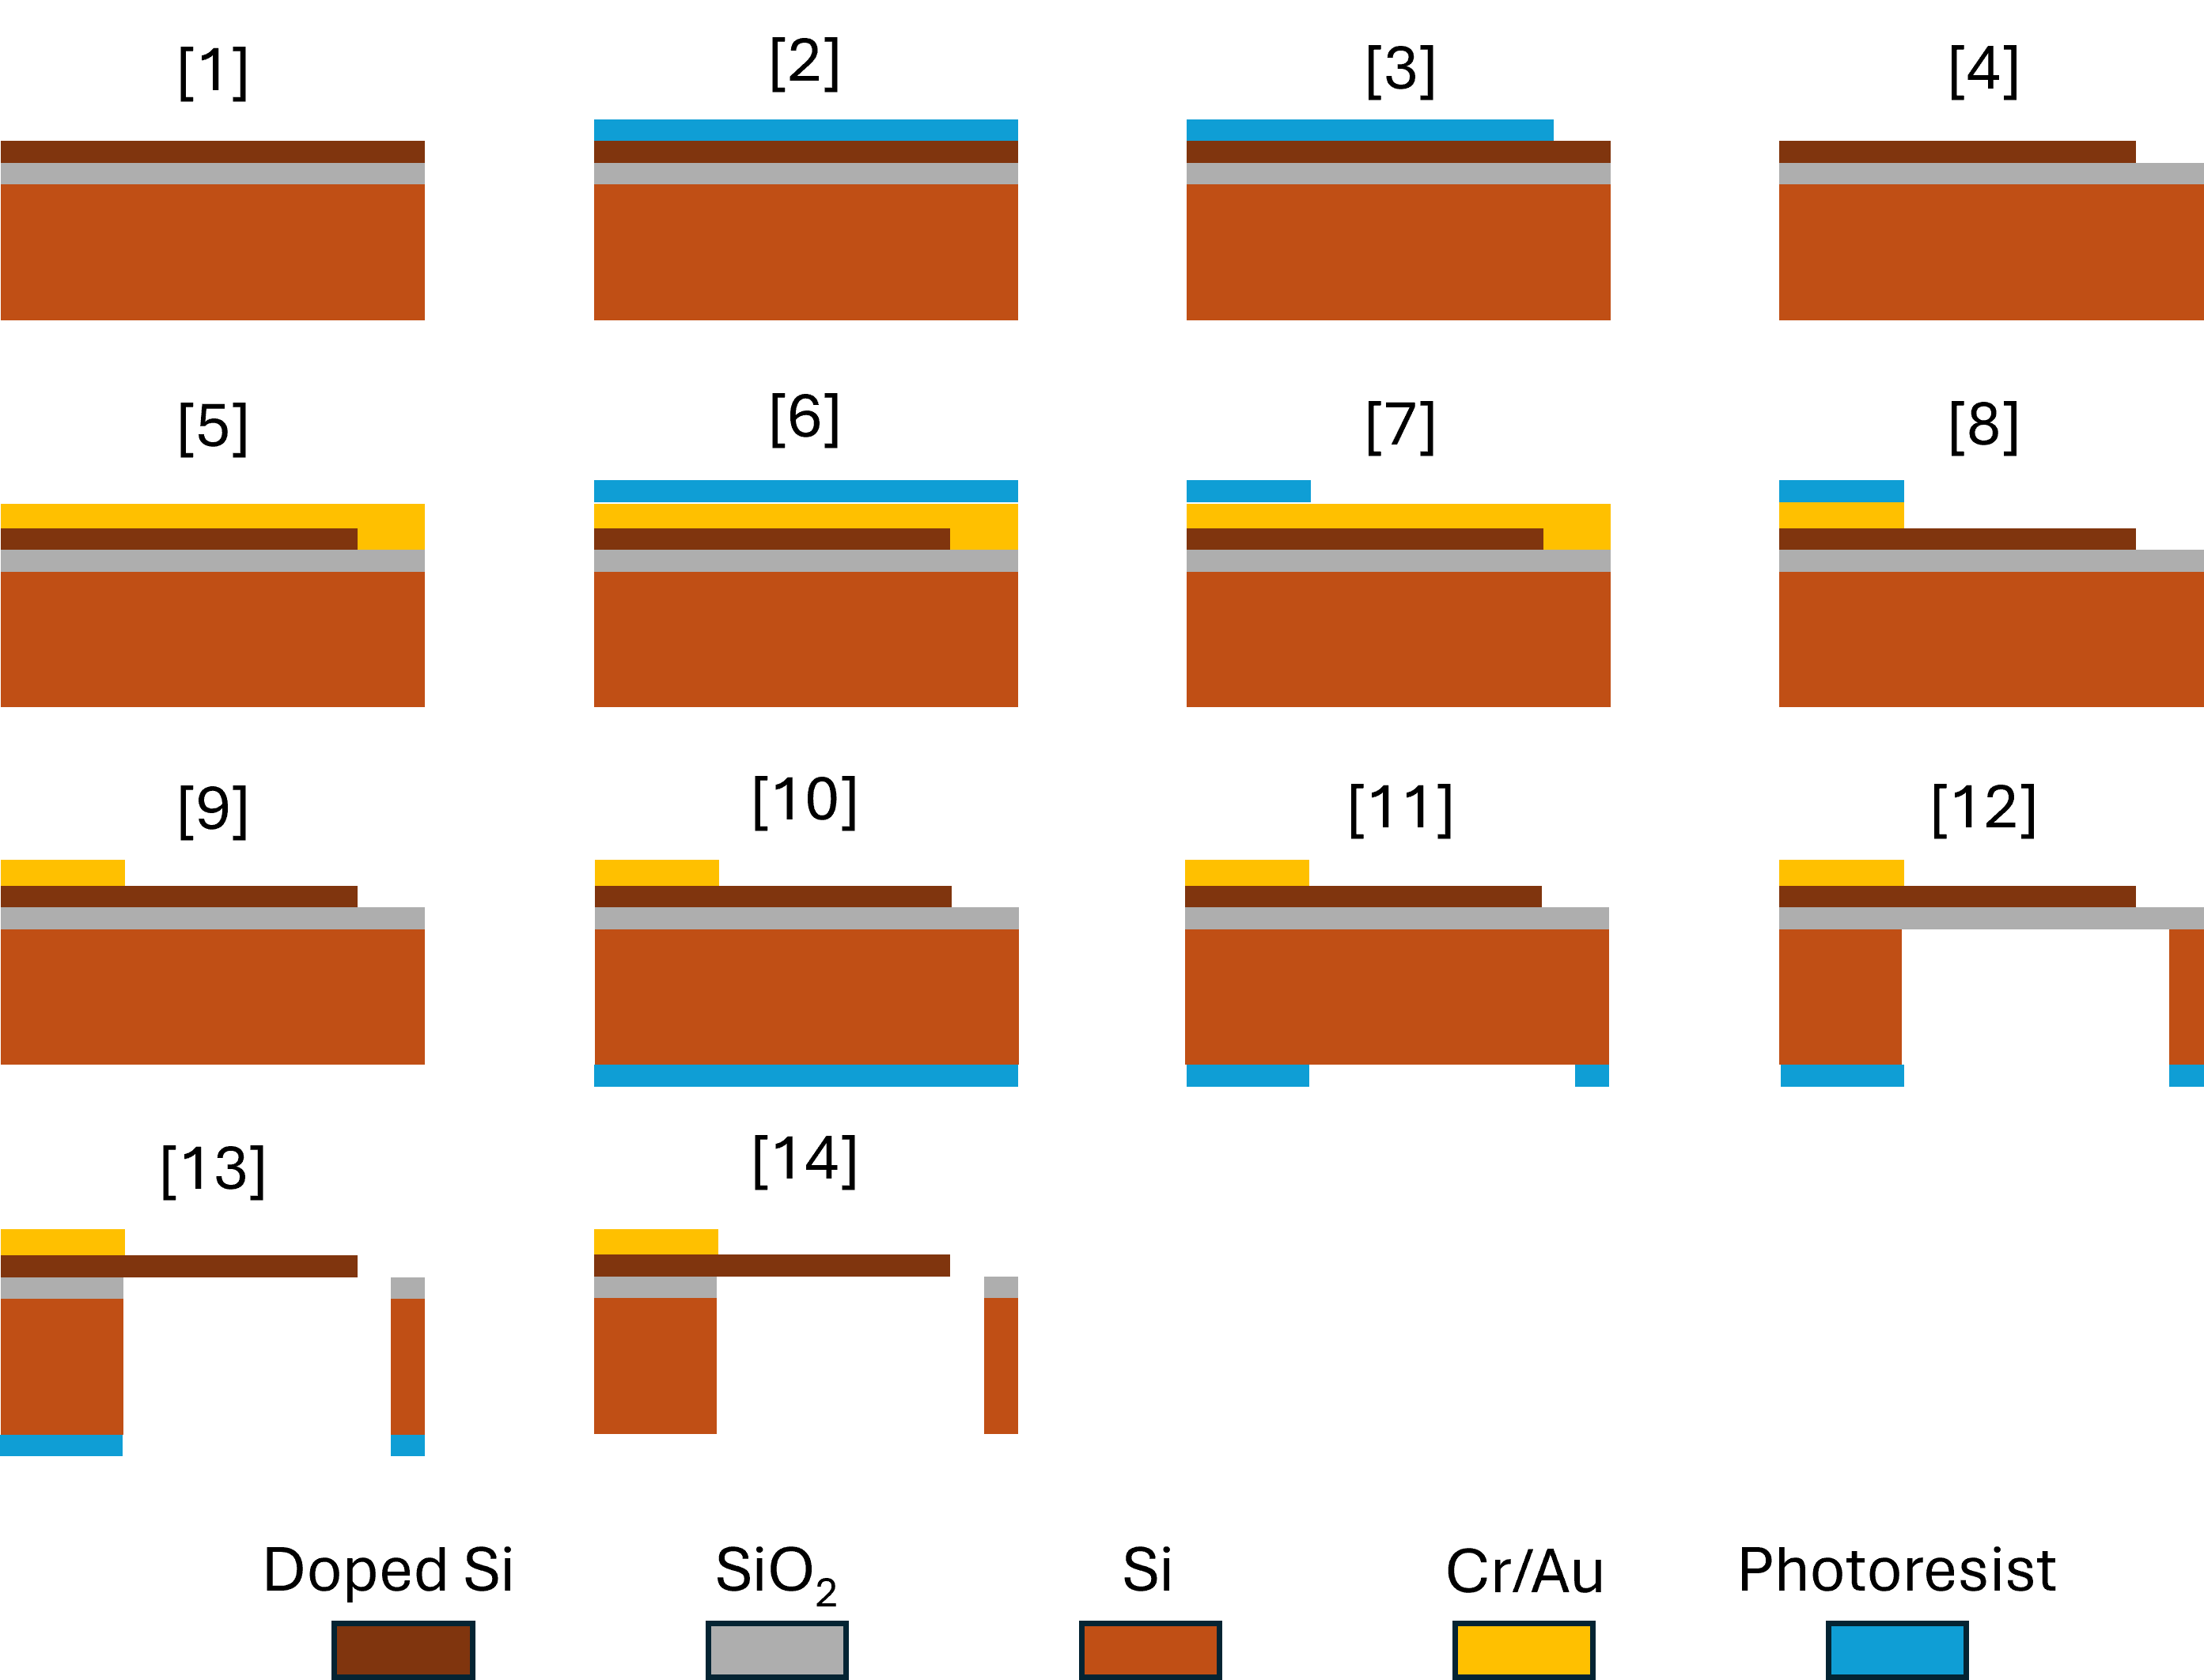
Fig. S1| Fabrication process of the nano silicon cantilever.
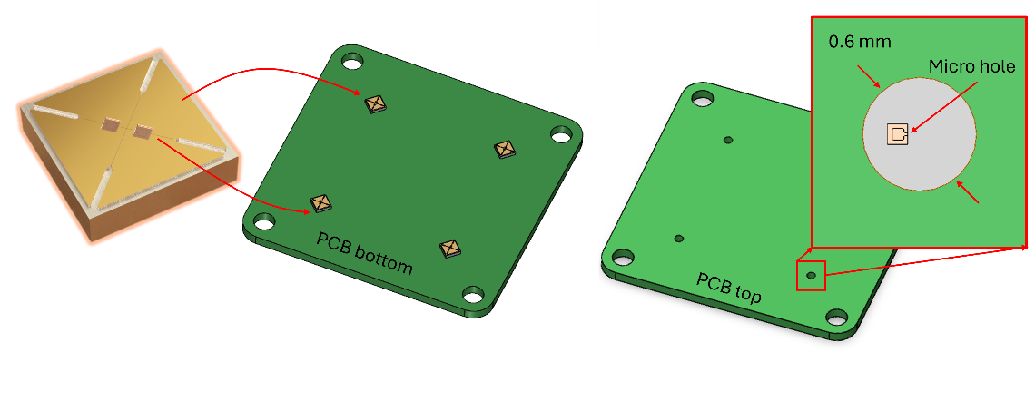
Fig. S2 | Integration of the silicon cantilever chips into the PCB.

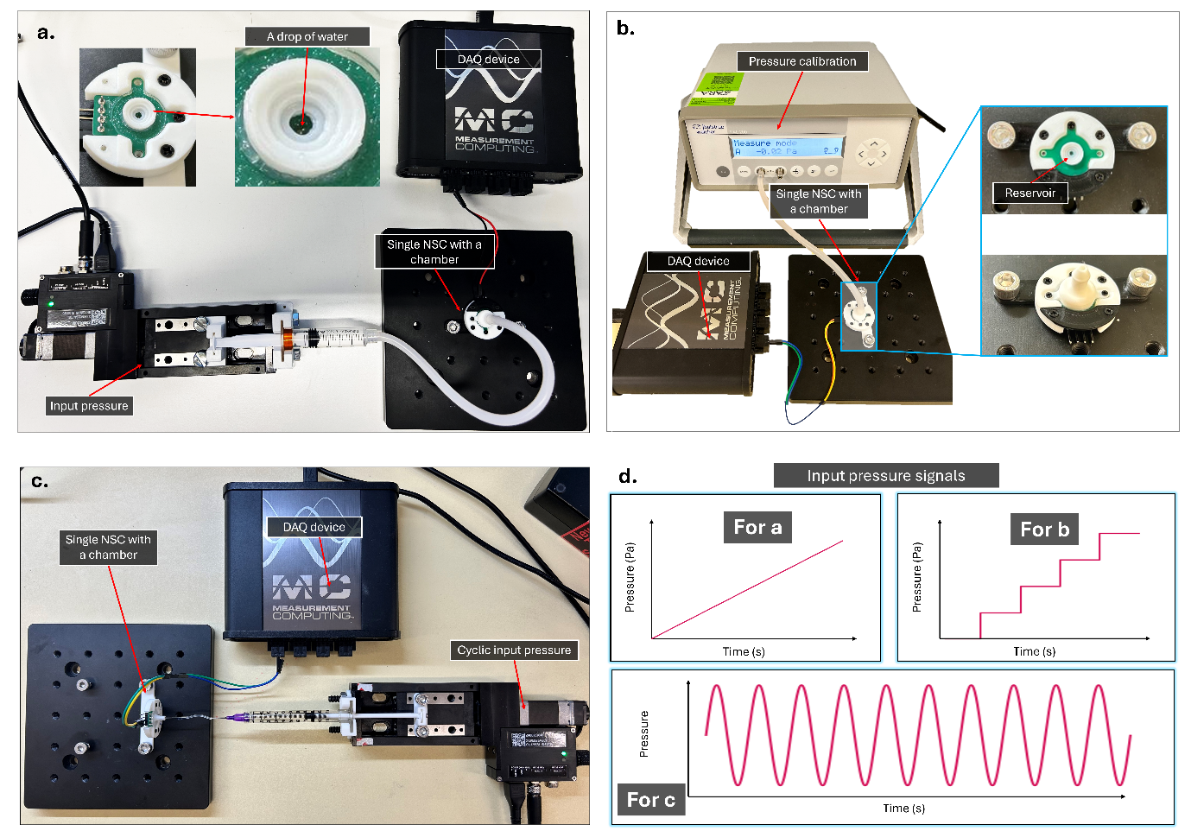
Fig. S3 | a, Experimental setup for operational limit test. b, Experimental setup for static pressure test. c, Experimental setup for dynamic pressure test.

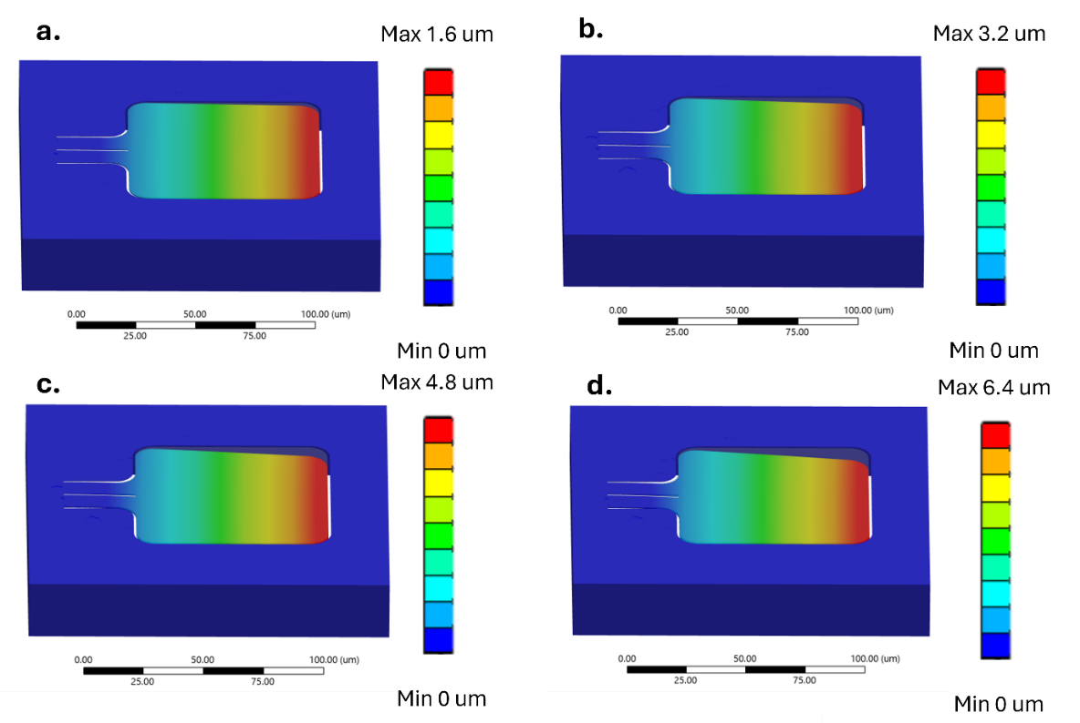
Fig. S4 | Results of FEA for the sensor responses to static pressure changes: a, 10 Pa. b, 20 Pa. c, 30 Pa. d, 40 Pa.

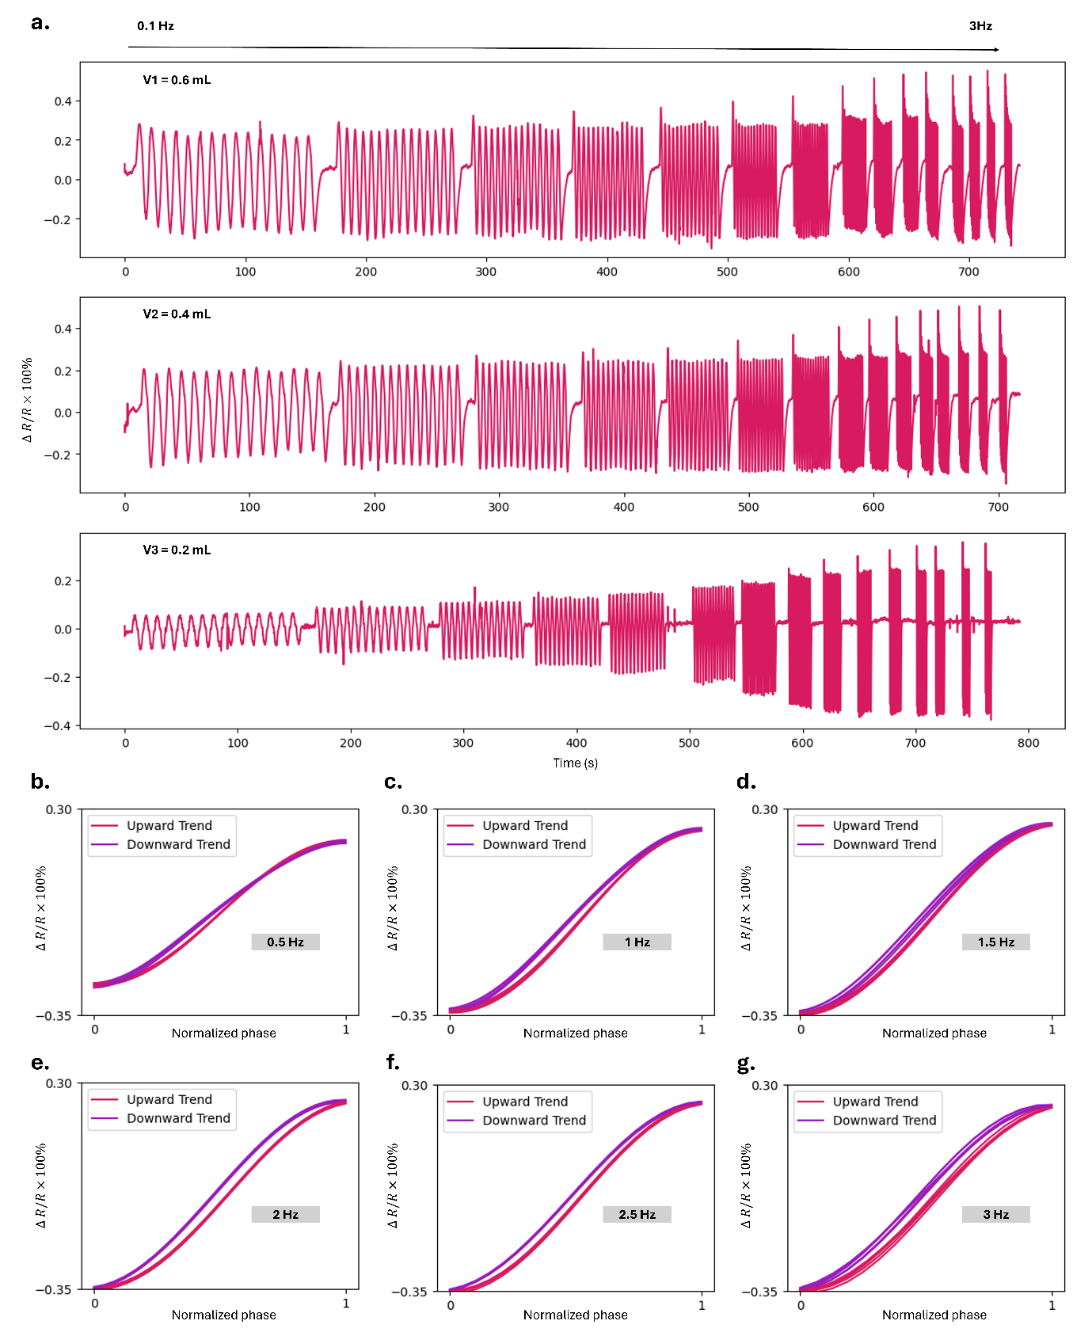
Fig. S5 | a, Recorded resistance changes of three different initial volumes with respect to the change of cyclic pressure frequency increasing from 0.1 Hz to 3 Hz. b-g, Normalized hysteresis loops for the data of V3 = 0.3 mL at the frequency of 0.5 Hz (b), 1 Hz (c), 1.5 Hz (d), 2 Hz (e), 2.5 Hz (f), 3 Hz (g).

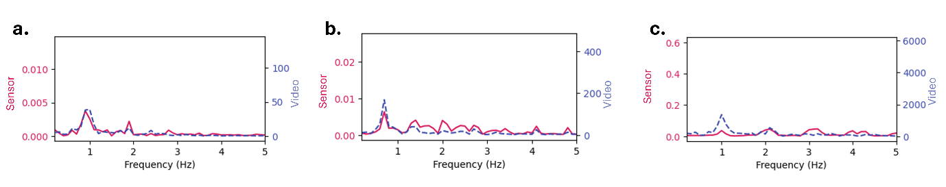
Fig. S6 | Results of Fast Fourier Transform (FFT) performance on the recorded optical/force signals.

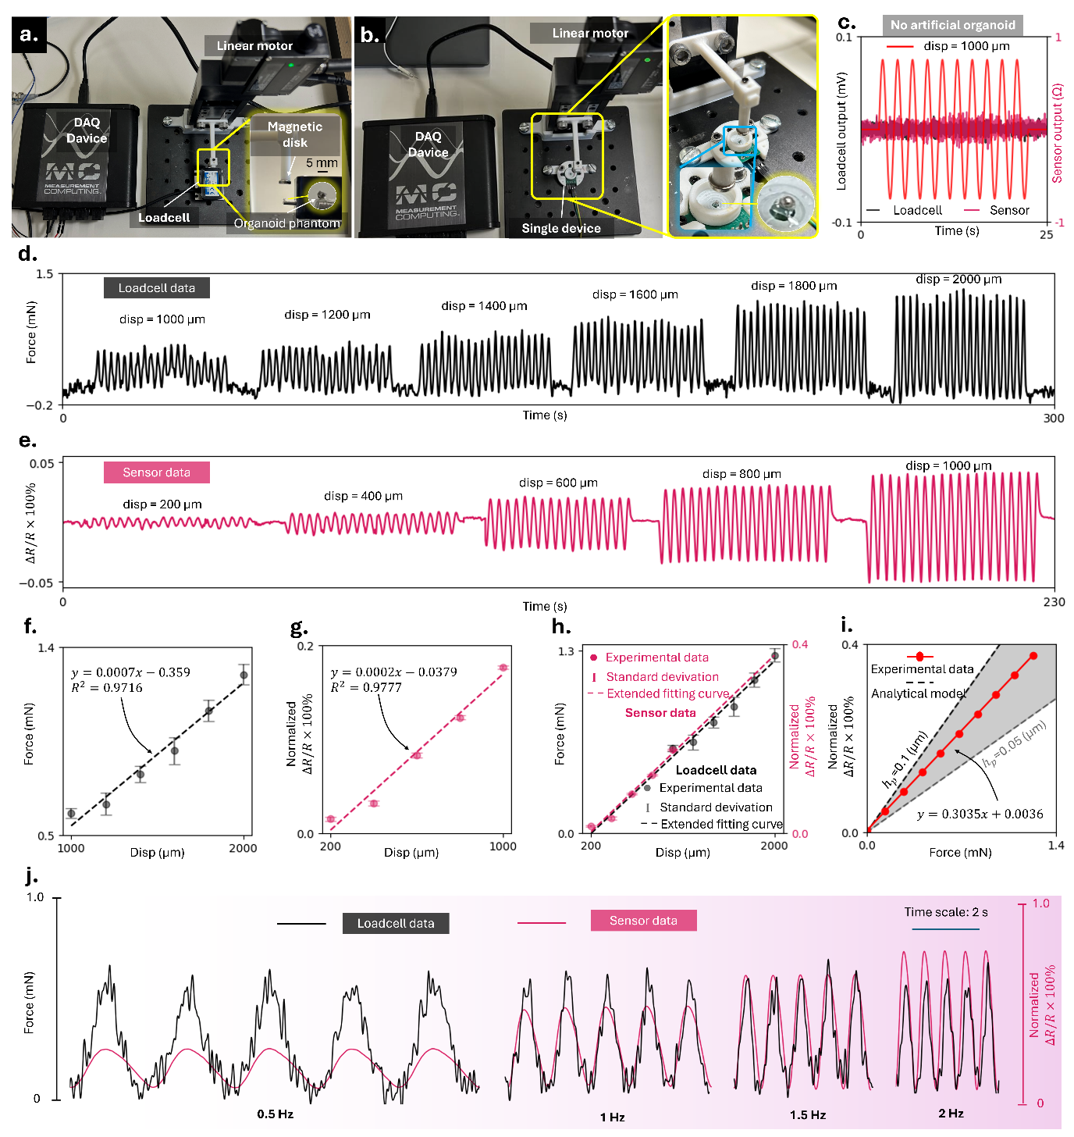
Fig. S7 | Approximate force sensitivity characterization. a, Experimental setup for magnetic force calibration using a load cell. b, Experimental setup for evaluating the force sensitivity of the sensor. c, Results of the control test without the magnetic-driven organoid indicating no Hall-effect interference. d, Load-cell measurements obtained in response to varying displacements of the permanent magnet. e, Corresponding sensor measurements recorded under the same displacement conditions. f–g, Computed mean signal amplitudes for the load cell (f) and the sensor (g), each presented with standard deviations and linear fitting curves. h, Extended comparison of the linear fitting curves for both the sensor and the load cell. i, Converted relationship between applied force and sensor resistance change based on the linear fits. j, Comparison between sensor signals and load-cell signals under input force frequencies ranging from 0.5 Hz to 2 Hz, in increments of 0.5 Hz.

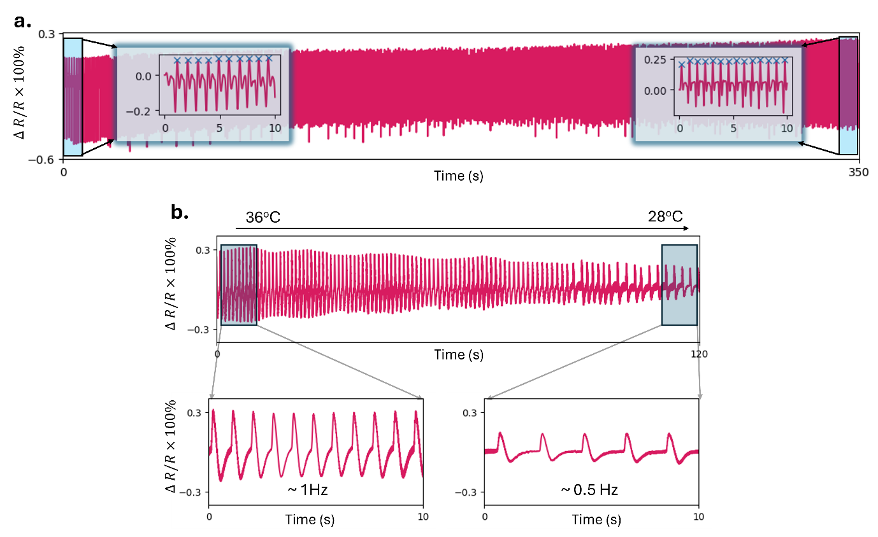
Fig. S8 | Recorded signals over the test of increasing (a) and decreasing (b) temperature effect with magnified views at the first and last ten seconds of the signals.

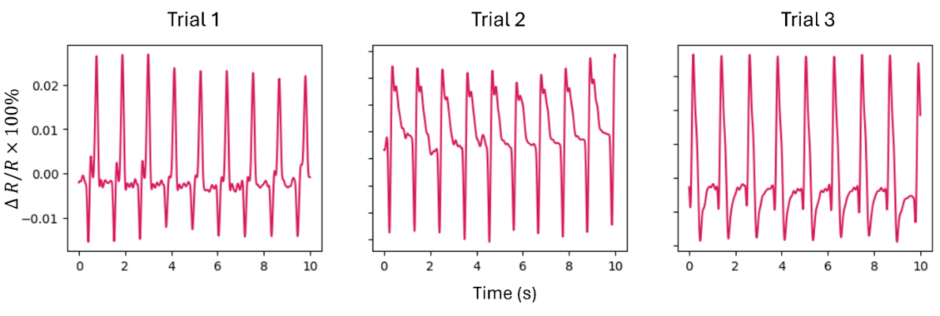
Fig. S9 | Recorded signals over a control test with 1% of DMSO for drug dosing.
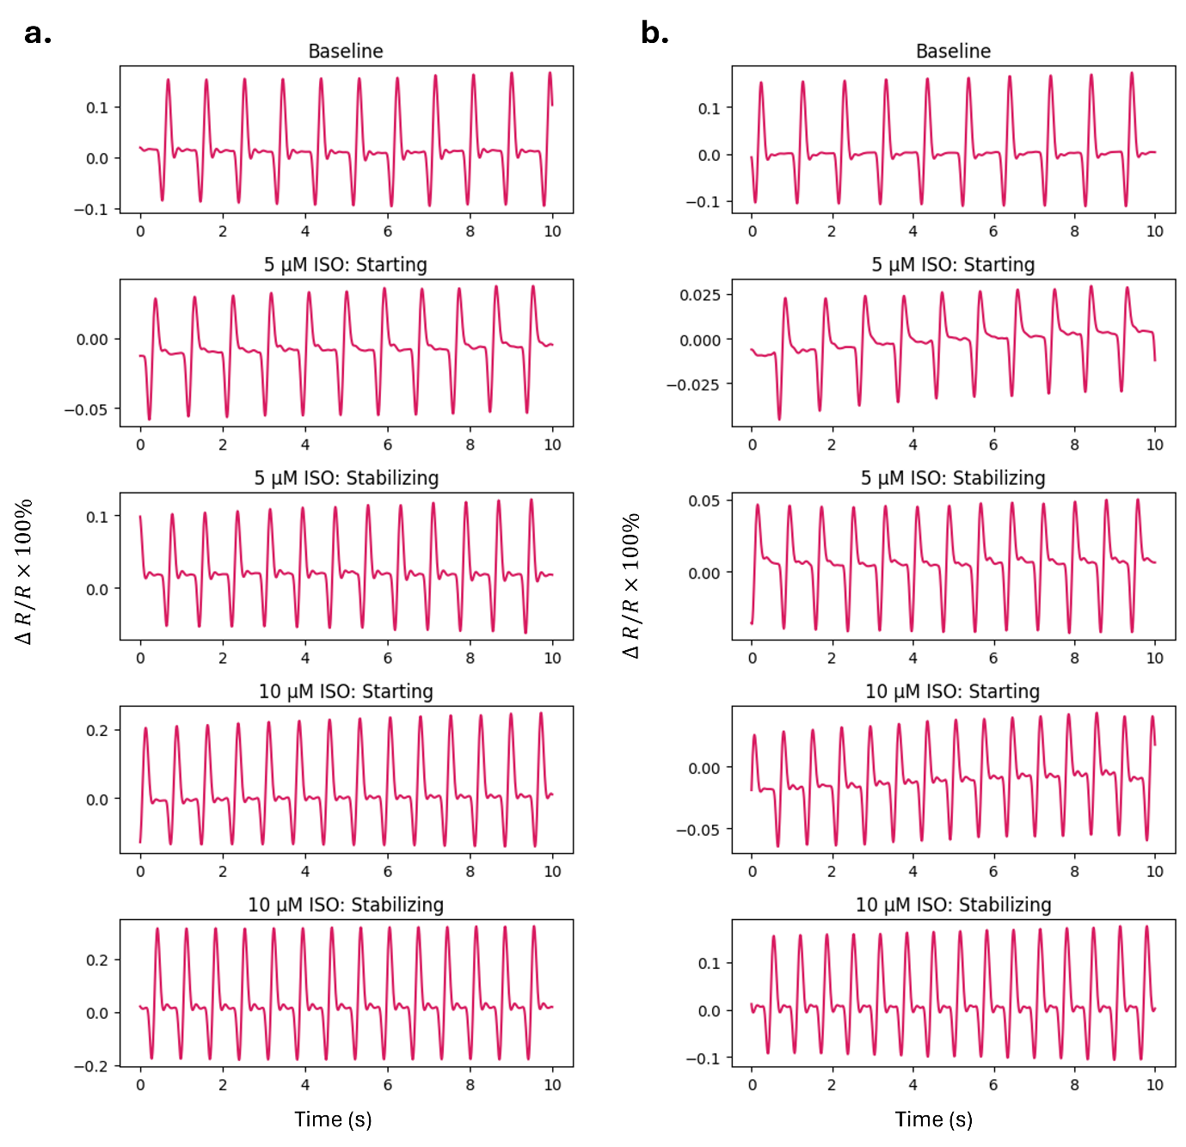
Fig. S10 | Recordings of two other trials with ISO drug scanning.
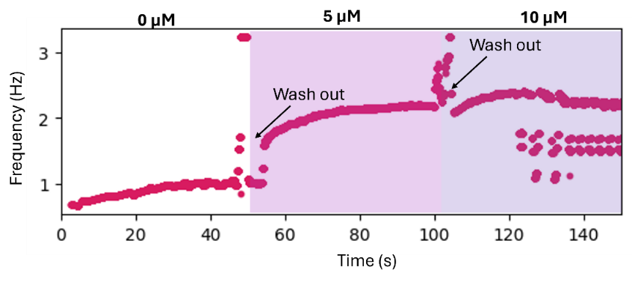
Fig. S11 | Frequency plotting over the DOFE drug testing (using the find-peaks method with a window of 5 seconds).

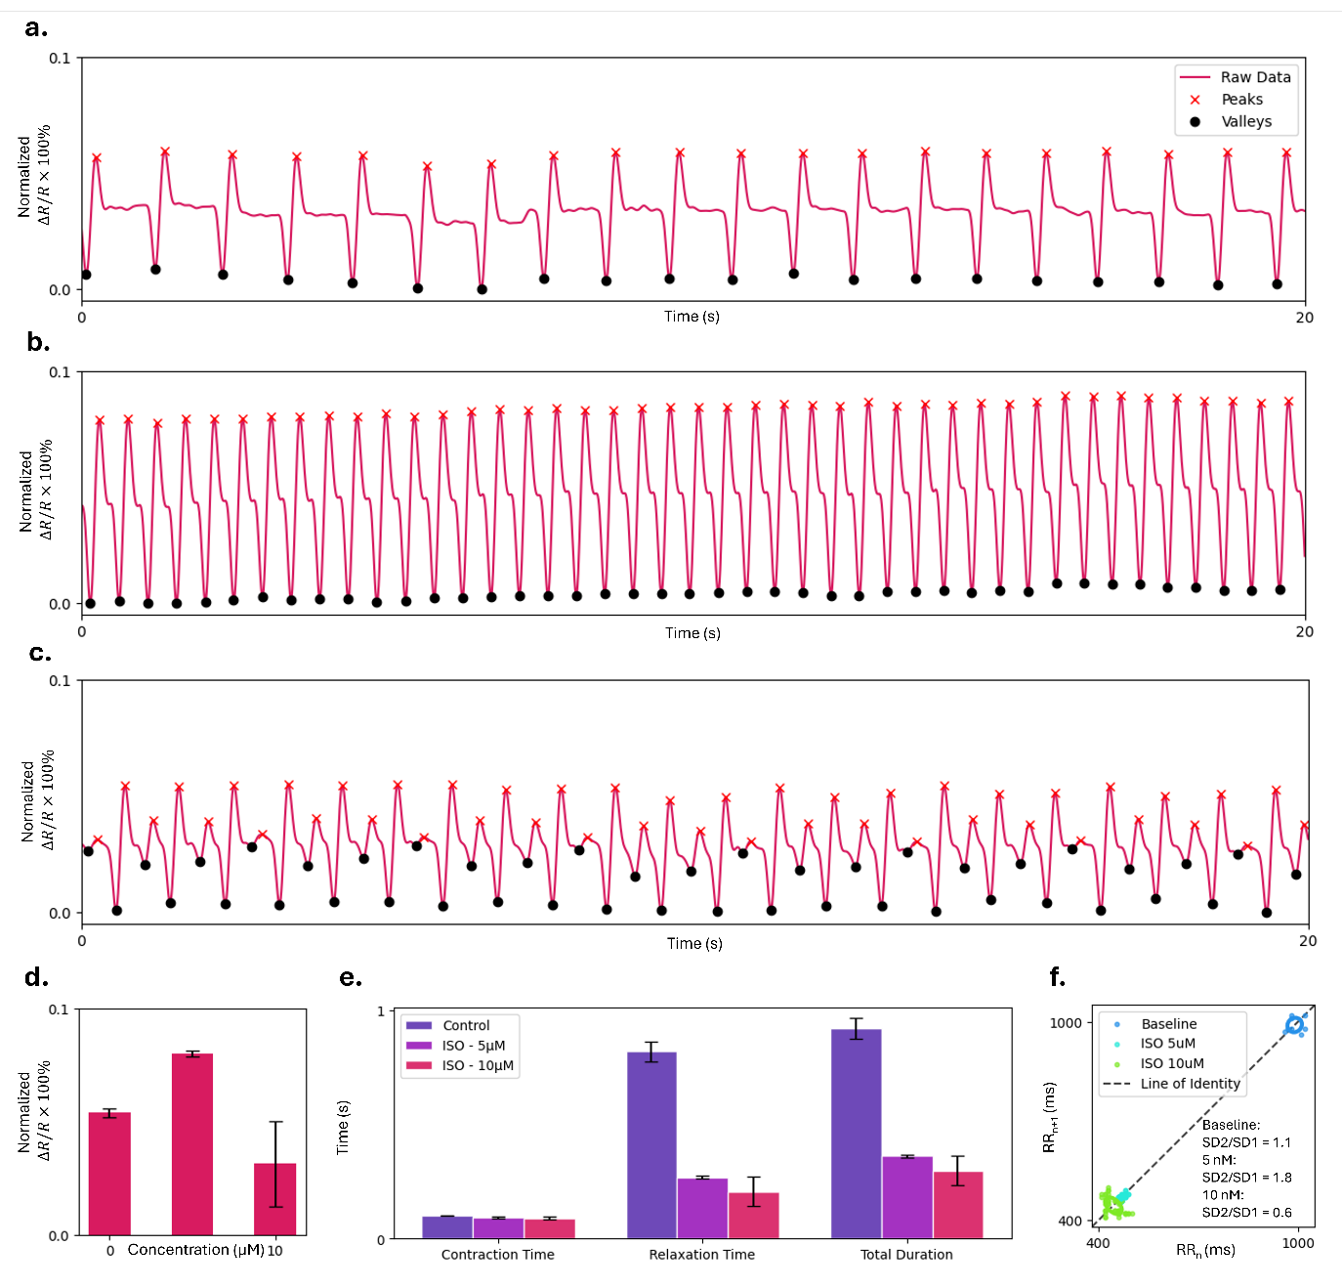
Fig. S12 | Extended analysis for the recorded data of ISO drug scanning with three different concentrations of control (0 µM), 5 µM, and 10 µM. a-c, Detected peaks and valleys of the sensor signals. d, Computed mean amplitudes of the organoid contraction with standard deviations. e, Computed mean contraction and relaxation time, and total contraction duration. f, Poincaré plot of the recorded data of ISO drug scanning. At 0 $μM$: SD1 = 20.6 ms and SD2 = 22.9 ms; at 5 $μM$: SD1 = 5.7 ms and SD2 = 10.3 ms; at 10 $μM$: SD1 = 30.8 ms and SD2 =18.0 ms.

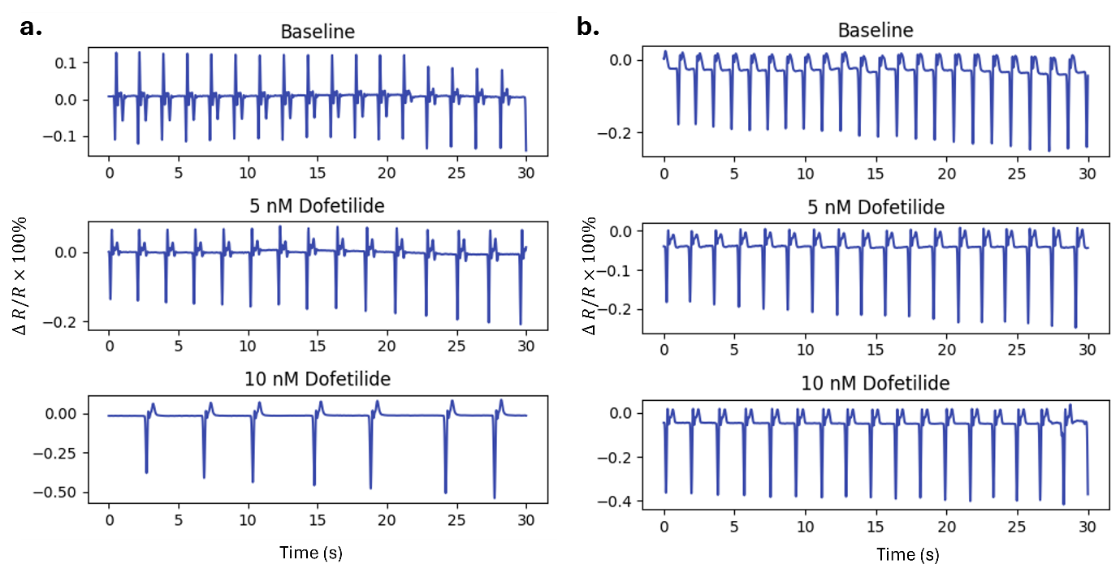
Fig. S13 | Recordings of two other trials with DOFE drug scanning.
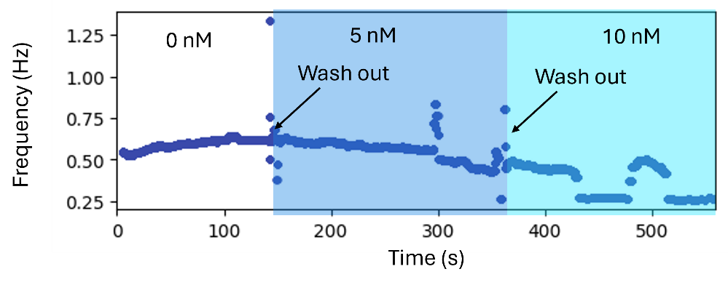
Fig. S14 | Frequency plotting over the DOFE drug testing (using the find-peaks method with a window of 5 seconds).

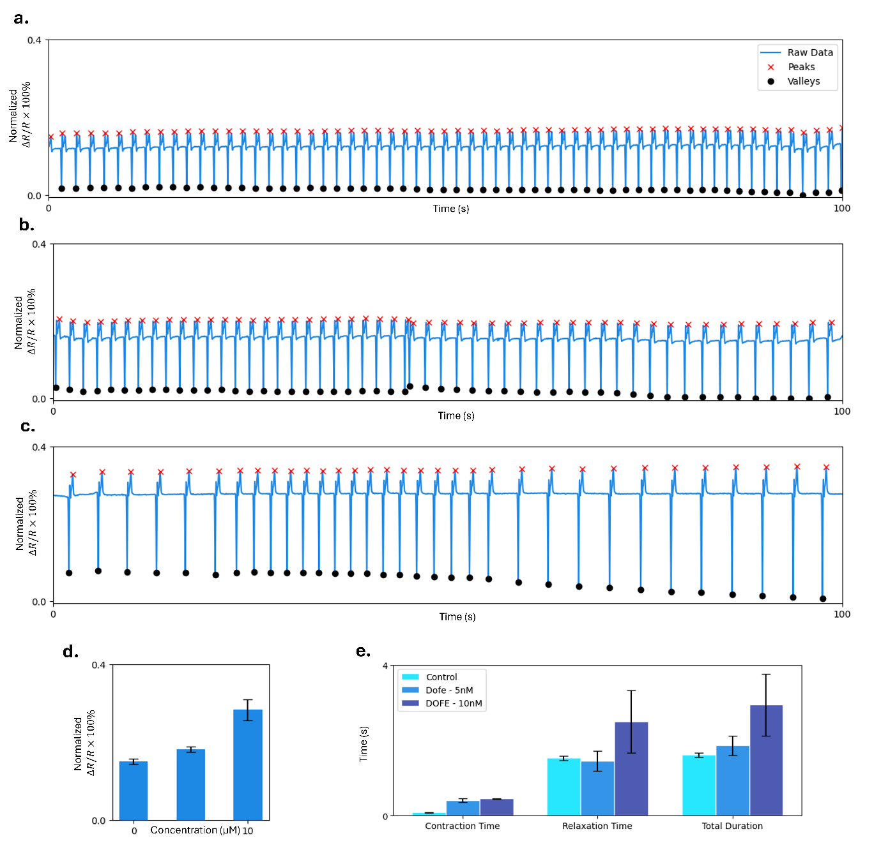
Fig. S15 | Extended analysis for the recorded data of DOFE drug scanning with three different concentrations of control (0 nM), 5 nM, and 10 nM. a-c, Detected peaks and valleys of the sensor signals. d, Computed mean amplitudes of the organoid contraction with standard deviations. e, Computed mean contraction and relaxation time, and total contraction duration.

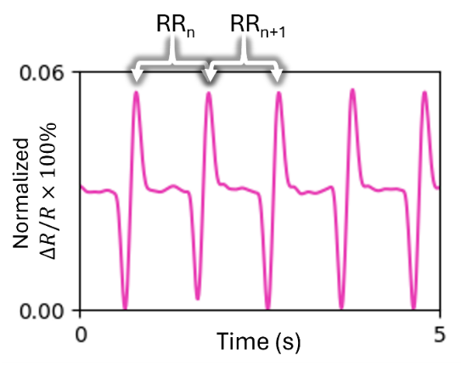
Fig. S16 | An illustration of how RR_{n} and RR_{n+1} are defined from the signals.

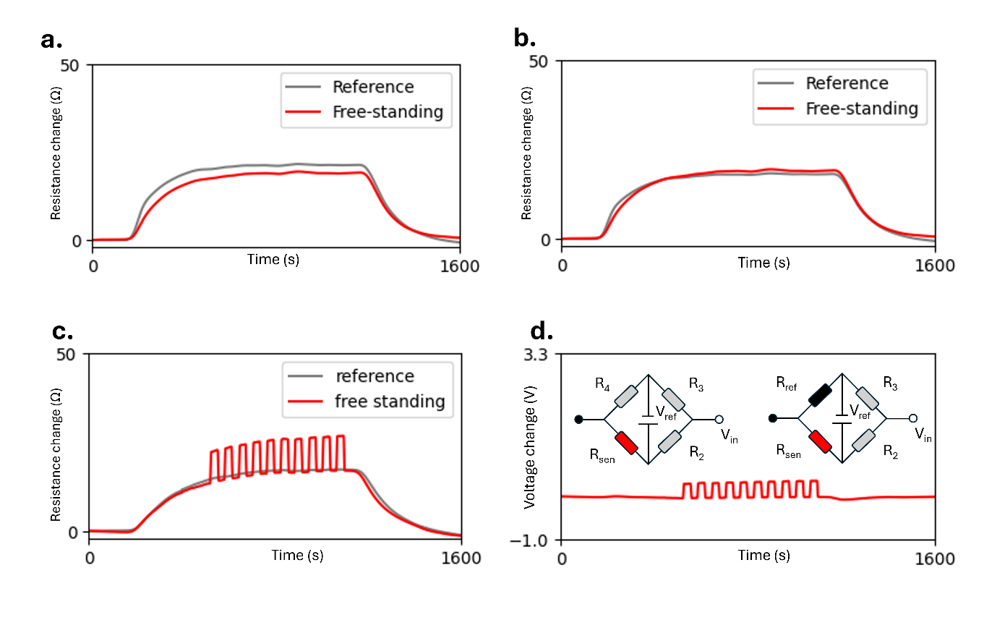
Fig. S17 | Temperature-compensation mechanism. a, Resistance changes of the reference and free-standing cantilevers during the temperature test. b, Corrected resistance of the reference cantilever after applying the scaling factor. c, Resistance changes of both cantilevers under combined pressure and temperature variations. d, Converted voltage output using the Wheatstone-bridge and amplifier configuration.

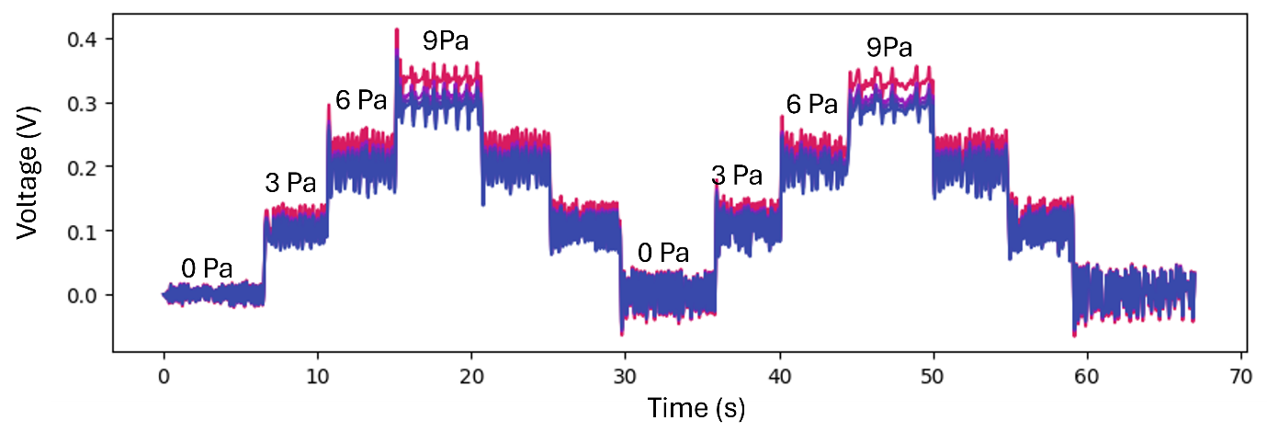
Fig. S18 | Results of the sensitivity test for all four sensors of the BWP.

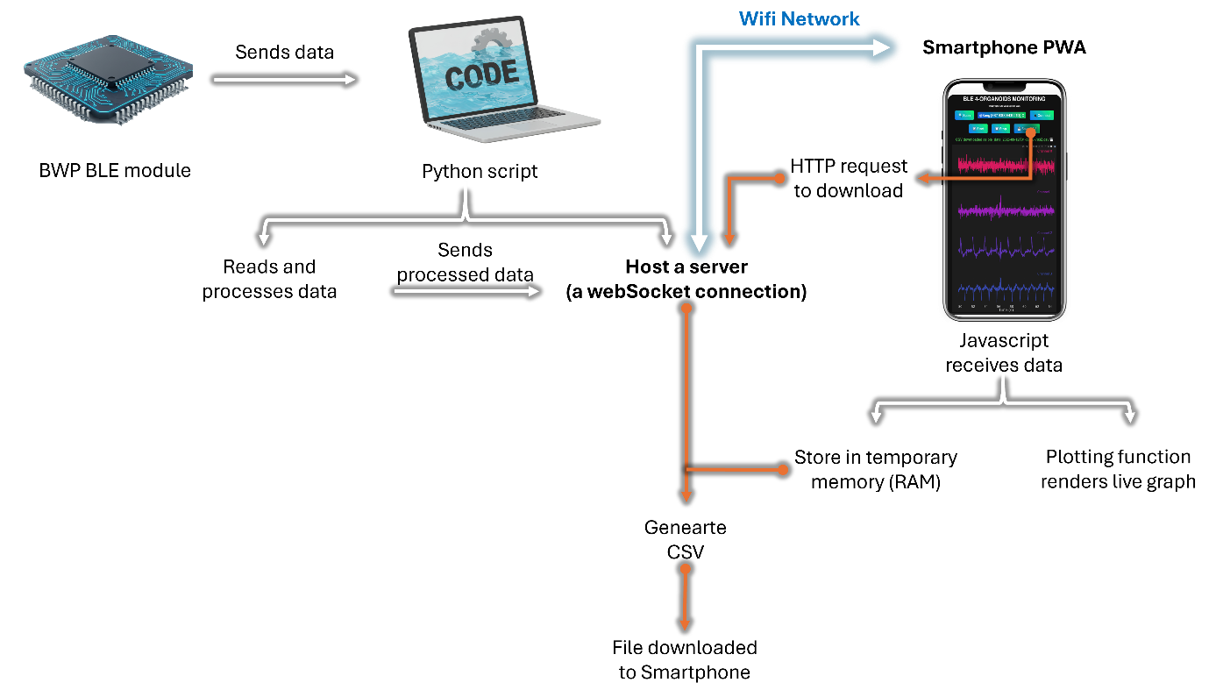
Fig. S19 | Schematic of the data flow between the BWP and the App

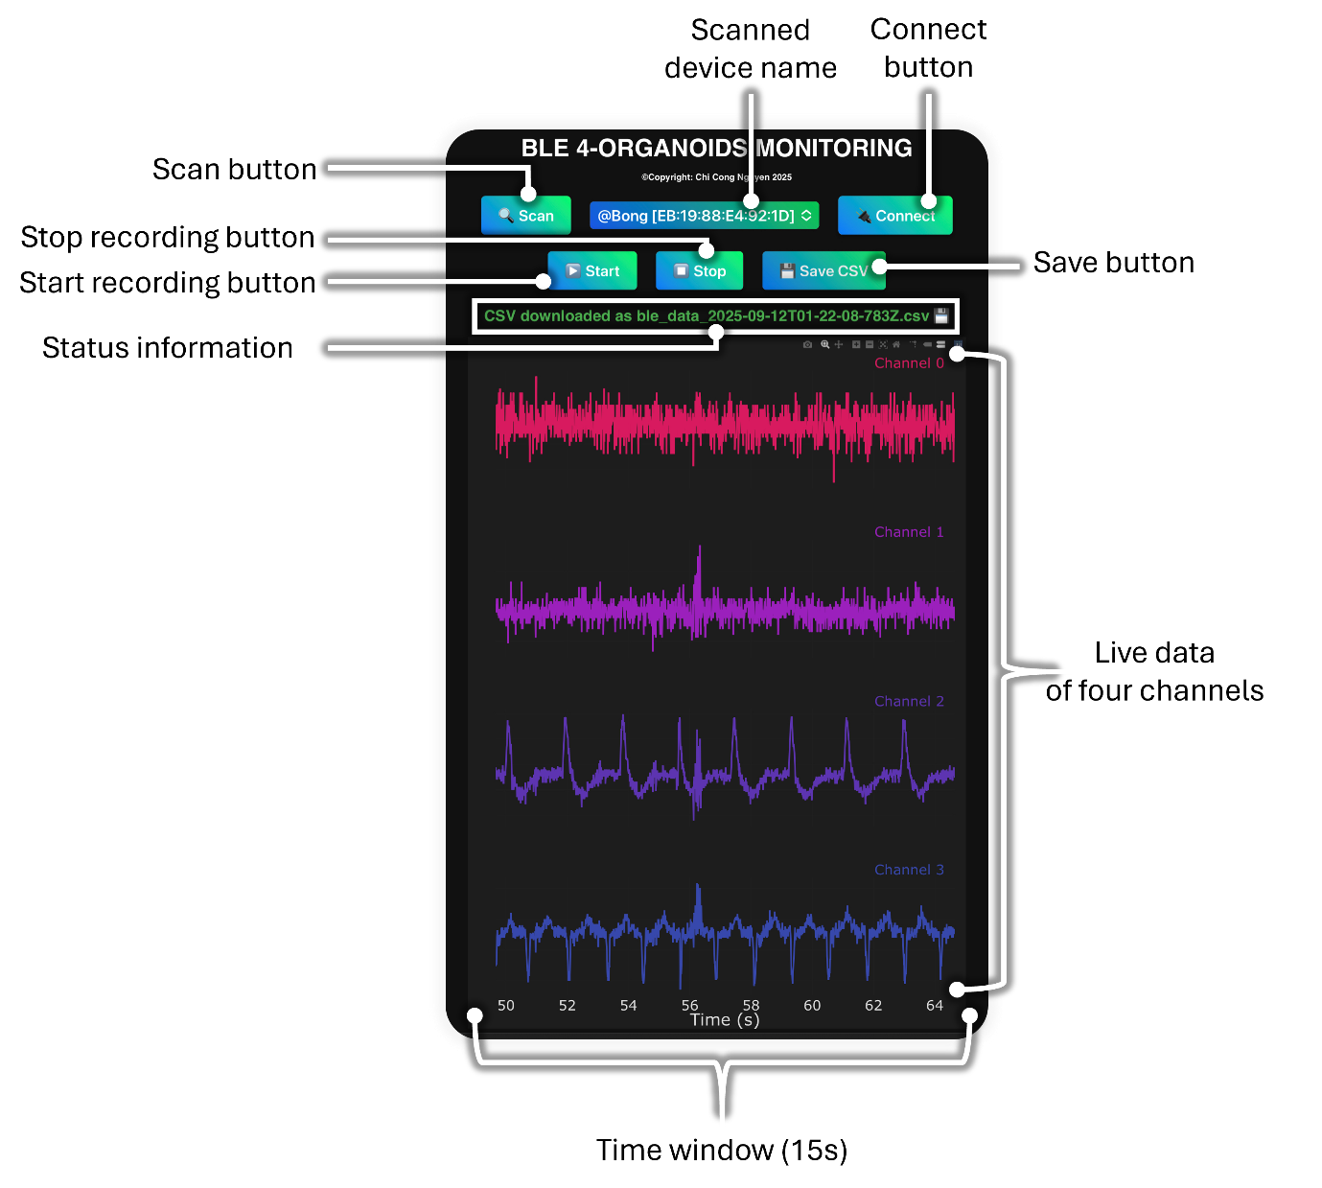
Fig. S20 | User interface of the developed App used with a smartphone.

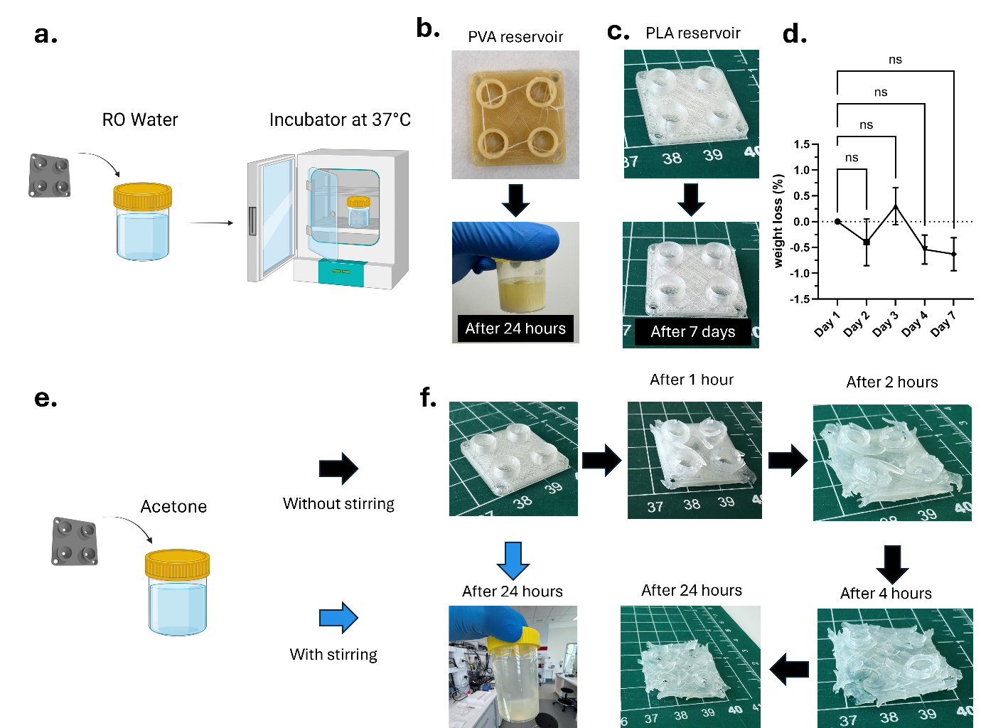
Fig. S21 | Results of degradable tests for the 3D printed PLA and PVA reservoirs. a, Reservoirs are put in RO water containers, which are placed into an incubator at 37 ºC. b, Dissolving status of the PVA reservoir after 24 hours. c, Dissolving status of the PLA reservoir after 7 days. d, Results of weight loss of the PLA reservoir over the tested week. e, Reservoirs are put in acetone with and without stirring. f, Dissolving status of the PLA reservoirs after 24 hours with and without stirring in acetone.
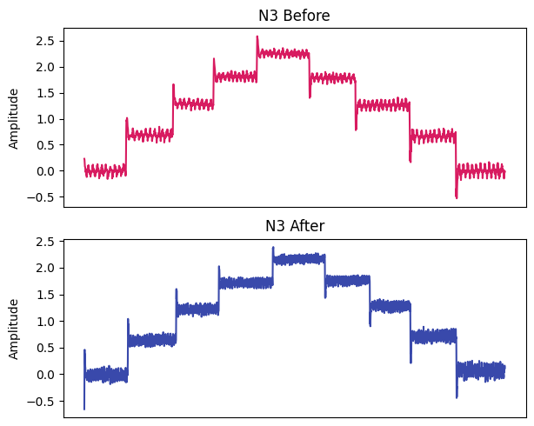
Fig. S22 | Results of the sensitivity test for the single device before and after all experiments with spherical EHTs.

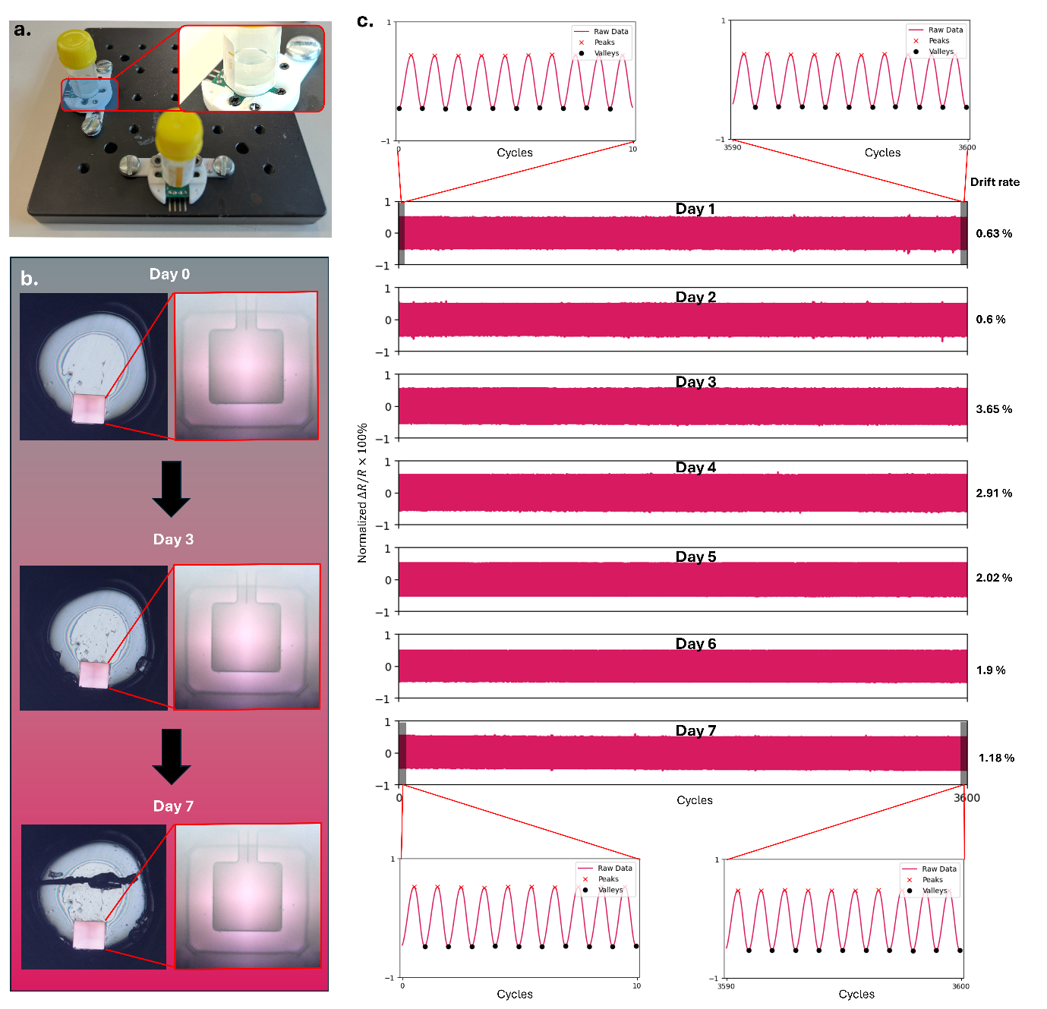
Fig. S23 | Long-term test. a, Experimental setup used to simulate long-term monitoring conditions, in which the device reservoir was filled with 1× PBS. b, Magnified optical images of the bottom of the PCB hole and the Si cantilever on Day 0, Day 3, and Day 7. c, Sensor recordings collected over 3,600 cycles across seven days, along with the computed drift rates.

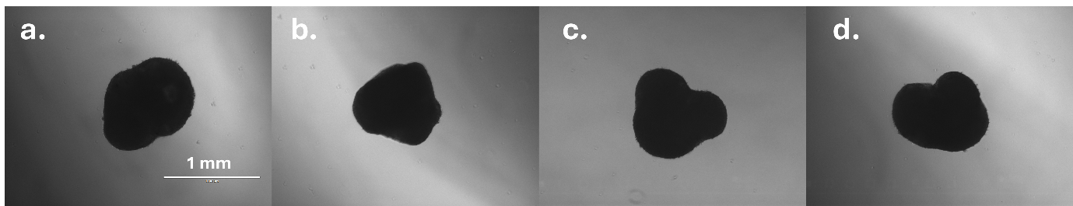
Fig. S24 | Microscopy images of some EHTs with varying geometries.

Supplementary movies
- Movie S1: Working principle of the BWP (Animation)
- Movie S2: Real-time monitoring of cardiac spherical EHT contractions
- Movie S3: Real-time monitoring of cardiac spherical EHT contractions under Isoproteronol (ISO) administration.
- Movie S4: Real-time monitoring of cardiac spherical EHT contractions under Dofetilide (DOFE) administration.
- Movie S5: Real-time monitoring of cardiac spherical EHT contractions under electrical stimulation (ES).
- Movie S6: Real-time wireless monitoring of cardiac spherical EHT contractions.

Supplementary references
1. Lind JU, et al. Instrumented cardiac microphysiological devices via multimaterial three-dimensional printing. Nature Materials 16, 303-308 (2017).
2. Matsudaira K, Nguyen T-V, Shoji KH, Tsukagoshi T, Takahata T, Shimoyama I. MEMS piezoresistive cantilever for the direct measurement of cardiomyocyte contractile force. Journal of Micromechanics and Microengineering 27, 105005 (2017).
3. Legant WR, Pathak A, Yang MT, Deshpande VS, McMeeking RM, Chen CS. Microfabricated tissue gauges to measure and manipulate forces from 3D microtissues. Proceedings of the National Academy of Sciences 106, 10097-10102 (2009).
4. Zhang F, et al. Continuous contractile force and electrical signal recordings of 3D cardiac tissue utilizing conductive hydrogel pillars on a chip. Materials Today Bio 20, 100626 (2023).
5. Zhang N, et al. Multifunctional 3D electrode platform for real-time in situ monitoring and stimulation of cardiac tissues. Biosensors and Bioelectronics 112, 149-155 (2018).
6. Fullenkamp DE, et al. Simultaneous electromechanical monitoring in engineered heart tissues using a mesoscale framework. Science Advances 10, eado7089 (2024).
7. Zhao H, et al. Compliant 3D frameworks instrumented with strain sensors for characterization of millimeter-scale engineered muscle tissues. Proceedings of the National Academy of Sciences 118, e2100077118 (2021).
8. Kim M, et al. Multimodal characterization of cardiac organoids using integrations of pressure-sensitive transistor arrays with three-dimensional liquid metal electrodes. Nano letters 22, 7892-7901 (2022).
9. Lyu Q, et al. A soft and ultrasensitive force sensing diaphragm for probing cardiac organoids instantaneously and wirelessly. Nature Communications 13, 7259 (2022).
10. Yin J, et al. Real-time electro-mechanical profiling of dynamically beating human cardiac organoids by coupling resistive skins with microelectrode arrays. Biosensors and Bioelectronics 267, 116752 (2025).
11. Strohm EM, et al. Noninvasive quantification of contractile dynamics in cardiac cells, spheroids, and organs-on-a-chip using high-frequency ultrasound. ACS Nano 18, 314-327 (2023).
12. Timoshenko S. History of strength of materials: with a brief account of the history of theory of elasticity and theory of structures. Courier Corporation (1983).
13. Happel J, Brenner H. Low Reynolds number hydrodynamics: with special applications to particulate media. Springer Science & Business Media (2012).
14. Wilke KL, Song Y, Lu Z, Wang EN. Enhanced laplace pressures for functional surfaces: wicking, switchability, and selectivity. Advanced Materials Interfaces 10, 2201967 (2023).
15. Hasimoto H. On the flow of a viscous fluid past a thin screen at small Reynolds numbers. Journal of the Physical Society of Japan 13, 633-639 (1958).
16. Shimoyama I, Matsumoto K, Nguyen B-K, Nguyen M-D, Phan H-P. Pressure-sensitive sensor (2017).
17. Bruus H. Theoretical microfluidics. Oxford university press (2007).
18. Poon C. Measuring the density and viscosity of culture media for optimized computational fluid dynamics analysis of in vitro devices. Journal of the mechanical behavior of biomedical materials 126, 105024 (2022).
19. Mills RJ, et al. Functional screening in human cardiac organoids reveals a metabolic mechanism for cardiomyocyte cell cycle arrest. Proceedings of the National Academy of Sciences 114, E8372-E8381 (2017).
20. Ma MS, Sundaram S, Lou L, Agarwal A, Chen CS, Bifano TG. High throughput screening system for engineered cardiac tissues. Frontiers in Bioengineering and Biotechnology 11, 1177688 (2023).
21. Long GL, Winefordner JD. Limit of detection. A closer look at the IUPAC definition. Analytical chemistry 55, 712A-724A (1983).
22. Kanda Y. A Graphical Representation of the Piezoresistance Coefficients in Silicon. Ieee T Electron Dev 29, 64-70 (1982).

