Tables
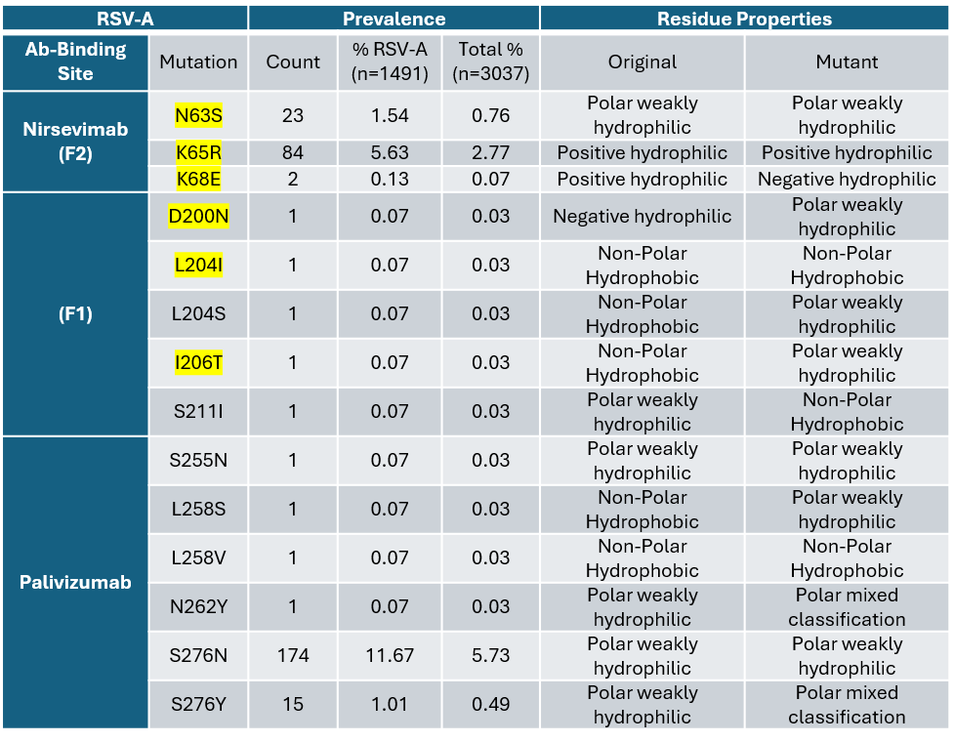
Table 1. Prevalence of mutations in antibody-binding sites on RSV-F from sequences collected in the UK, 2019-2024. Mutations are displayed within nirsevimab binding sites (divided into residues on the F2 and F1 sub-unit) and palivizumab sites with count representing the number of sequences in which the mutation was identified out of 3,037 samples (RSV-A and RSV-B subtype) samples. Biochemical properties of the reference amino acid are given alongside that of the mutated amino acid. Highlighted mutations signify those reported to have altered susceptibility to the antibody. Mutations found in RSV-A samples (n=1,491) compared to reference.

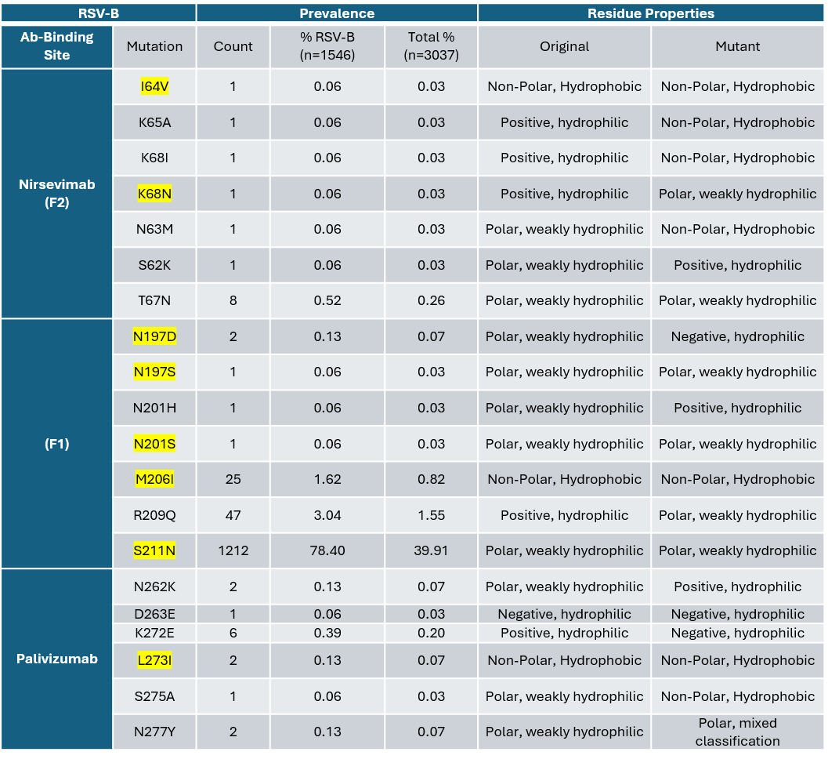
Table 2. Prevalence of mutations in antibody-binding sites on RSV-F from sequences collected in the UK, 2019-2024. Mutations are displayed within nirsevimab binding sites (divided into residues on the F2 and F1 sub-unit) and palivizumab sites with count representing the number of sequences in which the mutation was identified out of 3,037 samples (RSV-A and RSV-B subtype) samples. Biochemical properties of the reference amino acid are given alongside that of the mutated amino acid. Highlighted mutations signify those reported to have altered susceptibility to the antibody. Mutations found in RSV-B samples (n=1,546).

