
SHI-QI YUAN was born in Xiantao, Hubei Province, China in 1995. In 2017, she obtained a bachelor's degree in Software Engineering from Zhejiang Normal University.In 2024, she obtained a master's degree in Computer Technology at Liaoning Petrochemical University. During her graduate studies, her main research directions include machine learning and deep learning algorithm development and application. She has successfully applied for three software copyrights, and has received school-level scholarships multiple times.As the first author, published a research paper titled "Research on Strawberry Quality Grading Based on Object Detection and Stacking Fusion Model" in IEEE Access .

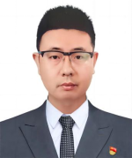
Yu Cao, currently an Associate Professor at college of Information and Control Engineering, Liaoning Petrochemical University has Obtained a Ph.D. degree at Northeastern University. His research focus spans complex network dynamics, machine learning algorithms and applications, big data analysis and cloud computing, as well as image processing. As the first author or corresponding author, he has contributed to the publication of over 40 papers and has been granted 4 patents both domestically and internationally. Additionally, has taken the lead in more than 10 research projects.

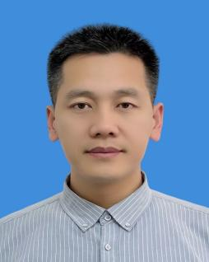
Tao Zhong, male, obtained his Master of Engineering degree from Northeastern University in July 2014. He currently serves as Deputy Manager of the Project Management Department (Safety and Environmental Protection Department) at Ansteel Group Engineering & Technology Co., Ltd., with his main professional focus on the design and research of electrical drive control in the metallurgical industry, EPC (Engineering, Procurement, Construction) project management, as well as the informatization and digitalization of project management. He has been honored with one Second Prize and one Third Prize respectively in the Management Modernization Innovation Achievements of Ansteel Group Co., Ltd. in 2021.


Xu Cheng received the B.S. degree in automation and the M.S. and Ph.D. degrees in system engineering from Northeastern University, China,in 2007, 2009, and 2015, respectively.Since 2017, she has been a Lecturer with Shenyang Agricultural University, China. Her research interests include integer programming and combinatorial optimization, intelligent optimization algorithm, and data analysis

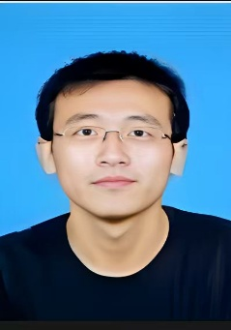
Xiaodong Wang , the Chief Engineer of the Green Building Division,Liaoning Provincial Building Design&Research Institude Co.,Ltd. Holding a master degree and a senior professional title of Senior Engineer.He graduated from Northeastern University in 2011 with a major in Control Theory and Control Engineering.Since 2011,he has been employed at Liaoning Provincial Builiding Desigh&Research Institute Co.,Ltd.His research focuses on the planning and design of data centers.

