Supplemental Materials

Table S1 Angiographic and procedural characteristics
Variable | Total  (n=1780) | New-Onset AF  (n=105) | Existing AF/non-AF  (n=1675) | p-value
Culprit vessel territory  LM/LAD  Others | 657 (36.9)  1123 (63.1) | 34 (32.4)  71 (67.6) | 623 (37.2)  1052 (62.8) | 0.349
Gp2b3a Inhibitors | 474 (26.6) | 35 (33.3) | 439 (26.2) | 0.109
Thrombectomy | 697 (39.2) | 37 (35.2) | 660 (34.9) | 0.396
Balloon Angioplasty | 1665 (93.5) | 97 (92.4) | 1568 (93.6) | 0.619
Coronary Stenting | 1529 (85.9) | 88 (83.8) | 1441 (86.0) | 0.526
Post-procedure TIMI 3 | 1691 (95.0) | 94 (89.5) | 1597 (95.3) | 0.008
Residual Thrombus | 15 (0.8) | 1 (1.0) | 14 (0.8) | 0.600
Continuous variables are presented as mean±SD and categorical variables presented as number (%)
Glycoprotein 2b3a, Gp2b3a; LAD, left anterior descending; LM, left main; PPCI, primary percutaneous coronary intervention; PCI, percutaneous coronary intervention; STEMI, ST elevation myocardial infarction.

Table S2: Univariate Cox regression for development of individual endpoints for patient with new-onset AF
Variable | HR | 95% CI | p-value
MACE | 1.002 | 0.732-1.373 | 0.990
MI | 2.748 | 0.975-7.744 | 0.056
HF | 0.879 | 0.479-1.613 | 0.678
Stroke | 1.290 | 0.386-4.310 | 0.679
Bleeding | 0.863 | 0.373-1.996 | 0.731
CV mortality | 0.982 | 0.620-1.553 | 0.936
All-cause mortality | 0.813 | 0.558-1.185 | 0.282

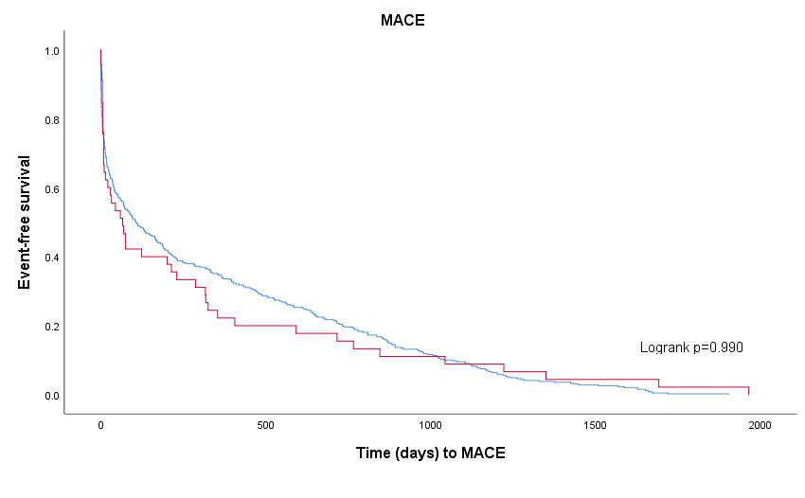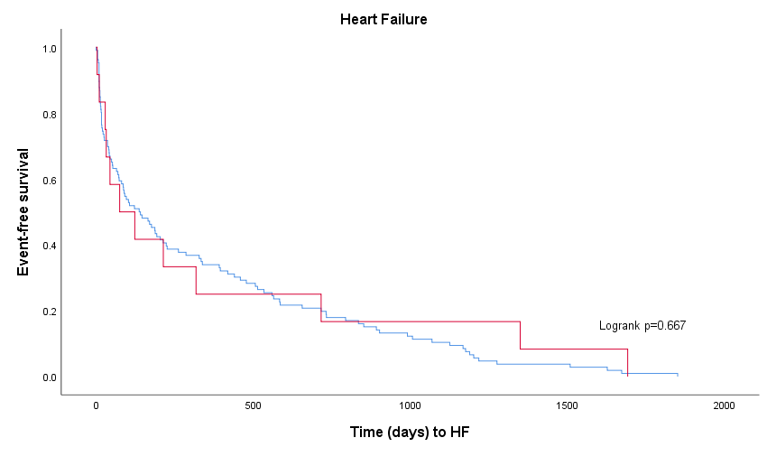

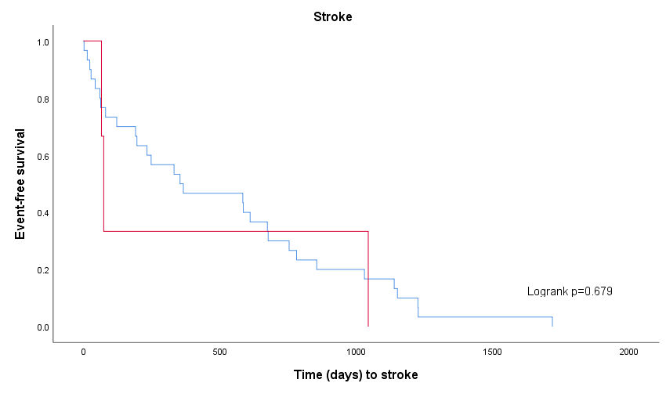

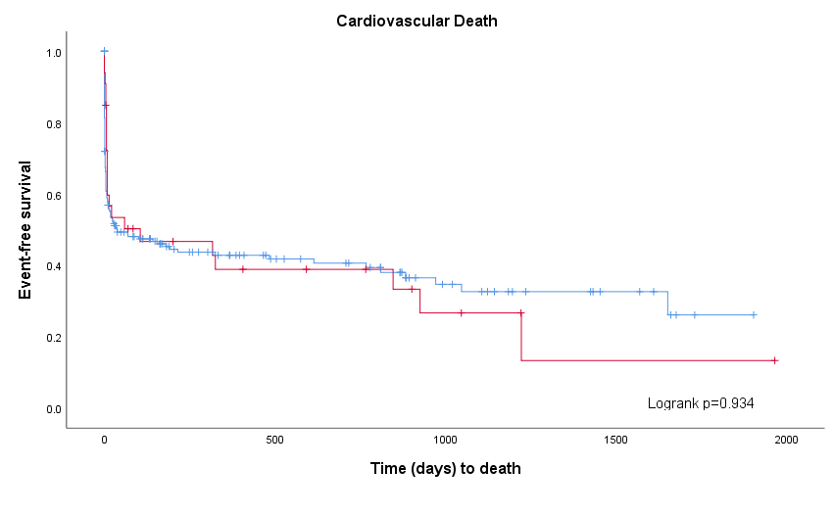
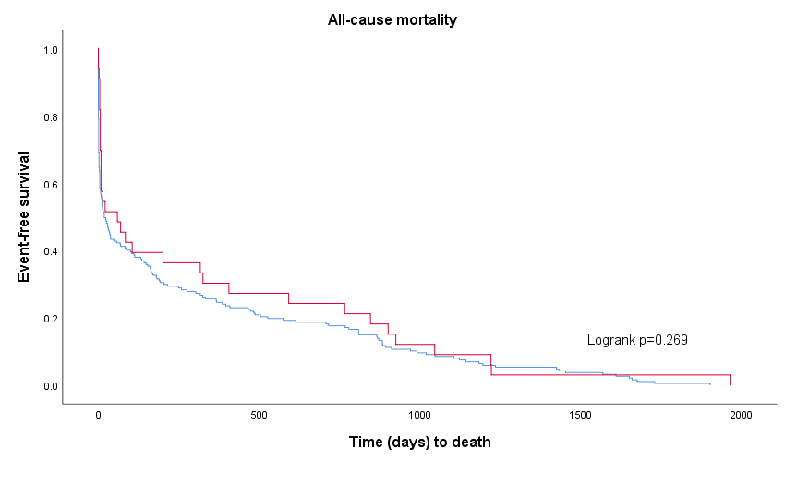

Figure S1: Kaplan-Meier curves of event-free survival for of a) MACE, b) heart failure and c) stroke, d) cardiovascular death and e) all-cause mortality between AF (red) and non-AF (blue) groups.

