A de novo bioinspired pH-sensitive magnetic hydrogel based on chitosan for synergistic chemo/hyperthermia therapy of MCF-7 breast cancer cells

Fatemeh Ghobadi¹, Franak Aghaz², Soheila Zare³,Mehdi Jaymand∗^{,2}, and Hossein Derakhshankhah^{4,*}

- Students Research Committee, Kermanshah University of Medical Sciences, Kermanshah, Iran
- Nano Drug Delivery Research Center, Health Technology Institute, Kermanshah University of Medical Sciences, Kermanshah, Iran
- Medicinal Biology Research Center, Health Technology Institute, Kermanshah University of Medical Sciences, Kermanshah, Iran
- Pharmaceutical Sciences Research Center, Health Institute, Kermanshah University of Medical Sciences, Kermanshah, Iran

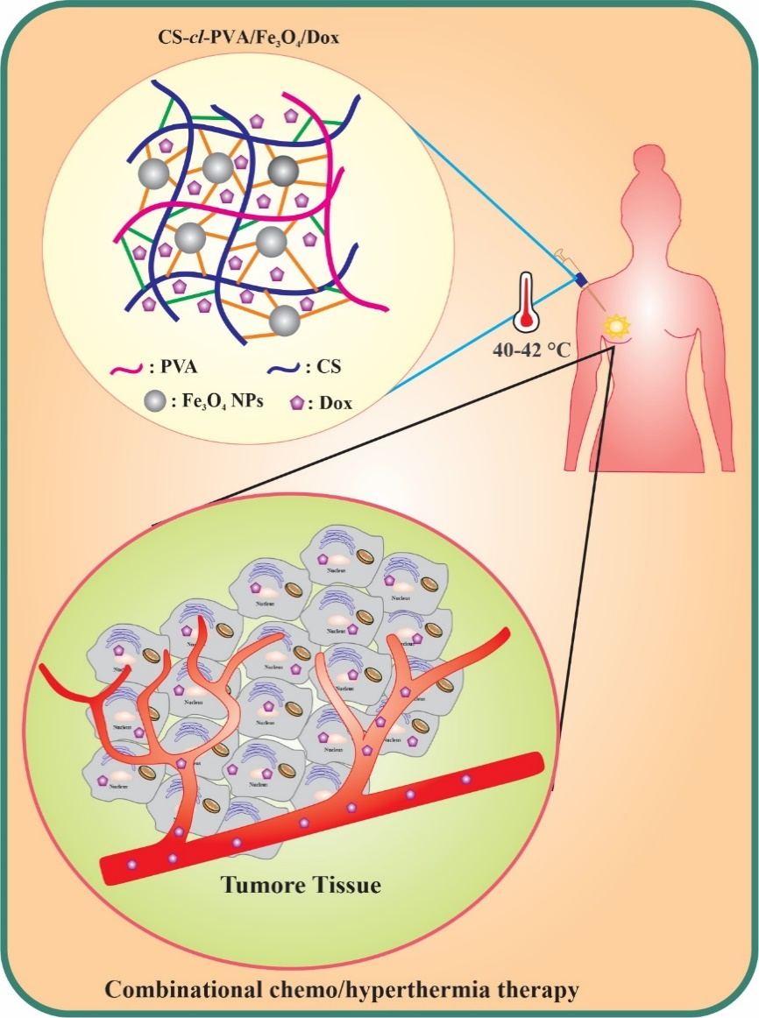

A de novo bioinspired pH-sensitive magnetic hydrogel was designed and developed based on chitosan (CS) and poly (vinyl alcohol) (PVA) for synergistic chemo/hyperthermia therapy of MCF-7 breast cancer cells.

∗ Correspondence to: Mehdi Jaymand (m_jaymand@yahoo.com; m.jaymand@gmail.com; mehdi.jaymand@kums.ac.ir) or Hossein Derakhshankhah (derakhshankhah.hossein@gmail.com)

