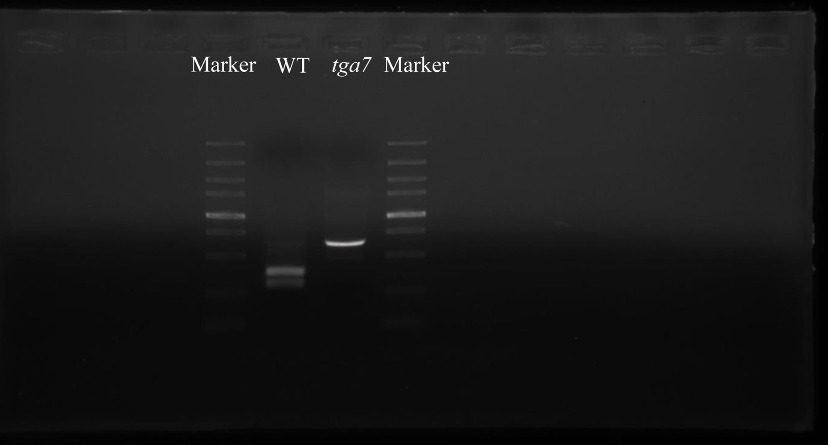

The original, full-length gel displayed in Fig. 1b

