Supplementary Information for

Discovery of Novel Anticancer Agents and Influenza Potential Biomarkers Through a Mass Spectrometry Foundation Model

Junxiao Wang^{1, #}, BeilunWang^{2, #}, Kaihong Huang², Zhaoguo Li¹, Lin Yu³, Yuting Li⁴, Yuanyue Li⁵, Yumei Cao¹, Sunde Xu¹, Yushen Du⁴, Liyan Yu⁶, Mohammad R. Seyedsayamdost^{7, 8, *}, Yihan Wu^{3, *} and Fei Xu^{1, *}

1 Department of Gastroenterology of the Second Affiliated Hospital and Institute of Pharmaceutical Biotechnology, School of Medicine, Zhejiang University, Hangzhou, China.
2 Department of Computer Science and Engineering, Southeast University, Nanjing, China
3 Department of Chemical and Environmental Engineering, Shanghai University, Shanghai, China
4 Institute of Immunology, Department of Surgical Oncology of The First Affiliated Hospital, Zhejiang University School of Medicine, Hangzhou, China
5 Department of Hepatobiliary and Pancreatic Surgery, The First Affiliated Hospital, Zhejiang University School of Medicine, Hangzhou, China
6 China Pharmaceutical Culture Collection, Institute of Medicinal Biotechnology, Chinese Academy of Medical Sciences & Peking Union Medical College, Beijing, China
7 Department of Chemistry, Princeton University, Princeton, NJ, USA.
8 Department of Molecular Biology, Princeton University, Princeton, NJ, USA
# These authors contributed equally to this work.
* Correspondence to: Fei Xu, fxu23@zju.edu.cn, Yihan Wu, yihanw@shu.edu.cn, Mohammad R. Seyedsayamdost, mrseyed@princeton.edu

Online Methods
Dataset
In this study, we created a comprehensive dataset named ComFaceDataset, which combines tandem mass spectra from various sources, including publicly available databases, commercial databases, and computationally generated spectra. For consistency, the dataset includes only spectra for [M+H]⁺ precursors. The ComFaceDataset incorporates experimental MS² spectra from the following sources: 3,015 compounds from the METLIN database, 2,588 compounds from the MoNA database, 20,478 compounds from the NIST database, and 5,561 compounds from the CANOPUS SVM training spectra dataset ¹. Additionally, MS² spectra from the CASMI2016 (208 compounds), CASMI2017 (156 compounds), and CASMI2022 (177 compounds) datasets were included in the ComFaceDataset (http://www.casmi-contest.org/). However, these spectra were excluded from the TrainDataset used for model training. We computationally generated MS² spectra using CFM-ID for 31,993 compounds from the npatlas natural product database and 9,163 compounds from the METLIN database ².
For compounds with multiple energy-level spectra, fragment peaks were aligned and merged to create a single spectrum. For compounds present in multiple database sources, their spectra were deduplicated, retaining only one copy. As a result, the ComFaceDataset contains 73,339 unique compounds with their corresponding [M+H]⁺ MS² spectra, providing a comprehensive and high-quality resource for model development and benchmarking.
The ComFaceDataset was randomly divided into two subsets: TrainDataset and ClassDataset. The TrainDataset includes 63,339 compounds with their corresponding [M+H]⁺ MS² spectra, serving as the primary data for model training. The ClassDataset contains 10,000 compounds and their spectra, used to evaluate model generalization and performance. CASMI spectra were excluded from the TrainDataset to ensure unbiased assessment. To support robust model validation and hyperparameter tuning, all spectra predicted by CFM-ID were removed from the ClassDataset, creating a test set named TestDataset. This set consists of 758 compounds with experimentally acquired [M+H]⁺ MS² spectra, offering a reliable benchmark for assessing the model’s performance on real-world spectral data.
For the fingerprint prediction task benchmarking, we used a compound dataset curated from the PubChem dataset, identical to the one reported in the CANOPUS paper ¹, comprising a subset of 1,106,938 PubChem compounds.
To further examine model robustness under realistic conditions, we evaluated all methods on a reported dataset. This dataset comprising 250 known antitumor natural products and prepared five standard mixtures, each containing 50 compounds. All mixtures were analyzed using a Q-Exactive Orbitrap mass spectrometer in positive ion mode. MS² spectra were extracted using the selected window of the calculated M+H precursor m/z. 156 out of 250 standards were successfully extracted. This dataset presents more complex background and lower signal-to-noise conditions, challenging spectral interpretation, and we named it AntitumorDataset.³
Model Architecture
We developed a deep neural network (DNN) to convert mass spectrometry data into molecular structure embeddings. The input to the model is a mass spectrum quantized at 1/3 Da resolution, where peaks from 0 to 2000 Da are linearly mapped into a 60,000-dimensional sparse vector.
To mitigate input sparsity, we first apply a one-dimensional convolution with a kernel size of 512, transforming the input into a [16, 4096] intermediate representation. The model then employs multiple parallel convolutional layers with varying strides (32, 48, 64, 96) to capture local patterns in the spectrum.
A 6-layer Transformer encoder (with d_model = 128 and 4 attention heads) follows to model the global contextual information. Finally, a fully connected layer projects the 32,768-dimensional Transformer output to a 500-dimensional embedding vector, which is used for similarity matching and downstream tasks.
Model Training
We employed a Siamese network architecture to train our model, using pairs of mass spectrometry data randomly sampled from the training set. The sampling process ensured an equal average number of spectrum pairs across predefined molecular fingerprint similarity intervals: (0, 0.3), (0.3, 0.5), (0.5, 0.7), (0.7, 0.8), and (0.8, 1).
To standardize input scale, peak intensities in each spectrum were normalized to the (0, 100) range based on their maximum value. To improve model robustness, we applied several data augmentation techniques: (1) Randomly adding up to three peaks with intensities not exceeding 0.02; (2) Randomly removing peaks with intensities below 0.1; (3) Introducing noise with amplitude not exceeding 0.1.
Both spectra in each pair were processed using identical model parameters. The similarity between their embeddings was calculated using cosine similarity, which was then compared against the actual molecular fingerprint similarity using mean squared error (MSE) loss.
The model was trained with the Adam optimizer using an initial learning rate of 0.004. Training was conducted with a batch size of 2048 for 3000 steps.
Embedding
To evaluate the performance of ComFaceID in modeling molecular structure similarity, we compared it with three baseline methods that also generate mass spectrometry-based embeddings: MS2DeepScore, Spec2Vec, and Modified Cosine ^{4,5}.
For each method, we computed embedding similarities and compared them to the actual molecular fingerprint similarities across all pairwise spectral combinations between the Source and Target databases. Three dataset configurations were considered: (1) TestDataset vs. TestDataset; (2) CASMI vs. ComFaceDataset (excluding CFM-ID predicted spectra); (3) AntitumorDataset vs. AntitumorDataset.
The baseline methods were implemented using the default settings as described in their original publications. Molecular fingerprint similarity was defined using the Tanimoto coefficient, and all embedding similarities were computed using cosine similarity. Since some methods may yield negative similarity scores, we used the Root Mean Square Error (RMSE) to quantify the discrepancy between the embedding similarity and the molecular fingerprint similarity ⁶.
Fingerprint
To enable the prediction of molecular fingerprints from learned embeddings, we introduce a lightweight prediction head consisting of three linear layers. Inspired by the feedforward networks (FFNs) commonly used in large language models (LLMs), the first linear layer expands the 500-dimensional embedding to a 2048-dimensional representation, followed by Layer Normalization to enhance feature stability. This is then projected through two additional linear layers, reducing the dimensionality to 1024 and finally to the target fingerprint space. To ensure compatibility with the output format of SIRIUS 5.6.3, the prediction head is trained to regress a hybrid fingerprint composed of 144 selected MACCS keys and 469 selected PubChem substructures ⁷. To prevent data leakage, the predictor is trained exclusively on the metric learning training set, with no overlap with the test set. We evaluate the fingerprint prediction accuracy of ComFaceID in direct comparison with SIRIUS using the CASMI 2022 benchmark dataset. Specifically, we compute the Tanimoto coefficient between the predicted and ground-truth fingerprints to quantify prediction error for both methods. In a simulated novel compound discovery scenario, we leverage the predicted fingerprints for similarity-based retrieval against the CANOPUS compound database, which contains 1,179,985 compounds with known fingerprints. For evaluation, any compound with a Tanimoto similarity above 0.9 is considered a ground-truth match, and performance is reported using precision-recall curves.
Classification
In this study, we used the classification data of compounds from the TrainDataset as the training set, which includes 322 distinct classes and 20 distinct superclasses. The classification system is derived from the ClassyFire ⁸, and each compound is assigned to a single class and superclass.
For model evaluation, we used a separate ClassDataset for testing. We selected CANOPUS 5.8.1 from the SIRIUS platform and a cosine similarity-based method as baseline approaches. ^{1,9} All tests were conducted on a dual AMD EPYC 7302 server.
For the CANOPUS method, we adopted the standard classification workflow provided by SIRIUS: molecular formula prediction → molecular fingerprint prediction → class prediction. To control execution time, we manually terminated the workflow if CANOPUS took more than one hour to process a spectrum and considered it a failure to obtain a result.
For the cosine similarity method, we computed the cosine similarity between each spectrum in the ClassDataset and all spectra in the TrainDataset. The similarities were ranked in descending order, and the classification result was determined by the majority class among the Top N (N = 1, 5, 10) most similar compounds.
Metabolite Structural Novelty Score Computation
For molecular fingerprints represented as binary vectors, we employ the Tanimoto distance as the similarity metric ¹⁰. Given two binary vectors A and B, the Tanimoto distance is computed as:
$$FPsim=Tanimoto(A,B)=\frac{|A∩B|}{|A|+|B|-|A∩B|}$$
For a given MS² spectrum of an unknown compound, A represents the predicted molecular fingerprint generated by our molecular fingerprint prediction model, while B corresponds to the actual molecular fingerprint of each small molecule in the PubChem compound database.
For given mass spectrometry data, the model generates a vector to indicate the probability of corresponding classification. For a given sequence, the Softmax function performs the following operations:
$$P\left(x_{i}\right)=\text{Softmax}\left(x_{i}\right)=\frac{\exp\left(x_{i}\right)}{\sum_{j}{\exp\left(x_{j}\right)}}$$
The Softmax function has the following characteristics: After processing a given sequence with the Softmax function, the new sequence of elements sums to 1. The closer a value is to$+∞$, the closer its Softmax output is to 1; the closer a value is to $-∞$, the closer its Softmax output is to 0.
For the weighting corresponding to the exact mass difference between the precursor m/z and the exact mass recorded in PubChem for each compound matched through FPsim. we adopted a combination of a power-law function and an exponential function to scale the exact mass difference into the interval $(0,1]$. When the exact mass difference is small, the function is highly sensitive to changes in the exact mass difference.
$$λ\left(ΔMass\right)=\frac{1}{{\left(1+ΔMass\right)}^{α}}\exp\left(-βΔMass\right)$$
α=0.025, β=0.004
For a given MS² spectrum of an unknown compound, its deviation from the hits can be defined using a vector $x$, which stands for the multi-dimensional structural similarity with ground truth:
$$x=\left[\begin{matrix}\text{FPsim},P\left(x_{i}\right),λ\left(\text{ΔMass}\right)\end{matrix}\right]$$
If the unknown compound is identical to a hit, $\left[\begin{matrix}\text{FPsim},P\left(x_{i}\right),λ\left(\text{ΔMass}\right)\end{matrix}\right]=\left[1,1,1\right]$
Therefore, we assess the structural novelty of an unknown compound by calculating the L2 norm distance between $x$ and [1,1,1] as follows:
$$MSN=\sqrt{\sum_{i=1}^{3}{{\left(x_{i}-1\right)}^{2}}}$$

LLM
In this study, we employed the large language model DeepSeek-R1-Distill-Qwen-32B and conducted embedding analysis experiments using the following prompt:“ You are a data analysis expert. Here we have some 'embedding' data related to peptide and non-peptide compounds. The 'embedding' is a 500-dimensional vector, which may exhibit either linear or nonlinear structures. Please write code to assist me in analyzing this data, with the goal of identifying common patterns and key features that distinguish peptide from non-peptide compounds based on the analytical results. For example, determine which key dimensions are most significant in differentiating the two types of compounds, and then further investigate how these dimensions relate to the classification of the compounds.”
During the experiment, DeepSeek-R1-Distill-Qwen-32B autonomously completed tasks including reading, preprocessing, and visualizing the embedding data. Without any human intervention, the model generated comprehensive analysis code that covered data preprocessing, class label separation, principal component analysis (PCA), identification of key discriminative dimensions, and data visualization, enabling systematic exploration of patterns that distinguish peptide from non-peptide compounds.
Murine Metabolomics Sample Preparation
Ten C57BL/6 J female mice (6-8 weeks of age) were purchased from Shanghai SLAC Laboratory Animal Co. Ltd. (China) and adapted in specific pathogen-free conditions for one week. Mice were randomly divided into two groups: a PBS mock-infected (Mock) group (n = 5) and an influenza A/WSN/1933-infected (H1N1) group (n = 5). To establish a murine model of H1N1 infection, mice of the H1N1 group were infected intranasally with 50 μL sterile PBS containing strain A/WSN/1933 (tcid₅₀). Control mice were mock infected with 50 μL sterile PBS. One nasal drip experiment for each mouse, and all mice in the two group were infected in the same day. All mice had access to water and food under a strict 12 h light/dark cycle. Fresh stool samples were collected for 7 days (once a day) and stored at -80℃.
The fecal samples were thawed on ice, and then 100 mg (± 1%) of feces was added to 600 μL of (2-Fluorophenyl) glycine (4 ppm) methanol and then vortexed for 30 s at - 20℃. Next, the fecal samples were subjected to ultrasound at room temperature for 10 min after grinding with 100 mg glass beads for 90 s at 60 Hz. Then, the samples were centrifuged at 12000 rpm for 20 min at 4℃, and 100 μL of supernatant was added into the detection bottle for LC-MS detection.
Actinomycelial Metabolomics Sample Preparation
The Streptomyces coelicolor M145, Streptomyces sp. 537 were provided by the laboratory of Prof. Xuming Mao and Yun Chen at Zhejiang University. Streptomyces sp. W307 (CGMCC 32721) and Streptomyces sp. ZS18011 were provided by the laboratory of Prof. Min Wu at Zhejiang University. All strains used for high throughput fermentation were provided by Liyan Yu’s laboratory at Institue of Materia Medica, Chinese Academy of Medical Science, Min Wu’s laboratory at Zhejiang University, Yun Chen’s laboratory at Zhejiang University, and Kui Hong’s laboratory at Wuhan University with the number of 3216, 63, 46, and 9, respectively.
Seed cultures for the 3334 strains and Streptomyces coelicolor M145 were directly inoculated into 100 mL Erlenmeyer flasks containing 20 mL of liquid culture medium (w/v), composed of glucose (1%), soluble starch (3%), cottonseed meal (2%), yeast extract (0.3%)，(NH₄)₂SO₄ (0.3%)，MgSO₄ (0.1%)，K₂HPO₄ (0.1%), NaCl (0.1%)，CaCO₃ (0.5%), pH 7.2 . The flasks were incubated at 28℃ on the rotatory shaker at 180 rpm for 7 days.
Each fermentation broth was added to acetone (9 mL:9 mL) and ultrasonication for 30-60 min. Then, the samples were centrifuged at 15,000 rpm for 30 min at 20℃, and the supernatants were transferred to 50 mL screw bottles and evaporated using the SpeedVac SPD2030. Once dried, extracts were redissolved in 1.2 mL DMSO and centrifuged at 15,000 rpm for 20 min at 20℃, 20 μL solutions added into the detection bottle for LC-MS analysis.
Liquid Chromatography and Tandem Mass Spectrometry
Metabolic profiles were generated using an ultra-high-performance liquid chromatography system (Shimadzu，Japan) coupled to an electrospray ionization tandem mass spectrometer (AB SCIEX ZENO Q-TOF 7600, America) with a spray voltage of 5.5 kV in positive mode. The MS¹ and MS² spectra were collected in untargeted (IDA) mode and the source conditions were as follows: workflow, small molecule; ion source gas 1, 50 psi; ion source gas 2, 50 psi; curtain gas, 35 psi; temperature, 500℃; collision energy 50V; CE spread, 25V; and resolution, 42000. Solvent A1 is ultrapure water 0.1% formic acid (v/v), and solvent A2 is acetonitrile with 0.1% formic acid (v/v).
For fecal samples, an increasing linear gradient of solvent A1/A2 (v/v) was used as follows: 0-1 min, 5% A2; 1-6 min, 5-50% A2; 6-21 min, 50-98% A2; 21-26 min, 98% A2; 26.5 min, 5% A2; and 30 min, 5% A2. The injection volume was 2 μL with a 0.3 mL/min flow rate using a C18 column (Thermo Acclaim™ 120 C18, 2.1 × 100 mm, 5 μm, 120 Å). The TOF MS scan range was m/z 100-2000 Da, and the TOF MSMS scan range was m/z 20-2000 Da.
For crude extracts, the settings of solvent A1/A2 (v/v) were used as follows: 0-1 min, 5% A2; 1-7 min, 5-100% A2; 7-10 min, 100% A2; and 10.1-13 min 5% A2. The injection volume was 1 μL with a 0.3 mL/min flow rate using a C18 column (Phenomenex Kinetex® 1.3 μm, C18, 30 × 2.1 mm, 100 Å). The main mass parameter change compared to fecal samples was TOF MS, from m/z 300 to 2000 Da.
Raw Data Preprocessing
The raw LC-MS data files (.wiff) were converted to .mzXML format using MSConvertGUI software (64 bit, ProteoWizard, version 3.0.22050), ¹¹ the parameter settings for MS¹ and MS² data were provided as follows, (i) for MS¹ data: peak picking, 1-1; subset, 1-1; threshold, absolute 100-most-intense; binary encoding precis, 32 bits; (ii) for MS/MS data: peak picking, 2-2; subset, 2-2; threshold, absolute 20-most-intense; binary encoding precis, 32 bits.
Processing for peak identification, filtration, alignment, database-matching etc. was using the HMDB and FUNEL modules from website NPCompass (npcompass.zju.edu.cn or npcompass.xulab.cloud) ¹², and the .csv format file named FilteredList containing the mass-to-charge ratio, retention time, peak intensity, the result of the database match, ect. was download to generated a peak table (with two columns, m/z and rt) for subsequent MS² data analysis.
For fecal samples, parameters for HMDB module were the defaults except for the following: signal intensity thresholds for samples, 1000; noise level for samples, 100; intensity threshold for adducts calculation, 1000; compound library to search, HMDB. The MS¹ data obtained from solvent was used as control file.
For crude extracts, parameters for FUNEL module were the defaults except for the following: compound library to search, NPA. Besides, the MS¹ data acquired from culture medium, solvent, and Streptomyces coelicolor M145 were used as control files. The MS² data were analyzed using the ComFaceID module with default settings, and the key parameters were described as follows: filter by mass, 2000; predict fingerprint or not, ture; filter by formula, false; ppm, 20; delta mz, 0.01; remove precursor, ture; output num: 200.
Fermentation, Extraction and Isolation
Seed cultures of ZS18011, 537 and W307 were directly inoculated into 1000 mL Erlenmeyer flasks containing 200 mL liquid culture mediums (w/v). MS medium for strains ZS18011 and W307, composed of soybean flour (2%), mannitol (2%), CaCO₃ (0.3%), pH 7.0. And R4 medium for 537, composed of glucose (0.5%)，proline (0.15%)，valine (0.118%), yeast extract (0.1%), casamino acid (0.005%), MgCl₂ (0.5%)，CaCl₂ (0.2%), K₂SO₄ (0.01%)，1× trace element solution [ZnCl₂ (40 mg/L), FeCl₃·6H₂O (200 mg/L), CuCl₂·2H₂O (10 mg/L), MnCl₂·4H₂O (10 mg/L), Na₂B₄O₇·10H₂O (10 mg/L), and (NH₄)₆Mo₇O₂₄·4H₂O (10 mg/L)]，TES (0.28%), pH 7.0. The flasks were incubated at 28℃ on the rotatory shaker at 180 rpm for 7 days.
For strain ZS18011, the 10 L fermentation was directly chromatographed on a C18 column with a MeCN/H₂O gradient system (0:100, 20:80, 40:60, 60:40, and 100:0) to yield four fractions (Fr.1-4). Then Fr.2 was subjected to preparative reversed-phase HPLC (MeCN/H₂O = 15-60%, 50 min) to provide forty subfractions (Fr.2-1~Fr.2-40). Fr.2-22 was further purified by semipreparative reversed-phase HPLC (MeCN/H₂O, Phenomenex Luna C18 250 × 4.6 mm, 5 μm, 100 Å) to obtain m/z 811 (2.0 mg).
For strain 537, the 50 L fermentation was directly chromatographed on a C18 column with a MeOH/H₂O gradient system (0:100, 30:70, 70:30, and 100:0) to yield four fractions (Fr.1-4). And Fr.2 was subjected to Sephadex LH-20 chromatography (30% MeOH) to provide ten subfractions (Fr.2-1~Fr.2-10). Fr.2-1, Fr.2-2, and Fr.2-3 were further purified by semipreparative reversed-phase HPLC (MeOH/H₂O, Phenomenex Luna C18 250 × 4.6 mm, 5 μm, 100 Å) to obtain m/z 382 (1.5 mg), m/z 434 (1.0 mg), and m/z 492 (2.0 mg), respectively.
For strain W307, the 10 L fermentation was extracted with EtOAc (3 × 10 L) and evaporated to yield the extract. The extract was chromatographed on a C18 column with a MeOH/H₂O gradient system (30:70, 50:50, 70:30, 90:10, and 100:0) to yield five fractions (Fr.1-5). Then Fr.1 was subjected to Sephadex LH-20 chromatography (100% MeOH) to provide eleven subfractions (Fr.1-1~Fr.1-11). Fr.1-2, Fr.1-4, and Fr.1-9 were further purified by semipreparative reversed-phase HPLC (MeOH/H₂O, YMC-Triart C18 250 × 4.6 mm, S-5 μm, 12 nm) to obtain m/z 728 (2.0 mg) and m/z 528 (1.0 mg), respectively.
Characterization of Compounds
Parvunaridin (m/z 811): yellow amorphous powder; UV (MeOH) λ_{max}: 210, 260, 280 nm; ¹H and ¹³C NMR data, Table S1; HR-ESI-MS: m/z 811.4764 [M + H] ⁺ (calcd. for C₄₁H₆₃N₈O₉, 811.4718).
Fraproketone A (m/z 434): yellow amorphous powder; UV (MeOH) λmax: 203, 290, 350 nm; 1H and 13C NMR data, Table S2; HR-ESI-MS: m/z 434.1792 [M + H] + (calcd. for C₂₂H₂₈NO₈, 434.1815).
Fraproketone B (m/z 492): yellow amorphous powder; UV (MeOH) λ_{max}: 203, 295, 350 nm; ¹H and ¹³C NMR data, Table S3; HR-ESI-MS: m/z 492.2202 [M + H] ⁺ (calcd. for C₂₅H₃₄NO₉, 492.2234).
Fraproketone C (m/z 382): yellow amorphous powder; UV (MeOH) λ_{max}: 203, 285, 350 nm; ¹H and ¹³C NMR data, Table S4; HR-ESI-MS: m/z 382.1888 [M + H] ⁺ (calcd. for C₁₉H₂₈NO₇, 382.1866).
Speibonmycin A (m/z 786): brown amorphous powder; UV (MeOH) λ_{max}: 220, 290 nm; ¹H and ¹³C NMR data, Table S5; HR-ESI-MS: m/z 786.2910 [M + H] ⁺ (calcd. for C₄₁H₄₄N₃O₁₃, 786.2874).
Speibonmycin B (m/z 528): brown amorphous powder; UV (MeOH) λ_{max}: 220, 290 nm; ¹H and ¹³C NMR data, Table S6; HR-ESI-MS: m/z 528.2380 [M + H] ⁺ (calcd. for C₂₇H₃₄N₃O₈, 528.2346).
Structural Elucidation
LC-HR-ESI-MS (AB SCIEX ZENO Q-TOF 7600, America), 1D/2D NMR (Bruker Ascend 600 MHz, Rheinstetten, Germany), and UV spectra (HITACHI 5430, Japan) were carried out for structural elucidation of all six new compounds.
For m/z 811, the planer structure was established as Ala¹-Dhb¹-Pro-Dhb²-Leu-Val-Ala²-Phe by 1D and 2D NMR. The coupling constants for the β-CH (5.65, 1H, q) and γ-CH₃ (1.67, 3H, d) of Dha¹ were determined to be 6.96 Hz and 7.02 Hz, respectively. Thus, the double bond configuration in Dhb¹ was identified as Z. Similarly, for Dhb², the coupling constants of the β-CH (6.49, 1H, q) and γ-CH₃ (1.63, 3H, d) were measured as 6.10 Hz and 7.02 Hz, respectively, leading to the assignment of the double bond configuration in Dha² as Z. The absolute configuration was established by 2D NMR and Marfey’s method ¹³. HPLC analysis results of Marfey's method reaction indicated that the compound contains L-Ala × 1, D-Ala × 1, D-Pro × 1, D-Leu × 1, D-Val × 1, and D-Phe × 1 (Figures S13). NOESY analysis was used to further determine the D/L configurations of Ala¹ and Ala². In the NOESY spectrum, neither the α-CH (4.21, 1H, m) nor the β-CH₃ (1.14, 3H, d, 7.08) of Ala² showed correlations with the aromatic proton signals of Phe (7.16, 1H, t, 7.02; 7.20, 1H, t, 7.20; 7.13, 1H, t, 7.08). Conformational analysis of S/R-Ala² indicated that the S-Ala² configuration is consistent with the observations from the NOESY spectrum (Figures S14). Thus, Ala² was determined to be L-configuration while Ala¹ was identified as D-configuration. Finally, the absolute configuration was established as Ala¹(D)-Dhb¹(Z)-Pro(D)-Dhb²(Z)-Leu(D)-Val(D)-Ala²(L)-Phe(D).
Bioactivity Assays
Cytotoxicity activities of all new compounds were evaluated against fourteen cells by the Cell Counting Kit (CCK-8) method; cisplatin and doxorubicin were used as positive controls. The samples were dissolved in the cell grade DMSO after accurately weighing to generate the 10 mM drug solution. The drug solution was further diluted to tenfold detection concentration by cell culture medium. The detection principle is that the CCK-8 reagent contains WST-8, which is reduced to a highly water-soluble yellow methyl product (formazan) by dehydrogenase in the cell mitochondria under the action of electron carrier 1-methoxy-5-methylphenazine dimethyl sulfate (1-methoxy PMS). The number of the nail products produced is directly proportional to the number of living cells. The experimental procedure include：(1) Inoculate cells: The cells were prepared into single cell suspension with the culture medium containing 10% fetal bovine serum, and the 96 well plates were inoculated with 90 μL cell culture medium (Adherent cell viewed 5×10⁴/mL and Suspension cell viewed 9×10⁴/mL) per well, then cultured at 5% CO₂ and 37℃ for 24 hours; (2) Add the sample solution to be tested: Add 10 μL sample solution to each well. One concentration was set for each sample during preliminary screening and three multiple holes were set for each concentration. Eight concentration gradients were set for each sample for IC₅₀ determination and three multiple holes were set for each concentration. The 96 well plates were cultured at 5% CO₂ and 37℃ for 48 hours. The experiment was divided into blank group, control group and drug group; (3) Color development: The old culture medium and drug solution of adherent cells was sucked out, then 100 μL of CCK-8 solution (diluted ten times with the basic medium) was added and the suspension cells was directly added 10 μL of CCK-8 stock solution. Culture at 37℃ with 5% CO₂ for 1-4 h (dark operation, real-time observation); (4) Result detection: The absorbance was measured at 450 nm with an enzyme labeling instrument and the original data and results were recorded; (5) The toxicity is expressed by cell inhibition, and the calculation formula is as follow: Cell inhibition (%) = (OD_{Control}-OD_{Drug})/(OD_{Control}-OD_{Blank})×100%. The IC₅₀ was calculated by software graphpad prism 8 (version 8.0.2, from GraphPad Software Inc)，and the experimental results are expressed in IC₅₀. The result was shown in Table S7.
Antimicrobial activity was tested against 16 different stains by conventional broth dilution assay. Bacteria were cultured in LB medium at 37°C. Minimum inhibitory concentration (MIC) was determined using the microtiter method according to CLSI guidelines. Overnight cultures of the test strains were diluted to an initial OD₆₀₀ of 0.005 in 100 μL per well in a 96-well plate. Compounds were tested at concentrations of 64, 32, 16, 8, 4, 2, 1, 0.5, 0.25, 0.125, 0.00625, and 0.003125 μM. Plates were incubated at 37°C for 16 hours, and OD₅₉₅ was measured before and after incubation. MIC values were defined as the compound concentration that increased OD₆₀₀ < 0.05 compared to the untreated culture. Controls included a negative control (100 μL bacterial culture), positive controls (different drugs), and a blank (100 μL LB broth without bacteria and drugs). All experiments were performed in three parallel one time, and the experiment was independently performed for twice. The result was shown in Table S7.

Figure S1. ComFaceID benchmarked against Spec2Vec, MS2DeepScore, and modified cosine similarity for extracting chemical information from MS² spectra by evaluating the dots density in scatter plots, closer clustering of points along the diagonal indicates better predictive performance. a, Benchmark results in TestDataset; b, Benchmark results in CASMI + ComFaceDataset (excluding CFM-ID predicted spectra), c, Benchmark results in AntitumorDataset.
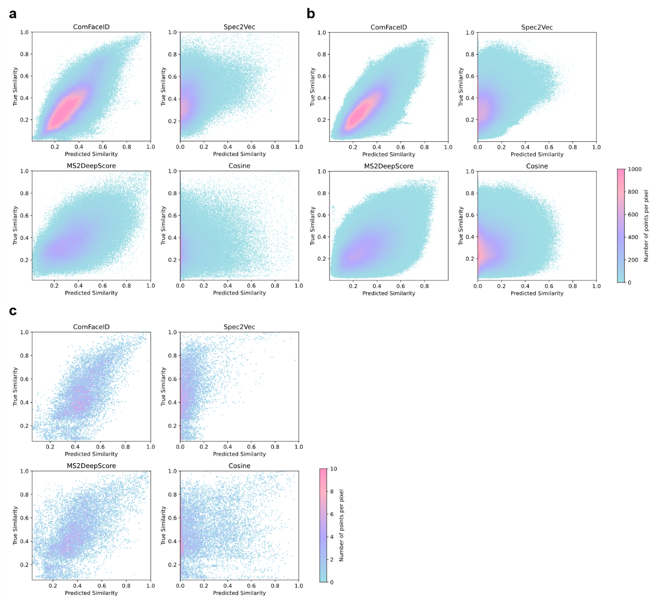
Figure S2. ComFaceID benchmarks against SIRIUS for molecular fingerprint prediction. a, Harp plot of fingerprint prediction accuracy across all fingerprint positions (bit range 0-600); Point-and-line chart of RMSE for comparing ComFaceID’s predicted fingerprint similarity against SIRIUS in b, TestDataset, c, CASMI2022, and d, AntitumorDataset. Spectra in TestDataset and AntitumorDataset were compared pairwise, and CASMI spectra were compared against ComFaceDataset (excluding CFM-ID predicted spectra); Precision-recall curves of ComFaceID compared with SIRIUS for evaluating the retrieval performance in e, CASMI2022 and f, AntitumorDatase; ROC curves of ComFaceID compared with SIRIUS for evaluating the retrieval performance in g, CASMI2022 and h, AntitumorDatase; i, ComFaceID benchmarks for molecular fingerprint prediction against SIRIUS on compounds >300 Da in CASMI 2022.
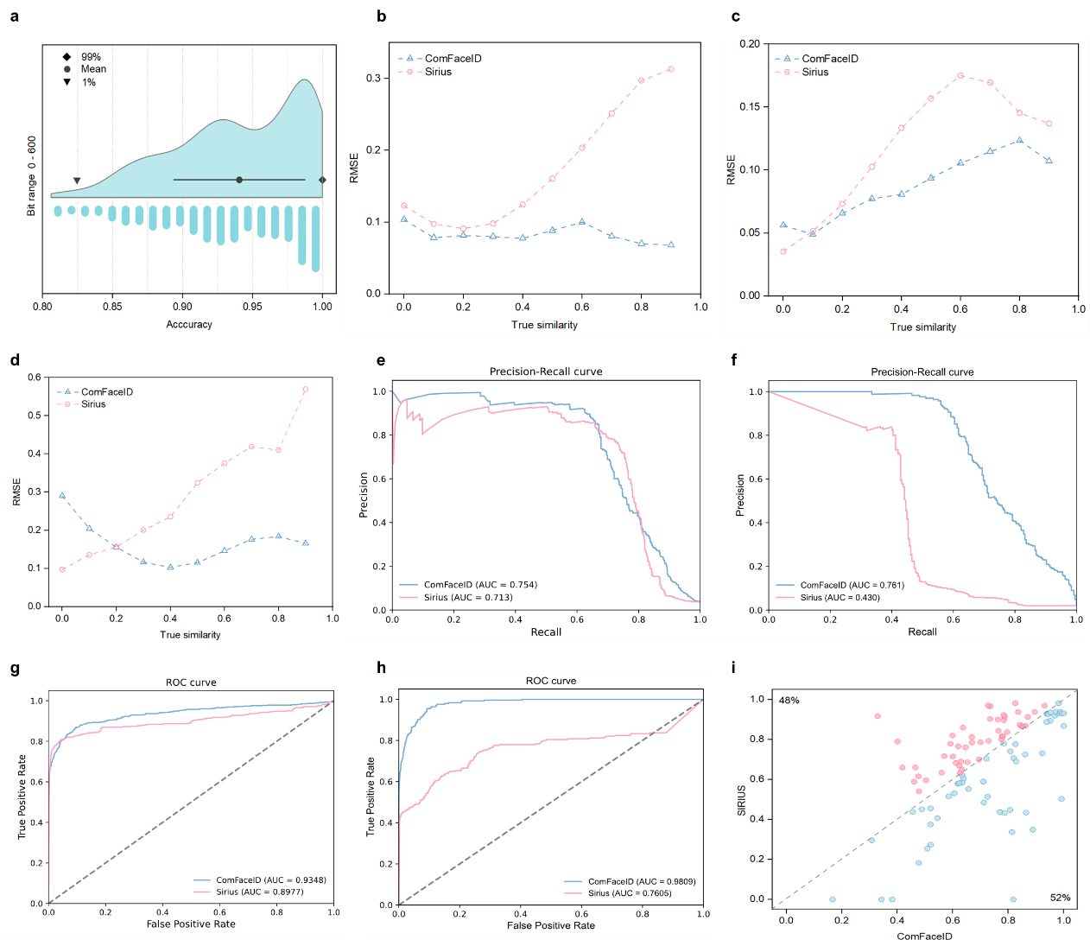

Figure S3. Benchmarking against CANOPUS and a cosine similarity score based Top-N majority-vote for compound structural classification. a, Bar charts for evaluating the recall (left), accuracy (middle) and precision (right) scores of ClassDataset compounds annotation with 24 ClassyFire superclasses; b, Bar charts of ClassDataset annotation with 480 ClassyFire classes; c, Bar charts of AntitumorDataset compounds annotation with 24 ClassyFire superclasses; d, Bar charts of AntitumorDataset compounds annotation with 480 ClassyFire classes.
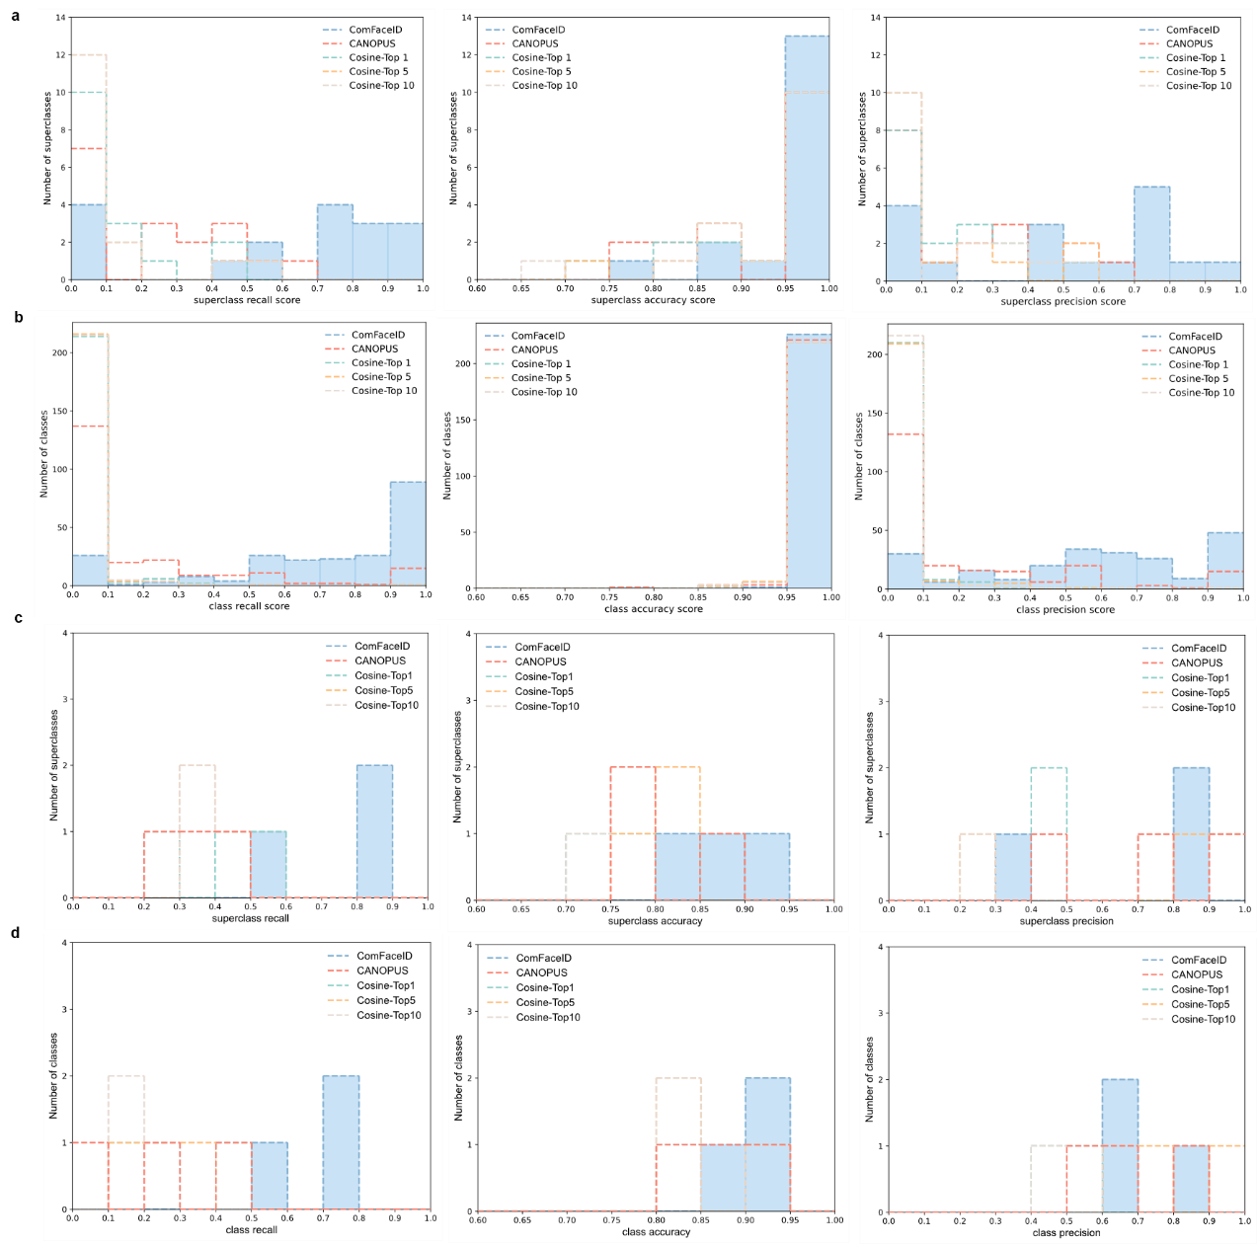

Figure S4. Interaction of ComFaceID embeddings with generative large language model DeepSeek-R1-Distill-Qwen-32B for feature identification and visualization. PCA plot for classify MS² spectra as peptides or non-peptides using ComFaceID embeddings.
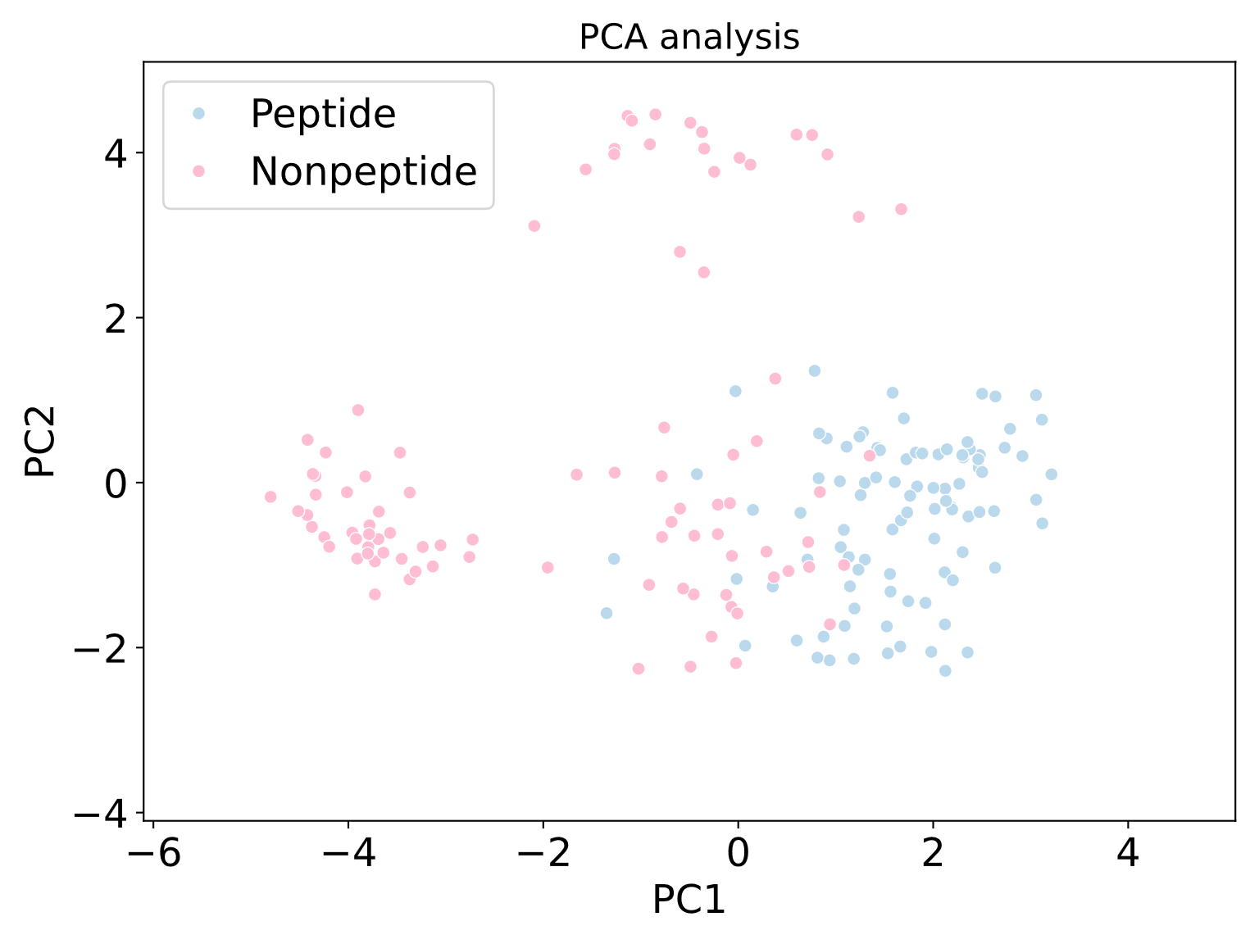

Figure S5. Heatmap of all metabolites filtered by FUNEL with blank medium and culture of S. coelicolor M145 as controls. The horizontal axis represents spectral similarity, while the vertical axis corresponds to m/z. A match was defined as a known secondary metabolite if the similarity score exceeded 0.9. The upper histogram illustrates the frequency distribution of metabolite similarity scores, while the right-side histogram displays the frequency distribution of m/z values.
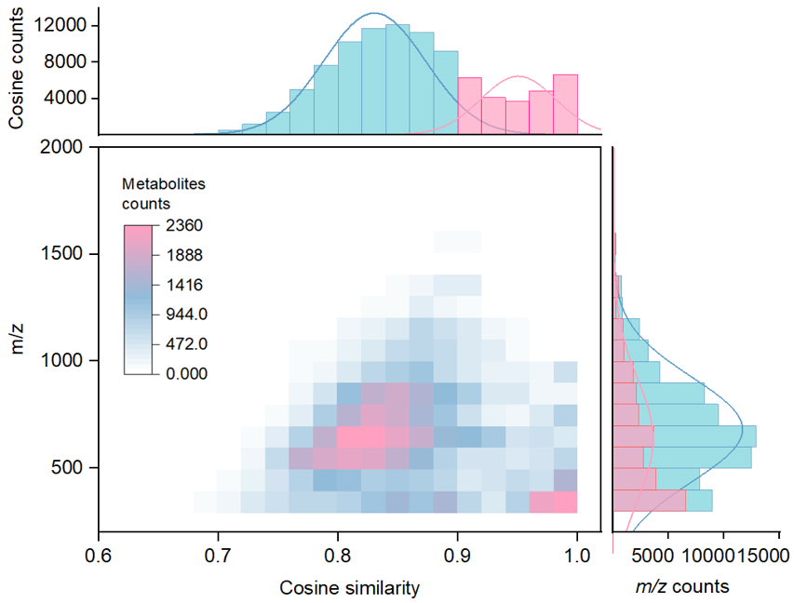

Figure S6. Superclass-level classification of metabolomic MS features in the top 10 actinobacterial genera (by strain count, black bars) as predicted by ComFaceID. The black dots in the lower-left corner indicate the presence of the corresponding structural superfamily within the predicted metabolome of each genus. The length of the bars represents the log₂(counts) of MS features, while the length of the black bars on the right indicates the average number of MS features per strain within each genus.
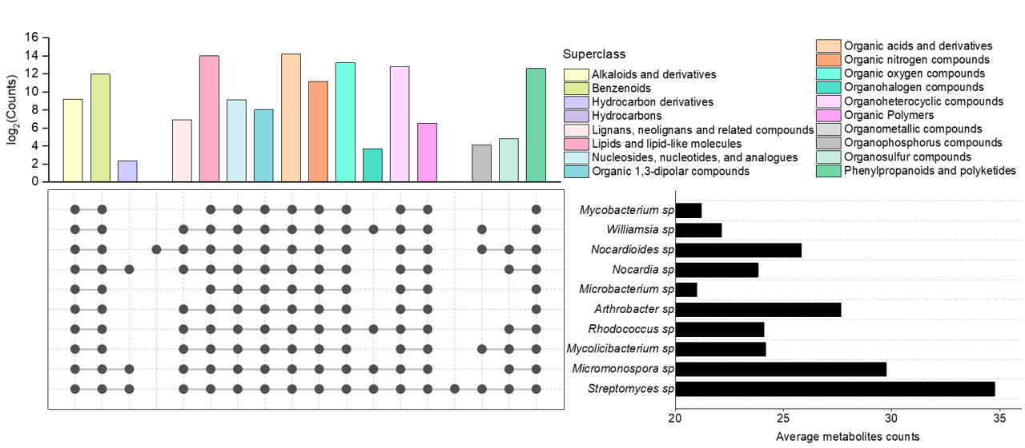

Figure S7. NMR and HR-ESI-MS spectra of parvunaridin (m/z 811) in DMSO-d6 (600 MHz). Full 1D/2D NMR datasets on parvunaridin were collected once.
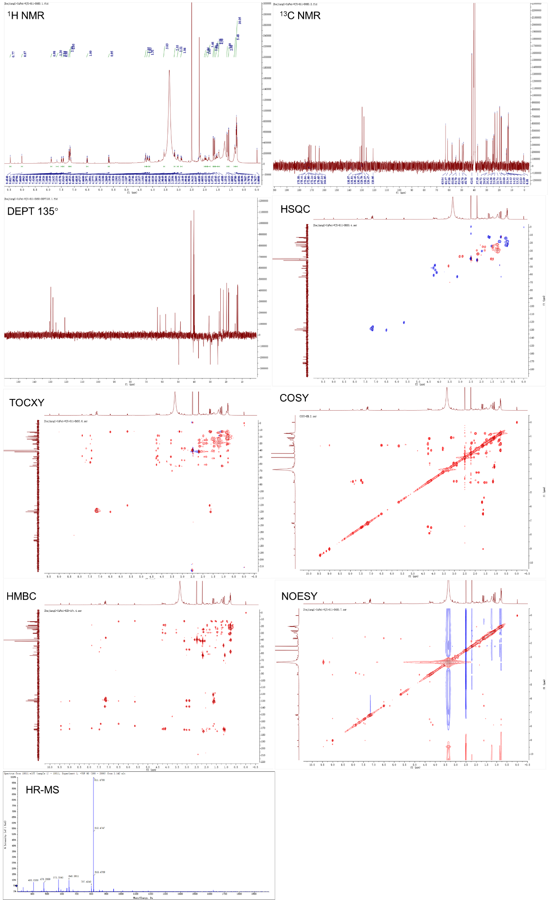
Figure S8. Determining the stereochemistry of parvunaridin. a, Partial NOESY correlations of parvunaridin and standard amino acids; b, HPLC analysis of Marfey’s method for parvunaridin and standard amino acids, semipreparative reversed-phase HPLC (MeCN/H₂O = 20-40, 50min, Phenomenex Luna C18, 250 × 4.6 mm, 5 μm, 100 Å); c, Preferential conformation of m/z 811 with different configurations.
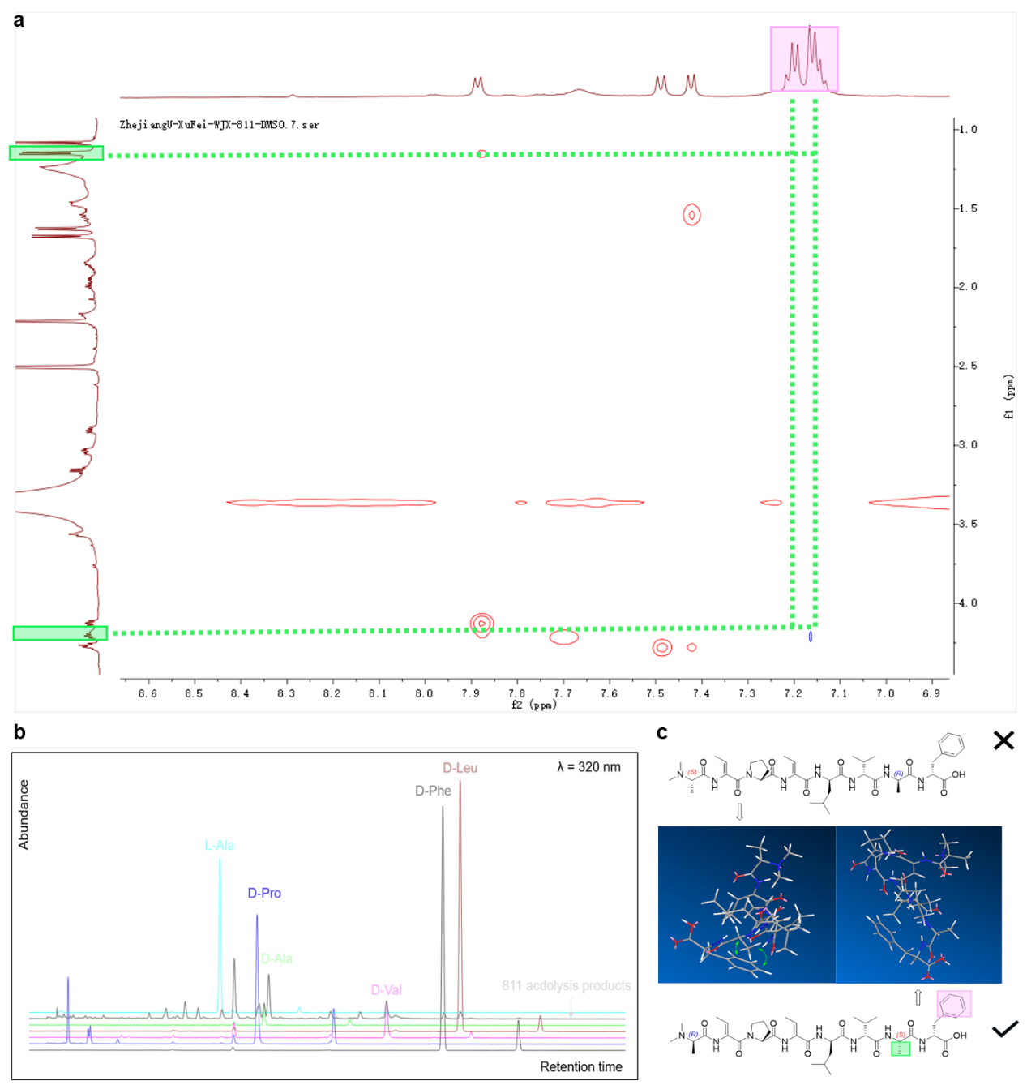

Figure S9. NMR and HR-ESI-MS spectra of fraproketone A (m/z 434) in DMSO-d6 (600 MHz). Full 1D/2D NMR datasets on fraproketones A were collected once.
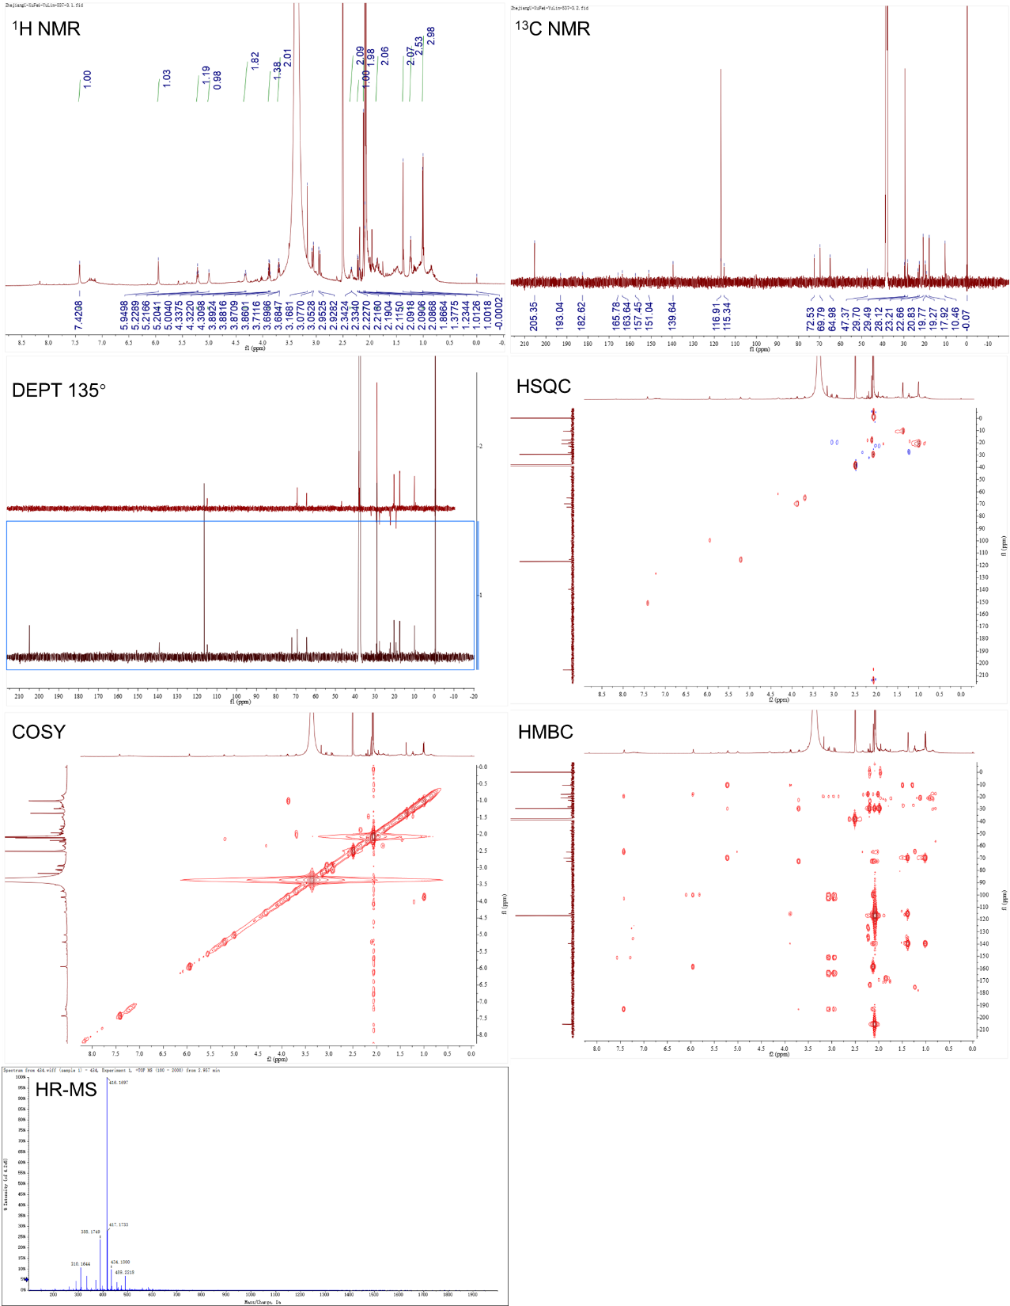

Figure S10. NMR and HR-ESI-MS spectra of fraproketone B (m/z 492) in DMSO-d6 (600 MHz). Full 1D/2D NMR datasets on fraproketones B were collected once.
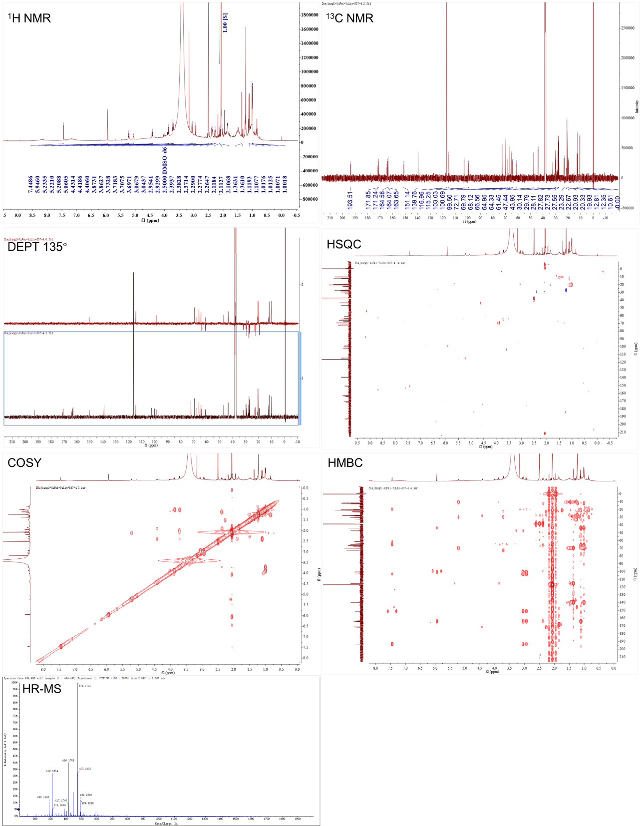

Figure S11. NMR and HR-ESI-MS spectra of fraproketone C (m/z 382) in DMSO-d6 (600 MHz). Full 1D/2D NMR datasets on fraproketones C were collected once.
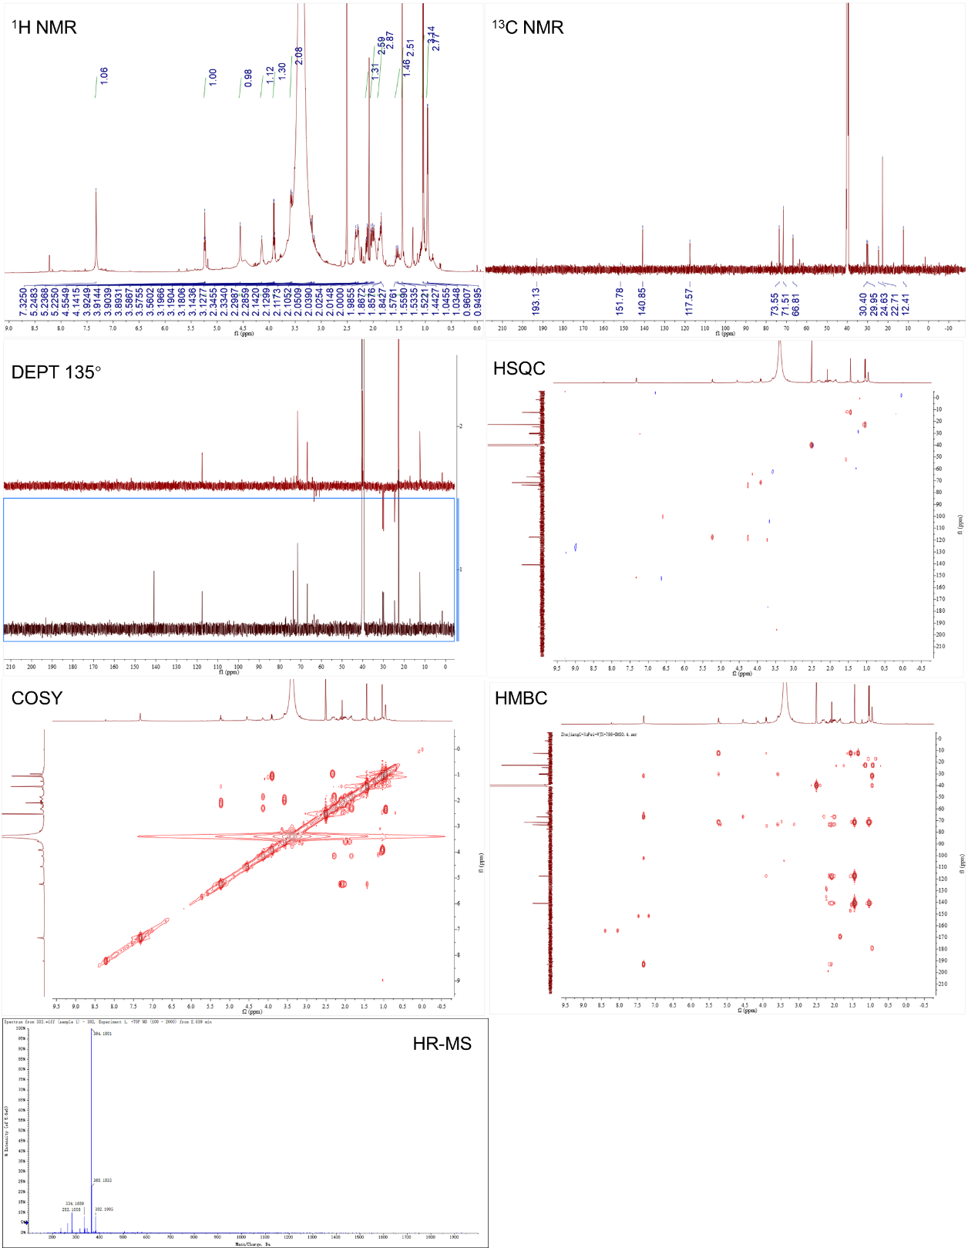

Figure S12. NMR and HR-ESI-MS spectra of Speibonmycin A (m/z 786) in DMSO-d6 (600 MHz). Full 1D/2D NMR datasets on Speibonmycin A were collected once.
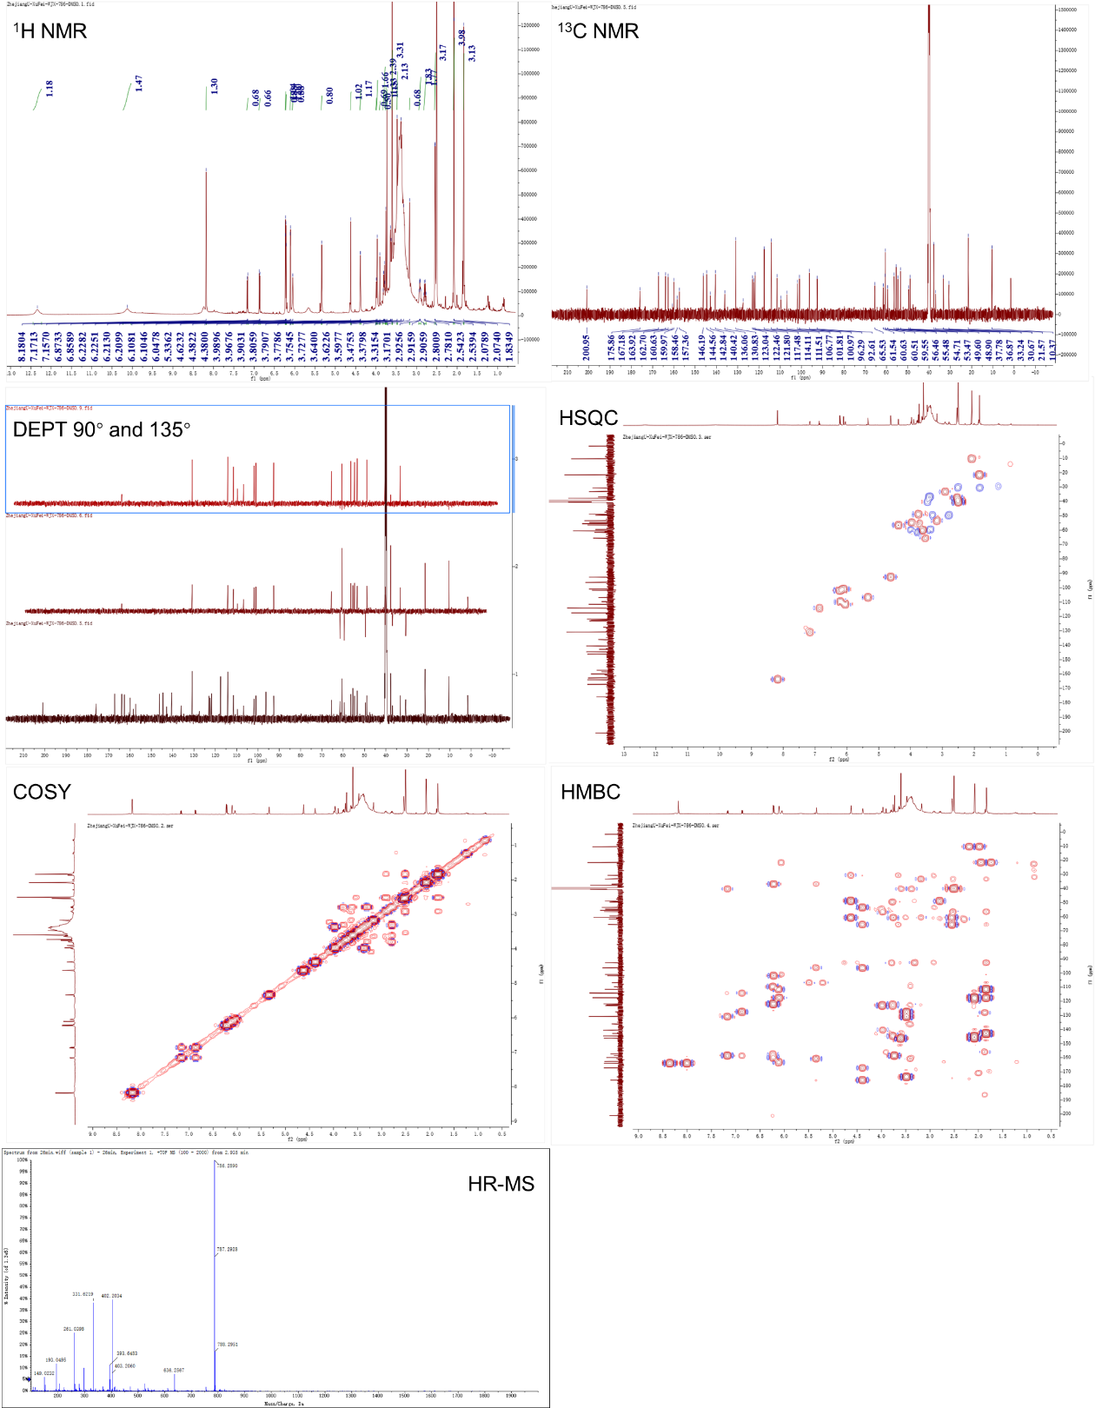

Figure S13. NMR and HR-ESI-MS spectra of Speibonmycin B (m/z 528) in DMSO-d6 (600 MHz). Full 1D/2D NMR datasets on Speibonmycin B were collected once.
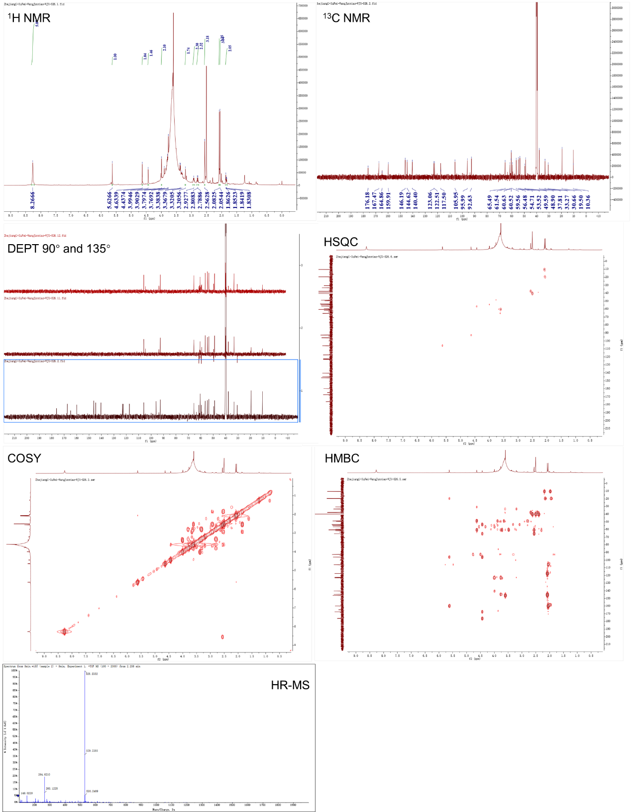

Figure S14. Comparative analysis by harp plot of 37,636 detected MS features. Fecal samples were continuously collected over 7 days, PBS as mock group and H1N1 as infection group. 37,636 unique MS features were detected on total, and 17,935 could be detected in infected mice (47.65% of total), accompanied by a significant reduction in metabolites diversity compared to mock-infected controls.
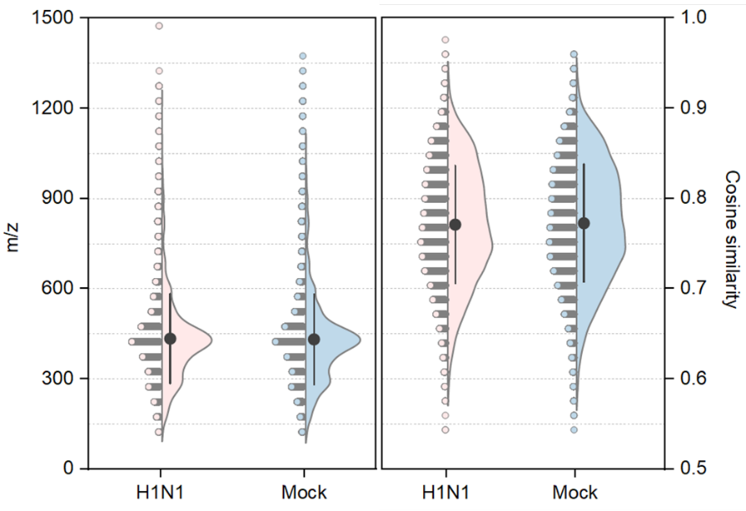

Figure S15. Heatmap of H1N1/Mock abundance ratios (log2-transformed) for the 42 significantly altered metabolite MS features across the survival period of the mice. (fold change > 2, P < 0.05)
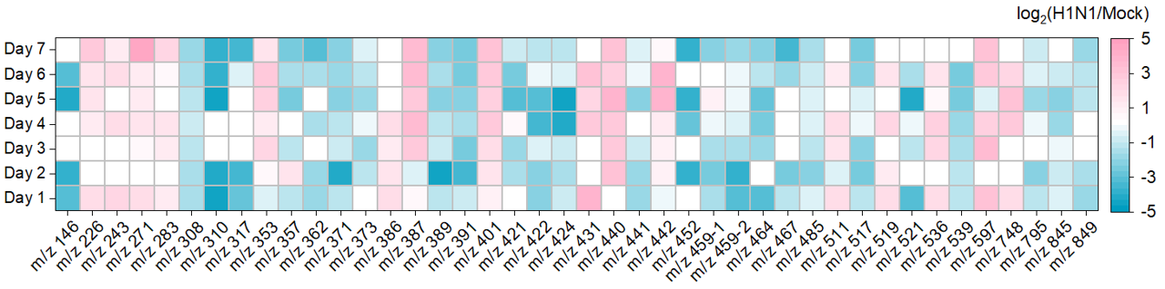

Figure S16. Comparison of top-1 matched structures predicted by ComFaceID and SIRIUS for 16 metabolites significantly upregulated (fold change > 2, P < 0.05) in the H1N1 group.

Figure S17. Comparison of top-1 matched structures predicted by ComFaceID and SIRIUS for 25 metabolites significantly downregulated (fold change > 2, P < 0.05) in the H1N1 group.

Figure S18. MS² spectra mirror-plot analysis of significant altered features with corresponding top-1 matched structure generated by ComFaceID. MID 62289 [LysoPE(15:0)], CAS 465167-6 (nutriacholic acid), CAS 474-25-9 (chenodiol), CAS 77-52-1 (prunol).
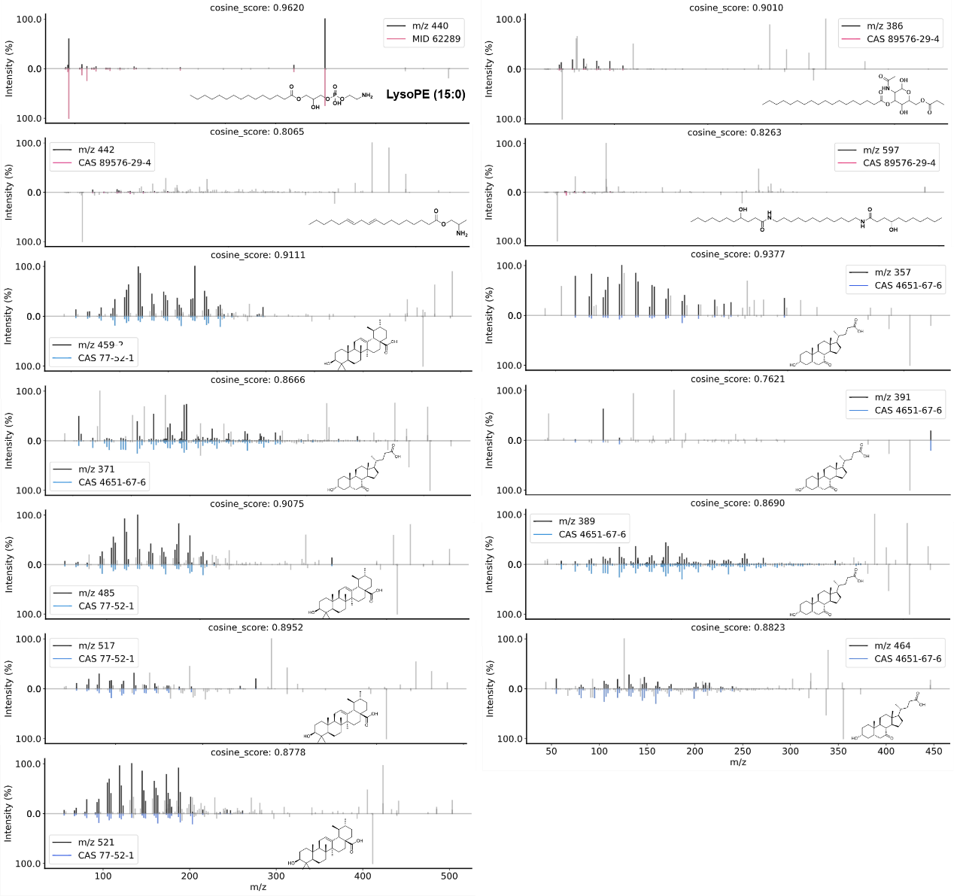

Table S1. NMR assignments for parvunaridin in DMSO-d₆ (δ in ppm, J in Hz). The numbering scheme for parvunaridin is shown below the table.
 | Position | δ_{H} | δ_{C}
Ala¹ | C=O |  | 172.66. C
 | N(CH₃)₂ | 3.0 (6H, s, overlapped) | 42.01, CH₃
 | CH (α) | 3.15 (1H, q, 6.90) | 63.04, CH
 | CH₃ (β) | 1.08 (1H, d, 6.90) | 12.83, CH₃
Dha¹ | C=O |  | 167.14, C
 | NH | 9.42 (1H, s)
 | C (α) |  | 131.54, C
 | CH (β) | 5.65 (1H, q, 6.96) | 120.95, CH
 | CH₃ (γ) | 1.67 (3H, d, 7.02) | 12.69, CH₃
Pro | C=O |  | 171.63, C
 | CH (α) | 4.27 (1H, t, 7.32) | 61.37, CH
 | CH₂ (β) | 2.24 (2H, t, 8.00) | 29.92, CH₂
 | CH₂ (γ) | 1.84 (2H, m) | 25.32, CH₂
 | CH₂ (δ) | 3.56 (2H, m) | 49.70, CH₂
Dha² | C=O |  | 164.05, C
 | NH | 8.98 (1H, s)
 | C (α) |  | 130.45, C
 | CH (β) | 6.49 (1H, q, 6.10) | 130.37, CH
 | CH₃ (γ) | 1.63 (3H, d, 7.02) | 13.32, CH₃
Leu | C=O |  | 172.24, C
 | NH | 7.40 (1H, d, 7.86)
 | CH (α) | 4.29 (1H, t, 6.60) | 52.01, CH
 | CH₂ (β) | 1.54 (2H, m) | 24.38, CH₂
 | CH (γ) | 0.85 (1H, m) | 14.32, CH
 | CH₃ (δ) | 0.77 (3H, overlapped) | 21.74, CH₃
 | CH₃ (δ') | 0.79 (3H, overlapped) | 23.58, CH₃
Val | C=O |  | 170.65, C
 | NH | 7.46 (1H, d, 8.82)
 | CH (α) | 4.12 (1H, dd, 6.60) | 57.86, CH
 | CH (β) | 1.98 (1H, m) | 30.72, CH
 | CH₃ (γ) | 0.76 (3H, m, overlapped) | 18.34, CH₃
 | CH₃ (γ') | 0.79 (3H, m, overlapped) | 19,77, CH₃
Ala² | C=O |  | 171.81, C
 | NH | 7.84 (1H, d, 7.32)
 | CH (α) | 4.21 (1H, m) | 48.70, CH
 | CH₃ (β) | 1.14 (3H, d, 7.08) | 18.60, CH₃
Phe | C=O |  | 172.97, C
 | NH | 7.69 (1H, d, 4.32)
 | CH (α) | 4.18 (1H, m) | 54.70, CH
 | CH₂ (β) | 2.89 (1H, m)  3.04 (1H, m) | 37.39, CH₂
 | C (γ) |  | 138,56, C
 | 1 | 7.16 (1H, t, 7.02) | 129.79, CH
 | 1' | 7.16 (1H, t, 7.02) | 129.79, CH
 | 2 | 7.20 (1H, t, 7.20) | 128.27, CH
 | 2' | 7.20 (1H, t, 7.20) | 128.27, CH
 | 3 | 7.13 (1H, t, 7.08) | 126.47, C

Table S2. NMR assignments for fraproketone A in DMSO-d6 (δ in ppm, J in Hz). The numbering scheme for fraproketone A is shown below the table.
Position | δ_{H} | δ_{C}
2 | 3.71 (1H, m) | 64.95, CH
3 | 2.28 (2H, m) | 22.67, CH₂
4 | 2.38 (2H, m) | 27.86, CH₂
5 | 4.42 (1H, t, 7.68) | 61.45, CH
6 |  | 171.24, C
7 | 7.45 (1H, s) | 151.14, C
8 |  | 103.03, C
9 |  | 193.51, C
10 |  | 72.71, C
11 | 2.11 (2H, d, 7.32) | 29.79, CH₂
12 | 5.21 (1H, t, 7.50) | 115.25, CH
13 |  | 139.76, C
13-CH₃ | 1.36, (3H, s) | 10.61, CH₃
14 | 3.86 (1H, q) | 69.79, CH
14-CH₃ | 1.01 (3H, d, 6.42) | 20.93, CH₃
15 | 2.94 (1H, d, 14.52)  3.05 (1H, d, 14.52) | 19.93, CH₂
16 |  | 100.69, C
17 |  | 163.65, C
18 |  | 164.07, C
19 |  | 164.58, C
20 | 5.95 (1H, s) | 99.50, CH
21 | 2.38 (1H, m) | 43.95, CH
21-CH₃ | 1.11 (3H, d, 6.84) | 12.35, CH₃
22 | 3.71 (1H, m) | 66.56, CH
22-CH₃ | 1.01 (3H, d, 6.42) | 20.33, CH₃
Table S3. NMR assignments for fraproketone B in DMSO-d6 (δ in ppm, J in Hz). The numbering scheme for fraproketone B is shown below the table.
Position | δ_{H} | δ_{C}
2 | 3.70 (1H, t, 7.80) | 64.98, CH
3 | 2.34 (2H, m) | 19.77, CH₂
4 | 1.87 (2H, m) | 28.12, CH₂
5 | 4.32 (1H, t, 7.62) | 64.98, CH
6 |  | 167.80, C
7 | 7.43 (1H, s) | 151.04, C
8 |  | 102.84, C
9 |  | 193.04, C
10 |  | 72.53, C
11 | 2.09 (2H, m) | 29.70, CH₂
12 | 5.22 (1H, t, 7.38) | 115.34, CH
13 |  | 139.64, C
13-CH₃ | 1.38, (3H, s) | 10.46, CH₃
14 | 3.87 (1H, q) | 69.79, CH
14-CH₃ | 1.01 (3H, d, 6.48) | 20.83, CH₃
15 | 2.94 (1H, d, 14.52)  3.07 (1H, d, 14.52) | 19.77, CH₂
16 |  | 100.19, C
17 |  | 163.64, C
18 |  | 158.29, C
18-CH₃ | 2.12 (3H, s) | 17.92, CH₃
19 |  | 165.78, C
20 | 5.95 (1H, s) | 99.56, CH

Table S4. NMR assignments for fraproketone C in DMSO-d6 (δ in ppm, J in Hz). The numbering scheme for fraproketone C is shown below the table.
Position | δ_{H} | δ_{C}
2 | 4.14 (1H, t, 7.74) | 66.81, CH
3 | 1.86 (1H, m)  2.31 (1H, m) | 24.63, CH₂
4 | 2.01 (2H, m) | 29.95, CH₂
5 | 3.58 (1H, t, 6.72) | 62.56, CH
6 |  | 168.08, C
7 | 7.32 (1H, s) | 151.78, C
8 |  | 102.24, C
9 |  | 193.13, C
10 |  | 73.55, C
11 | 2.13 (1H, dd, 7.26)  2.11 (1H, dd, 7.26) | 30.40, CH₂
12 | 5.24 (1H, t, 7.08) | 117.57, CH
13 |  | 140.85, C
13-CH₃ | 1.44, (3H, s) | 12.41, CH₃
14 | 3.90 (1H, q) | 71.51, CH
14-CH₃ | 1.03 (3H, d, 6.42) | 22.71, CH₃
15 | 3.14 (2H, m) | 31.87, CH₂
16 | 2.30 (1H, m) | 22.71, CH
16-CH₃ | 0.95 (2H, d, 6.72) | 17.01, CH₃
17 |  | 178.72, C

Table S5. NMR assignments for Speibonmycin A in DMSO-d6 (δ in ppm, J in Hz). The numbering scheme for Speibonmycin A is shown below the table.
Position | δ_{H} | δ_{C}
1 | 2.79 (2H, m) | 49.60, CH₂
2 | 3.79 (2H, m) | 61.54, CH₂
3a | 4.62 (1H, s) | 92.61, CH
4 | 2.91 (1H, m) | 33.24, CH
4a | 3.90 (1H, m) | 60.63, CH
4b | 1.84 (2H, m) | 30.67, CH₂
5-CH₃ | 2.54 (3H, s) | 55.48, CH₃
6 | 3.17 (1H, s) | 53.47, CH
7 | 4.38 (1H, d, 1.32) | 56.46, CH
9 | 3.90 (1H, m) | 54.71, CH
9-CH₂ | 3.64 (1H, m) | 59.55, CH₂
9a |  | 122.46, C
10 |  | 140.42, C
11 |  | 146.19, C
11-OCH₃ | 3.60 (3H, s) | 60.51, CH₃
12 |  | 117.48, C
12-CH₃ | 2.07 (3H, s) | 10.37, CH₃
13 |  | 144.56, C
13a |  | 123.04, C
13b | 3.75 (1H, s) | 48.90, CH
13c | 3.48 (1H, m) | 65.53, CH
1' | 1.84 (3H, s) | 21.57, CH₃
2' |  | 142.84, C
3' | 6.05 (1H, d, 1.86) | 111.51, CH
4' |  | 162.70, C
5' | 6.11 (1H, d, 1.86) | 100.97, CH
6' |  | 167.18, C
7' |  | 117.48, C
8' |  | 200.95, C=O
9' |  | 121.80, C
10' |  | 157.36, C
11' | 6.23 (1H, d, 1.86) | 101.81, CH
12' |  | 163.92, C
13' | 6.23 (1H, d, 1.86) | 109.64, CH
14' |  | 136.06, C
15' | 3.38 (2H, s) | 36.87, CH₂
16' |  | 159.97, C
17' | 5.34 (1H, s) | 106.77, CH
18' |  | 160.58, C
19' |  | 96.29, C
20' |  | 175.86, C=O

Table S6. NMR assignments for Speibonmycin B in DMSO-d6 (δ in ppm, J in Hz). The numbering scheme for Speibonmycin B is shown below the table.
Position | δ_{H} | δ_{C}
1 | 2.81 (2H, m) | 49.59, CH₂
2 | 3.77 (2H, m) | 61.54, CH₂
3a | 4.64 (1H, s) | 92.63, CH
4 | 2.93 (1H, m) | 33.27, CH
4a | 3.90 (1H, m) | 60.63, CH
4b | 1.85 (2H, m) | 30.66, CH₂
5-CH₃ | 2.56 (3H, s) | 55.48, CH₃
6 | 3.21 (1H, s) | 53.52, CH
7 | 4.44 (1H, d, 1.92) | 56.48, CH
9 | 3.99 (1H, m) | 54.71, CH
9-CH₂ | 3.32 (1H, m) | 59.56, CH₂
9a |  | 122.51, C
10 |  | 140.40, C
11 |  | 146.19, C
11-OCH₃ | 3.60 (3H, s) | 60.52, CH₃
12 |  | 117.50, C
12-CH₃ | 2.08 (3H, s) | 10.36, CH₃
13 |  | 144.62, C
13a |  | 123.06, C
13b | 3.76 (1H, s) | 48.90, CH
13c | 3.66 (1H, m) | 65.49, CH
15' | 2.05 (3H, s) | 19.50, CH₃
16' |  | 159.91, C
17' | 5.63 (1H, s) | 105.95, CH
18' |  | 167.47, C
19' |  | 95.99, C
20' |  | 176.18, C=O
Table S7. Antimicrobial and antitumor activity profiles of compounds Speibonmycin A and B. Bold values indicate superior activity compared to clinical used control drugs.

Targets | Controlª | Speibonmycin A | Speibonmycin B
Bacterium (MIC, μM)
A.baumannii | 2 (P) | 2 | 4
A. pylori | 4 (P) | 2 | 8
B. subtilis | 1 (V) | 1 | 2
E. cloacae | 0.5 (P) | 16 | 32
E. faecalis ATCC19433 | 1 (V) | 16 | 64
E. coli ATCC25922 | 0.5 (P) | 8 | 32
S. aureus MRSA | 1 (V) | 1 | 4
P. mirabilis | 64 (P) | 12 | 32
Providencia | 64 (P) | 16 | 8
P. aeruginosa ATCC27853 | 0.5 (P) | 24 | 32
K. pneumoniae ATCC13833 | 8 (P) | 1 | 8
S. flexneri | 0.5 (P) | 6 | 16
S. aureus ATCC29213 | 2 (V) | 1 | 2
S. epidermidis | 4 (V) | 0.5 | 1
S. pyogenes | 1 (V) | 1 | 2
S. maltophilia ATCC13637 | 64 (V) | 0.5 | 0.5
Cancer cell (IC₅₀ μM)
A-673 | 0.0267 (D) | 0.0029 | 0.0043
CAL-62 | 0.1120 (D) | 0.0036 | 0.0091
DU145 | 0.1327 (D) | 0.3729 | 0.3015
HCT-116 | 0.5233 (D) | 0.3515 | 5.4767
HeLa | 0.0520 (D) | 0.0161 | 0.0231
HOS | 0.1063 (D) | 0.0174 | 0.0247
K-562 | 0.7604 (D) | 0.0017 | 0.0053
MCF-7 | 0.9743 (D) | 8.0537 | 10.0907
PATU8988T | 0.0094 (D) | 0.0501 | 0.1856
TE-1 | 0.2177 (D) | 0.0746 | 0.1173
786-O | 0.1184 (D) | 0.1477 | 0.1850
5637 | 0.0337 (D) | 0.0109 | 0.0205
L-02 | 0.0701 (D) | 0.5134 | 0.4697
293T | 0.0772 (D) | 0.3400 | 0.2985
ªcontrol drugs are abbreviated as follows: V, vancomycin; P, Polymyxin, D, Doxorubicin. Cells with blue color indicate non-tumor cells.

Reference
- Dührkop, K., Nothias, L. F., Fleischauer, M. et al. Systematic classification of unknown metabolites using high-resolution fragmentation mass spectra. Nat Biotechnol. 39, 462–471 (2021).
- Want, E. J. Metlin: a metabolite mass spectral database. Ther Drug Monit. 27, 747 (2005).
- Ji, H. C., Du, R., Dai, Q.L., et al. DeepMASS: unknown compound annotation using semantic similarity of mass spectral language and chemical space localization. bioRxiv. https://doi.org/10.1101/2024.05.30.596727 (2024).

- Huber, F., van der Burg, S., van der Hooft, J. J. J. et al. MS2DeepScore: a novel deep learning similarity measure to compare tandem mass spectra. J Cheminform. 13, 84 (2021).
- Huber. F., Ridder. L., Verhoeven. S., et al. Spec2Vec: Improved mass spectral similarity scoring through learning of structural relationships. PLoS Comput. Biol. 17, e1008724 (2021).
- Hyndman, R. J., & Koehler, A. B. Another look at measures of forecast accuracy. INT J FORECASTING. 22, 679-688 (2006).
- Durant, J. L., Leland, B. A., Henry, D. R., & Nourse, J. G. Reoptimization of MDL keys for use in drug discovery. Chem. Inf. Comput. Sci. 42, 1273–1280 (2002).
- Feunang, F. D., Eisner, R., Knox, C., Chepelev, L. L., Hastings, J., Owen, G., ... & Wishart, D. S. ClassyFire: automated chemical classification with a comprehensive, computable taxonomy. J. Cheminf. 8, 61 (2016).
- Dührkop, K., Fleischauer, M., Ludwig, M. et al. SIRIUS 4: a rapid tool for turning tandem mass spectra into metabolite structure information. Nat Methods. 16, 299–302 (2019).
- Jaccard, P. Étude comparative de la distribution florale dans une portion des Alpes et des Jura. Bulletin de la Société Vaudoise des Sciences Naturelles, 37, 547-579 (1901).
- Kessner, D., Chambers, M., Burke, R., Agus, D., & Mallick, P. ProteoWizard: open source software for rapid proteomics tools development. Bioinformatics. 24, 2534-2536 (2008).
- Zhang, R., Wang, B., Wang, C., Huang, K., et al. A two-stage metabolome refining pipeline for natural products discovery. Synth. Syst. Biotechnol. 10, 600-609 (2025).
- Marfey, P. Determination of D-amino acids. II. Use of a bifunctional reagent, 1,5-difluoro-2,4-dinitrobenzene. Carlsberg Research Communications. 49, 591–596 (1984).

