Supplementary Materials
Deciphering West Antarctic Ice Sheet dynamics through statistical magnetostratigraphy: A 3.3-Myr record of Ross embayment sedimentation responses to global climate transitions
Xiangyu Zhao^{1,2}, Saiko Sugisaki^{3*}, Tim van Peer^{4,5,6}, Yusuke Suganuma^{2,7}, Chuang Xuan⁴, Wenshen Xiao⁸, Laura De Santis⁹, Robert McKay¹⁰, Denise Kulhanek^{11,12}, Sunghan Kim¹³, Zhifang Xiong¹⁴, Tina van de Flierdt¹⁵, Heng Liu¹⁴, R. Mark Leckie¹⁶, IODP Expedition 374 Scientists¹⁷

¹ School of Oceanography, Shanghai Jiao Tong University, Shanghai, China
² National Institute of Polar Research, Japan
³ Geological Survey of JAPAN, AIST, Tsukuba, Japan
⁴ School of Ocean and Earth Science, National Oceanography Centre Southampton, University of Southampton, Southampton, UK
⁵ Department of Earth Sciences, University College London, London, UK
⁶ School of Geography, Geology and the Environment, University of Leicester, Leicester, UK
⁷ Department of Polar Science, SOKENDAI (The Graduate University for Advanced Studies), Japan
⁸ State Key Laboratory of Marine Geology, Tongji University, Shanghai, China.
⁹ National Institute of Oceanography and Applied Geophysics - OGS, Italy
¹⁰Antarctic Research Centre, Victoria University of Wellington, Wellington, New Zealand
¹¹ International Ocean Discovery Program, Texas A&M University, College Station, TX, USA
¹² Institute of Geosciences, Christian-Albrechts-University of Kiel, Kiel, Germany
¹³ Korea Polar Research Institute, Incheon, South Korea
¹⁴ Key Laboratory of Marine Geology and Metallogeny, First Institute of Oceanography, Ministry of Natural Resources, Qingdao, China
¹⁵ Department of Earth Science and Engineering, Imperial College London, UK
¹⁶ Department of Earth, Geographic, and Climate Sciences, University of Massachusetts Amherst, USA
¹⁷ Full list of Expedition 374 members in Supplementary Note 1
*Corresponding Author
Saiko Sugisaki (s.sugisaki@aist.go.jp); Xiangyu Zhao (xy.zhao@sjtu.edu.cn)
S1. Rock magnetism
S1.1 Measurements
Anhysteretic remanent magnetization (ARM) was imparted on the cube samples by a biasing DC field of 50 μT superimposed on a decaying AF from a peak at 70 mT. ARM was measured at 20 AF demagnetizations steps (every 2 mT from 0 to 10 mT, every 5 mT up to 80 mT) on a 2G 755R SRM at the National Institute of Polar Research, Japan. Isothermal remanent magnetization (IRM) acquisition curves and first-order reversal curves (FORCs) were measured for selected samples on a vibrating sample magnetometer (MicroMag 3900, Princeton Measurements Corporation) at the Center for Advanced Marine Core Research (CMCR), Kochi University, Japan. IRM acquisition curves were obtained with logarithmic increments to a maximum field of 1 T. FORCs (n=100) were measured using the variable-resolution approach (Zhao et al., 2015), with a saturation field of ±500 mT and an averaging time of 200 ms. For thermomagnetic measurements, samples were heated in an inert argon atmosphere from 50 °C to 700 °C and cooled back to 50 °C at a rate of 10 °C /min under an inducing magnetic field of 0.3 T in a vacuum (~ 1 Pa) on a magnetic balance (Natsuhara Giken MNB-89) at CMCR.
S1.2 Results
The IRM curves show that the samples are basically saturated at 300 mT, with a major fraction below 100 mT (Fig. S1). The IRM curves can be fitted by one Burr (type XII) component (Zhao et al., 2018), suggesting that the magnetic materials at Hole U1524A are of a similar origin. The low coercivity suggests that these magnetic minerals are likely terrigenous. FORC diagrams show funnel-shaped contours that are typical of vortex state magnetic minerals (Fig. S2) (e.g., Roberts et al., 2017), which is common for fine-grained (e.g., submicron) terrestrial materials. The absence of an elongated central ridge along Hu=0 suggests an absence of nanosized single domain magnetite particles, making it unlikely that very fine-grained magnetic particles (e.g., airborne dust particles or magnetofossils) contribute to the bulk magnetic properties or NRM records.
Thermoremanent measurements of four samples from the top and bottom of Hole U1524A show similar variation in magnetization upon heating and cooling (Fig. S3). The irreversibility of the curves suggest that alteration occurred during heating, probably around 400 °C. All curves have similar Curie temperatures (550 ~ 570 °C), which are lower than that of stoichiometric magnetite (580 °C), suggesting that the magnetic minerals are probably low-titanium titanomagnetite (Lattard et al., 2006).
Overall, the rock magnetic results demonstrate that the sediments of Hole U1524A have homogeneous magnetic properties, and their coercivity distribution can be fitted by a single magnetic component. These results suggest that vortex-state titanomagnetite is the dominant magnetic mineral.
These results facilitate the interpretation of NRM records at Hole U1524A. First, vortex state magnetic minerals are common and suitable NRM carriers. They often preserve primary paleomagnetic records, but wide coercivity distributions shown by IRM acquisition experiments suggest that low coercivity magnetic minerals are also abundant. This fraction is susceptible to drilling overprints and expected to yield pronounced $∆NRM\left(0, 20\right)$. Nevertheless, the magnetic properties are highly homogeneous at Hole U1524A, so $∆NRM\left(0, 20\right)$ reflects variations in concentration. As a result, $∆NRM\left(0, 20\right)$ is essentially a meaningful proxy for the abundance of magnetic minerals rather than undesired contamination from drilling.
Figure S1. IRM unmixing. The samples are residues from u-channel sampling (UCR) of Sections U1524A-5H-2W (a, b) and U1524A-7H-2W (c, d), respectively. IRM unmixing was performed on acquisition curves (a, c) rather than gradient curves (b, d) to minimize the impact of noise. The coercivity spectra can be ascribed to a single Burr type XII distribution.
Figure S2. FORC diagrams characterized by a funnel contour. So-called central ridges (along Hu=0) typical for non- or weakly interacting uniaxial single domain particles are not present.
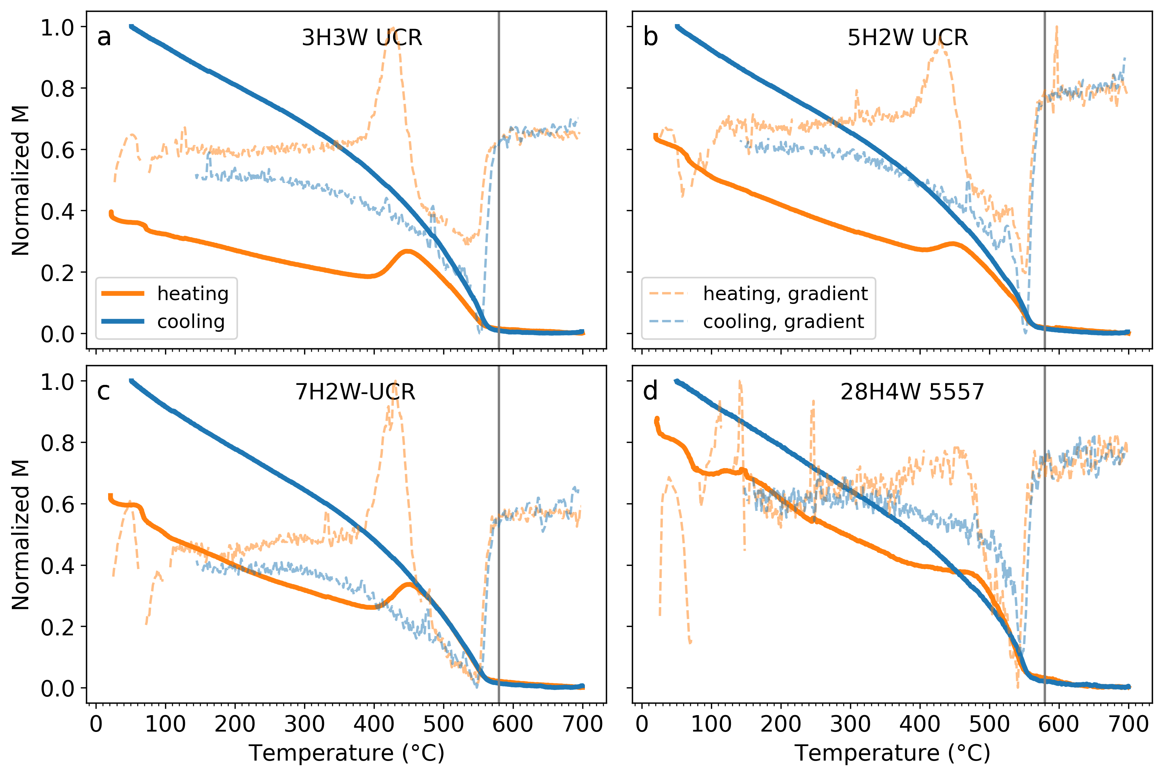
Figure S3. Temperature-dependent magnetization measurements for samples from Hole U1524A. Solid lines are heating (orange) and cooling (blue) curves of induced magnetization under a magnetizing field of 300 mT. Dashed lines are corresponding derivatives, which help to visualize the sharpest phase transition. The Curie temperature of stoichiometric magnetite (580 °C) is marked by the gray vertical line.
S2. Paleomagnetic Results
Detailed post-cruise paleomagnetic experiments on u-channel and discrete cube samples classify the quality of our NRM data into three types. ChRM can be defined for samples of types I and II, which have different persistence of secondary magnetization upon demagnetization. Secondary magnetization can be effectively removed at 10 ~ 20 mT peak AF for type I samples (Fig. S4 a, b), while it can persist above 20 mT peak AF for type II samples with same polarity as ChRM (Fig. S4 c). Samples classified as type III do not have qualified ChRMs, which shows a noisy demagnetization pattern in both direction and amplitude (Fig. S4 d, e). Moreover, such NRM demagnetization is not reproducible at given checkpoints (20, 40 and 60 mT peak AF in Fig. S4 d, e), where samples were repeatedly demagnetized and measured three times. Resulting variances at these checkpoints are too substantial to be ascribed to instrumental drift (Fig. S4 d₁, e₁), especially at peak AF above 40 mT. It is noticed that type III is often associated with very weak initial NRM intensity (NRM < 3 × 10⁻⁴ A/m), and frequently occurs in the interval of Cores U1524A-23H to 27H in Unit II, where diatom oozes are most abundant (Fig. 1b). Below this interval (from Cores U1524A-28H to -32X, ~ 246 to ~ 273 mbsf), ChRM can be defined with acceptable MAD values, despite similar lithology (Fig. 3b).
As a convention, ChRMs with $MAD≥15°$ are considered ill-defined and those with $MAD≤10°$ are considered reliable (McElhinny and McFadden, 2000). Here, we slightly relaxed the criteria, i.e., using $MAD≤15°$, to utilize data from samples with weak NRM but reasonable ChRM. Overall, 145 discrete samples out of 699 samples (~21%) and ~ 97.6% of the u-channel samples were included to constrain the magnetostratigraphy (Fig. 3b).
Figure S4. AF demagnetization of NRM of representative samples. (a-c) Examples of results with qualified ChRM. Each sample is shown with its NRM intensity as a function of peak AF (1) and the Zijderveld plot (2) where the horizontal (x-y) components are shown as circles and the vertical (y-z) component is shown as squares. The intervals used for determining ChRM are indicated with colored segments; (d - f) Examples of results with unqualified ChRM. Q values and parameters of ChRM (inclination and MAD values) are listed for each sample.
S3. Truncated von Mises distribution and unmixing inclination histograms
The von Mises distribution can be viewed as the normal distribution on a circle defined on $x∈[-π, π)$ with probability density function:
$$\begin{aligned}f\left(x,κ,μ\right)=\frac{exp\left(κ\cos\left(x-μ\right)\right)}{2πI_{0}\left(κ\right)},\#\left(A1\right)\end{aligned}$$
where $κ>0$ is a concentration parameter that adjust the shape of the distribution, $μ∈[-π, π)$ is the mean direction, and $I_{0}$ is the modified Bessel function of order 0.
Due to its analogy to the normal distribution, the von Mises distribution is widely used to describe angular distribution. However, inclination data varies between $\left[-\frac{π}{2}, \frac{π}{2}\right]$, which only covers a semi-circle range of the von Mises distribution. Therefore, fitting the von Mises distribution to the inclination data will yield unmeaningful results outside the defined range. For analyzing inclination data, we customize the von Mises distribution as follows:
$$\begin{aligned}f_{tr}\left(x,κ,μ\right)=\left\{\begin{aligned}\frac{exp\left(κ\cos\left(x-μ\right)\right)}{2πI_{0}\left(κ\right)D\left(κ,μ\right)}, &x∈[-\frac{π}{2}, \frac{π}{2}] \\ 0 , & x∉[-\frac{π}{2}, \frac{π}{2}]\end{aligned}\right.,\#\left(A2\right)\end{aligned}$$
where $D\left(κ,μ\right)=F\left(\frac{π}{2},κ,μ\right)-F\left(-\frac{π}{2},κ,μ\right)$ with $F\left(x,κ,μ\right)$ being the distribution function of $f\left(x,κ,μ\right)$. This customized density function confines the inclination within the range $x∈[-\frac{π}{2}, \frac{π}{2}]$ by truncating the probability beyond the range to 0. $D\left(κ,μ\right)$ is to adjust the integral of $f_{tr}\left(x,κ,μ\right)$ over $[-\frac{π}{2}, \frac{π}{2}]$ to 1.
Figure S5 shows inclination histograms generated by the TK03 model (Tauxe and Kent, 2004) and best-fits by the truncated von Mises distribution (eq. A2). The results demonstrate that the truncated von Mises distribution can effectively approximate inclination histograms corresponding to paleosecular variations.

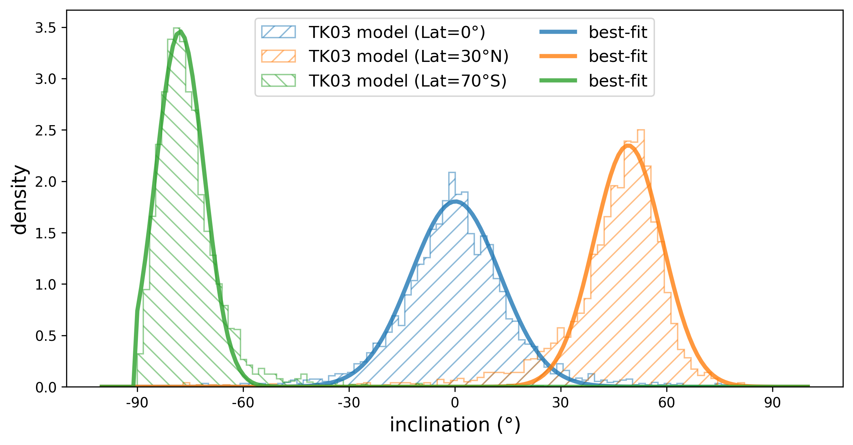
Figure S5. Inclination histograms generated by the TK03 model (n=3000) and best-fit results using the truncated von Mises distribution. Three histograms correspond to TK03 models with latitude = 0, 30$°$N, and 70$°$S, respectively.
Generally, a linear mixture model of the truncated von Mises distributions can be fitted to an arbitrary inclination histogram, $H\left(x\right)$:
$$\begin{aligned}H\left(x\right)=\sum_{i}{f_{tr}\left(x,κ_{i},μ_{i}\right)}+ε\left(x\right),\#\left(A3\right)\end{aligned}$$
where i denotes the i-th component and $ε\left(x\right)$ the residual. The shipboard inclination data of natural remanent magnetization demagnetized at 20 mT peak AF (NRM_{@20mT}) and inclination of characteristic remanent magnetization (ChRM) for u-channel and discrete samples are unmixed using eq. A3. The inclination histogram of the u-channel dataset is unmixed by a four-component model, while a 2-component model is sufficient for the dataset of discrete samples (Fig. S6).
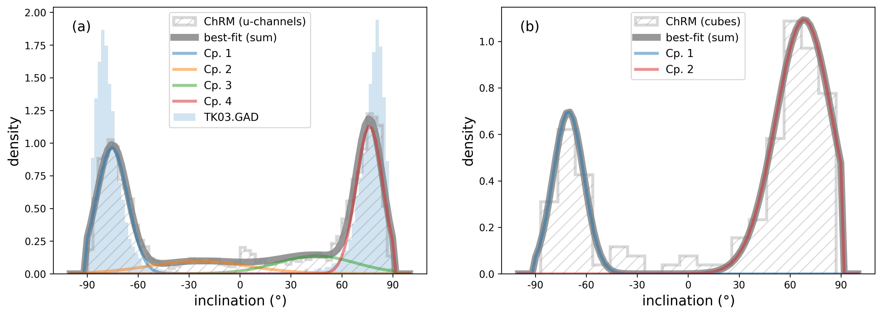
Figure S6. Unmixing of ChRM inclination dataset of (a) u-channels and (b) discrete cubes. The GAD inclination calculated using the TK03.GAD model exhibits a similar histogram to the stable inclination components, Cp. 1 and Cp. 4 of u-channels.
S4. Quality parameter for NRM at low demagnetization level
The intensity loss of NRM between two demagnetization steps at $f_{1}$ and $f_{2}$ is defined as:$\begin{aligned}Q\left(f_{1},f_{2}\right)= \frac{\left\|{\vec{NRM}}_{@f_{1}}-{\vec{NRM}}_{@f_{2}}\right\|}{\left\|{\vec{NRM}}_{@f_{2}}\right\|}=\frac{ΔNRM\left(f_{1},f_{2}\right)}{{NRM}_{@f_{2}}},\#(A4)\end{aligned}$
where ${\vec{NRM}}_{@f}$ and ${NRM}_{@f}$ are vector and scalar of NRM at demagnetization level f, respectively, and $ΔNRM\left(f_{1},f_{2}\right)$ is the amplitude of the vector difference between ${\vec{NRM}}_{@f_{1}}$ and ${\vec{NRM}}_{@f_{2}}$. Here, we set $f_{1}$ = 0 and $f_{2}$ = 20 mT to align with shipboard NRM data derived at low demagnetization levels. Consequently, $Q\left(0,20\right)$ quantifies the loss of NRM intensity upon demagnetization up to a 20 mT peak AF. This parameter potentially reflects the quality of an NRM record. For instance, $Q\left(0,20\right)=1$ indicates that NRM recorded by minerals with coercivity lower than 20 mT is as strong as the NRM remaining at 20 mT. In contrast, $Q\left(0,20\right)=10$ signifies that the low-coercivity NRM component, which is more susceptible to overprints, dominates the NRM record, which is unlikely to contain the primary signal.
The u-channel dataset from Hole U1524A reveals a strong correlation between the $Q(0,20)$ and MAD values show a strong correlation, suggesting the effectiveness of $Q(0,20)$ as a NRM quality parameter. In the two-dimensional space constructed using $I_{c}$ and $Q$ (referred to as the $I_{c}-Q$ plot hereafter), the data clusters correspond to $\log_{10}{Q}$ values within two standard deviations from the mean and to inclination values within the intervals of ± ($60°$, $90°$) (Fig. S7), whereas the distribution of data with $\log_{10}{Q}≥\overline{Q}+2σ_{Q}$ appears random. This pattern closely resembles the distribution in the hexbin plot of $I_{c}$ and MAD (Fig. S7), where high-quality ChRM data points (i.e., data with $MAD≤10°$) cluster within the same inclination intervals.
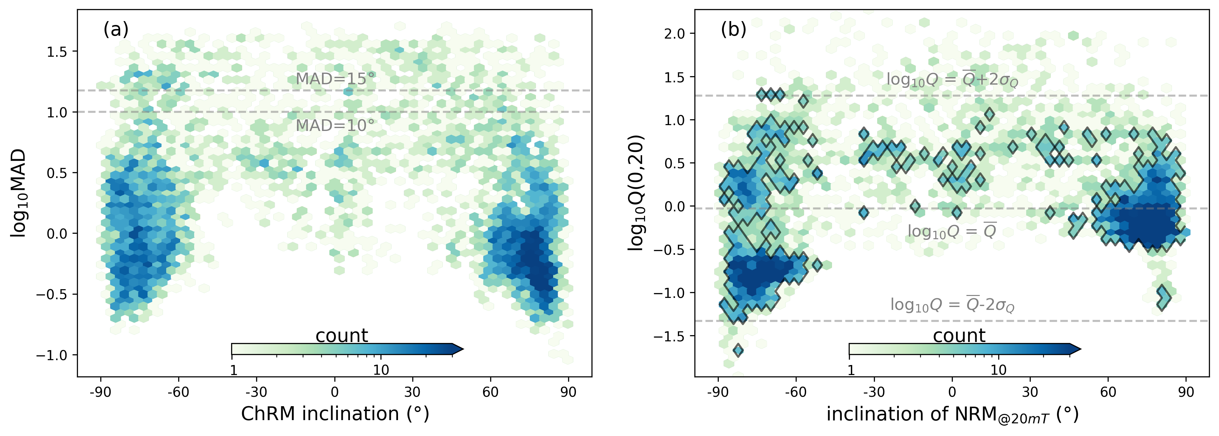
Figure S7. Statistical characteristics of u-channel data of Hole U1524A. (a) Inclination of ChRM versus maximum angular deviation (MAD) values with dash lines corresponding to $MAD=10°$ and $MAD=15°$. The color map indicates the frequency of the occurrence of data falling within a given range on the hexbin plot; (b) inclination of NRM_{@20mT} of u-channel data versus $Q$ values with dash lines corresponding to $\overline{Q}$ and $\overline{Q}±2σ_{Q}$, where $\overline{Q}$ and $σ_{Q}$ stand for the mean and stand deviation of $\log_{10}Q$. The black contour delineates regions on the $I_{c}-Q$ plot where data counts are ≥ 5.
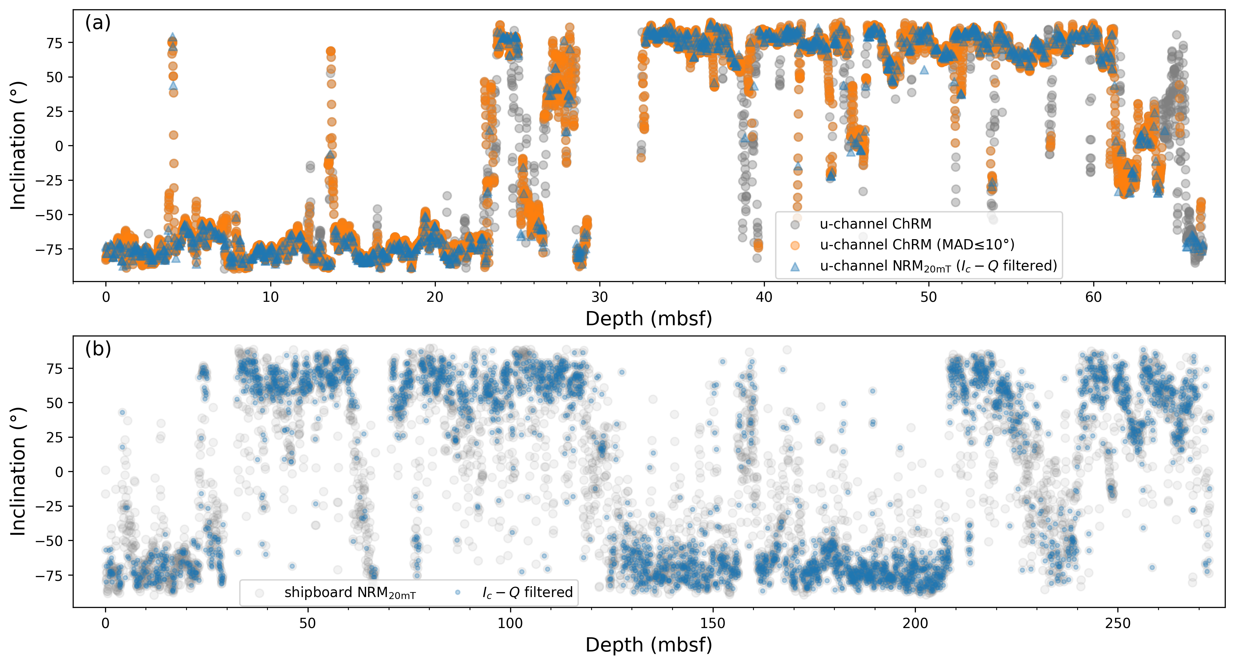
Figure S8. Inclination profiles of u-channel (a) and shipboard (b) datasets. (a) ChRM inclination values for all measurements are displayed in gray. ChRM inclination values with $MAD≤10°$ are highlighted in orange. NRM_{@20mT} inclination values, filtered based on the statistical characteristics of u-channel data (as shown in Fig. S7b), are indicated in blue; (b) The shipboard NRM_{@20mT} dataset is displayed in gray, and the filtered subset, as marked by the black contour in Fig. 4d, is shown in blue.
However, there are certain scenarios where $Q$ and MAD do not exhibit correlation, which can result in scatter on the MAD-$Q$ plot. Firstly, if remanence carriers are primarily composed of low coercivity minerals, $ΔNRM\left(0, 20\right)$ will likely overshadow NRM_{@20mT} even when ChRM exists, yielding large $Q$ but qualified MAD values. Secondly, when samples contain low concentration of remanence carriers, such as those affected by diagenetic dissolution, they neither preserve ChRM nor acquire pronounced overprints. Consequently, $Q$ values may appear random when NRM_{@20mT} and $ΔNRM(0, 20)$ are weak and susceptible to measurement noise. Additionally, if NRM_{@20mT} remains dominated by secondary NRM, $Q(0,20)$ will fail to represent ChRM and is therefore not anticipated to correlate with MAD.
S5. Applicability of the statistical approach
In section 3.3, we demonstrated that our novel statistical approach is highly effective in filtering problematic shipboard NRM dataset of Hole U1524A. This approach works under a critical precondition: secondary magnetization, such as drilling overprints and viscous remanent magnetization, can be primarily removed at low demagnetization levels (e.g., ≤ 20 mT peak AF). Such conditions are generally satisfied for typical deep-sea sediments recovered by IODP expeditions (Acton et al., 2002), suggesting that our method has broad applicability.
However, weakly magnetized sediments may pose unique challenges. NRM intensities after overprint removal can drop to a level (e.g., 10⁻⁴ A/m as for Hole U1524A) that often degrades signal-to-noise ratio, which also critically affect ChRM determination. An example of such challenges is present in the Oligocene–early Miocene sediment cores from IODP Site U1406 (Northwest Atlantic), where 95% of its initial ChRM dataset derived from 20 – 60 mT is associated with $MAD≥15°$ (Fig. S9a). Conventional magnetostratigraphic frameworks fail under such noise-dominated scenarios. Van Peer et al., (2017) developed advanced filtering strategies that combine optimizing the ChRM range and utilizing the directional dispersion parameter ($α_{95}$) of ChRM.
To validate the applicability of our method, we applied it to the NRM_{@20mT} dataset of IODP Site U1406. Remarkably, the analysis reveals two distinct in the $I_{c}-Q$ plot (Fig. S9b), replicating the pattern observed in Hole U1524A (Fig. 4d), despite the scatter in the plot being even more pronounced than in Hole U1524A. The clusters’ centers in the $I_{c}-Q$ plot correspond to inclination values similar to those in the $I_{c}-MAD$ plot, which suggests that the clustered datasets represent primary NRM records. Therefore, the application to IODP Hole U1524A and Site U1406 demonstrates the effectiveness of this statistical approach, especially when prompt magnetostratigraphic decisions are demanded or conventional magnetostratigraphic frameworks are hindered by insufficient ChRM constraints.
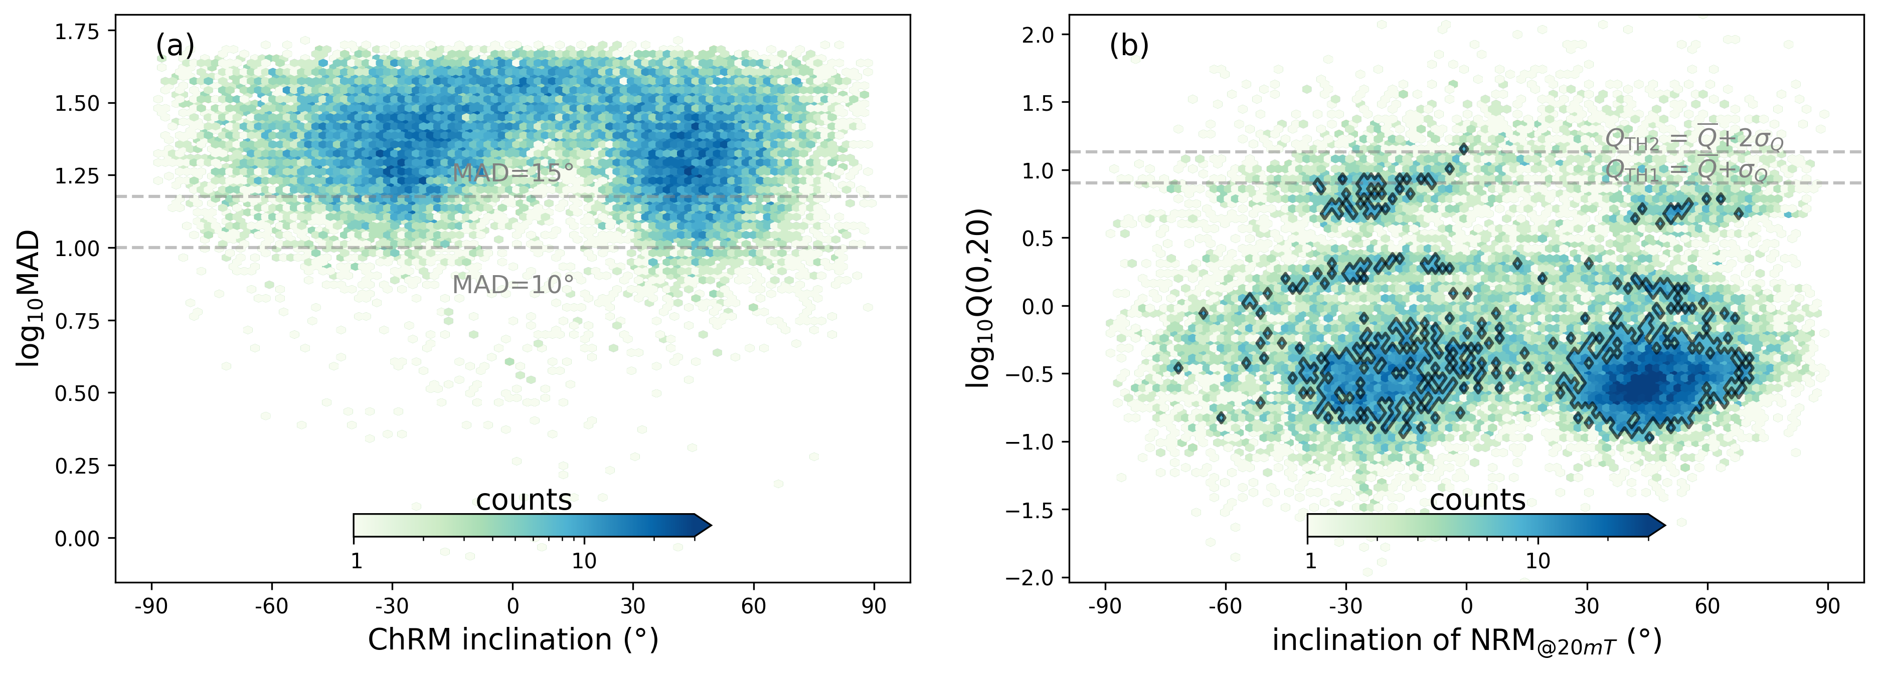
Figure S9. Statistical characteristics of u-channel data of IODP Site U1406. (a) Inclination of ChRM versus maximum angular deviation (MAD) values with dash lines corresponding to $MAD=10°$ and $MAD=15°$. The color map indicates the frequency of the occurrence of data falling within a given range on the hexbin plot; (b) inclination of NRM_{@20mT} of u-channel data versus Q values with dash lines corresponding to $Q=\overline{Q}+σ_{Q}$ and $Q=\overline{Q}+2σ_{Q}$. The black contour delineates regions on the $I_{c}-Q$ plot where data counts are ≥ 8.
S6. Reversal index
Following Bayes’ theorem we can construct a reversal index, $R\left(i_{c}\right)$, to quantify the probability of an observed inclination value, $I=i_{c}$, representing the reversed polarity ($Pl=r$):
$$\begin{aligned}R\left(i_{c}\right)=p\left(Pl=r|I=i_{c}\right)=\frac{p\left(I=i_{c}|Pl=r\right)p\left(Pl=r\right)}{p\left(I=i_{c}\right)},\#(A5)\end{aligned}$$
where $p\left(Pl=r\right)$ is the prior distribution of inclination data representing the reversed polarity, $p\left(I=i_{c}|Pl=r\right)$ is the likelihood function of inclination given the reversed polarity, and $p\left(I=i_{c}\right)$ is the marginal probability of inclination. With the information provided by the unmixing, we obtain:
$$\begin{aligned}R\left(i_{c}\right)=\frac{\sum_{k}{p_{k}^{r}\left(i_{c}\right)}}{\sum_{k}{P_{k}^{n}\left(i_{c}\right)}+\sum_{k}{P_{k}^{r}\left(i_{c}\right)}},\#(A6)\#\end{aligned}$$
where $p_{k}^{n}\left(i_{c}\right)$ and $p_{k}^{r}\left(i_{c}\right)$ are the probability of the k-th normal (n) and reversal (r) components at $i_{c}$, respectively.

Table S1. Diatom biostratigraphic events of IODP Hole U1524A.
Datum code | Datum type | Species name | Core, Section | Depth (mbsf) | Age (Ma)
D1 | LAD | Actinocyclus ingens | 2H-CC | 13.77 | 0.6
D2 | LAD | Actinocyclus fasciculatus | 10H-CC | 89.94 | 1.9
D3 | LAD | Thalassiosira vulnifica | 10H-CC | 89.94 | 2.2
D4 | LAD | Actinocyclus maccollumii | 10H-CC | 89.94 | 2.4
D5 | LAD | Rouxia diploneides | 10H-CC | 89.94 | 2.4
D6 | LAD | Thalassiosira complicata | 10H-CC | 89.94 | 2.5
D7 | FAD | Actinocyclus fasciculatus | 11H-CC | 99.56 | 2.7
D8 | LAD | Thalassiosira striata | 11H-CC | 99.56 | 2.9
D9 | FAD | Actinocyclus maccollumii | 18H-CC | 160.86 | 2.8
D10 | FAD | Fragilariopsis robusta | 26H-CC | 237.07 | 3.1
D11 | FAD | Fragilariopsis laqueata | 26H-CC | 237.07 | 3.1
D12 | FAD | Fragilariopsis bohatyi | 26H-CC | 237.07 | 3.3
D13 | FAD | Thalassiosira vulnifica | 31F-CC | 270.68 | 3.2
D14 | FAD | Thalassiosira elliptipora | 32X-CC | 273.01 | 3.3
The original data are from the Proceedings of the International Ocean Discovery Program Volume 374 (McKay et al., 2019). FAD: first appearance datum; LAD: last appearance datum. Depth corresponds to the position of core catcher (CC) samples.

Reference
Acton, G. D., Okada, M., Clement, B. M., Lund, S. P., & Williams, T. (2002). Paleomagnetic overprints in ocean sediment cores and their relationship to shear deformation caused by piston coring. Journal of Geophysical Research: Solid Earth, 107(B4), EPM-3.
Lattard, D., Engelmann, R., Kontny, A., & Sauerzapf, U. (2006). Curie temperatures of synthetic titanomagnetites in the Fe‐Ti‐O system: Effects of composition, crystal chemistry, and thermomagnetic methods. Journal of Geophysical Research: Solid Earth, 111(B12).
McElhinny, M. W., & McFadden, P. L. (1999). Paleomagnetism: continents and oceans. Elsevier.
McKay, R.M., De Santis, L., Kulhanek, D.K., and the Expedition 374 Scientists, 2019. Ross Sea West Antarctic Ice Sheet History. Proceedings of the International Ocean Discovery Program, 374: College Station, TX (International Ocean Discovery Program). https://doi.org/​10.14379/​iodp.proc.374.2019
Roberts, A. P., Almeida, T. P., Church, N. S., Harrison, R. J., Heslop, D., Li, Y., ... & Zhao, X. (2017). Resolving the origin of pseudo‐single domain magnetic behavior. Journal of Geophysical Research: Solid Earth, 122(12), 9534-9558.
Tauxe, L., & Kent, D.V., 2004. A simplified statistical model for the geomagnetic field and the detection of shallow bias in paleomagnetic inclinations: was the ancient magnetic field dipolar? In: Channell, J.E.T., Kent, D.V., Lowrie, W., Meert, J. (Eds.), Time Scales of the Paleomagnetic Field. American Geophysical Union, Washington, pp. 101–115.
Van Peer, T. E., Xuan, C., Lippert, P. C., Liebrand, D., Agnini, C., & Wilson, P. A. (2017). Extracting a detailed magnetostratigraphy from weakly magnetized, Oligocene to early Miocene sediment drifts recovered at IODP Site U1406 (Newfoundland margin, northwest Atlantic Ocean). Geochemistry, Geophysics, Geosystems, 18(11), 3910-3928.
Zhao, X., Fujii, M., Suganuma, Y., Zhao, X., & Jiang, Z. (2018). Applying the Burr type XII distribution to decompose remanent magnetization curves. Journal of Geophysical Research: Solid Earth, 123(10), 8298-8311.
Zhao, X., Heslop, D., & Roberts, A. P. (2015). A protocol for variable‐resolution first‐order reversal curve measurements. Geochemistry, Geophysics, Geosystems, 16(5), 1364-1377.

