Genome Refinement in Pacific Bluefin Tuna Thunnus orientalis: Chromosome-Level Assembly Using Hybrid Linkage Data

Xi Fu¹, Daiki Saka¹, Kazutoshi Yoshitake², Taiju Saito³, Milos Havelka³, Osamu Nishimiya³, Takahiro Matsubara³, Rie Goto³, Toshinao Ineno⁴, Shuichi Asakawa^{1,*}
¹ Graduate School of Agricultural and Life Sciences, The University of Tokyo, Tokyo, 113-8657, Japan
² School of Marine Biosciences, Kitasato University, Kanagawa, 252-0373, Japan
³ South Ehime Fisheries Research Center, Ehime University, Ainan, 798-4205, Japan
⁴Aquaculture Research Institute, Shingu Station, Kindai University, Wakayama, 647-1101, Japan
*To whom correspondence should be addressed.

Table S1. Paired-end RNA-seq read information. Forty-six previously released, paired-end RNA-seq data were used as RNA-seq sources for the T. orientalis genome annotation. Mapping was performed by STAR v.2.7.11b (STAR, RRID: SCR_004463).

Experiment Run ID | Experiment ID | Sequence Read Archive ID | Tissue | Uniquely mapped reads (%)
DRR458350 | DRX442617 | DRP009968 | ovary | 88.95
DRR458351 | DRX442618 | DRP009968 | ovary | 88.93
DRR458352 | DRX442619 | DRP009968 | ovary | 89.31
DRR458353 | DRX442620 | DRP009968 | tastis | 88.40
DRR458354 | DRX442621 | DRP009968 | tastis | 89.58
DRR458355 | DRX442622 | DRP009968 | tastis | 89.09
SRR8756174 | SRX5546927 | SRP188943 | White muscle | 95.99
SRR8756175 | SRX5546926 | SRP188943 | Superficial white muscle | 93.86
SRR8756176 | SRX5546925 | SRP188943 | Superficial red muscle | 87.00
SRR8756177 | SRX5546924 | SRP188943 | Deep red muscle | 82.78
SRR8756178 | SRX5546923 | SRP188943 | Superficial white muscle | 93.07
SRR8756179 | SRX5546922 | SRP188943 | Deep white muscle | 92.79
SRR8756180 | SRX5546921 | SRP188943 | Compact Ventricle | 85.57
SRR8756181 | SRX5546920 | SRP188943 | Atrium | 83.99
SRR8756182 | SRX5546919 | SRP188943 | Deep white muscle | 92.65
SRR8756183 | SRX5546918 | SRP188943 | Spongy Ventricle | 86.21
SRR8756184 | SRX5546917 | SRP188943 | White muscle | 94.35
SRR8756185 | SRX5546916 | SRP188943 | White muscle | 93.39
SRR8756186 | SRX5546915 | SRP188943 | White muscle | 84.35
SRR8756187 | SRX5546914 | SRP188943 | White muscle | 83.40
SRR8756188 | SRX5546913 | SRP188943 | White muscle | 79.06
SRR8756189 | SRX5546912 | SRP188943 | White muscle | 74.35
SRR8756190 | SRX5546911 | SRP188943 | White muscle | 85.37
SRR8756191 | SRX5546910 | SRP188943 | White muscle | 93.65
SRR8756192 | SRX5546909 | SRP188943 | White muscle | 30.85
SRR8756193 | SRX5546908 | SRP188943 | White muscle | 41.72
SRR8756194 | SRX5546907 | SRP188943 | Compact Ventricle | 84.32
SRR8756195 | SRX5546906 | SRP188943 | Spongy Ventricle | 83.73
SRR8756196 | SRX5546905 | SRP188943 | Spongy Ventricle | 84.58
SRR8756197 | SRX5546904 | SRP188943 | Deep red muscle | 86.27
SRR8756198 | SRX5546903 | SRP188943 | Atrium | 83.78
SRR8756199 | SRX5546902 | SRP188943 | Compact Ventricle | 87.91
SRR8756200 | SRX5546901 | SRP188943 | Superficial white muscle | 93.05
SRR8756201 | SRX5546900 | SRP188943 | Atrium | 81.27
SRR8756202 | SRX5546899 | SRP188943 | Superficial red muscle | 91.99
SRR8756203 | SRX5546898 | SRP188943 | Deep white muscle | 92.62
SRR8756204 | SRX5546897 | SRP188943 | White muscle | 87.47
SRR8756205 | SRX5546896 | SRP188943 | White muscle | 73.51
SRR8756206 | SRX5546895 | SRP188943 | White muscle | 87.88
SRR8756207 | SRX5546894 | SRP188943 | White muscle | 85.59
SRR8756208 | SRX5546893 | SRP188943 | Red muscle | 74.01
SRR8756209 | SRX5546892 | SRP188943 | White muscle | 86.42
SRR8756210 | SRX5546891 | SRP188943 | Red muscle | 72.04
SRR8756211 | SRX5546890 | SRP188943 | Red muscle | 76.56
SRR8756212 | SRX5546889 | SRP188943 | White muscle | 71.20
SRR8756213 | SRX5546888 | SRP188943 | White muscle | 86.22

﻿

Table S2. Full-genome protein sequence information of twelve representative fish species.

Information on full-genome protein sequences of four tuna species (Upper part)
Species | Common name | Scaffold N50 (Mb) | Genome size (Mb) | protein-coding genes | Reference or Accession
Thunnus albacares | Yellowfin tuna | 34.6 | 792.1 | 24,623 | GCF_914725855.1
Thunnus maccoyii | Southern bluefin tuna | 33.8 | 782.4 | 24,659 | GCF_910596095.1
Euthynnus affinis | Eastern little tuna | 29.1 | 758.24 | 23,059 | GCA_019973915.1  [1]
Katsuwonus pelamis | skipjack tuna | 32.7 | 827.9 | 32,001 | GCA_041053085.1  [2]

Information on full-genome protein sequences of representative fish species (Lower part)
Species | Common name | Scaffold N50 (Mb) | Genome size (Mb) | protein-coding genes | Reference or Accession
Seriola lalandi dorsalis | Yellowtail amberjack | 1.3 | 732 | 25,573 | GCF_002814215.1
Oryzias latipes | Japanese medaka | 31.2 | 734 | 22,070 | GCF_002234675.1
Anabas testudineus | climbing perch | 25.1 | 555.6 | 23,846 | GCF_900324465.2
Danio rerio | zebrafish | 59.3 | 1400 | 27,039 | GCF_049306965.1
Gasterosteus aculeatus | three-spined stickleback | 20.4 | 471.9 | 22,598 | GCF_016920845.1
Hippocampus comes | tiger tail seahorse | 2 | 492.1 | 21,184 | GCF_001891065.2

Table S3. Statistical results of the 24 pseudochromosomes of the improved T. orientalis genome.

Chromosome in the present assembly | Size (bp) | GC content (%) | Percentage of the genome
1 | 39,217,975 | 39.41 | 4.93
2 | 21,523,452 | 39.38 | 2.71
3 | 42,023,264 | 39.25 | 5.28
4 | 36,104,902 | 39.45 | 4.54
5 | 38,264,006 | 39.42 | 4.81
6 | 36,199,720 | 39.65 | 4.55
7 | 36,250,107 | 39.6 | 4.56
8 | 30,911,443 | 39.82 | 3.89
9 | 37,149,219 | 39.45 | 4.67
10 | 35,532,070 | 39.46 | 4.47
11 | 30,792,284 | 39.56 | 3.87
12 | 31,066,550 | 39.12 | 3.9
13 | 36,486,977 | 39.61 | 4.59
14 | 32,769,959 | 39.2 | 4.12
15 | 31,795,176 | 39.67 | 4
16 | 34,973,738 | 39.49 | 4.4
17 | 34,195,991 | 39.23 | 4.3
18 | 27,360,815 | 39.98 | 3.44
19 | 28,941,527 | 39.57 | 3.64
20 | 28,328,389 | 39.61 | 3.56
21 | 34,078,809 | 39.44 | 4.28
22 | 30,535,465 | 39.92 | 3.84
23 | 26,838,675 | 39.53 | 3.37
24 | 30,504,448 | 39.4 | 3.83
Total | 791,844,961 |  | 99.55

Table S4. Major categories and quantities of repeat elements in the T. orientalis genome assembly. Elements with a percentage of 0 were deleted from this table.

==================================================
number of length percentage
elements* occupied of sequence
--------------------------------------------------
Retroelements 108280 30580663 bp 3.84 %
SINEs: 9912 1533091 bp 0.19 %
LINEs: 91987 25797628 bp 3.24 %
L2/CR1/Rex 56328 17107701 bp 2.15 %
R1/LOA/Jockey 6807 977754 bp 0.12 %
R2/R4/NeSL 1368 758371 bp 0.10 %
RTE/Bov-B 9783 2327692 bp 0.29 %
L1/CIN4 4204 1868838 bp 0.23 %
LTR elements: 6381 3249944 bp 0.41 %
BEL/Pao 298 428049 bp 0.05 %
Gypsy/DIRS1 2727 1236894 bp 0.16 %
Retroviral 2832 1209248 bp 0.15 %

DNA transposons 79928 17004590 bp 2.14 %
hobo-Activator 31517 6888111 bp 0.87 %
Tc1-IS630-Pogo 39150 7630273 bp 0.96 %
Tourist/Harbinger 2114 531597 bp 0.07 %

Rolling-circles 184 142448 bp 0.02 %
Unclassified: 1088539 174264846 bp 21.90 %
Total interspersed repeats: 221873174 bp 27.89 %

Small RNA: 7542 1411561 bp 0.18 %
Satellites: 719 85310 bp 0.01 %
Simple repeats: 384820 17103504 bp 2.15 %
Low complexity: 46814 2638066 bp 0.33 %
==================================================
* most repeats are fragmented by insertions or deletions
have been counted as one element

Table S5. Summary of functional annotation of predicted proteins.
 | Database | Count | Percentage (%)
Total genes |  | 22,640
InterProScan | PANTHER | 20,235 | 89.38
InterProScan | Pfam | 17,403 | 76.86
InterProScan | Gene3D | 16,399 | 72.43
InterProScan | SUPERFAMILY | 15,242 | 67.32
InterProScan | FunFam | 11,994 | 52.97
InterProScan | SMART | 8,562 | 37.81
InterProScan | CDD | 8,932 | 39.45
InterProScan | PRINTS | 5,068 | 22.38
InterProScan | PIRSF | 1,568 | 6.92
InterProScan | NCBIfam | 1,231 | 5.43
InterProScan | SFLD | 101 | 0.45

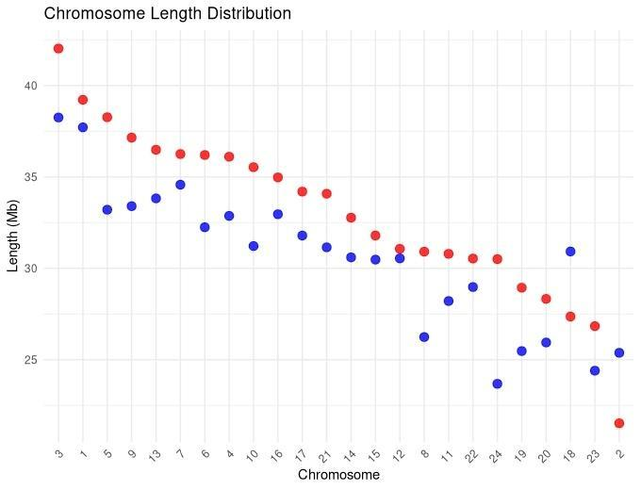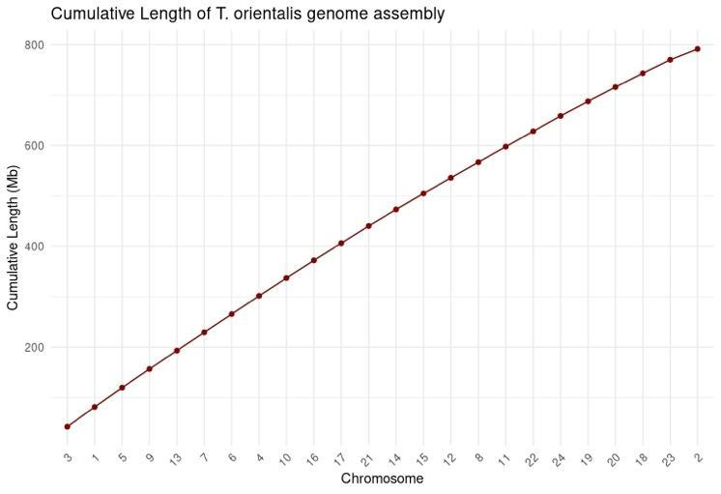

Figure S1. Length distribution of the Thunnus orientalis genome assembly. (Upper) The length of the 24 longest scaffolds in the assembly. Red points represent pseudochromosomes ordered according to gene-level synteny with the Japanese medaka, Oryzias latipes (blue points). (Bottom) Cumulative length of the T. orientalis genome assembly.

References
1. Havelka M, Sawayama E, Saito T, Yoshitake K, Saka D, Ineno T, et al. Chromosome-scale genome assembly and transcriptome assembly of kawakawa Euthynnus affinis; A tuna-like species. Front Genet. 2021;12:739781.
2. Liang X, Huang J, Liu B, Wu F, Liu J, Lu J. A chromosome-level genome assembly of skipjack tuna, Katsuwonus pelamis (Perciformes: Scombridae). Sci Data. 2024;11:1405.

