Bioactive Thymol in Epoxy Network Toward Durable and Protective Polymeric Coatings
Arunkumar Patil¹, N S Pawar¹, Pundalik Mali¹, Madhukar Tayade¹, Kundan Borse¹ Vikas Patil*²
¹Department of Chemistry, Pratap college Amalner, Kavayitri Bahinabai Chaudhari North Maharashtra University, Jalgaon, India 42540.
²University Institute of Chemical Technology (UICT), Kavayitri Bahinabai Chaudhari North Maharashtra University, Jalgaon 425001, India
Corresponding Author: Email id: vikasudct@gmail.com; arunkumardpatil@rediffmail.com

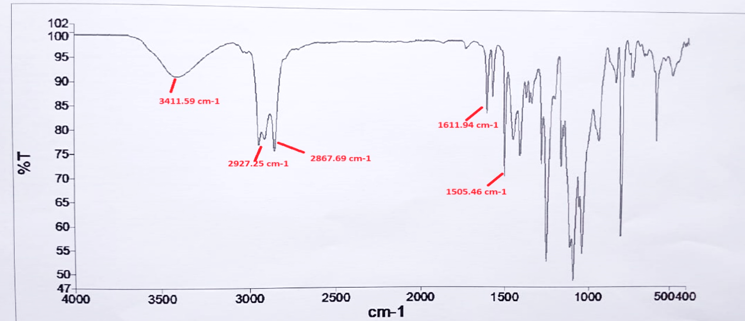
Figure 1. The FTIR spectra of TBMP.

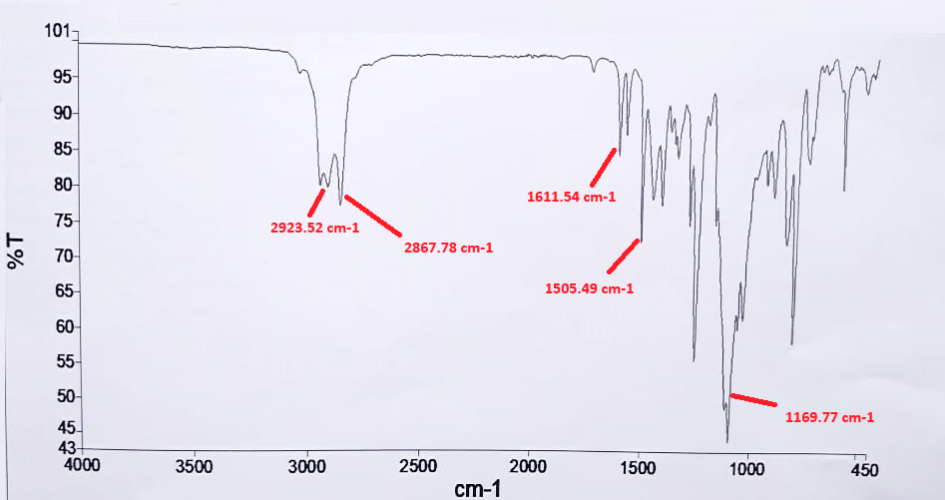
Figure 2. The FTIR spectra of TMTO.

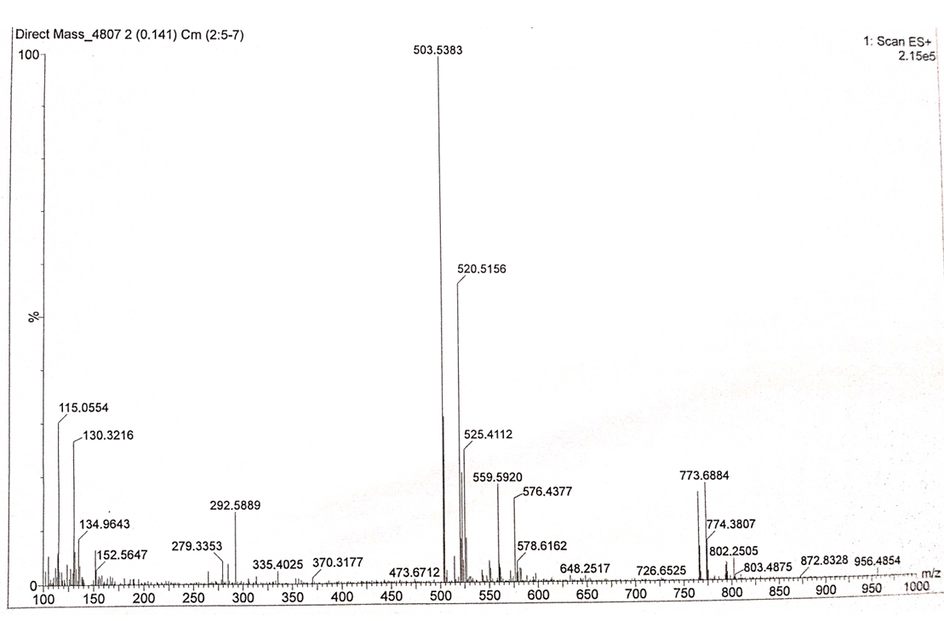

Figure 3. Mass spectra of TBMP.
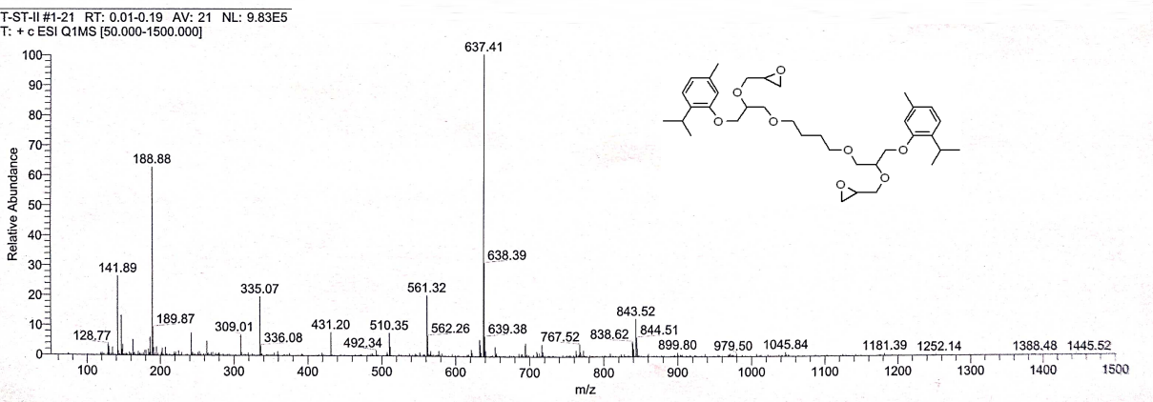
Figure 4. Mass spectra of TMTO.

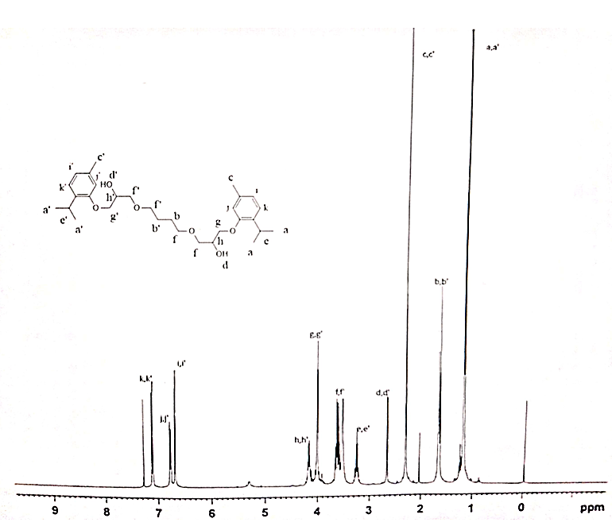
Figure 5. ¹H-NMR of TBMP.

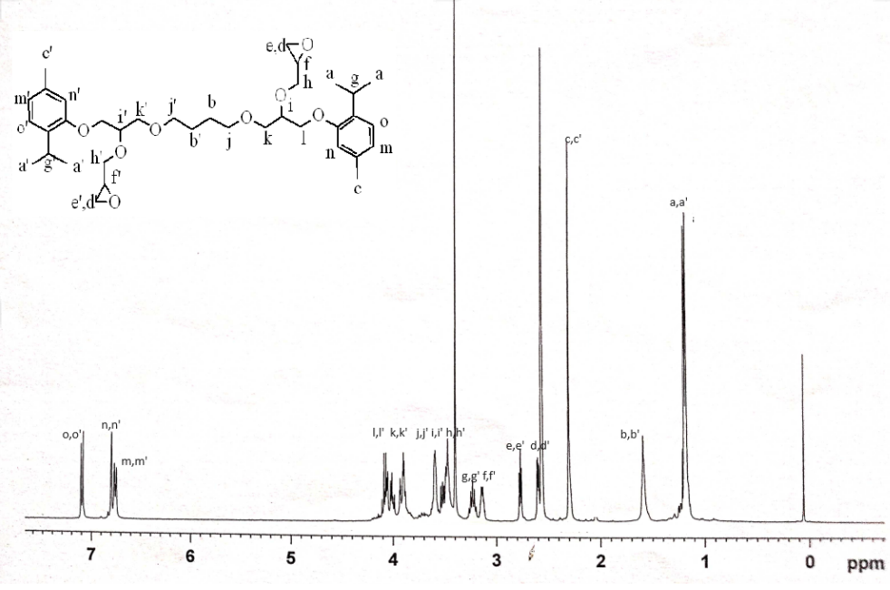
Figure 6. ¹H-NMR of TMTO

