Supplementary Table 1. Genotyping results of 217 accessions in USDA rice mini-core using 12 functional markers
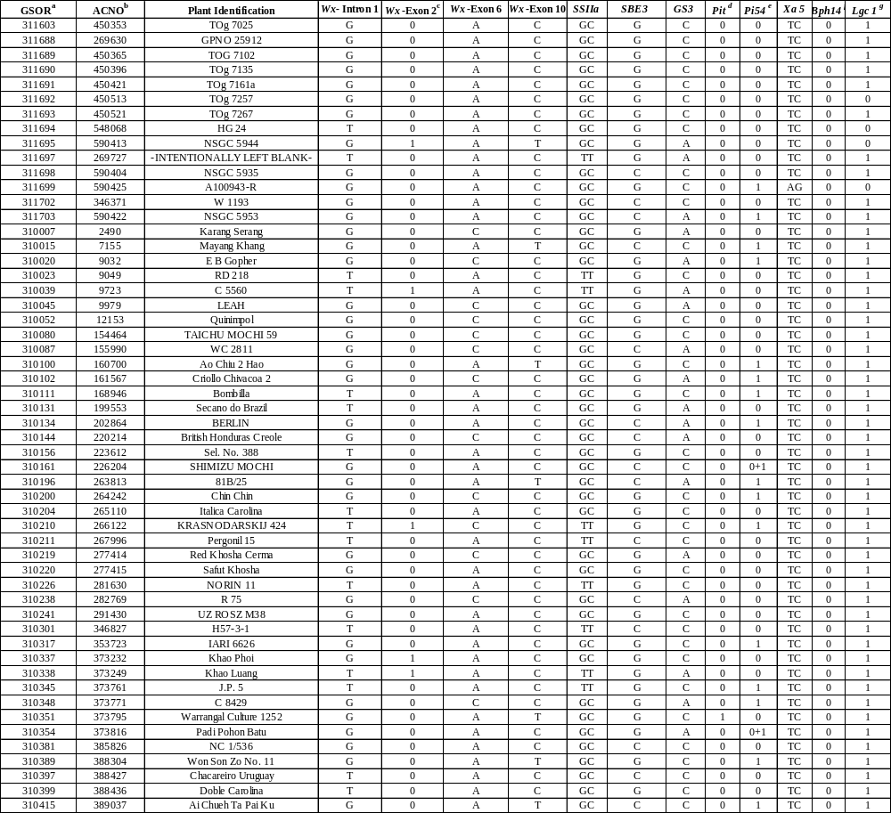

Supplementary Table 1 continued
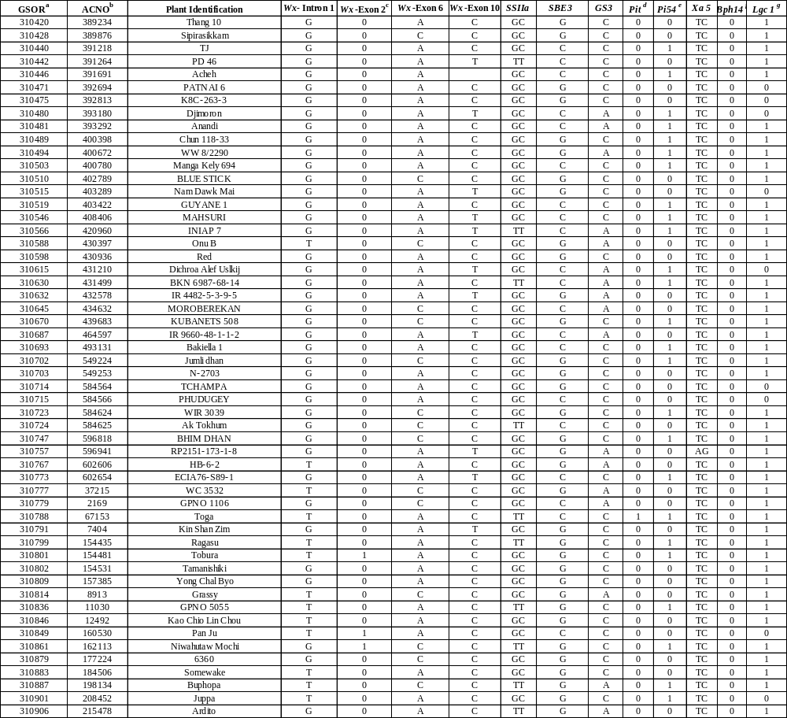

Supplementary Table 1 continued
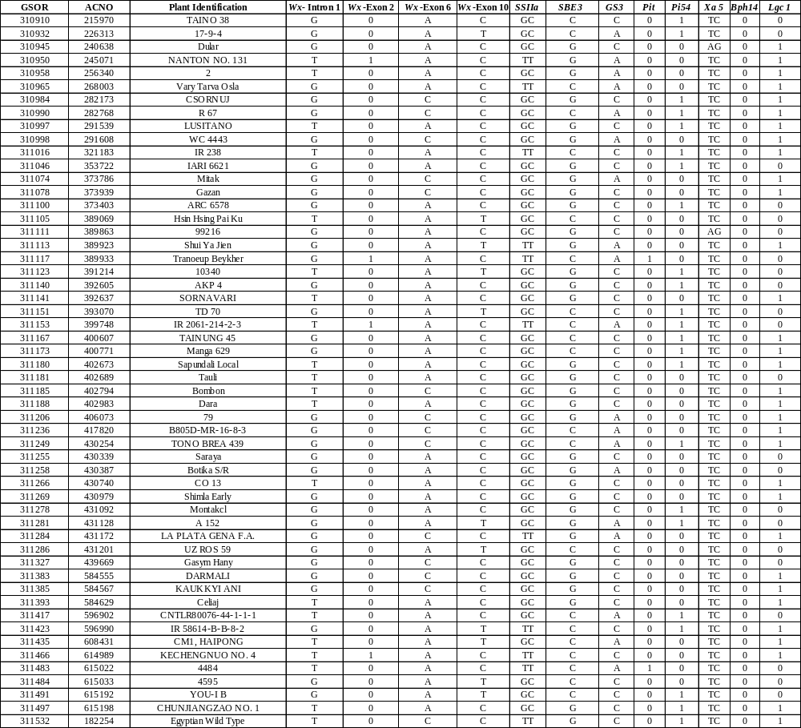
Supplementary Table 1 continued
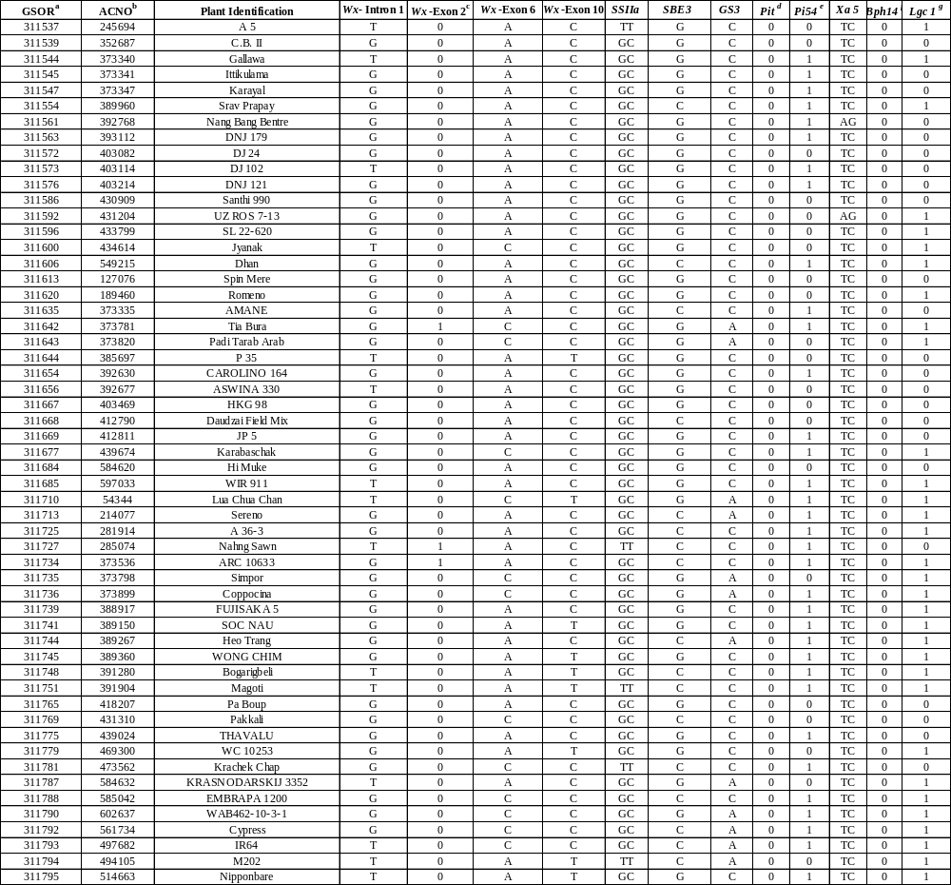
ªGSOR = genetic stock number. ^{b}ACNO = accession number. GSOR and GSOR are as designated by Agrama et al (2010)
^{c.}For Wx-Exon 2, 1 means no 23 bp duplication, 2 means a 23 bp duplication; ^{d.}For Pit gene, 1 means LTR insertion, 0 means no LTR insertion; ^{e.}For Pi54 gene, 0 means a 144 bp deletion, 1 means no 144 bp deletion; ^{f.}For Bph 14 gene, S means susceptible allele; ^{g.}For Lgc 1 gene, 0 means a 3.5 Kb deletion, 1 means no 3.5 Kb deletion.

