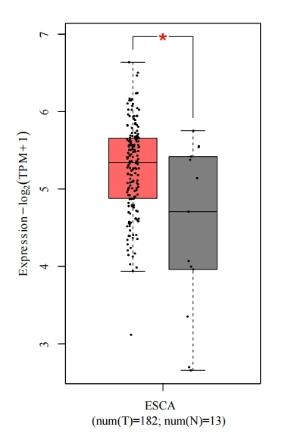

Supplementary Fig. S1 Box plots comparing the mRNA expression levels of Sp1 between ESCA tumor samples (n=182) and matched normal tissues (n=13). The analysis was performed using the GEPIA2 online tool (http://gepia2.cancer-pku.cn/). The box plots were generated with the following parameters: |Log2FC| Cutoff set to 0.5 and “Matched Normal Data” option selected to strictly compare TCGA tumors against their own matched TCGA normal controls. The p-value is calculated by the Student's t-test and is displayed on the graph (*p < 0.05).

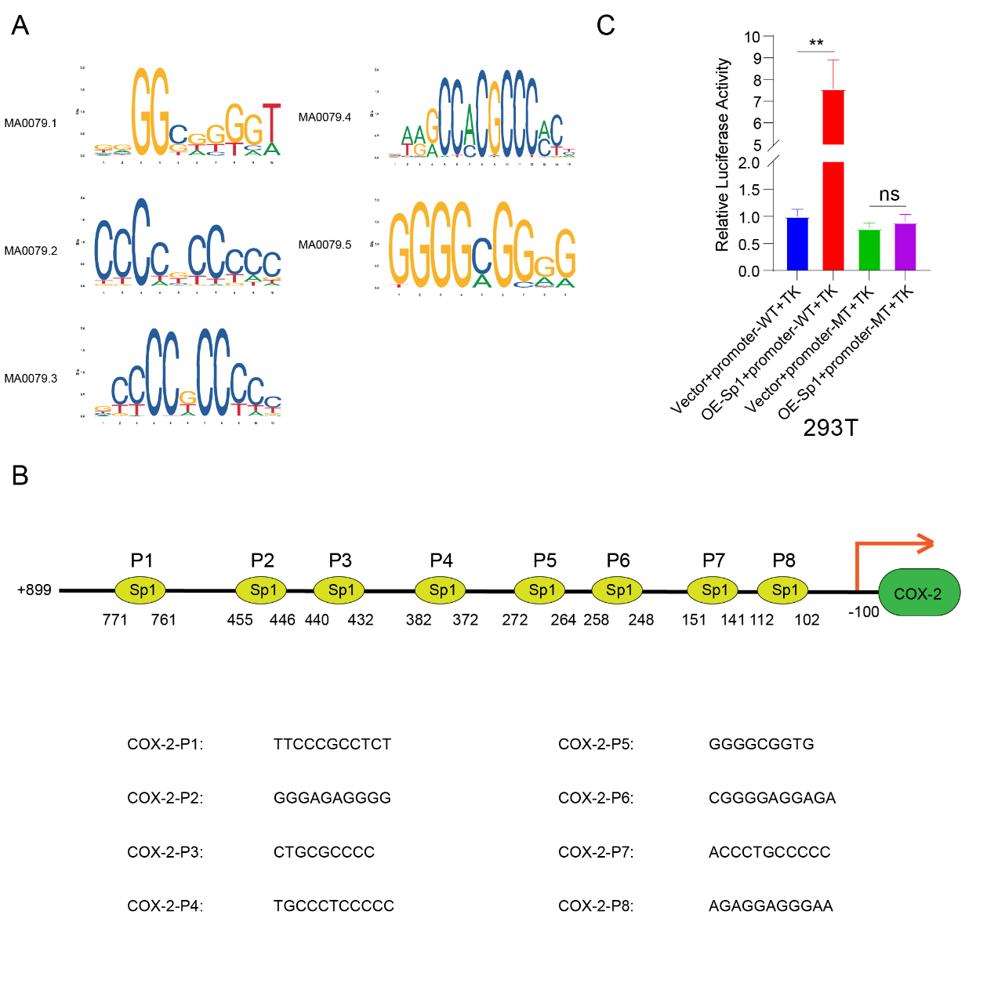
Supplementary Fig. S2 Sp1 transcriptionally activates COX-2 expression by directly binding to its promoter.
(A) Five Sp1 binding motifs (MA0079.1-MA0079.5) predicted by JASPAR database. (B) Schematic of human COX-2 promoter region (-100 to +899 bp) showing eight predicted Sp1 binding sites. (C) Dual-luciferase reporter assay in 293T cells. Sp1 overexpression significantly activated the wild-type (WT) COX-2 promoter. Deletion mutations in the Sp1 binding sites abolished this transactivation, reducing activity to baseline levels and eliminating Sp1 responsiveness. Data represent mean ± SD (n=3); **p < 0.01, NS (not significant); one-way ANOVA with Tukey's test.

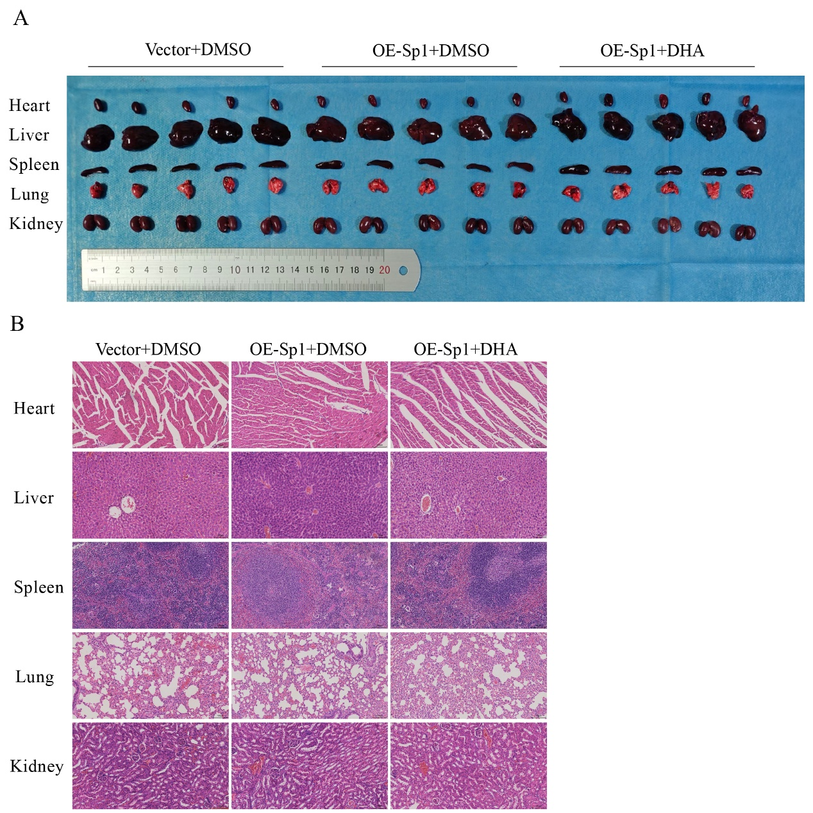

Supplementary Fig. S3 Evaluation of the in vivo safety profile of DHA treatment in xenograft mouse models.
(A) Representative macroscopic images of major organs (heart, liver, spleen, lungs, and kidneys) harvested from nude mice in the Control (PCMV3 + DMSO), Sp1-overexpression (OE-Sp1 + DMSO), and DHA-treated (OE-Sp1 + DHA, 100 mg/kg) groups. (B) Representative hematoxylin and eosin (H&E)-stained sections of the corresponding major organs. No significant histopathological abnormalities or morphological alterations were observed in any of the groups, including the DHA-treated group, indicating that DHA administration at this dosage did not cause detectable systemic toxicity.

