Supplementary Data

Microstructural reorganisation and mechanical property enhancement in PHAs and their wood biocomposites through post-fabrication heat-treatment in annealing and partial-melting conditions.

Vincent Mathel^{1,2}*, Pauline Le Quellec², Shazed Aziz^{1,2}, Darren Martin^{1,2}, Peter Halley^{1,2}, Michael Tobias Heitzmann^{2,3}, Luigi-Jules Vandi^{2,3}*
¹School of Chemical Engineering, The University of Queensland, Brisbane, QLD 4072, Australia

²Centre for Advanced Materials Processing and Manufacturing (AMPAM), The University of Queensland, Brisbane QLD 4072, Australia
³School of Mechanical and Mining Engineering, The University of Queensland, Brisbane QLD 4072, Australia
*Corresponding authors: Vincent Mathel (E-mail: v.mathel@uq.edu.au); Luigi-Jules Vandi (E-mail: l.vandi@uq.edu.au)

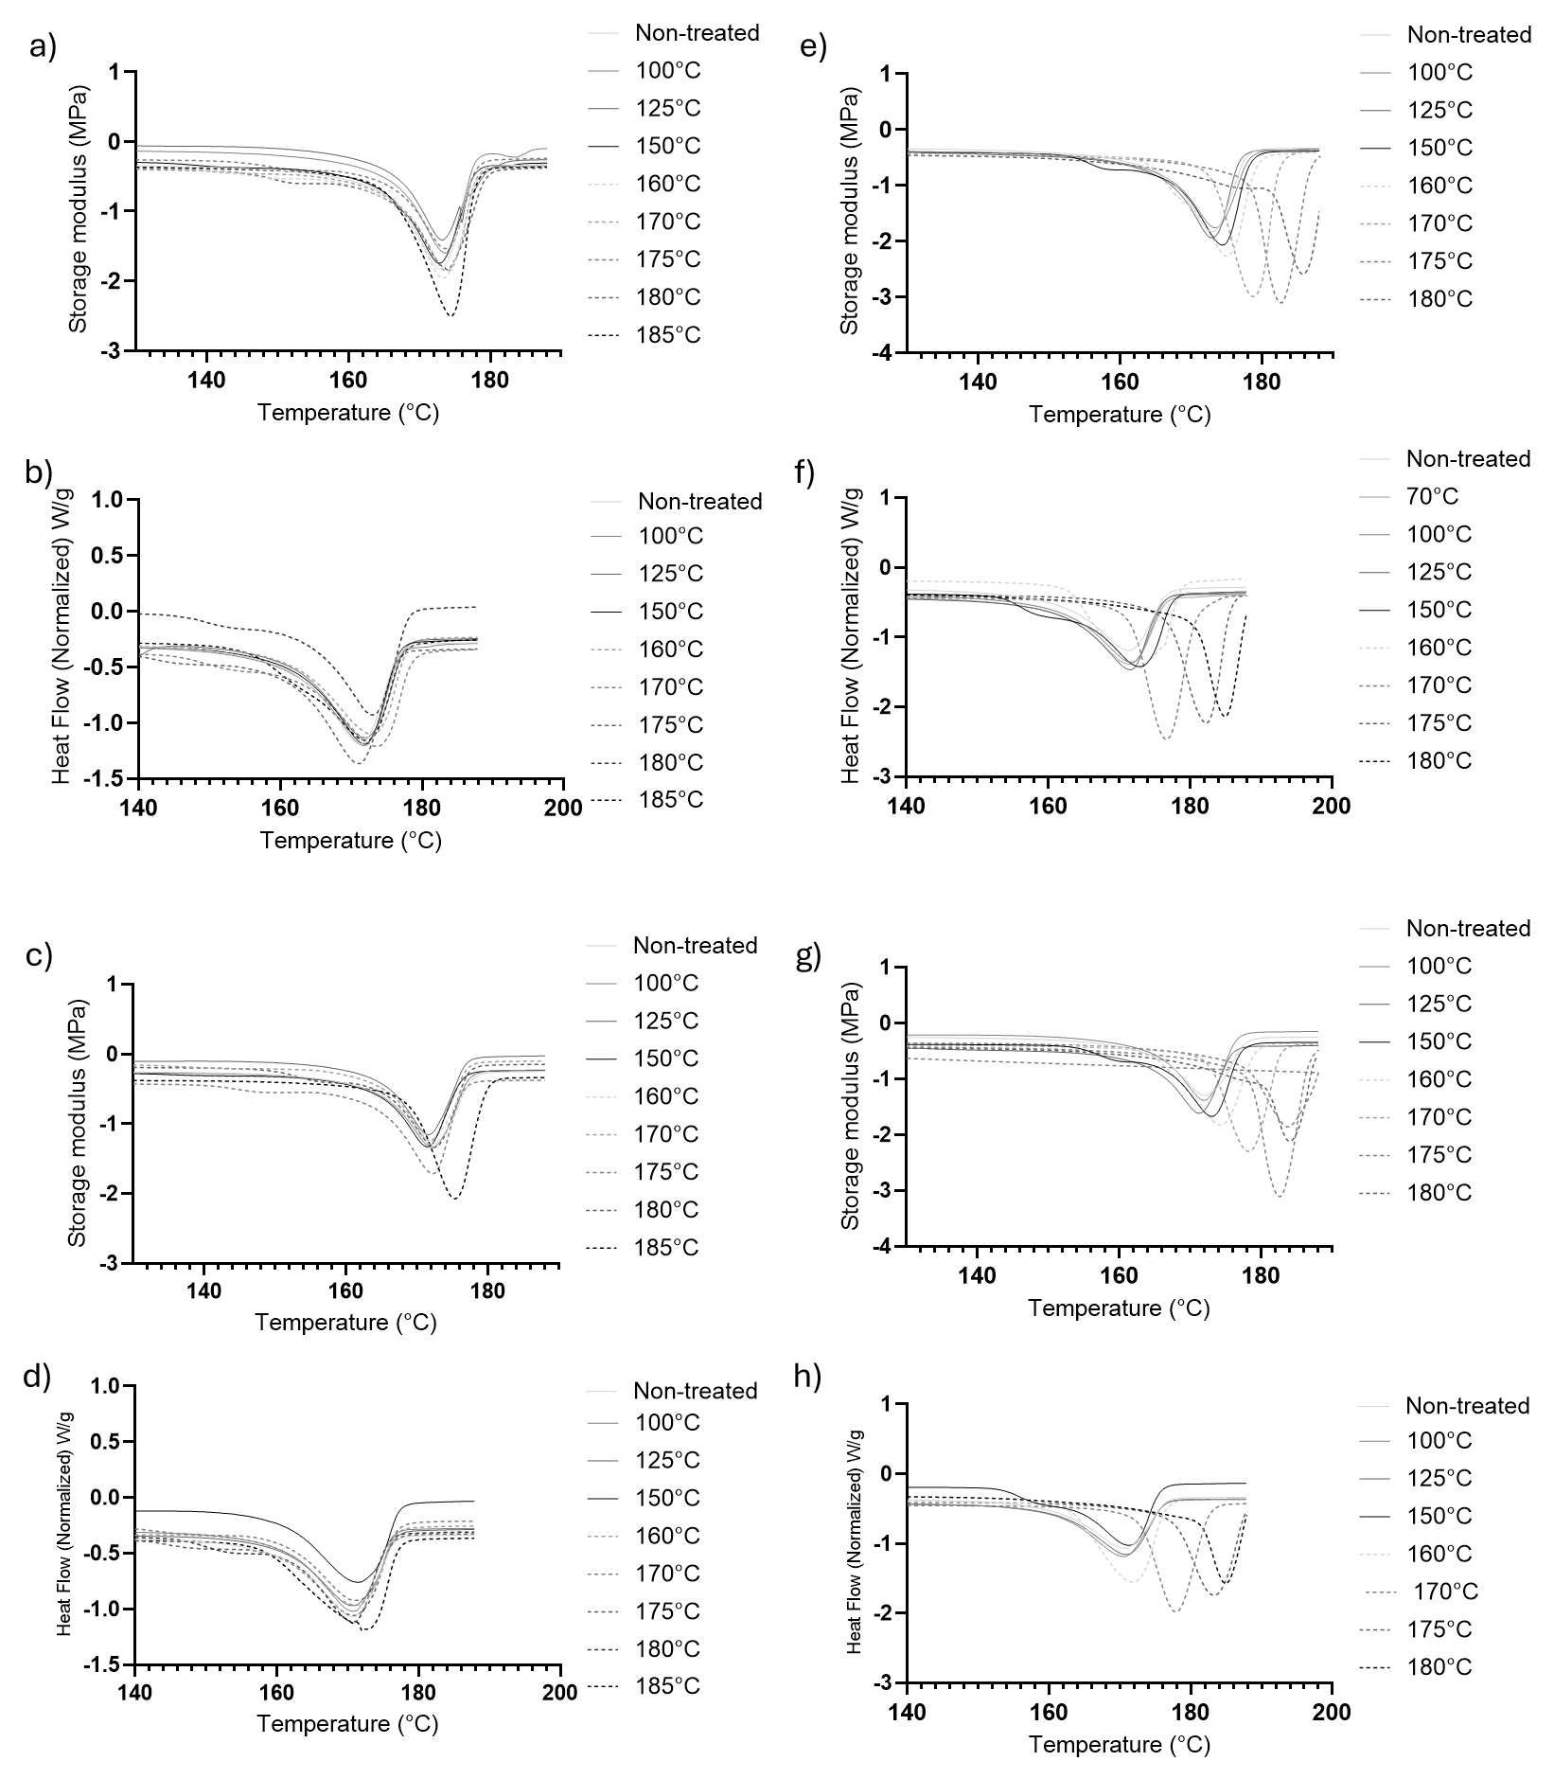
Fig.S1: heating DSC curves obtained after heat post-treatment during 5 min for a) PHBV, b) PHBV/P34HB, c) PHBV-Wood, d) PHBV/P34HB-wood and heat post-treatment during 30 min for e) PHBV, f) PHBV/P34HB, g) PHBV-Wood, h) PHBV/P34HB-wood
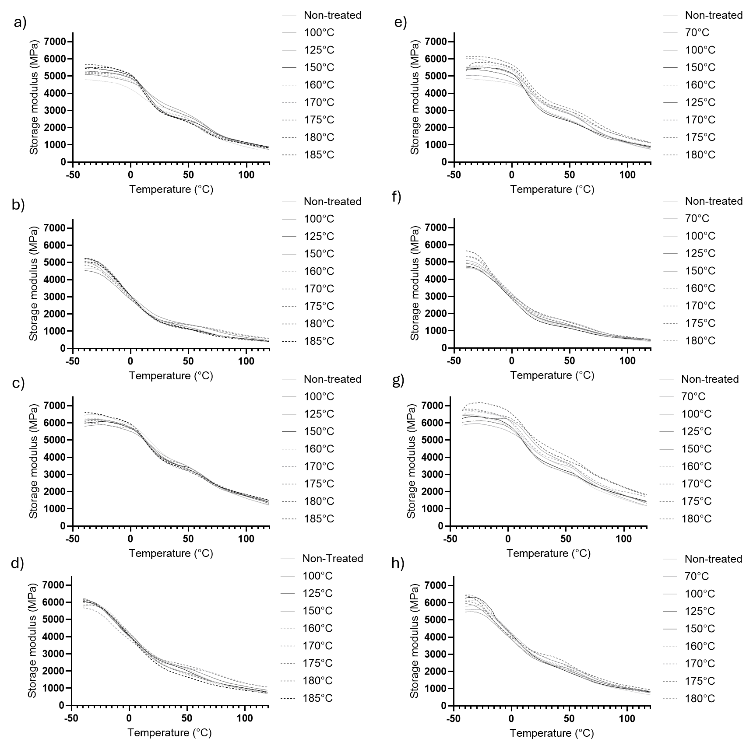
Fig.S2: DMA curves obtained after heat post-treatment during 5 min for a) PHBV, b) PHBV/P34HB, c) PHBV-Wood, d) PHBV/P34HB-wood and heat post-treatment during 30 min for e) PHBV, f) PHBV/P34HB, g) PHBV-Wood, h) PHBV/P34HB-wood

Table S1: Evolution of %MAF and %RAF of materials in function of heat post-treatment condition
Post-treatment temperature (℃) | % MAF
Post-treatment temperature (℃) | PHBV |  | PHBV/P34HB |  | PHBV-Wood |  | PHBV/P34HB-Wood
↓
Duration (min) →
Duration (min) → | 5 | 30 | 5 | 30 | 5 | 30 | 5 | 30
Non-treated | 0.37 |  | 0.73 |  | 0.45 |  | 0.63
70 | - | 0.40 | - | 0.69 | - | 0.39 | - | 0.57
100 | 0.42 | 0.45 | 0.72 | 0.71 | 0.38 | 0.41 | 0.70 | 0.59
125 | 0.48 | 0.54 | 0.72 | 0.73 | 0.45 | 0.47 | 0.64 | 0.64
150 | 0.55 | 0.55 | 0.78 | 0.75 | 0.43 | 0.47 | 0.65 | 0.65
160 | 0.52 | 0.53 | 0.76 | 0.76 | 0.44 | 0.51 | 0.67 | 0.65
170 | 0.49 | 0.52 | 0.73 | 0.73 | 0.46 | 0.44 | 0.62 | 0.65
175 | 0.52 | 0.47 | 0.71 | 0.73 | 0.40 | 0.37 | 0.64 | 0.57
180 | 0.56 | 0.48 | 0.78 | 0.72 | 0.45 | 0.43 | 0.68 | 0.62
185 | 0.55 | - | 0.76 | - | 0.50 | - | 0.72 | -
 | % RAF
Non-treated | 35.4±1.5 |  | 25.9±0.2 |  | 37.2±1.0 |  | 22.2±0.5
70 | - | 0.46 | - | 0.23 | - | 0.41 | - | 0.30
100 | 0.43 | 0.40 | 0.19 | 0.20 | 0.41 | 0.39 | 0.20 | 0.27
125 | 0.37 | 0.31 | 0.20 | 0.17 | 0.35 | 0.30 | 0.22 | 0.22
150 | 0.30 | 0.29 | 0.15 | 0.16 | 0.36 | 0.30 | 0.23 | 0.21
160 | 0.34 | 0.30 | 0.16 | 0.16 | 0.33 | 0.27 | 0.21 | 0.22
170 | 0.35 | 0.30 | 0.16 | 0.18 | 0.31 | 0.31 | 0.22 | 0.23
175 | 0.32 | 0.35 | 0.17 | 0.19 | 0.36 | 0.36 | 0.23 | 0.29
180 | 0.29 | 0.33 | 0.14 | 0.19 | 0.31 | 0.31 | 0.19 | 0.23
185 | 0.30 | - | 0.19 | - | 0.28 | - | 0.17 | -

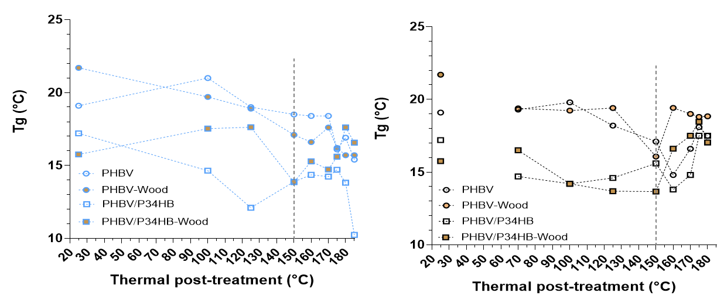
Fig. S3: Evolution of Tg evaluated by DMA for heat post-treated materials for 5 min (left) and 30 min (right)

Table S2: Evolution of Tg evaluated by DMA for all materials in function of heat post-treatment condition
Post-treatment temperature (℃) | Tg (℃)
Post-treatment temperature (℃) | PHBV |  | PHBV/P34HB |  | PHBV-Wood |  | PHBV/P34HB-Wood
↓
Duration (min) →
Duration (min) → | 5 | 30 | 5 | 30 | 5 | 30 | 5 | 30
Non-treated | 19.1 |  | 17.2 |  | 21.7 |  | 15.8
70 | - | 19.3 | - | 14.7 | - | 19.4 | - | 16.5
100 | 21.0 | 19.8 | 14.6 | 14.2 | 19.7 | 19.2 | 17.5 | 14.2
125 | 19.0 | 18.2 | 12.1 | 14.6 | 18.9 | 19.4 | 17.6 | 13.7
150 | 18.5 | 17.1 | 13.8 | 15.6 | 17.1 | 16.1 | 13.9 | 13.7
160 | 18.4 | 14.8 | 14.3 | 13.8 | 16.6 | 19.4 | 15.3 | 16.6
170 | 18.4 | 16.6 | 14.2 | 14.8 | 17.6 | 19.0 | 14.7 | 17.5
175 | 16.1 | 18.1 | 14.7 | 17.5 | 16.2 | 18.8 | 15.6 | 18.5
180 | 16.9 | 17.5 | 13.8 | 17.5 | 15.7 | 18.8 | 17.6 | 17.0
185 | 15.4 | - | 10.2 | - | 15.7 | - | 16.6 | -

