ARRIVE checklist
- Study design
To investigate whether the LAB screened from C. elegans model had the same effects in mammal, LAB strains were further investigated to determine their capabilities to decrease the load of C. jejuni in mice and chicken. To induce ileitis, the C57BL/6 mice were infected orally with 100 T. gondii cysts (ME49 strain; obtained from the Jiangsu Institute of Parasitic Diseases, Remington, Wuxi, China) in 0.3 mL phosphate-buffered saline (PBS, pH 7.4) by gavage, as described previously. As shown in Figure 1, for the 4 days thereafter, the mice were successively (at 1 h intervals) treated with LAB (10⁹ CFU in 0.3 mL or 0.3 mL PBS) and C. jejuni NCTC 11168 (10⁹ CFU in 0.3 mL) by gavage on 2 consecutive days (Line 543, Methods, paragraph 7). The C. jejuni loads in their faeces were checked 3 days later. All birds were administered 10⁸ CFU of C. jejuni NCTC 11168 in a 0.3 mL suspension by oral gavage. Twenty-four hours after oral gavage, LAB (10⁸ CFU in 0.3 mL) were orally administered daily to 11 groups (in total 88 birds) of C. jejuni-inoculated birds for two weeks. PBS was administered to the remaining one C. jejuni group of birds (8 birds). Chicks were sacrificed at 23 days post-inoculation (Line 566, Methods, paragraph 8).
- Sample size
The detailed grouping arrangement of mice and chicken experiment were shown in Figure 1. The number of animals on each group was 8 in mice and chicken experimen(Line 535, 560, Methods, paragraph 7 and 8).
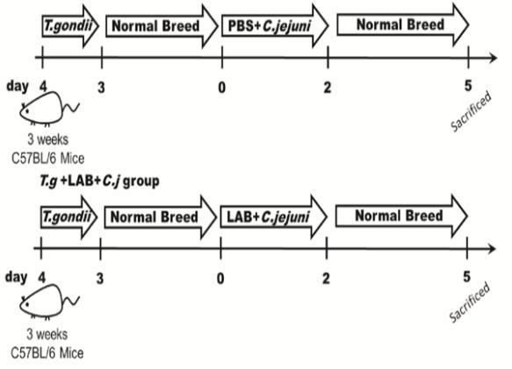
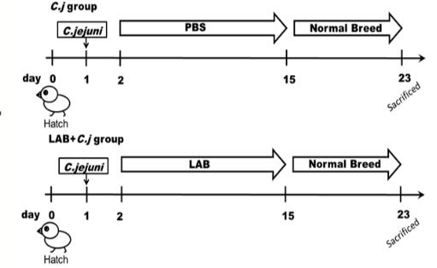
- Inclusion and exclusion criteria
Figure 1 Experimental design for mice and chicken
The mice were included in the study if they underwent successful T. gondii and C. jejuni infection. The mice were excluded if the animal died prematurely due to the acute infection of T. gondii, preventing the collection of histological and feces data. Campylobacter jejuni could symbiotically grow and will not cause disease in chickens. So every chicken could be included (Line 546, Methods, paragraph 7 and 8).
- Randomisation
Ninety six 3-week-old female C57BL/6 mice, weighing 12–15g, were obtained from Shanghai Laboratory Animal Center (Shanghai, China) and randomly divided into 12 groups (8 mice/group): the intact group and the castration group. Random numbers were generated using the standard = RAND() function in Microsoft Excel(Line 535, Methods, paragraph 7).
White leghorn chicken eggs (Jinan Baizhun Biologic Inspection Company, Ltd., China) were maintained in an egg incubator until the chicks hatched. About 24 hours after hatching, 8 chicks were randomly assigned to several groups: the intact group and the castration group. Random numbers were generated using the standard = RAND() function in Microsoft Excel(Line 560, Methods, paragraph 8).
- Blinding
For each animal, four different investigators were involved as follows: a first investigator administered the treatment based on the different LABs. This investigator was the only person aware of the treatment group allocation. A second investigator was responsible for the blood collection and execution of animals, whereas a third investigator performed the dissection. Finally, a fourth investigator (also unaware of treatment) assessed intervention and treatment effect of LAB(Line 553, 574, Methods, paragraph 7 and 8).
- Outcome measures
The C. jejuni loads in mice faeces were checked 3 days later. The faeces were resuspended in sterile PBS and serially diluted. The diluted samples were spread on Columbia blood agar with a C. jejuni selective supplement and incubated at 5% oxygen concentration at 37°C for 48 h (Line 549, Methods, paragraph 7). After incubation, the numbers (CFU) of C. jejuni in the samples were counted. Chicks were sacrificed at 23 days post-inoculation, and the cecal contents were diluted in ice-cold PBS to 0.1 g/mL. Ten-fold serial dilutions of each sample were prepared and then plated on Columbia blood agar with a C. jejuni selective supplement and incubated at a 5% oxygen concentration at 37°C for 48 h (Line 572, Methods, paragraph 8).
- Statistical methods
GraphPad Prism 5.0 and Origin 9.0 were used to perform the statistical analysis, and SPSS Statistics 20.0 was used for the significance analysis. The data were expressed as means ± standard deviations (SDs). Kaplan-Meier survival analysis was used to assess the survival rate of C. elegans. Correlation analysis of the C. elegans groups was conducted using SPSS Statistics 20.0 and Origin 9.0. The groups were compared using a two-tailed Student’s t-test, and a two-sided p value of less than 0.05 was considered statistical significance. Mean values with different superscript letters over the bars are significantly different (p < 0.05) (Line 578, Methods, paragraph 9).
- Experimental animals
Three-week-old female C57BL/6 mice obtained from Shanghai Laboratory Animal Center (Shanghai, China) were used in the experiments. Eight mice were housed in each cage (Line 538, Methods, paragraph 7). White leghorn chicken eggs (Jinan Baizhun Biologic Inspection Company, Ltd., China) were maintained in an egg incubator until the chicks hatched. About 24 hours after hatching, 8 chicks were randomly assigned to several groups (Line 558, Methods, paragraph 8).
- Experimental procedures
To induce ileitis, the C57BL/6 mice were infected orally with 100 T. gondii cysts (ME49 strain; obtained from the Jiangsu Institute of Parasitic Diseases, Remington, Wuxi, China) in 0.3 mL phosphate-buffered saline (PBS, pH 7.4) by gavage, as described previously. As shown in Figure 1, for the 4 days thereafter, the mice were successively (at 1 h intervals) treated with LAB (10⁹ CFU in 0.3 mL or 0.3 mL PBS) and C. jejuni NCTC 11168 (10⁹ CFU in 0.3 mL) by gavage on 2 consecutive days. The C. jejuni loads in their faeces were checked 3 days later. The faeces were resuspended in sterile PBS and serially diluted. The diluted samples were spread on Columbia blood agar with a C. jejuni selective supplement and incubated at 5% oxygen concentration at 37°C for 48 h. After incubation, the numbers (CFU) of C. jejuni in the samples were counted (Line 543, Methods, paragraph 7).
All birds were administered 10⁸ CFU of C. jejuni NCTC 11168 in a 0.3 mL suspension by oral gavage. Twenty-four hours after oral gavage, LAB (10⁸ CFU in 0.3 mL) were orally administered daily to 11 groups (in total 88 birds) of C. jejuni-inoculated birds for two weeks. PBS was administered to the remaining one C. jejuni group of birds (8 birds). Chicks were sacrificed at 23 days post-inoculation, and the cecal contents were diluted in ice-cold PBS to 0.1 g/mL. Ten-fold serial dilutions of each sample were prepared and then plated on Columbia blood agar with a C. jejuni selective supplement and incubated at a 5% oxygen concentration at 37°C for 48 h(Line 565, Methods, paragraph 8).
Figure 1 Experimental design for mice and chicken
- Results
To investigate whether the LAB screened from C. elegans model had the same effects in mammal, 11 LAB strains with different effects on C. elegans immune gene transcription were further investigated, to determine their capabilities to decrease the load of C. jejuni in mice. Seven days after T. gondii infection, the mice developed acute ileitis and likely to die, so the C. jejuni loads were checked on day 5. The load of C. jejuni in the faeces of mice in the C. jejuni infected group reached 10⁸ CFU/g. LAB strains 13-7, Z5 and G20, which had already shown an outstanding ability to protect the nematodes, also exerted superior suppressive effect on C. jejuni load (less than 10⁶ CFU/g faeces) in the mouse intestinal tract (Figure 2) (Line 253, Results, paragraph 7).
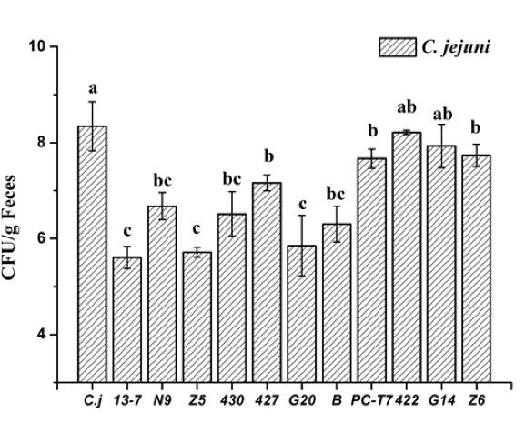
Figure 2 C. jejuni load in mice
The inhibitory effect of LABs on C. jejuni colonization in chicks’ cecum was examined. Approximately 24 h after hatching, chicks were inoculated orally with C. jejuni, and then LAB was administered daily for two weeks. CFU of C. jejuni in chicken cecum in all groups were evaluated on day 23. The average value of C. jejuni increased to 10⁸ CFU/g cecal content in the C. jejuni infected group. Z5 and 427, exerted most significant suppressive effects on C. jejuni colonisation in the chicken cecum, which resulted in C. jejuni loads fell to below 10⁴ CFU/g cecal content in these two groups (Figure 3) (Line 284, Results, paragraph 8).
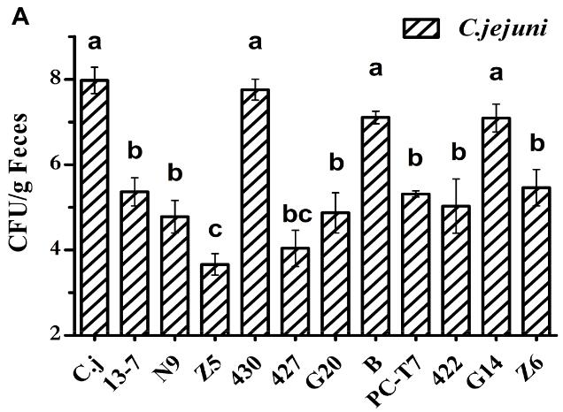
- Abstract
Figure 3 C. jejuni load in chicken
Background and purpose: Campylobacter jejuni is the major microbacillary pathogen responsible for human coloenteritis. Lactic acid bacteria have been shown to protect against Campylobacter infection. This study established a Caenorhabditis elegans life-span model enabling preselection of lactic acid bacteria to counter Campylobacter jejuni infection. Our aim was to evaluate the effects of the Caenorhabditis elegans life-span model in mice and chicken.
Experimental approach: the C57BL/6 mice were infected orally with 100 T. gondii cysts (ME49 strain; obtained from the Jiangsu Institute of Parasitic Diseases, Remington, Wuxi, China) in 0.3 mL phosphate-buffered saline (PBS, pH 7.4) by gavage. For the 4 days thereafter, the mice were successively (at 1 h intervals) treated with LAB (10⁹ CFU in 0.3 mL or 0.3 mL PBS) and C. jejuni NCTC 11168 (10⁹ CFU in 0.3 mL) by gavage on 2 consecutive days. The C. jejuni loads in their faeces were checked 3 days later. All birds were administered 10⁸ CFU of C. jejuni NCTC 11168 in a 0.3 mL suspension by oral gavage. Twenty-four hours after oral gavage, LAB (10⁸ CFU in 0.3 mL) were orally administered daily to 11 groups (in total 88 birds) of C. jejuni-inoculated birds for two weeks. PBS was administered to the remaining one C. jejuni group of birds (8 birds). Chicks were sacrificed at 23 days post-inoculation, and the cecal contents were diluted in ice-cold PBS to 0.1 g/mL.
Key results: Seven days after T. gondii infection, the load of C. jejuni in the faeces of mice in the C. jejuni infected group reached 10⁸ CFU/g. LAB strains 13-7, Z5 and G20, which had already shown an outstanding ability to protect the nematodes, also exerted superior suppressive effect on C. jejuni load (less than 10⁶ CFU/g faeces) in the mouse intestinal tract. In chicken, the average value of C. jejuni increased to 10⁸ CFU/g cecal content in the C. jejuni infected group. Z5 and 427, exerted most significant suppressive effects on C. jejuni colonisation in the chicken cecum, which resulted in C. jejuni loads fell to below 10⁴ CFU/g cecal content in these two groups.
Conclusions and implications: These results showed that Caenorhabditis elegans provides a reliable model enabling researchers to screen for LAB antagonistic to Campylobacter jejuni on a large scale.
- Background
Campylobacter jejuni is the major microbacillary pathogen responsible for human coloenteritis. Lactic acid bacteria have been shown to protect against Campylobacter infection. But LAB that showed a good ability to inhibit the growth of C. jejuni in vitro are less effective in antagonising C. jejuni in animals and animal models have the disadvantages of high cost, a long cycle, cumbersome operation and insignificant immune response indicators. Caenorhabditis elegans is increasingly used to screen probiotics for anti-pathogenic property. However, no research on the use of C. elegans to screen for probiotic candidates antagonistic to C. jejuni has been conducted to date. At the same time, the reliability of the life-span model of Caenorhabditis elegans was needed to verify using Campylobacter jejuni -infected mice and chicken model.
- Objectives
The primary objective of this study was to use Campylobacter jejuni -infected mice and chicken model to verify the reliability of the life-span model of Caenorhabditis elegans.
- Ethical statement
All the mice experimental procedures (#JIPD2017030) had been approved by the Animal Care and Use Committee at the Jiangsu Institute of Parasitic Diseases. All the chicken experimental procedures were approved by the Animal Care and Use Committee at Jiangsu Nannong Hi-technology company, LTD. All the experiments adhered to the Ministry of Science and Technology of China’s Guide for the Care and Use of Laboratory Animals (Line 591, Declarations, paragraph 1).
- Housing and husbandry
Three-week-old female C57BL/6 mice obtained from Shanghai Laboratory Animal Center (Shanghai, China) were used in the experiments. Eight mice were randomly housed in each cage, with a 12-h light-dark cycle and a controllable environment (humidity, 45% ± 5%; temperature, 22°C ± 2°C). White leghorn chicken eggs (Jinan Baizhun Biologic Inspection Company, Ltd., China) were maintained in an egg incubator until the chicks hatched. About 24 hours after hatching, 8 chicks were randomly assigned to several groups (Line 535, Methods, paragraph 7 and 8).
- Animal care and monitoring
Throughout the experimental cycle, we monitored the physiological state of the animals and found that they had no obvious painful symptoms.
- Interpretation/ scientific implications
The mice and chicken model proved the C. elegans life-span model could be used to screen for C. jejuni-antagonistic LAB on a large scale.
- Generalisability/ translation
The significant correlation between the ability of LAB to clear C. jejuni in mice and their ability to enhance the survival rate of C. jejuni-infected nematodes indicates that the life-span model of C. elegans infected with C. jejuni can to some extent be applied to C. jejuni-infected mammals.At the same time, the significant correlation between the ability of LAB in clearing C. jejuni in chicken and that in elevating the survival rate of C. jejuni-infected nematodes still indicated that C. elegans is a good model organism for screening for C. jejuni-resistive LAB strains on a large scale.
- Declaration of interests
The authors declare that they have no competing interests (Line 603, Declarations, paragraph 4).

