Production, Characterization, and Functional Properties of Protein Concentrate from Momordica cochinchinensis Seeds
Anh Van Nguyen¹, Khanh Kim Nguyen¹, Uyen Nguyen Thao Le¹, Anh Minh Tran¹, Binh Cong Nguyen¹, Hoai Thi Ngoc Nguyen¹, Anh Thi Ngoc Vu^{2,3*}
¹ Faculty of Food Science and Technology, Ho Chi Minh City University of Industry and Trade, Ho Chi Minh City, Viet Nam
² Laboratory of Advanced Materials Chemistry, Institute for Advanced Study in Technology, Ton Duc Thang University, Ho Chi Minh City, Vietnam
³ Faculty of Applied Sciences, Ton Duc Thang University, Ho Chi Minh City, Viet Nam
Corresponds to: vuthingocanh@tdtu.edu.vn
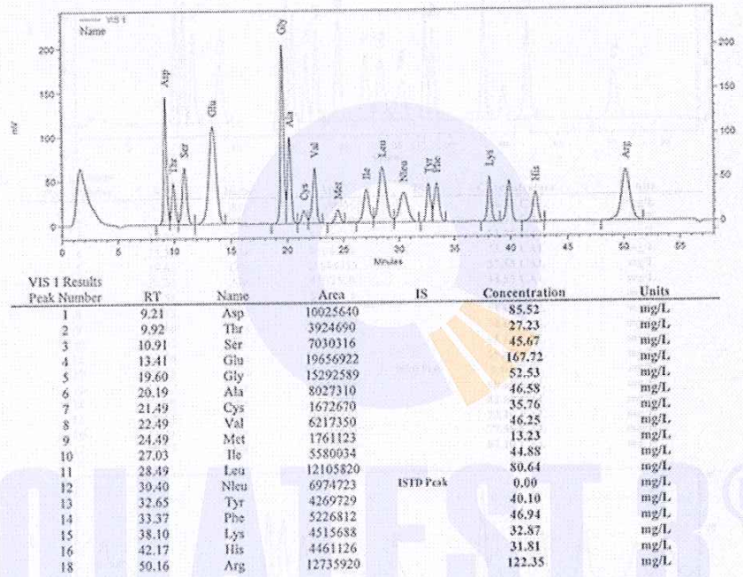
Fig S1. Chromatogram of amino acid contents in MCPC

Fig S2. Trolox calibration curve
Table S1. Antioxidant capacity of MCPC
Protein sample concentration  (µg/mL) | TEAC  (µg Trolox/mL)
50 | 9.05±0.20
100 | 17.89±0.23
150 | 21.69±0.29
200 | 23.63±0.19

