Chemical, Electrochemical and Surface Studies of New Metal-organic Networks as Corrosion Inhibitors for Carbon Steel in Sulfuric Acid Environment

Abd El-Aziz S. Fouda^{1*}, Safaa Eldin H. Etaiw ², Gannat S. Hassan ²
¹Department of Chemistry, Faculty of Science, Mansoura University, Mansoura-35516, Egypt, email: asfouda@hotmail.com; Fax: +2 050 2202264 Tel: +2 050 2365730
²Department of Chemistry, Faculty of Science, Tanta University, Tanta-31527, Egypt
Supplementary Materials
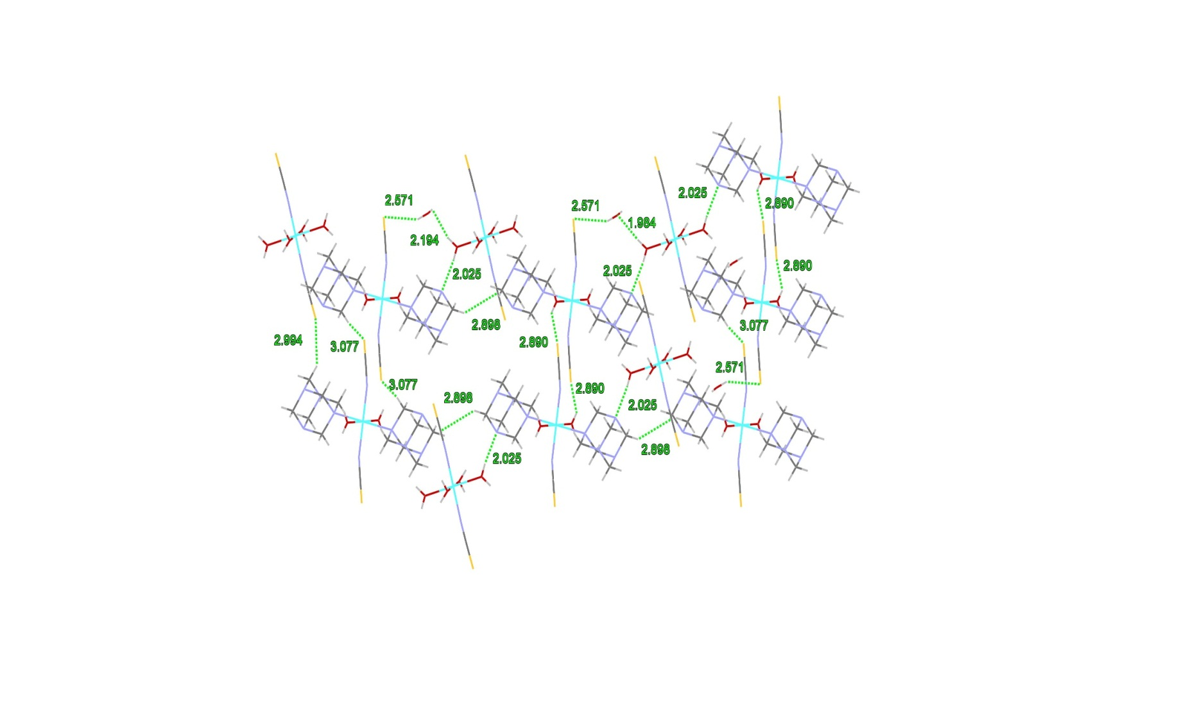

Figure S1 1D-chain of SC1 connected by H-bonds along the b-axis
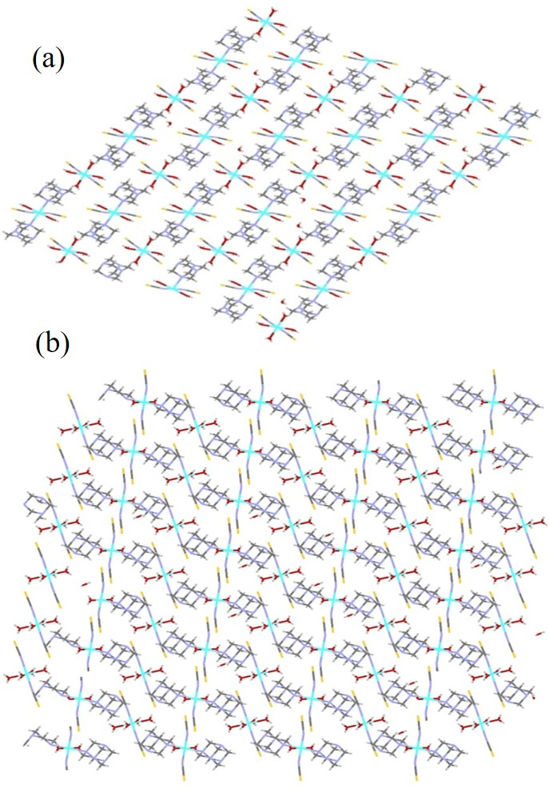
Figure S2 Perspective view of 3D-framework of SC1 along (a) a-axis and (b) b-axis

Figure S3 Visualization of the corrugated 1D-chain of the SCP2 down the projection of the ac -plane showing the distribution of the methyl groups at both sides of the chain

Figure S4 Visualization of the 3D-network structure of the SCP2 down the projection of b -axis showing the methyl groups and (qox) molecules located in the space of the network

Figure S5 View showing the distorted ring structure in the network of SCP2

Table S1 Crystal data and structure refinement parameters of SC 1
Chemical formula | C₁₆ H₄₀ Co₂ N₁₂ O7 S₄
Formula weight | 774.70
Crystal system | Triclinic
Space group | P -1
a (Å) | 7.8696(16)
b (Å) | 8.9388(18)
c (Å) | 12.827(3)
α (°) | 94.07(3)
β (°) | 96.94(3)
γ (°) | 114.85(3)
V (Å³) | 805.3(4)
Z, wavelength | 1, 0.7 Å
D_{calcd} (g/cm³) | 1.597
Absorption coefficient, mm^{–1} | 1.348
F(000) | 402.0
θ range, deg | 1.590°– 29.996°
Index range h, k, l | 11,12,18
R_{int} | 0.023
Data/restraint/parameters | 4761/16/ 226
Goodness of fit on F ² | 1.1158
Final R₁, wR₂ (I > 2σ(I)) | 0.0279, 0.0843
Δρ_{max}, eÅ⁻³ , Δρ_{min}, eÅ⁻³ | 0.58,-0.77
CCDC NO | 1991081
Co2—N1 | 2.100 | N1—C1 | 1.166
Co2—O2 | 2.065
Co2—O3 | 2.106
N2—C2 | 1.166 | N3—C3 | 1.488
C2—S2 | 1.645 | N3—C4 | 1.493
 |  | N3—C5 | 1.490
 |  | C7—N4 | 1.479
 |  | C4—N5 | 1.474
 |  | C5—N6 | 1.478
CO2—C2  N2—S2  C_{O}1—O1  C_{O}1—N1  C_{O}1—N3  N2— C2— S2  Co2— N2— C2  N1— C_{O}1— O1 | 3.265  2.811  2.088  2.051  2.305  178.37  177.28  90.16 | C7—N6  C5—N6  H83—O4—H84  N1—C1—S1  C_{O}1—N1—C1  C3— N3— C5 | 1.474  1.478  104.45  179.27  163.39  107.40
Table S2 needs to be tabulated correctly
Table S2 Bond lengths (Å) and bond angles (deg.) of SC1

Table S3 Crystal data and structure refinement parameters of the SCP 2
Chemical formula | C₂₃H₃₅N₈OSn₃Co
Formula weight | 854.65
Crystal system | Monoclinic
Space group | C₂/c
a (Å) | 16.837(3),
b (Å) | 12.542(3),
c (Å) | 33.116(7)
α (°) | 90
β (°) | 93.29(3)
γ (°) | 90
V (Å³) | 6982(2)
Z | 8
D_{calcd} (g/cm³) | 1.626
Absorption coefficient, mm^{–1} | 2.614
F(000) | 3312.0
Crystal size, mm | 0.040 x 0.070 x 0.090
θ range, deg | 1.213°– 29.763°
Index range h, k, l | -23 / 23, 0/ 17, 0/ 46
R_{int} | 0.0572
Data/restraint/parameters | 9198/4/ 333
Goodness of fit on F ² | 0.9458
Final R₁, wR₂ (I > 2σ(I)) | 0.0609, 0.1588
Δρ_{max}, eÅ⁻³ , Δρ_{min}, eÅ⁻³ | 1.61, -0.49
CCDC NO | 1948888

Table S4 Bond lengths (Å) and bond angles (deg.) of the SCP 2
Co1—C1 | 1.877 (5) | Sn1—C7 | 2.112 (9)
Co1—C2 | 1.884 (6) | Sn1—C8 | 2.127 (7)
Co1—C3 | 1.879 (6) | Sn1—C9 | 2.091 (9)
Co1—C4 | 1.872 (5) | Sn1—C10 | 2.132 (7)
Co1—C5 | 1.881 (6) | Sn1—C11 | 2.114 (7)
Co1—C6 | 1.881 (6) | Sn1—C12 | 2.118 (7)
C1—N1 | 1.152 (7) | Sn1—N1 | 2.291 (5)
C2—N2 | 1.141 (8) | Sn1—N4 | 2.314 (5)
C3—N3 | 1.146 (7) | Sn2—N2 | 2.309 (5)
C4—N4  C5—N5  C6—N6  N7—C16  N7—C23  N8—C21  N8—C22  O1— Sn3— N3  Co1— C1— N1  Co1— C2— N2  Co1— C3— N3 | 1.146 (7)  1.155 (8)  1.132 (8)  1.383 (8)  1.300 (8)  1.373 (8)  1.304 (9)  177.17 (8)  178.6 (5)  178.5 (5)  178.6 (5) | Sn3—N3  Sn2—N6  O2— Sn3  Sn1—N1—C1  Sn2—N2—C2  Sn3—N3—C3  Sn1—N4—C4  Sn2—N6—C6  Co1— C4— N4  Co1— C5— N5  Co1— C6— N6 | 2.310 (5)  2.320 (6)  2.251 (4)  159.4 (5)  158.0 (5)  156.5 (5)  162.17 (2)  150.1 (6)  176.8 (7)  178.0 (6)  176.6 (6)

