Table 1. Survey Instrument Dimensions
Dimension | Description
Organizational Commitment | Binary assessment of ED misuse reduction as organizational priority
Perceived Drivers | Open-ended and categorical questions regarding assumed causes of ED misuse
Organizational Effectiveness | Five-point Likert scale ratings (1=Very Poor, 5=Excellent) across four domains: Technical aspects (analytical capabilities, process improvement); Human aspects (staffing, leadership, communication); Financial aspects (budget management, resource allocation); Data aspects (data collection, analysis, utilization)
De-implementation Success | Frequency of successful program discontinuation (Always, Often, Sometimes, Rarely, Never)
Priority-Setting Challenges | Primary difficulties in organizational decision-making
Decision-Making Factors | Influences on strategic priority selection
Emotional Responses | Descriptive terms characterizing feelings about ED misuse prioritization

Summary of CHNA Priority Ranking (Table 2)
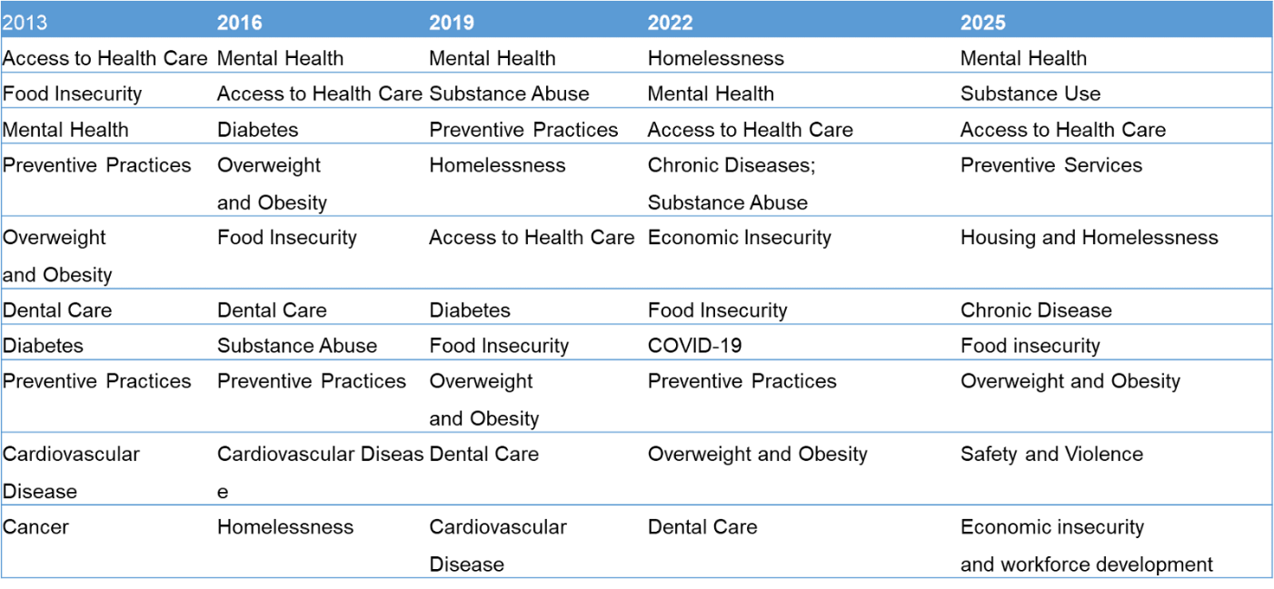
Survey Participant Characteristics & Organizational Commitment (Table 3) 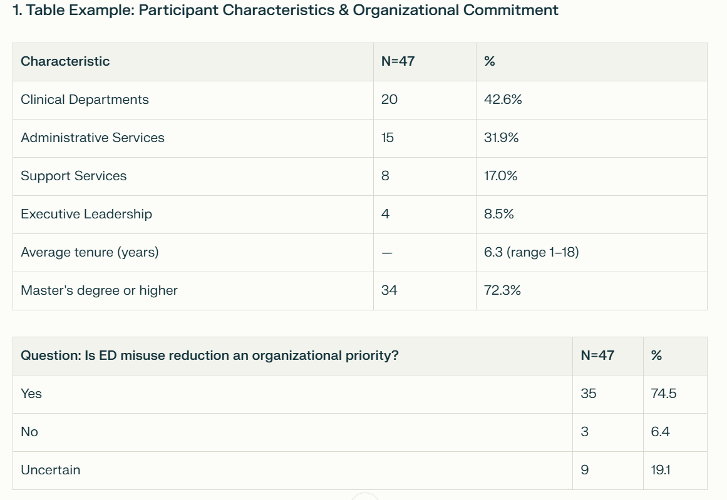

Table 4. Cross-tabulation: Perceived Organizational Effectiveness vs. De-implementation Success
De-implementation Success Rate | High Effectiveness Domains* | Low Effectiveness Domains** | Total | Expected Value
Always/Often Successful (>60%) | 12 (75.0%) | 4 (25.0%) | 16 | 11.2/4.8
Sometimes Successful (40-60%) | 14 (70.0%) | 6 (30.0%) | 20 | 14.0/6.0
Rarely/Never Successful (<40%) | 7 (63.6%) | 4 (36.4%) | 11 | 7.7/3.3
Total | 33 | 14 | 47 | 47
*High effectiveness: Technical (70.2%) and Human aspects (59.6%)
**Low effectiveness: Financial (53.2%) and Data aspects (51.0%)

