Supplementary material
Table S1. Model selection for GLM models of Trypanosoma cruzi EIP in Triatoma infestans acclimated to four temperature treatments that differed in temperature mean and temperature variability.
Models for EIP | df | LRT | AIC
~ T+ P_{m} + bi + mb + bi x mb | 9 | - | 700.33
~ T + bi + mb + bi x mb | 8 | 0.9733 | 698.34*
~ T+ bi + mb | 7 | < 0.01 | 708.33
~ bi + mb + bi x mb | 5 | < 0.01 | 725.00
~ T | 5 | < 0.01 | 722.41
GLM: Generalized linear model; EIP: Extrinsic incubation period; df: degrees of freedom; LRT: likelihood ratio test; AIC: Akaike's information criterion; T: Temperature treatments; P_{m}: mouse parasitemia; bi: ingested blood; mb: body mass before infection. * selected model.

Table S2. Tukey test for EIP GLM model
 | Estimate | Std. Error | z value | p
18V - 18C | 0.005 | 0.007 | 0.632 | 0.580
27C - 18C | 0.050 | 0.011 | 4.525 | < 0.001
27V - 18C | 0.037 | 0.010 | 3.819 | < 0.001
27C - 18V | 0.045 | 0.011 | 3.994 | < 0.001
27V - 18V | 0.032 | 0.010 | 3.214 | < 0.005
27V - 27C | -0.013 | 0.012 | -1.058 | 0.580

Table S3. Model selection for GAM models of T. cruzi parasitic load in Triatoma infestans acclimated to four temperature treatments that differed in temperature mean and temperature variability. The one in bold is the selected model.
GAM models for parasitic load | df | AIC
~ T + s(ID) + s(Days, by = T) + te(mb, bi, by = T) + P_{m} | 46.632 | 1452.900
~ T + s(ID+ s(Days, by = T) + te(mb, by =T) | 45.858 | 1448.647 *
~ s (ID) + s(Days, by=T) + te(mb, bi, by =T) | 53.985 | 1482.309
~ T+ s (ID)+ s(Days, by=T) + te(mb, bi) | 34.610 | 1421.588
~ T + s(ID)+ s(Days) + te(mb, bi, by= T) | 34.750 | 1426.263
~ T + s(ID)+ s(Days) + te(mb, bi) | 33.889 | 1554.681
~ T + s(ID)+ s(Days) + te(mb, bi, by= T) | 38.313 | 1323.659
~ T + s(ID)+ Days + te(mb, bi, by = T | 33.889 | 1428.384
~ T + s(ID, + s(Days, by = T) + s(mb, by = T) + s(bi, by = T) + P_{m} | 52.028 | 1286.549
~ T + s(ID)+ s(Days, by = T) + s(mb, by = T) + s(bi, by = T) | 53.077 | 1284.569
~ s(ID,) + s(Days, by = T) + s(mb, by = T) + s(bi, by = T) | 52.847 | 1284.406
~ s(ID)+ s(Days, by = T) + s(mb) + s(bi, by = T) + P_{m} | 43.893 | 1296.872
~ s(ID) + s(Days, by = T) + s(mb) + s(bi, by = T) | 44.861 | 1290.069
~ s(ID)+ s(Days, by = T) + mb + s(bi, by = T) | 41.999 | 1296.056
~ s(ID ") + s(Days, by = T) + mb + s(bi) | 24.126 | 1330.877
~ s(ID) + s(Days) + s(mb, by = T) + s(bi) | 24.946 | 1319.625
~ s(ID) + s(Days, by = T) + s(mb) + s(bi) | 31.630 | 1327.146
~ T + s(ID) + s(Days, by = T) + s(bi, by = T) + P_{m} | 43.772 | 1304.689
~ T + s(ID) + s(Days, by = T) + P_{m} | 21.678 | 1357.071
~ T + s(ID)+ s(Days) + s(mb) + s(bi) + P_{m} | 20.094 | 1330.822

GAM: Generalized additive model; df: degrees of freedom, LRT: likelihood ratio test, AIC: Akaike's information criterion; T: Temperature treatment; s: spline; ID: triatomine individuals; Days: time measured as days; m_{b}: body mass before infection; b_{i}: ingested blood; P_{m}: mouse parasitemia.

Table S4. Model selection for GAMLSS models for the probability of Trypanosoma cruzi positive dejections in Triatoma infestans acclimated to four temperature treatments that differed in temperature mean and temperature variability. All modes have a random effect by individual (ID).
GAMLSS models for positive dejections | gl | AUC | AIC
~T * cs(Days)+random(factor(ID)) * P_{m} + bi *mb | 78.978 | 0.988 | 325.855
~T * cs(Days)+random(factor(ID)) * P_{m} + bi + mb | 99.06 | 0.988 | 323.809
~T * cs(Days)+random(factor(ID)) + Pm + bi + mb | 99.06 | 0.988 | 323.809
~T * cs(Days)+random(factor(ID)) + bi * bmb | 99.128 | 0.988 | 323.933
~T * cs(Days)+random(factor(ID)) + Pm + bi | 98.123 | 0.988 | 321.898
~T * cs(Days)+random(factor(ID)) + bi | 97.182 | 0.988 | 320.153
~T * cs(Days)+random(factor(ID)) | 96.498 | 0.988 | 318.761*
~T + cs(Days)+random(factor(ID)) | 78.978 | 0.978 | 349.802
~T + random(factor(ID)) | 6.255 | 0.691 | 528.287
GAMLSS: Generalized additive model for location, scale and shape; df: degrees of freedom, AUC: Area under the ROC Curve, AIC: Akaike's criterion; T: Temperature treatment; cs: cubic spline; Days: time measured as days; ID: triatomine individuals; P_{m}: mouse parasitemia; b_{i}: ingested blood; m_{b}: body mass before infection.
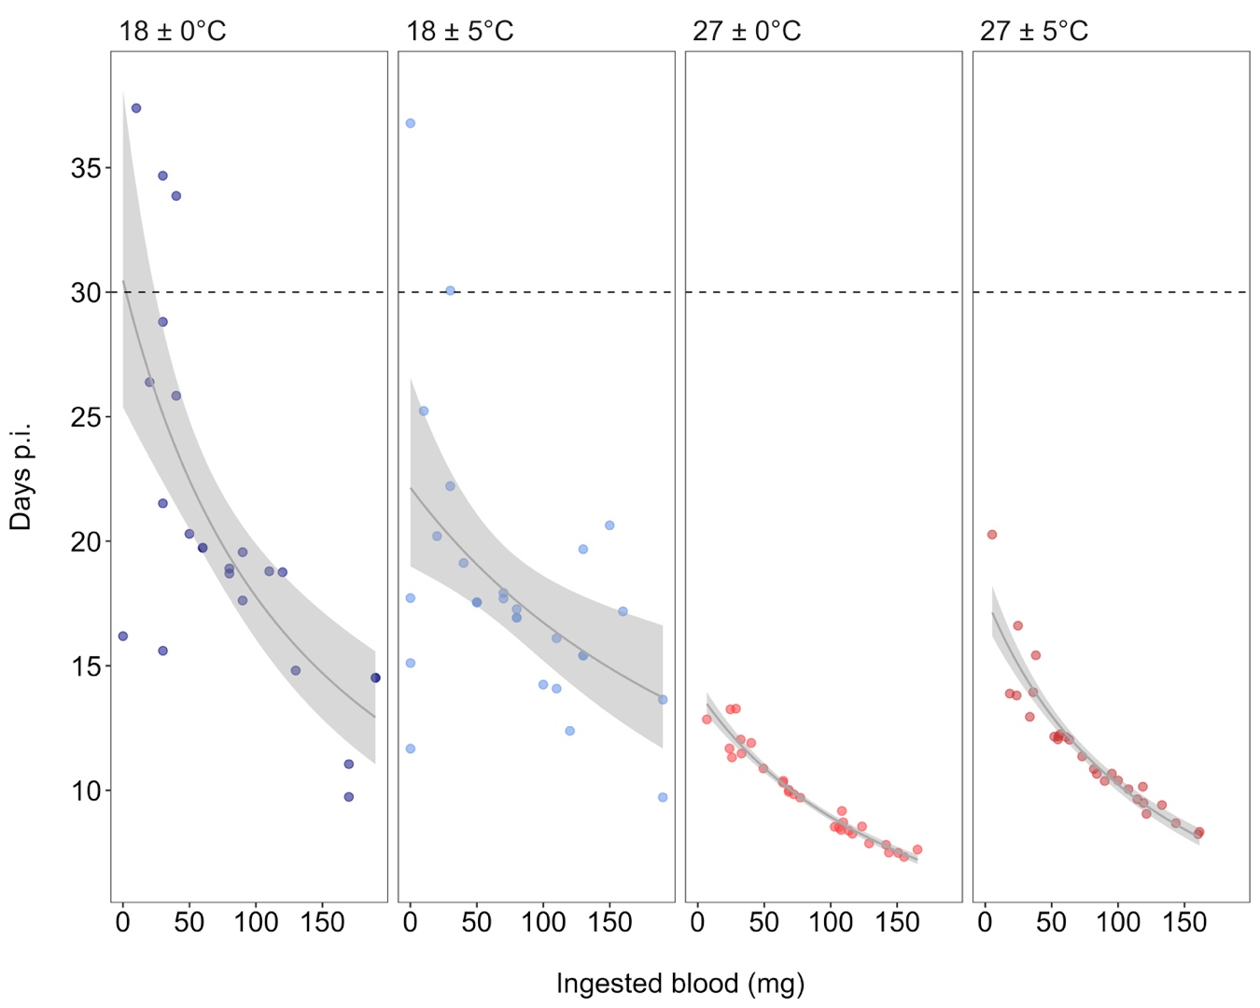
Fig. S1. Predicted extrinsic incubation period (EIP, in days) of Trypanosoma cruzi in Triatoma infestans as a function of ingested infective blood volume (bi, in mg), modeled using a generalized linear model (GLM). Each point represents the first positive detection of an individual. Treatments are shown in different panels: constant cold (18 ± 0 ºC, blue, n = 23), variable cold (18 ± 5 ºC, light blue, n = 28), constant warm (27 ± 0 ºC, red, n = 29), and variable warm (27 ± 5 ºC, dark red, n = 28). The shaded area indicates the standard error of the mean (s.e.m.) of the predicted EIP. Dotted horizontal lines indicate the refeeding day.

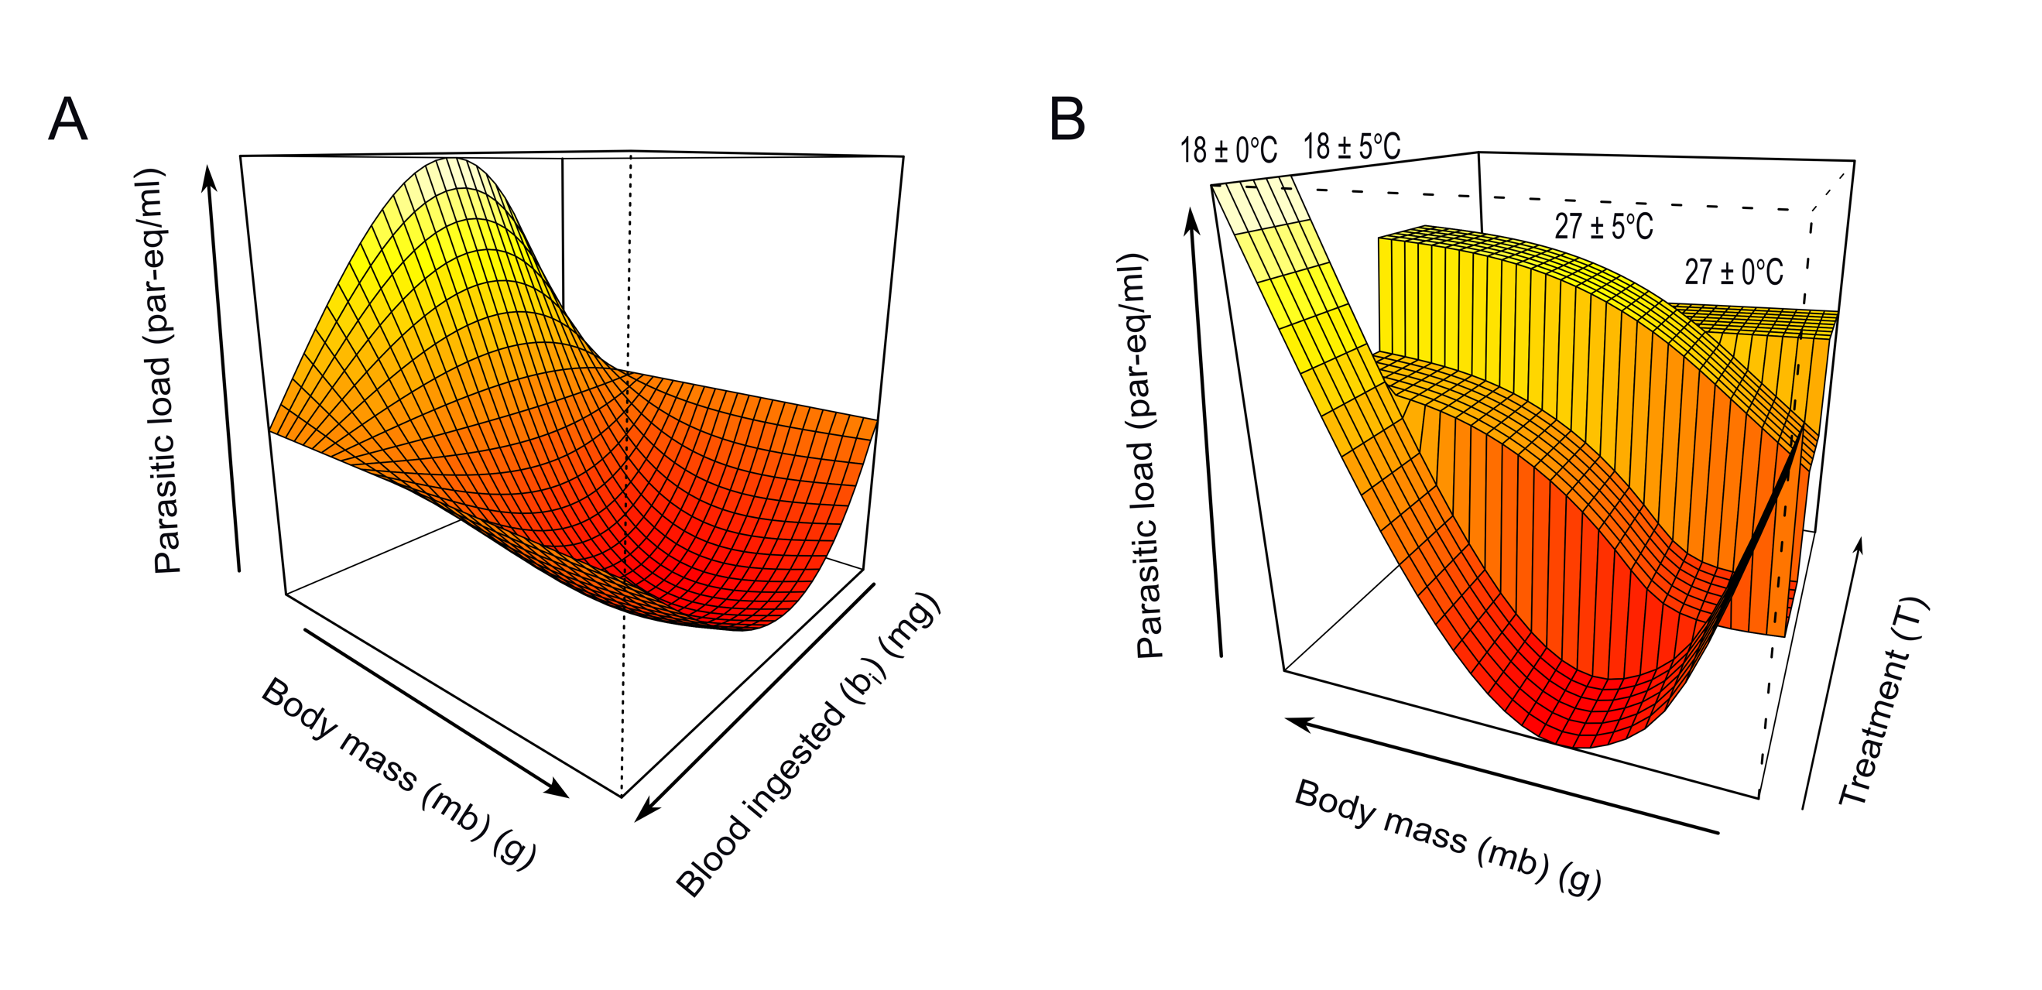Fig. S2. Effect of the interaction of body mass and blood ingested on parasitic load from the GAM model. mb) body mass of T. infestans individuals before infection in grams, bi) Blood ingested during the infection in mg.

