Field-Ready DNA Extraction from Scat Using Magnetic Nanoparticles: A Simple Tool for Wildlife Monitoring
Letizia Dondi, Rahul Chaudhari, Natalie Schmitt, Jocelyn Poissant, Marco Musiani, Carlos Filipe and Yingfu Li*

Supplementary Information

Supplementary Fig. 1. DNA Recovery from different starting amount of scat material. DNA yield increased with greater initial scat weight (150 mg, 300 mg, 450 mg), indicating that the method is scalable and suitable for extracting higher amounts of DNA when larger sample inputs are used.

Supplementary Fig. 2. Mitochondrial sequence alignment of Cervidae species obtained from NCBI. The alignment illustrates the primer-binding regions used in the DI assay, which was developed for specificity to Rangifer tarandus.

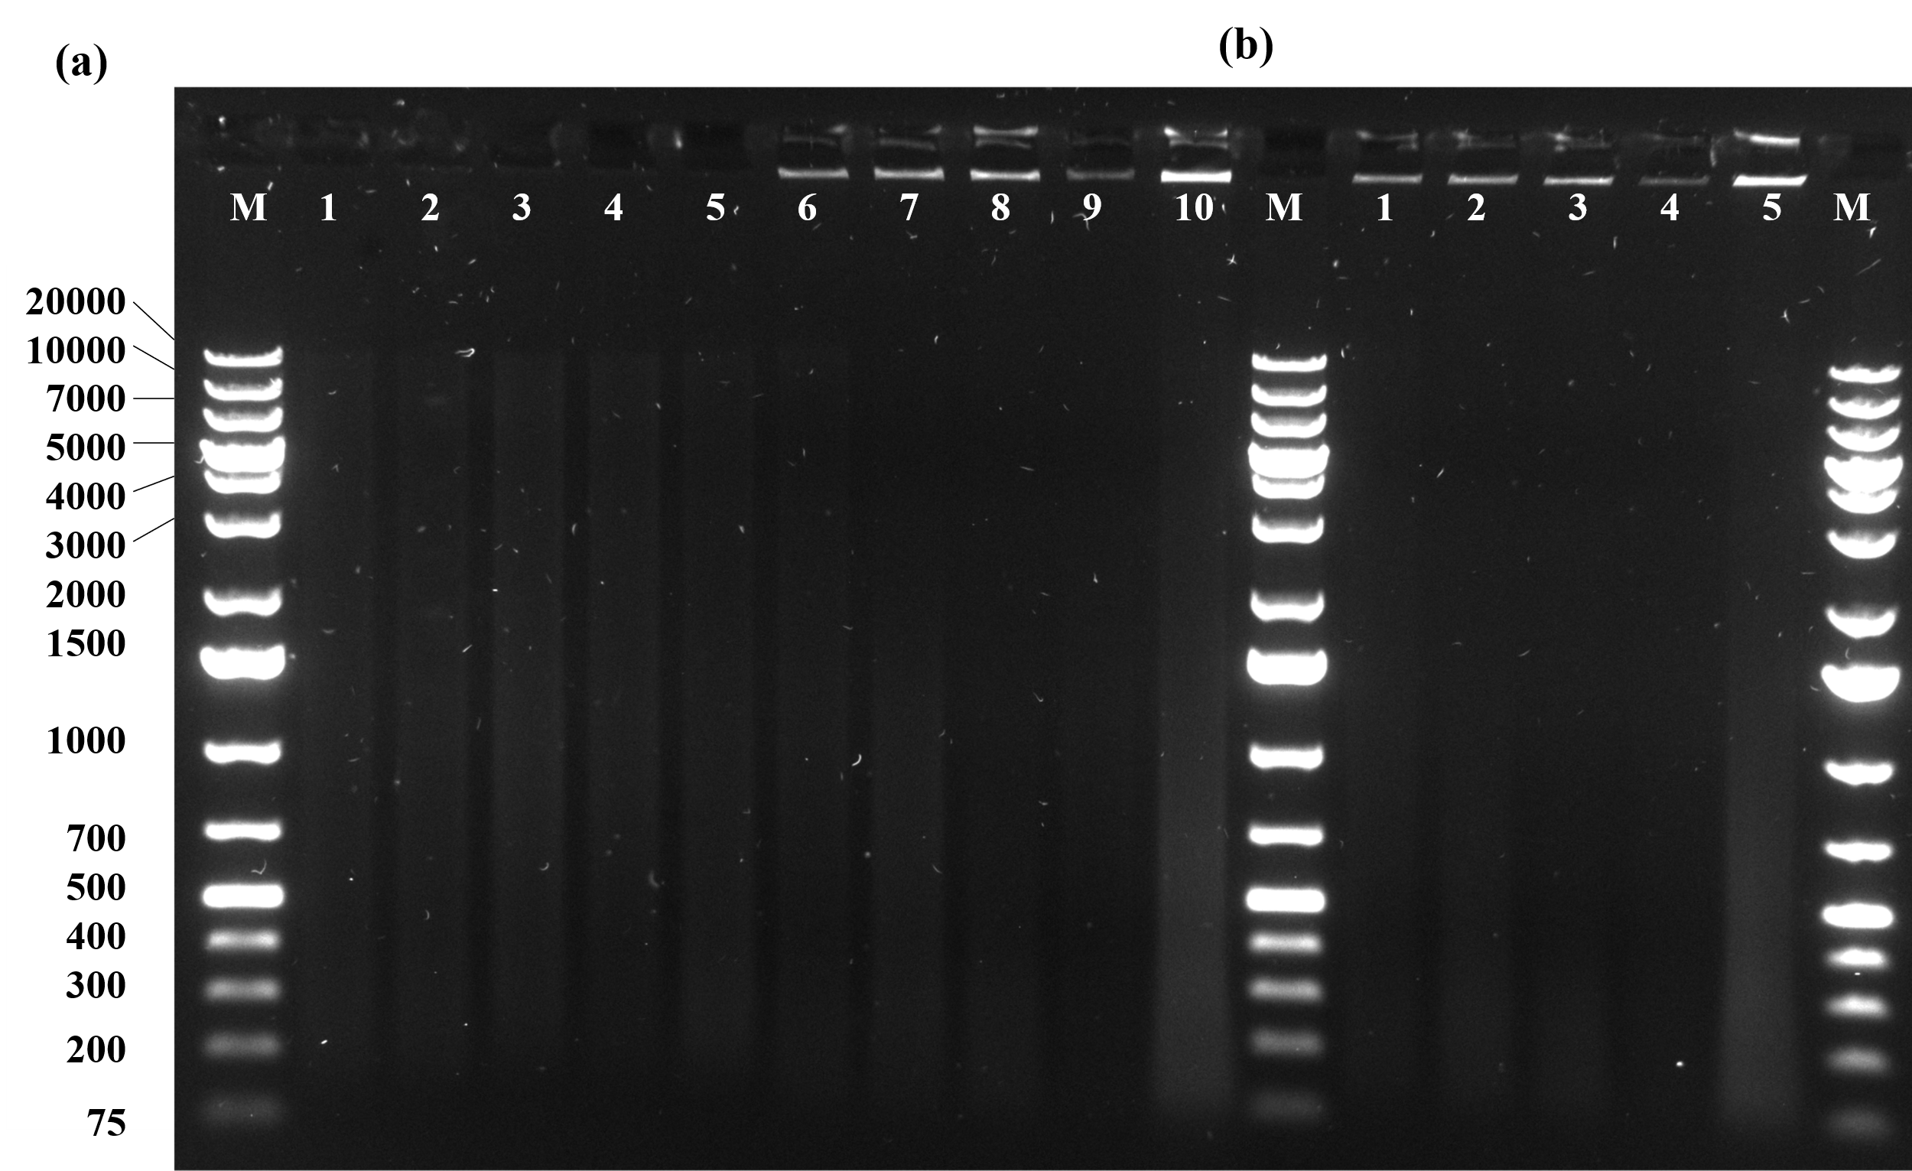
Supplementary Fig 3. DNA fragmentation analysis of R. tarandus scat by gel electrophoresis. (a) DNA extracted using the QIAamp® Fast DNA Stool Kit (lanes 1–5) and the in-house MNP method (lanes 6–10). M: GeneRuler™ 1 kb Plus DNA Ladder. (b) In-house MNP extracts incubated with RNase A to remove RNA contamination (lanes 1–5). M: GeneRuler™ 1 kb Plus DNA Ladder.

