Supplementary Table S1. Representative hairpin secondary structures at mutation sites across different genes and taxa

Gene | Genome |  |  |  |  | Mutation |  |  | Hairpin secondary structures
Hairpin secondary structures at mutation sites in PE_PGRS genes
PE_PGRS7 | Mtb H37Rv vs 4860 (CP053092.1) |  |  |  |  | A680G |  |  | 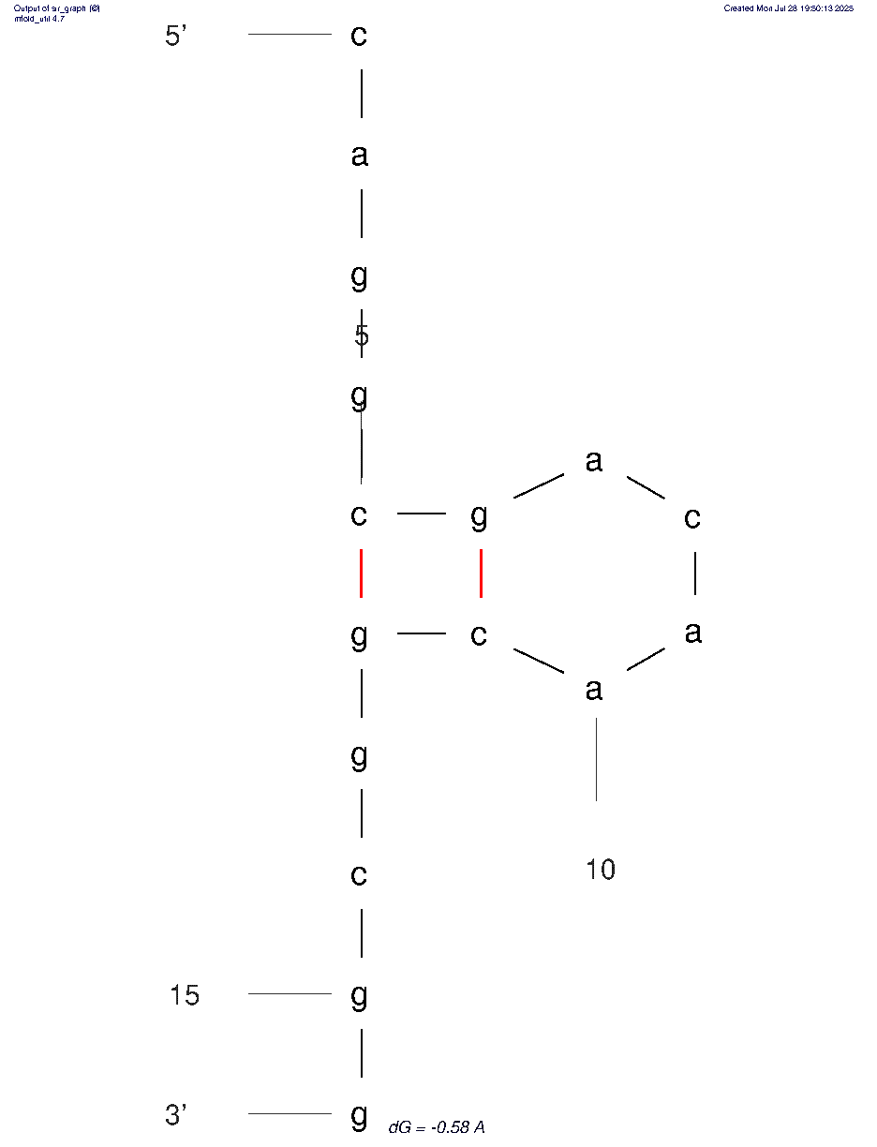
PE_PGRS7 | ΔG (kcal/mol) |  | ΔH  (kcal/mol) |  |  | ΔS (cal/mol·K) | Tm (°C)
PE_PGRS7 | –0.58 |  | –25.60 |  |  | –80.67 | 44.2
PE_PGRS7 | Sequence (5'→3')
PE_PGRS7 | ggcggcgcaggcgacaacggcgg
PE_PGRS7 | Mtb H37Rv vs 4860 (CP053092.1) |  |  |  |  | C4T |  |  | A  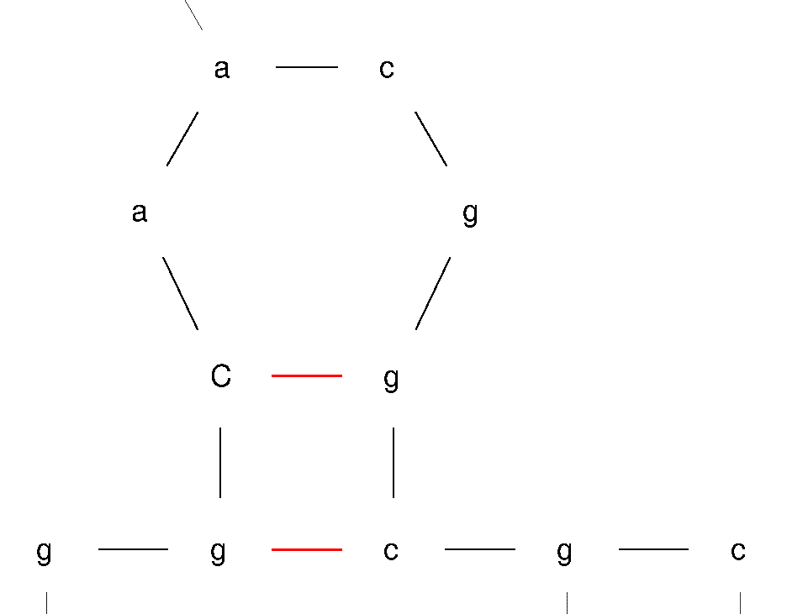  B  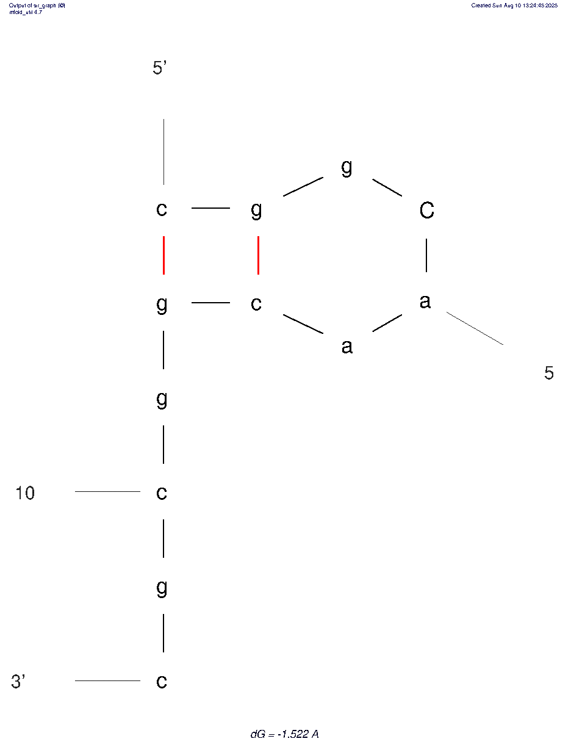
PE_PGRS7 | ΔG (kcal/mol) |  | ΔH  (kcal/mol) |  |  | ΔS (cal/mol·K) | Tm (°C)
PE_PGRS7 | A - 0.01 |  | 16.70 |  |  | -53.81 | 37.2°C
PE_PGRS7 | B -1.52 |  | - 20.10 |  |  | -59.91 | 62.4°C
PE_PGRS7 | Sequence (5'→3')
PE_PGRS7 | ccggCaacggcgccgacggggcggccggg
PE_PGRS7 | Mtb H37Rv vs 4860 (CP053092.1) |  |  |  |  | A14T |  |  | 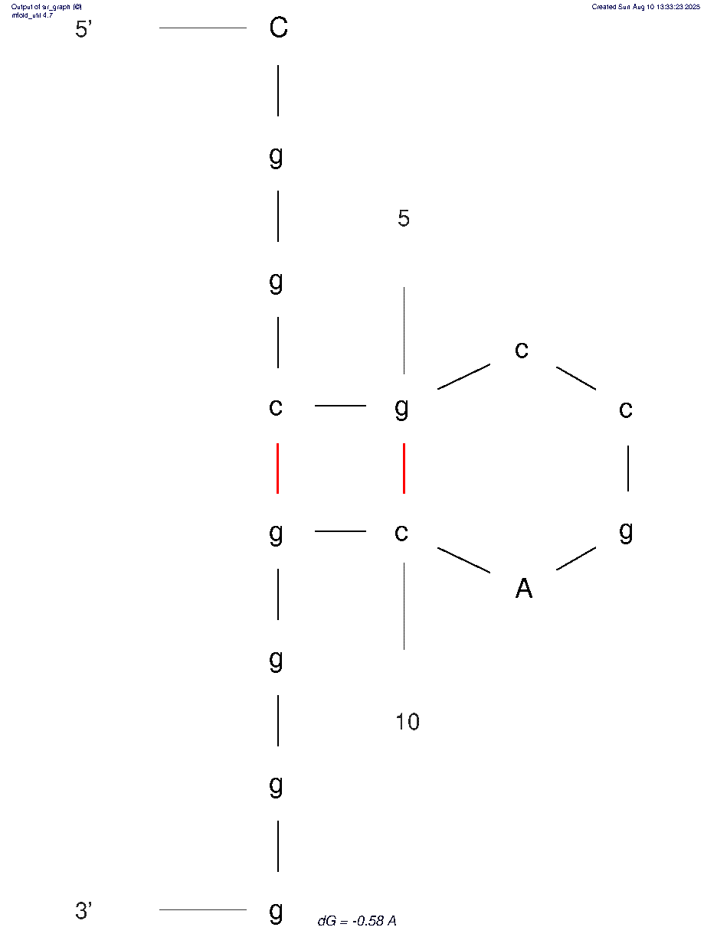
PE_PGRS7 | ΔG (kcal/mol) |  | ΔH  (kcal/mol) |  |  | ΔS (cal/mol·K) | Tm (°C)
PE_PGRS7 | -0.58 |  | -22.40 |  |  | -70.35 | 45.3°C
PE_PGRS7 | Sequence (5'→3')
PE_PGRS7 | CggcgccgAcgggg
PE_PGRS7 | H37Rv vs Mtb 4860 (CP053092.1) |  |  |  |  | G45C |  |  | 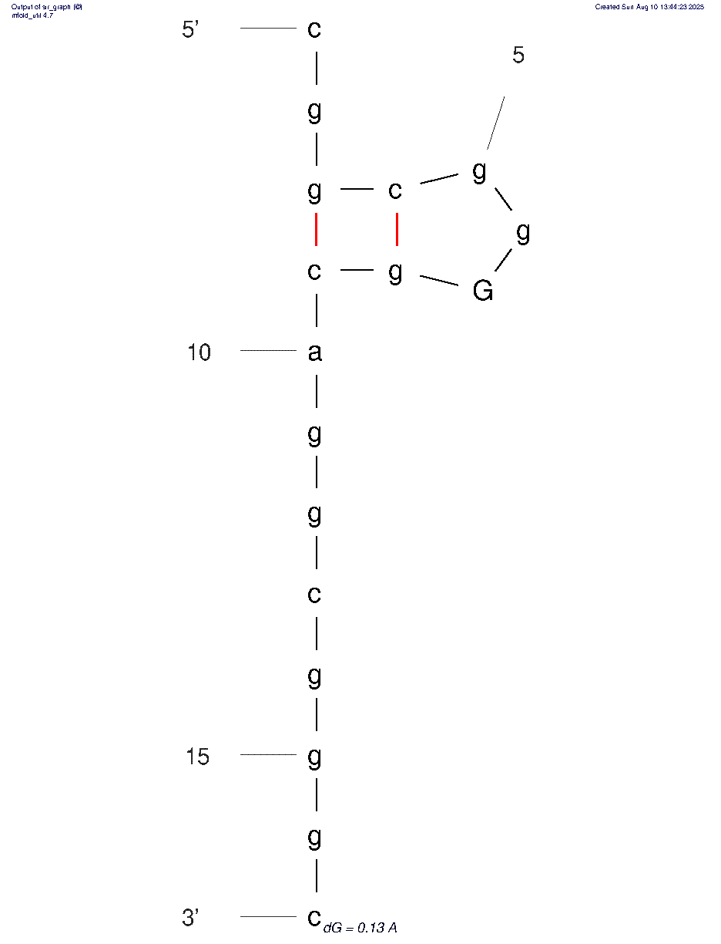
PE_PGRS7 | ΔG (kcal/mol) |  | ΔH  (kcal/mol) |  |  | ΔS (cal/mol·K) | Tm (°C)
PE_PGRS7 | +0.13 |  | -19.60 |  |  | -63.61 | 35.0°C
PE_PGRS7 | Sequence (5'→3')
PE_PGRS7 | cggcggGgcaggcgggc
PE_PGRS7 | H37Rv vs Mtb 4860 (CP053092.1) |  |  |  |  | A48G  G50A |  |  | 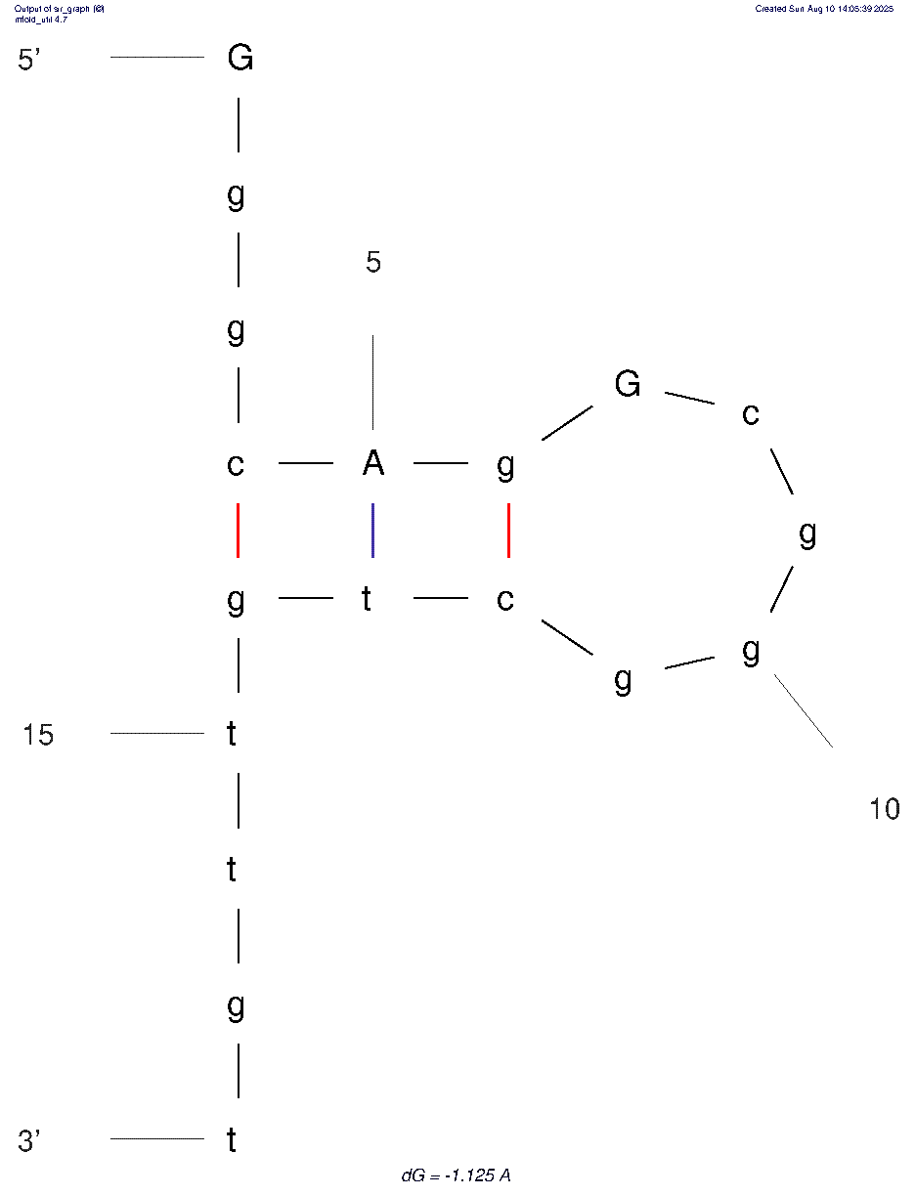
PE_PGRS7 | ΔG (kcal/mol) |  | ΔH  (kcal/mol) |  |  | ΔS (cal/mol·K) | Tm (°C)
PE_PGRS7 | -1.12 |  | -31.10 |  |  | -96.66 | 48.6°C
PE_PGRS7 | Sequence (5'→3')
PE_PGRS7 | GggcAgGcgggctgttgt
PE_PGRS 53 | H37Rv vs M. bovis BCG Pasteur ATCC 35734 CP109681.1 |  |  |  |  | G505A  G506T |  |  | 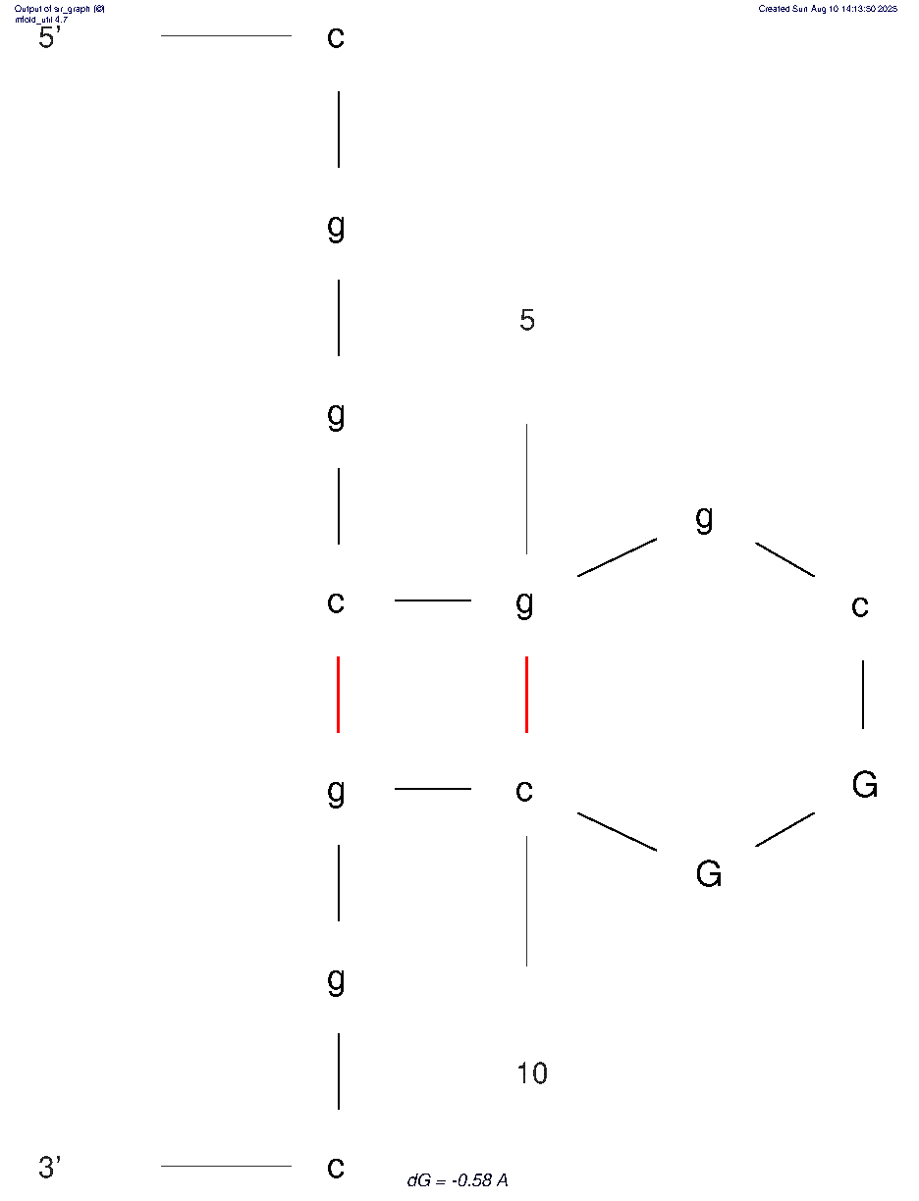
PE_PGRS 53 | ΔG (kcal/mol) |  | ΔH  (kcal/mol) |  |  | ΔS (cal/mol·K) | Tm (°C)
PE_PGRS 53 | -0.58 |  | -24.90 |  |  | -78.41 | 44.4°C
PE_PGRS 53 | Sequence (5'→3')
PE_PGRS 53 | ccggcggcGGcggcggggccggcgc  cggcggcGGcggc
PE_PGRS 53 |  | Mtb H37Rv vs M. bovis BCG Pasteur _{ATCC 35734} CP109681.1 |  |  | C210G, G213C, C216G |  |  |  | 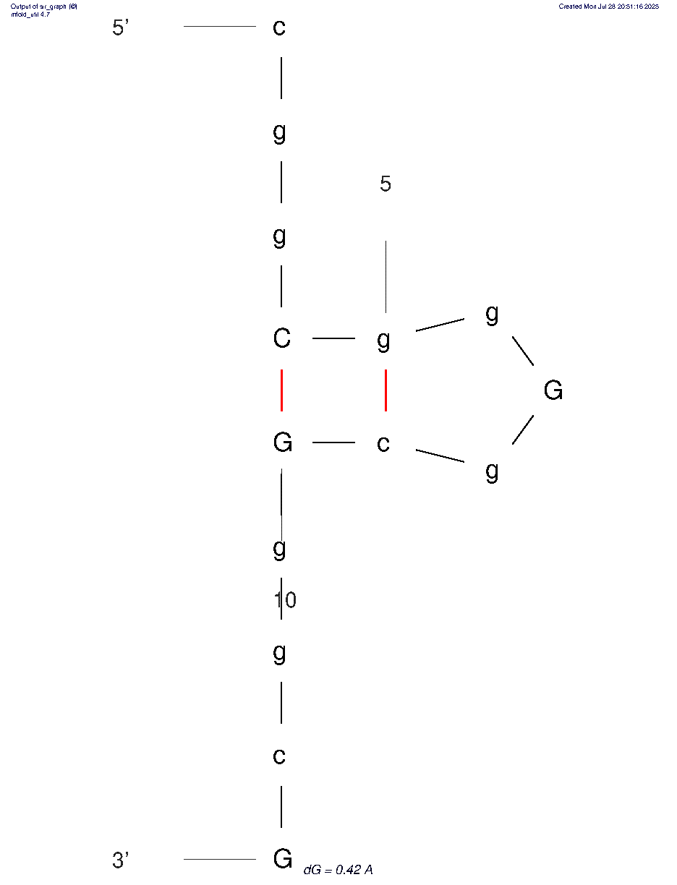
 |  | ΔG (kcal/mol) |  | ΔH  (kcal/mol) | ΔS (cal/mol·K) |  |  | Tm (°C)
 |  | +0.42 |  | -19.60 | -64.55 |  |  | 30.5°C
 |  | Sequence (5'→3')
 |  | cggCggGgcGggcGc
PE_PGRS 53 |  | H37Rv vs M. bovis BCG Pasteur ATCC 35734 CP109681.1 |  |  | C213G  G217A |  |  |  | 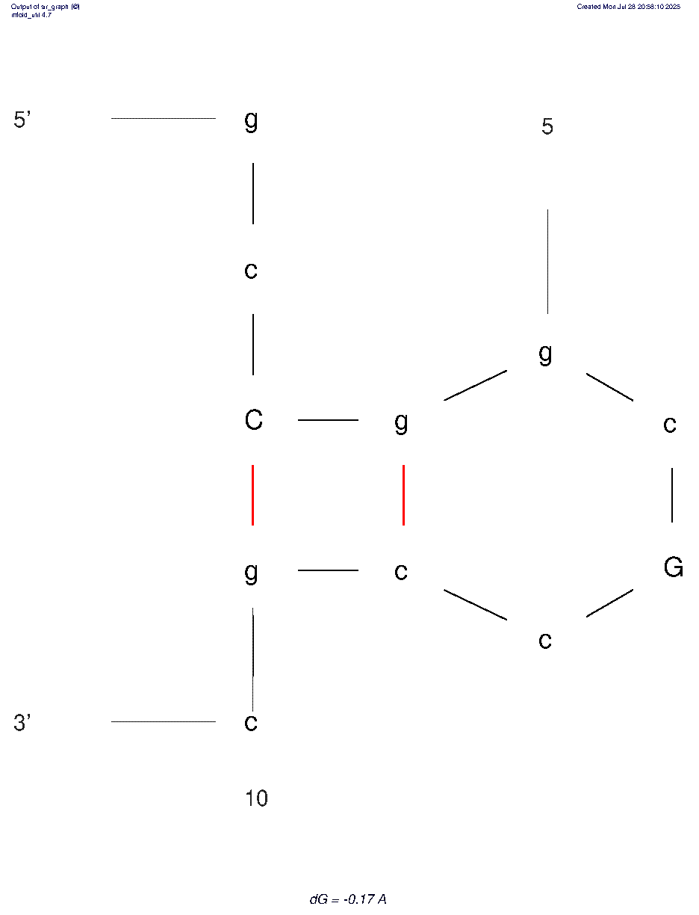
 |  | ΔG (kcal/mol) |  | ΔH  (kcal/mol) | ΔS (cal/mol·K) |  |  | Tm (°C)
 |  | -0.17 |  | -22.20 | -71.03 |  |  | 39.4°C
 |  | Sequence (5'→3')
 |  | gcCggcGccgc
Hairpin secondary structures at mutation sites in ligD, ligB
ligD |  | Mtb H37Rv vs 4860 (CP053092.1) |  |  | TGC1030CGC |  |  |  | 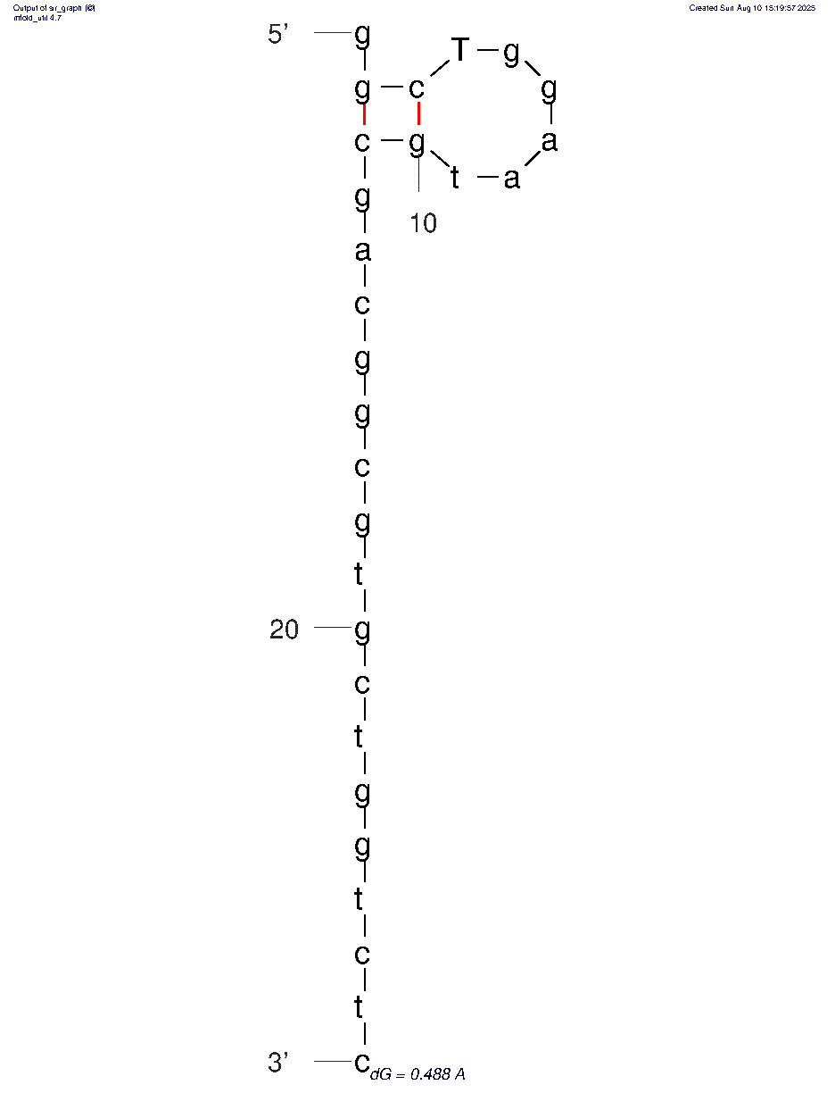
 |  | ΔG (kcal/mol) |  | ΔH  (kcal/mol) | ΔS (cal/mol·K) |  |  | Tm (°C)
 |  | -0.50 |  | -18.50 | -58.04 |  |  | 45.6°C
 |  | Sequence (5'→3')
 |  | сggcTggaatgcgacggcgtgctggtctc
ligB |  | Mtb H37Rv vs 4860 (CP053092.1) |  |  | CCG271TCG |  |  |  | 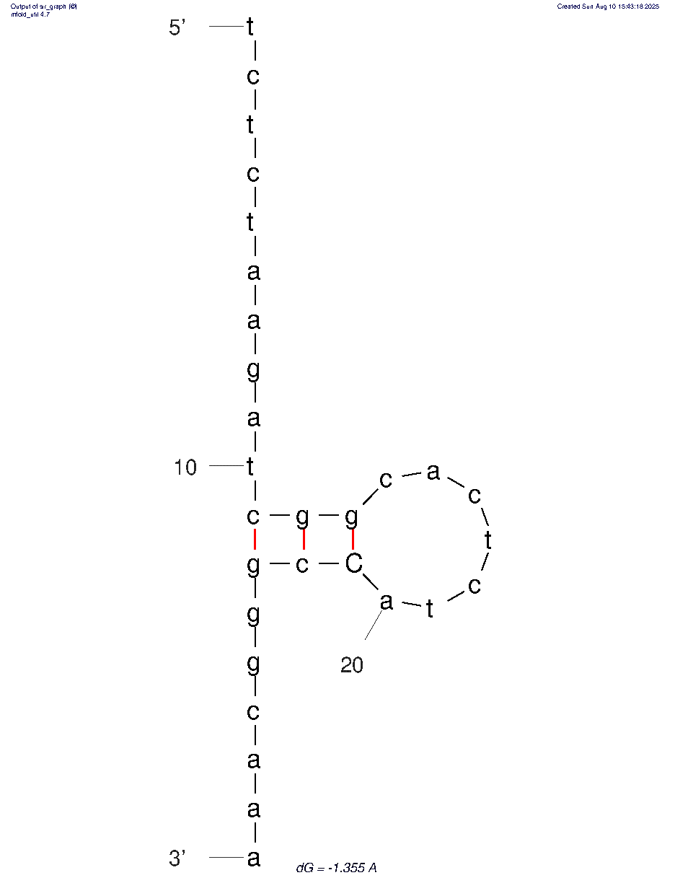
 |  | ΔG (kcal/mol) |  | ΔH  (kcal/mol) | ΔS (cal/mol·K) |  |  | Tm (°C)
 |  | -0.50 |  | -18.50 | -58.04 |  |  | 45.6°C
 |  | Sequence (5'→3')
 |  | tctctaagatcggcactctaCcgggcaaa

Hairpin secondary structures at mutation sites in Human immunodeficiency virus type 1 (HXB2), HIV1/HTLV-III/LAV; GenBank: K03455.1
pol |  | HIV1/HTLV-III/LAV;  GenBank: K03455.1 |  |  | M184V  ATG→GTG |  |  |  | A  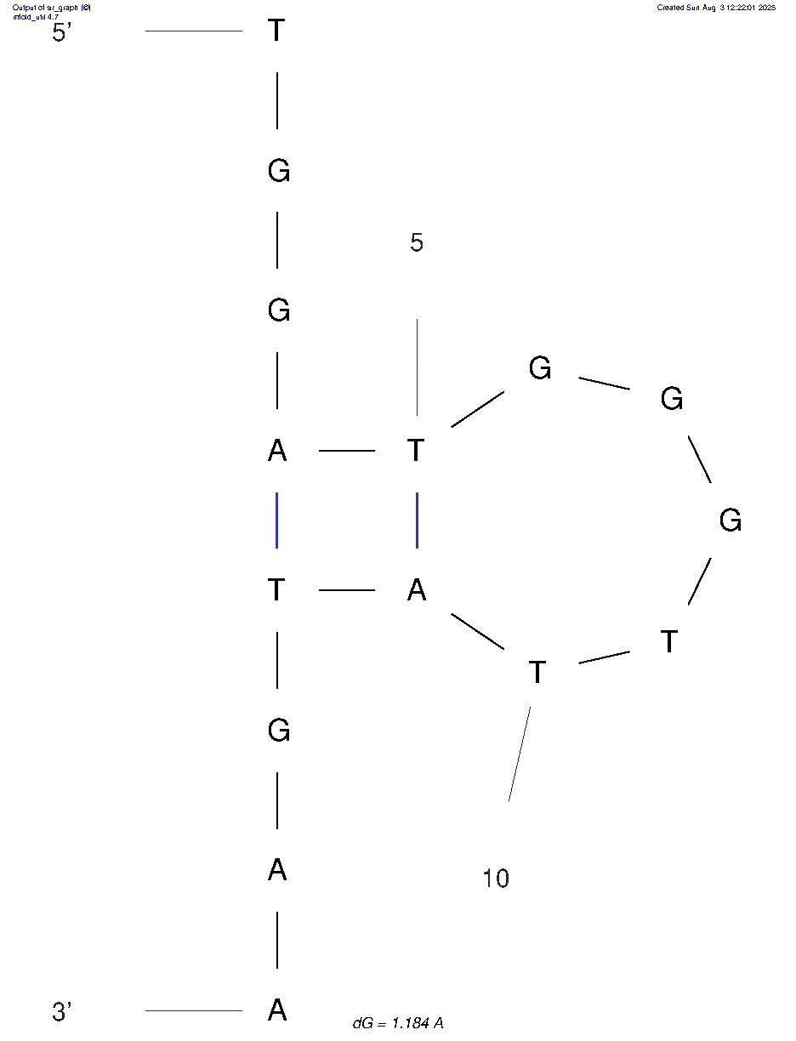  B  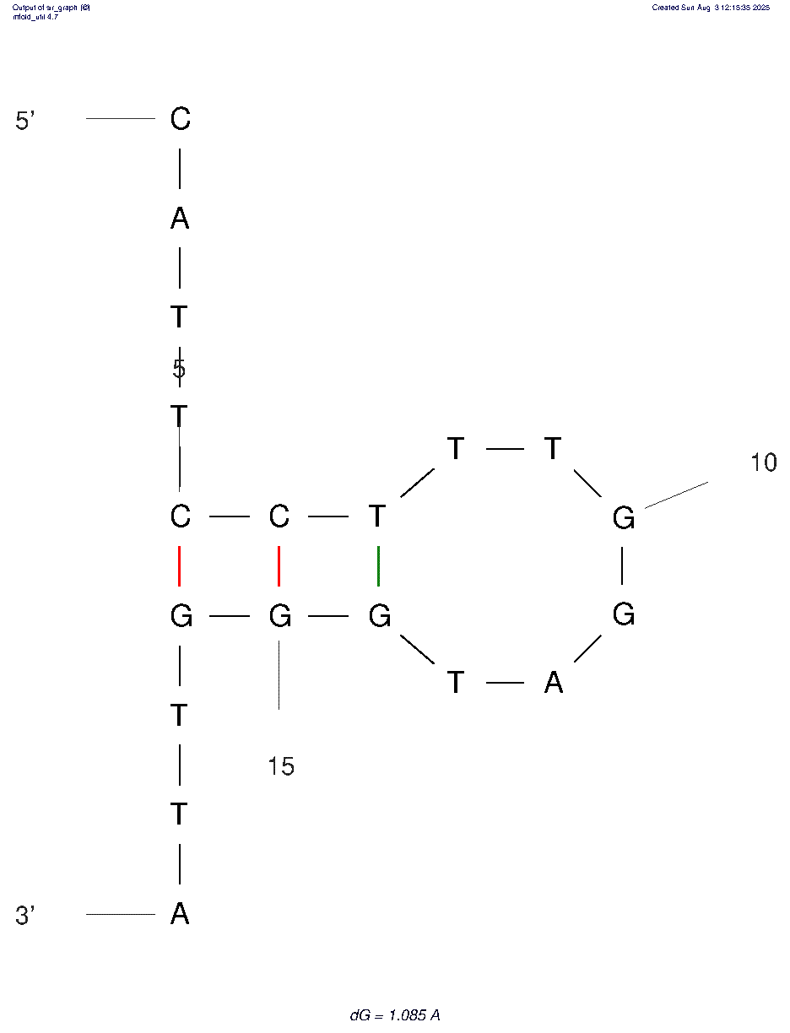
 |  | ΔG (kcal/mol) |  | ΔH  (kcal/mol) | ΔS (cal/mol·K) |  |  | Tm (°C)
 |  | A +1.18 |  | -10.00 | -36.05 |  |  | 4.2°C
 |  | B +1.09 |  | -19.20 | -65.42 |  |  | 20.3°C
 |  | Sequence (5'→3')
cattcctttggAtgggttatgaactccatcctgataaa
Atgggttatgaactccatcctgataaa
Hairpin secondary structures at mutation sites in SARS-CoV-2 (Gene ID: 43740568, NC_045512.2 (21563..25384)^{34, 35}
S- Spike Protein |  | SARS-CoV-2 (Gene ID: 43740568, NC_045512.2 (21563..25384) |  |  | D614 ^{34, 35}  A→G |  |  |  | A  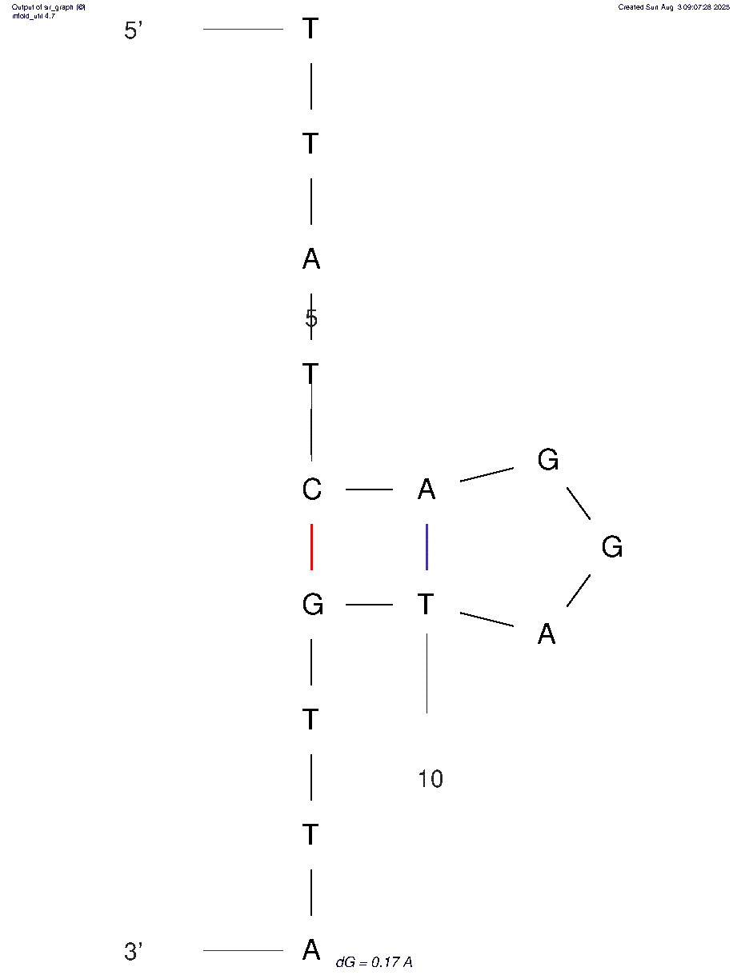  B  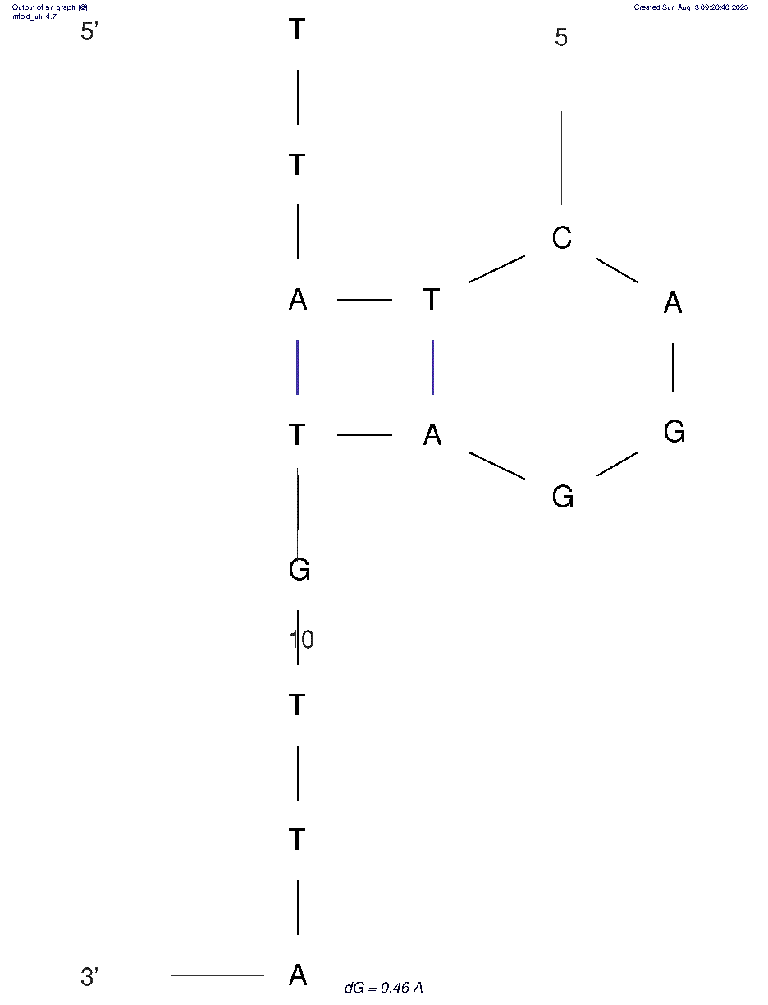
 |  | ΔG (kcal/mol) |  | ΔH  (kcal/mol) | ΔS (cal/mol·K) |  |  | Tm (°C)
 |  | A +0.17 |  | -15.70 | -51.17 |  |  | 33.7°C
 |  | B +0.46 |  | -19.50 | = -64.36 |  |  | 29.8°C
 |  | Sequence (5'→3')
 |  | caggAtgtt
S- Spike Protein |  | SARS-CoV-2 (Gene ID: 43740568, NC_045512.2 (21563..25384) |  |  | 292 ALDP 295^{34, 35} |  |  |  | A  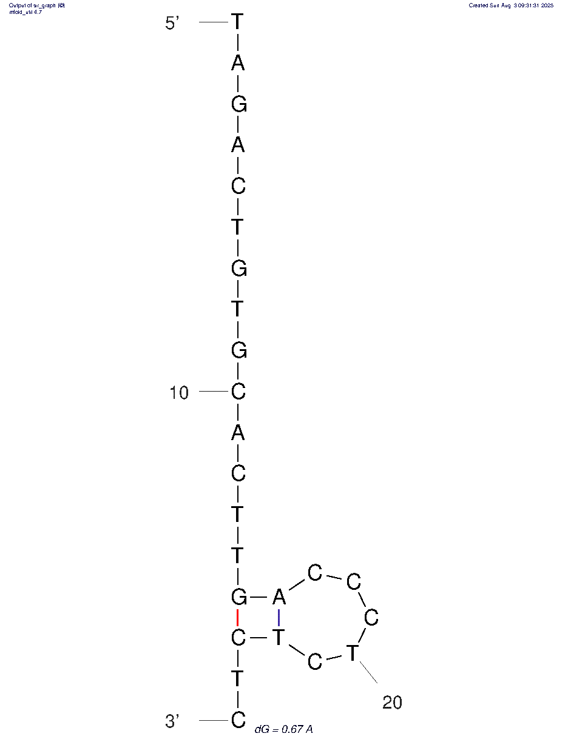  B  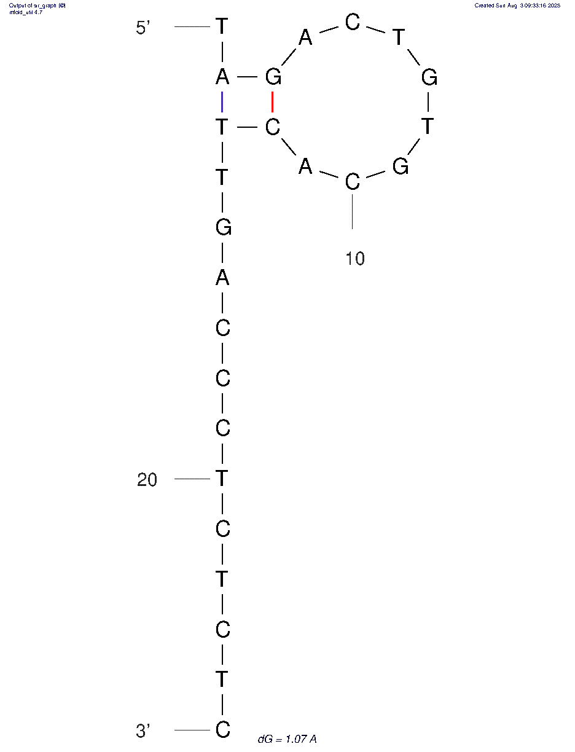
 |  | ΔG (kcal/mol) |  | ΔH  (kcal/mol) | ΔS (cal/mol·K) |  |  | Tm (°C)
 |  | A +0.67 |  | -18.80 | -62.78 |  |  | 26.3°C
 |  | B +1.07 |  | -15.60 | -53.75 |  |  | 17.1°C
 |  | Sequence (5'→3')
 |  | gCACTTGACCct
S- Spike Protein |  | SARS-CoV-2 (Gene ID: 43740568, NC_045512.2 (21563..25384) |  |  | L54W  Ttg→tgg^{34, 35} |  |  |  | 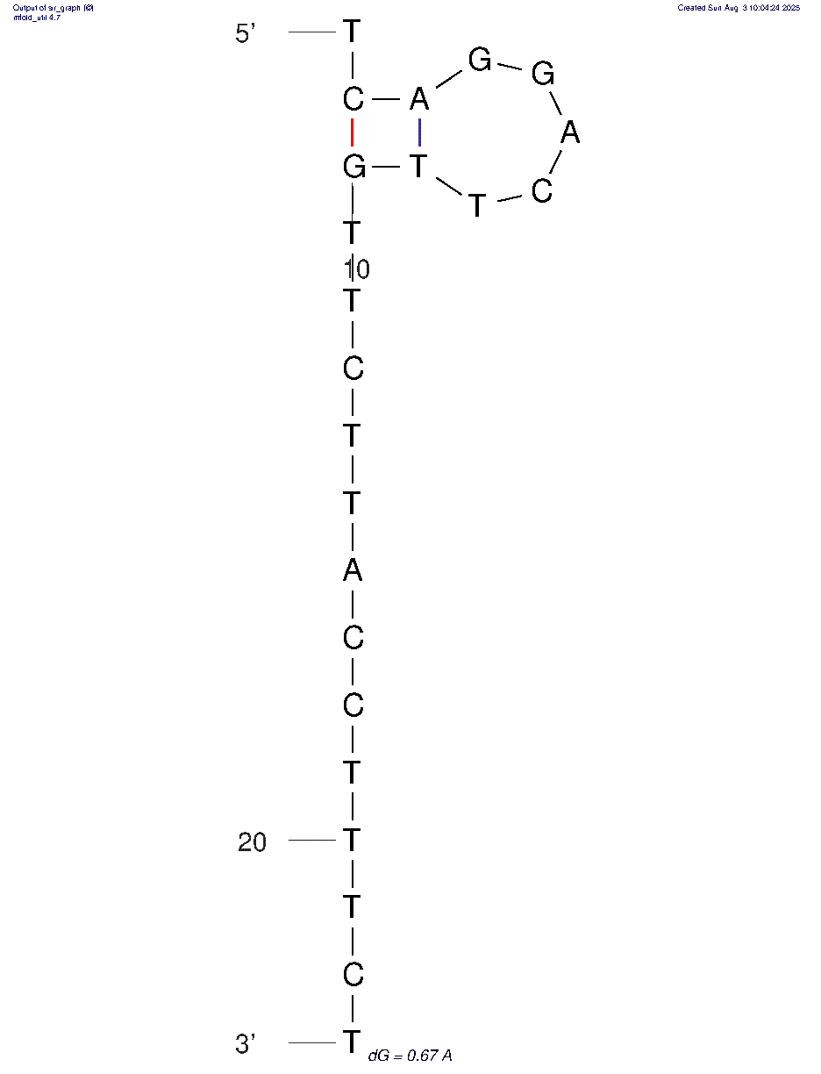
 |  | ΔG (kcal/mol) |  | ΔH  (kcal/mol) | ΔS (cal/mol·K) |  |  | Tm (°C)
 |  | -0.00 |  | -16.10 | -51.91 |  |  | 37.0°C
 |  | Sequence (5'→3')
 |  | gactTgTtctta
S- Spike Protein |  | SARS-CoV-2 (Gene ID: 43740568, NC_045512.2 (21563..25384) |  |  | F55I  Ttc→atc ^{34, 35} |  |  |  | 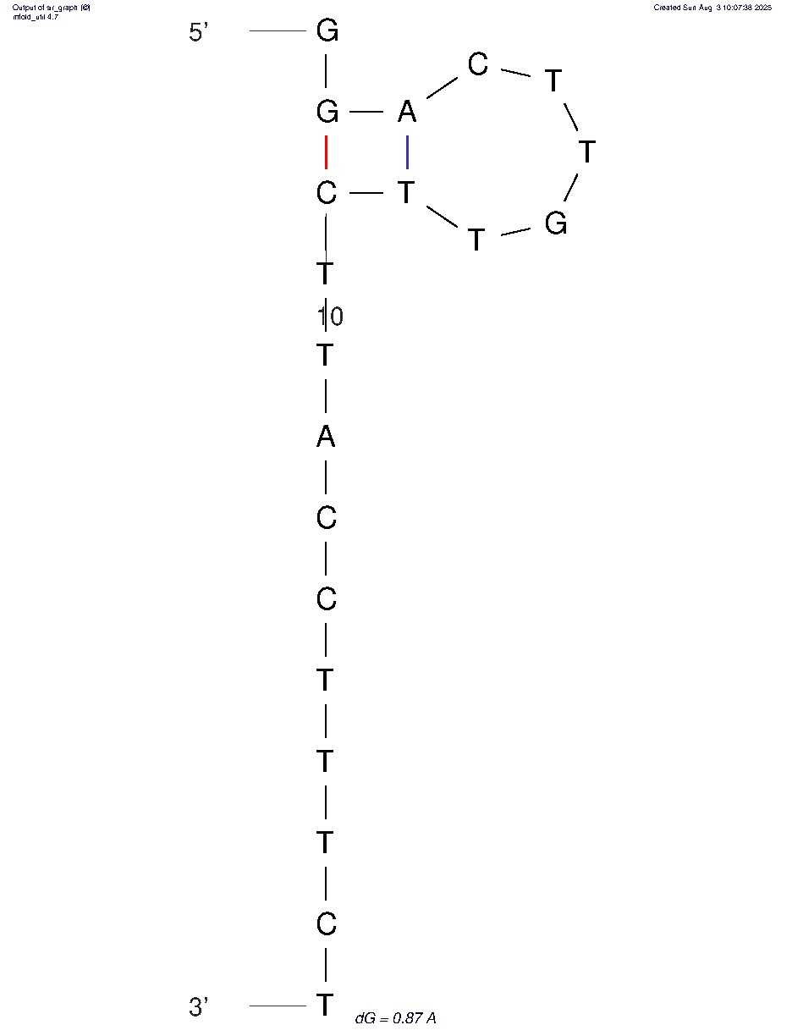
 |  | ΔG (kcal/mol) |  | ΔH  (kcal/mol) | ΔS (cal/mol·K) |  |  | Tm (°C)
 |  | +0.87 |  | -18.50 | -62.45 |  |  | 23.1°C
 |  | Sequence (5'→3')
 |  | gactTgTtctta
Hairpin secondary structures at “malignant” mutation sites in Human BRCA1:BRCA1 DNA repair associated
BRCA1:BRCA1 DNA repair associated |  | NM_007294.4(BRCA1) |  |  | c.181T>G (p.Cys61Gly) |  |  |  | 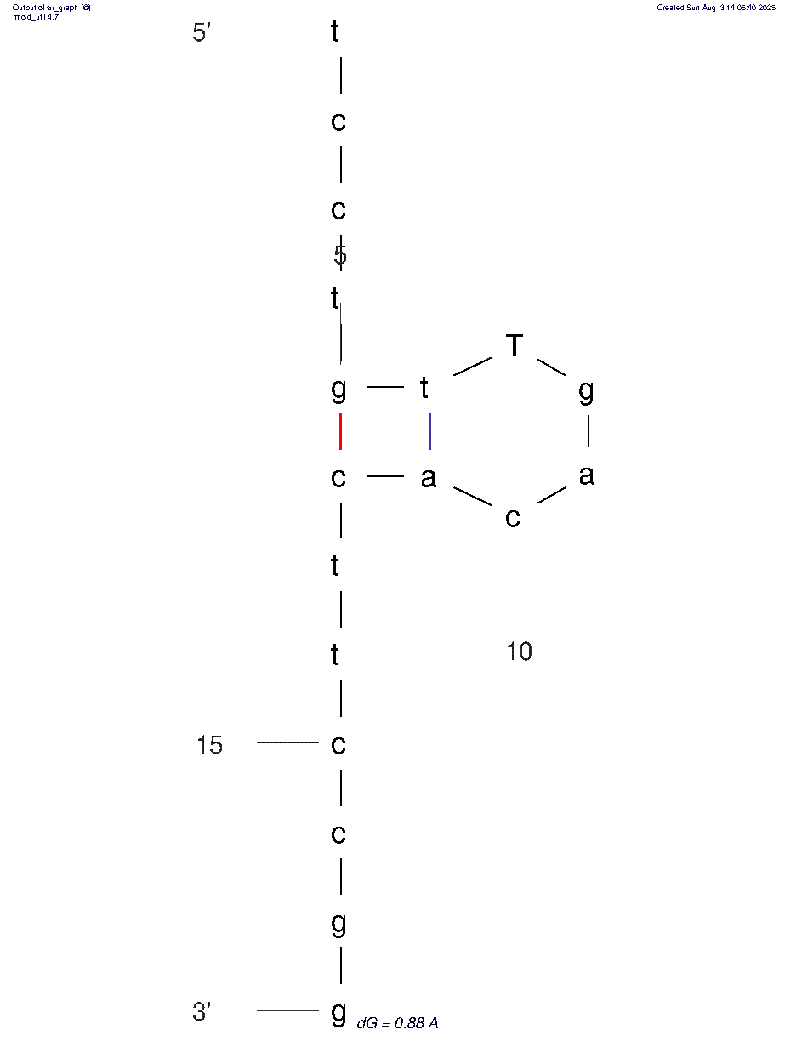  (reverse)
 |  | ΔG (kcal/mol) |  | ΔH  (kcal/mol) | ΔS (cal/mol·K) |  |  | Tm (°C)
 |  | +0.88 |  | -19.90 | -67.00 |  |  | 23.9°C
 |  | Sequence (5'→3')
 |  | AccagaagaaagggccttcacagTtgtcctttatgtaagaa

Supplementary Table S2 | Thermodynamic stability of secondary structures formed by oligonucleotides with different stem compositions (stems indicated in brackets)
Sequence | Tetramer | ΔG (kcal/mol) | ΔH (kcal/mol) | ΔS (cal/mol·K) | Tm (°C)
AA[CGGC]ACCA[GCCG]AA | CGGC  GCCG | –4.33 | –39.60 | –113.72 | 75.1
AA[CGGC]ACCA[GCC]AA | CGGC  GCC | –1.77 | –30.50 | –92.63 | 56.1
AA[CGGG]ACCA[CCCG]AA | CGGG  CCCG | -3.93 | 41.00 | -119.5 | 69.9
AA[GGGC]ACCA[GCCC]AA | GGGC  CCCG | -3.52 | -38.20 | -111.82 | 68.5°
AA[CGGC]ACCA[CCG]AA | CGCG  CCG | –2.62 | –29.80 | –87.64 | 66.9
CAA[GGG]ACCA[CCC]AAG  AA[GGG]ACCA[CCC]AA | GGG | -0.81 | –31.60 | -99.27 | 53.6
AA[GGG]ACGCGTACA[CCC]AA (longer loop) | GGG  CCC | –1.11 | –31.60 | –98.31 | 45.2°C
AA[GGGG]ACCA[CCCC]AA | GGGG  CCCC | -3.12 | -39.60 | -117.62 | 63.5
CAA[CGG]ACCA[CCG]AAG | CGG  CCG | -2.42 | 33.00 | 98.60 | 61.5
CAA[CGG]ACCA[CCG]AAG | CGG  CCG | -2.01 | -30.20 | -90.89 | 59.1
A[CTTC]ACCA[GAAG]A  (control) | CTTC  GAAG | -1.66 | -35.10 | -107.82 | 52.4

Supplementary Table S3 | Mutator frequencies, CGGC abundance, and distribution of out-of-frame stop codons across bacterial species
Species | Frequency of mutators in the population (%) | CGGC abundance,  (%) | Out-of-frame stop codons  (1-nt indels, %) | Out-of-frame stop codons  (2-nt indels,%)
Escherichia  coli | 0.5, 1.0, 1.9, 12.1³² | 0.55 | 2.08 | 1.67
Salmonella  enterica | 3.6 ³² | 0.75^{S.typhimurium}  0.73^{S. typhi} | 1.9  1.92 | 1.61  1.62
Pseudomonas  aeruginosa | 19.5, 30, 53.2, 54, 92³² | 1.79 | 0.18 | 0.98
Hemophilus  influenzae | 2.4, 14.5 ³² | 0.16 | 2.88 | 2.38
Neisseria  meningitidis | 22.2, 56.8 ³² | 1.11  1.06 | 1.70  1.15 | 1.48  1.44
Klebsiella  pneumoniae | 14.5 ³² | 1.07 | 1.47 | 1.47
Vibrio  parahaemolyticus | 5.13, 0 ³² | 0.27 | 2.33 | 2.07
Staphylococcus  aureus | 1.4, 4, 14.6 ³² | 0.07 | 3.66 | 2.96
Stenotrophomonas maltophilia | 21.8 ³² | 0.56 | 1.64 | 1.25
Supplementary Table S4 | List of 88 bacterial genomes, (74 species) included in the study, with corresponding GenBank accession numbers , (NCBI)

 | Species | Accession code
 | Acinetobacter baumannii | CP043953.1
 | Actinomyces israelii strain F0345 | CP124548.1
 | Actinomyces naeslundii strain FDAARGOS_1037 | CP066049.1
 | Bacillus anthracis str. 'Ames Ancestor' | NC007530.2
 | Bacillus cereus strain FORC_047 | CP017060.1
 | Bacteroides fragilis strain FDAARGOS_1225 | CP069563.1
 | Bifidobacterium longum subsp. longum JCM 1217 | NC015067.1
 | Bordetella parapertussis strain A005 | CP025070.1
 | Bordetella pertussis strain H640 | CP025371.1
 | Borrelia recurrentis | CP000993.1
 | Borrelia duttonii Ly | CP000976.1
 | Brucella abortus 2308 | NC007624.1
 | Burkholderia cepacia strain BC16 chr. 1 | CP045235.1
 | Burkholderia cepacia strain BC16 chr. 2 | CP045236.1
 | Burkholderia mallei ATCC 23344 chr 2 | CP000011.2
 | Burkholderia mallei ATCC 23344 chr. 1 | CP000010.1
 | Campylobacter coli str. FDAARGOS_735 | CP046317.1
 | Chlamydia pneumoniae Wien1 | LN846980.1
 | Chlamydia trachomatis D/UW-3/CX | AE001273.1
 | Citrobacter freundii ATCC 8090 | CP049015.1
 | Clostridioides difficile str. S-0253 | CP076401.1
 | Clostridium botulinum str. 1169 | CP013681.1
 | Corynebacterium diphtheriae str. NCTC11397 | LN831026.1
 | Corynebacterium glutamicum ATCC 13032 | BA000036.3.
 | Cronobacter sakazakii str. CS-931 | CP027107.1
 | Cutibacterium acnes subsp. acnes NBRC 107605 | AP01623.1
 | Desulfovibrio desulfuricans str. L4 | CP072608.1
 | Eikenella corrodens str. NCTC10596 | LT906482.1
 | Escherichia coli O157:H7 str. Sakai DNA | NC002695.2
 | Escherichia coli str. K-12 substr. MG1655 | NC000913.3
 | Fusobacterium nucleatum subsp. nucleatum ATCC 25586 | CP028101.1
 | Haemophilus influenzae str. FDAARGOS_1560 | CP085952.1
 | Klebsiella oxytoca str. NCTC13727 | LR134333.1
 | Klebsiella pneumoniae subsp. pneumoniae HS11286 | CP003200.1
 | Klebsiella pneumoniae subsp. rhinoscleromatis str. KP4831 | CP0962.1
 | Legionella pneumophila str. Philadelphia-1 | CP013742.1
 | Leptospira interrogans serovar Copenhageni str. FDAARGOS_203 | CP020414.2
 | Listeria monocytogenes EGD-e | NC003210.1
 | Metamycoplasma hominis str. FBG | CP055151.1
 | Moraxella catarrhalis str. CCRI-195ME | CP018059.1
 | Mycobacterium avium subsp. avium str. DSM 44156 | CP046507.1
 | Mycobacterium chelonae CCUG 47445 | CP007220.1
 | Mycobacterium intracellulare str. FDAARGOS_1564 | CP085945.1
 | Mycobacterium kansasii ATCC 12478 | CP006835.1
 | Mycobacterium leprae Kyoto-2 DNA | AP014567.1
 | Mycobacterium leprae str. MRHRU-235-G | NZ_CP029543.1
 | Mycobacterium marinum CCUG20998 | CP024190.1
 | Mycobacterium tuberculosis str. 11502 | CP070338.1
 | Mycobacterium tuberculosis str. 4860 | CP053092.1
 | Mycobacterium tuberculosis str. 5005 | CP049108.1
 | Mycobacterium tube NZ_CP029543.1rculosis str. BLR 4299 2019 | CP125620.1
 | Mycobacterium tuberculosis str. BLR-31d | CP110674.1
 | Mycobacterium tuberculosis 9248 | CP115447.1
 | Mycobacterium tuberculosis H37Rv | NC_000962.3
 | Mycobacteroides abscessus str. FLAC054 | CP014961.1
 | Mycolicibacterium fortuitum subsp. fortuitum JCM6387 | AP025518.1
 | Mycoplasma pneumoniae FH | CP010546.1
 | Neisseria meningitidis str. LNP24198 | CP060280.1
 | Neisseria meningitidis str. PartJ-Nmeningitidis-RM8376 | CP064367.1
 | Nocardia asteroides str. NCTC11293 | LR134352.1
 | Porphyromonas gingivalis ATCC 33277 | NC010729.1
 | Pseudomonas aeruginosa PAO1 | NC002516.2
 | Pseudomonas fluorescens str. NCTC10038 | LS483372.1
 | Rickettsia japonica YH | AP011533.1
 | Rickettsia prowazekii str. Breinl | CP004889.1
 | Rhodococcus erythropolis R138 | CP007255.1
 | Salmonella enterica subsp. enterica serovar Typhi Ty2 | AE014613.1
 | Salmonella enterica subsp. enterica serovar Typhimurium str. LT2 | NC003197.2
 | Salmonella Typhimurium str. LT2 | NC003197.2
 | Staphylococcus aureus str. BLR-DV | CP058312.1
 | Staphylococcus aureus subsp. aureus | NC007795.1
 | Staphylococcus epidermidis str. ATCC 14990 | CP035288.1
 | Staphylococcus haemolyticus str. ATCC 620 | CP035291.1
 | Staphylococcus saprophyticus subsp. saprophyticus ATCC 15305 | NC007350.1
 | Stenotrophomonas maltophilia NCTC10257 | LT906480.1
 | Streptococcus agalactiae str. NGBS128 | CP012480.1
 | Streptococcus mutans str. FDAARGOS 1458 | CP077404.1
 | Streptococcus pneumoniae str. NCTC7465 | LN831051.1
 | Streptococcus pyogenes str. NCTC12064 | LS483338.1
 | Streptomyces griseus str. NBC_01018 | CP108682.1
 | Treponema pallidum subsp. pallidum str. TpN-CL5 | CP095416.1
 | Treponema denticola ATCC 35405 | NC_002967.9
 | Thermus aquaticus Y51MC23 | CP010822.1
 | Veillonella parvula DSM 2008 | CP001820.1
 | Vibrio cholerae str. RFB16 chr. 2 | CP043556.1
 | Vibrio cholerae str. RFB16 chr. 1 | CP043554.1
 | Vibrio parahaemolyticus RIMD 2210633 DNA chr.1 | BA000031.2
 | Vibrio parahaemolyticus RIMD 2210633 DNA chr.2 | BA000032.2

