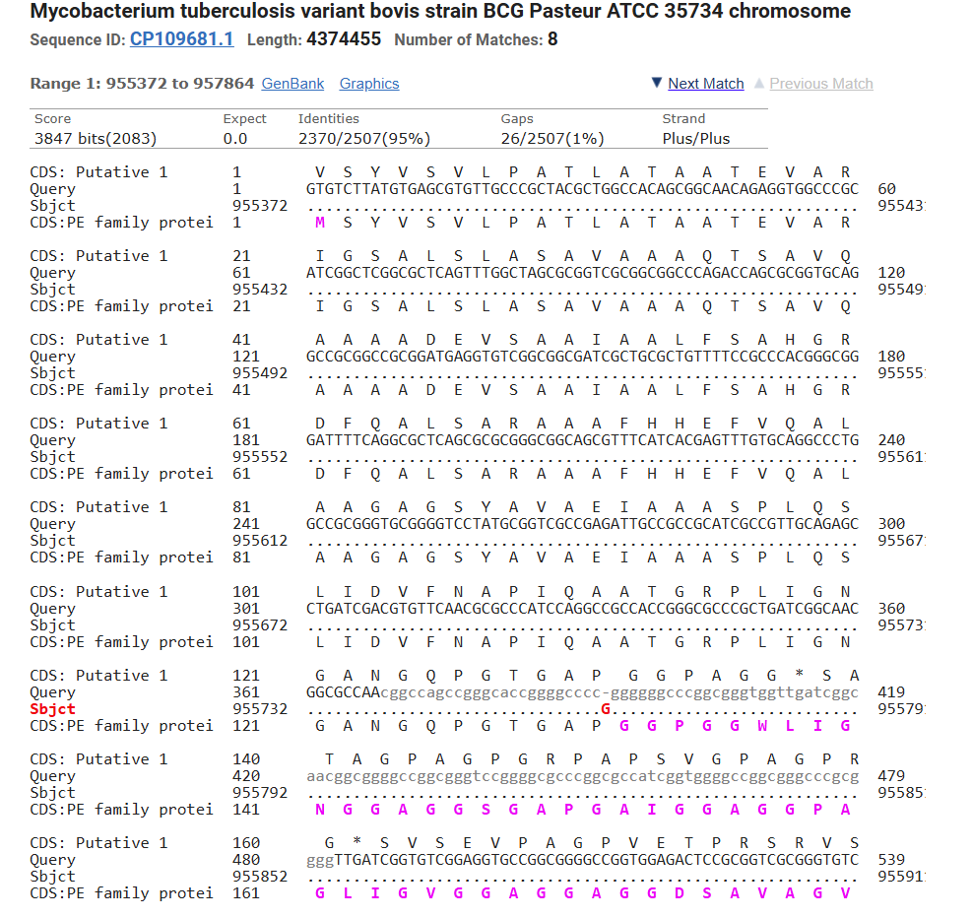  А  (A) Indel in Mtb strain 5005 leads to extension of the open reading frame.  (B) The translated product in Mtb H37Rv consists of 138 amino acids.  (C) The translated product in strain Mtb 5005 consists of 444 amino acids. | 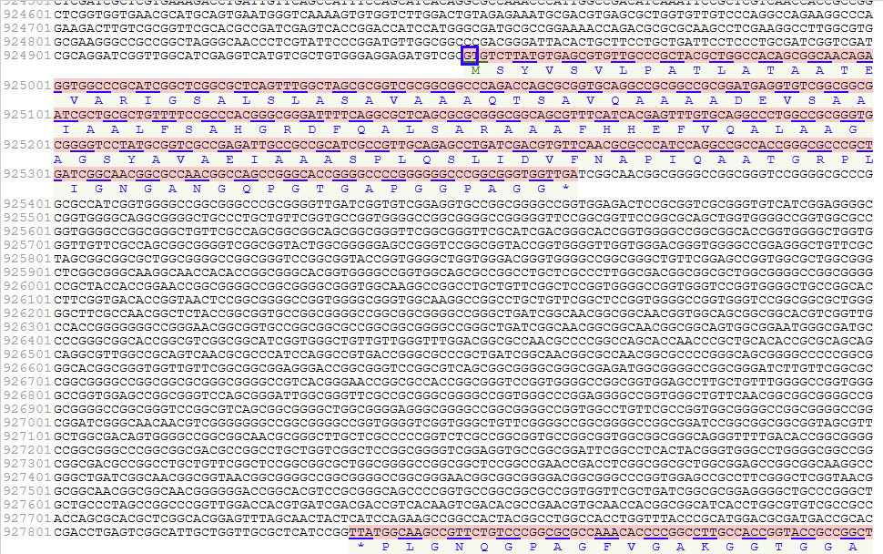  В
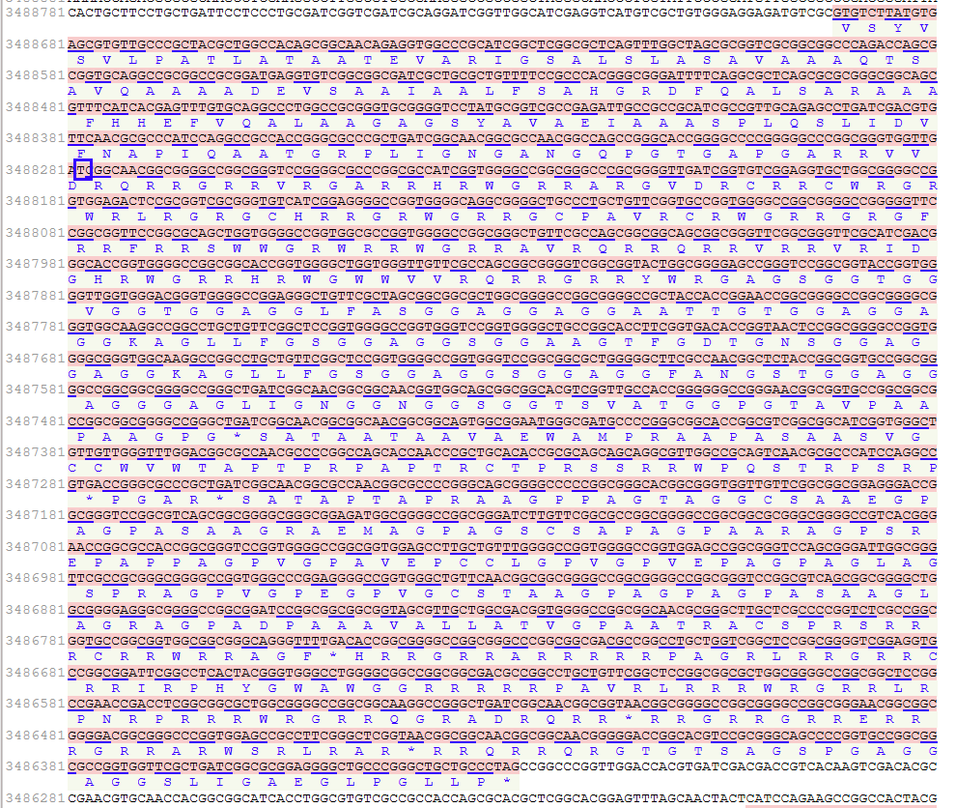
С
Suppl. Fig. S1. Indel-driven frame shift mutation and peptide elongation in the PE_PGRS 12 gene in M. tuberculosis strain 5005 (CP049108.1) versus M. tuberculosis H37Rv

