Supplemental Material

Industrial air pollution and lung and bronchus cancer survival in New Mexico, USA

Table of Contents
Table S1 Calibrated parameters (effective distance k in EWPM) for selected chemicals.
Table S2 Adjusted HR (95% CI) for the effect of industrial air pollution exposure on cancer-specific mortality due to lung and bronchus cancer (LBCS) in New Mexico, 1990-2019, with exposure estimated across different spatial scales.
Fig. S1 Directed acyclic graph (DAG) for the covariates in the Cox proportional hazards model with time-dependent covariates of this study, as supported by related literature.
Fig. S2 Average air pollution exposure intensity in New Mexico and its surrounding areas during 1990 - 2019 estimated using the EWPM model (a: 1,1,1-Trichloroethane, b: Cobalt)..
Fig. S3 AdjHRs for single- and two-pollutant Cox models. The point reflects the adjHR, the vertical line represents the 95% confidence interval.
Table S1 Calibrated parameters (effective distance k in EWPM) for selected chemicals.
Pollutant | CAS numberª |  |  | Spearman rank correlation test
 |  |  |  | Optimal k (km) |  | Coefficient^{b} |  | p-value
1,2,4-Trimethylbenzene |  |  | 95636 | 11 | 0.999 |  | < 0.001*
Chlorine |  |  | 7782505 | 50 | 0.772 |  | < 0.001*
Ethylbenzene |  |  | 100414 | 11 | 0.999 |  | < 0.001*
Cobalt |  |  | 7440484 | 50 | 0.999 |  | < 0.001*
Chromium |  |  | 7440473 | 38 | 0.660 |  | 0.001*
Manganese |  |  | 7439965 | 50 | 0.491 |  | 0.032*
Mercury |  |  | 7439976 | 50 | 0.793 |  | 0.033*
Copper |  |  | 7440508 | 34 | 0.060 |  | 0.039*
1,1,1-Trichloroethane |  |  | 71556 | 29 | 0.7 |  | 0.047*
ª CAS Registry Number: A unique identifier assigned by the Chemical Abstracts Service to each substance; order in descending order of p-value.
^{b}Sorted by ascending Spearman rank correlation p-value.
*Statistically significant (p-value < 0.05).

Table S2 Adjusted HR (95% CI) for the effect of industrial air pollution exposure on cancer-specific mortality due to lung and bronchus cancer (LBCS) in New Mexico, 1990-2019, with exposure estimated across different spatial scales.
 | Individual | Census tract | Zip code
Polluant (CAS number)ª | Adjusted^{b}HR (95% CIs)
1,1,1-Trichloroethane (71556) | 1.15 (1.09, 1.21) * | 1.15 (1.09, 1.21) * | 1.14 (1.09,1.19) *
Cobalt (7440484) | 1.14 (1.07, 1.21) * | 1.14 (1.07, 1.21) * | 1.13 (1.07,1.19) *
Chromium (7440473) | 1.08 (1.01, 1.15) | 1.07 (1.02, 1.13) | 1.04 (1.00, 1.08)
Copper (7440508) | 1.04 (0.98, 1.10) | 1.04 (0.99, 1.10) | 1.04 (1.00, 1.09)
Ethylbenzene (100414) | 1.00 (0.94, 1.06) | 0.99 (0.94, 1.04) | 0.98 (0.94, 1.02)
Chlorine (7782505) | 1.01 (0.97, 1.05) | 1.00 (0.96, 1.04) | 1.00 (0.96, 1.04)
Manganese (7439965) | 1.02 (0.93, 1.11) | 1.02 (0.94, 1.10) | 0.99 (0.94, 1.05)
1,2,4-Trimethylbenzene (95636) | 0.95 (0.90, 1.01) | 0.95 (0.90, 1.00) | 0.94 (0.90, 1.00)
Mercury (7439976) | 0.91 (0.82, 1.01) | 0.93 (0.86, 1.01) | 0.92 (0.87, 0.98)
*Statistically significant following Bonferroni adjustment for multiple testing at the 0.05 level.
ª CAS Registry Number: A unique identifier assigned by the Chemical Abstracts Service to each substance.
^{b} Adjusted for diagnosis age, gender, race/ethnicity, diagnosis stage, and urbanicity.

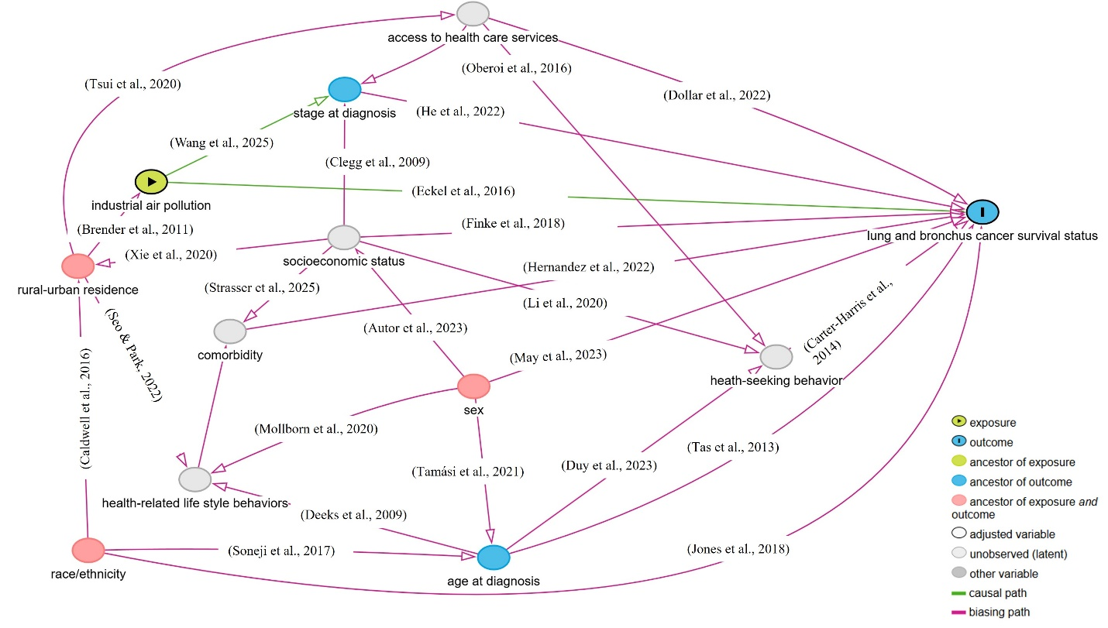
Fig.S1 Directed acyclic graph (DAG) for the covariates in the Cox proportional hazards model with time-dependent covariates of this study, as supported by related literature.
a
b
Fig.S2 Average air pollution exposure intensity in New Mexico and its surrounding areas during 1990 - 2019 estimated using the EWPM model (a: 1,1,1-Trichloroethane, b: Cobalt).
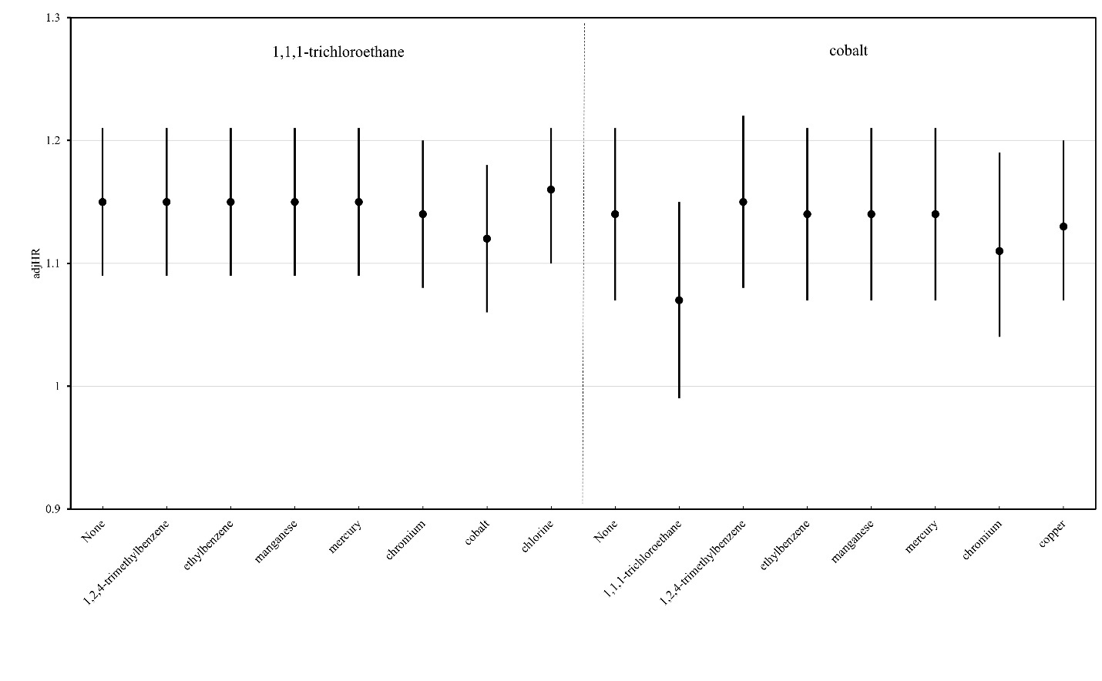
Fig.S3 AdjHRs for single- and two-pollutant Cox models. The point reflects the adjHR, the vertical line represents the 95% confidence interval.

References
Autor, D., Figlio, D., Karbownik, K., Roth, J., & Wasserman, M. (2023). Males at the Tails: How Socioeconomic Status Shapes the Gender Gap. Economic Journal (London, England), 133(656), 3136–3152. https://doi.org/10.1093/ej/uead069
Brender, J. D., Maantay, J. A., & Chakraborty, J. (2011). Residential proximity to environmental hazards and adverse health outcomes. American Journal of Public Health, 101 Suppl 1(Suppl 1), S37-52. https://doi.org/10.2105/AJPH.2011.300183
Caldwell, J. T., Ford, C. L., Wallace, S. P., Wang, M. C., & Takahashi, L. M. (2016). Intersection of Living in a Rural Versus Urban Area and Race/Ethnicity in Explaining Access to Health Care in the United States. American Journal of Public Health, 106(8), 1463–1469. https://doi.org/10.2105/AJPH.2016.303212
Carter-Harris, L., Hermann, C. P., Schreiber, J., Weaver, M. T., & Rawl, S. M. (2014). Lung cancer stigma predicts timing of medical help-seeking behavior. Oncology Nursing Forum, 41(3), E203-10. https://doi.org/10.1188/14.ONF.E203-E210
Clegg, L. X., Reichman, M. E., Miller, B. A., Hankey, B. F., Singh, G. K., Lin, Y. D., Goodman, M. T., Lynch, C. F., Schwartz, S. M., Chen, V. W., Bernstein, L., Gomez, S. L., Graff, J. J., Lin, C. C., Johnson, N. J., & Edwards, B. K. (2009). Impact of socioeconomic status on cancer incidence and stage at diagnosis: selected findings from the surveillance, epidemiology, and end results: National Longitudinal Mortality Study. Cancer Causes & Control : CCC, 20(4), 417–435. https://doi.org/10.1007/s10552-008-9256-0
Deeks, A., Lombard, C., Michelmore, J., & Teede, H. (2009). The effects of gender and age on health related behaviors. BMC Public Health, 9, 213. https://doi.org/10.1186/1471-2458-9-213
Dollar, K. R., Neutel, B. S., & Hsia, D. W. (2022). Access to Care Limits Lung Cancer Screening Eligibility in an Urban Safety Net Hospital. Journal of Primary Care & Community Health, 13, 21501319221128700. https://doi.org/10.1177/21501319221128701
Duy, H. M., Lee, J., Han, W., Rajaguru, V., & Jang, S.-Y. (2023). The Health-Seeking Behavior of the Elderly with Non-Communicable Diseases in Coastal Areas of Vietnam. Healthcare (Basel, Switzerland), 11(4). https://doi.org/10.3390/healthcare11040465
Eckel, S. P., Cockburn, M., Shu, Y. H., Deng, H. Y., Lurmann, F. W., Liu, L. H., & Gilliland, F. D. (2016). Air pollution affects lung cancer survival. THORAX, 71(10), 891–898. https://doi.org/10.1136/thoraxjnl-2015-207927
Finke, I., Behrens, G., Weisser, L., Brenner, H., & Jansen, L. (2018). Socioeconomic Differences and Lung Cancer Survival-Systematic Review and Meta-Analysis. Frontiers in Oncology, 8, 536. https://doi.org/10.3389/fonc.2018.00536
He, S., Li, H., Cao, M., Sun, D., Yang, F., Yan, X., Zhang, S., He, Y., Du, L., Sun, X., Wang, N., Zhang, M., Wei, K., Lei, L., Xia, C., Peng, J., & Chen, W. (2022). Survival of 7,311 lung cancer patients by pathological stage and histological classification: a multicenter hospital-based study in China. Translational Lung Cancer Research, 11(8), 1591–1605. https://doi.org/10.21037/tlcr-22-240
Hernandez, D., Cheng, C.-Y., Hernandez-Villafuerte, K., & Schlander, M. (2022). Survival and comorbidities in lung cancer patients: Evidence from administrative claims data in Germany. Oncology Research, 30(4), 173–185. https://doi.org/10.32604/or.2022.027262
Jones, C. C., Mercaldo, S. F., Blume, J. D., Wenzlaff, A. S., Schwartz, A. G., Chen, H., Deppen, S. A., Bush, W. S., Crawford, D. C., Chanock, S. J., Blot, W. J., Grogan, E. L., & Aldrich, M. C. (2018). Racial Disparities in Lung Cancer Survival: The Contribution of Stage, Treatment, and Ancestry. Journal of Thoracic Oncology : Official Publication of the International Association for the Study of Lung Cancer, 13(10), 1464–1473. https://doi.org/10.1016/j.jtho.2018.05.032
Jones, C. H., & Dolsten, M. (2024). Healthcare on the brink: navigating the challenges of an aging society in the United States. Npj Aging, 10(1), 22. https://doi.org/10.1038/s41514-024-00148-2
Li, X., Deng, L., Yang, H., & Wang, H. (2020). Effect of socioeconomic status on the healthcare-seeking behavior of migrant workers in China. PloS One, 15(8), e0237867. https://doi.org/10.1371/journal.pone.0237867
May, L., Shows, K., Nana-Sinkam, P., Li, H., & Landry, J. W. (2023). Sex Differences in Lung Cancer. Cancers, 15(12). https://doi.org/10.3390/cancers15123111
Mollborn, S., Lawrence, E. M., & Hummer, R. A. (2020). A gender framework for understanding health lifestyles. Social Science & Medicine (1982), 265, 113182. https://doi.org/10.1016/j.socscimed.2020.113182
Oberoi, S., Chaudhary, N., Patnaik, S., & Singh, A. (2016). Understanding health seeking behavior. Journal of Family Medicine and Primary Care, 5(2), 463–464. https://doi.org/10.4103/2249-4863.192376
Roberts, J. I., Patten, S. B., Wiebe, S., Hemmelgarn, B. R., Pringsheim, T., & Jetté, N. (2015). Health-related behaviors and comorbidities in people with epilepsy: Changes in the past decade. Epilepsia, 56(12), 1973–1981. https://doi.org/10.1111/epi.13207
Seo, A.-R., & Park, K.-S. (2022). Residential Characteristics as Factors Related to Healthy Behavior Practices-Decision Tree Model Analysis Using a Community Health Survey from Korea. International Journal of Environmental Research and Public Health, 19(12). https://doi.org/10.3390/ijerph19127390
Soneji, S., Tanner, N. T., Silvestri, G. A., Lathan, C. S., & Black, W. (2017). Racial and Ethnic Disparities in Early-Stage Lung Cancer Survival. Chest, 152(3), 587–597. https://doi.org/10.1016/j.chest.2017.03.059
Strasser, K. M., Singh, D., Graves, J., & Moormeier, J. A. (2025). Comparison of comorbidity to socioeconomic status in patients with non-small cell lung cancer in a safety net population. Journal of Clinical Oncology, 34(15_suppl), e18070–e18070. https://doi.org/10.1200/JCO.2016.34.15_suppl.e18070
Tamási, L., Horváth, K., Kiss, Z., Bogos, K., Ostoros, G., Müller, V., Urbán, L., Bittner, N., Sárosi, V., Vastag, A., Polányi, Z., Nagy-Erdei, Z., Daniel, A., Nagy, B., Rokszin, G., Abonyi-Tóth, Z., Moldvay, J., Vokó, Z., & Gálffy, G. (2021). Age and Gender Specific Lung Cancer Incidence and Mortality in Hungary: Trends from 2011 Through 2016. Pathology Oncology Research : POR, 27, 598862. https://doi.org/10.3389/pore.2021.598862
Tas, F., Ciftci, R., Kilic, L., & Karabulut, S. (2013). Age is a prognostic factor affecting survival in lung cancer patients. Oncology Letters, 6(5), 1507–1513. https://doi.org/10.3892/ol.2013.1566
Tsui, J., Hirsch, J. A., Bayer, F. J., Quinn, J. W., Cahill, J., Siscovick, D., & Lovasi, G. S. (2020). Patterns in Geographic Access to Health Care Facilities Across Neighborhoods in the United States Based on Data From the National Establishment Time-Series Between 2000 and 2014. JAMA Network Open, 3(5), e205105. https://doi.org/10.1001/jamanetworkopen.2020.5105
Wang, M., Kim, R. Y., Kohonen-Corish, M. R. J., Chen, H., Donovan, C., & Oliver, B. G. (2025). Particulate matter air pollution as a cause of lung cancer: epidemiological and experimental evidence. British Journal of Cancer. https://doi.org/10.1038/s41416-025-02999-2
Xie, S., Hubbard, R. A., & Himes, B. E. (2020). Neighborhood-level measures of socioeconomic status are more correlated with individual-level measures in urban areas compared with less urban areas. Annals of Epidemiology, 43, 37-43.e4. https://doi.org/10.1016/j.annepidem.2020.01.012

