Low Voltage Electron Microscopy: Enabling advances in the preparation and imaging of biological thin sections
Daniela Vieira¹, Emad Shahnam¹, Christina Burks², Steven Felkoski², Ru-ching Hsia², Jared Lapkovsky¹
Supplementary information

 | - TEM, 25 kV | - STEM, 15 kV |  | - TEM, 25 kV
Method I - Post stained absent | 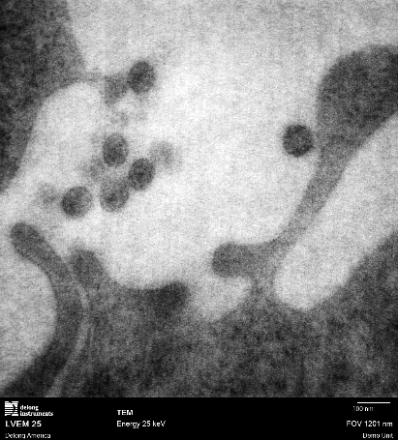 | 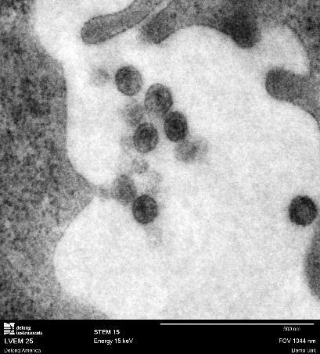 | Method II – Post stained present | 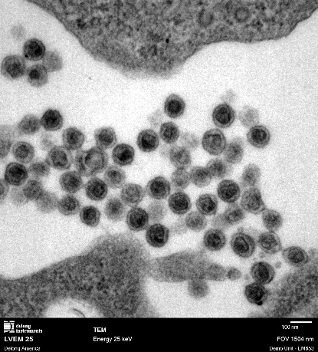
Figure S1. Comparative high-magnification images of samples prepared without uranyl acetate (Method I – post-staining absent) and with standard uranyl acetate staining (Method II – post-stained). As discussed in the manuscript, in TEM mode at an accelerating voltage of 25 kV, the absence of UA results in reduced image sharpness compared to UA-stained samples. However, in STEM mode at 15 kV, the presence of UA appears to be less critical, as similar structural information can still be obtained from unstained samples.
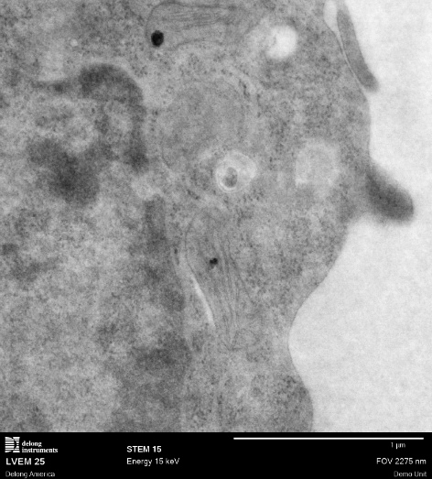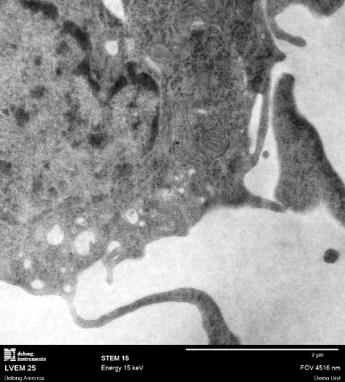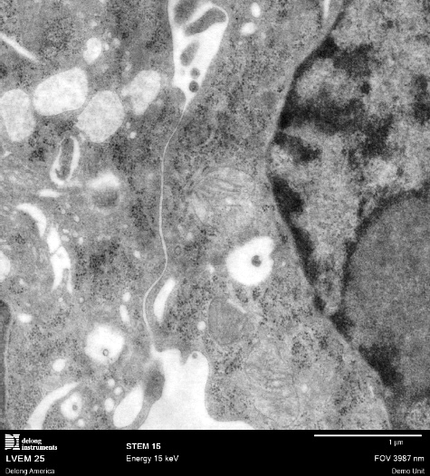
Figure S2. STEM images of samples prepared without uranyl acetate, showing detailed internal ultrastructure. These results demonstrate that high-contrast ultrastructural imaging is achievable without uranyl-based staining protocols.
 | - HV-TEM | - LVEM
AOI SNR (6.0x6.0µm) | 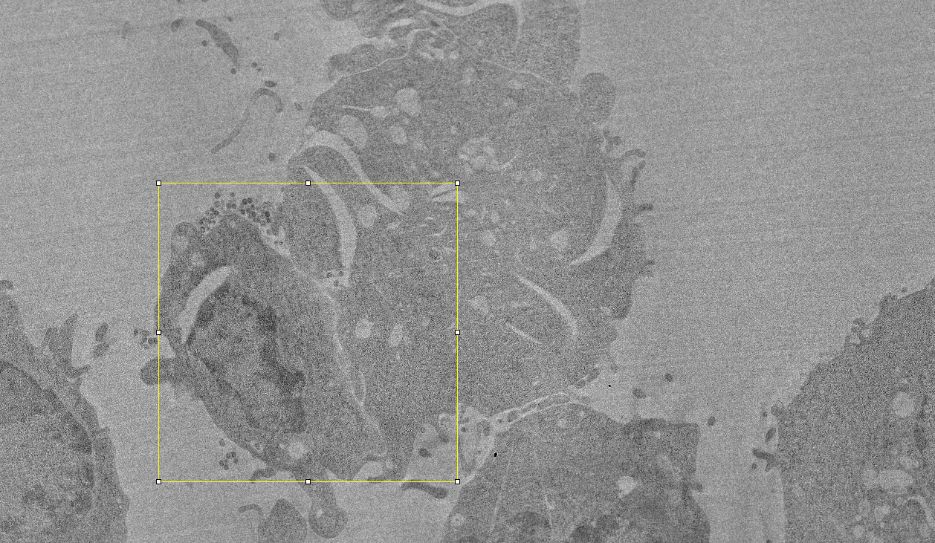 | 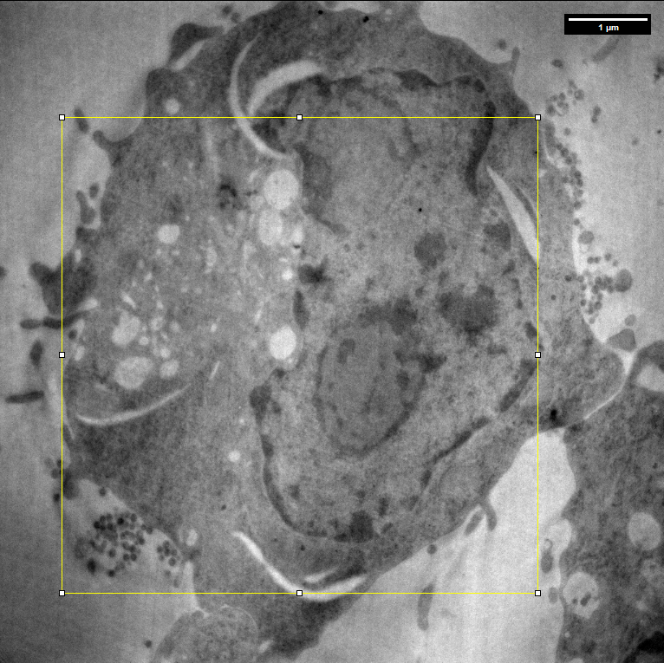
AOI CNR | 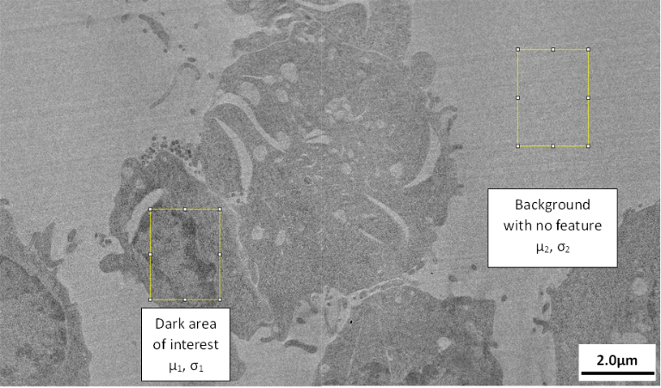 | 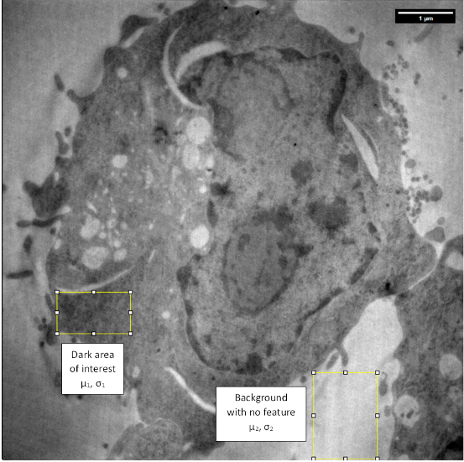
Figure S3. Area of interest (AOIs) selected for SNR and CNR calculations in images acquired using (A) HV-TEM and (B) LVEM. AOIs were chosen to represent both signal and background areas for quantitative comparison.

Table 1 - Dataset for CNR calculation
 | Mean Gray Value |  | StdDev |  | CNR
 | HV-TEM | LVEM | HV-TEM | LVEM
Area of interest | 31105.4 | 21897.5 | 9225.4 | 4875.5 | 0.80242
Background | 39768.1 | 51573.3 | 5607.1 | 4224.5 | 4.600103

