Table S1. Model parameters. Infection rates are given per individual per day; other rates are given per day.
♣2018-2019 death rate in Ontario, Statistics Canada.
♦Taken to be 70% higher than actual number of deaths / cases (July 2021, Statistics Canada) per day, since only infected susceptible die at this rate.

Symbol | Description | Values
α^{W}, α^{A}, α^{D} | Ratio of infectivity of asymptomatic and symptomatic individuals | 3.0 [1]
β^{W} | Rate of symptomatic infections of susceptibles by wild type | 3.3E-9
β^{A} | Rate of symptomatic infections of susceptibles by Alpha | 5.5E-9 [2]
β^{D} | Rate of symptomatic infections of susceptibles by Delta | 7.6E-9 [2]
β^{W}_{V1,PZ} | Rate of symptomatic infections of individuals vaccinated with one Pfizer dose by wild type | 0.2×β^{W} [3, 4]
β^{W}_{V2,PZ} | Rate of symptomatic infections of individuals vaccinated with both Pfizer doses by wild type | 0.05×β^{W [4]}
β^{A}_{V1,PZ} | Rate of symptomatic infections of individuals vaccinated with one Pfizer dose by Alpha | 0.5×β^{A} [5]
β^{A}_{V2,PZ} | Rate of symptomatic infections of individuals vaccinated with both Pfizer doses by Alpha | 0.07×β^{A} [5]
β^{D}_{V1,PZ} | Rate of symptomatic infections of individuals vaccinated with one Pfizer dose by Delta | 0.67×β^{D} [6]
β^{D}_{V2,PZ} | Rate of symptomatic infections of individuals vaccinated with both Pfizer doses by Delta | 0.12×β^{D} [6]
β^{W}_{V1,AZ} | Rate of symptomatic infections of individuals vaccinated with one AstraZeneca dose by wild type | 0.2×β^{W} [4]
β^{W}_{V2,AZ} | Rate of symptomatic infections of individuals vaccinated with both AstraZeneca doses by wild type | 0.05×β^{W [4]}
β^{A}_{V1,AZ} | Rate of symptomatic infections of individuals vaccinated with one AstraZeneca dose by Alpha | 0.5×β^{A} [7]
β^{A}_{V2,AZ} | Rate of symptomatic infections of individuals vaccinated with both AstraZeneca doses by Alpha | 0.34×β^{A [7]}
β^{D}_{V1,AZ} | Rate of symptomatic infections of individuals vaccinated with one AstraZeneca dose by Delta | 0.67×β^{D [6]}
β^{D}_{V2,AZ} | Rate of symptomatic infections of individuals vaccinated with both AstraZeneca doses by Delta | 0.4×β^{D} [6]
β^{X}_{R} | Rate of symptomatic infection of individual recovered from a different variant | 0.05×β^{X}
γ^{W}, γ^{A}, γ^{D} | Recovery rate | 1/28 [8]
ε_{PZ} | Fraction of Pfizer vaccines | 0.95
η_{V1} | Rate of individuals with one vaccine dose losing immunity | 1/(2×365)
η_{V2} | Rate of individuals with both vaccine doses losing immunity | 1/(8×365)
η_{R} | Rate of recovered individuals losing immunity | 1/(8×365)
μ | Natural death rate | 298.7♣
μ^{W} | Death rate from wild-type infections | 0.001♦
μ^{A} | Death rate from Alpha infections | 1.6×μ^{W}
μ^{D} | Death rate from Delta infections | 1.8×μ^{W}
μ^{W}_{V}, μ^{A}_{V}, μ^{D}_{V} | Death rate of infected vaccinated individuals | 0.15×(μ^{W}, μ^{A}, μ^{D})
σ^{W}, σ^{A}, σ^{D} | Fraction of asymptomatic infections | 0.5 [9]
σ^{W}_{V}, σ^{A}_{V}, σ^{D}_{V} | Fraction of asymptomatic infections among vaccinated individuals | 0.85
σ^{W}_{R}, σ^{A}_{R}, σ^{D}_{R} | Fraction of asymptomatic infections among recovered individuals | 0.85

Vaccination rates. Vaccination rates follow Ontario timeline. Vaccination is assumed to begin on t_{vac}⁰ = December 14 2020. Vaccination rate increases linearly until it peaks at the end of June (t_{vac}¹ = June 30 2021). Prior to the end of May (t_{vac}² = May 31 2021), dosing interval is Δt⁰ = 16 weeks. Afterwards, dosing interval is Δt^{PZ} = 4 weeks for Pfizer and Δt^{AZ} = 8 weeks for AstraZeneca.

$$ω_{1}(t)=\left\{\begin{aligned}0, t<t_{\text{vac}}^{0} \\ r_{0}\frac{t-t_{\text{vac}}^{0}}{t_{\text{vac}}^{1}-t_{\text{vac}}^{0}}, t_{\text{vac}}^{0}<t<t_{\text{vac}}^{1} \\ \left(r_{0}-r_{\text{ss}}\right)\text{exp}\left(-0.03\left(t-t_{\text{vac}}^{1}\right)\right)+r_{\text{ss}}, t_{\text{vac}}^{1}<t\end{aligned}\right.$$
$ω_{2}^{M}(t)=\left\{\begin{aligned}0, t<t_{\text{vac}}^{0} \\ 1/{∆t^{0}}, t_{\text{vac}}^{0}<t<t_{\text{vac}}^{2} \\ 1/{∆t^{M}}, t_{\text{vac}}^{2}<t\end{aligned}\right.$, M = PZ, AZ

where r₀ and r_{ss} are taken to be 1.1% and 0.05% of the population per day. These parameters are chosen so that at the end of July 2021, 71% of the population have received at least one dose and 57% are fully vaccinated, consistent with Ontario statistics (COVID19Tracker.ca).

Non-pharmaceutical interventions (NPI). The NPI severity index (λ, shown in Fig. S1) is chosen in part based on Ontario COVID-19 lockdown timeline and Google mobility data, and in part to fit the predicted new case numbers against provincial data. Effective disease infectivity is obtained by scaling all infectivity parameters (β^{X}’s and β^{X}_{V,M}’s) simultaneously.
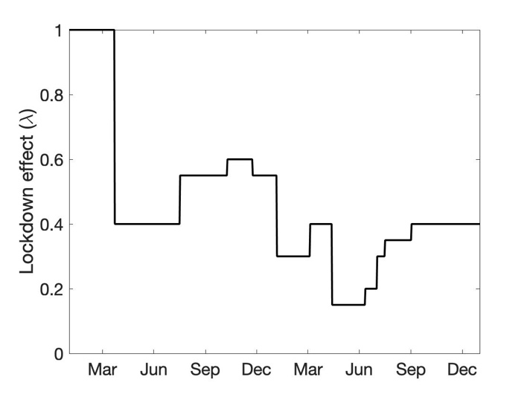
Figure S1. NPI index (λ) between January 1 2020 and December 31 2021.

References

1. Li, Y., et al., Asymptomatic and symptomatic patients with non-severe coronavirus disease (COVID-19) have similar clinical features and virological courses: a retrospective single center study. Frontiers in microbiology, 2020. 11: p. 1570.
2. Updates on COVID-19 Variants of Concern. 2021, National Collaborating Ccentre for Infectious Diseases.
3. Thompson, M.G., et al., Interim estimates of vaccine effectiveness of BNT162b2 and mRNA-1273 COVID-19 vaccines in preventing SARS-CoV-2 infection among health care personnel, first responders, and other essential and frontline workers—eight US locations, December 2020–March 2021. Morbidity and Mortality Weekly Report, 2021. 70(13): p. 495.
4. Bernal, J.L., et al., Effectiveness of the Pfizer-BioNTech and Oxford-AstraZeneca vaccines on covid-19 related symptoms, hospital admissions, and mortality in older adults in England: test negative case-control study. bmj, 2021. 373.
5. Hall, V.J., et al., Effectiveness of BNT162b2 mRNA vaccine against infection and COVID-19 vaccine coverage in healthcare workers in England, multicentre prospective cohort study (the SIREN Study). 2021.
6. (WHO), W.H.O., COVID-19 weekly epidemiological update. 2021.
7. Emary, K.R., et al., Efficacy of ChAdOx1 nCoV-19 (AZD1222) vaccine against SARS-CoV-2 variant of concern 202012/01 (B. 1.1. 7): an exploratory analysis of a randomised controlled trial. The Lancet, 2021. 397(10282): p. 1351-1362.
8. Barman, M.P., et al., COVID-19 pandemic and its recovery time of patients in India: A pilot study. Diabetes & Metabolic Syndrome: Clinical Research & Reviews, 2020. 14(5): p. 1205-1211.
9. Oran, D.P. and E.J. Topol, The proportion of SARS-CoV-2 infections that are asymptomatic: a systematic review. Annals of internal medicine, 2021. 174(5): p. 655-662.

