Supplementary Information

Physiology-informed layered sensing for intelligent human-exoskeleton interaction

The supplementary information file includes:

Supplementary Text
Figs. S1 to S11
Tables S1 to S3

Supplementary Text
Note S1: The distinction between bio-torque and net-torque decoding
Our study employs two distinct decoding strategies for joint moment estimation, each tailored to a specific experimental context. The core distinction lies in the physiological quantity being inferred: biological joint torque and net joint moment.
- Biological Joint Torque: This represents the intrinsic moment generated by the user's muscles. In Phase I (zero-torque mode), the exoskeleton is passive and applies no torque, which means the biological torque is, by definition, equivalent to the net joint moment. Under this controlled and label-rich condition, our multimodal sEMG+IMU decoder demonstrates superior accuracy (LOSO RMSE=0.13 Nm/kg). This performance highlights the critical role of sEMG signals in capturing the user's muscular activation patterns, which are a direct indicator of their motor intent and internal physiological state. The ability to accurately estimate biological torque is foundational for understanding and modeling human neuromechanics.
- Net Joint Moment: This is the total moment acting on a joint, encompassing both the user's biological torque and the torque applied by the exoskeleton. In Phase II, where the exoskeleton provides active assistance, the net joint moment becomes the most relevant variable for closed-loop adaptive control. However, obtaining ground-truth labels for biological torque under active assistance is a significant challenge, as standard inverse dynamics models (e.g., OpenSim) can only compute the net moment from kinematic data. To address this, we transitioned to an IMU-only decoder. IMU signals, by their very nature, capture the resulting kinematics driven by the combined effects of both human and robotic forces. Therefore, an IMU-only model provides a pragmatic and effective means of perceiving the net joint moment, which is a crucial input for adapting assistive strategies.
In summary, our work demonstrates a principled approach: utilizing a high-fidelity sEMG+IMU model to validate our system's ability to decode the user's internal biological effort in a controlled setting, while deploying a more practical IMU-only model to capture the net biomechanical outcome in an active assistance scenario. This distinction underscores the nuanced trade-offs between decoding pure physiological intent and perceiving the total mechanical state in real-world human-exoskeleton interaction.

Note S2: Non-linear admittance control for torque tracking
The exoskeleton control system adopts a cascaded architecture comprising an outer-loop non-linear admittance controller and an inner-loop PID-based velocity controller (see control diagram in Fig. S6). The outer loop regulates cable actuation dynamics based on the force tracking error:

where F_{d} is the desired cable force and F_{m} is the measured force. This error is transformed into the desired cable velocity V_{d} — defined as the target linear velocity at the Bowden cable output — through a non-linear admittance model:

To improve adaptability under varying interaction dynamics, the virtual damping C_{v} and virtual inertia
M_{v} are defined as continuous functions of the force error magnitude:
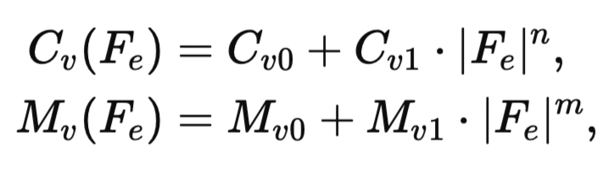
where C_{v0}, C_{v1}, M_{v0}, M_{v1}, n, and m are empirically tuned design parameters. This formulation ensures that when ∣F_{e}∣ is large, the controller imposes higher virtual damping and inertia to suppress oscillatory behavior and improve robustness. Conversely, for small errors, the system remains more compliant and responsive.
The resulting desired velocity V_{d} is tracked by an inner-loop PID controller, which generates the motor current command I_{d} based on the velocity tracking error e_{v} = V_{d} - V_{m}, where V_{m} is the measured cable velocity:
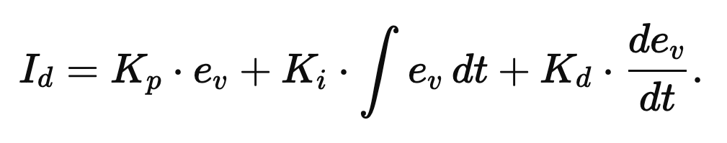
A minimal baseline cable tension (~3 N) is maintained at all times to prevent Bowden cable slacking, ensuring continuous contact and avoiding backlash in torque transmission.
This cascaded control framework, combined with baseline tension management, enables stable, responsive, and robust torque tracking under dynamic human–exoskeleton interactions.
Note S3: Gait cycle percentage labeling and perturbation timing
To support phase-specific control and analysis, all gait-related events in this study are aligned to a normalized gait cycle percentage based on the left heel strike as a temporal reference.
Gait Cycle Definition
We define each gait cycle by detecting consecutive threshold crossings in the left heel force sensing resistor (FSR) signal. Specifically, a gait cycle begins at time t₀, when the left heel FSR signal first crosses its predefined activation threshold (heel strike), and ends at time t_{f}, when the next such crossing occurs. The time between t₀ and t_{f} is linearly mapped to a normalized scale from 0 % to 100%, such that:

This normalization enables consistent phase annotation across variable-speed gait cycles.
Application in Perturbation Timing (Task III)
In Task III, we apply low-magnitude torque perturbations selectively during early and late gait phases, specifically at 0-20% and 80-100% of the gait cycle. These intervals correspond approximately to foot swing and terminal dorsiflexion, which are biomechanically sensitive to unexpected torques.
Since the gait cycle is defined with respect to the left heel strike, a 50% phase offset is applied to synchronize perturbation timing on the contralateral limb. That is:
- Perturbations applied to the left leg occur when the left gait phase is within 0-20% or 80-100%.
- Perturbations applied to the right leg are scheduled when the left gait phase is within 50-70% or 30-50%, respectively.
This adjustment ensures that perturbations on each side are aligned with that limb’s own early or late swing phase, maintaining biomechanical relevance and bilateral symmetry in perturbation design.
By using a single, consistent gait-phase reference (left heel strike) and accounting for natural inter-limb phase offsets, we enable accurate and interpretable alignment of perturbation events with functional gait subphases.
Figure S1: Fabrication steps for the smart leg sleeves. (1) Screen-print the graphene layer. (2) Attach sEMG electrodes using conductive silver yarns. (3) Sew conductive traces with silver yarns. (4) Join the side seams to form a tubular leg sleeve.

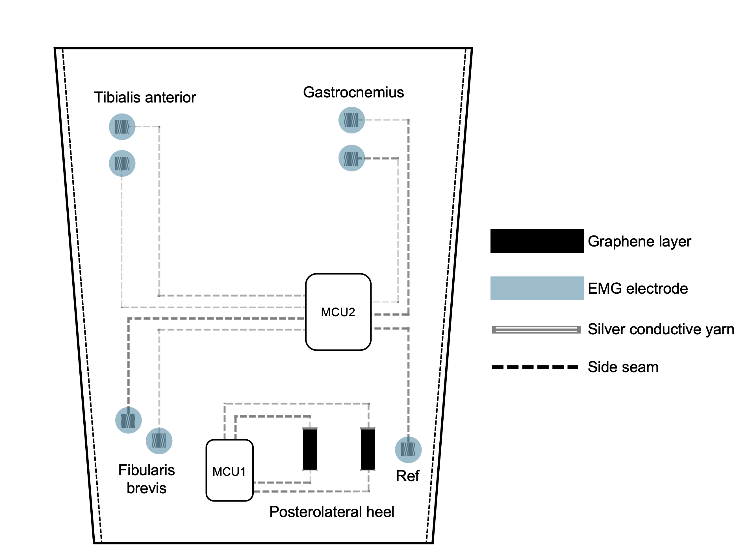

Figure S2: Modular wireless sensing readout for bilateral multimodal signal acquisition during human-exoskeleton interaction. The system comprises two wireless readout modules per leg, each consisting of a battery-powered ESP32 microcontroller, a 9-axis inertial measurement unit (MPU-9250), and either a textile strain sensor array (2-channel) or sEMG electrodes (3-channel) with a dedicated analog front-end (ADS1293). The strain signals are routed through voltage divider circuits to enable low-power, high-sensitivity skin deformation monitoring. sEMG signals are amplified and digitized via SPI. All sensor data are transmitted via Wi-Fi to an on-body edge processor (Jetson Nano), which performs real-time decoding. The bilateral setup captures 6-channel sEMG, 4-channel strain, and 4 × 9-axis IMU signals across both legs, enabling integrated perception of musculoskeletal and kinematic states.

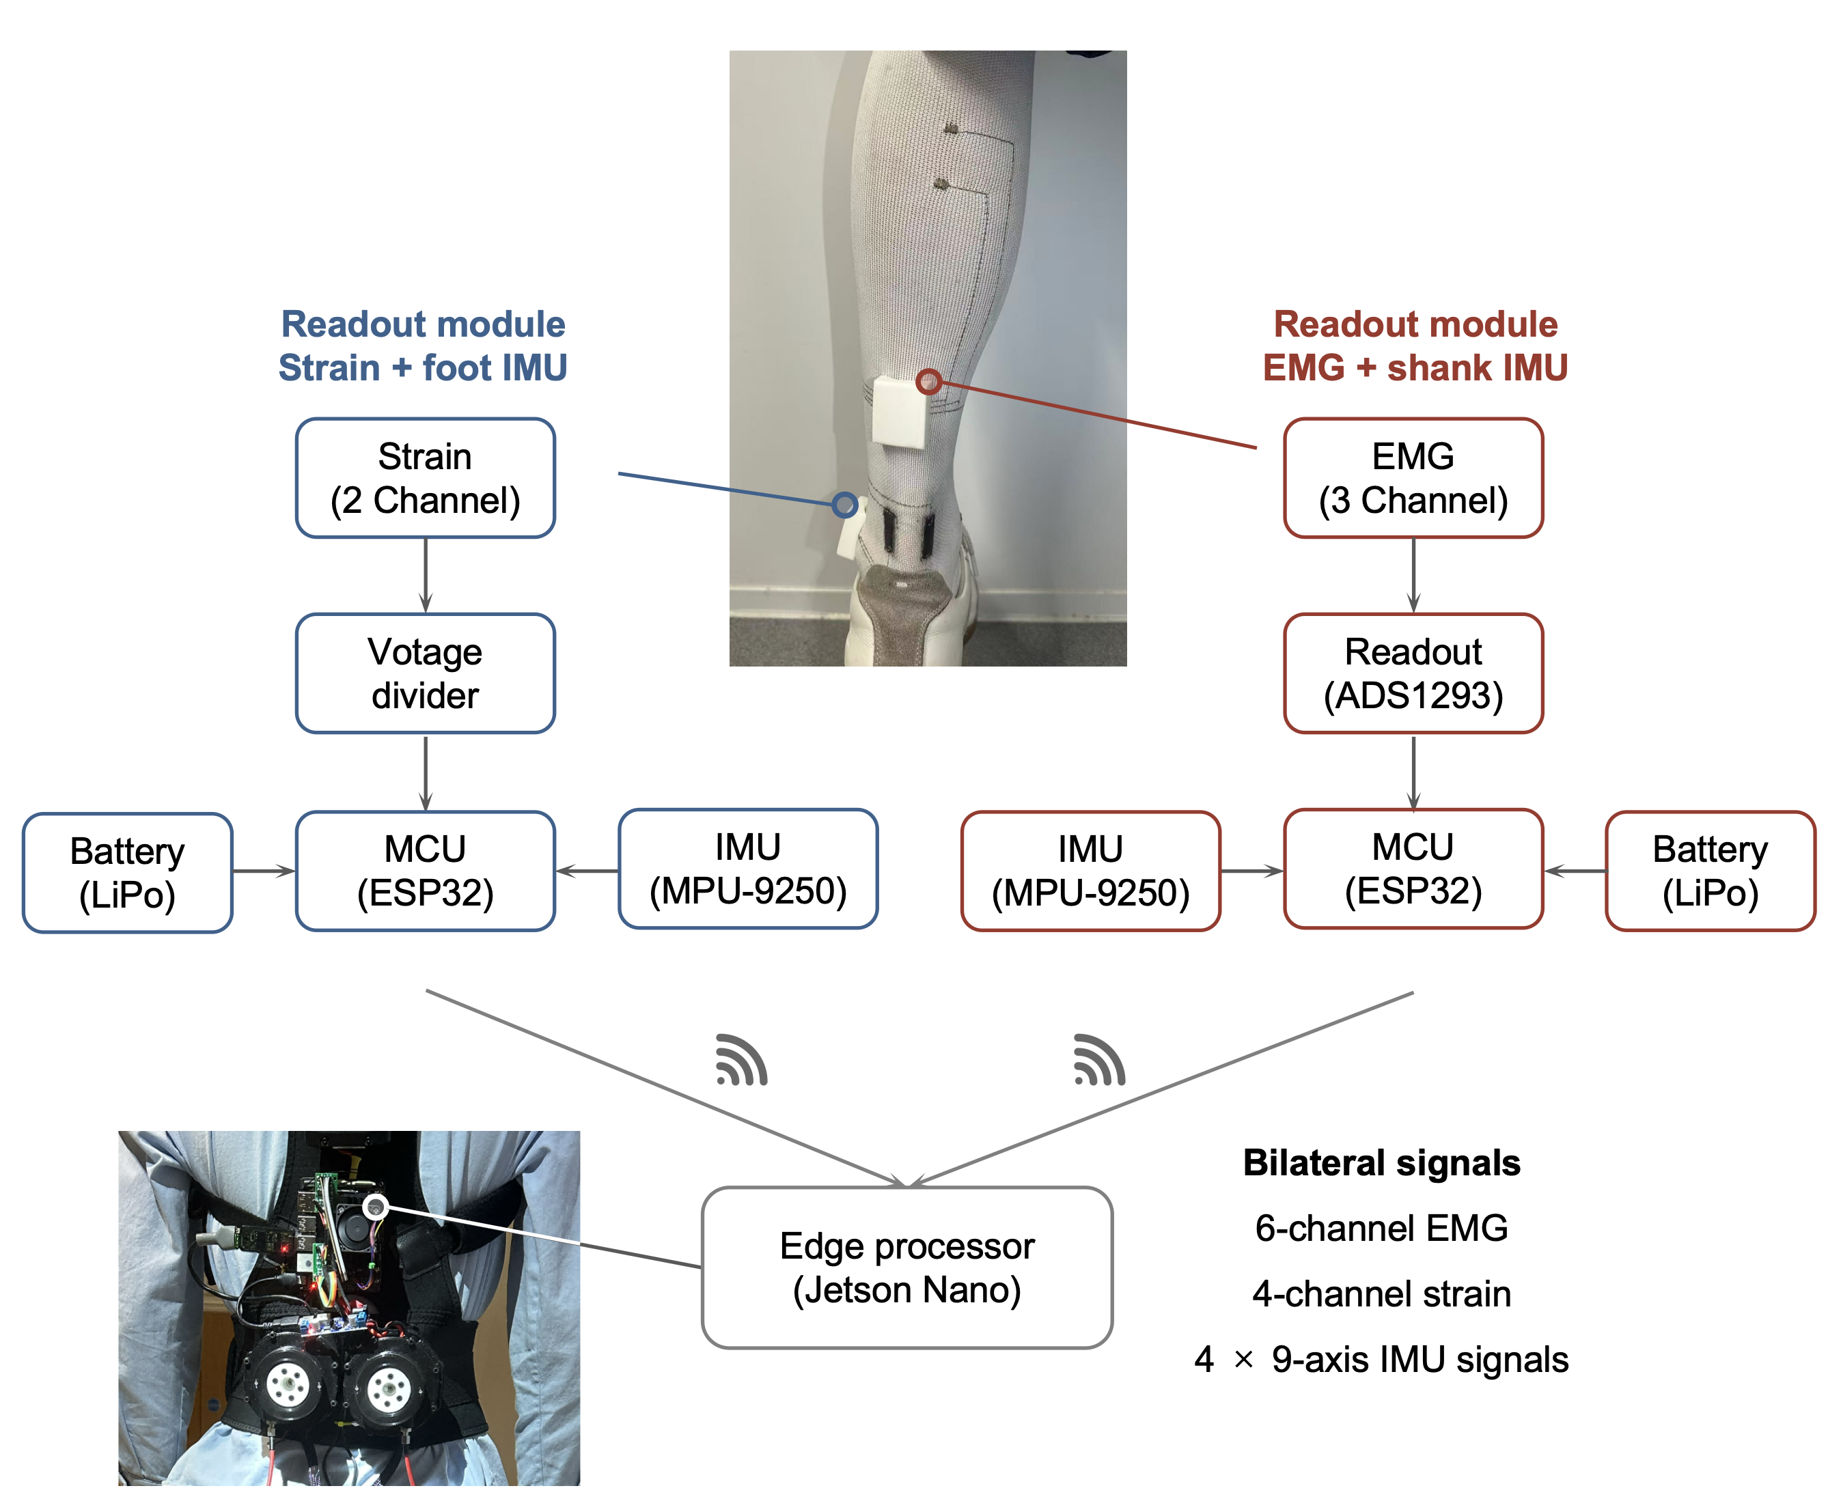

Figure S3: Autonomous cable-driven ankle exoskeleton. The developed ankle exoskeleton used in this study is portable and self-contained. Assistance was provided by the actuation units mounted on the back support. The assistive torque was transmitted by the Bowden cable to the foot brace, which results in the assistance in the plantarflexion. A 500 N force sensor was adopted to provide force feedback to the system. The main processor was mounted on the backpack, which communicates with motor drivers by CAN. The battery used in this system is 24V and 4Ah.

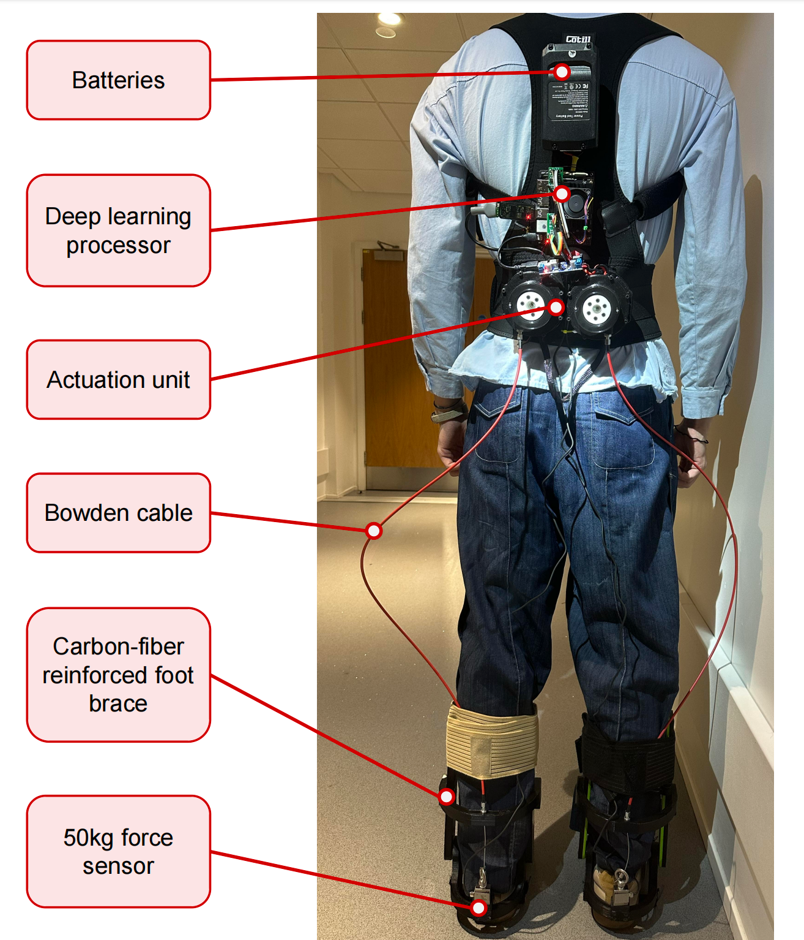
Figure S4: Joint torque estimation experiment in a biomechanics laboratory.

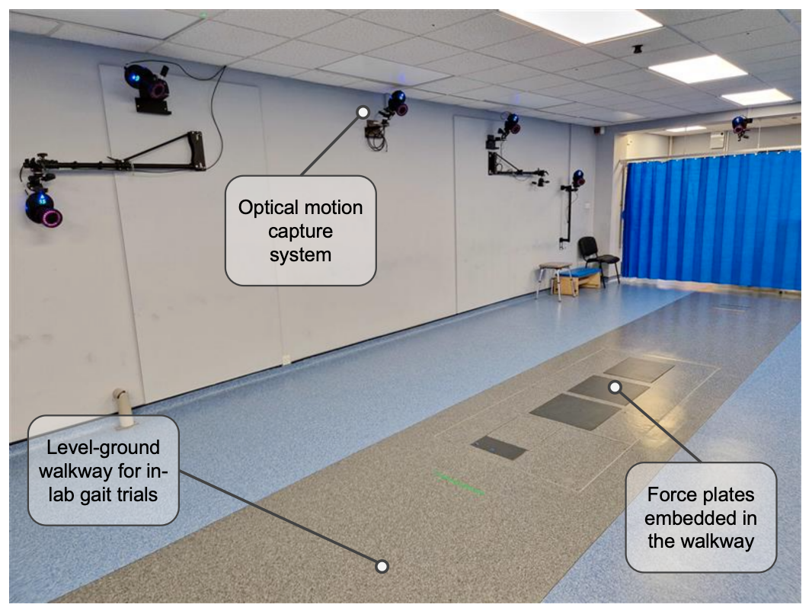

Figure S5: Pipeline of real-time gait percentage estimation using plantar pressure sensing. To obtain continuous gait cycle information, we designed a custom insole system (top), which integrates an 8-channel array of Force Sensing Resistors (FSRs) to capture plantar pressures from both feet. The analog signals are digitized by an onboard ADC and processed via a microcontroller unit (MCU) before being wirelessly streamed to an edge processor through UDP protocol. The entire sensing module is powered by a compact 3.7 V rechargeable battery. The raw sensor data are first low-pass filtered (2nd-order Butterworth) and synchronized across left and right feet. A sliding window buffer (16 channels × 200 frames) is then passed through two depthwise separable convolutional layers followed by a 1D CNN and a bidirectional LSTM (BiLSTM), enabling temporal feature extraction and sequence decoding. The model outputs a 2D representation (O1, O2), which is transformed using the arctan2(O1, O2) function to generate a continuous gait percentage from 0% to 100%.
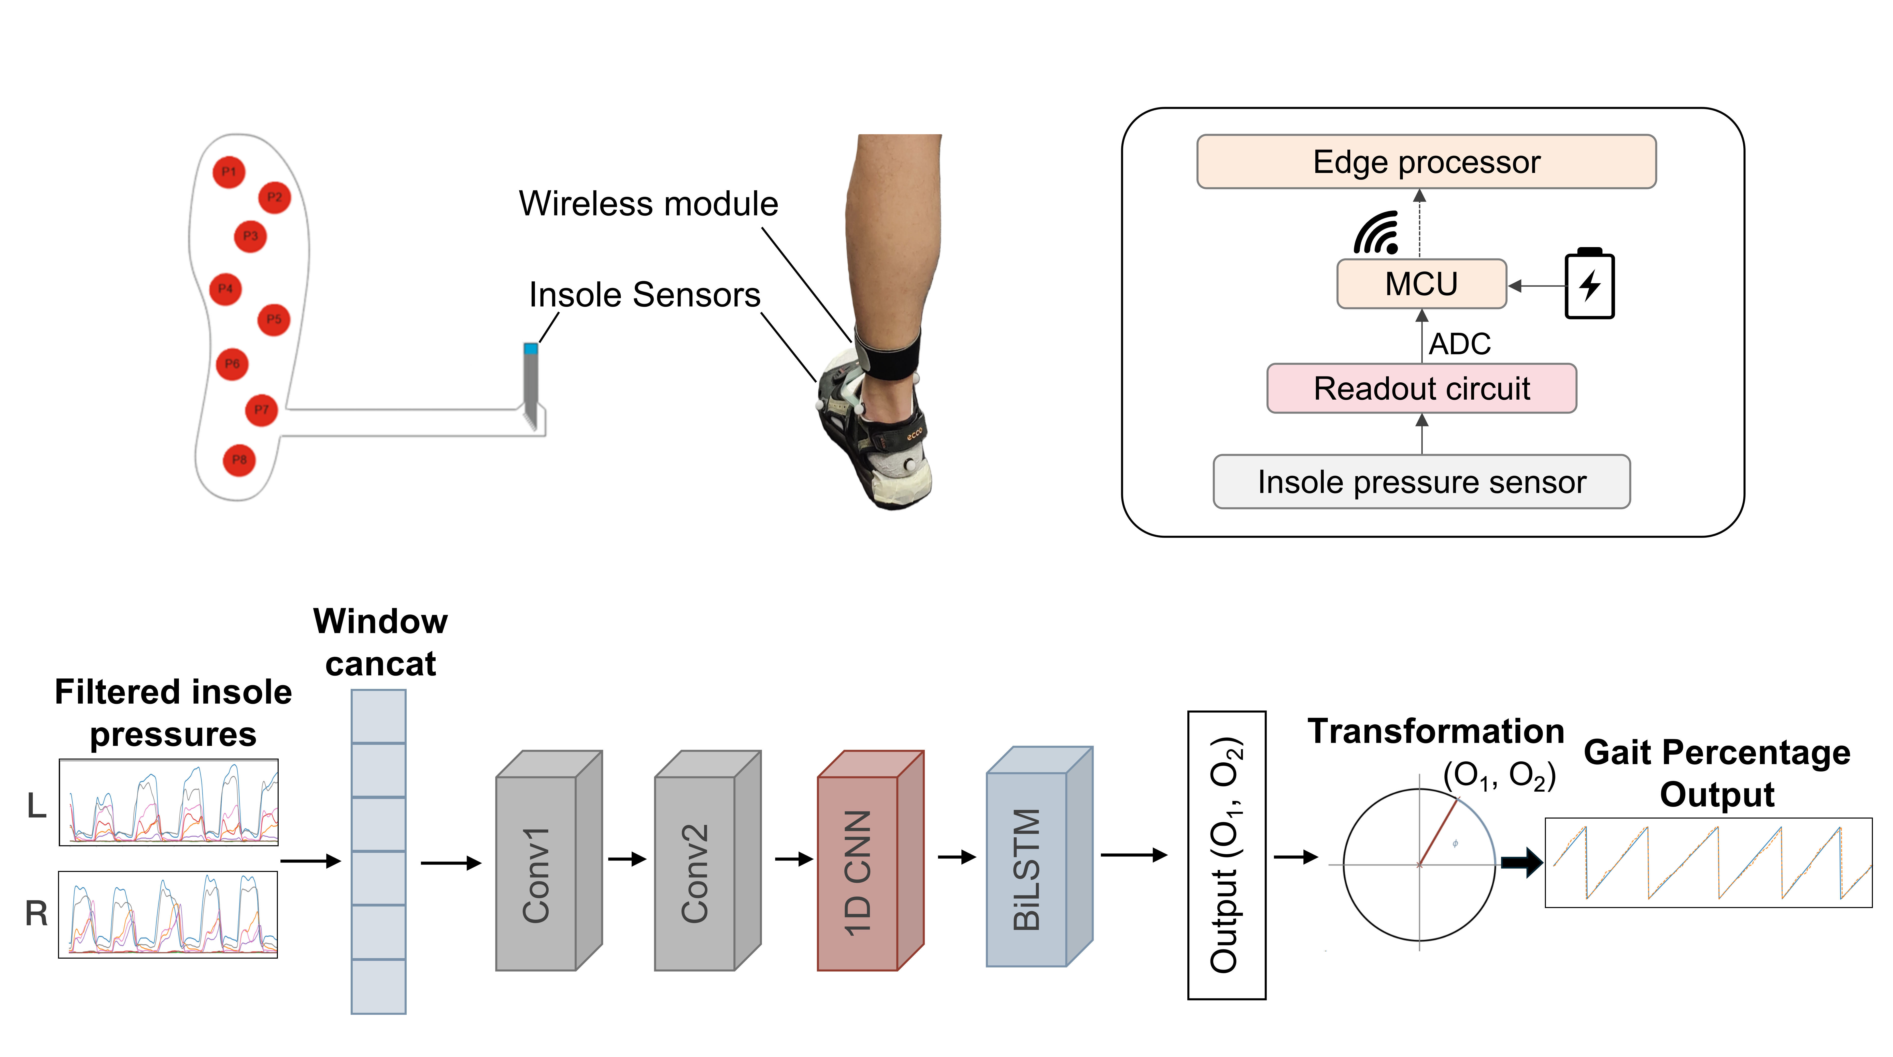

Figure S6: Task dependent control framework of the exoskeleton. Based on different tasks, the reference generation of the exoskeleton varies. For Task I, the exoskeleton delivers the minimal baseline torque to avoid cable slack without actively assisting. For Task II, 9-axis IMU signals from foot and shank are fed into the trained joint moment decoder that outputs the estimated net ankle moment. A post-processing stage then applies scaling and phase-shifting to the estimated moment which normalized by user body mass. For Task III, eight-channel insole pressure profiles are fed into the trained gait percentage decoder that estimate the current gait cycle percentage. The estimated phase triggers the torque-pulse generator which produces the torque impulses below the safety threshold during ankle dorsiflexion for both foots. The desired ankle torque is tracked by the closed-loop adaptive admittance controller (Note S2) thus the desired assistance is provided to the subject.

Figure S7: Experimental protocol for metabolic condition transitions. Each trial began with approximately 3 minutes of zero-torque walking to establish a metabolic baseline. Assistive control conditions—defined by combinations of torque scaling factor (α) and actuation delay (Δt)—were then activated in sequence. Each condition was held for ~3 minutes to allow metabolic steady-state to be reached. No rest was imposed between transitions, permitting continuous physiological adaptation. After several transitions, a rest period was introduced to conclude the trial. Sensor inputs for model training were extracted from concatenated segments: a fixed 3-second context window preceding each control transition and a sliding 6-second window post-transition. Only segments fully contained within a single assistive condition were retained for ground-truth labeling.

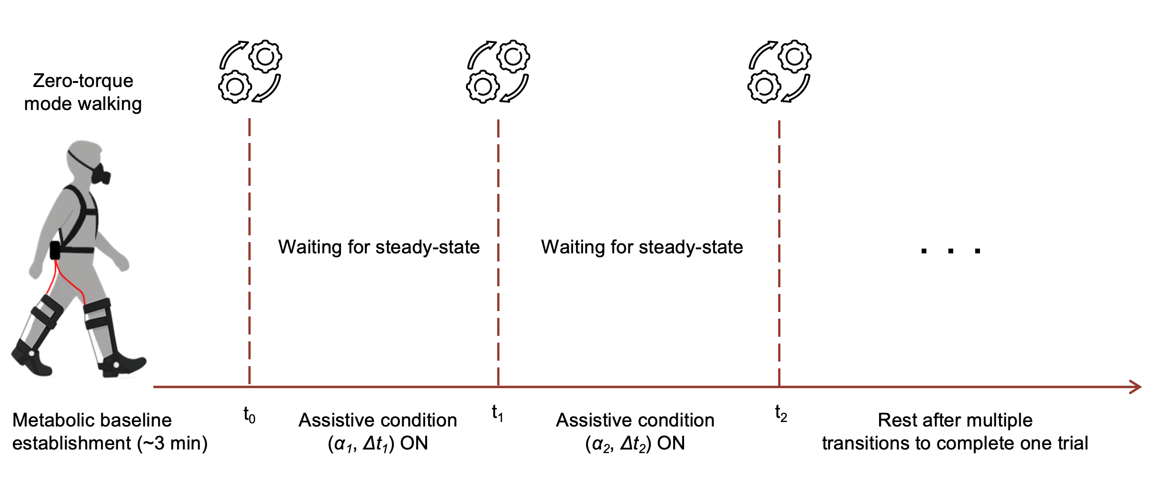

Figure S8: The optimal parameters and training curves of the joint moment estimation decoder.
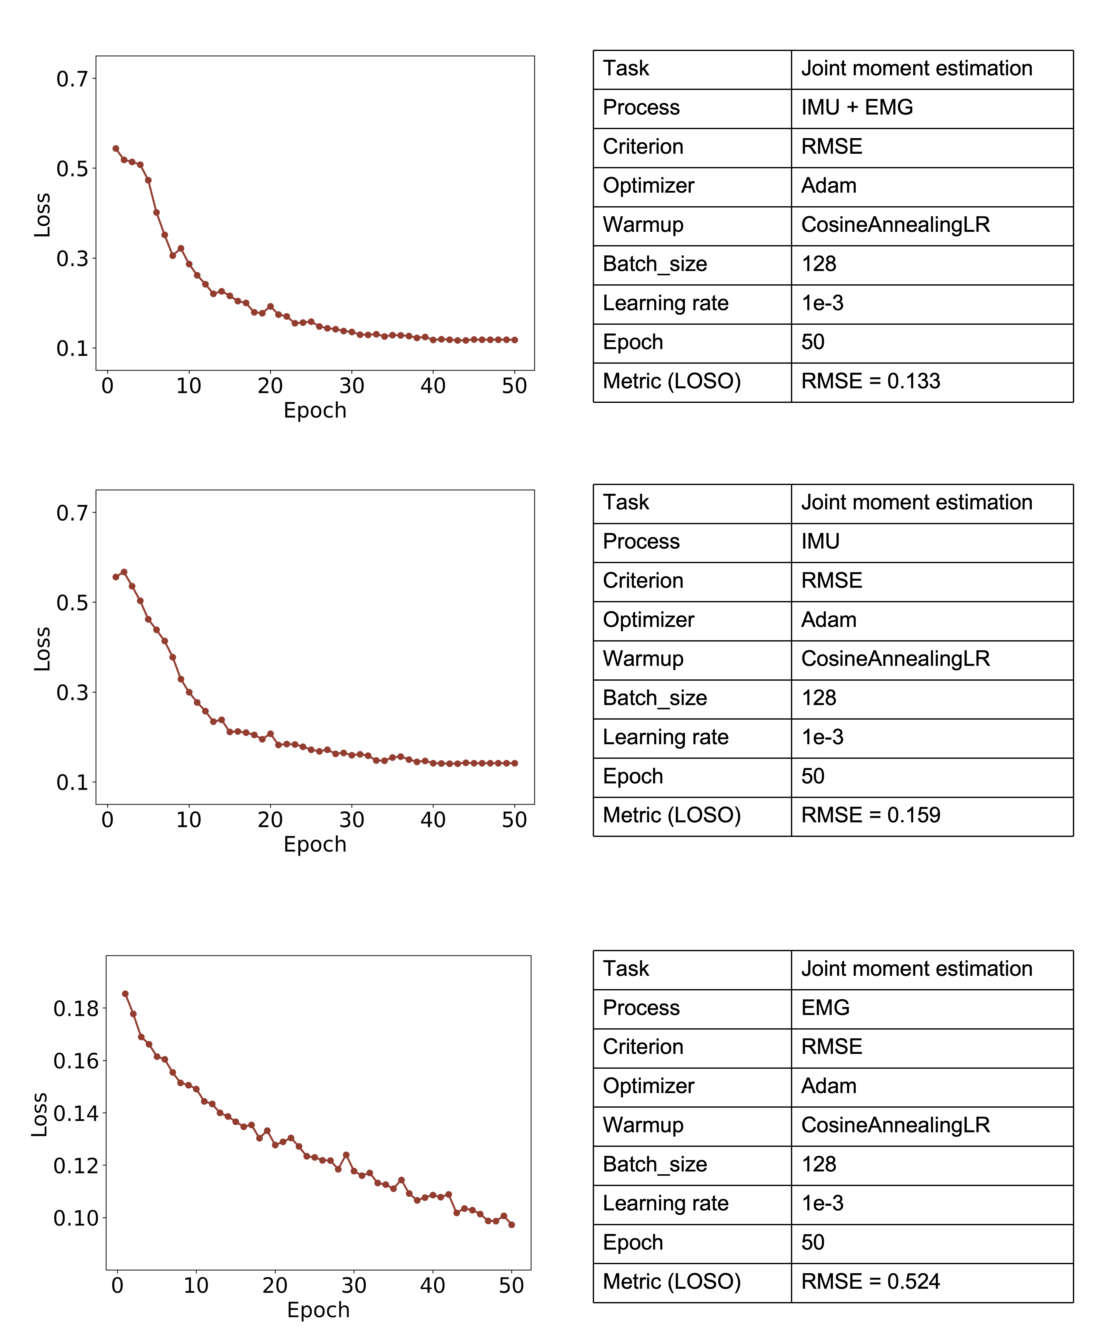

Figure S9: The optimal parameters and training curves of the metabolic consumption monitoring decoder.
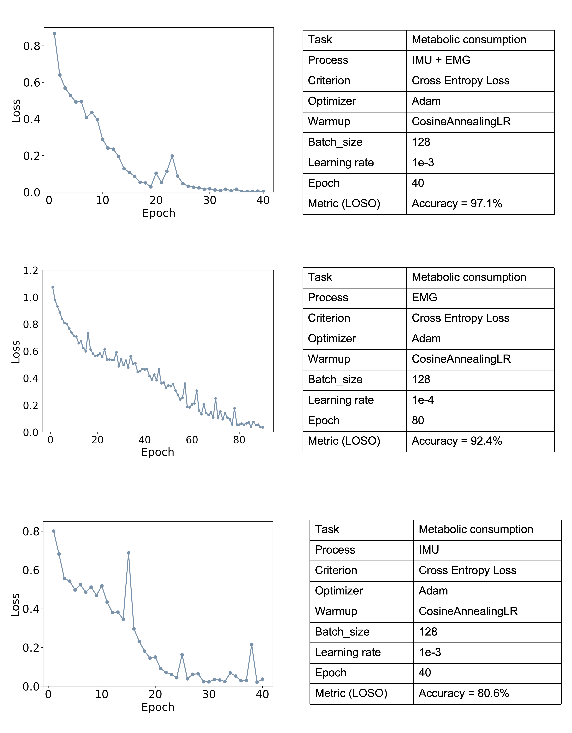

Figure S10: The optimal parameters and training curves of the potential harm detection decoder.

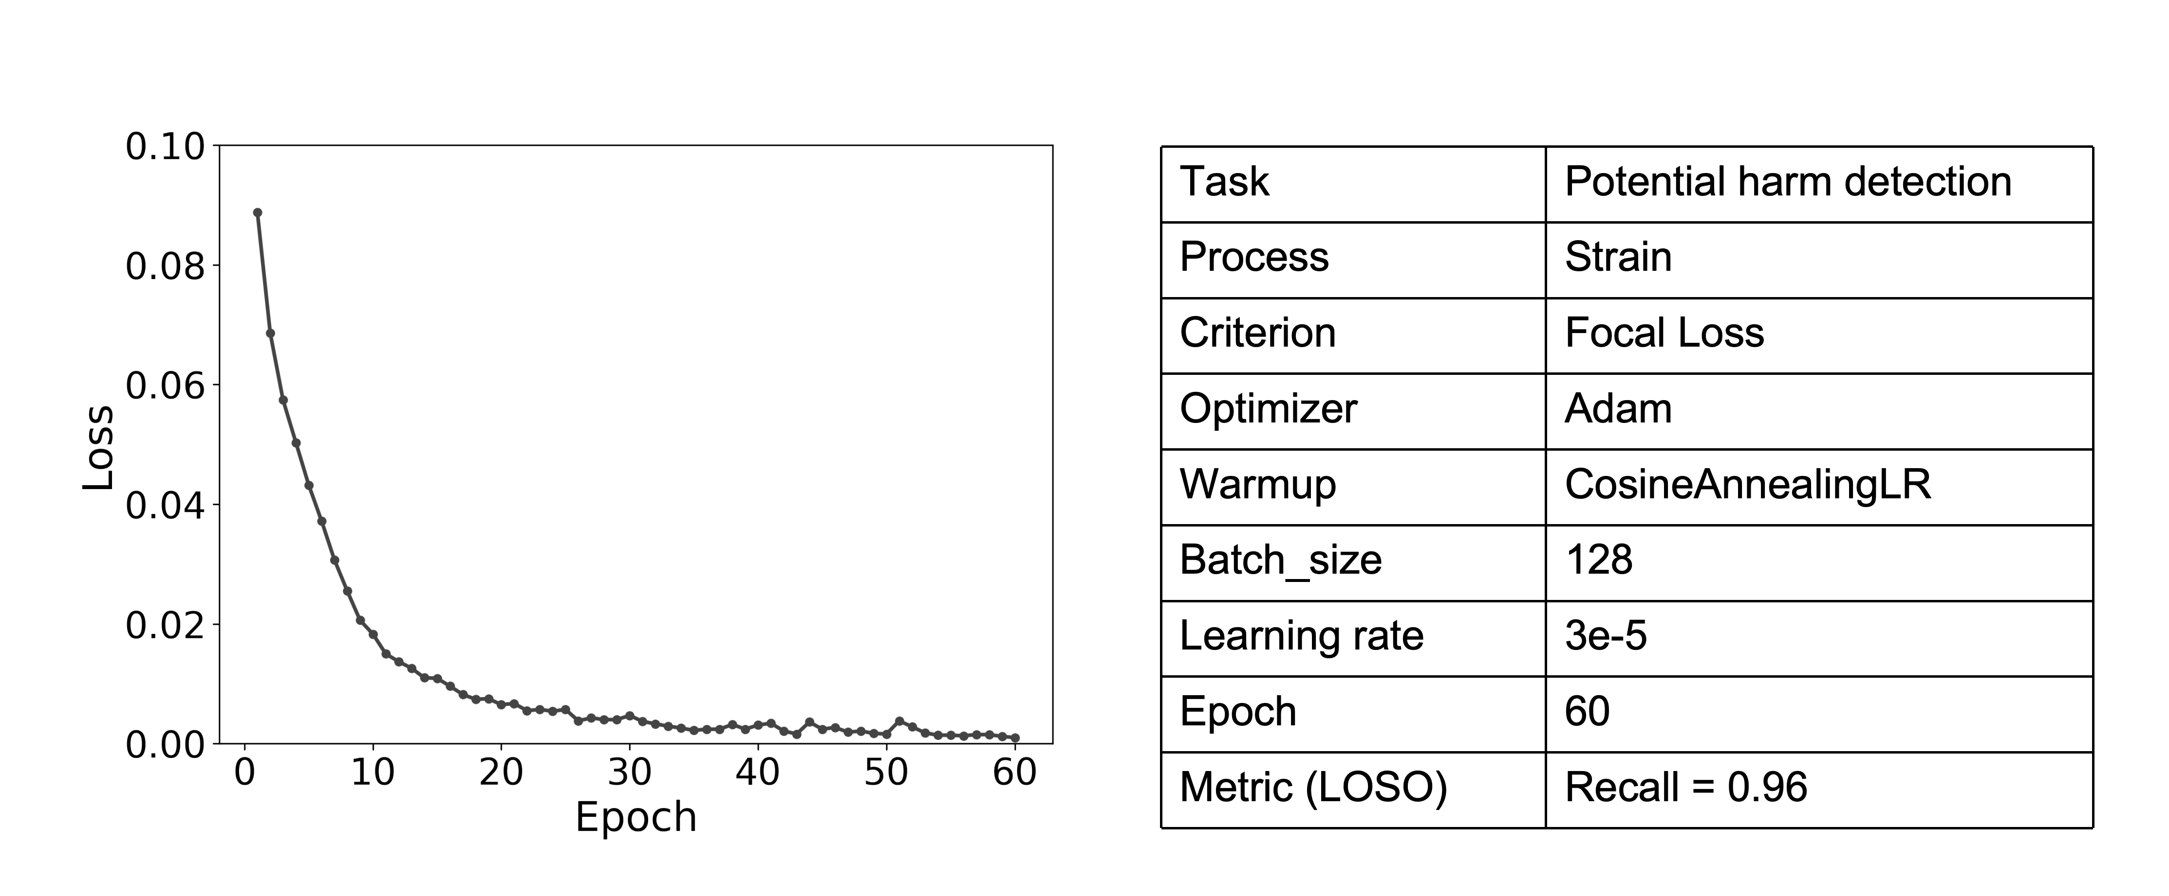

Figure S11: Distribution of average walking speeds during Phase I (joint moment estimation) experiment.

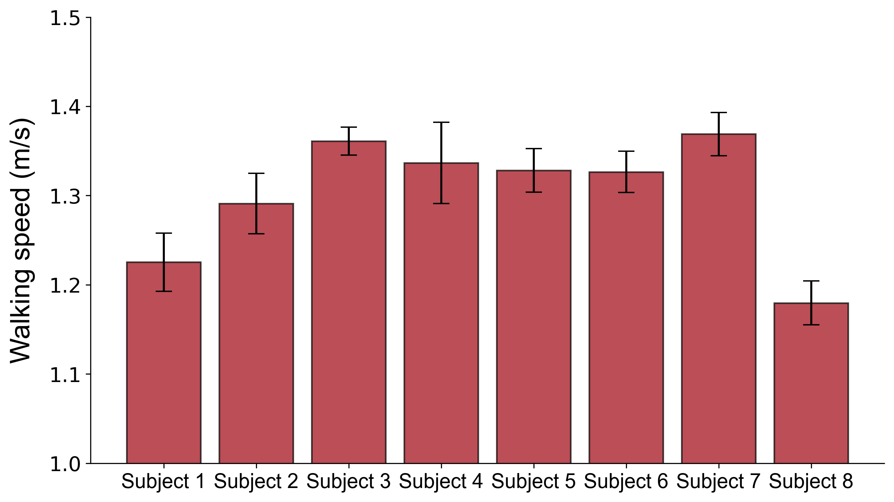

Table S1: Summary of strain sensor and EMG electrode characterization results.

Sensor Type | Metric | Specification
Strain sensor | Printing material | Graphene ink (TIMREX KS 25 + IPA + ethyl cellulose)
Strain sensor | Gauge factor | 112.6 ± 7.9
Strain sensor | Hysteresis | 6.3 ± 1.1%
Strain sensor | Strain range | 0.1%-10%
Strain sensor | Durability | >10,000 cycles
EMG electrode | Electrode material | Towel-based textile with graphene/PEDOT:PSS
EMG electrode | Electrode size | ~1 cm × 1 cm
EMG electrode | Input impedance | <300 kΩ (@ 10–450 Hz)
EMG electrode | SNR | ~10–15 dB

Table S2: Specification of developed cable-driven ankle exoskeleton. The specifications of the ankle exoskeleton are listed. Estimated Operating Time and ideal assisted distance was calculated based on 5.04 km/h (1.4m/s) walking speed.

Parameter | Value
System weight | 2.7kg
Rated voltage | 24V
Battery capacity | 4 Ah
Peak torque | 53Nm
Estimated operating time | 1.2 h
Ideal assisted distance | 6.04 km

Table S3: Demographic information of all participants and their involvement in experimental phases. Summary of subject ID, age, sex, height, weight, and participation across the three experimental phases: (I) joint moment estimation, (II) metabolic condition classification, and (III) potential risk detection. All participants were healthy adults with no known gait impairments. See Methods for inclusion criteria and ethical approval details.

Subject ID | Age (years) | Sex | Height (cm) | Weight (kg) | Phase I | Phase II | Phase III
S1 | 22 | M | 183 | 92 | ✓ | ✓
S2 | 24 | F | 163 | 66 | ✓
S3 | 24 | M | 178 | 68 | ✓ | ✓ | ✓
S4 | 31 | M | 172 | 84 | ✓ | ✓ | ✓
S5 | 24 | F | 174 | 60 | ✓ |  | ✓
S6 | 22 | F | 174 | 66 | ✓
S7 | 27 | M | 184 | 78 | ✓ | ✓ | ✓
S8 | 22 | M | 193 | 92 | ✓ | ✓
S9 | 25 | M | 184 | 86 |  | ✓ | ✓
S10 | 24 | F | 163 | 54 |  | ✓ | ✓
S11 | 28 | M | 182 | 72 |  | ✓ | ✓
S12 | 34 | M | 178 | 81 |  |  | ✓

