Supporting Information

Spatiotemporal control of the bacteria to express interferon-γ by focused ultrasound for tumor immunotherapy
Yuhao Chen^{1, 2#} , Meng Du^{1, 2#}, Zhen Yuan ³, Fei Yan ^{4*}, Zhiyi Chen^{1, 2*}
¹ The First Affiliated Hospital, Medical Imaging Centre, Hengyang Medical School, University of South China, Hengyang, Hunan, 421001, China.
² Institute of Medical Imaging, Hengyang Medical School, University of South China, Hengyang, Hunan, 421001, China.
³ Faculty of Health Sciences, University of Macau, Taipa, Macau SAR, China.
⁴ CAS Key Laboratory of Quantitative Engineering Biology, Shenzhen Institute of Synthetic Biology, Shenzhen Institutes of Advanced Technology, Chinese Academy of Sciences, Shenzhen, 518055, China.
*Co-corresponding Authors: Fei Yan, PhD, E-mail: fei.yan@siat.ac.cn; Zhiyi Chen, PhD, E-mail: zhiyi_chen@usc.edu.cn.

Supporting figures

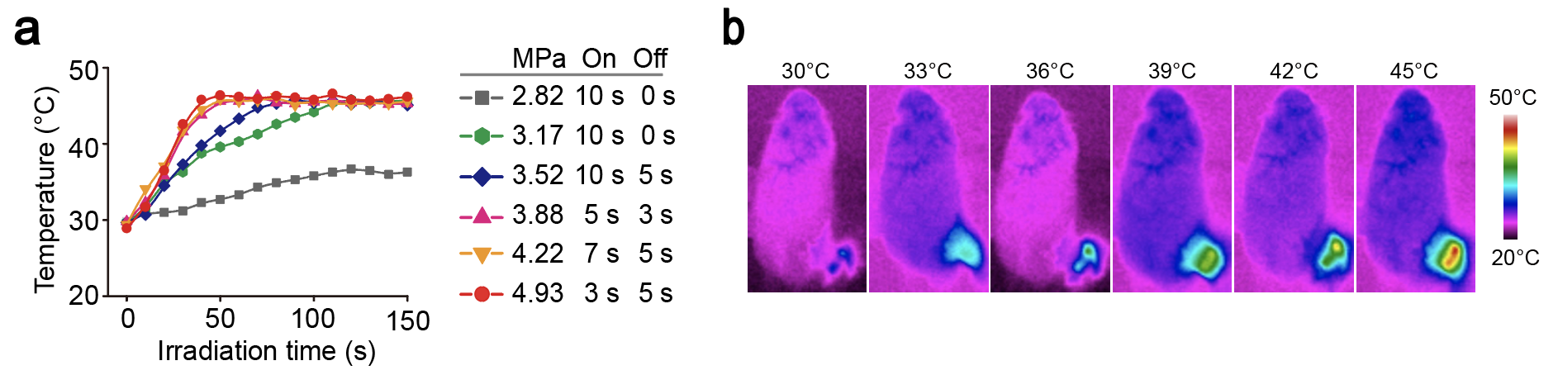

Figure S1. Ultrasound-mediated targeted heating of mice. a: Quantification of relative temperature of mice leg under focused ultrasound irradiation with the acoustic pressure of 2.82 MPa, 3.17 MPa, 3.52 MPa, 3.88 MPa, 4.22 MPa and 4.93 MPa. b: Representative IR thermal images of the mice under focused ultrasound irradiation.

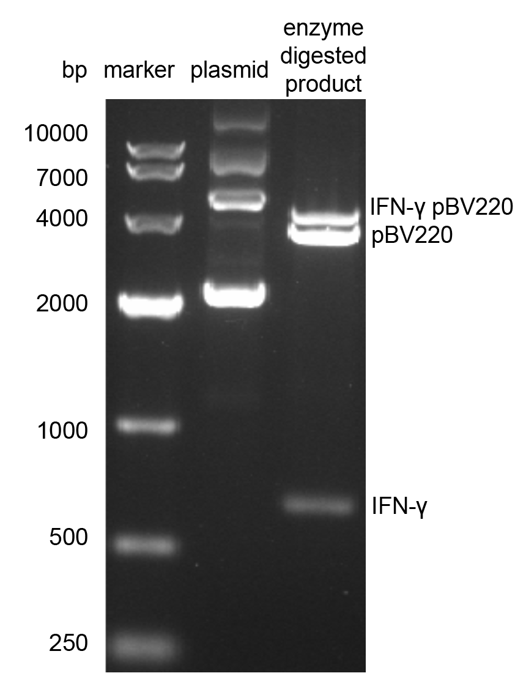

Figure S2. Agarose gel electrophoresis of constructed plasmid. The plasmid was cleaved by EcoRI and SalI enzymes and then performed agarose gel electrophoresis to observed the DNA band sequence size. Band 1 is pure IFN-γ pBV220 plasmid, Band 2 is the plasmid that has undergone an enzyme digestion reaction.

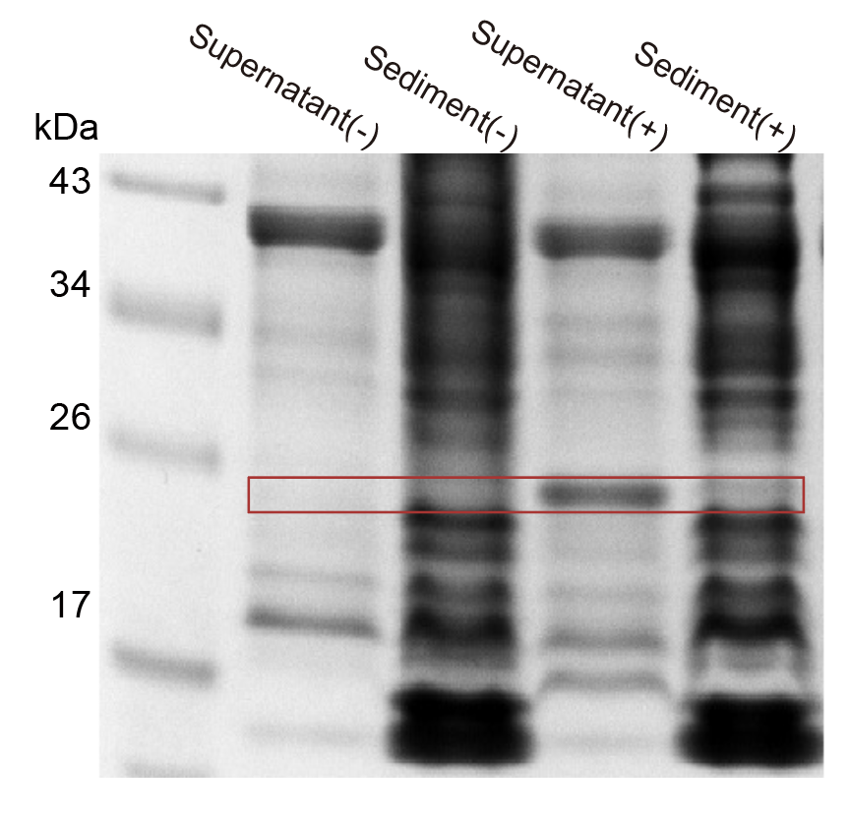
Figure S3. Verification of solubility of protein expressed by bacteria. SDS-PAGE protein analysis of IFN-γ protein from induced or uninduced URB after ultrasonic lysis.

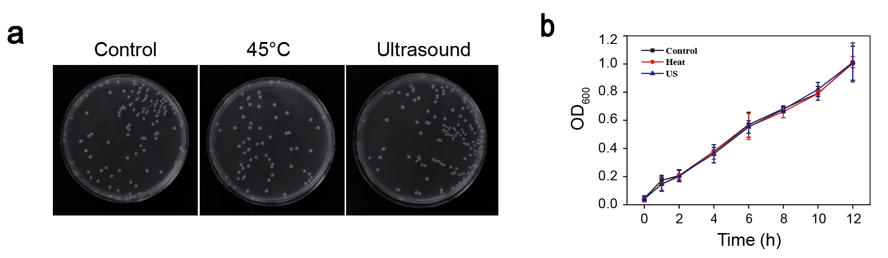
Figure S4. Detection of bacteria activity. a: Representative photographs of solid Luria-Bertani (LB) agar plates of bacterial colonization after 45℃ heating or ultrasound irradiation. b: OD₆₀₀ value change of bacteria solution after 45℃ heating or ultrasound irradiation.

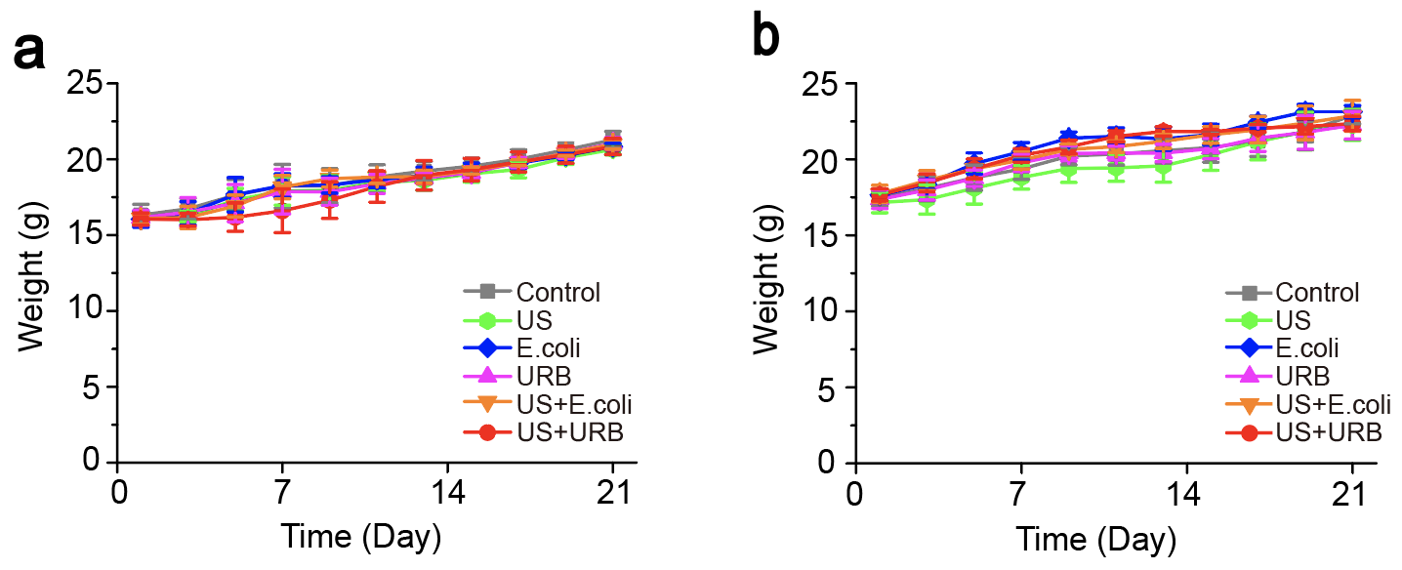
Figure S5. Weights of mice in different groups after treatment. a: The weights curves of mice bearing 4T1 tumors in different groups. b: The weights curves of mice bearing primary tumor and distant tumor in different groups.

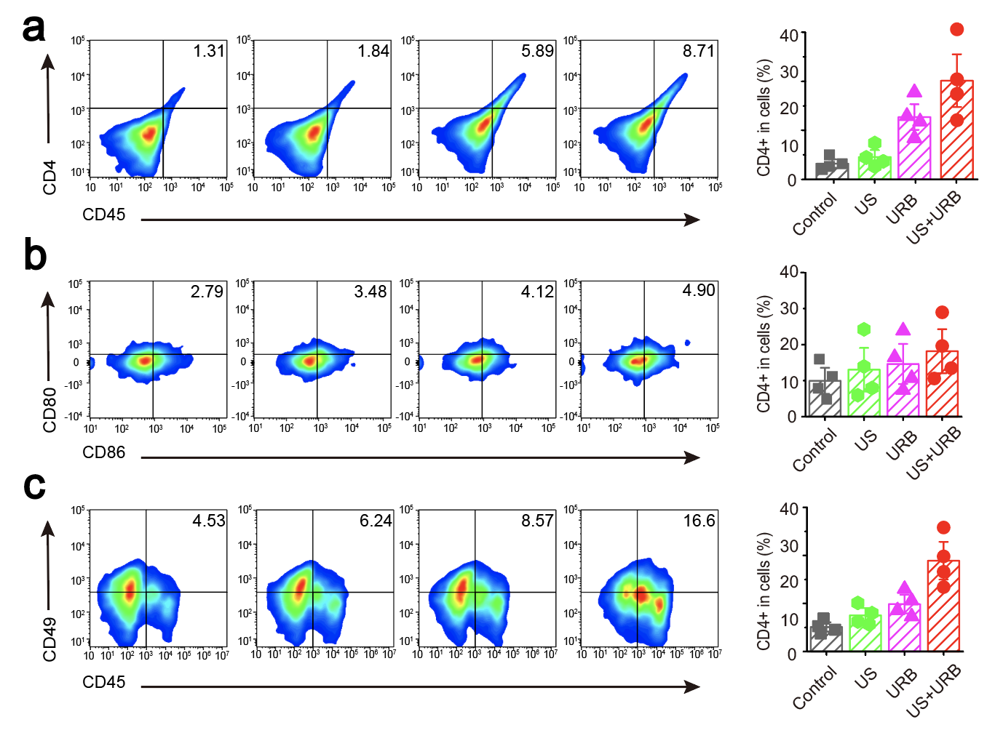
Figure S6. Quantification of proportions of immune cells in the tumor at day 7 after treatment in the primary tumor inhibition experiment. a: Representative flow cytometry plots and quantification of CD4⁺CD45⁺ T cells in the tumor. b: Representative flow cytometry plots and quantification of CD80⁺CD86⁺ dendritic cells among CD11b⁺ cells in the tumor. c: Representative flow cytometry plots and quantification of CD49⁺CD45⁺ NK cells in the tumor.

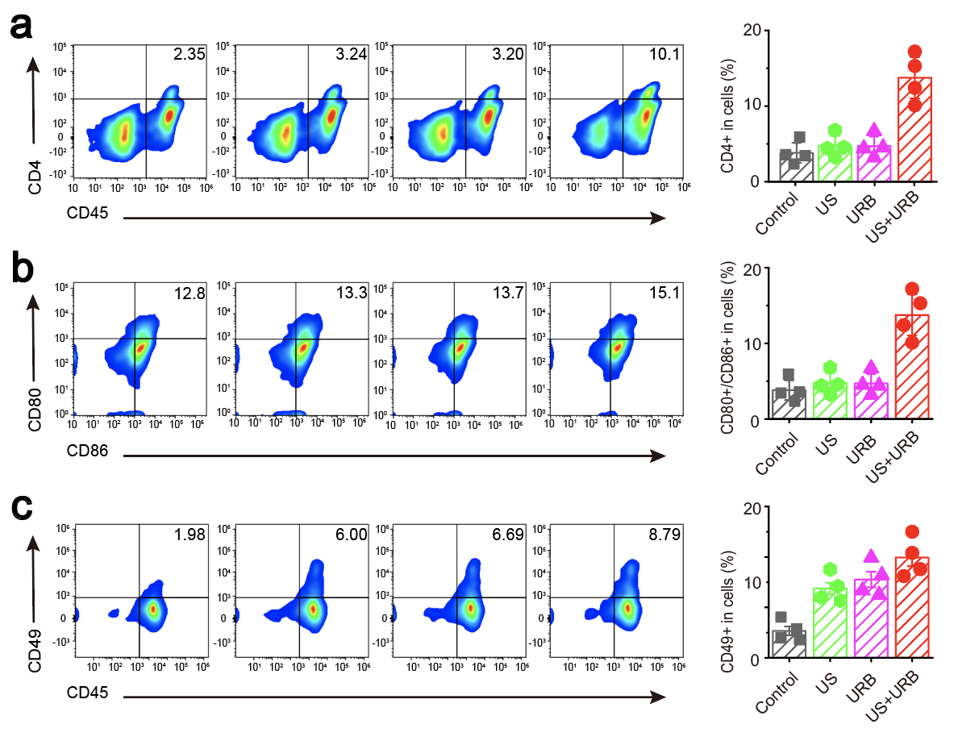
Figure S7. Quantification of proportions of immune cells in the spleen at day 7 after treatment in the distant tumor inhibition experiment. a: Representative flow cytometry plots and quantification of CD4⁺CD45⁺ T cells in the spleen. b: Representative flow cytometry plots and quantification of CD80⁺CD86⁺ dendritic cells among CD11b⁺ cells in the spleen. c: Representative flow cytometry plots and quantification of CD49⁺CD45⁺ NK cells in the spleen.

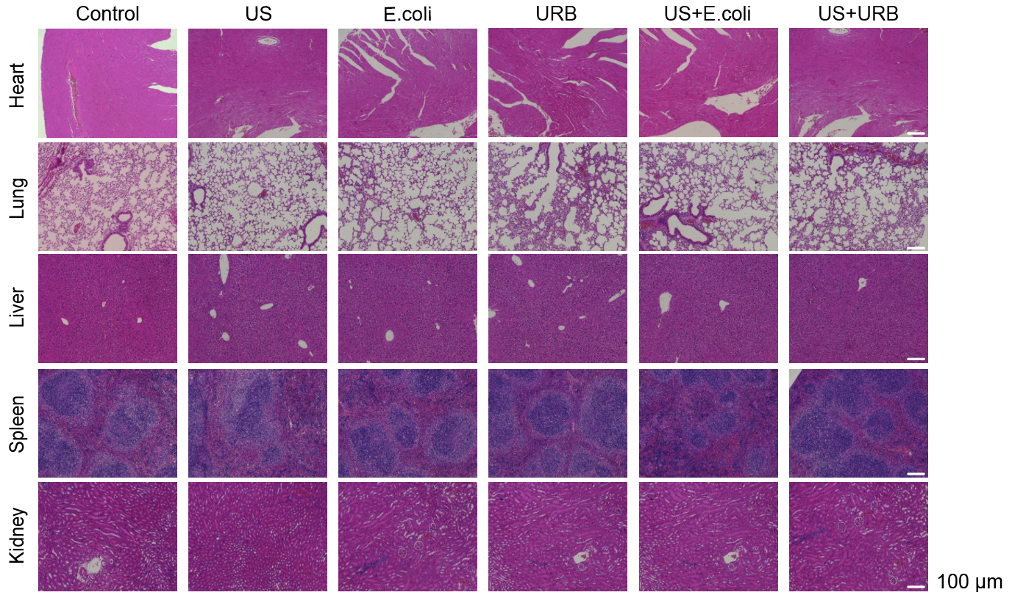

Figure S8. Representative images of H&E-stained organ slices of mice with different treatment.

Supporting tables

Table S1. Blood biochemistry of mice from the tin vivo treatment experiment.
 | PBS | US | E.coli | URB | US + E.coli | US+URB
Alanine aminotransferase (ALT) (U/L) | 78.901 | 62.498 | 73.126 | 88.972 | 90.357 | 62.744
Aspartate aminotransfe rase (AST) (U/L) | 126.488 | 92.262 | 110.106 | 93.206 | 101.264 | 129.367
Uric nitrogen (BUN) (mg/dL) | 21.933 | 19.212 | 23.598 | 17.849 | 21.536 | 21.152
Creatinine（Cr）(μmol/L) | 20.405 | 20.654 | 23.312 | 20.45 | 22.086 | 24.744
Direct Bilirubin (DBIL) (μmol/L) | 9.964 | 10.486 | 11.082 | 10.492 | 12.959 | 13.741
Total bilirubin (TBIL) (μmol/L) | 17.613 | 16.29 | 18.292 | 20.409 | 19.843 | 20.45

Table S2. Blood routine of mice from the tin vivo treatment experiment.
 | PBS | US | E.coli | URB | US+E.coli | US+URB
WBC (10⁹/L) | 3.0 | 5.3 | 3.2 | 3.6 | 3.7 | 4.4
Lymph#(10⁹/L) | 2.9 | 4.1 | 2.6 | 2.8 | 2.4 | 3.2
Mon# (10⁹/L) | 0.2 | 0.2 | 0.1 | 0.1 | 0.1 | 0.2
Gran# (10⁹/L) | 0.9 | 1.0 | 1.3 | 0.7 | 1.2 | 1.2
Lymph% (%) | 64.0 | 75.6 | 67.1 | 77.7 | 64.7 | 74．9
Mon% (%) | 5.4 | 4.6 | 4.4 | 4.0 | 3.9 | 4.9
Gran%(%) | 30.6 | 19.8 | 28.5 | 18.3 | 32.1 | 29.5
RBC (10¹²/L) | 8.70 | 7.81 | 7.87 | 7.21 | 7.68 | 7.92
HGB (g/L) | 128 | 115 | 114 | 118 | 113 | 120
HCT (%) | 40.6 | 36.3 | 36.5 | 35.1 | 36.2 | 37.2
MCV (fl) | 46.7 | 46.5 | 46.5 | 48.8 | 47.2 | 46.2
MCH (pg) | 14.7 | 14.7 | 14.4 | 14.9 | 14.7 | 14.6
MCHC (g/L) | 315 | 316 | 312 | 307 | 312 | 318
RDW (%) | 17.3 | 19.9 | 17.3 | 18.8 | 18.0 | 17.5
PLT (10⁹/L) | 707 | 625 | 558 | 360 | 482 | 507
MPV (fl) | 5.5 | 5.5 | 5.7 | 4.9 | 6.2 | 5.6
PDW (%) | 16.3 | 16.3 | 16.4 | 17.0 | 16.1 | 16.5
PCT (%) | 0.388 | 0.563 | 0.302 | 0.276 | 0.298 | 0.375

