Supplemental Material
Electric-Field Engineering and SISSO Prediction of Schottky Barrier Heights
Qian Chen¹, Chenghua Sun², Xinjie Wang¹, Lixuan Wang¹, Guoqiang Hao¹*, Jisong Hu^{3,5}*, Rui Zhang⁴*, Qingguo Xu⁶*
¹ School of Materials Science and Engineering, East China University of Science and Technology, Shanghai 200237, China.
²Department of Chemistry and Biotechnology, Swinburne University of Technology, Victoria 3122, Australia
³ School of Materials Science and Engineering, Hanshan Normal University, Chaozhou, Guangdong, 521041, China.
⁴ Faculty of Chemical Engineering and Energy Technology, Shanghai Institute of Technology, Shanghai, 201418, PR China.
⁵ Shenzhen Key Laboratory of Polymer Science and Technology, College of Materials Science and Engineering, Shenzhen University, Shenzhen, 518060, China.
⁶ Shanghai Solar Energy Research Center Co., Ltd, 201100, China.

Table S1 The Work Function (WF) of monolayer graphene and each monolayer MX₂.
Structure (Monolayer) | WF (eV)
C | 4.258
CrSe₂ | 4.723
MoS₂ | 4.664
MoSe₂ | 4.473
WS₂ | 4.380
WSe₂ | 4.461

Table S2 The variation of contact types of different heterostructures with the applied electric field.
Structure | Electric field range (V/Å) | Type of contact
C-CrSe₂ | -0.5 ≤ E ≤ -0.4 | Ohmic contact
C-CrSe₂ | E = -0.3 | p-type Quasi-Ohmic contact
C-CrSe₂ | E = -0.2 | p-type Schottky contact
C-CrSe₂ | E = -0.1 | n-type Schottky contact
C-CrSe₂ | E = 0.0 | n-type Quasi-Ohmic contact
C-CrSe₂ | 0.1 ≤ E ≤ 0.5 | Ohmic contact
C-MoS₂ | E = -0.5 | Ohmic contact
C-MoS₂ | E = -0.4 | p-type Quasi-Ohmic contact
C-MoS₂ | -0.3 ≤ E ≤ -0.2 | p-type Schottky contact
C-MoS₂ | E = -0.1 | n-type Schottky contact
C-MoS₂ | E = 0.0 | n-type Quasi-Ohmic contact
C-MoS₂ | 0.1 ≤ E ≤ 0.5 | Ohmic contact
C-MoSe₂ | E = -0.5 | Ohmic contact
C-MoSe₂ | E = -0.4 | p-type Quasi-Ohmic contact
C-MoSe₂ | -0.3 ≤ E ≤ -0.1 | p-type Schottky contact
C-MoSe₂ | 0.0 ≤ E ≤ 0.3 | n-type Schottky contact
C-MoSe₂ | E = 0.4 | n-type Quasi-Ohmic contact
C-MoSe₂ | E = 0.5 | Ohmic contact
C-WS₂ | E = -0.5 | Ohmic contact
C-WS₂ | E = -0.4 | p-type Quasi-Ohmic contact
C-WS₂ | -0.3 ≤ E ≤ -0.2 | p-type Schottky contact
C-WS₂ | -0.1 ≤ E ≤ 0.0 | n-type Schottky contact
C-WS₂ | E = 0.1 | n-type Quasi-Ohmic contact
C-WS₂ | 0.2 ≤ E ≤ 0.5 | Ohmic contact
C-WSe₂ | -0.5 ≤ E ≤ -0.4 | Ohmic contact
C-WSe₂ | E = -0.3 | p-type Quasi-Ohmic contact
C-WSe₂ | -0.2 ≤ E ≤ 0.0 | p-type Schottky contact
C-WSe₂ | 0.1 ≤ E ≤ 0.3 | n-type Schottky contact
C-WSe₂ | E = 0.4 | n-type Quasi-Ohmic contact
C-WSe₂ | E = 0.5 | Ohmic contact

Table S3 Subdivided electric field regulation range of each C-MX₂.
Structure | Electric field regulation range (V/Å)
C-CrSe₂ | -0.3, -0.27, -0.24, -0.21, -0.2, -0.18, -0.15, -0.12, -0.1, -0.09, -0.06, -0.03, 0.0
C-MoS₂ | -0.4, -0.36, -0.32, -0.3, -0.28, -0.24, -0.2, -0.16, -0.12, -0.1, -0.08, -0.04, 0.0
C-MoSe₂ | -0.4, -0.33, -0.3, -0.26, -0.2, -0.19, -0.12, -0.1, -0.05, 0.0, 0.02, 0.09, 0.1, 0.16, 0.2, 0.23, 0.3, 0.4
C-WS₂ | -0.4, -0.355, -0.31, -0.3, -0.265, -0.22, -0.2, -0.175, -0.13, -0.1, -0.085, -0.04, 0.0, 0.005, 0.05, 0.1
C-WSe₂ | -0.3, -0.23, -0.2, -0.16, -0.1, -0.09, -0.02, 0.0, 0.05, 0.1, 0.12, 0.19, 0.26, 0.33, 0.4
Note: The subdivided electric field intervals use the quasi-Ohmic contact point as the boundary, with a step size equal to one-tenth of the interval length. If the interval contains data in the range of −0.5 to 0.5 eV, it is also inserted accordingly.
Table S4 The E_{g}, ΔQ_{C}, and P_{TB} of five C-MX₂ heterostructures as a function of the applied electric field.
Structure | E (V/Å) | E_{g} (eV) | ΔQ_{C} (e) | P_{TB}
C-CrSe₂ | -0.3 | 0.687582 | -0.254213355 | 0.020057671
C-CrSe₂ | -0.27 | 0.687928 | -0.241103696 | 0.020026079
C-CrSe₂ | -0.24 | 0.6874 | -0.227350778 | 0.020021748
C-CrSe₂ | -0.21 | 0.686452 | -0.214520112 | 0.019978235
C-CrSe₂ | -0.2 | 0.68612 | -0.209412694 | 0.01994318
C-CrSe₂ | -0.18 | 0.685375 | -0.200830881 | 0.019938495
C-CrSe₂ | -0.15 | 0.68459 | -0.187654922 | 0.01989391
C-CrSe₂ | -0.12 | 0.683789 | -0.174185849 | 0.019891106
C-CrSe₂ | -0.1 | 0.683507 | -0.165546626 | 0.019849687
C-CrSe₂ | -0.09 | 0.682656 | -0.160903532 | 0.019840826
C-CrSe₂ | -0.06 | 0.682234 | -0.147698327 | 0.019798385
C-CrSe₂ | -0.03 | 0.681038 | -0.13516556 | 0.01979342
C-CrSe₂ | 0 | 0.680925 | -0.12142183 | 0.019757195
C-MoS₂ | -0.4 | 1.117344 | -0.285177428 | 0.021103978
C-MoS₂ | -0.36 | 1.120595 | -0.268256843 | 0.021077293
C-MoS₂ | -0.32 | 1.123196 | -0.250804705 | 0.021054118
C-MoS₂ | -0.3 | 1.123582 | -0.2421456 | 0.021047659
C-MoS₂ | -0.28 | 1.124594 | -0.233320676 | 0.021000803
C-MoS₂ | -0.24 | 1.125748 | -0.215656447 | 0.020972608
C-MoS₂ | -0.2 | 1.12606 | -0.197764853 | 0.02097063
C-MoS₂ | -0.16 | 1.12552 | -0.180501779 | 0.02090317
C-MoS₂ | -0.12 | 1.124776 | -0.163012422 | 0.020861399
C-MoS₂ | -0.1 | 1.123336 | -0.154045878 | 0.020840003
C-MoS₂ | -0.08 | 1.122826 | -0.145267865 | 0.020837172
C-MoS₂ | -0.04 | 1.120067 | -0.127940548 | 0.02077929
C-MoS₂ | 0 | 1.117475 | -0.110513334 | 0.020736072
C-MoSe₂ | -0.4 | 1.537885 | -0.098389924 | 0.023513854
C-MoSe₂ | -0.33 | 1.536133 | -0.089025998 | 0.022705359
C-MoSe₂ | -0.3 | 1.535383 | -0.085084337 | 0.0223669
C-MoSe₂ | -0.26 | 1.534657 | -0.079831489 | 0.021921903
C-MoSe₂ | -0.2 | 1.533647 | -0.071841639 | 0.021263248
C-MoSe₂ | -0.19 | 1.533393 | -0.070540414 | 0.021156868
C-MoSe₂ | -0.12 | 1.532918 | -0.061396086 | 0.020408387
C-MoSe₂ | -0.1 | 1.53274 | -0.058799021 | 0.020203863
C-MoSe₂ | -0.05 | 1.532216 | -0.052230727 | 0.019672822
C-MoSe₂ | 0 | 1.531875 | -0.045700443 | 0.019166571
C-MoSe₂ | 0.02 | 1.531868 | -0.043137663 | 0.018984032
C-MoSe₂ | 0.09 | 1.532128 | -0.034023417 | 0.018311724
C-MoSe₂ | 0.1 | 1.531999 | -0.032699929 | 0.018206023
C-MoSe₂ | 0.16 | 1.532036 | -0.024859777 | 0.017646461
C-MoSe₂ | 0.2 | 1.532731 | -0.019658139 | 0.017274713
C-MoSe₂ | 0.23 | 1.533105 | -0.015736625 | 0.017008376
C-MoSe₂ | 0.3 | 1.534085 | -0.00651692 | 0.01639276
C-MoSe₂ | 0.4 | 1.535845 | 0.006824183 | 0.015563722
C-WS₂ | -0.4 | 1.282713 | -0.206635139 | 0.023707634
C-WS₂ | -0.355 | 1.284987 | -0.186480991 | 0.0236342
C-WS₂ | -0.31 | 1.286668 | -0.167011784 | 0.023596961
C-WS₂ | -0.3 | 1.287607 | -0.162975802 | 0.023566977
C-WS₂ | -0.265 | 1.28745 | -0.14748539 | 0.023523566
C-WS₂ | -0.22 | 1.287798 | -0.127932116 | 0.023473242
C-WS₂ | -0.2 | 1.287619 | -0.119057808 | 0.02343387
C-WS₂ | -0.175 | 1.287408 | -0.108492288 | 0.023392582
C-WS₂ | -0.13 | 1.286348 | -0.089767774 | 0.023323167
C-WS₂ | -0.1 | 1.285111 | -0.077516464 | 0.02326568
C-WS₂ | -0.085 | 1.284254 | -0.071238957 | 0.023223125
C-WS₂ | -0.04 | 1.282074 | -0.054299896 | 0.023088033
C-WS₂ | 0 | 1.280035 | -0.043675382 | 0.022801195
C-WS₂ | 0.005 | 1.279872 | -0.042857747 | 0.022772985
C-WS₂ | 0.05 | 1.278394 | -0.037194729 | 0.022263975
C-WS₂ | 0.1 | 1.275349 | -0.031074371 | 0.021688589
C-WSe₂ | -0.3 | 1.627892 | -0.081586701 | 0.022460662
C-WSe₂ | -0.23 | 1.634408 | -0.072626883 | 0.021662061
C-WSe₂ | -0.2 | 1.635755 | -0.068780088 | 0.021322529
C-WSe₂ | -0.16 | 1.6392 | -0.063712165 | 0.020909751
C-WSe₂ | -0.1 | 1.639761 | -0.056011569 | 0.020248349
C-WSe₂ | -0.09 | 1.64 | -0.054765233 | 0.020160983
C-WSe₂ | -0.02 | 1.6364 | -0.045862114 | 0.019430853
C-WSe₂ | 0 | 1.641003 | -0.043295269 | 0.019227769
C-WSe₂ | 0.05 | 1.6405 | -0.036954457 | 0.018717463
C-WSe₂ | 0.1 | 1.63976 | -0.030594137 | 0.0182583
C-WSe₂ | 0.12 | 1.6394 | -0.027991486 | 0.018065409
C-WSe₂ | 0.19 | 1.6367 | -0.019047692 | 0.017397935
C-WSe₂ | 0.2 | 1.636397 | -0.017744849 | 0.017312974
C-WSe₂ | 0.26 | 1.633 | -0.010022609 | 0.016752286
C-WSe₂ | 0.3 | 1.630397 | -0.004850227 | 0.016410518
C-WSe₂ | 0.33 | 1.6283 | -0.000805744 | 0.016147945
C-WSe₂ | 0.4 | 1.62364 | 0.019488785 | 0.0158216

Table S5 The constituent elements of the studied MX₂ and the basic physical properties of their corresponding elemental substances.
Element or its corresponding simple substance  Features | M (Cr, Mo, W) | X (S, Se) | C
Relative atomic mass | M₁ | M₂ | M₃
Atomic radius | R_{m1} | R_{m2} | R_{m3}
Subvalence electrons | q_{(n-1)d1} | q_{(n-1)p2} | q_{(n-1)p3}
Outermost electrons | q_{ns1} | q_{ns2} | q_{ns3}
Valence electrons | Ne₁ | Ne₂ | Ne₃
Pauling electronegativity | χ₁ | χ₂ | χ₃
Electron affinity | E_{A1} | E_{A2} | E_{A3}
First ionization energy | E_{i1} | E_{i2} | E_{i3}
Melting point | T_{m1} | T_{m2} | /
Density | ρ₁(g/cm³) | ρ₂(g/cm³) | ρ₃(g/cm³)
Boiling point | bp₁(K) | bp₂(K) | bp₃(K)
Thermal conductivity | λ₁(W/mK) | λ₂(W/mK) | λ₃(W/mK)
Electrical resistivity | ρ₁(nΩ∙m) | / | ρ₃(nΩ∙m)
Heat capacity | c₁(J/gK) | c₂(J/gK) | /
Note: Basic physical properties of the constituent elements in the studied heterostructures (Feature₁, Feature₂, Feature₃).

Figure S1 (a) High-symmetry path in k-space. (b) Graphene band structure.

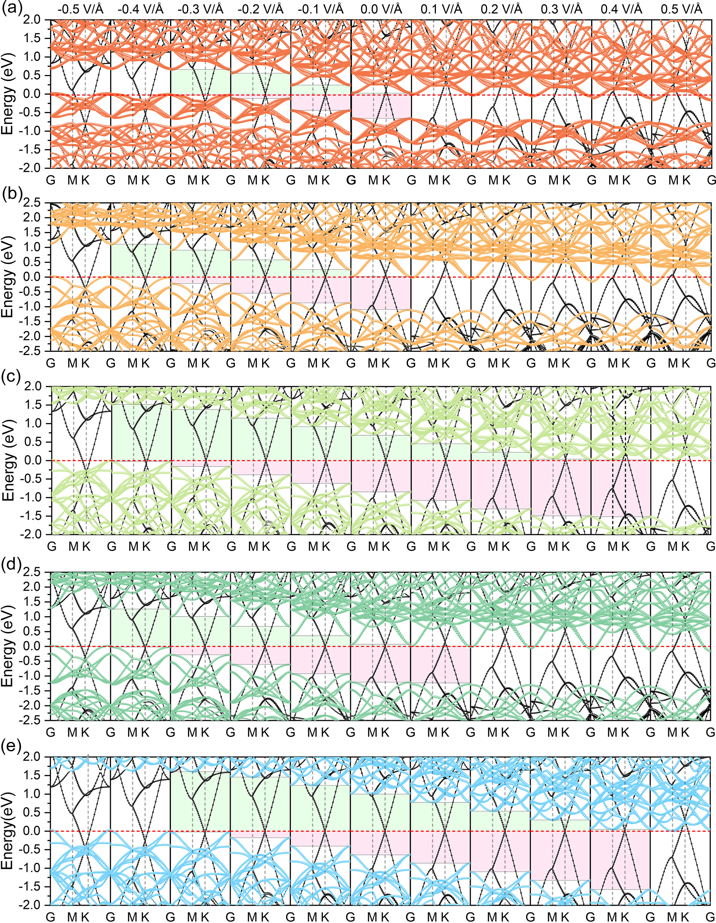
Figure S2 Projected band structures of C-MX₂[(a) C-CrSe₂, (b) C-MoS₂, (c) C-MoSe₂, (d) WS₂ (e) WSe₂] under external electric fields ranging from -0.5 to 0.5 V/Å with an interval of 0.1 V/Å.
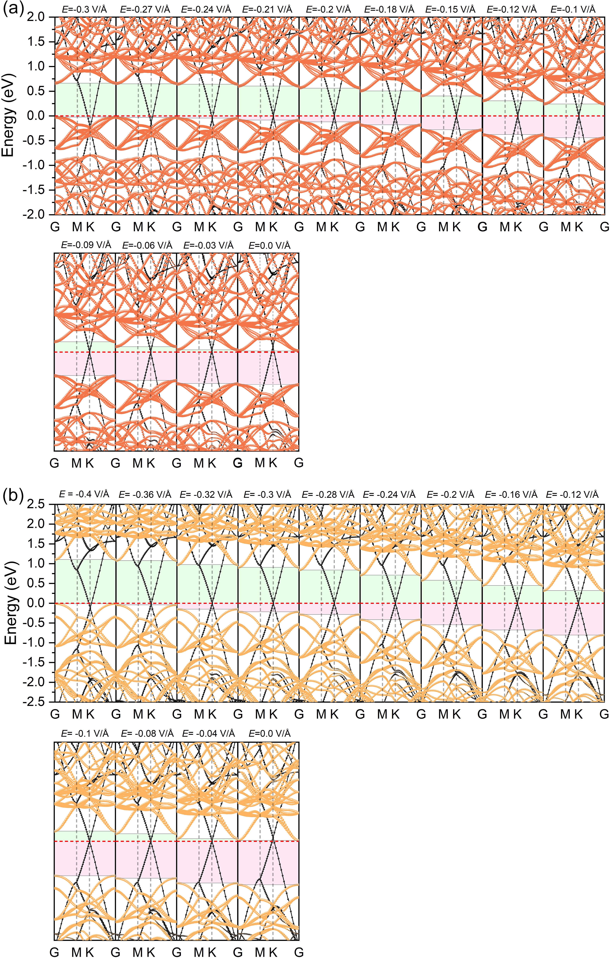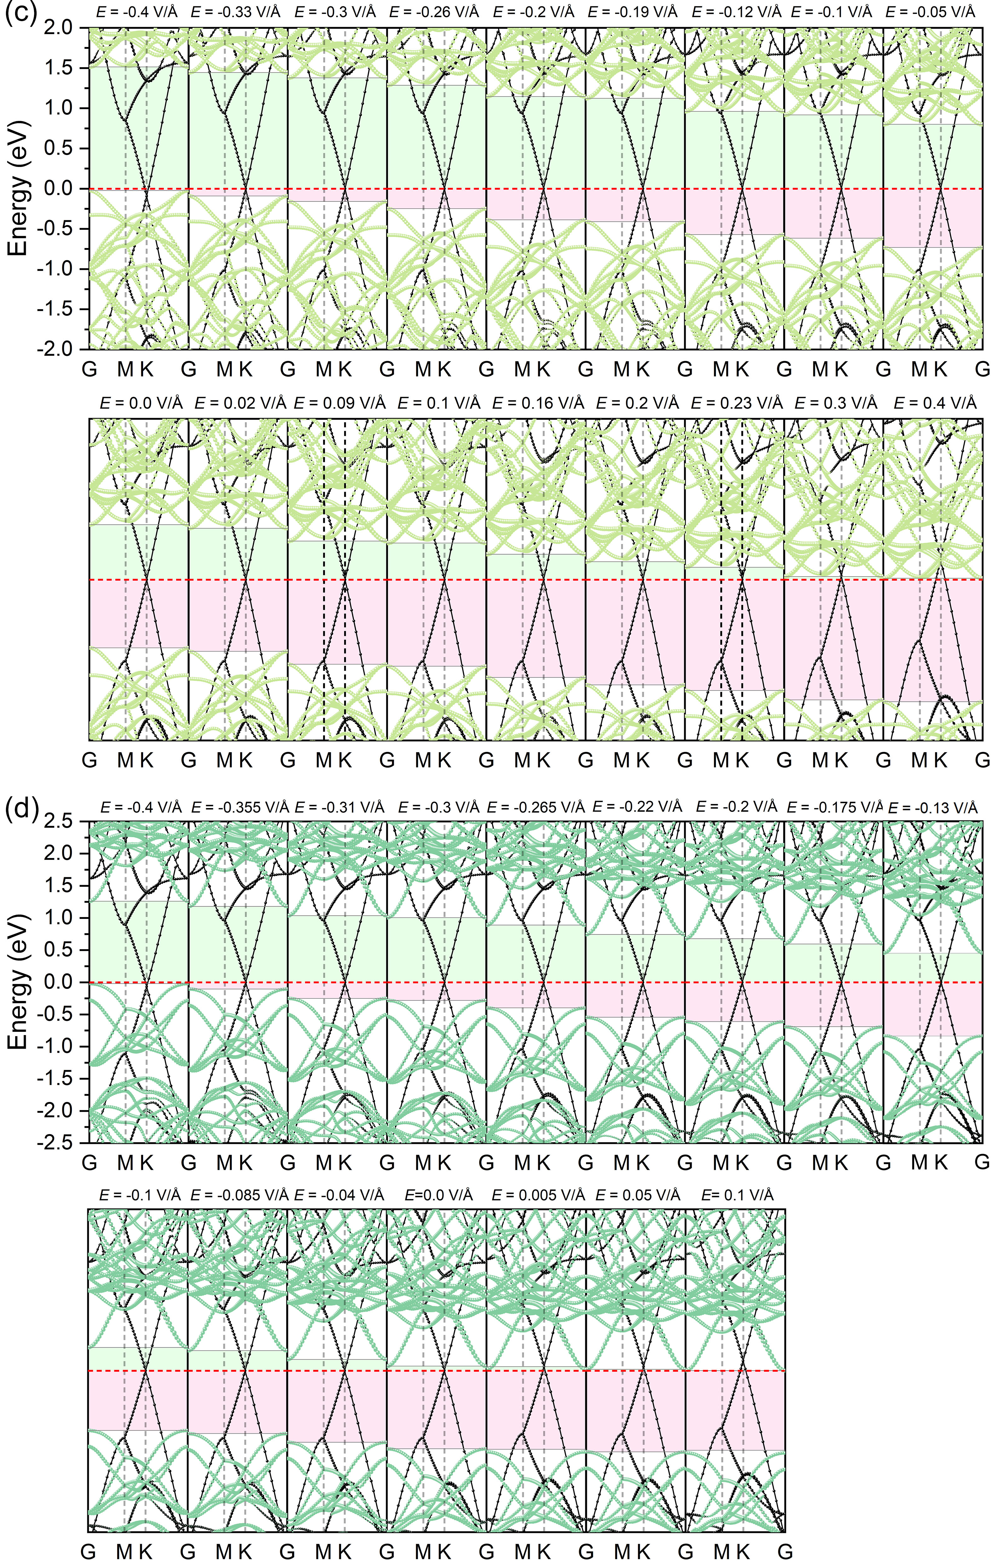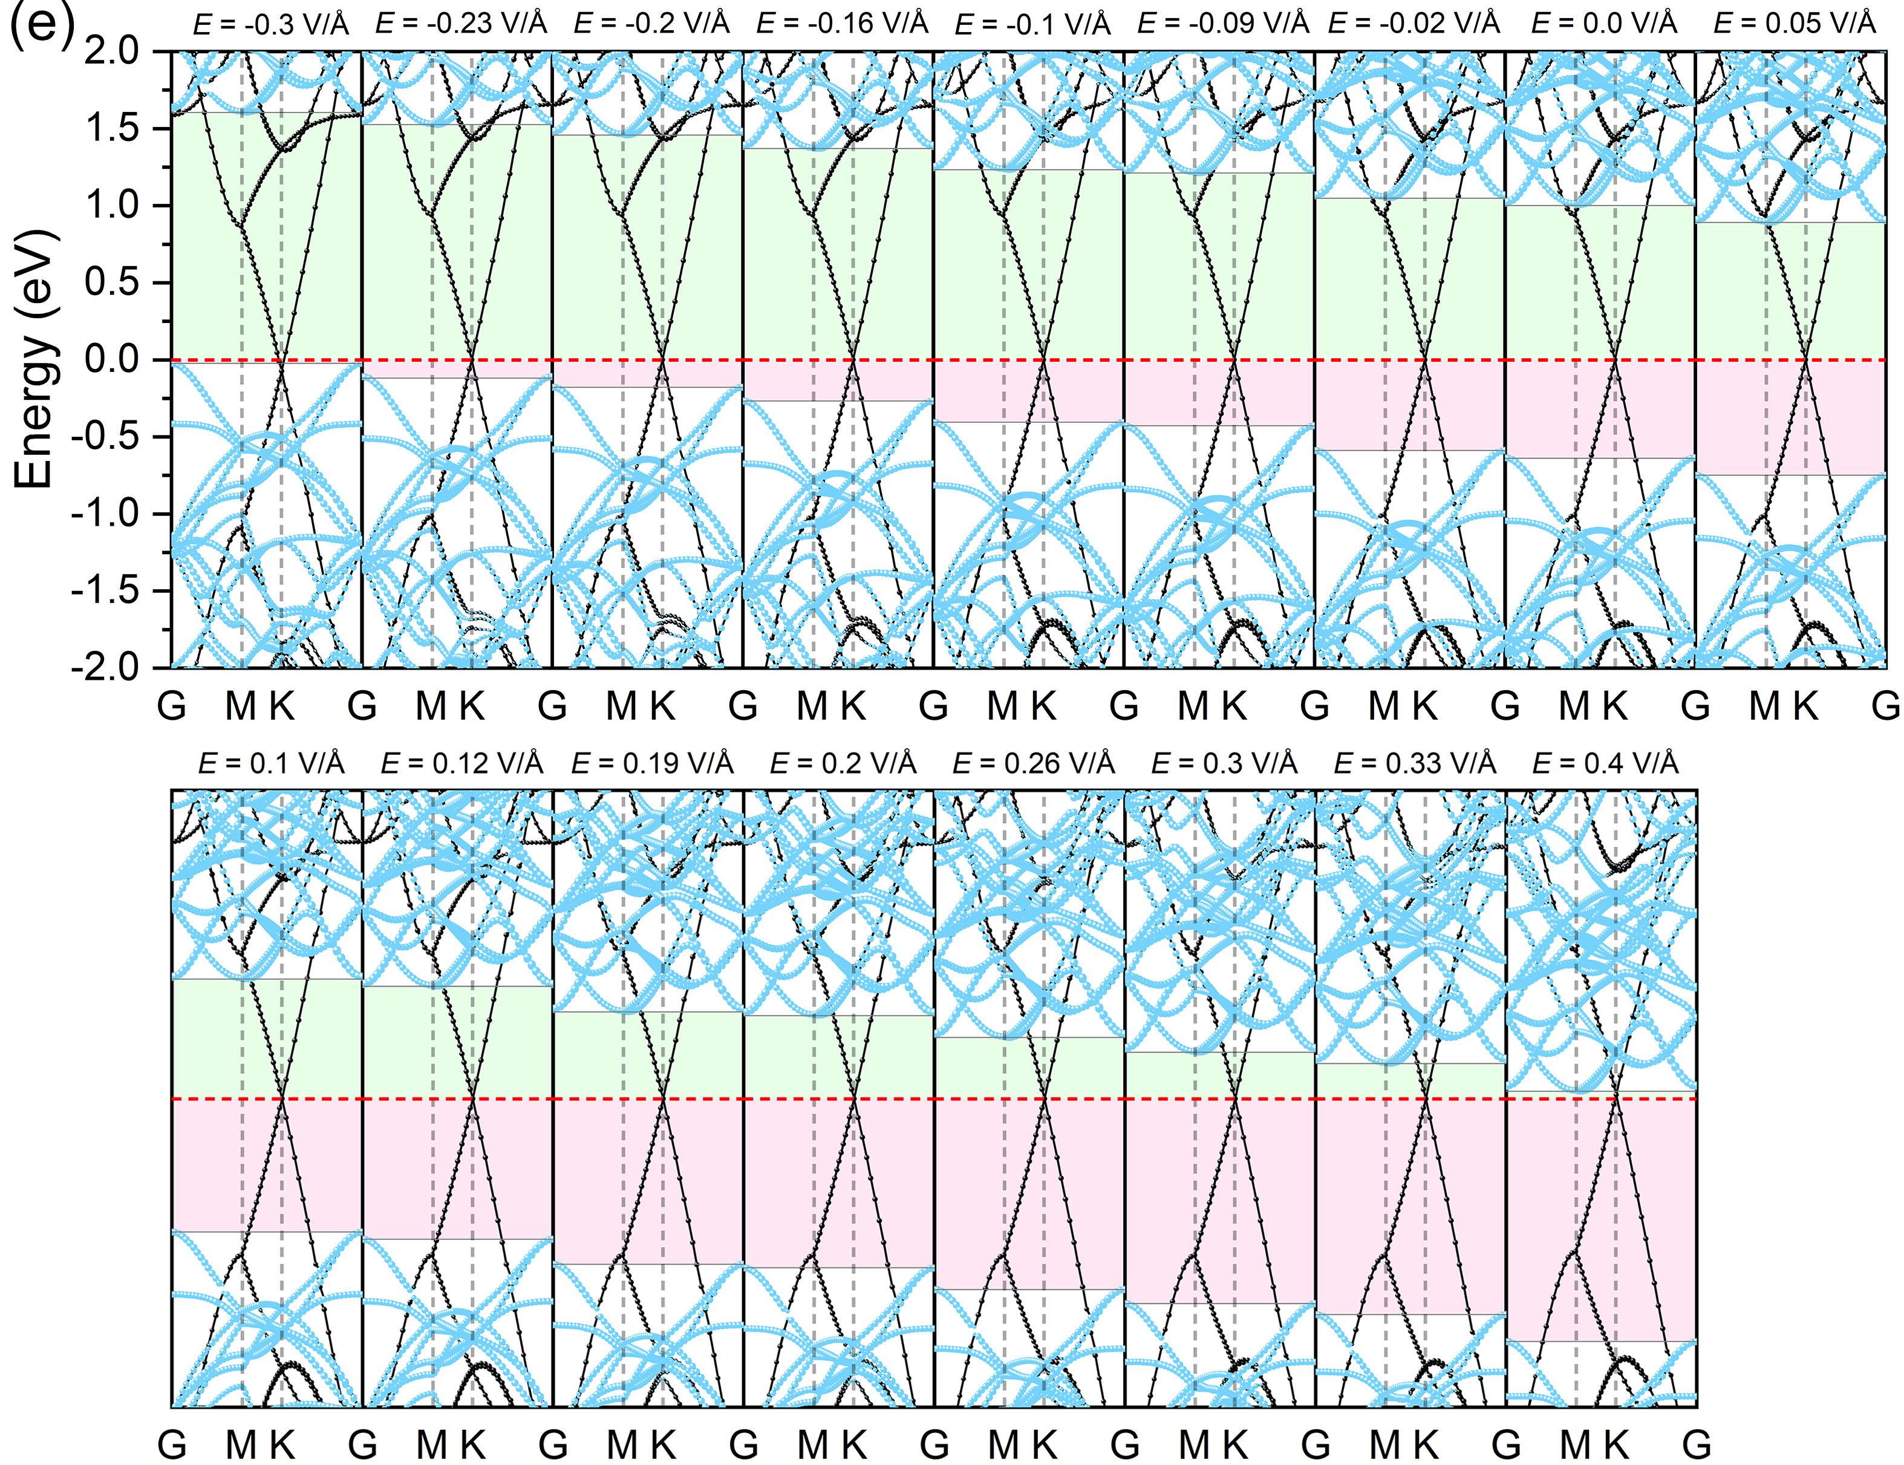
Figure S3 Projected band structures of five heterostructures [(a) C-CrSe₂, (b) C-MoS₂, (c) C-MoSe₂, (d) C-WS₂, (e) C-WSe₂] with reduced electric field interval spacing.

Figure S4 The functional relationship between the W_{C} and the applied electric field in each C-MX₂ heterostructure.
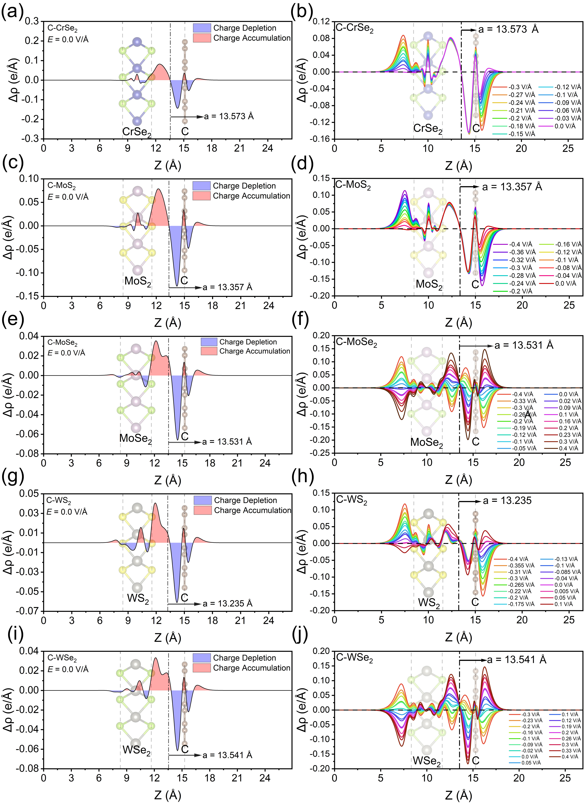
Figure S5 Plane averaged charge density differences of each heterostructure at E = 0 V/Å and under various electric fields.
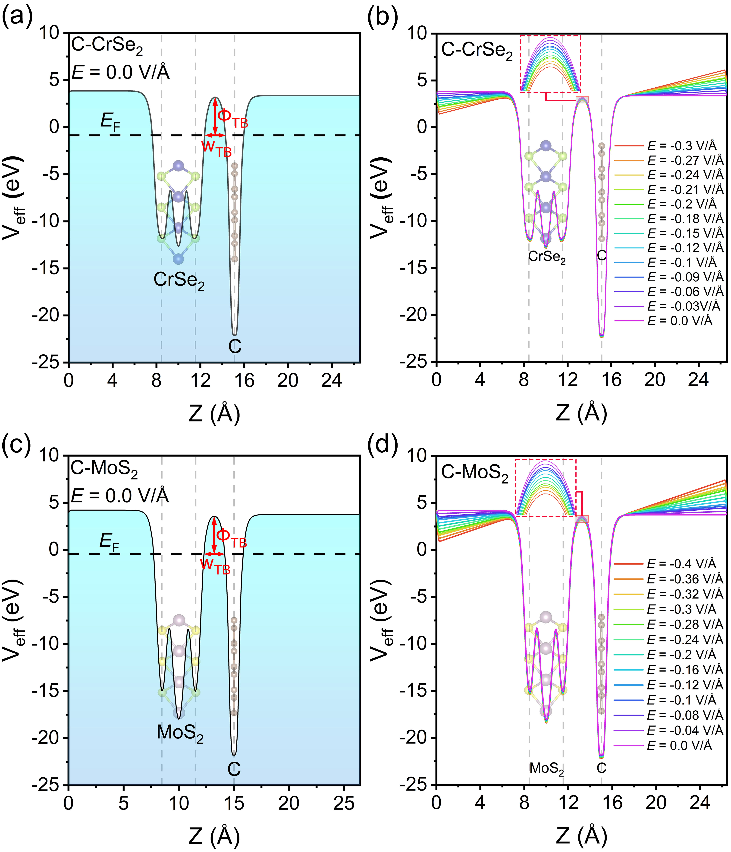
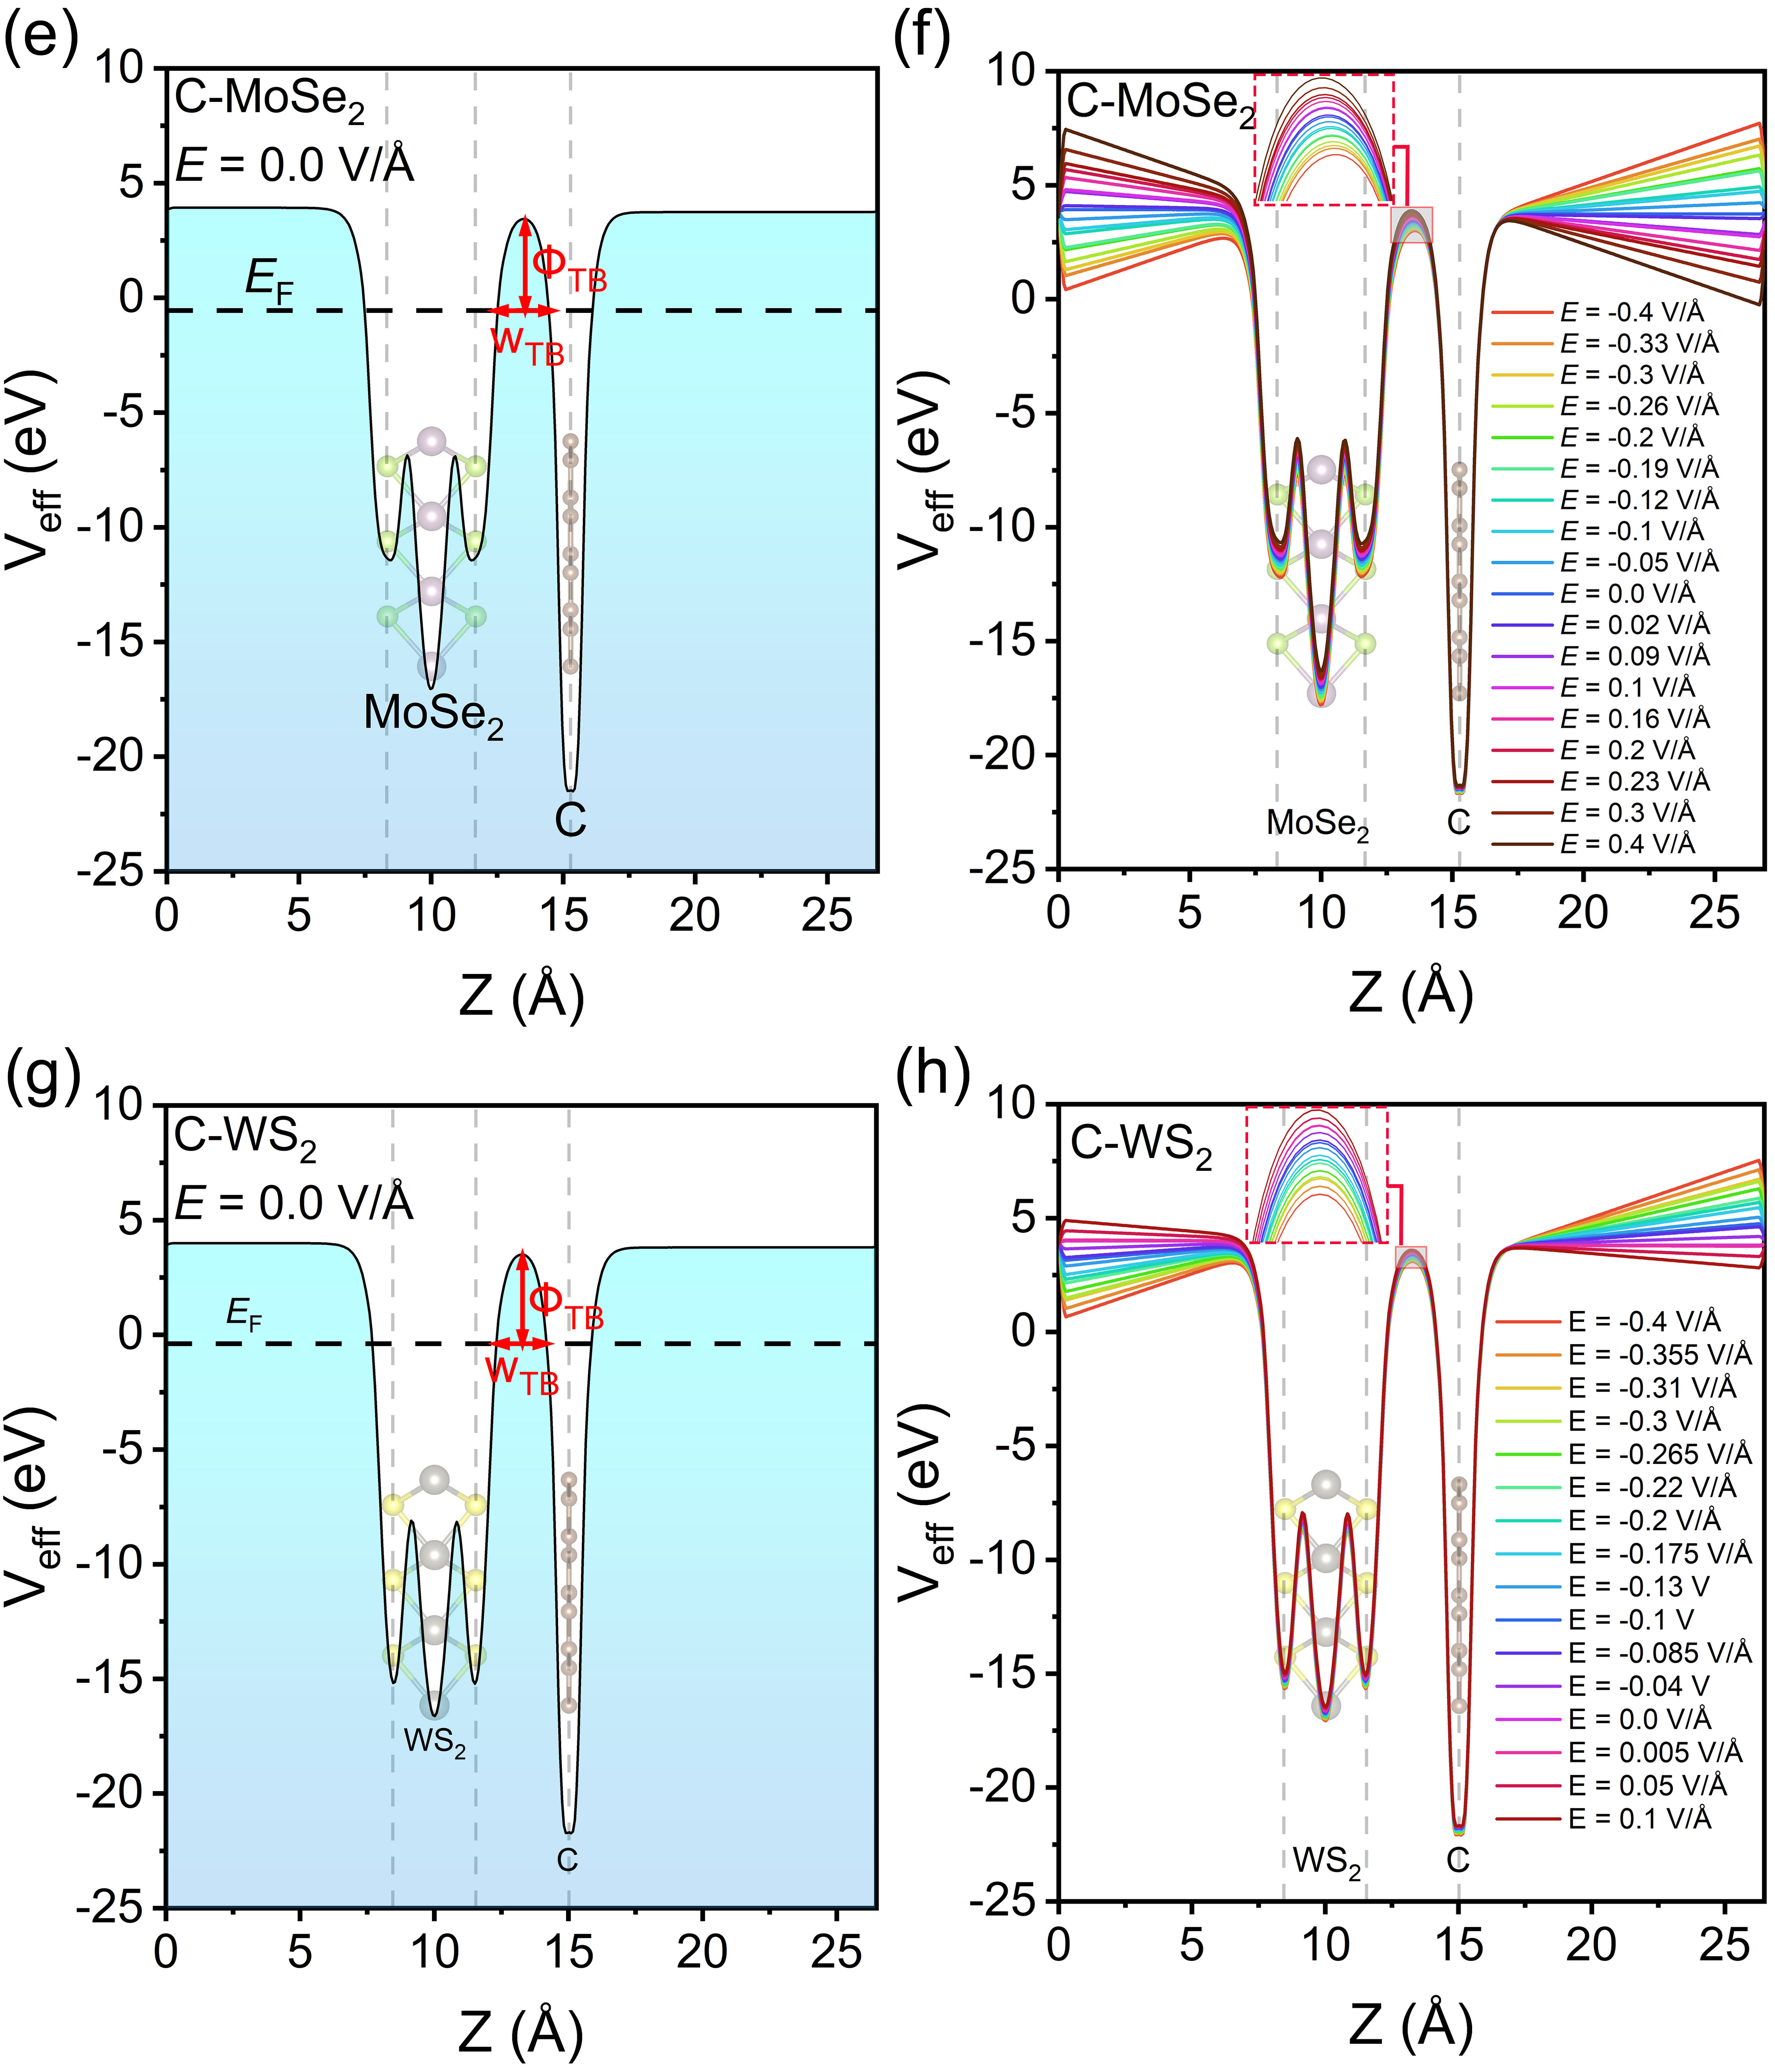
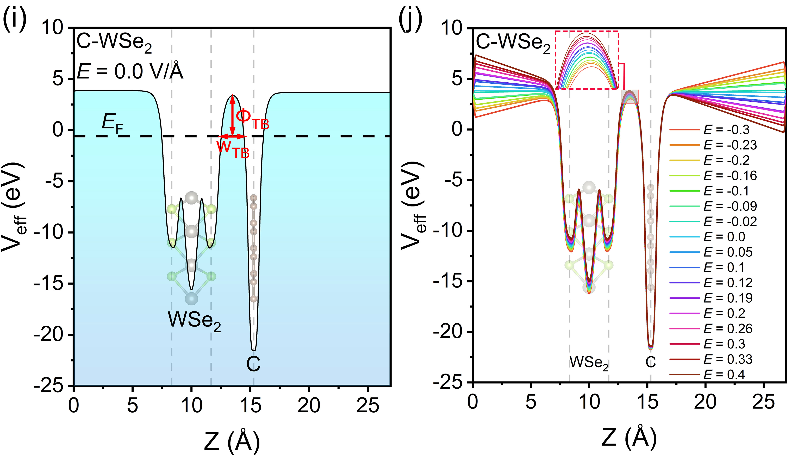
Figure S6 Effective electrostatic potential of each heterostructure at E = 0 V/Å and under various electric fields.

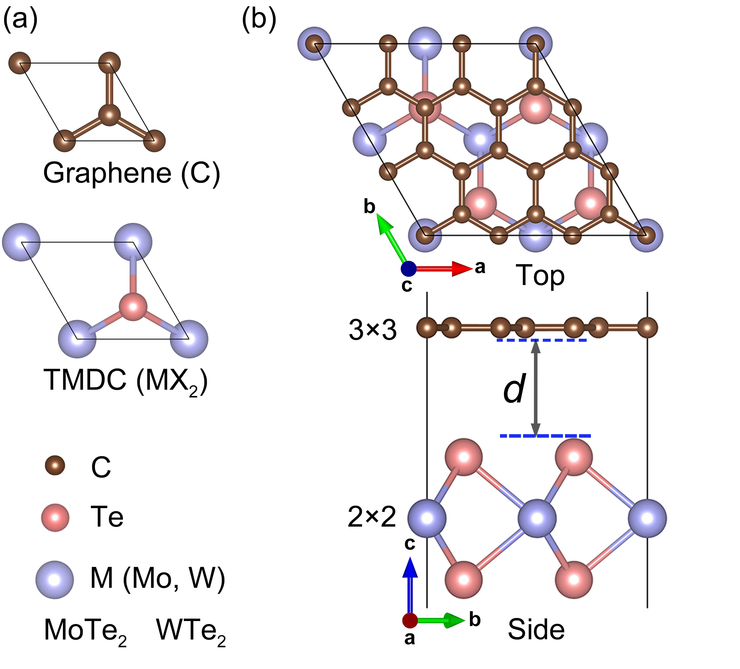
Figure S7 (a) Unit cell structures of graphene and MX₂ (MoTe₂ or WTe₂). (b) Top and side views of C-MX₂.

