Supplement
Mapping the minds of spectators during extreme ritual: A psychological network perspective

Short synopsis of the history and structure of the Nine Emperor God Festival in Southern Thailand
The Nine Emperor God Festival (also known as Vegetarian Festival) is celebrated annually during the ninth lunar month of the Thai calendar. The origins of the ritual can be traced to 5,000 year old pre-Chinese Shaman rituals (Chan, 2006). The main feature of these practices involves high ordeal performers (spirit mediums, numbers are estimated to be about 10,000) to go into trance and to then receive powerful spiritual warriors and gods. Once possessed, these high ordeal performers perform acts of magic to solve problems, cure ailments, forecast the future, protect people, communities and business against evil forces, resolve disputes and the like. These folk practices allowed rural Chinese communities that were barred from the Taoist practices at the Royal Court to have access to a spiritual realm that was otherwise closed to them (see Chan, 2006). According to popular belief, these practices arrived in Southern Thailand in the early 19th century with Chinese dance groups visiting Chinese mining workers. The nine-day ritual officially starts with the raising of the ceremonial lantern pole in the perimeter of the shrine to invite Chinese spirits and gods to descend to Earth. The focal point of the ritual is to invite these spirits to descend and to incorporate spirit mediums (we use high ordeal performers and spirit mediums interchangeably in the following text). Each spirit medium has one (in rate cases more than one) designated spirit or deity. Spirit mediums are identified through a variety of means and undergo a lengthy training and socialization procedure to control their trance states and properly enact the rites while being possessed by the visiting spirits. The ritual lasts nine days and each day individual spirit mediums go into trance and perform various acts of self-mortification or self-mutilation. These include piercings with needles, skewers, knifes, saws or other objects (typically to the face and tongue, but also the upper body), flogging with ritualistic whips shaped in the form of snakes, walking over fire, cutting of one’s tongue, forehead or back with swords or other sharp objects, climbing bladed ladders and inviting people to throw firecrackers at their bare feet, chest and face. There are various narratives associated with these practices (Cohen, 2001), typically focusing on the supernatural status of the performers during trance and to demonstrate their ability to incorporate these visiting spirits and perform the magical powers that lead to healing and protection of the community. One major concern is the authenticity of the performers and whether they indeed were incorporated by the spirits. The extensive self-mutilations combined with the fast healing process post-ritual are assumed to be proof of the supernatural status of the performers. Facial and bodily scars as well as tattoos are visible markers of spirit mediumship status outside the festival period. Without the performance of the spirit mediums, the festival has no purpose. Therefore, the spirit mediums and their daily performances are crucial for fulfilling the purpose and the success of the ritual.
The most central ritual of the festival are the large street processions where the spirit mediums parade through town and are invited by families to bless the houses and business of the believers. Pierced performers walk distances up to 20 km barefoot in the midday sun while being showered with firecrackers. Spectators line the streets to provide ritual offerings and invite the gods (high ordeal performers) to their house or shop to perform cleansing rites with whips, fire, sprinkling water or throwing rice. Spectators also throw fireworks (with the belief that the louder and bigger the noise of the firework and drums, the more luck will be received because noise chases evil spirits away and loud noises are believed to be heard by the heavenly gods people seek protection from). Other rituals are performed daily at various hours within the shrine and attract equally large number of spectators. A number of other rituals are equally spectacular as the street parades, involving fire walking, cutting your body with axes or swords during divination or healing performances, climbing blade towers and other extra-ordinary feats. Some of these acts also involve collective chanting and meditation in the presence of the spirit mediums and requests to perform healing rituals.
Spectators are important within the ritual structure even though they do not perform any of these high ordeal acts. For example, all spectators are expected to restrict their food intake and follow specific ritualistic practices and restrictions during the ritual period. These restrictions include not eating meat or animal products (e.g., milk or egg), not eating certain types of spices, not engaging in sex during the period of the ritual and wearing white while attending the rituals. Spectators therefore provide the audience for the ritual to be performed: without spectators there would be no ritual in this form and the performers’ actions would be meaningless. More importantly, it is the spectators’ belief in the other-worldly powers of the performers that provides the incentive and stage for the performers to engage in these acts. Spectators request the services of the performers, inviting them into their houses and business to bless them and provide good fortunes, to divine the future or to cure ailments. The believing audience is both the context and the justification for the performance of these high ordeal acts. For this ritual to function, spectators need to believe in what is on display. In return, spectators who believe in this ritual receive tangible benefits from attending and participating in the ritual. Further information on individual spiritual components is provided in table S1 and figures S1 to S14 depict scenes during the ritual.

Information on the Instruments and Measurement Validation Process
The instruments were adapted from previously published sources or newly developed for the current purposes. All items went through a thorough validation process. First, all items were generated by the first author and discussed in lab meetings with colleagues from religious studies and social and behavioral neuroscience at XXXXXXX. Second, two professional Thai translators who are familiar with the research context translated the items from English into Thai. A third bilingual researcher then integrated the two versions. Third, this integrated version was then carefully revised and edited by the second and third author, who have extensive experience with instrument translation and the research context. Fourth, this translated version was then presented the authorities at all the participating shrines. The shrine authorities at each shrine went through the instrument and commented on any items or phrases that may be unclear or may misrepresent the spiritual concepts of importance to the ritual. Small adjustments were made in response to these sessions. The final instrument was trialled by all the research assistants that were helping with the data collection in two separate sessions. Given the extensive revision process involving experts in religious studies, social and behavioral neuroscience, professional translators, researchers with years of ethnographic experience in this context and verification of the items by the shrine authorities, we are confident that the items and scales are representing the intended content.
Social connection responses
We measured identity fusion with the spirit mediums and the shrine as the focal institutional structure with a shortened version of the scale developed by Swann et al. (2012). We used these items: ‘I am strong because of people at my shrine’, ‘I am strong because of the presence of the spirit mediums (high ordeal performers)’, ‘I make the shrine strong’ and ‘I make the people at the shrine strong’. This scale has been used in a variety of contexts and performs well in capturing the theoretically defined social bonding responses (Bortolini et al., 2018; Gomez et al., 2011; Kavanagh et al., 2019). Cronbach’s alpha for this scale was .92 (average correlation .73). A visual version of this scale with overlapping circles item have been validated for this ritualistic context and has been successfully applied with spirit mediums (Fischer & Kruekaew, 2020).
Social identity responses were measured by three items measuring social connectedness to different referent groups (Harb & Smith, 2008). The items are also conceptually related to items that have been used in previous rounds of the World Value Survey in Thailand (Welzel & Inglehart, 2010), but we decided to focus on slightly different targets. We asked whether individuals felt socially connected (linked) to family and friends; spirit mediums and other believers that are not present at the moment. The items were tested in a number of pilot tests with both spirit mediums and observing participants in 2013 and 2014. Our participants reported no problem in understanding and responding to these items.
Finally, we also coded behavioral responses that indicate social connectedness. We asked whether the spectator had walked with any spirit medium during the festival and whether the spectator had donated money to the shrine during the current ritual. These items were based on previous ethnographic work (Cohen, 2001; Fischer & Kruekaew, 2020) and measure behavioral indicators of social connection. These responses were coded as yes or no.
Emotional and affective responses
Affect was measured with a total of seven items adapted from the Positive and Negative Affect Scale (Watson, Clark and Tellegen, 1988, a previously validated Thai version available in Boonyarit, Chuawanlee, Macaskill, & Supparerkchaisakul, 2013) and aesthetic experiences scale (Zentner et al., 2008), using a five-point likert scale. Positive affect was measured with four items: ‘strong’, ‘joy’, ‘peaceful’ (from Zentner et al., 2008) and ‘happy’ (because this item has been used in previous research on ritual (e.g., Fischer et al., 2014; Wiltermuth & Heath, 2001)). These four items showed good internal reliability (alpha .84, average correlation .56). We used three negative affect terms (anxiety, fear, sad) from Watson et al. (1988), which have been previously validated for Thai samples. This scale was internally consistent (alpha = .81, average correlation .58).
Awe was measured with two items, asking spectators to indicate how much they felt ‘awe’ at the ritual today and whether they ‘felt small and insignificant today’. Both used the same response scale as for the other affect items. The correlation between these two items was .29 (p < .01). We conducted a principal component analysis of affect and awe. Two components with an eigenvalue larger 1 emerged (explained variance 59.06%). The first factor had loadings from all the positive mood items (range of loadings after VARIMAX rotation was from .67 to .83) as well the response to the ‘feeling in awe’ item (loading .55). The second factor consisted of all the negatively valenced items (loadings ranging from .75 to .84). The awe item ‘feeling insignificant’ loaded equally strongly on both components (.41). Therefore, awe was as expected a complex emotion, involving both positively and negatively valenced experiences.
Pain was measured for both the perceived pain attributed to the spirit mediums during the specific ritual as well as the subjective pain experienced by the individual (the observer of the ritual) at the moment of responding (see Singer et al., 2004 for a similar treatment). A standard numerical rating scale anchored by 0 (no pain) and 10 (worst pain imaginable) was used. The two attributed pain and subjective pain measures correlated .28 (p < .01).
Belief measures
Authenticity was measured with four items, adapted from Morhart et al. (2015) and Napoli et al. (2014) based on extensive field work by the first and third author. Issues of authenticity were repeatedly brought up in interactions with individuals at shrines during pilot tests and previous studies in the same context. The items were modelled based on concerns that were expressed spontaneously and repeatedly in conversations and interviews during previous field work. The four items were: ‘I felt the spiritual power and spiritual presence of the spirits today’, ‘Spirit mediums at this temple are authentic and real’, ‘I believe spirit mediums have supernatural powers’, and ‘I believe that spirit mediums care about the people’. Cronbach’s alpha was .89 (average r = .68).
Behavioral measures
We captured involvement in sacred market exchanges using three items. These were based on field work by Cohen (2001) and previous ethnographic work by the first and third author. We asked whether respondents had consulted (for divination, healing, protection or other spiritual purposes) a) spirit mediums (high ordeal performers) during the Vegetarian Festival, b) at other occasions outside the Vegetarian Festival and c) whether the respondent had placed a table outside his home or business to receive the blessings of spirit mediums (high ordeal performers). All responses were coded as yes or no. The three items showed an average correlation of .41 and Cronbach’s alpha of .68.
Demographic variables
First, we coded whether participants were male or female. We also attempted to measure relative social status in this population. We asked individuals to free list their occupation or current work. These free-listings were then coded into a three-level categorical variable, after extensive discussions with local informants about the social status of occupations in the community. We classified people as low status category (-1) if they worked as manual labourers, street vendors, or in low skilled work in tourism or hospitality (chamber maids, cleaners), as high status (+1) if they worked for local or central government, were studying at a university or listed a professional job (which required university level education). All other responses were categorized as 0, effectively contrasting high vs low status occupations.
We measured whether the respondent had a family member who was a high ordeal performer, whether the respondent had a non-familial social relationship with any high ordeal performer (e.g., friends, colleague, neighbour) and whether the respondent was a performer him or herself. Importantly, the respondent might be a spirit medium but was not performing as a spirit medium for this particular ritual and this shrine when responding to our study measures. It is important to note that spirit mediums when not being in trance often visit and observe ritual performances at other shrines. There were virtually no relationships between these categories, except that performers were more likely to report having other family members who are also spirit mediums (r = .16, p < .001).

Network models for cross-sectional data
We use recently developed network models for psychological data (Costantini et al., 2015; Epskamp et al., 2018; Golino et al., 2020). A network approach maps observed indicators (nodes) and the relationship with other nodes (edges). Due to the highly interconnected nature of psychological systems, networks modelled on psychological data tend to be fully saturated including many edges (capturing correlations between observed indicators) that are close to but not exactly zero. We used the Extended Bayesian Information Criterion Gaussian Least Absolute Shrinkage and Selection Operator (EBICglasso; Foygel & Drton, 2010) because this regression-based approach has been shown to more faithfully represents the overall network while preserving parsimony by constraining close to zero edges to exactly zero. The analysis of the network architecture can provide novel insights into mental maps during rituals because it does not assume that there are latent variables that causally define constructs based on locally independent indicators. Local associations between measured indicators can provide valuable insights into a cognitive and behavioral ecosystem that stabilizes and structures ritual belief and practice.
We tested the distinctiveness of network clusters with bootstrapped Exploratory Graph Analysis (Epskamp & Fried, 2018) using a walktrap algorithm (Yang et al., 2016) which is superior to standard methods for identifying optimal number of clusters (Golino et al., 2020). To overcome potential instabilities and accuracy problems in sample specific solutions, we bootstrapped the EGA results using 1,000 samples. We examine both the dimension stability (number of clusters) and structural consistency (placement of each node within communities) to provide evidence of the stability of the clustering solution. Full results are reported below. To represent the optimal solution and aid interpretability of node positions, we ran a multidimensional scaling analysis assuming ordinal data on the network data and used the resulting coordinates to plot the EGA network solution, which allows a direct interpretation of the distances between nodes in the MDS-representation of the network.
As discussed in the main text, we also calculated the extent to which individual nodes within communities identified in the EGA link to other nodes in other communities (Jones et al., 2019). We report Bridge strength, which is calculated as the sum of the absolute value of all edges that exist between a specific node within a community and all nodes that are not in the same community as the focal node. In other words, it reports which node within a network community is most strongly connected overall to any other communities within the network. We also report Bridge expected influence (2-step), which includes both direct and indirect effects that a given node within a community has with other communities, either directly (e.g., node 1 -> node 3) or indirectly through other nodes (e.g., node 1 -> node 2 -> node 3). Bridge expected influence accounts for the direction of the effect. For example, a specific negative mood (sadness) may decrease positive feelings (happiness) but also activate nodes within in a social connection cluster (feel closer to friends & family). Therefore, these bridge network statistics can provide important information on the important nodes that connect network communities.

Other centrality indicators & stability of the centrality indices
In the main text, we report node or centrality strength which is the sum of the absolute values of the weights on the edges connected to a node and can be interpreted as a measure of overall connectedness within the network. Here, we comment on two other centrality indicators that are commonly reported in psychological network studies (see Constantini et al., 2015, Epskamp et al., 2018). Betweenness centrality is the sum of the number of times a node is located on the shortest path between any other combination of nodes, indicating to which extent a node acts as “middlemen” or “broker” within the larger network structure (Epskamp et al., 2018). A third type we calculated is closeness centrality. This can be thought of as similar to flow speed through the network (Borgatti, 2005; Freeman, 1978; Sabidussi, 1966), the extent to which a specific node acts like ‘superconductor’ connecting other nodes either directly or indirectly. All data on centrality indices is shown in Table S2.
For betweenness indicators of centrality, that is the average pathlength between any two nodes via the focal node, the most central nodes lying on the connection with other nodes were ‘feeling connected to spirit mediums’, walking with spirit mediums during the festival, identifying with other believers at the ritual, wanting to know what others are thinking, feeling happy and feeling fear. Again, social and emotional cognitions are central in the network and have the shortest path length to many other nodes. At the same time, one of the ambiguity items (‘wanting to know what others are thinking’) also showed high between centrality, suggesting that need for closure components about other people’s thoughts are also important within the larger network. For closeness centrality, two identity items (connected to spirit mediums, connected to other believers not at the festival) showed the highest closeness, followed by feeling happy and the belief that spirit mediums care for the welfare of people. This again suggests that social connection and emotional responses together with the belief that the spirit mediums do care about humans are most important for connecting other nodes. In line with social signalling theories of ritual (Sosis, 2003), belief systems may be an important benefit that shift benefit-cost ratios and deter non-believers.
To examine the robustness of centrality indices, we ran a case-drop bootstrap model with 1,000 bootstrap iterations, dropping a minimum of 5% of participants up to a maximum of 75% participants. We calculated the correlation of the node centrality indices of the bootstrapped sample with the full sample (see Figure S11). The network statistics were robust to case drop (defined as a correlation of > .70 of the sampled and original network in at least 95% of cases) for strength (.75), edges (.75), and closeness (.672). The betweenness centrality index showed lower robustness (.128). One plausible explanation is that in dense networks (such as ours) where two nodes about equally link one community with another community, the shortest paths from any other node in the cluster will pass through either one of the two nodes. During bootstrapping, one of the nodes may be arbitrarily larger by a tiny fraction in each run with random replacement, which over the accumulated runs results in greater instability in betweenness estimates (Fried, 2018). Therefore, the betweenness strength may require more careful interpretation.

Stability of the EGA clustering solution
We ran a bootstrap analysis, using 1,000 sample to examine the stability of the clustering solution. Examining the item stability (see Figure S12 and column ‘Overall’ in Table S3), most of the nodes showed good structural stability above the recommended .70 threshold (Christensen & Golino, 2019). The lowest stability was found for identification with family and friends (.53), followed by the four positive mood indicators (happy, joyful, strong, peaceful; all stability indices .59). The two awe items were around the recommended threshold of .70. The remaining items showed overall adequate or good stability. When examining the stability indicators per cluster, it becomes evident that connection to family and friends showed some loadings together with beliefs and also positive emotions, but rather low loadings overall. The positive emotion items formed a separate cluster in a number of cases, as indicated in relative consistent loadings on cluster 6 (see Table S4). The belief items also showed sizable loadings on this factor. The relative strength of positive emotion items vs belief items with their respective cluster therefore shifted across solutions, but the consistent cross-loadings are aligned with the more parsimonious five cluster solution. The two awe items also showed some weak tertiary cross-loadings on the negative emotion cluster, supporting the complexity of awe as an emotional concept. Considering the overall results of the network centrality indicators, the stability of items and the loadings, we decided to retain all items in our network analysis. The greater complexity of the positive emotion items suggests that they are central to the experience of ritual, hence showing more cross-loadings across the clusters. The only item that could have been removed based on the loading patterns alone is the item asking about identification with family and friends, because the cluster parameters suggests that it is only weakly loading on other clusters within the network. However, given the previous studies suggesting that family connections are important (Konvalinka et al., 2011) and considering that this node was well-connected throughout the network (even though it did not highly load on any single cluster), we decided to keep it in our network. The means, standard deviations and correlations between the five clusters are shown in Table S5.

Table S1.
Short description and number of respondents per ritual element in the current study
Ritual element | Description of the ritual element | N
Lantern Pole Raising | A large wooden pole is blessed and then raised in the shrine. The Nine Emperor God (principal deity of the festival) is believed to descent on this pole. | 51
Nine Emperor God Welcome | Invitation ritual for the Nine Emperor God. Involves collective chanting in the shrine compound and lighting of the ceremonial lamp affixed to the Lantern Pole to indicate that the Nine Emperor God has arrived. | 38
Chanting | Various events during the festival involving collective chanting for merit making and soliciting good fortunes. | 102
Various Spirit Possessions | Various daily events in which spirit mediums go into trance, perform acts of magic and self-mortification. Spectators can ask for advice and blessings from the spirit mediums. | 106
Birth-Death God Invitation | Ritual performed on the 3rd day of the festival. Invites two major deities to participate in the festival. Involves both collective chanting and a short procession to a sacred ground. Various acts of self-mortification are performed. | 86
Fire Walk | One of the most auspicious rituals during the festival. Spirit mediums circle a ceremonial fire and perform a fire walk. It is thought to purify the spirit and body. | 65
Piercing | Preparation for the street procession. Spirit mediums go into trance in the pre-dawn hours and prepare for the street procession. This involves a large number of spirit mediums undergoing extreme body piercings (with objects that symbolize weapons to fight bad spirits during the procession). | 81
Street procession | Central ritual, with pierced spirit mediums parading barefoot through town and blessing houses and business. Involves acts of self-mortification (ceremonial cutting, bleeding, burning). | 128
Piercing removal | Return to the shrine and ceremonial removal of the pierced objects. Celebrations with shared food, burning of spirit money and throwing of fire crackers. | 40
Propitiation of the 7 Stars | Collective chanting ceremony in the shrine compounds on the 7th day of the festival. Ritualistic objects (blessed ribbons, spirit money, etc.) is produced and distributed among spectators. | 77
Bridge Crossing | Ceremonial crossing of a wooden bridge where spirit mediums bless and approve each person. Performed on the last day of the festival. Symbolizes cleansing and purification and a new start of all individuals who undergo this crossing. | 107
Nine Emperor God Farewell | Farewell to the Nine Emperor God. Involves collective chanting within the shrine and procession to a sacred place to perform the final parting rites, accompanied by fire crackers and large bonfires made of spiritual money. | 140
Lantern Pole Lowering | The large wooden pole is dismantled, blessed and stored. Bamboo twigs from the pole are removed and distributed among spectators (because of their presumed sacred nature). Celebratory meal within the shrine to mark the end of the fasting. | 20

Table S2.
Centrality parameters for all items
 | Nodes | Betweenness | Closeness | Strength
1 | B.supernatural | 31 | 0.0015 | 0.93
2 | B.spirit.real | 4 | 0.0014 | 0.98
3 | B.powers | 7 | 0.0014 | 1.09
4 | B.welfare | 42 | 0.0016 | 1.15
5 | awe | 31 | 0.0015 | 0.70
6 | insignificant | 5 | 0.0013 | 0.46
7 | happy | 64 | 0.0016 | 1.27
8 | strong | 26 | 0.0015 | 0.97
9 | joyful | 13 | 0.0015 | 0.71
10 | peace | 13 | 0.0015 | 0.95
11 | fear | 54 | 0.0014 | 1.19
12 | anxiety | 12 | 0.0013 | 0.97
13 | sad | 30 | 0.0013 | 0.82
14 | Fusion.shrine | 6 | 0.0014 | 0.94
15 | Fusion.strong | 15 | 0.0014 | 1.07
16 | Fusion.solidarity | 1 | 0.0013 | 1.09
17 | Fusion.shrine.strong | 25 | 0.0013 | 1.06
18 | Pain.self | 0 | 0.0010 | 0.35
19 | Pain.medium | 16 | 0.0012 | 0.51
20 | NFC.1 | 0 | 0.0009 | 0.72
21 | NFC.2 | 31 | 0.0009 | 0.95
22 | NFC3 | 69 | 0.0010 | 0.73
23 | NFC.4 | 46 | 0.0010 | 0.79
24 | Identity.Fam | 41 | 0.0015 | 0.71
25 | Identity.Spirit | 125 | 0.0017 | 1.08
26 | Identity.Buddh | 75 | 0.0017 | 0.74
27 | Advice.Festival | 29 | 0.0011 | 0.95
28 | Advice.Outside | 0 | 0.0011 | 0.81
29 | Table.Blessing | 0 | 0.0012 | 0.49
30 | Walk.Spirits | 83 | 0.0014 | 0.81
31 | Donation | 16 | 0.0012 | 0.61

Table S3.

Average item stability across 1,000 bootstrap solutions
 | Overall | 1 | 2 | 3 | 4 | 5 | 6 | 7 | 8
fear | 0.998 | 0.998 | 0.001 | 0 | 0 | 0 | 0.001 | 0 | 0
anxiety | 0.998 | 0.998 | 0.001 | 0 | 0 | 0 | 0.001 | 0 | 0
sad | 0.987 | 0.987 | 0.002 | 0 | 0 | 0 | 0.009 | 0.002 | 0
Pain.self | 0.909 | 0.909 | 0.001 | 0 | 0 | 0 | 0.007 | 0.077 | 0.006
Pain.medium | 0.908 | 0.908 | 0.001 | 0 | 0 | 0 | 0.008 | 0.077 | 0.006
B.spirit.real | 0.757 | 0 | 0.757 | 0 | 0 | 0 | 0.241 | 0.002 | 0
B.powers | 0.757 | 0 | 0.757 | 0 | 0 | 0 | 0.241 | 0.002 | 0
B.welfare | 0.757 | 0 | 0.757 | 0 | 0 | 0 | 0.241 | 0.002 | 0
B.supernatural | 0.750 | 0 | 0.750 | 0 | 0 | 0 | 0.248 | 0.002 | 0
awe | 0.696 | 0.010 | 0.696 | 0 | 0 | 0 | 0.267 | 0.027 | 0
insignificant | 0.690 | 0.016 | 0.690 | 0 | 0 | 0 | 0.267 | 0.027 | 0
happy | 0.587 | 0 | 0.587 | 0 | 0 | 0 | 0.41 | 0.003 | 0
strong | 0.587 | 0 | 0.587 | 0 | 0 | 0 | 0.41 | 0.003 | 0
joyful | 0.587 | 0 | 0.587 | 0 | 0 | 0 | 0.41 | 0.003 | 0
peace | 0.587 | 0 | 0.587 | 0 | 0 | 0 | 0.41 | 0.003 | 0
Advice.Festival | 0.995 | 0 | 0.001 | 0.995 | 0 | 0 | 0 | 0.003 | 0.001
Advice.Outside | 0.995 | 0 | 0.001 | 0.995 | 0 | 0 | 0 | 0.003 | 0.001
Table.Blessing | 0.994 | 0 | 0.001 | 0.994 | 0 | 0 | 0.005 | 0 | 0
Walk.Spirits | 0.992 | 0 | 0.001 | 0.992 | 0.001 | 0 | 0.006 | 0 | 0
Donation | 0.981 | 0 | 0.001 | 0.981 | 0.004 | 0 | 0.012 | 0.002 | 0
Fusion.shrine | 0.999 | 0 | 0.001 | 0 | 0.999 | 0 | 0 | 0 | 0
Fusion.strong | 0.999 | 0 | 0.001 | 0 | 0.999 | 0 | 0 | 0 | 0
Fusion.solidarity | 0.999 | 0 | 0.001 | 0 | 0.999 | 0 | 0 | 0 | 0
Fusion.shrine.strong | 0.999 | 0 | 0.001 | 0 | 0.999 | 0 | 0 | 0 | 0
Identity.Buddh | 0.958 | 0 | 0.002 | 0.003 | 0.958 | 0 | 0.025 | 0.012 | 0
Identity.Spirit | 0.955 | 0 | 0.003 | 0.003 | 0.955 | 0 | 0.027 | 0.012 | 0
Identity.Fam | 0.529 | 0 | 0.096 | 0.005 | 0.529 | 0 | 0.358 | 0.012 | 0
NFC.1 | 0.999 | 0 | 0.001 | 0 | 0 | 0.999 | 0 | 0 | 0
NFC.2 | 0.999 | 0 | 0.001 | 0 | 0 | 0.999 | 0 | 0 | 0
NFC3 | 0.997 | 0 | 0.001 | 0 | 0 | 0.997 | 0 | 0.001 | 0.001
NFC.4 | 0.997 | 0 | 0.001 | 0 | 0 | 0.997 | 0 | 0.001 | 0.001

Table S4
Mean loading matrix from bootstrap analysis
Node | 1.00 | 2.00 | 3.00 | 4.00 | 5.00 | 6.00 | 7.00 | 8.00
fear | 0.48 | 0.00 | -0.04 | 0.00 | 0.01 | -0.02 | 0.06 | 0.08
anxiety | 0.46 | -0.01 | -0.01 | 0.00 | 0.00 | -0.02 | 0.04 | 0.05
sad | 0.24 | -0.03 | 0.00 | 0.01 | 0.07 | -0.05 | 0.05 | 0.02
Pain.self | 0.12 | 0.00 | 0.00 | 0.00 | 0.00 | 0.00 | 0.15 | 0.17
Pain.medium | 0.12 | -0.02 | -0.01 | -0.01 | 0.01 | -0.02 | 0.14 | 0.17
B.spirit.real | -0.01 | 0.26 | 0.02 | 0.03 | 0.00 | 0.16 | 0.01 | 0.00
B.powers | -0.01 | 0.30 | 0.00 | 0.03 | 0.00 | 0.18 | 0.01 | -0.02
B.welfare | -0.01 | 0.23 | 0.02 | 0.08 | 0.00 | 0.17 | 0.01 | -0.02
B.supernatural | 0.00 | 0.22 | 0.01 | 0.05 | 0.00 | 0.16 | 0.05 | -0.01
awe | 0.04 | 0.15 | -0.01 | 0.01 | 0.02 | 0.10 | 0.04 | 0.01
insignificant | 0.08 | 0.08 | -0.01 | 0.01 | 0.00 | 0.05 | 0.04 | 0.01
happy | -0.06 | 0.23 | 0.02 | 0.06 | 0.00 | 0.27 | 0.03 | 0.00
strong | -0.01 | 0.17 | 0.02 | 0.03 | 0.01 | 0.21 | 0.02 | 0.00
joyful | -0.06 | 0.12 | 0.02 | 0.00 | 0.00 | 0.13 | 0.02 | 0.00
peace | -0.01 | 0.20 | 0.03 | 0.02 | 0.00 | 0.20 | 0.01 | 0.00
Advice.Festival | 0.00 | 0.01 | 0.47 | 0.03 | -0.01 | 0.01 | 0.02 | 0.06
Advice.Outside | 0.00 | 0.01 | 0.41 | 0.01 | 0.01 | 0.00 | 0.01 | 0.06
Table.Blessing | -0.01 | 0.00 | 0.24 | 0.02 | 0.00 | 0.01 | 0.00 | -0.01
Walk.Spirits | -0.01 | 0.03 | 0.31 | 0.06 | -0.01 | 0.03 | 0.01 | 0.02
Donation | -0.04 | 0.04 | 0.20 | 0.02 | 0.00 | 0.05 | 0.01 | 0.00
Fusion.shrine | 0.00 | 0.02 | 0.03 | 0.32 | 0.00 | 0.02 | 0.01 | 0.00
Fusion.strong | 0.00 | 0.05 | 0.00 | 0.36 | 0.00 | 0.03 | 0.02 | 0.00
Fusion.solidarity | 0.00 | 0.03 | 0.00 | 0.38 | 0.01 | 0.03 | 0.01 | 0.00
Fusion.shrine.strong | 0.00 | 0.02 | 0.01 | 0.36 | 0.00 | 0.02 | 0.01 | 0.00
Identity.Buddh | 0.00 | 0.02 | 0.02 | 0.22 | 0.02 | 0.04 | 0.03 | 0.01
Identity.Spirit | 0.01 | 0.07 | 0.09 | 0.22 | 0.00 | 0.05 | 0.02 | 0.01
Identity.Fam | -0.03 | 0.06 | 0.03 | 0.09 | 0.01 | 0.08 | -0.01 | -0.04
NFC.1 | 0.00 | 0.00 | -0.01 | 0.00 | 0.39 | 0.00 | 0.00 | 0.00
NFC.2 | 0.02 | 0.00 | 0.00 | 0.00 | 0.49 | 0.01 | 0.01 | 0.04
NFC3 | 0.04 | 0.01 | 0.00 | 0.02 | 0.30 | 0.01 | 0.02 | 0.05
NFC.4 | 0.02 | 0.00 | 0.00 | 0.00 | 0.41 | 0.00 | 0.01 | 0.04

Table S5

Means, standard deviations, and correlations with confidence intervals

Variable | M | SD | 1 | 2 | 3 | 4
1. Belief & positive affect | 0.54 | 0.15
2. Negative affect & pain | 0.15 | 0.15 | -.23**
 |  |  | [-.29, -.17]
3. Ambiguity | 0.42 | 0.17 | .04 | .13**
 |  |  | [-.03, .10] | [.07, .19]
4. Social connection | 0.52 | 0.16 | .66** | -.18** | .04
 |  |  | [.62, .69] | [-.24, -.12] | [-.03, .10]
5. Behaviors | 0.38 | 0.32 | .38** | -.21** | -.03 | .45**
 |  |  | [.32, .43] | [-.27, -.15] | [-.09, .03] | [.39, .50]

Note. M and SD are used to represent mean and standard deviation, respectively. All data has been transformed to a common 0 to 1 metric. Values in square brackets indicate the 95% confidence interval for each correlation. The confidence interval is a plausible range of population correlations that could have caused the sample correlation (Cumming, 2014). * indicates p < .05. ** indicates p < .01.

Table S6
Bridge Strength Parameters (ordered by Bridge Strength within each cluster)
Node | Item | Expected Influence 2-step | Bridge Strength
Negativity/Pain
sad | Sad | 0.14 | 0.39
fear | Fear | -0.25 | 0.28
Pain.medium | Feel pain of medium | -0.26 | 0.19
anxiety | Anxious | -0.16 | 0.12
Pain.self | Feel pain | 0.00 | 0.05
Belief/Positivity/Awe
B.welfare | Mediums care about people | 0.54 | 0.34
happy | Happy | 0.26 | 0.34
strong | Strong | 0.39 | 0.24
joyful | Joyful | -0.08 | 0.20
awe | Felt awe | 0.37 | 0.19
insignificant | Felt small & insignificant | 0.29 | 0.18
B.supernatural | Felt spiritual power & presence today | 0.39 | 0.16
peace | At peace | 0.28 | 0.14
B.spirit.real | Mediums are authentic & real | 0.33 | 0.12
B.powers | Mediums have supernatural powers | 0.27 | 0.09
Ritual behavior
Donation | Donated to shrine | 0.34 | 0.32
Walk.Spirits | Walked with mediums | 0.41 | 0.28
Advice.Festival | Asked for advise at festival | 0.26 | 0.14
Advice.Outside | Asked mediums for advice | 0.19 | 0.09
Table.Blessing | Put table to receive blessings | 0.15 | 0.09
Social Connection
Identity.Spirit | Feel connected to mediums | 0.86 | 0.49
Identity.Fam | Feel connected to family | 0.52 | 0.46
Fusion.strong | Strong because of mediums at shrine | 0.50 | 0.18
Fusion.shrine | Strong because of people at shrine | 0.39 | 0.15
Fusion.shrine.strong | Make people at shrine strong | 0.35 | 0.14
Fusion.solidarity | Make shrine strong | 0.38 | 0.14
Identity.Buddh | Feel connected to other Buddhists | 0.38 | 0.12
Ambiguity
NFC3 | Like to know what people are thinking | 0.35 | 0.19
NFC.2 | Uncomfortable when not understanding reason for events | 0.11 | 0.08
NFC.4 | Want to know rather than stay uncertain | 0.19 | 0.07
NFC.1 | Don’t like uncertain situation | -0.01 | 0.05

Figure S1.
Ritually pierced spirit medium
‘
Figure S2.
A spirit medium pierced with a ritualistic weapon


Figure S3.
Nightly firewalking organized by Shui Tui Shrine
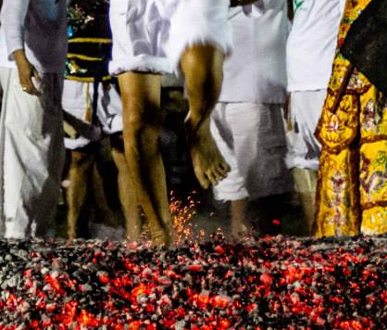

Figure S4.
Spirit medium performing healing rituals at Shui Tui Shrine
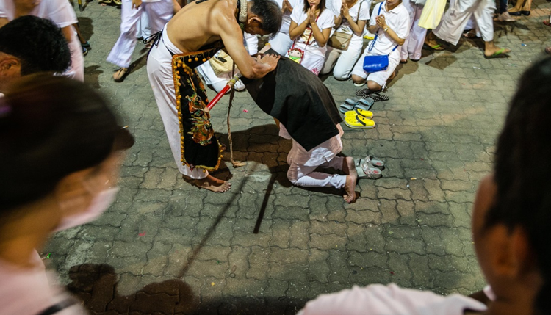

Figure S5.
Spectators lining up to receive blessings by the spirit mediums in Kathu shrine
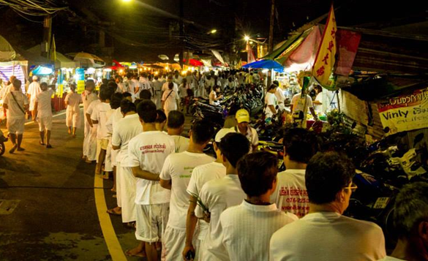

Figure S6.
Spirit medium blessing a table placed in front of a local house
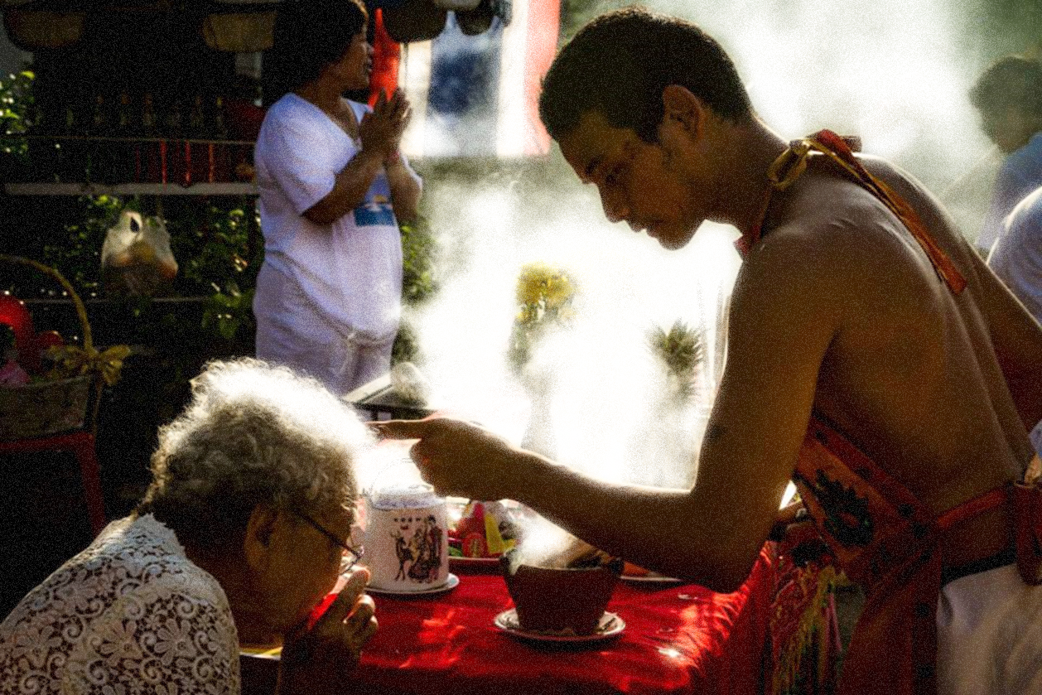

Figure S7.
A bleeding spirit medium blessing a child during the street parade organized by Kathu shrine
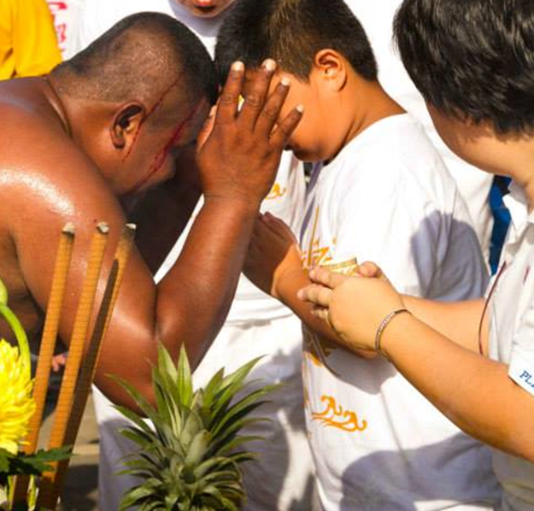
Figure S8.
Spectators trying to catch a sacramental piece of cloth thrown by a spirit medium (Kathu Shrine)
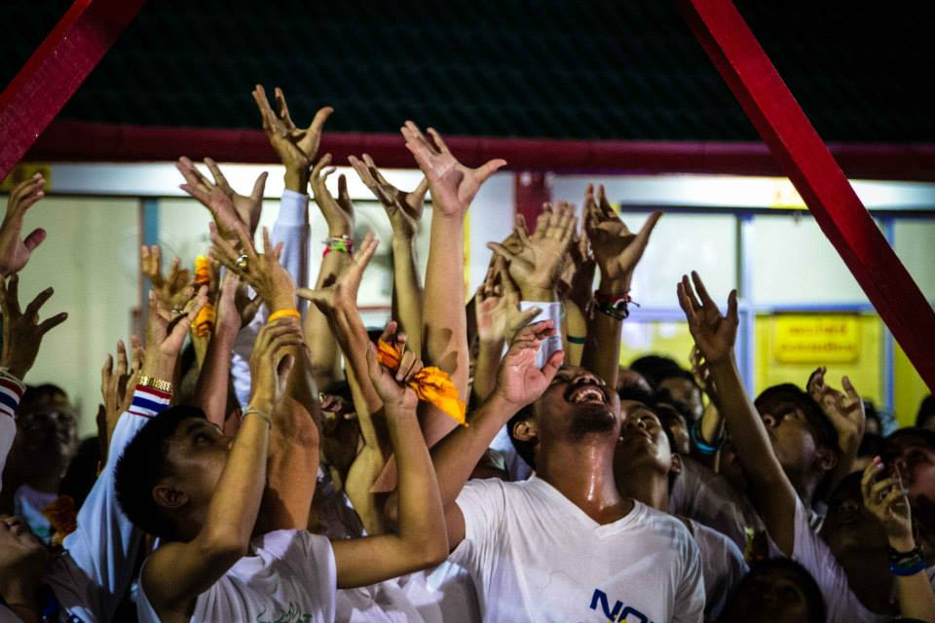
Figure S9.
Spectators sending off the spirit mediums at the end of the ritual in a symbolic bonfire (Kathu Shrine)
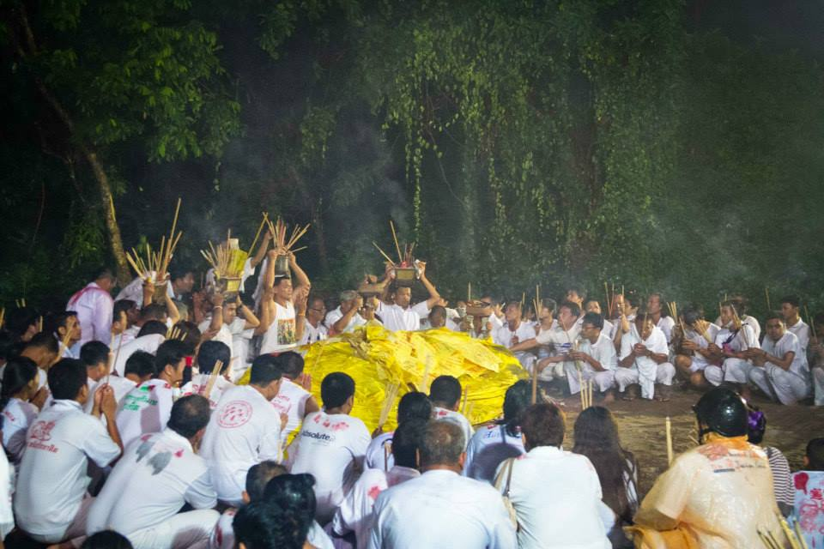
Figure S10.
A procession leaving the Kathu shrine grounds to the sound of fireworks
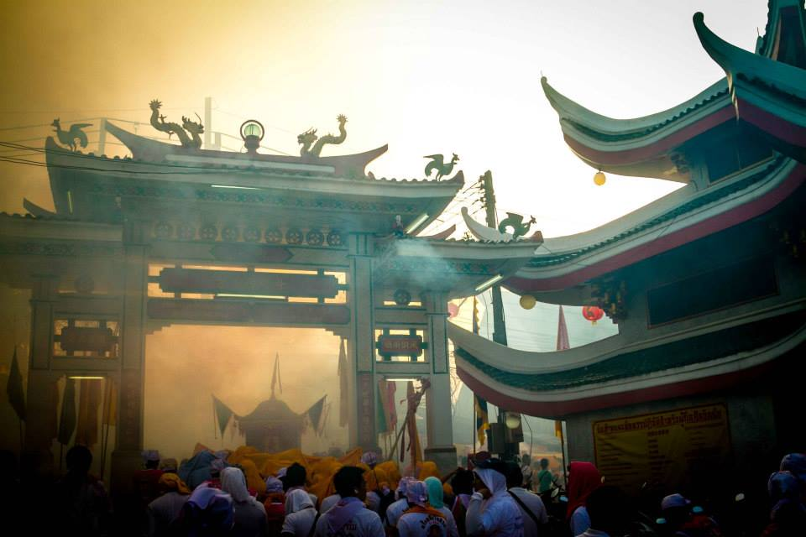

Figure S11
Stability of the centrality indicators to case drop

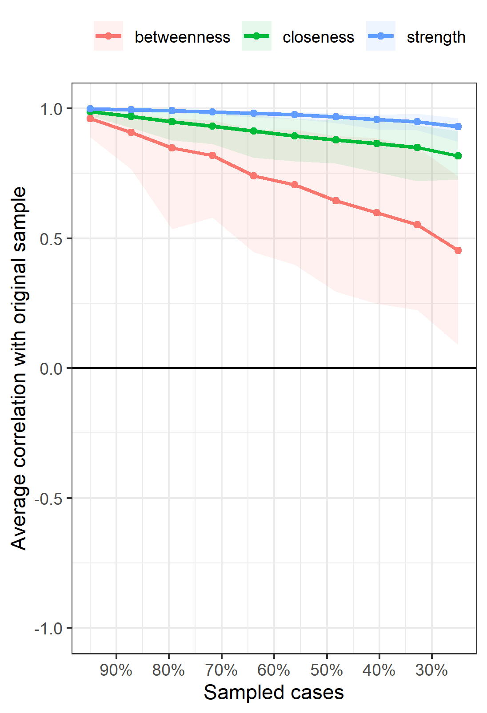

Figure S12
Item stability in the EGA bootstrap analysis, N=1,000 iterations

Figure S13
Bootstrapped difference test between all pairwise non-zero edge weights

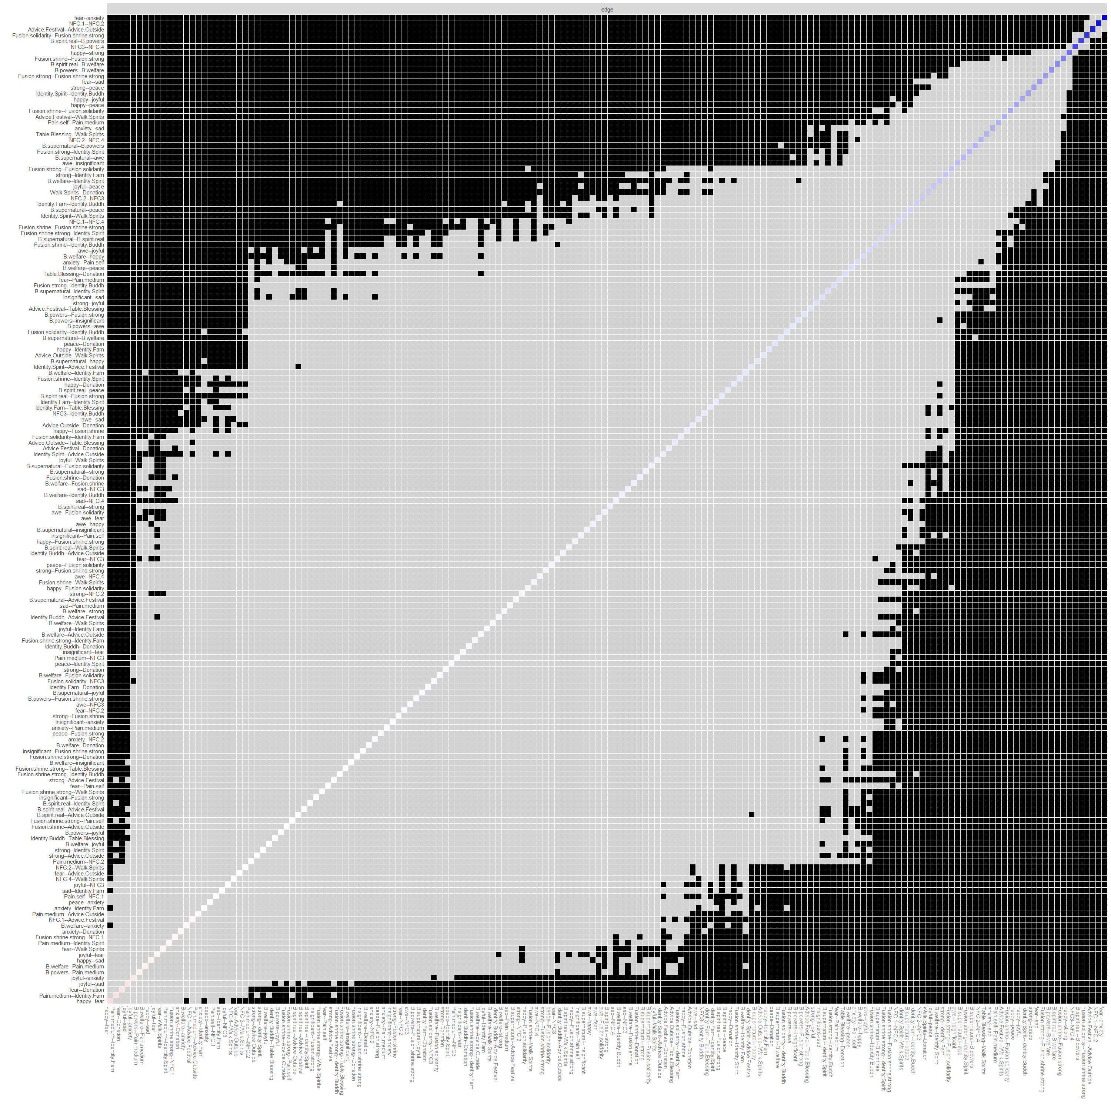
Note: p < .05; bootstrap sample N = 1,000; Grey boxes indicate edges that differ not significantly from each other, black boxes indicate significant differences; edges are ordered by edge strength

References
Borgatti, S. P. (2005). Centrality and network flow. Social Networks, 27(1), 55–71. https://doi.org/10.1016/j.socnet.2004.11.008
Bortolini, T., Newson, M., Natividade, J. C., Vázquez, A., & Gómez, Á. (2018). Identity fusion predicts endorsement of pro-group behaviours targeting nationality, religion, or football in Brazilian samples. British Journal of Social Psychology, 57(2), 346–366. https://doi.org/10.1111/bjso.12235
Christensen, A. P., & Golino, H. (2019). Estimating the stability of psychological dimensions via Bootstrap Exploratory Graph Analysis: A Monte Carlo simulation and tutorial [Preprint]. PsyArXiv. https://doi.org/10.31234/osf.io/9deay
Cohen, E. (2001). The Chinese Vegetarian Festival in Phuket. Religion, ethnicity and tourism on a Southern Thai Island. White Lotus Press.
Costantini, G., Epskamp, S., Borsboom, D., Perugini, M., Mõttus, R., Waldorp, L. J., & Cramer, A. O. J. (2015). State of the aRt personality research: A tutorial on network analysis of personality data in R. Journal of Research in Personality, 54, 13–29. https://doi.org/10.1016/j.jrp.2014.07.003
Epskamp, S., Borsboom, D., & Fried, E. I. (2018). Estimating psychological networks and their accuracy: A tutorial paper. Behavior Research Methods, 50(1), 195–212. https://doi.org/10.3758/s13428-017-0862-1
Epskamp, S., & Fried, E. I. (2018). A tutorial on regularized partial correlation networks. Psychological Methods, 23(4), 617–634. https://doi.org/10.1037/met0000167
Fischer, R., & Kruekaew, J. (2020). Synchrony vs. Pain in males and females: An examination of differential effects on social bonding in a naturally occurring ritual. Religion Brain & Behavior, 10(4), 407–427. https://doi.org/10.1080/2153599X.2019.1626271
Foygel, R., & Drton, M. (2010). Extended Bayesian information criteria for Gaussian graphical models. Proceedings of the 23rd International Conference on Neural Information Processing Systems - Volume 1, 604–612.
Freeman, L. C. (1978). Centrality in social networks conceptual clarification. Social Networks, 1(3), 215–239. https://doi.org/10.1016/0378-8733(78)90021-7
Fried, E. (2018, February 5). FAQ on network stability, part II: Why is my network unstable? Psych Networks. https://psych-networks.com/network-stability-part-ii-common-problems-and-questions/
Golino, H., Shi, D., Christensen, A. P., Garrido, L. E., Nieto, M. D., Sadana, R., Thiyagarajan, J. A., & Martinez-Molina, A. (2020). Investigating the performance of exploratory graph analysis and traditional techniques to identify the number of latent factors: A simulation and tutorial. Psychological Methods, 25(3), 292–320. https://doi.org/10.1037/met0000255
Gomez, A., Brooks, M. L., Buhrmester, M. D., Vazquez, A., Jetten, J., & Swann, W. B., Jr. (2011). On the nature of identity fusion: Insights into the construct and a new measure. In Journal of Personality and Social Psychology (Vol. 100, Issue 5, pp. 918–933). AMER PSYCHOLOGICAL ASSOC. https://doi.org/10.1037/a0022642
Harb, C., & Smith, P. B. (2008). Self-Construals Across Cultures: Beyond Independence—Interdependence. Journal of Cross-Cultural Psychology, 39(2), 178–197. https://doi.org/10.1177/0022022107313861
Jones, P. J., Ma, R., & McNally, R. J. (2019). Bridge Centrality: A Network Approach to Understanding Comorbidity. Multivariate Behavioral Research, 1–15. https://doi.org/10.1080/00273171.2019.1614898
Kavanagh, C. M., Jong, J., McKay, R., & Whitehouse, H. (2019). Positive experiences of high arousal martial arts rituals are linked to identity fusion and costly pro-group actions. In EUROPEAN JOURNAL OF SOCIAL PSYCHOLOGY (Vol. 49, Issue 3, pp. 461–481). WILEY. https://doi.org/10.1002/ejsp.2514
Konvalinka, I., Xygalatas, D., Bulbulia, J., Schjodt, U., Jegindo, E.-M., Wallot, S., Van Orden, G., & Roepstorff, A. (2011). Synchronized arousal between performers and related spectators in a fire-walking ritual. Proceedings of the National Academy of Sciences, 108(20), 8514–8519. https://doi.org/10.1073/pnas.1016955108
Sabidussi, G. (1966). The centrality index of a graph. Psychometrika, 31(4), 581–603. https://doi.org/10.1007/BF02289527
Sosis, R. (2003). Why arent we all hutterities? Costly signaling theory and religious behavior. In HUMAN NATURE-AN INTERDISCIPLINARY BIOSOCIAL PERSPECTIVE (Vol. 14, Issue 2, pp. 91–127). ALDINE DE GRUYTER DIVISION WALTER DE GRUYTER INC. https://doi.org/10.1007/s12110-003-1000-6
Welzel, C., & Inglehart, R. (2010). Agency, Values, and Well-Being: A Human Development Model. Social Indicators Research, 97(1), 43–63. https://doi.org/10.1007/s11205-009-9557-z
Yang, Z., Algesheimer, R., & Tessone, C. J. (2016). A comparative analysis of community detection algorithms on artificial networks. Scientific Reports, 6(1), 30750. https://doi.org/10.1038/srep30750

