SUPPLEMENTAL METHODS
Amplification and sequencing: Sample libraries were prepared and sequenced at the Environmental Sample Preparation and Sequencing Facility at Argonne National Laboratory (Lemont, IL). For prokaryotes (archaea and bacteria), 16S rRNA genes were amplified in polymerase chain reactions (PCRs) using primers (515F/806R) that target the V4 region of the 16S rRNA gene (Parada et al. 2016); for fungi, ITS2 regions were amplified in PCR reactions using ITS9f/ITS4R primers (Ihrmark et al. 2012; Smith & Peay 2014). Each 25 µL PCR reaction contained 9.5 µL of MoBio PCR Water (Certified DNA-Free), 12.5 µL of QuantaBio’s AccuStart II PCR ToughMix (2x concentration, 1x final), 1 µL Golay barcode tagged forward primer (5 µM concentration, 200 pM final), 1 µL reverse primer (5 µM concentration, 200 pM final), and 1 µL of template DNA. The conditions for PCR are as follows: 94 °C for 3 minutes to denature the DNA, with 35 cycles at 94 °C for 45 s, 50 °C for 60 s, and 72 °C for 90 s; with a final extension of 10 min at 72 °C to ensure complete amplification. Amplicons were then quantified using PicoGreen (Invitrogen, Carlsbad, CA) and a plate reader (Infinite® 200 PRO, Tecan Group Ltd., Männedorf, Switzerland). Once quantified, volumes of each of the products were pooled into a single tube in equimolar amounts. This pool was then cleaned using AMPure XP Beads (Beckman Coulter) and quantified using a fluorometer (Qubit, Invitrogen, Carlsbad, CA). After quantification, the molarity of the pool was determined, diluted down to 2 nM, denatured, and then diluted to a final concentration of 6.75 pM with a 10% PhiX spike for sequencing on the Illumina MiSeq platform (Illumina Inc., San Diego, CA), resulting in 251 bp paired-end reads.

Bioinformatics: Both 16S and ITS2 datasets were denoised, joined, delineated into amplicon sequence variants (ASVs) using DADA2 (Callahan et al. 2016), without further trimming/truncation prior to ASV delineation in the QIIME2 environment (v. 2019.7; Bolyen et al. 2019). We then assigned representative sequences a taxonomic classification using the Naïve Bayes classifier through the sklearn python package for 16S rRNA sequences with the SILVA database (Release 132; Quast et al. 2013) and a confidence of 0.7. We assigned taxonomic classifications of the ITS2 of the ribosomal operon to representative sequences using consensus BLAST (% identity = 80%, e value = 0.001, and minimum fraction of assignments = 0.51; Camacho et al. 2009) and the UNITE reference database (version 8.0, Abarenkov et al. 2010). Fungal ASVs were further classified as ectomycorrhizal (EM) using FUNGuild (Nguyen et al. 2016); all ASVs assigned to the family Glomeraceae were classified as arbuscular mycorrhizal (AM) fungi. All sequence data are deposited at the Sequence Read Archive under the Bioproject PRJNA743681.

References:
Abarenkov, K., Nilsson, R.H., Larsson, K.-H., Alexander, I.J., Eberhardt, U., Erland, S., et al. (2010). The UNITE database for molecular identification of fungi – recent updates and future perspectives. New Phytologist, 186, 281–285.
Bolyen, E., Rideout, J.R., Dillon, M.R., Bokulich, N.A., Abnet, C.C., Al-Ghalith, G.A., et al. (2019). Reproducible, interactive, scalable and extensible microbiome data science using QIIME 2. Nat Biotechnol, 37, 852–857.
Camacho, C., Coulouris, G., Avagyan, V., Ma, N., Papadopoulos, J., Bealer, K., et al. (2009). BLAST+: architecture and applications. BMC Bioinformatics, 10, 421.
Callahan, B.J., McMurdie, P.J., Rosen, M.J., Han, A.W., Johnson, A.J.A. & Holmes, S.P. (2016). DADA2: High-resolution sample inference from Illumina amplicon data. Nature Methods, 13, 581–583.
Ihrmark, K., Bödeker, I.T.M., Cruz-Martinez, K., Friberg, H., Kubartova, A., Schenck, J., et al. (2012). New primers to amplify the fungal ITS2 region – evaluation by 454-sequencing of artificial and natural communities. FEMS Microbiol Ecol, 82, 666–677.
Nguyen, N.H., Song, Z., Bates, S.T., Branco, S., Tedersoo, L., Menke, J., et al. (2016). FUNGuild: An open annotation tool for parsing fungal community datasets by ecological guild. Fungal Ecology, 20, 241–248.
Parada, A.E., Needham, D.M. & Fuhrman, J.A. (2016). Every base matters: assessing small subunit rRNA primers for marine microbiomes with mock communities, time series and global field samples. Environmental Microbiology, 18, 1403–1414.
Quast, C., Pruesse, E., Yilmaz, P., Gerken, J., Schweer, T., Yarza, P., et al. (2013). The SILVA ribosomal RNA gene database project: improved data processing and web-based tools. Nucleic Acids Res, 41, D590–D596.
Smith, D.P. & Peay, K.G. (2014). Sequence depth, not PCR replication, improves ecological inference from next generation DNA sequencing. PLoS ONE, 9, e90234.

SUPPLEMENTAL TABLES
Table S1: Study site characteristics.
Site | Pseudonym¹ | Dominant vegetation | Soil taxonomic family | MAT² (C) | MAP³ (cm) | Maximum sampling depth (cm)
Oak Savanna (OS) | San Joaquin Experimental Grassland | Quercus douglasii | Coarse loamy, mixed, active, thermic Mollic Haploxeralfs | 16.7 | 50.2 | 270
Pine Oak Forest (POF) | Soaproot Saddle | Calocedrus decurrens, Pinus ponderosa | Fine loamy, mixed, semiactive, mesic Ultic Haploxeralfs | 13.6 | 86 | 232
Mixed Conifer Forest (MCF) | Providence Creek Watershed | Pinus ponderosa, Abies concolor | Coarse loamy, mixed, superactive, frigid Humic Dystroxerepts | 9.2 | 99.4 | 216
Subalpine Forest (SAF) | Shorthair | Abies magnifica, Pinus contorta | Sandy-skeletal, mixed, Typic Cryorthents | 4.8 | 107 | 115
Sagerbush Shrubland (SBS) | Granite 2 (GR2) | Artemisia tridentata ssp. vaseyana | Coarse-loamy, mixed, superactive, mesic Typic Calciargids | 8.5 | 24.7 | 80
Pinyon Juniper Woodland (PJW) | Granite 3 (GR3) | Pinus monophylla, Juniperus occidentalis, Artemisia tridentata ssp. vaseyana | Coarse-loamy, mixed, superactive, mesic Typic Calciargids | 7.3 | 27.7 | 55
Subalpine Shrubland (SAS) | Granite 5 (GR5) | Pinus monophylla, Juniperus occidentalis, Artemisia tridentata ssp. vaseyana | Loamy-skeletal, mixed, superactive, mesic Typic Haplargids | 3.3 | 42.1 | 53
Alpine Desert Grassland (ADG) | Barcroft | Koeleria macrantha, Carex douglasii | Loamy-skeletal, mixed, superactive Typic Haplocryids | 0.1 | 53.8 | 172
¹ Pseudonyms refer to previously published site names.
² Mean annual air temperature (1981 – 2018, PRISM Climate Group, Oregon State University, http://prism.oregonstate.edu; accessed May 2020).
³ Mean annual precipitation (1981 – 2018, PRISM Climate Group, Oregon State University, http://prism.oregonstate.edu; accessed May 2020).

Table S2: Beta coefficients and p-values of beta-regressions of the relative abundance (%) of ectomycorrhizal (EM) and arbuscular mycorrhizal (AM) fungi with soil depth (cm). Bolded values represent sites where depth is significant (p < 0.05).
 |  | EM |  | AM
 | Site | β | p | β | p
SSCZO | OS | < |0.01| | 0.950 | < |0.01| | 0.918
 | POF | - 0.08 | 0.059 | < |0.01| | 0.596
 | MCF | 0.02 | 0.740 | -- | --
 | SAF | 0.18 | 0.004 | < |0.01| | 0.985
WMET | SBS | - 0.11 | 0.360 | - 0.13 | 0.033
 | PJW | 0.25 | 0.205 | - 0.02 | 0.578
 | SAS | < |0.01| | 0.962 | - 0.03 | 0.760
 | ADG | - 0.02 | 0.728 | - 0.04 | 0.030

Table S3: χ² values of competing mixed effects models of enzyme activity (μmol) normalized by soil weight, microbial biomass carbon (MBC), and soil organic carbon (SOC). Bolded coefficients represent significant (p < 0.05) fixed effects. Key: BG = β-glucosidase, NAG = N-acetylglucosamine, AP = acid phosphatase, MAT = mean annual temperature (°C), MAP = mean annual precipitation (mm).

 | Enzyme |  | Model* | Horizon | MAT | Horizon*MAT | MAP | Horizon*MAP | AIC
μmol kg⁻¹ soil |  | BG | 1 | 1.39E+01 |  |  |  |  | 226.04
 |  |  | 2 | 1.54E+01 | 2.89E+00 | 1.68E+01 |  |  | 233.07
 |  |  | 3 | 1.41E+01 |  |  | 3.07E-02 | 6.55E+00 | 269.00
 |  |  | 4 | 1.53E+01 | 4.14E+00 | 1.27E+01 | 6.26E-02 | 4.11E+00 | 278.57
 |  | NAG | 1 | 4.76E+00 |  |  |  |  | 191.00
 |  |  | 2 | 5.55E+00 | 1.52E-02 | 2.10E+01 |  |  | 197.60
 |  |  | 3 | 5.41E+00 |  |  | 1.16E+00 | 7.45E+00 | 231.33
 |  |  | 4 | 6.04E+00 | 3.00E-04 | 1.94E+01 | 2.32E+00 | 5.53E+00 | 239.07
 |  | AP | 1 | 2.06E+01 |  |  |  |  | 147.03
 |  |  | 2 | 2.06E+01 | 2.60E-01 | 2.87E+00 |  |  | 171.13
 |  |  | 3 | 2.15E+01 |  |  | 2.85E-02 | 9.25E+00 | 189.26
 |  |  | 4 | 2.14E+01 | 1.21E-01 | 1.67E+00 | 8.17E-02 | 7.68E+00 | 214.65
μmol mol⁻¹ MBC |  | BG | 1 | 5.20E+00 |  |  |  |  | 174.79
 |  |  | 2 | 6.02E+00 | 9.99E-02 | 6.58E+00 |  |  | 189.07
 |  |  | 3 | 5.52E+00 |  |  | 4.01E+00 | 9.40E-02 | 215.57
 |  |  | 4 | 6.01E+00 | 3.30E-03 | 7.64E+00 | 5.29E+00 | 6.55E-02 | 228.80
 |  | NAG | 1 | 3.53E+00 |  |  |  |  | 155.13
 |  |  | 2 | 4.67E+00 | 8.82E-01 | 1.05E+01 |  |  | 164.54
 |  |  | 3 | 4.29E+00 |  |  | 5.22E+00 | 8.72E-01 | 193.30
 |  |  | 4 | 5.69E+00 | 1.35E+00 | 1.16E+01 | 7.20E+00 | -1.89E-05 | 201.33
 |  | AP | 1 | 7.20E+00 |  |  |  |  | 179.93
 |  |  | 2 | 8.82E+00 | 5.72E+00 | 1.26E+00 |  |  | 194.81
 |  |  | 3 | 6.73E+00 |  |  | 5.70E+00 | 6.24E-01 | 219.44
 |  |  | 4 | 8.14E+00 | 4.13E+00 | 1.13E+00 | 4.28E+00 | 5.03E-01 | 235.82
μmol mol⁻¹ SOC |  | BG | 1 | 2.47E+01 |  |  |  |  | 254.34
 |  |  | 2 | 2.72E+01 | 1.30E-01 | 1.69E+01 |  |  | 262.63
 |  |  | 3 | 2.66E+01 |  |  | 3.24E+00 | 5.74E+00 | 294.41
 |  |  | 4 | 2.86E+01 | 1.16E-01 | 1.32E+01 | 2.56E+00 | 2.88E+00 | 306.14
 |  | NAG | 1 | 1.61E+01 |  |  |  |  | 223.75
 |  |  | 2 | 1.88E+01 | 7.25E+00 | 1.98E+01 |  |  | 224.99
 |  |  | 3 | 1.69E+01 |  |  | 5.86E-01 | 6.20E+00 | 264.60
 |  |  | 4 | 2.00E+01 | 7.74E+00 | 1.88E+01 | 4.06E-01 | 6.74E+00 | 266.17
 |  | AP | 1 | 4.34E+01 |  |  |  |  | 230.95
 |  |  | 2 | 4.23E+01 | 7.56E+00 | 1.66E+00 |  |  | 248.54
 |  |  | 3 | 4.50E+01 |  |  | 1.77E+00 | 5.05E+00 | 273.76
 |  |  | 4 | 4.46E+01 | 1.01E+01 | 8.81E-01 | 3.81E+00 | 4.41E+00 | 290.66
*1 = log₁₀(enzyme) ~ Horizon + (1|Pit)
2 = log₁₀(enzyme) ~ Horizon + MAT + Horizon *MAT + (1|Pit)
3 = log₁₀(enzyme) ~ Horizon + MAP + Horizon *MAP + (1|Pit)
4 = log₁₀(enzyme) ~ Horizon + MAT + Horizon *MAT + MAP + Horizon *MAP + (1|Pit).

SUPPLEMENTAL FIGURES
Figure S1: Principal coordinates analysis (PCoA) plots of prokaryote (A) and fungal (B) community composition across study sites. The percentage in parentheses indicates the variation explained by each axis.
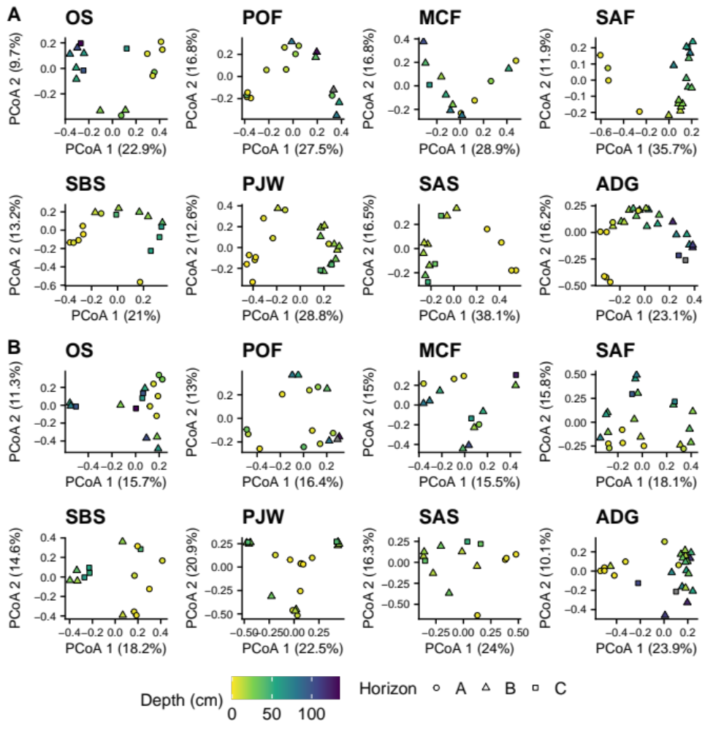
Figure S2: Mean and standard error of within horizon β-diversity (using Bray-Curtis dissimilarity).
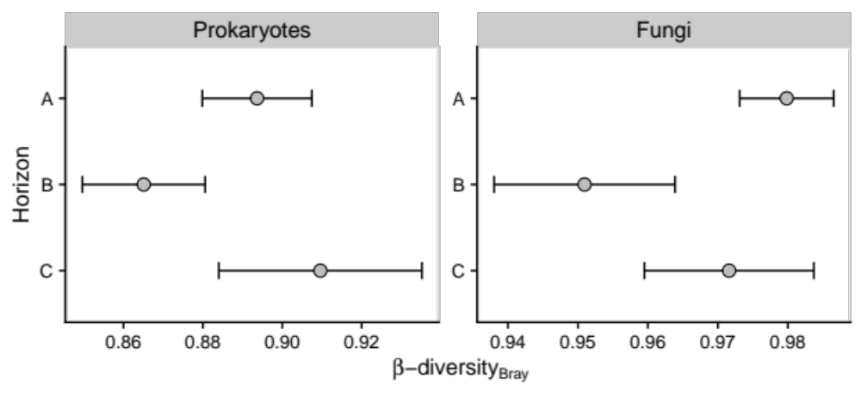

Figure S3: Average relative abundance of prokaryotic taxa (A) and fungal classes (B) that significantly change (p-adjusted < 0.05) with depth at each site. Colored are calculated using loess regression. Dashed lines represent depths of major horizon boundaries (boundary between B and C horizons is not shown when a C horizon was not encountered).
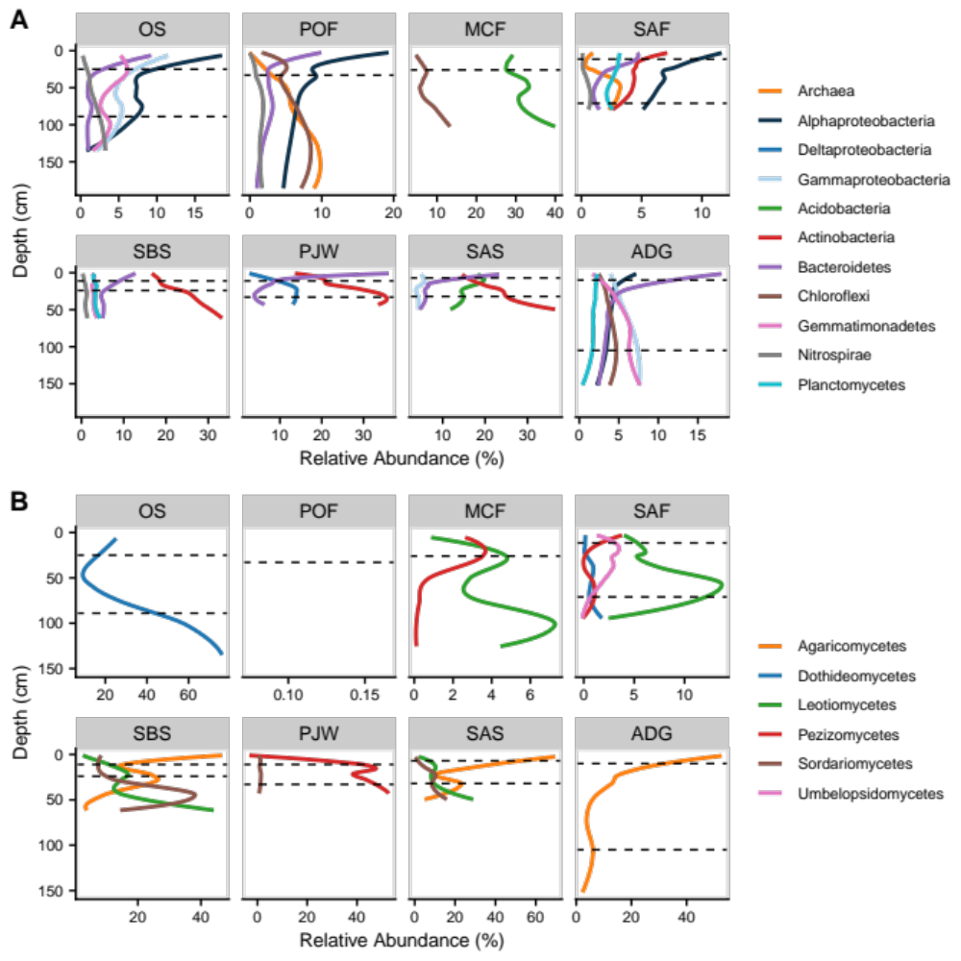
Figure S4: Relative abundance of ectomycorrhizal (A) and arbuscular mycorrhizal (B) fungi among sites and major horizons. Bars represent means, error bars represent standard error of the mean, and points represent samples. Letters represent significant differences among sites for each major horizon (Tukey HSD, p < 0.05).
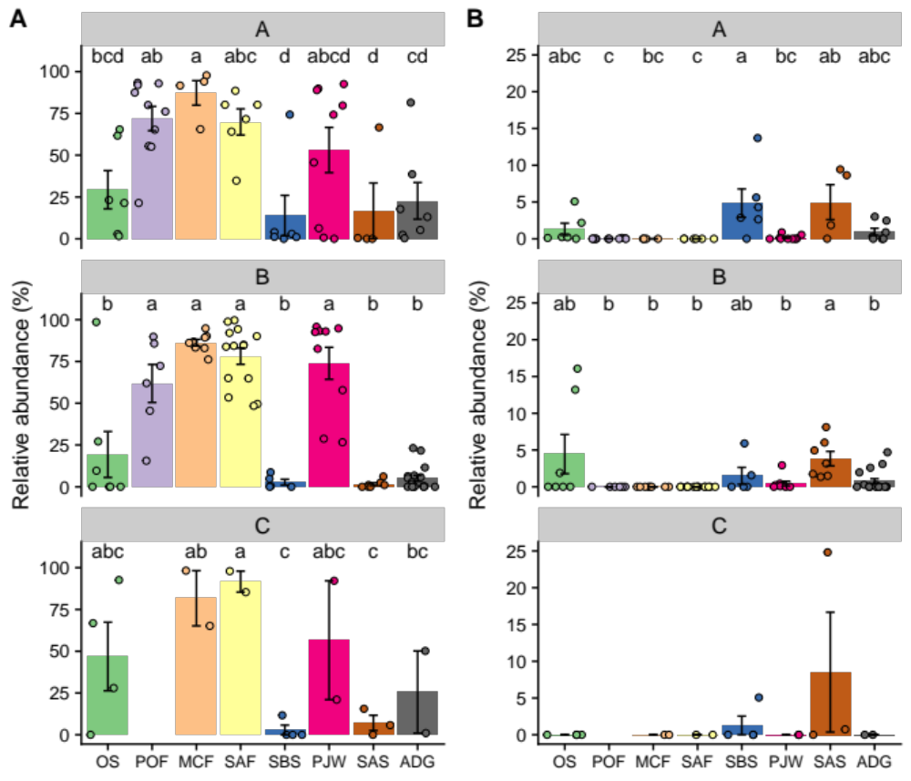

Figure S5: Extracellular enzyme activity of β-glucosidase (BG), N-acetylglucosamine (NAG), acid phosphatase (AP) on soil weight basis colored by site (A), mol microbial biomass carbon (MBC, B), and mol soil organic carbon (SOC, C).
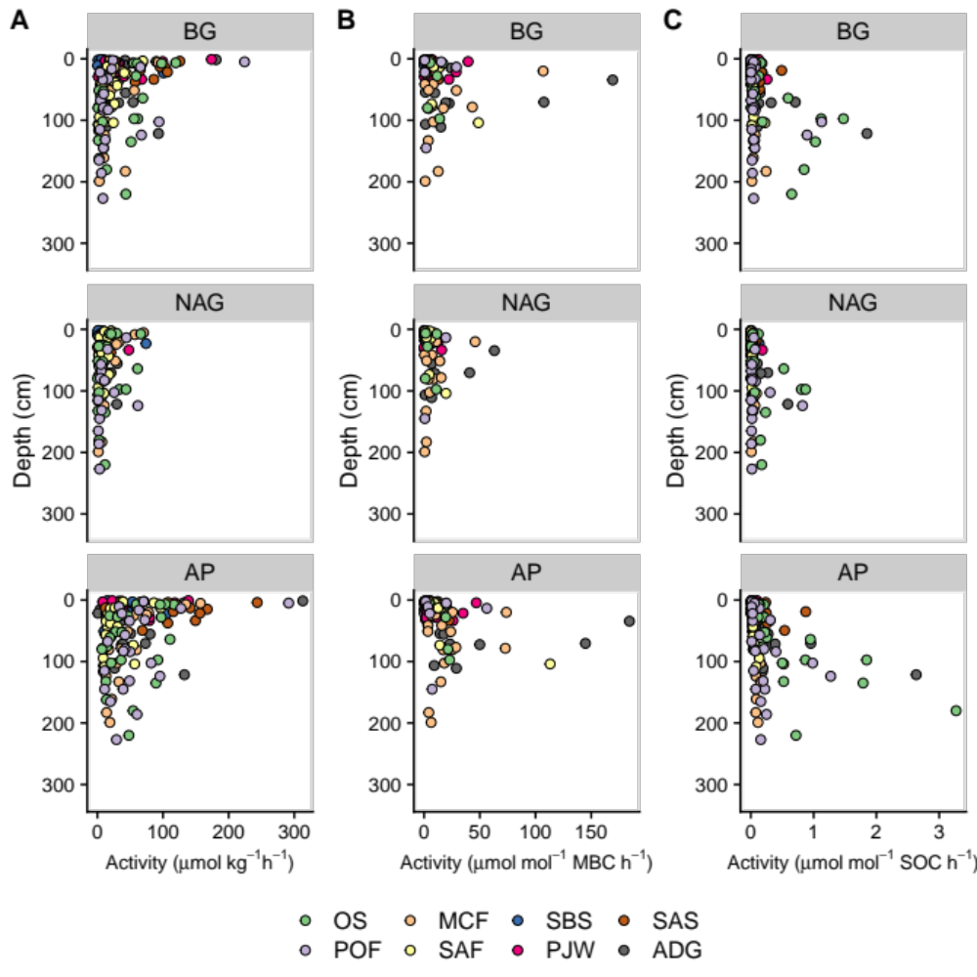

Figure S6: Extracellular enzyme activity of β-glucosidase (BG), N-acetylglucosamine (NAG), acid phosphatase (AP) on soil weight basis across sites and major horizons. Points represent samples and boxplots represents the median and interquartile range. Whiskers extend to the highest/lowest value within 1.5 times the interquartile range from the interquartile range.

Figure S7: Extracellular enzyme activity of β-glucosidase (BG), N-acetylglucosamine (NAG), acid phosphatase (AP) on a mol microbial biomass carbon (MBC) basis across sites and major horizons. Points represent samples and boxplots represents the median and interquartile range. Whiskers extend to the highest/lowest value within 1.5 times the interquartile range from the interquartile range.
Figure S8: Extracellular enzyme activity of β-glucosidase (BG), N-acetylglucosamine (NAG), acid phosphatase (AP) on a mol soil organic carbon (SOC) basis across sites and major horizons. Points represent samples and boxplots represents the median and interquartile range. Whiskers extend to the highest/lowest value within 1.5 times the interquartile range from the interquartile range.

