Overcoming Immune Exclusion in Cirrhotic Hepatocellular Carcinoma via Cryoablation: Insights from Molecular pH Imaging

Jessica G. Santana¹, Annabella Shewarega^{2,3}, David Nam³, Marie-Louise Löffler^{3,4}, Tabea Kao^{3,4,5}, Xuchen Zhang⁶, Vinzent Kahl^{3,4}, Fahmeed Hyder^{1,3}, Julius Chapiro^{1,3,7}, Daniel Coman^{1,3*}

¹ Department of Biomedical Engineering, Yale University, New Haven, CT, United States
² Department of Diagnostic and Interventional Radiology and Neuroradiology, University Hospital Essen, Hufelandstreet 55, 45147 Essen, Germany
³ Department of Radiology and Biomedical Imaging, Yale School of Medicine, 333 Cedar Street, New Haven, CT 06510 United States
⁴ Department of Radiology, Charité-Universitätsmedizin Berlin, corporate member of Freie Universität Berlin, Humboldt-Universität, and Berlin Institute of Health, 10117 Berlin, Germany
⁵ Berlin Institute of Health at Charité - Universitätsmedizin Berlin, Berlin, Germany.
⁶ Department of Surgical Pathology, Yale University School of Medicine, 20 York Street New Haven, CT 06510, United States.
⁷ Department of Internal Medicine, Section for Digestive Diseases, Yale University School of Medicine, 333 Cedar St, New Haven, CT 06510, United States.

Contact E-Mail: daniel.coman@yale.edu

Supplementary Methods 1:

Animal model

All animal experiments were approved by the Yale University Institutional Animal Care and Use Committee (IACUC) and conducted in accordance with institutional and NIH guidelines for humane animal treatment. To model hepatocellular carcinoma (HCC) in the context of chronic liver inflammation, Mdr2 knockout (Mdr2–/–) mice on an FVB/N background were used. These mice were generously provided by Dr. Mario Strazzabosco, Yale Liver Cancer Center. The Mdr2–/– model develops spontaneous chronic liver inflammation due to impaired biliary phospholipid secretion, mimicking features of primary sclerosing cholangitis and providing a fertile substrate for tumorigenesis.

Toxin-induced liver cirrhosis

The induction of cirrhosis was performed by repetitive oral administration of escalating doses of carbon tetrachloride (Sigma Aldrich, 99.9 56-23-5) (CCl₄) (CCl₄, 50% (vol/vol) in olive oil, three times per week for 24 weeks. The dosing schedule consisted of 0.875 ml/kg (1st dose, week 1), 1.75 ml/kg (2nd to 9th dose, week 1 – 4), 2.5 ml/kg (10th to 23rd dose, week 4 – 8), and 3.25 ml/kg (after week 8), according to previously established protocol^{[30]}.

Supplementary Methods 2: Histologic Processing

Tissue collection and processing

Immediately after Biosensor Imaging of Redudant Deviations in Shifts (BIRDS) imaging, animals were sacrificed for tissue harvesting. Necropsy included tumor, surrounding liver parenchyma, and spleen, fixed in 10% buffered formalin overnight at 4°C, paraffin-embedded, and sectioned into 5 µm-thick slices for radiological-pathological correlation.

Immunohistochemistry

5 µm-thick sectioned slices were stained for a standardized Hematoxylin-and-Eosin (H&E) stain according to protocols used for general histopathology evaluation and quantification of tumor viability and necrosis. Immunohistochemistry (IHC) was performed evaluating for CD3⁺ (Clone CD3-12, ab11089, 1:200, Abcam), CD8⁺ (4SM15, 14-0808-37, 1:200, ThermoFisher), CD68⁺ (Clone 2449D, 1:500, R&D Systems), and CD206⁺ (Clone MMR/CD206, AF2535, 1:200, R&D Systems). Briefly, sections were deparaffinized at 50°C for 20 minutes followed by 20 min in histoclear and hydrated in a graded ethanol series. Heat-induced antigen retrieval was conducted with EDTA buffer (1.35mM in deionized water, pH=8.0) or Citrate buffer (10mM in deionized water, pH =6.0) at 95 °C in water bath. Upon cooling, slides were washed in 1X washing buffer (1% bovine serum albumin (BSA), 0.1% Tween-20, 500 mL 1X phosphate buffered saline (PBS)) and blocked for 30 min with 200 mL DAKO Dual Endogenous Protein Block (S2003, Aligent Technologies, Santa Clara/CA). Slides were washed three times with 1X washing buffer and incubated for 60 min with 5 drops of 2.5% host serum. Primary antibody incubation was performed overnight at 4°C in a hydration chamber. Slides were washed three times in 1X washing buffer and incubated with the secondary antibody enzyme conjugate (1:200, ImmPRESS (Peroxidase) polymer Anti-Rat or Anti-Goat IgG reagent, Vector Laboratories). Subsequently, slides were washed three times in 1X washing buffer, treated with diaminobenzine (DAB) chromogen for 30 – 90 seconds, and counterstained with 4 drops of hematoxylin. Slides were dehydrated and mounted with Vectamount solution for analysis.

Image analysis and quantification

For immunohistochemistry, tissue analysis included staining for hematoxylin-eosin (H&E), CD3⁺, CD8⁺, CD68⁺, CD206⁺, and Masson’s trichrome. Slides were scanned using the Aperio Scope XT Digital Slide Scanner (Aperio, Vista, CA, USA) at 20 × magnification (3.94 × 10⁶ pixels = 1 mm²). The evaluation of cirrhosis was based on the presence of architectural hepatic distortion, regenerative nodules, and fibrotic septa. A board-certified pathologist (X.X.) confirmed the stage of cirrhosis across samples. Fibrosis index was calculated by the ratio of the fibrosis area to the total sample area, expressed in pixels, and calculated automatically using the Leica Aperio Image Scope Positive Pixel Count (PPC) algorithm. The optimum threshold for positive pixels that corresponded to the areas of trichrome staining was determined using the software by changing the hue value and color saturation using the original image for comparison. For immune infiltrate quantification, the PPC measured proportions of medium (NPositive/Ntotal) and strong pixel (NStrongPositive/Ntotal) staining expressed in pixels Ratios of tumor to liver positive pixel proportions. Four representative regions of interest (ROI) in the tumor border and core (no inclusion of the edge of the tumor) were selected for each marker in each tumor. The positive pixel count was divided per ROI to calculate the average percentage cell positivity per mm² hotsop area separately for peritumoral and intratumoral regions.

For fibrosis index quantification, the PPC algorithm was previously tuned. The hue value parameter was chosen to allow quantification of the blue stained areas corresponding to collagen deposition in Masson’s trichome staining (hue value = 0.82). hue width for pixel detection was set to 0.225. The quantification was determined taking the ratio of the fibrosis area to the total sample area, expressed in pixels in Masson’s trichome staining.

Sample Size Calculations

A statistical sample size calculation was conducted using nQuery (version 2017, Sample Size and Power Calculation, "Statsols" by Statistical Solutions Ltd). The analysis determined a sample size of N = 8 per group to be sufficient for detecting significant differences between group means at the second decimal with a high probability (90% power) at a significance level of α = 5%.

Supplementary figures and legends
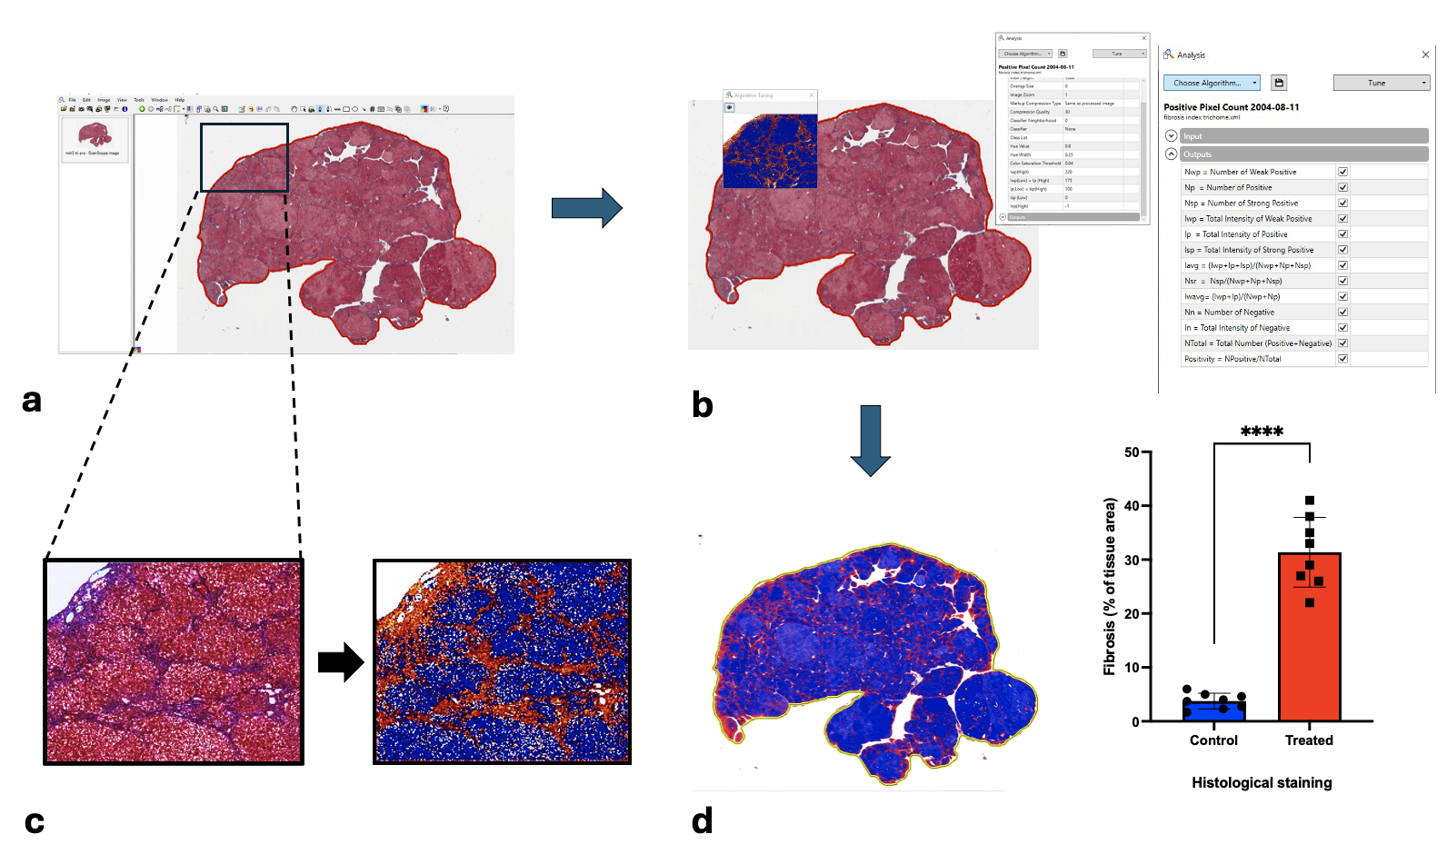

Figure S1. A representation of automated quantification of fibrosis expressed as the percentage of positive pixels to the total number of pixels using the Leica Aperio Image Scope Positive Pixel Count (PPC) algorithm. (a) Image scanned at 20X shows H&E staining of liver parenchyma from CCl4-treated Mdr2-/- mice. (b) By tuning the algorithm, the hue value parameters were chosen to allow the quantification of the blue/purple-stained areas corresponding to collagen deposition in Masson’s trichome staining (hue value = 0.66). The hue width for pixel detection was set to 0.225. (c) Representation of PPC analysis where the color detected by the algorithm (orange) corresponded to the collagen deposition (purple) on Masson’s trichome staining. (d) Quantification as the ratio of the fibrosis area to the total sample area, expressed in pixels (27.63 ± 2.348; ****p<0.0001). Bars represent mean ± SD.

