Supplementary material

Compartmentalized VEGF Receptor Expression in Hypothalamic Tanycytes Reveals a Novel Non-Endothelial Axis of VEGF Signaling
(Tanycytes as a Novel Non-Endothelial Target of VEGF Signaling)

Ombeline Desruelle¹, Manon Leclerc¹, Sreekala Nampoothiri¹, Daniela Fernandois¹, Claude-Alain Maurage¹, Markus Schwaninger², Vincent Prevot ¹ and Ines Martinez-Corral^{1#}

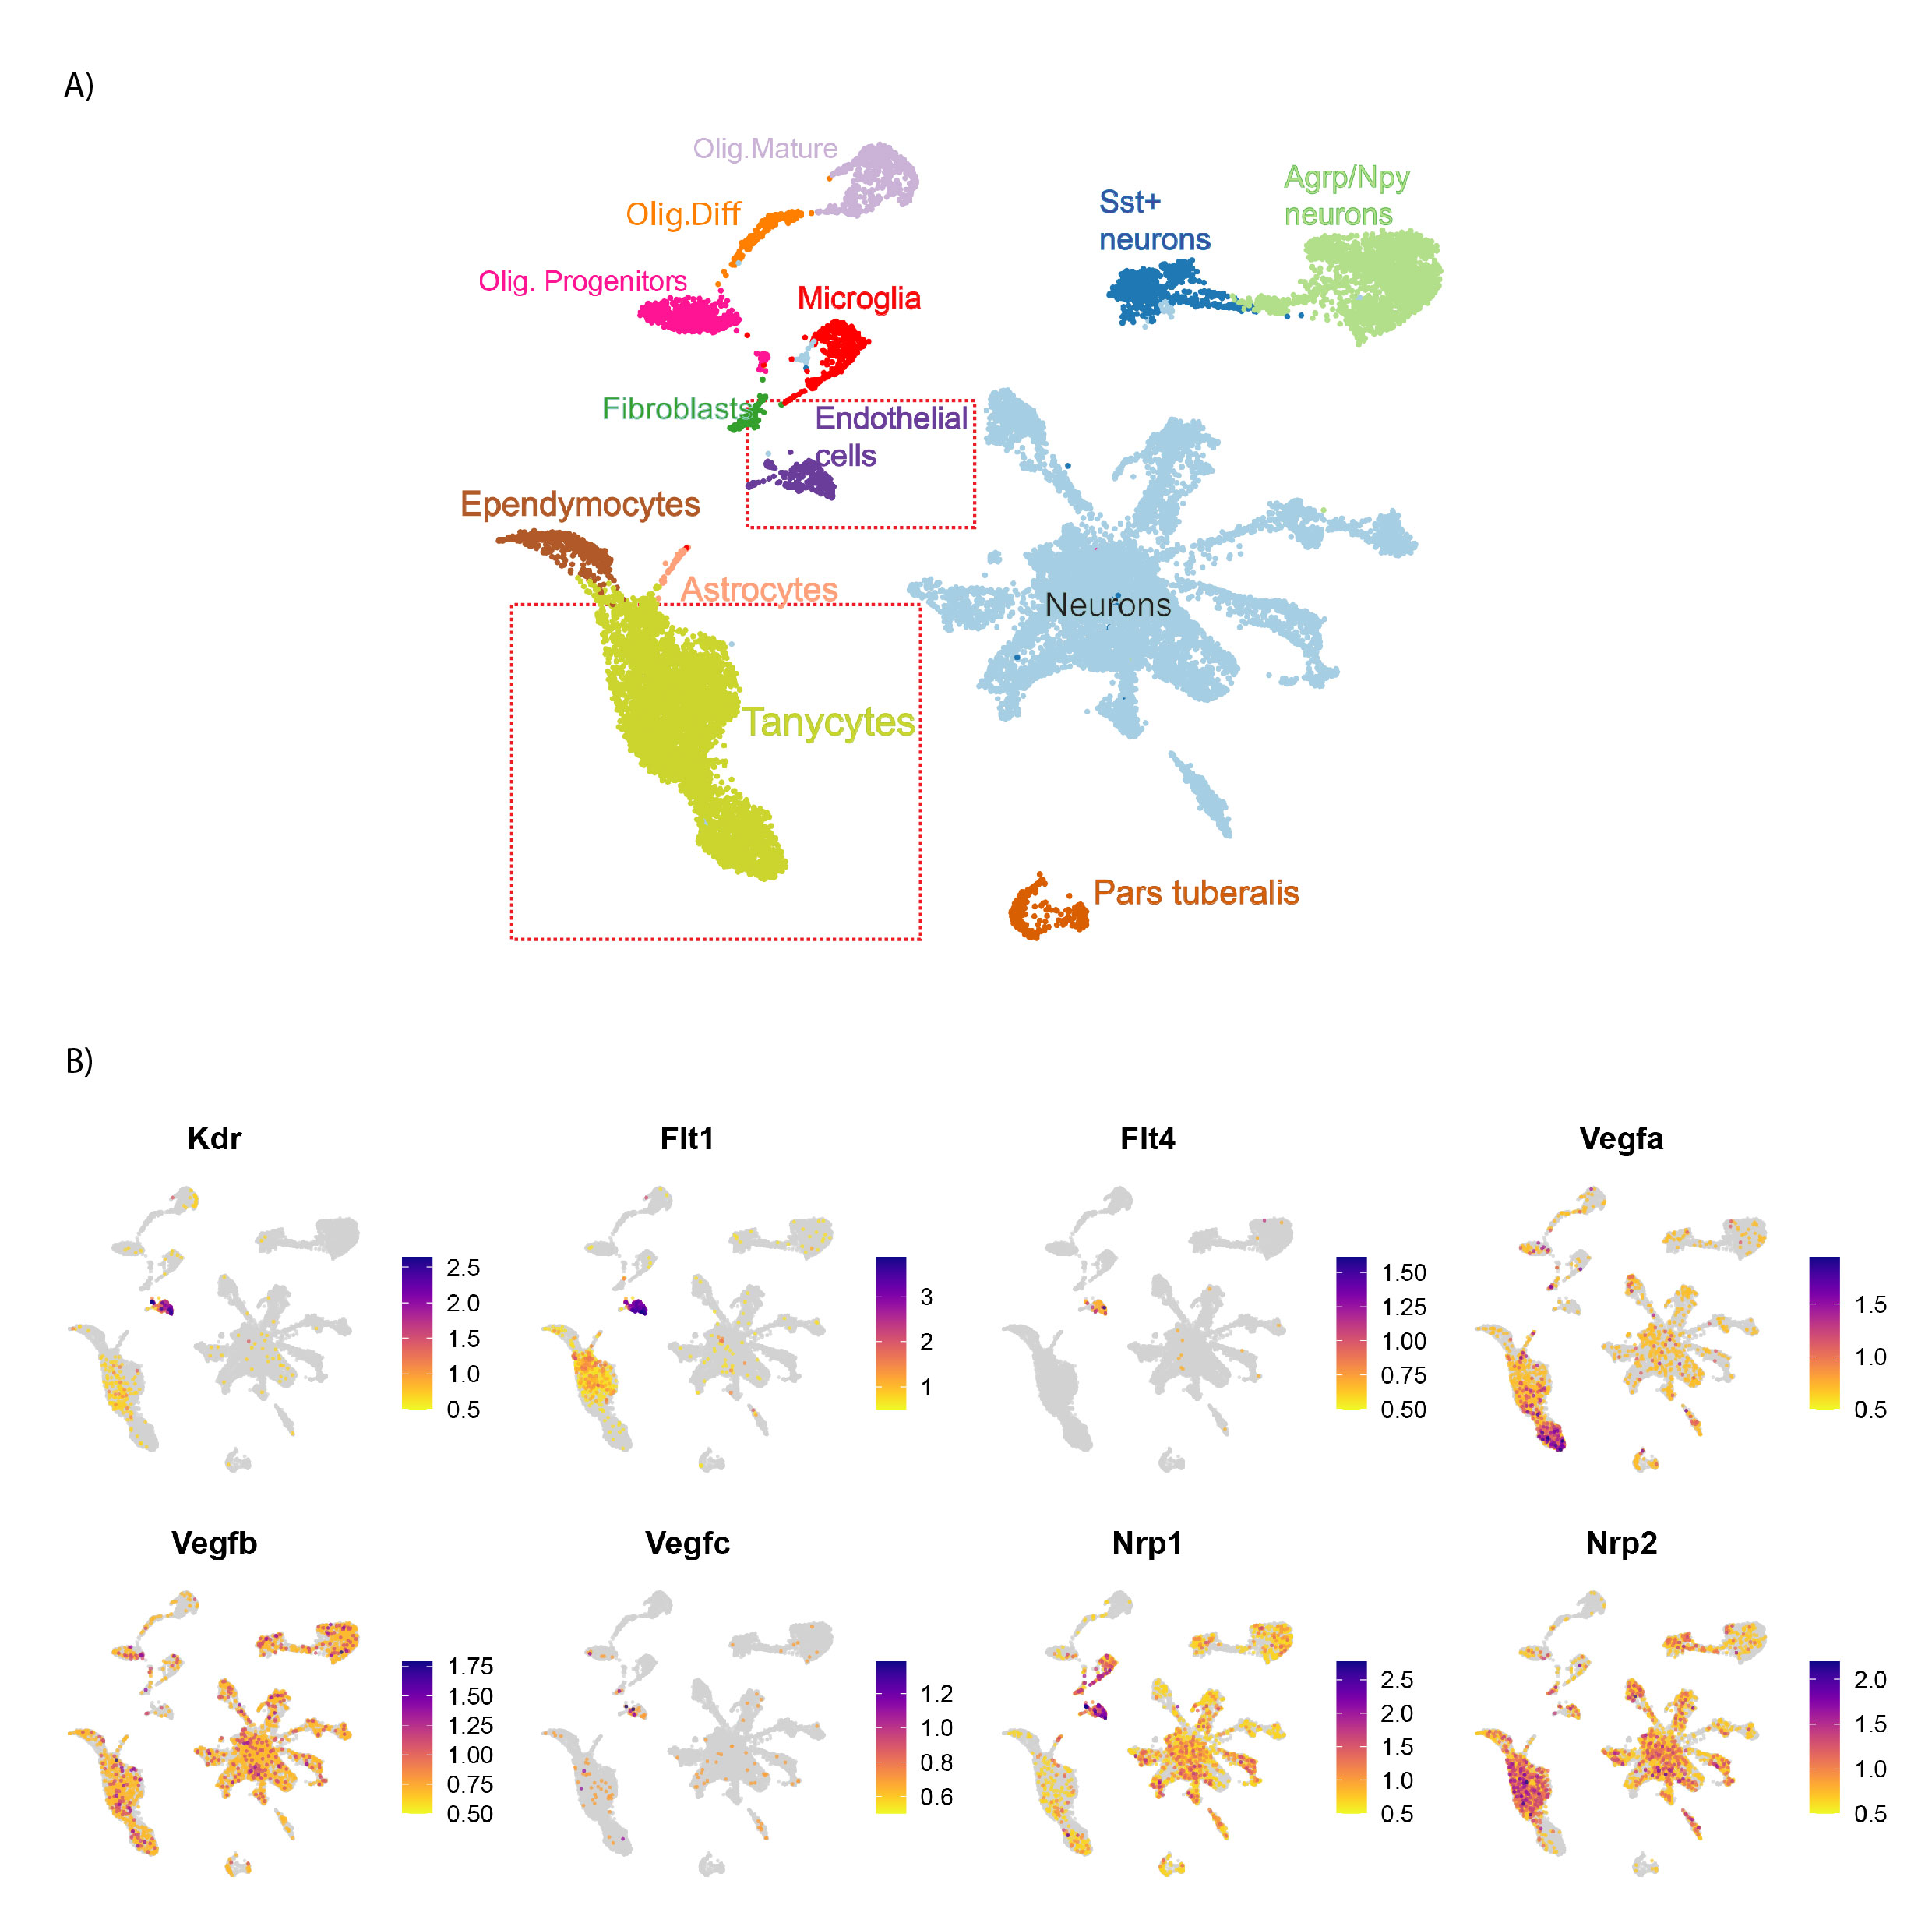
Supplementary Figure 1. Single cell RNA sequencing of VEGFR family in the hypothalamus
A) Reanalysis of scRNA-seq ME dataset from ¹⁸ showing UMAP of the different cell clusters. (B) Feature plots showing VEGFRs (Kdr, Flt1 and Flt4), ligands (Vegfa, Vegfb and Vegfc) and co-receptors (Nrp1 and Nrp2) in the identified cell clusters. Red squares indicate the endothelial and tanycytic cluster.

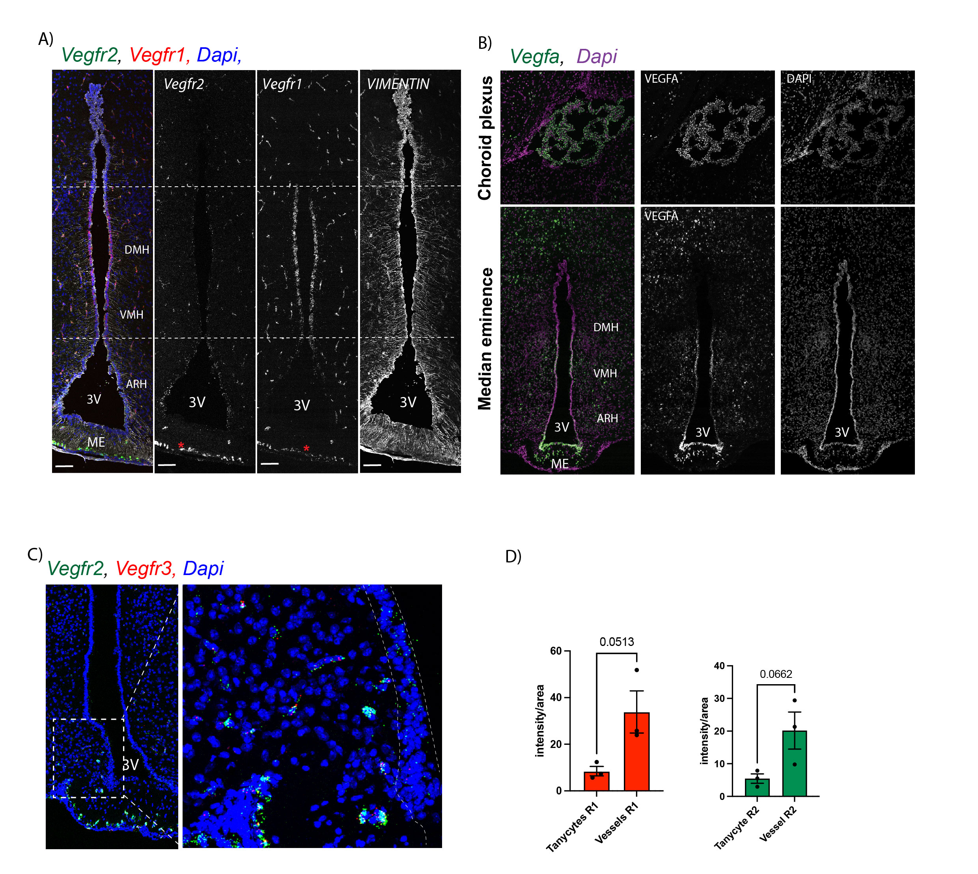
Supplementary Figure 2. VEGFR1, VEGFR2 and VEGFR3 in tanycytes(
A) In situ hybridization images for Vegfr1 (red) and Vegfr2 (green) in coronal sections of the hypothalamic tuberal region of adult male mice. Vimentin immunoreactivity is shown in white and nuclei counterstaining (DAPI) in blue. Images are low-magnification views of the 3V. Blood vessels are indicated by red asterisks. (B) In situ hybridization images for Vegfa (green) in coronal sections of the choroid plexus (upper panel) and the hypothalamic tuberal region of adult male mice (lower panel). Nuclei counterstaining (DAPI) in blue (A) or magenta (B). Images are low-magnification views of the 3 V. (C) In situ hybridization images for Vegfr2 (green) and Vegfr3 (red) (green). Note that Vegf3 is highly expressed at the level of the ME vasculature (white asterisks). (D) Quantification for VEGFR1 and VEGFR2 protein expression in tanycytes compared to blood vessels. Data is represented in percentage of intensity (n=3). Data are represented as mean ± standard error deviation (SEM). Statistical analysis was performed using student t-test. n = 3. * = p < 005. Scale bar = 100 μm in all panels. ARH, arcuate nucleus of the hypothalamus; ME, median eminence; VMH, ventromedial nucleus of the hypothalamus; DMH, dorsomedial nucleus of the hypothalamus; 3V, third ventricle.
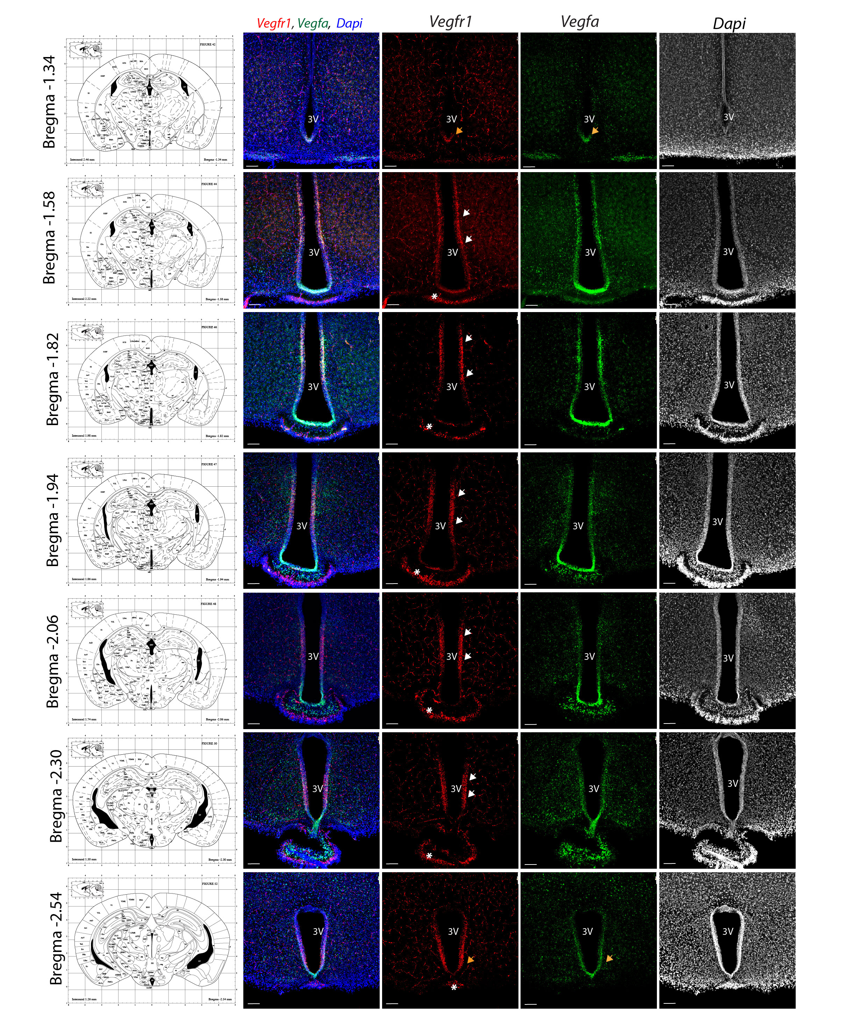
Supplementary Figure 3. Rostro-caudal analysis of Vegfr1 and Vegfa expression in adult males
In situ hybridization images for Vegfr1 (red) and Vegfa (green) in coronal sections of the hypothalamic tuberal region from adult male mice at different rostro-caudal levels (from bregma −1.34 mm to −2.54 mm). Low-magnification images show the third ventricle (3V) region. Corresponding anatomical reference images from the Allen Brain Atlas are shown on the left for orientation. Nuclei are counterstained with DAPI (blue). White arrows indicate Vegfr1 expression in VMH/DMH tanycytes. Red arrows denote Vegfa expression in ME tanycytes. Orange arrows highlight overlapping domains of Vegfr1 and Vegfa expression, observed only at the most anterior and posterior levels of the ME. Asterisks indicate blood vessels at the level of the ME, with high expression of vegfr1. Scale bar = 100 μm in all panels. ARH, arcuate nucleus of the hypothalamus; ME, median eminence; VMH, ventromedial hypothalamic nucleus; DMH, dorsomedial hypothalamic nucleus; 3V, third ventricle.

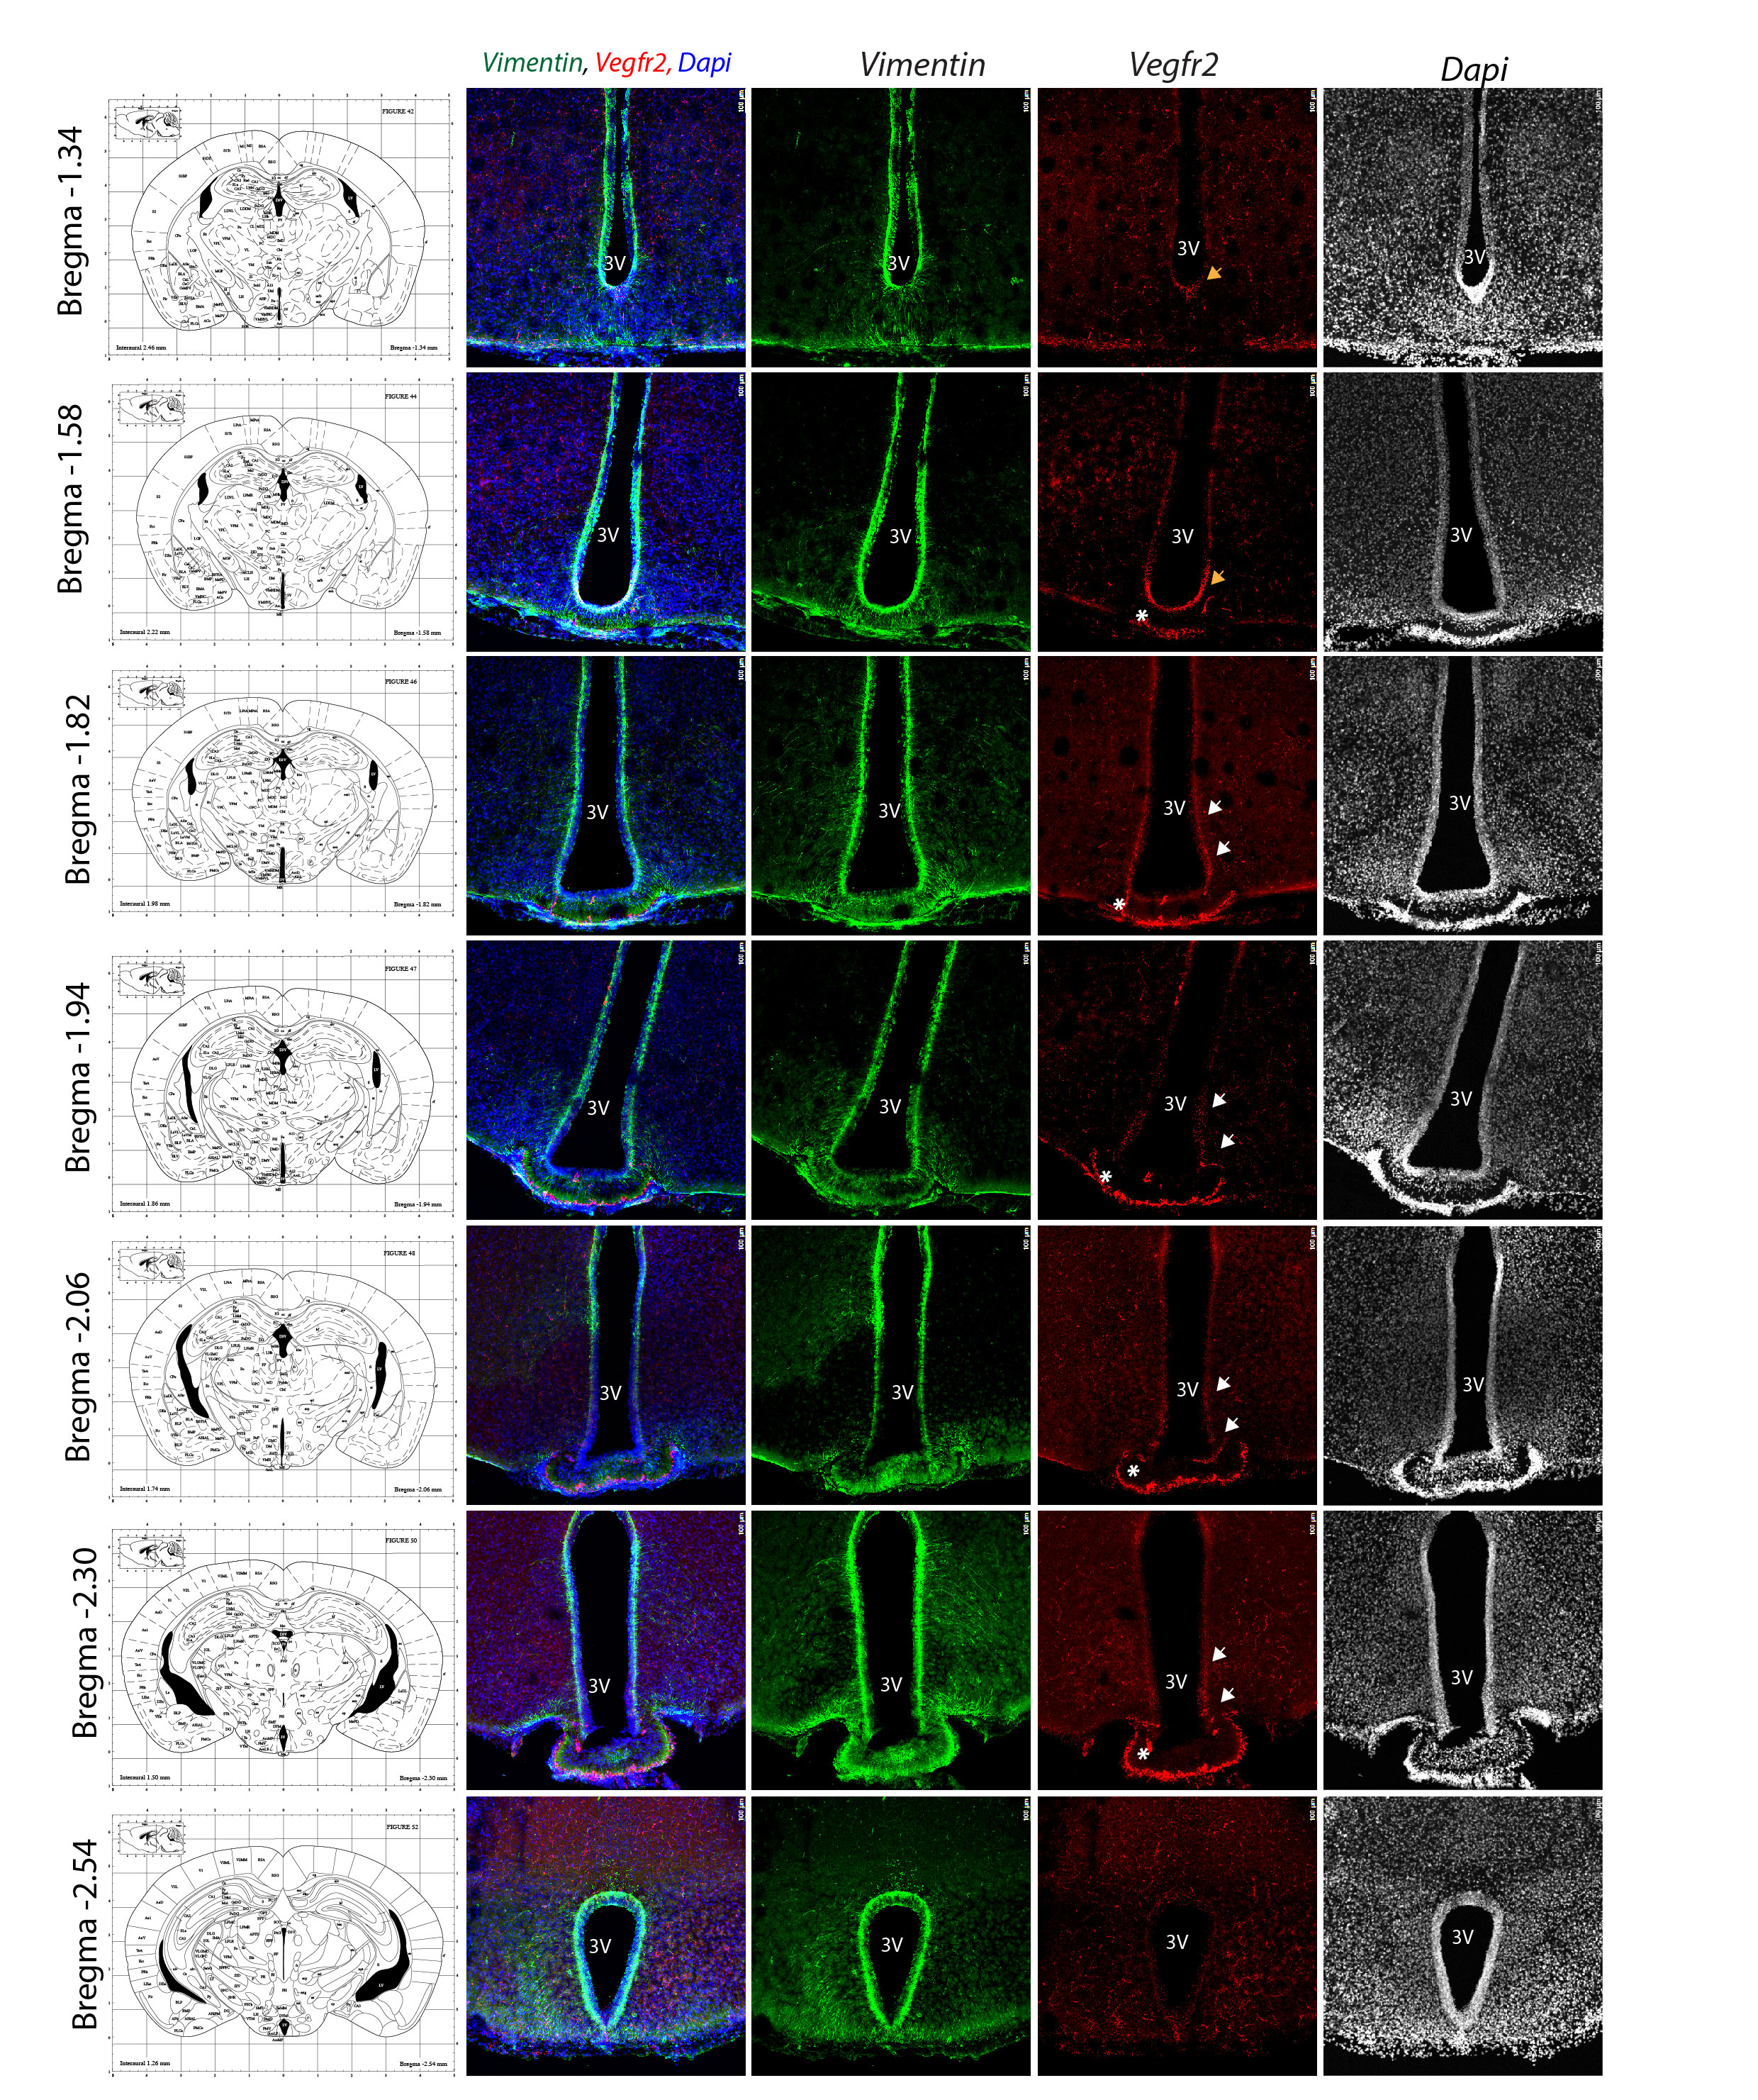
Supplementary Figure 4. Rostro-caudal analysis of Vegfr2 expression in adult males
In situ hybridization images for Vegfr2 (red) combined with immunofluorescence against vimentin (green), a marker of tanycytes, in coronal sections of the hypothalamic tuberal region from adult male mice. Sections span rostro-caudal levels of the ME from bregma −1.34 mm to −2.54 mm. Anatomical reference images from the Allen Brain Atlas are shown on the left for orientation. Nuclei are counterstained with DAPI (blue). White arrows indicate Vegfr2 expression in vimentin-positive (vimentin⁺) ARH-tanycytes located along the third ventricle. Orange arrows highlight Vegfr2 expression in tanycytes located in the anterior and posterior zones of the ME. Asterisks denote strong Vegfr2 signal in fenestrated blood vessels within the ME. Scale bar = 100 μm in all panels. ARH, arcuate nucleus of the hypothalamus; ME, median eminence; VMH, ventromedial hypothalamic nucleus; DMH, dorsomedial hypothalamic nucleus; 3V, third ventricle.
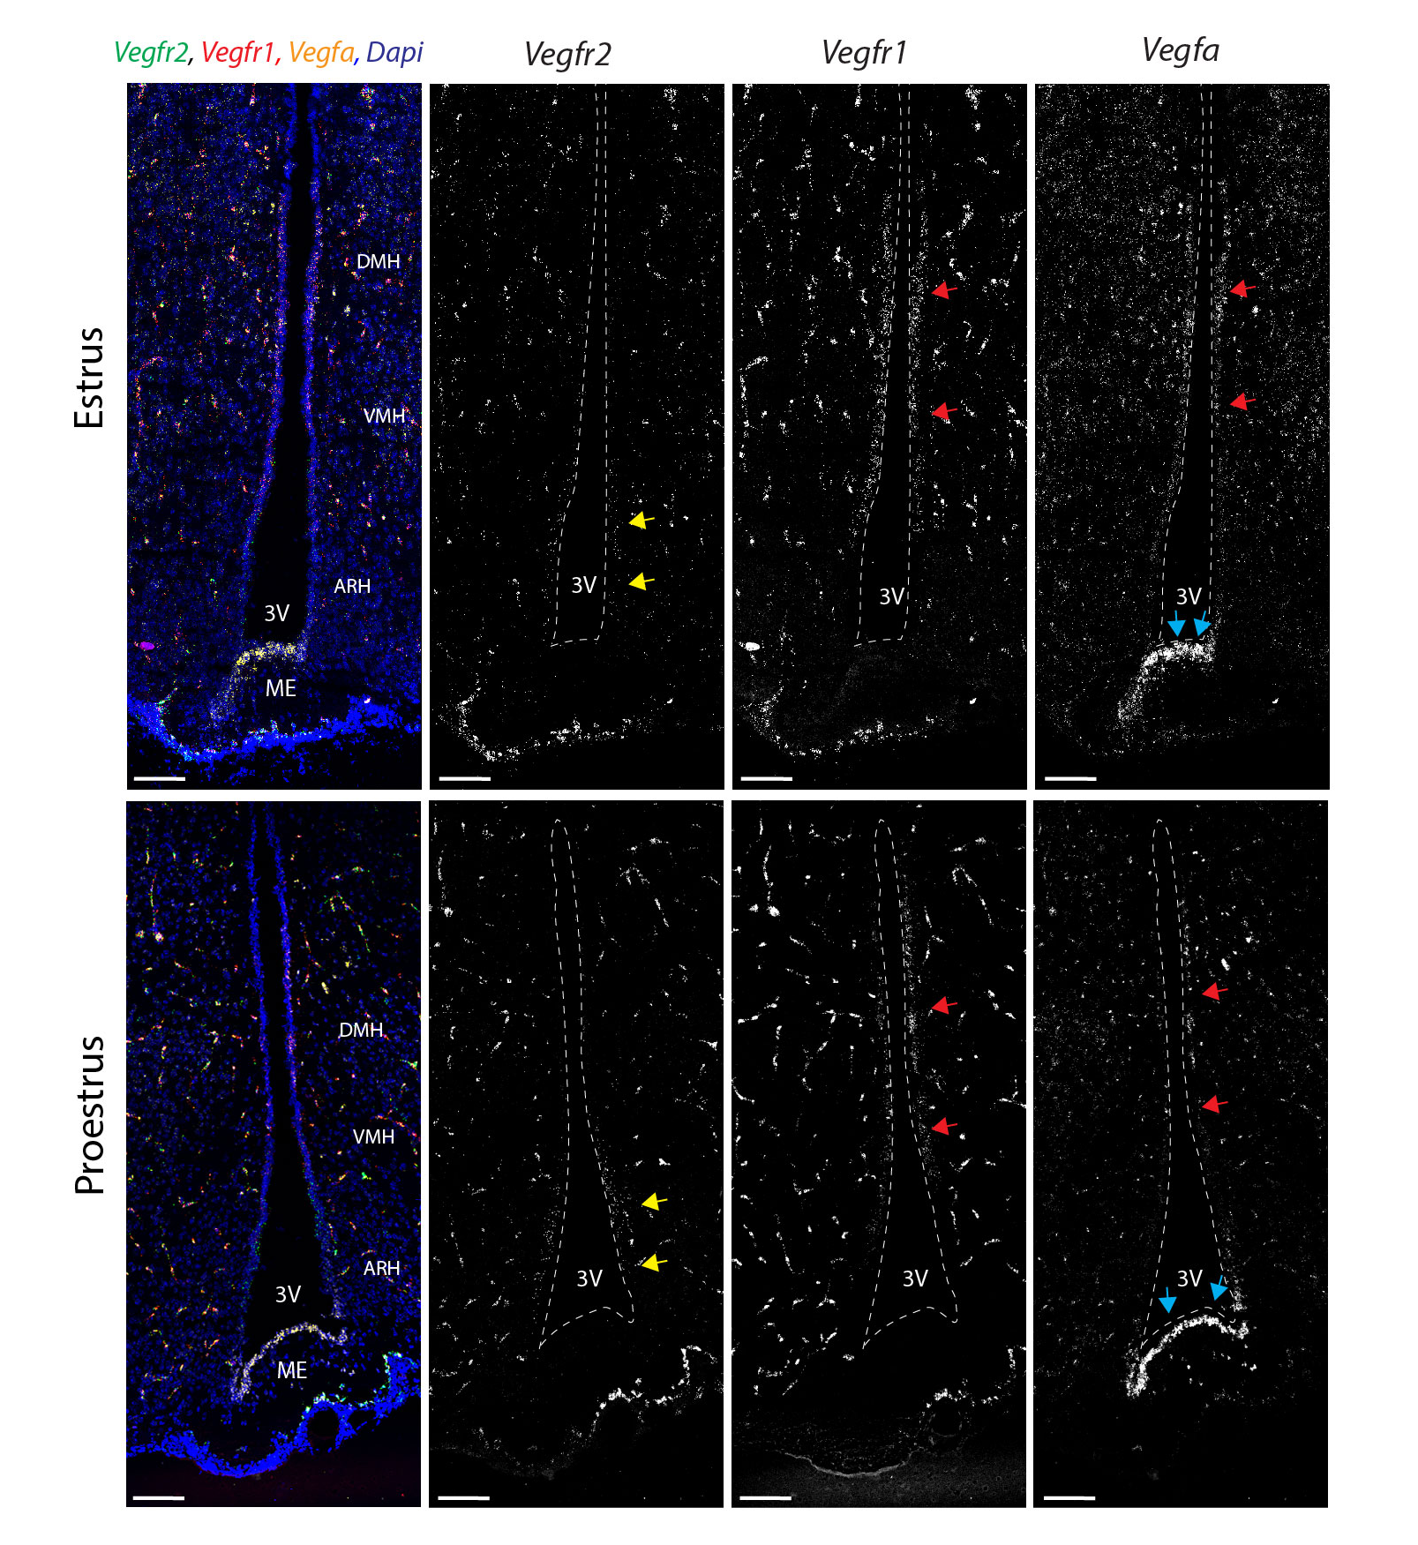

Supplementary Figure 5. Vegfr1, Vegfr2 and Vegfa in females
In situ hybridization (RNAscope) images for Vegfr1 (red), Vegfr2 (green) and Vegfa (green) in coronal sections of the hypothalamic tuberal region of adult female mice at different days of the estrus cycle. Upper panel: Low-magnification image of the 3V of females in Estrus. Lower panels: Low-magnification image of the 3V of females in proestrus. Individual channels are shown in grey for Vegfr2, Vegfr1 and Vegfa. Note that Vegfa is highly expressed at the level of the ME tanycytes (blue arrows) and DMH tanycytes (red arrows). While Vegfr2 is mainly expressed in the ARH tanycytes (yellow arrows). Dotted line indicated the 3V limits. Scale bar = 100 μm.

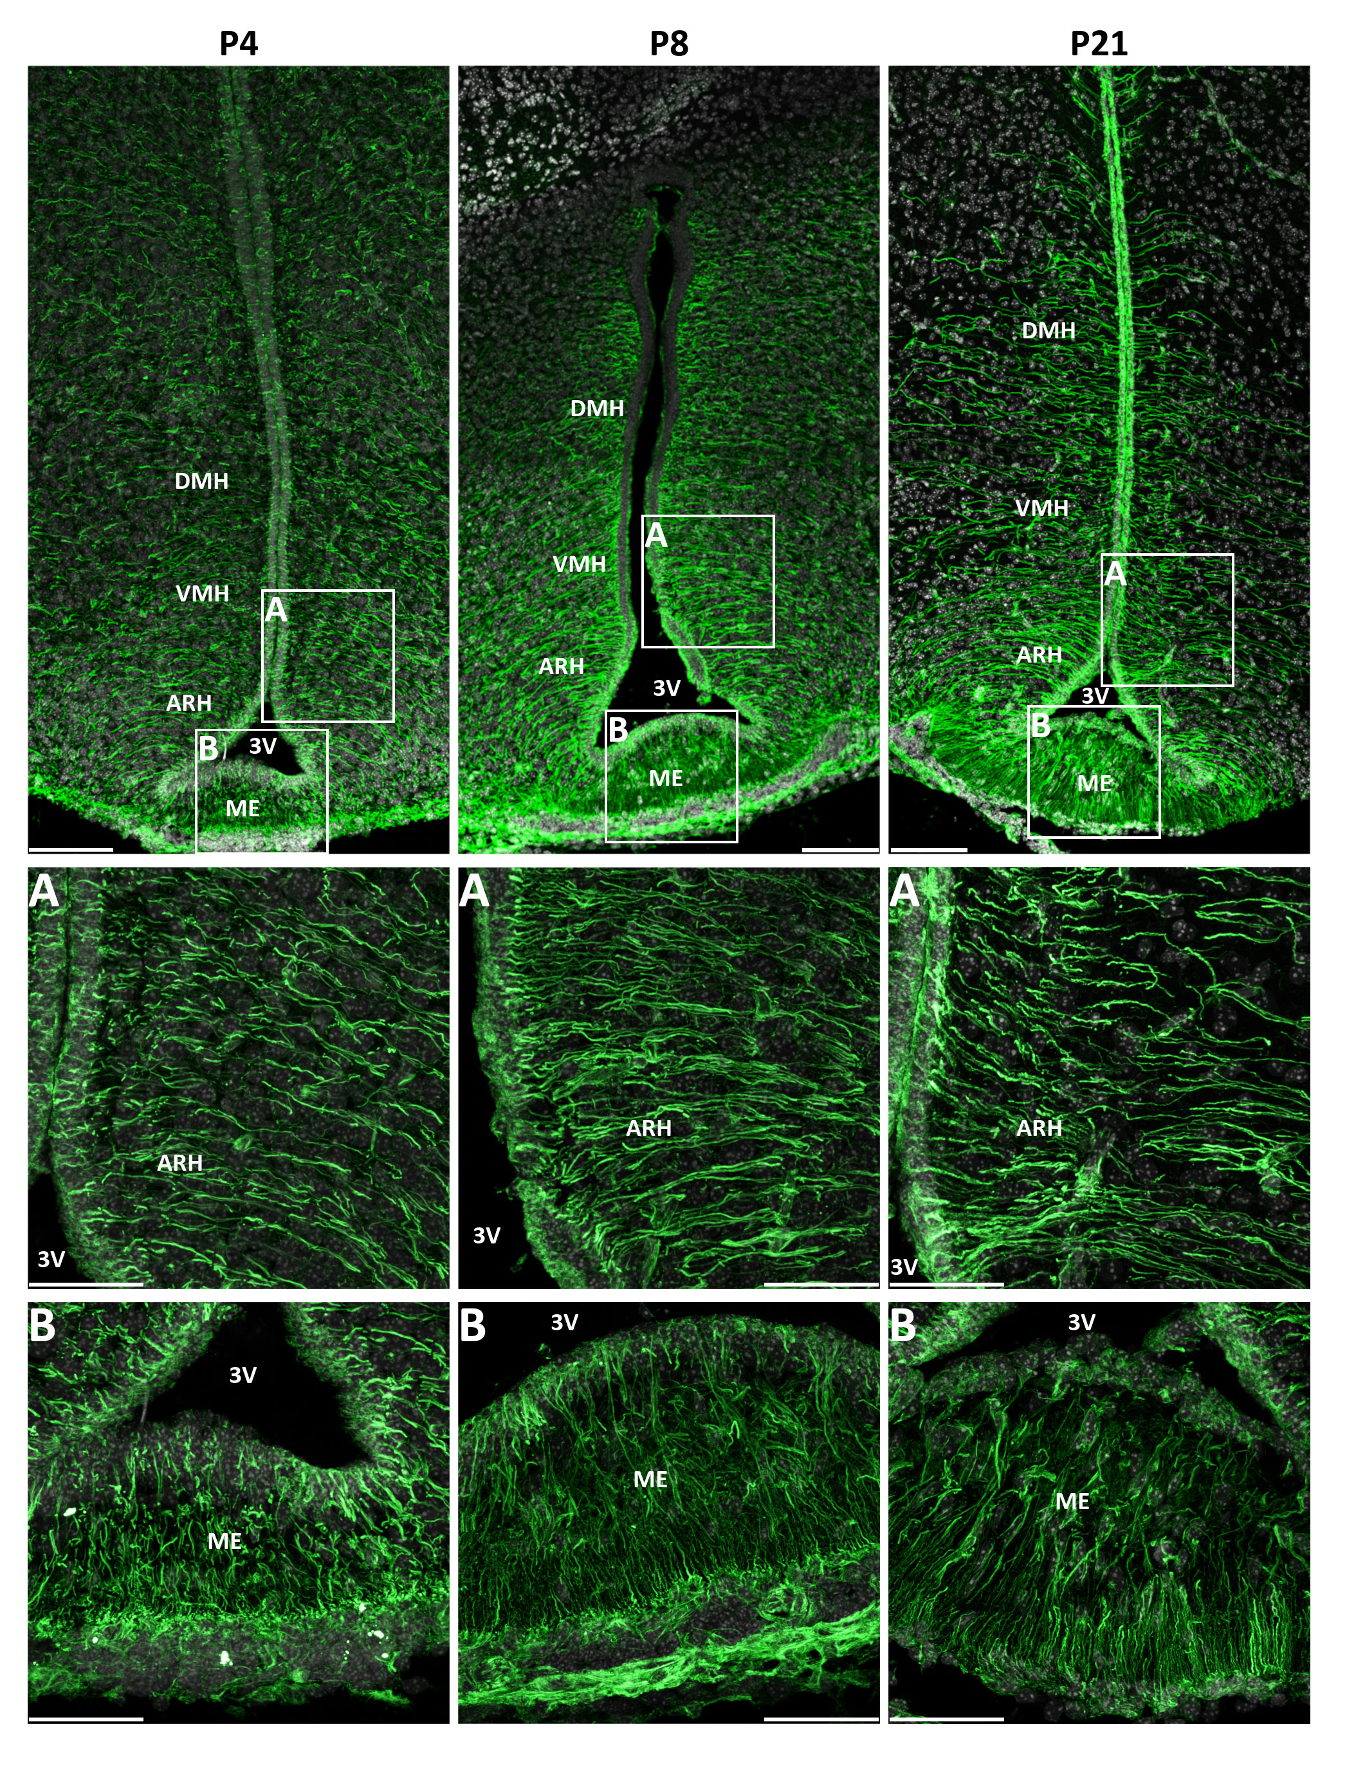
Supplementary Figure 6. Tanycytes’ morphology during postnatal development
Immunostaining images against Vimentin (green) in coronal sections of the hypothalamic tuberal region of male mice at postnatal days P4, P8 and P21. Nuclei are counterstained with DAPI (white). Upper panels: low magnifications of the 3V region. (A-B): higher magnification of the boxed regions of the upper panels showing the establishment of the linear processes of the ARH tanycytes (A), and the branching of ME tanycytes across development (B). Scale bar = 100 μm in the upper pannels, 50 µm in ARH, arcuate nucleus of the hypothalamus; ME, median eminence; VMH, ventromedial hypothalamic nucleus; DMH, dorsomedial hypothalamic nucleus; 3V, third ventricle.

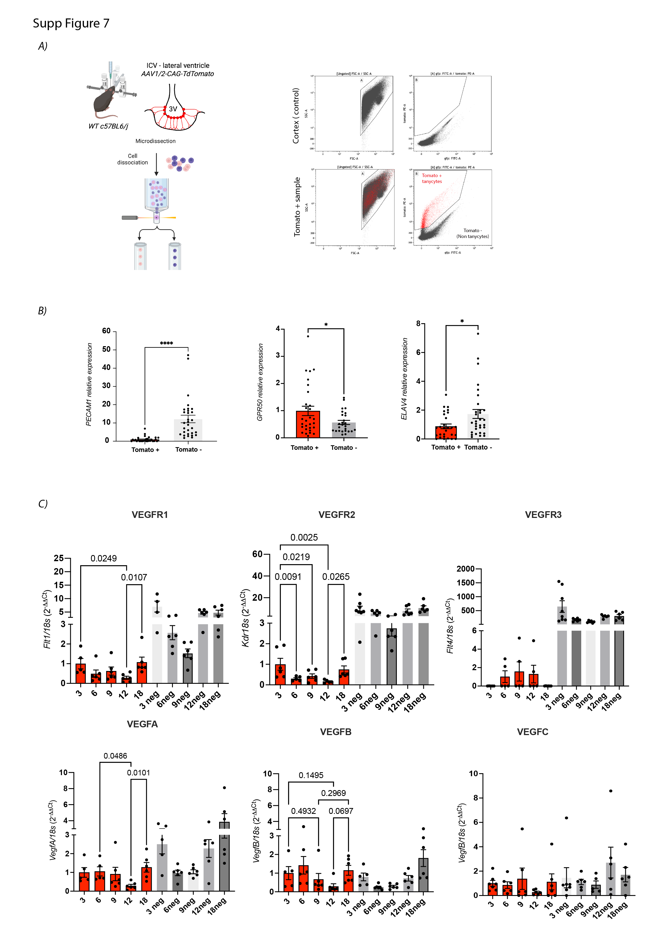
Supplementary Figure 7. Vegfr family in aging
(A) Schematic representation of the workflow for FACS-based isolation of tanycytes from the ME of adult male mice and representative FACS plots illustrating the gating strategy for tanycyte isolation (B) qPCR analysis of endothelial marker Pecam1, tanycyte marker Gpr50 , and neuronal marker Elavl4, confirming the identity and purity of the sorted population (C) qPCR analysis of Vegfr1, Vegfr2, and Vegfr3 mRNA expression levels, and their ligands, in tomato+ (tanycytes) and tomato – (non tanycytes) isolated from male mice aged 3, 6, 9, 12, and 18 months. Notably, Vegfr2 expression shows a progressive decline with age, while Vegfr1 remain stable in tanycytes and Vegfr3 is barely detected in this population. Note the high level of expression of the three receptors, but specially Vegfr3 in the negative compartment (that includes endothelial cells). qPCR data are normalized to housekeeping genes 18S, and presented as mean ± SEM; n = 5–6 mice per time point. Statistical analysis was performed using one-way ANOVA with Fisher’s LSD post hoc test. p < 0.05 considered significant

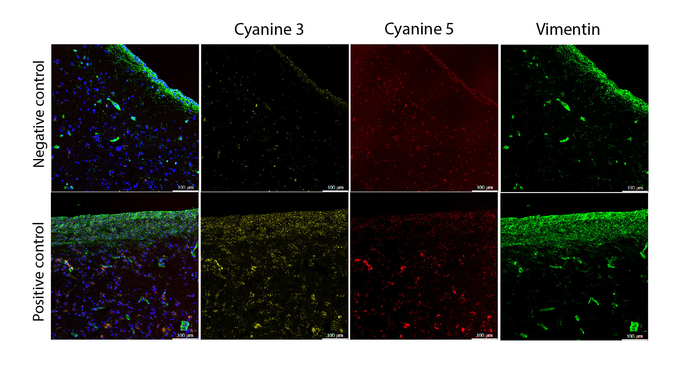

Supplementary Figure 8. Vegfr family in human tanycytes
Representative RNAscope images of positive and negative control probes, demonstrating probe specificity and signal quality. Single channels are shown. Note that human postmortem tissue exhibits elevated background fluorescence, necessitating careful interpretation of puncta.

