SUPPLEMENTARY FIGURES:

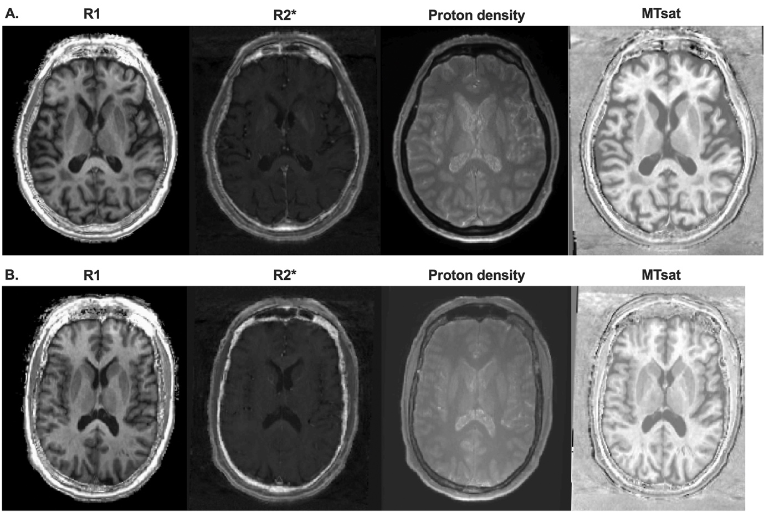

Supplementary Figure 1. Representative unprocessed quantitative parameter maps from participants. We present axial slices of four raw quantitative MPM-derived maps, R1, R2*, proton density, and MTsat to demonstrate image quality and spatial distribution. A. The images are derived from a healthy 77-year-old female participant in native spaces. B. The images are derived from a 71-year-old female patient with Parkinson’s disease in native spaces. MPM: multiparametric mapping. MTsat: magnetic transfer saturation. R1: longitudinal relaxation rate. R2* effective transfer relaxation rate.

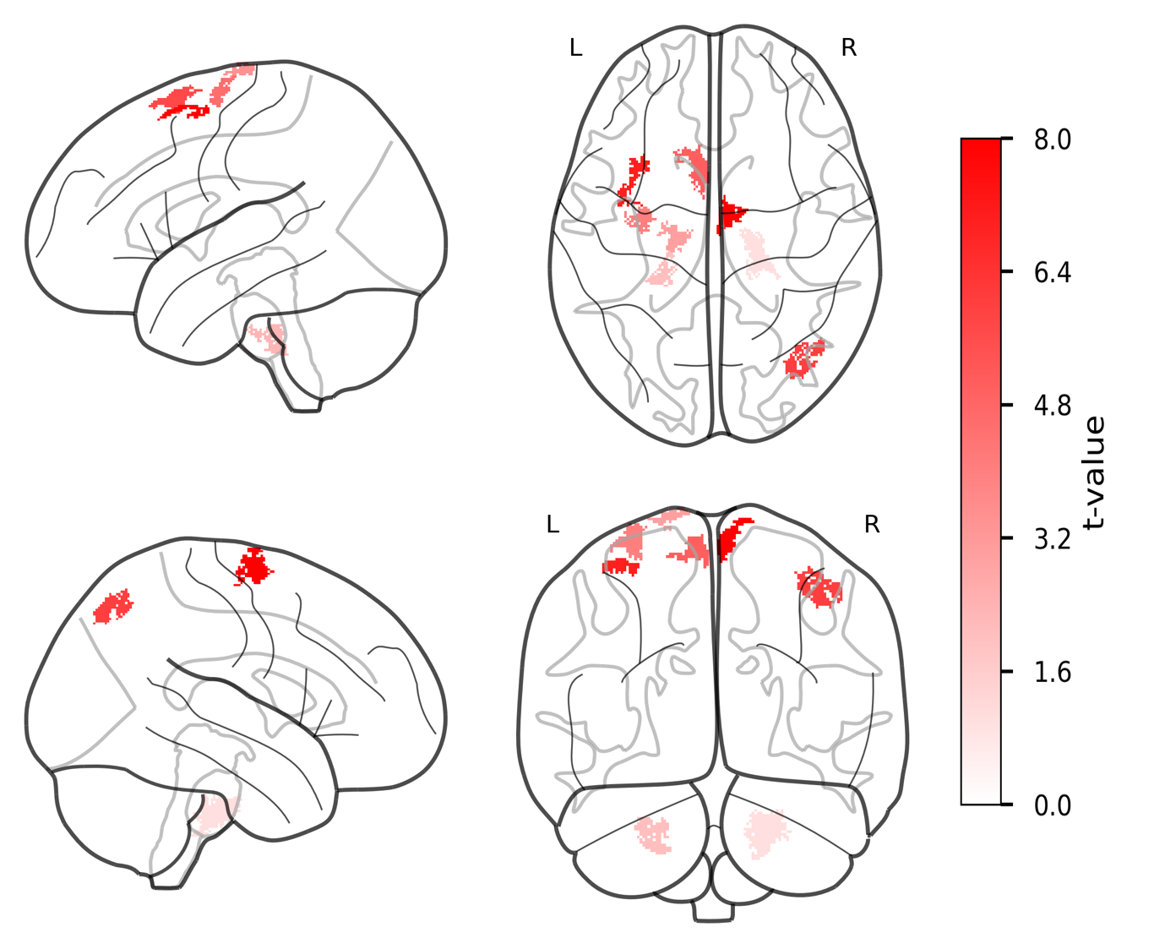

Supplementary Figure 2. Group differences in R1 values between PwPD and HCs in white matter. The statistical parametric maps from voxel-wise group comparison of R1 values are presented, displayed on a standard brain template in sagittal, axial, and coronal views. The statistical maps show t-statistics, where red clusters have higher R1 values in PwPD (PwPD > HCs). The color bar reflects voxel-wise t-statistics, with higher absolute t-values indicating stronger group differences only. Cluster-defining threshold was set to T = 3.18 (p < .001, uncorrected) with a cluster extent threshold of k ≥ 20 voxels. FWE correction was applied at the cluster levels for the PwPD > HCs contrast: FWEc = 137, df = [1, 94]. df: degrees of freedom. FWE: family-wise error. HCs: healthy controls. k: number of voxels. L: left hemisphere. PwPD: patients with Parkinson’s disease. R: right hemisphere. R1: longitudinal relaxation rate. T: t-statistic.

Supplementary Table 1. Clusters with significant differences in R1 values between PwPD and HCs in white matter.
 | cluster level |  |  |  | peak level |  | mm | mm | mm
 | P_{FWE-corr} | q_{FRD-corr} | K_{E} | P_{uncorr} | T | (Z_{E}) | mm | mm | mm
PwPD > HCs
MCP | .000 | .000 | 328 | .000 | 5.80 | 5.36 | 22 | -24 | -35
rPCR | .004 | .002 | 188 | .000 | 5.64 | 5.22 | 41 | -74 | 47
rSCR | .000 | .000 | 312 | .000 | 5.30 | 4.94 | 6 | -6 | 71
lSCR | .000 | .000 | 268 | .000 | 5.18 | 4.85 | -5 | -14 | 74
lSCR | .000 | .000 | 304 | .000 | 5.07 | 4.76 | -3 | 10 | 64
MCP | .022 | .008 | 144 | .000 | 4.87 | 4.59 | -25 | -32 | -37
lSCR | .007 | .003 | 173 | .000 | 4.80 | 4.53 | -31 | -9 | 69
lSCR | .029 | .009 | 138 | .000 | 4.64 | 4.39 | -16 | -16 | 78
lSCR | .030 | .009 | 137 | .000 | 4.18 | 4.00 | -30 | 15 | 59

The table presents the clusters demonstrating significant group differences in R1 values at the cluster level. FDR-corr: false-discovery rate-corrected. FWE-corr: family-wise error-corrected. HCs: healthy controls. lSCR: left superior corona radiata. K_{E}: cluster extent. MCP: middle cerebellar peduncle. PwPD: patients with Parkinson’s disease. R1: longitudinal relaxation rate. rPCR: right posterior corona radiata. rSCR: right superior corona radiata. Uncorr: uncorrected. Z_{E:} equivalent z-scores.

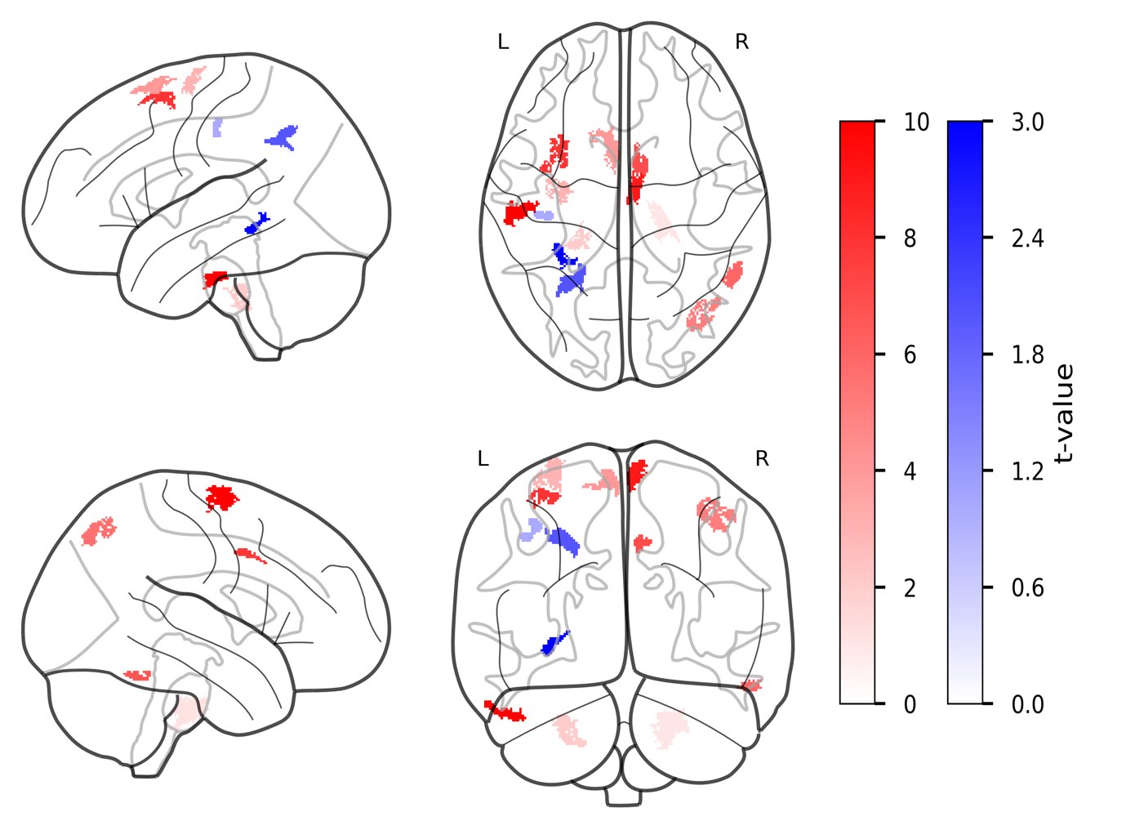
Supplementary Figure 3. Group differences in R2* values between PwPD and HCs in white matter. The statistical parametric maps from voxel-wise group comparison of R2* values are presented, displayed on a standard brain template in sagittal, axial, and coronal views. The statistical maps show t-statistics, where red clusters have higher R2* values in PwPD (PwPD > HCs), and blue clusters have higher R2* values in HCs (HCs > PwPD). The color bars reflect voxel-wise t-statistics, with higher absolute t-values indicating stronger group differences only. Cluster-defining threshold was set to T = 3.18 (p < .001, uncorrected) with a cluster extent threshold of k ≥ 20 voxels. FWE correction was applied at the cluster levels for PwPD > HCs contrast: FWEc = 154, df = [1, 94] and HCs > PwPD contrast: FWEc = 253, df = [1, 94]. df: degrees of freedom. FWE: family-wise error. HCs: healthy controls. k: number of voxels. L: left hemisphere. PwPD: patients with Parkinson’s disease. R: right hemisphere. R2*: effective transverse relaxation rate. T: t-statistic.

Supplementary Table 2. Clusters with significant differences in R2* values between PwPD and HCs in white matter.

 | cluster level |  |  |  | peak level |  | mm | mm | mm
 | P_{FWE-corr} | q_{FRD-corr} | K_{E} | P_{uncorr} | T | (Z_{E}) | mm | mm | mm
PwPD > HCs
MCP | .000 | .000 | 272 | .000 | 5.91 | 5.44 | 22 | -24 | -35
rPCR | .006 | .002 | 168 | .000 | 5.56 | 5.16 | 41 | -74 | 47
rSS | .021 | .006 | 140 | .000 | 5.49 | 5.10 | 56 | -49 | -22
rSCR | .000 | .000 | 311 | .000 | 5.44 | 5.06 | 6 | -6 | 71
lSCR | .000 | .000 | 275 | .000 | 5.22 | 4.88 | -5 | -14 | 74
MCP | .035 | .008 | 129 | .000 | 5.10 | 4.78 | -25 | -32 | -37
lSCR | .000 | .000 | 259 | .000 | 4.96 | 4.66 | -3 | 10 | 64
rC | .025 | .007 | 136 | .000 | 4.96 | 4.66 | 7 | 6 | 41
lSCR | .003 | .001 | 186 | .000 | 4.68 | 4.43 | -33 | -10 | 70
lSS | .002 | .001 | 199 | .000 | 4.57 | 4.34 | -58 | -21 | -29
lSCR | .006 | .002 | 167 | .000 | 4.28 | 4.08 | -31 | 10 | 60
HCs > PwPD
lSS | .019 | .003 | 142 | .000 | 4.26 | 4.06 | -31 | -38 | -5
lSCR | .008 | .002 | 161 | .000 | 3.65 | 3.52 | -37 | -21 | 48
lSCR | .000 | .000 | 416 | .000 | 3.59 | 3.47 | -29 | -54 | 42

The table presents the clusters demonstrating significant group differences in R2* values at the cluster level. FDR-corr: false-discovery rate-corrected. FWE-corr: family-wise error-corrected. HCs: healthy controls. lSCR: left superior corona radiata. lSS: left sagittal stratum. K_{E}: cluster extent. MCP: middle cerebellar peduncle. PwPD: patients with Parkinson’s disease R2*: effective transversal relaxation rate. rC: right cingulum. rPCR: right posterior corona radiata. rSPC: right superior corona radiata. rSS: right sagittal stratum. Uncorr: uncorrected. Z_{E:} equivalent z-scores.

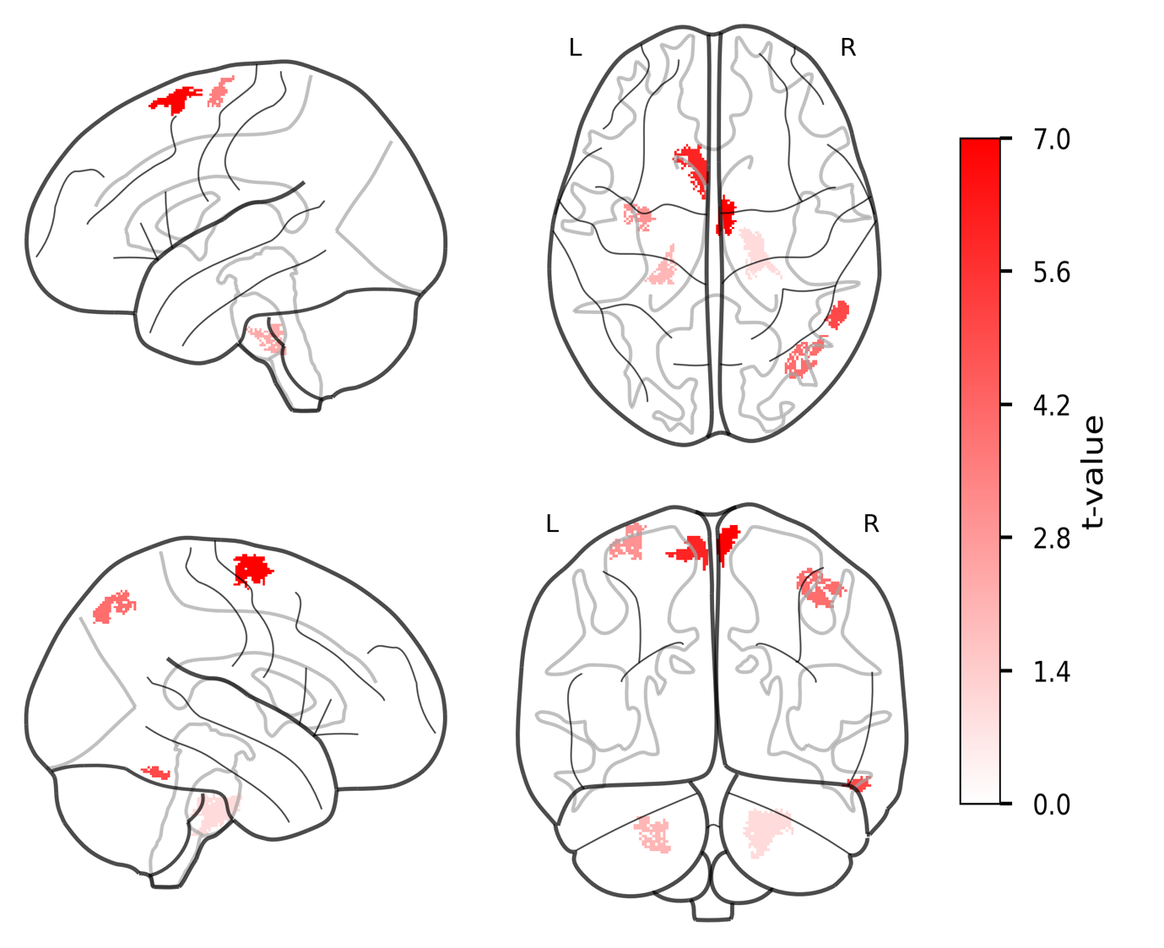
Supplementary Figure 4. Group differences in proton density values between PwPD and HCs in white matter.
The statistical parametric maps from voxel-wise group comparison of proton density values are presented, displayed on a standard brain template in sagittal, axial, and coronal views. The statistical maps show t-statistics, where red clusters have higher proton density values in PwPD (PwPD > HCs), and blue clusters have higher proton density values in HCs (HCs > PwPD). The color bars reflect voxel-wise t-statistics, with higher absolute t-values indicating stronger group differences only. Cluster-defining threshold was set to T = 3.18 (p < .001, uncorrected) with a cluster extent threshold of k ≥ 20 voxels. FWE correction was applied at the cluster levels for: FWEc = 122, df = [1, 94]. df: degrees of freedom. FWE: family-wise error. HCs: healthy controls. k: number of voxels. L: left hemisphere. PwPD: patients with Parkinson’s disease. R: right hemisphere. T: t-statistic.

Supplementary Table 3. Clusters with significant differences in proton density values between PwPD and HCs in white matter.

 | cluster level |  |  |  | peak level |  | mm | mm | mm
 | P_{FWE-corr} | q_{FRD-corr} | K_{E} | P_{uncorr} | T | (Z_{E}) | mm | mm | mm
PwPD > HCs
MCP | .000 | .000 | 351 | .000 | 5.81 | 5.36 | 22 | -24 | -35
rPCR | .006 | .003 | 164 | .000 | 5.58 | 5.18 | 41 | -74 | 47
rSS | .041 | .014 | 122 | .000 | 5.53 | 5.13 | 55 | -51 | -22
rSCR | .000 | .000 | 348 | .000 | 5.44 | 5.06 | 6 | -6 | 71
lSCR | .000 | .000 | 437 | .000 | 5.10 | 4.78 | -7 | -14 | 75
lSCR | .000 | .000 | 312 | .000 | 5.04 | 4.73 | -8 | 15 | 67
MCP | .022 | .008 | 135 | .000 | 4.83 | 4.56 | -25 | -32 | -37
lSCR | .009 | .004 | 154 | .000 | 4.47 | 4.24 | -28 | -7 | 70

The table presents the clusters demonstrating significant group differences in proton density values at the cluster level. FDR-corr: false-discovery rate-corrected. FWE-corr: family-wise error-corrected. HCs: healthy controls. lSCR: left superior corona radiata. K_{E}: cluster extent. MCP: middle cerebellar peduncle. PwPD: patients with Parkinson’s disease. rPCR: right posterior corona radiata. rSPC: right superior corona radiata. rSS: right sagittal stratum. Uncorr: uncorrected. Z_{E:} equivalent z-scores.

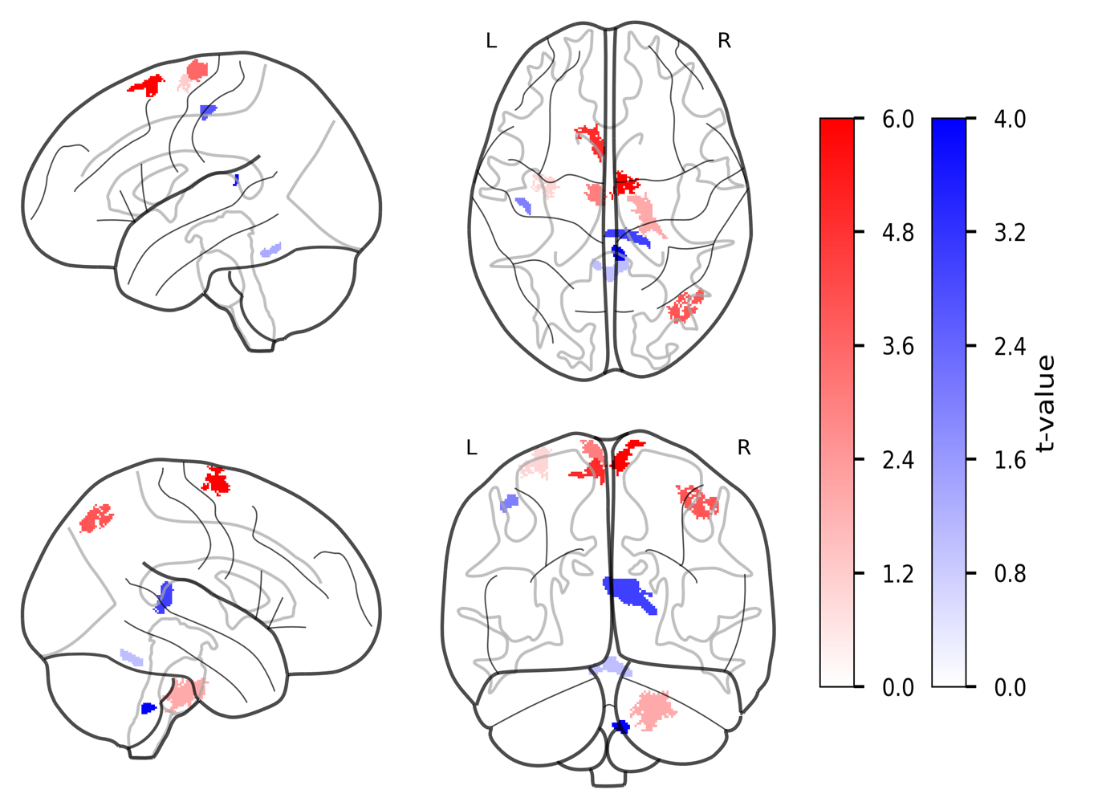
Supplementary Figure 5. Group differences in MTsat values between PwPD and HCs in white matter. The statistical parametric maps from voxel-wise group comparison of MTsat values are presented, displayed on a standard brain template in sagittal, axial, and coronal views. The statistical maps show t-statistics, where red clusters have higher MTsat values in PwPD (PwPD > HCs), and blue clusters have higher MTsat values in HCs (HCs > PwPD). The color bars reflect voxel-wise t-statistics, with higher absolute t-values indicating stronger group differences only. Cluster-defining threshold was set to T = 3.18 (p < .001, uncorrected) with a cluster extent threshold of k ≥ 20 voxels. FWE correction was applied at the cluster levels for PwPD > HCs contrast: FWEc = 167, df = [1, 94] and HCs > PwPD contrast: FWEc = 138, df = [1, 94]. df: degrees of freedom. FWE: family-wise error. HCs: healthy controls. k: number of voxels. L: left hemisphere. MTsat: magnetic transfer saturation. PwPD: patients with Parkinson’s disease. R: right hemisphere. T: t-statistic.

Supplementary Table 4. Clusters with significant differences in MTsat values between PwPD and HCs in white matter.

 | cluster level |  |  |  | peak level |  | mm | mm | mm
 | P_{FWE-corr} | q_{FRD-corr} | K_{E} | P_{uncorr} | T | (Z_{E}) | mm | mm | mm
PwPD > HCs
MCP | .000 | .000 | 340 | .000 | 5.74 | 5.31 | 22 | -24 | -35
rPCR | .005 | .002 | 187 | .000 | 5.59 | 5.19 | 41 | -74 | 47
rSCR | .000 | .000 | 273 | .000 | 5.19 | 4.86 | 55 | -51 | -22
lSCR | .001 | .001 | 230 | .000 | 5.06 | 4.75 | 6 | -6 | 71
lSCR | .002 | .001 | 209 | .000 | 4.67 | 4.42 | -7 | -14 | 75
lSCR | .010 | .004 | 167 | .000 | 4.62 | 4.38 | -8 | 15 | 67
HCs > PwPD
sCC | .000 | .000 | 525 | .000 | 4.24 | 4.05 | -20 | -42 | 12
rICP | .000 | .000 | 391 | .000 | 3.82 | 3.68 | 1 | -55 | -18
lSLF | .034 | .006 | 118 | .000 | 3.73 | 3.59 | -43 | -17 | 53
rPCR | .020 | .005 | 151 | .000 | 3.68 | 3.55 | 6 | -43 | -46

The table presents the clusters demonstrating significant group differences in MTsat values at the cluster level. FDR-corr: false-discovery rate-corrected. FWE-corr: family-wise error-corrected. HCs: healthy controls. lSCR: left superior corona radiata. lSLF: left superior longitudinal fasciculus. K_{E}: cluster extent. MCP: middle cerebellar peduncle. PwPD: patients with Parkinson’s disease. rICP: right inferior cerebellar peduncle. rPCR: right posterior corona radiata. rSPC: right superior corona radiata. sCC: splenium of corpus callosum. Uncorr: uncorrected. Z_{E:} equivalent z-scores.

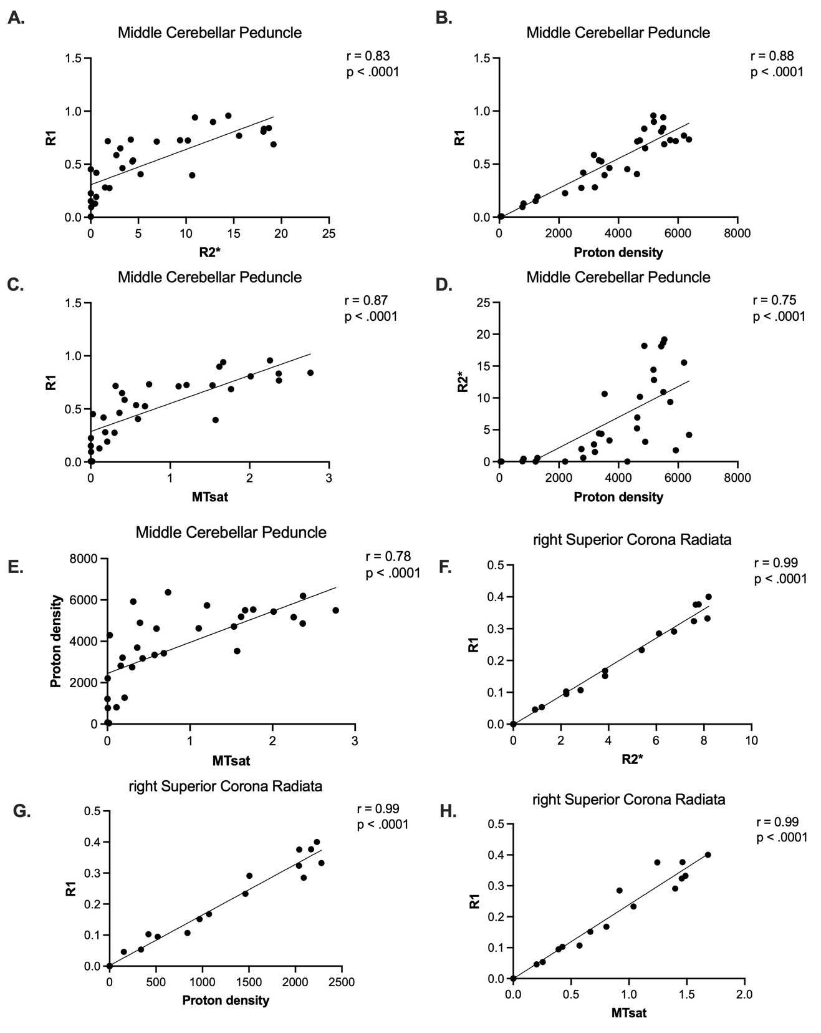

Supplementary Figure 6. Scatter plots of cross-modal correlation between mean MPM parameter values in clusters with significant group differences in white matter. The figure presents multiple panels with scatter plots and key statistical data assessing the correlation between mean MPM-derived parameters from overlapping clusters with significant differences between PwPD and HCs in the middle cerebellar peduncle (A-E) and right superior corona radiata (F-H). Only the clusters that passed the Bonferroni correction (p < .00625) were included in the presented analysis. HCs: healthy controls. MPM: multiparametric mapping. MTsat: magnetic transfer saturation. PwPD: patients with Parkinson’s disease. R1: longitudinal relaxation rate. R2*: effective transverse relaxation rate.

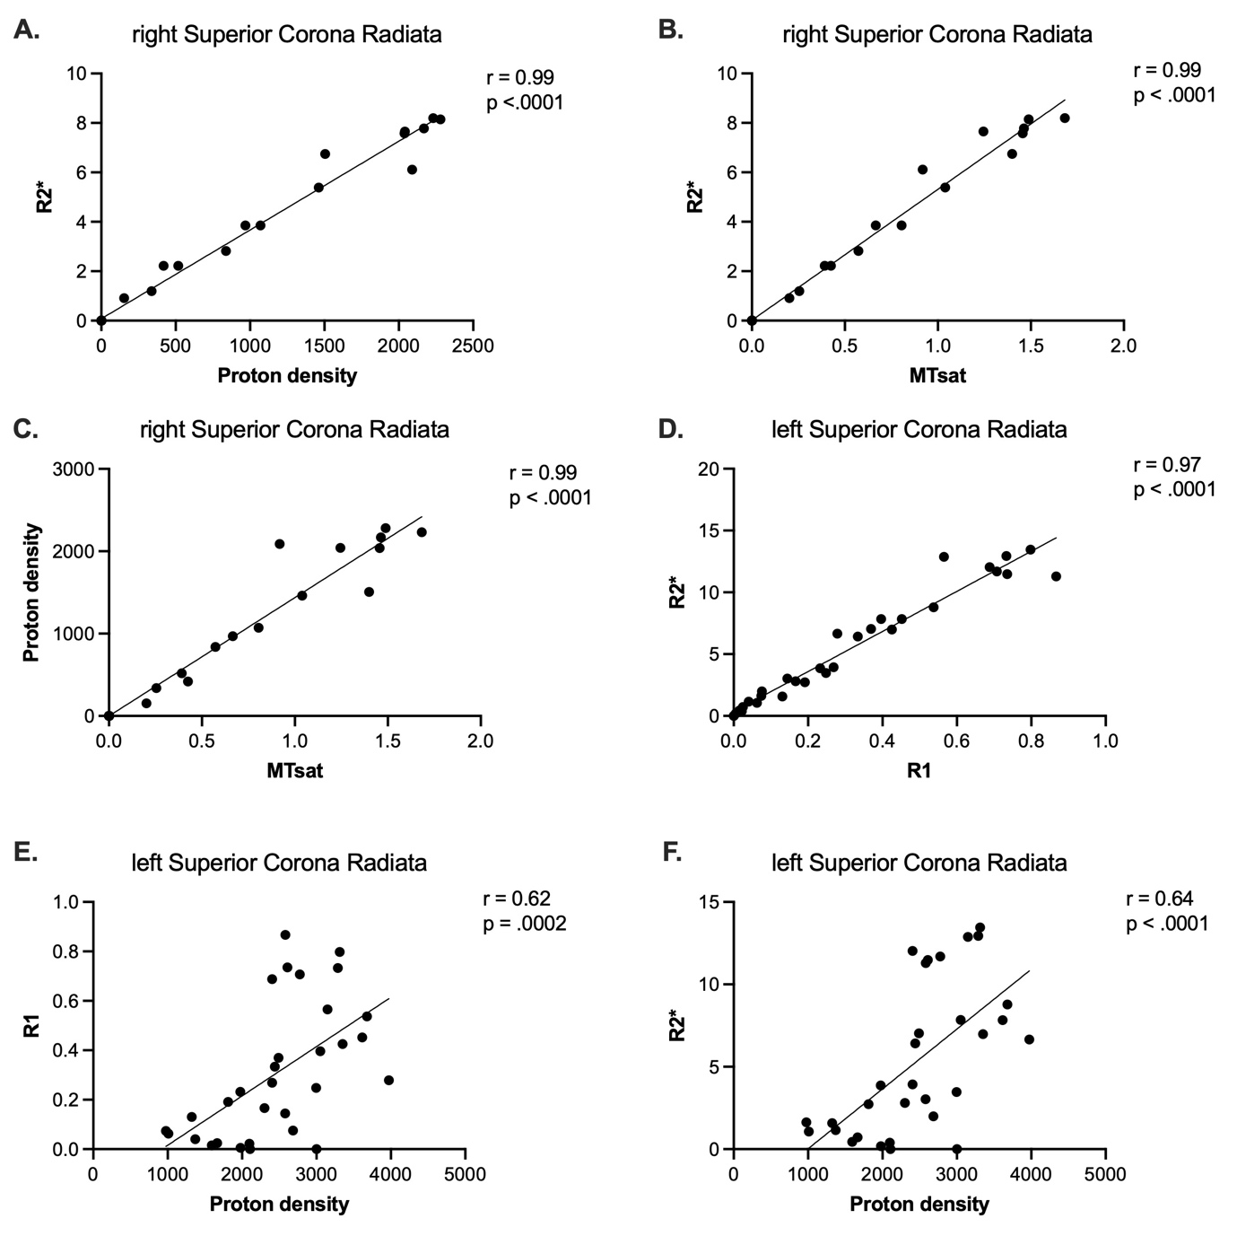

Supplementary Figure 7. Scatter plots of cross-modal correlation between mean MPM parameter values in clusters with significant group differences in white matter. The figure presents multiple panels with scatter plots and key statistical data assessing the correlation between mean MPM-derived parameters from overlapping clusters with significant differences between PwPD and HCs in bilateral superior corona radiata (right: A-D and left: E and F). Only the clusters that passed the Bonferroni correction (p < .00625) were included in the presented analysis. HCs: healthy controls. MPM: multiparametric mapping. MTsat: magnetic transfer saturation. PwPD: patients with Parkinson’s disease. R1: longitudinal relaxation rate. R2*: effective transverse relaxation rate.

Supplementary Figure 8. Venn-encoded overlap of identified group differences across MPM modalities in white matter. The figure illustrates the clusters with identified significant group-based differences in biophysical properties informed by MPM modalities, including R1, R2*, proton density, and MTsat. Identified clusters are color-coded depending on the number of MPM modalities with identified differences. HCs: healthy controls. L: left hemisphere. MPM: multiparametric mapping. MTsat: magnetic transfer saturation. PwPD: patients with Parkinson’s disease. R: right hemisphere. R1: longitudinal relaxation rate. R2*: effective transverse relaxation rate.

