SUPPLEMENT 1: Summary of statistical metrics for the sensitivity analysis to topology and distance functions.

Table S1. Summary of the statistical metrics for validating the climate zones in the different gridded datasets for the rectangular and hexagonal map topology. Bold numbers indicate better performance relative to the APHRODITE dataset.

RECTANGULAR TOPOLOGY
STATISTICAL TEST | PERSIANN-CDR | TRMM | CMORPH | CHIRPS
ARI | 0.31 | 0.39 | 0.37 | 0.33
HI | 0.43 | 0.44 | 0.33 | 0.41
AMI | 0.41 | 0.46 | 0.35 | 0.39
HEXAGONAL TOPOLOGY
 | PERSIANN-CDR | TRMM | CMORPH | CHIRPS
ARI | 0.34 | 0.25 | 0.10 | 0.44
HI | 0.41 | 0.30 | 0.11 | 0.52
AMI | 0.39 | 0.38 | 0.15 | 0.51

Table S2. As in Table S1, but for the different distance functions.
EUCLIDEAN DISTANCE FUNCTION
STATISTICAL TEST | PERSIANN-CDR | TRMM | CMORPH | CHIRPS
ARI | 0.31 | 0.39 | 0.37 | 0.33
HI | 0.43 | 0.44 | 0.33 | 0.41
AMI | 0.41 | 0.46 | 0.35 | 0.39
COSINE DISTANCE FUNCTION
ARI | 0.37 | 0.23 | 0.40 | 0.45
HI | 0.44 | 0.31 | 0.37 | 0.49
AMI | 0.42 | 0.38 | 0.37 | 0.49
MANHATTAN DISTANCE FUNCTION
ARI | 0.34 | 0.49 | 0.12 | 0.24
HI | 0.41 | 0.57 | 0.12 | 0.28
AMI | 0.39 | 0.49 | 0.17 | 0.35
CHEBYSHEV DISTANCE FUNCTION
ARI | 0.13 | 0.31 | 0.24 | 0.28
HI | 0.25 | 0.52 | 0.31 | 0.52
AMI | 0.26 | 0.44 | 0.29 | 0.43

SUPPLEMENT 2: Spatial patterns of the three climate zones in the different rainfall datasets.
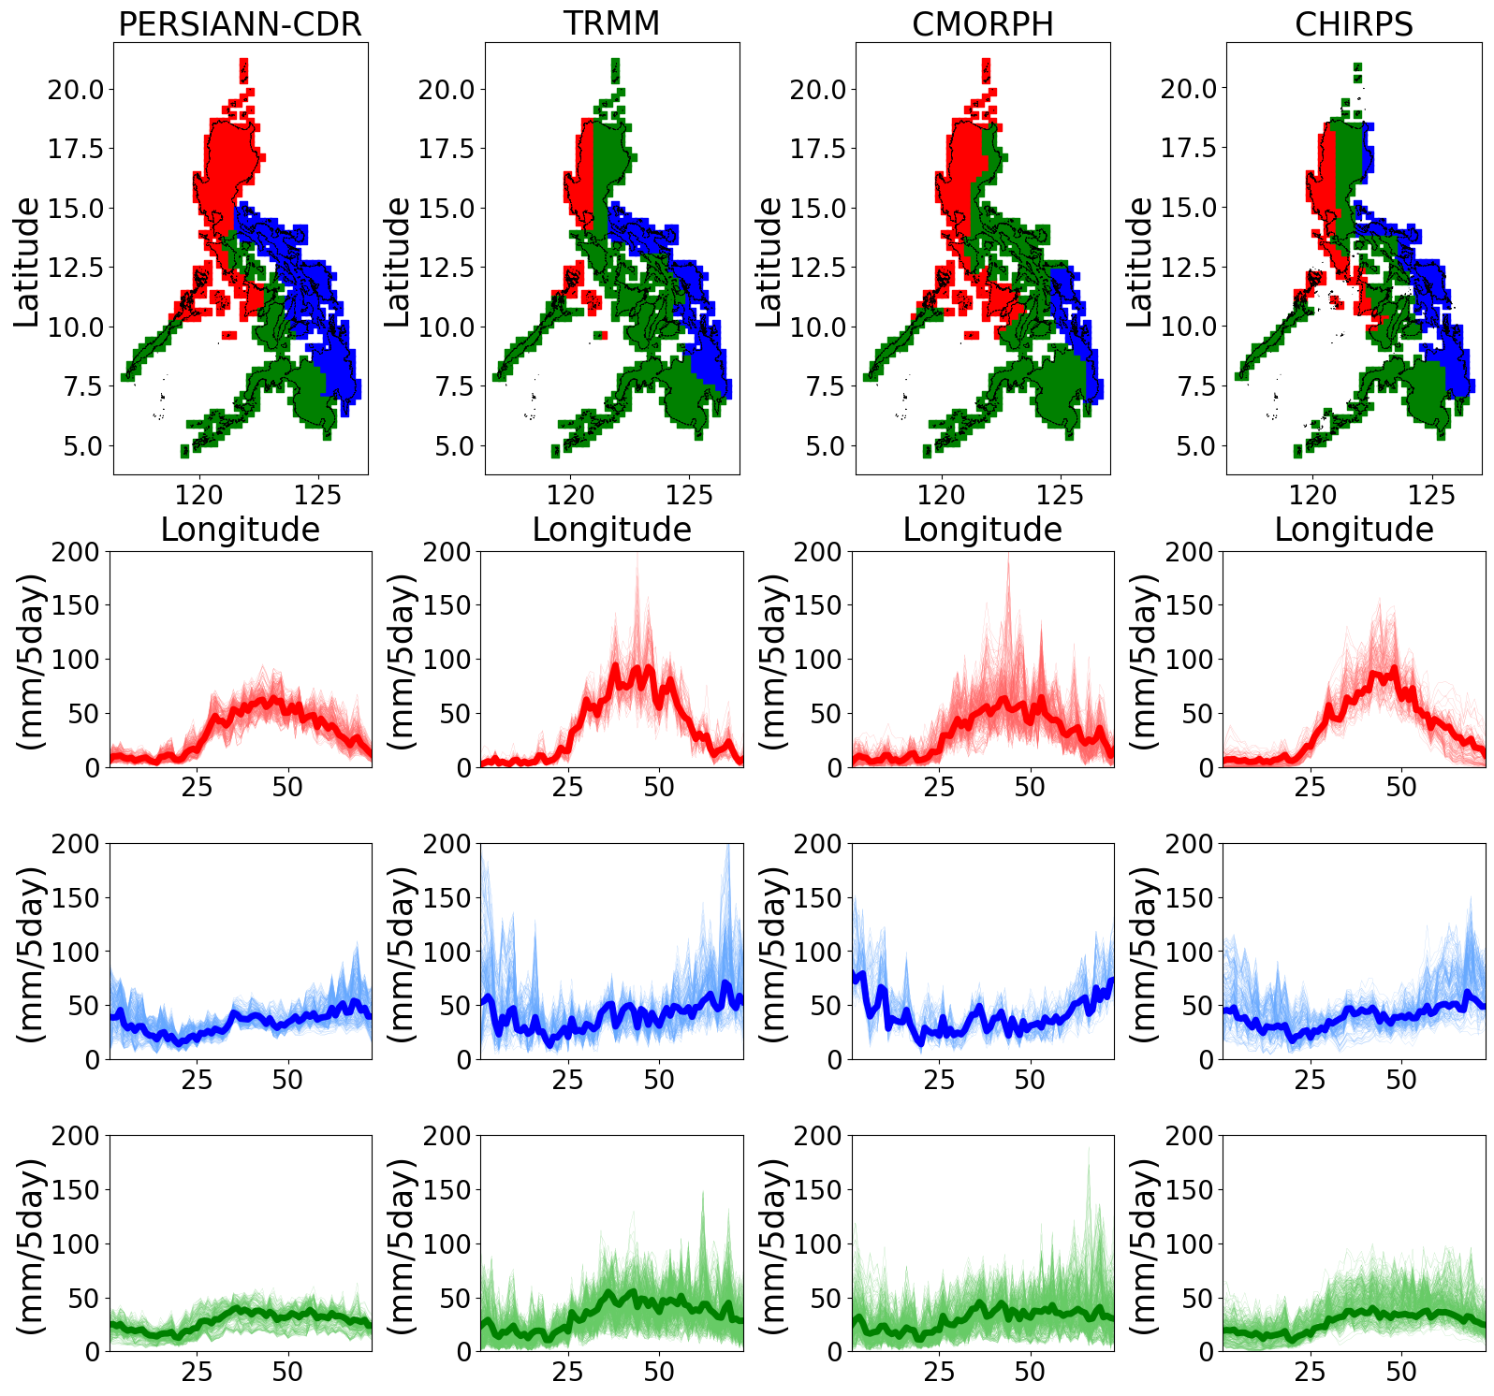
Figure S1. Spatial maps of the climate zones in the different rainfall datasets using the recommended hyperparameters, as summarized in Table 3.

SUPPLEMENT 3: Examination of the gridpoints that are different from the reference APHRODITE dataset.
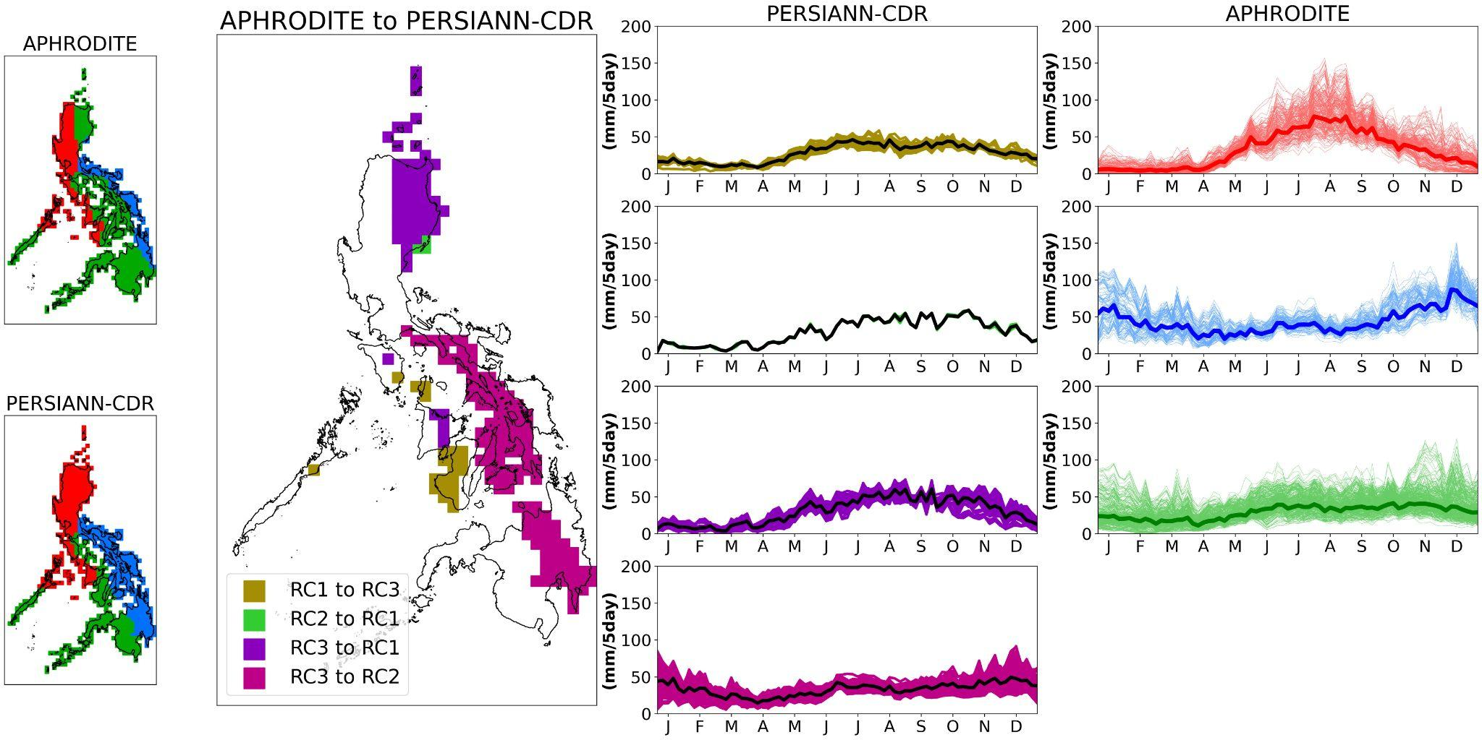
Figure S2. Spatial map of grid points whose climate classification changed from the APHRODITE dataset to the PERSIAN-CDR dataset (e.g., RC1 to RC3 in the figure are the grid points that were initially classified as RC1 in the APHRODITE but were classified as RC3 in PERSIANN-CDR). The time series of the three climate zones in the APHRODITE dataset is shown in the rightmost column.

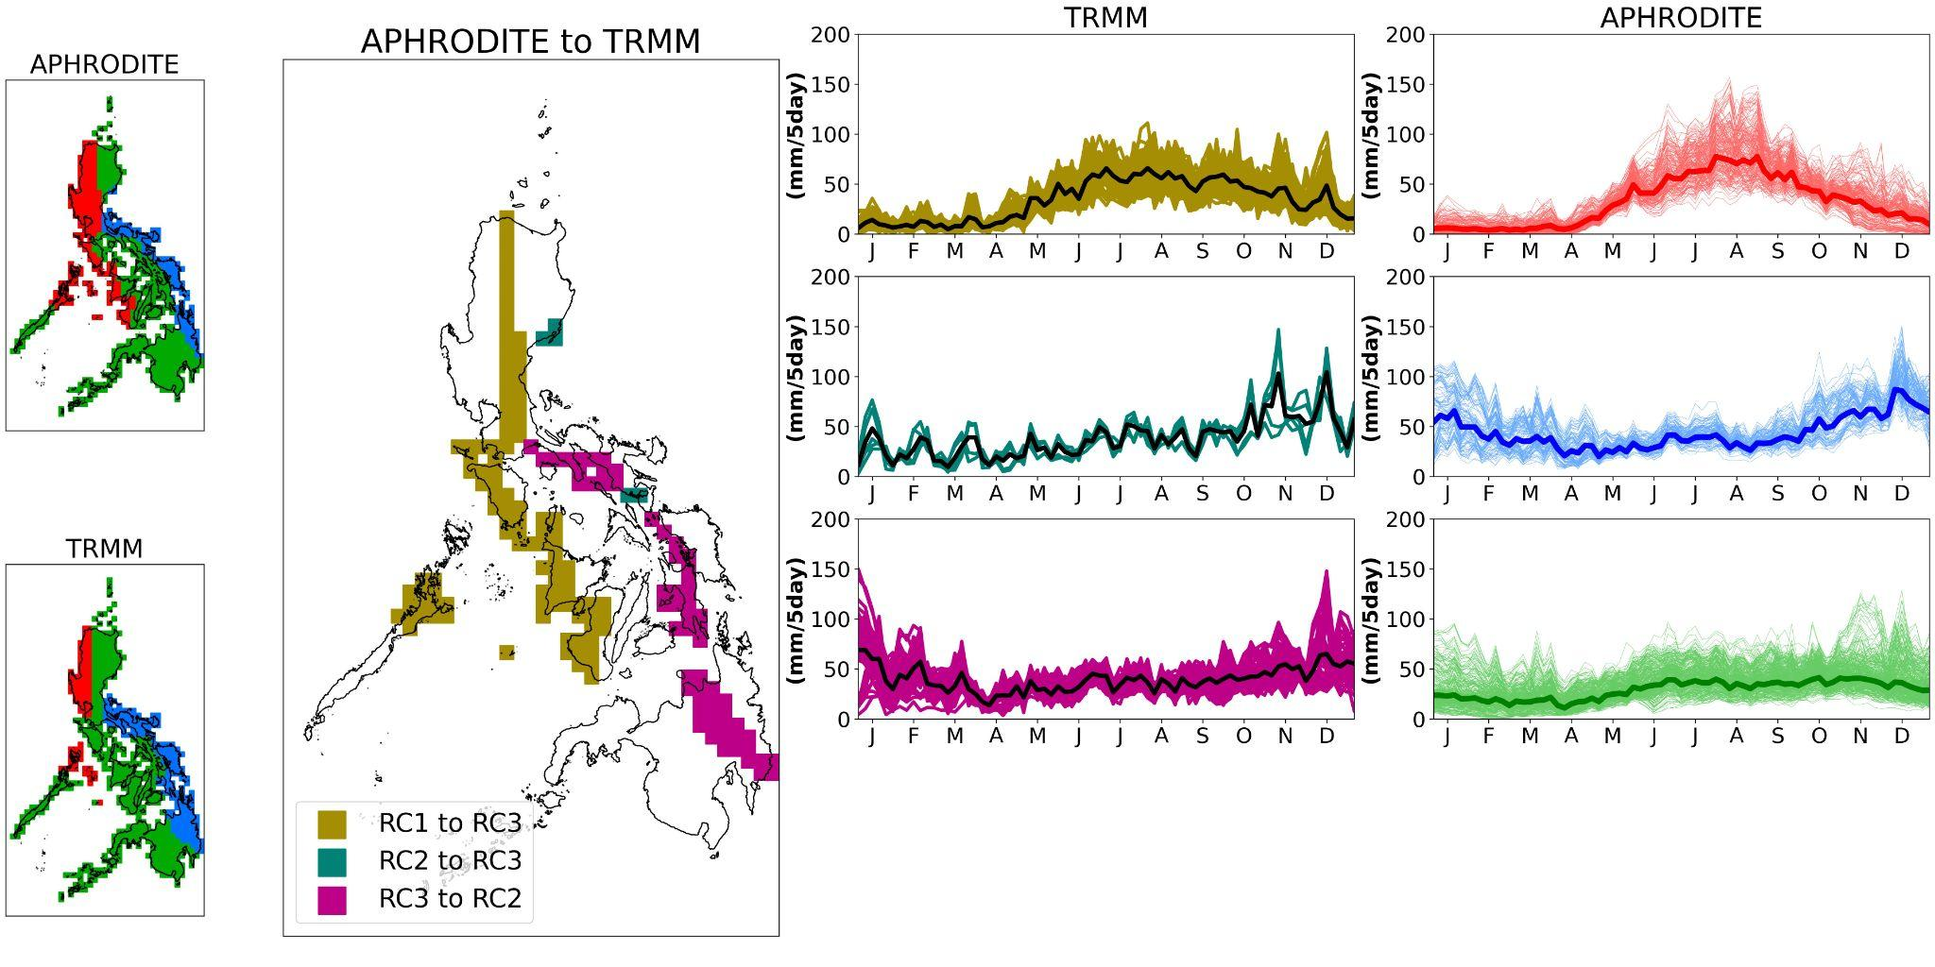
Figure S3. As in Figure S2, but for the TRMM dataset.

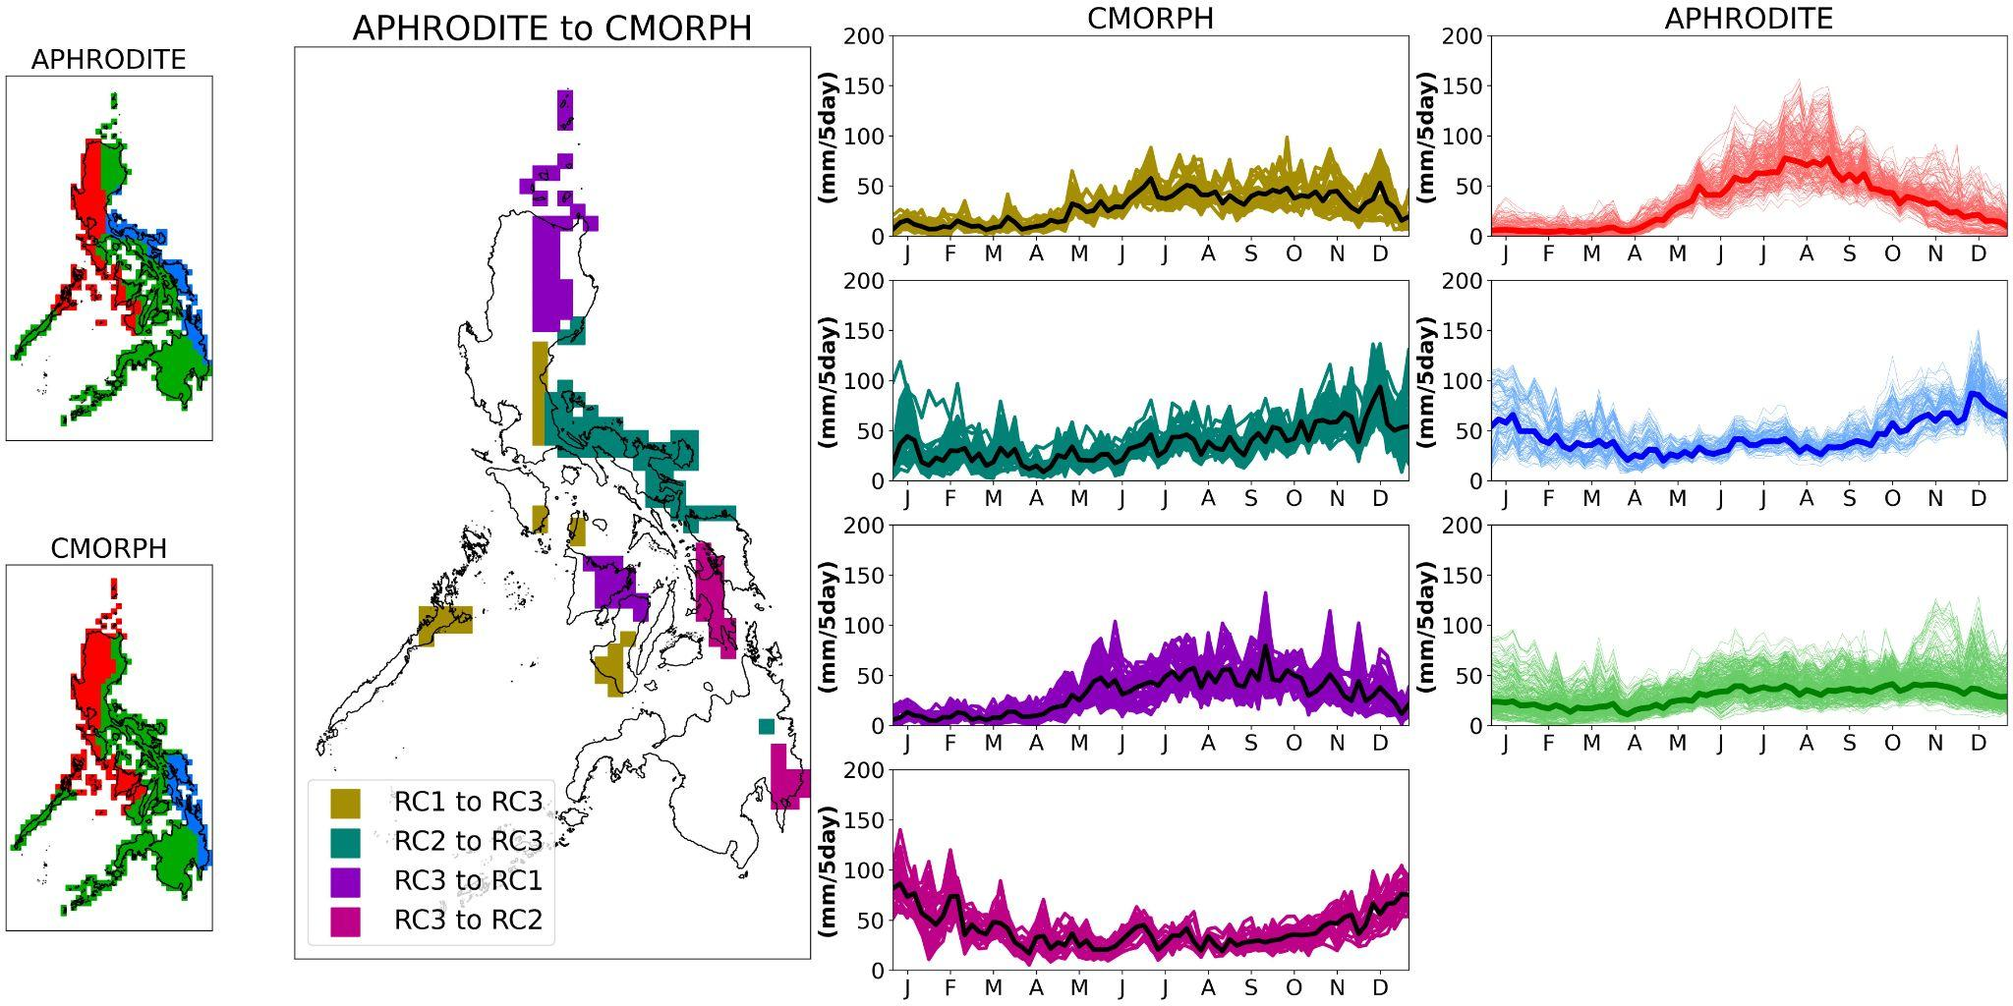
Figure S4. As in Figure S2, but for the CMORPH dataset.

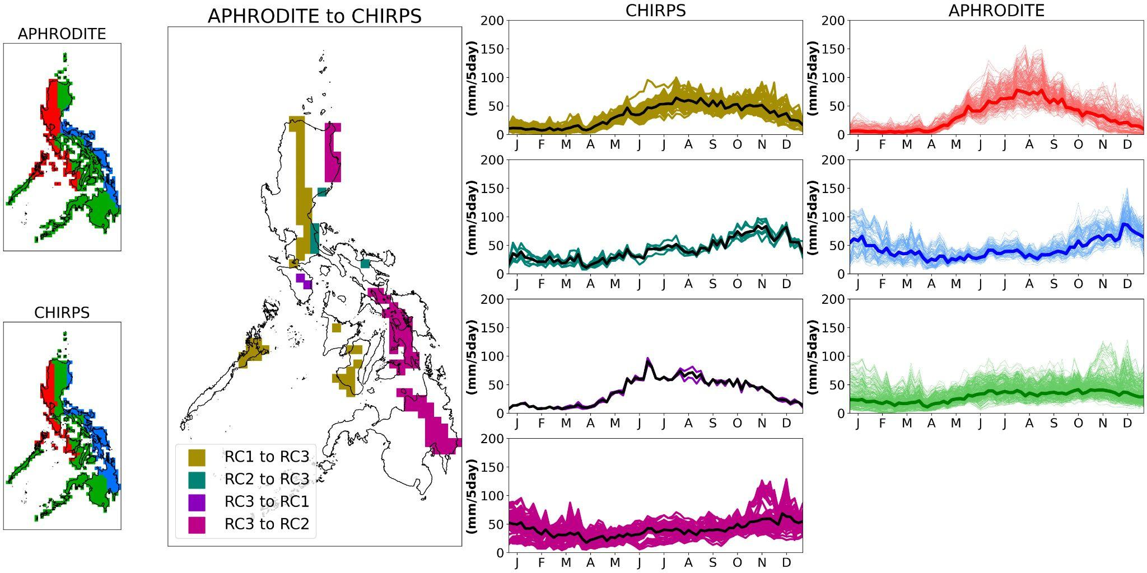
Figure S5. As in Figure S2, but for the CHIRPS dataset.

