Supplementary Materials

Table S1. Health behaviour distribution between diagnostic groups
Number of Health Behaviours | Schizophrenia (n = 225) | Affective Disorders (n = 185)
0, N (%) | 17 (7.6) | 20 (10.8)
1, N (%) | 52 (23.1) | 48 (25.9)
2, N (%) | 58 (25.8) | 49 (26.5)
3, N (%) | 58 (25.8) | 34 (18.4)
4, N (%) | 31 (13.8) | 23 (12.4)
5, N (%) | 9 (4.0) | 11 (6.1.)

Table S2. Chi-square associations between health behaviours
Behaviour 1 | Behaviour 2 | χ² | p-value
Tobacco use | Coffee Consumption | 15.68 | < 0.001
Tobacco use | Alcohol Use | 26.74 | < 0.001
Tobacco use | Substance Use | 31.63 | < 0.001
Tobacco use | Exercise | 1.56 | 0.21
Tobacco use | Diet | 0.08 | 0.77
Coffee Consumption | Alcohol Use | 1.93 | 0.16
Coffee Consumption | Substance Use | 0.36 | 0.55
Coffee Consumption | Exercise | 1.90 | 0.66
Coffee Consumption | Diet | 0.02 | 0.88
Alcohol Use | Substance Use | 23.56 | < 0.001
Alcohol Use | Exercise | 0.54 | 0.82
Alcohol Use | Diet | 1.03 | 0.31
Substance Use | Exercise | 3.85 | 0.05
Substance Use | Diet | 7.23 | 0.007
Exercise | Diet | 9.79 | 0.002

*Significance threshold adjusted for multiple corrections. New alpha threshold set to: p = 0.0033

Figure S1. Sexual abuse and number of health behaviours
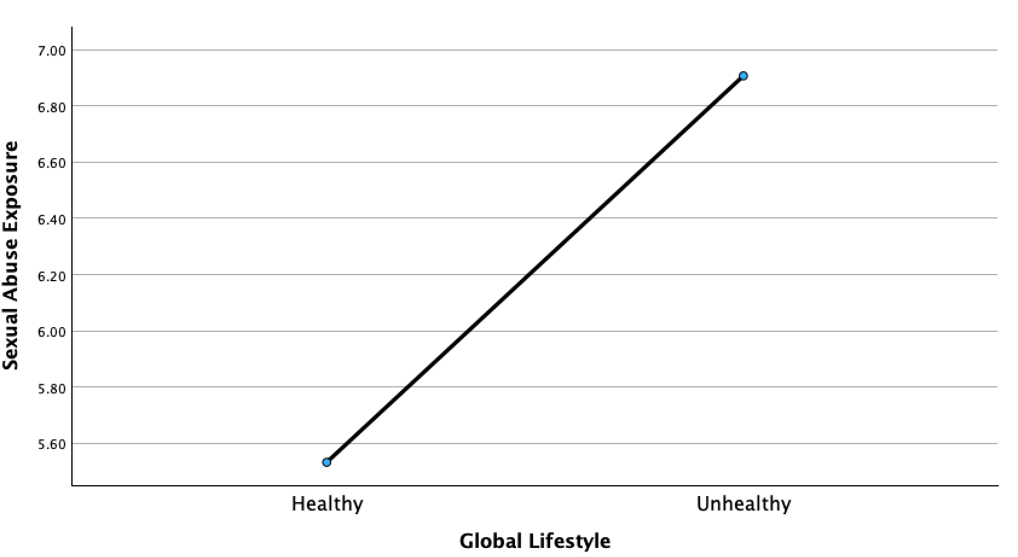
ANCOVA, F = 4.29, p = 0.04, adjusted for age, sex, and ethnicity. Patients with more severe sexual abuse history have unhealthier lifestyles.

Figure S2. Sexual abuse and number of health behaviours
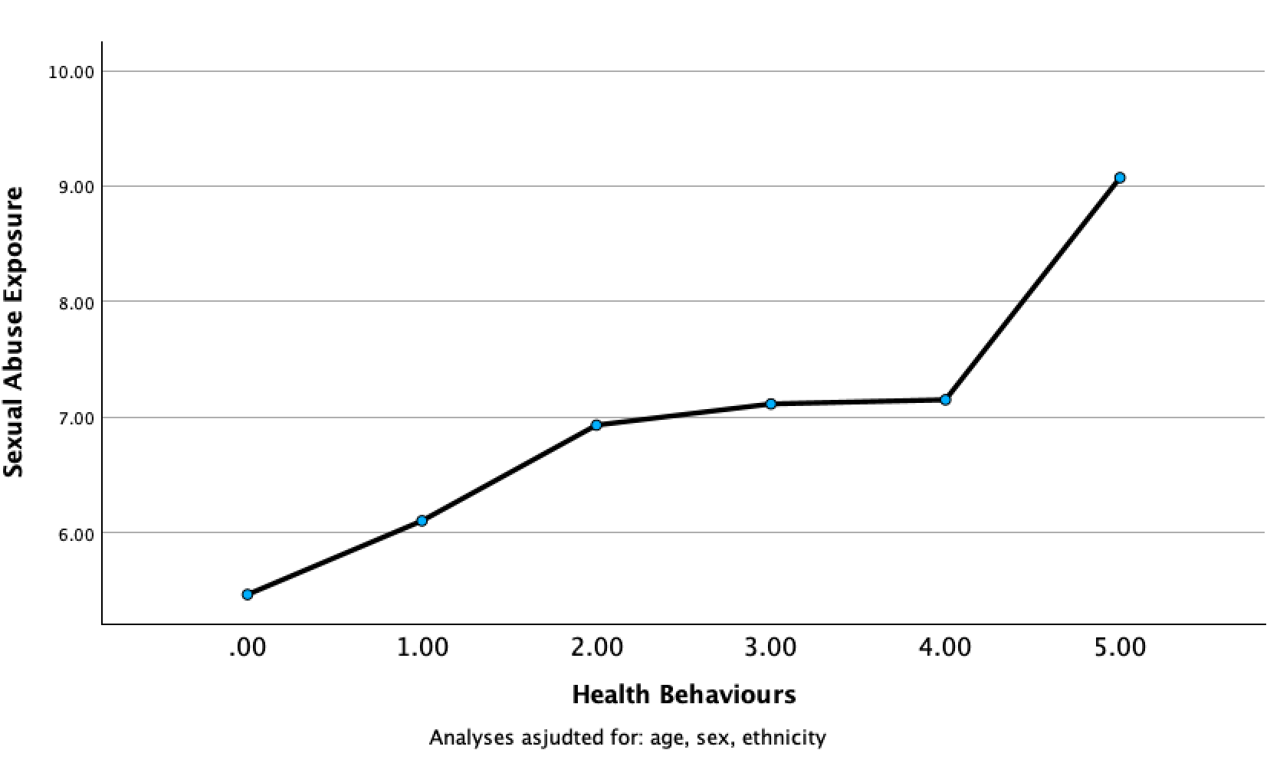
ANCOVA, F = 3.15, p = 0.008, adjusted for age, sex, and ethnicity. Patients with more severe sexual abuse history have more unhealthy behaviours.

