Appendices

Appendix A: Psychometric and Behavioral Components of the LD Risk Assessment Questionnaire
Component | Purpose | Adapted From
Learning Disabilities Checklist (LDC) | Observational indicators of early LD traits | Alhassan & Abosi (2014); Bjureberg et al. (2016)
Disruptive Behavior Disorders Rating Scale (DBDRS) | ADHD behaviors (hyperactivity, inattention) | Agyei et al. (2017); American Psychiatric Association (2013)
WRAT-5 Subtests (Reading, Spelling, Math) | Academic achievement | Wilkinson & Robertson (2017) – Wide Range Achievement Test, 5th Ed.
Working Memory | Retention and manipulation of information | Wechsler (2020) – WISC-V
Processing Speed | Visual matching and cognitive efficiency | Wechsler (2020) – WISC-V Processing Speed Index
Phonological Awareness & Rapid Naming | Early literacy and reading fluency | Torgesen, Wagner, & Rashotte (2021) – CTOPP-2
Vocabulary & Reading Comprehension | Language proficiency and reading understanding | Dunn (2019) – PPVT-5; Wiederholt & Bryant (2012) – GORT-5
Math Fluency | Timed arithmetic skill assessment | Wechsler (2009); Psychological Corporation – WIAT-III
Emotional Regulation & Executive Function | Emotional control, planning, and task regulation | Gioia, Isquith, Guy, & Kenworthy (2015) – BRIEF-2; Gratz & Roemer (2004); Diamond (2020)

Appendix B: Summary of Psychometric and Statistical Validity Tests
Construct / Variable | Cronbach’s Alpha | Chi-Square (χ²) | p-value | ANOVA (F)
Academic Achievement (WRAT) | -0.176 | 43.02 | 0.0000 | –
Language Development | -0.022 | 45.25 | 0.0000 | –
Working Memory | – | – | – | 86.91
Sex vs. LD Risk Label | – | 19.27 | 0.0001 | –
Multinomial Logistic Model Fit † | – | 1251.07 | 0.0000 | –
† Log-Likelihood Ratio: LL-Null = −2218.6 vs. LL-Full = −967.53 (Pseudo R² = 0.5639)

Appendix C: Cross-validation Macro-F1 scores features extraction
Model | Mean | Std.
SVM | 0.9657 | 0.0086
RF | 0.9570 | 0.0118
XGBoost | 0.9548 | 0.0117
LR | 0.7772 | 0.0206
Appendix D:
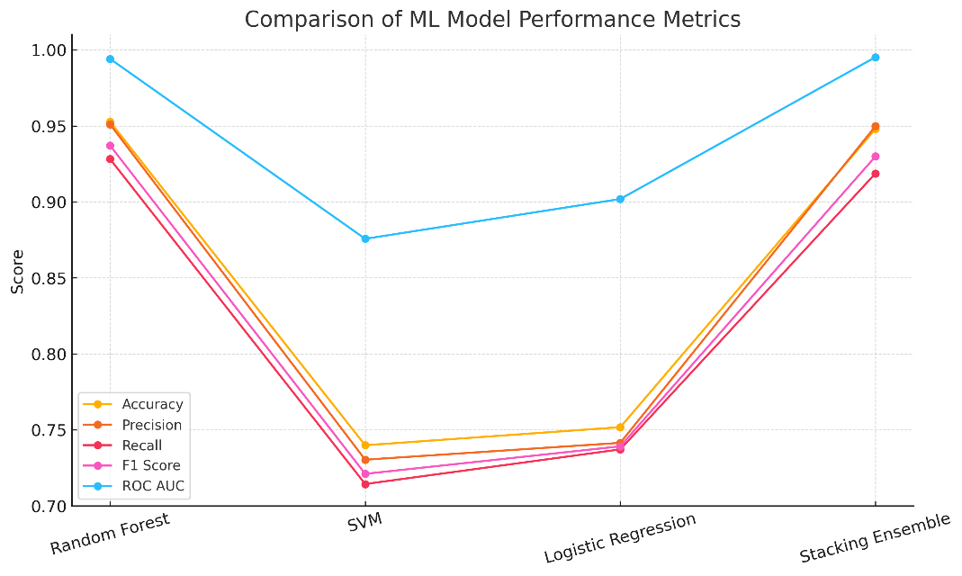
Stacking and Baseline models’ comparison

