Persistent Multi-System Impairments Detected by Wearable Monitoring in Long COVID Cases reporting Fatigue up to Three Years Post-Infection
Supplementary Data

Contents
Contents 1
Supplementary Figures 2
Supplementary Figure 1. Correlations between outcome measures. 2
Supplementary Figure 2. Sensitivity analysis: Deficits in cases when compared to a control group matched for BMI. 3
Supplementary Figure 3. Complete case analysis: Aggregate outcome measures 4
Supplementary Figure 4. Complete case analysis: single outcome measures. 5
Supplementary Figure 5. Complete case analysis: Trajectories 6
Supplementary Figure 6. Trajectories of health from time of infection 7
Supplementary Figure 7. Extended symptoms: Aggregate outcome measures. 8
Supplementary Figure 8. Extended symptoms: Trajectories of health. 9
Supplementary Figure 9. Distribution of symptoms 10
Supplementary Tables 11
Supplementary Table 1. Definition of outcome measures 11
Supplementary Table 2. Definition of aggregate outcome measures. 12
Supplementary Table 3. Association between participant status and aggregate outcome measures. 13
Supplementary Table 4. Association between participant status and single outcome measures. 14
Supplementary Table 5. Association between participant status and individual cognitive tasks. 15
Supplementary Table 6. Monitoring duration and details. 16
Supplementary Table 7. Association between participant status and outcome measure temporal variability. 17
Supplementary Table 8. Complete case analysis: Aggregate outcome measures 18
Supplementary Table 9. Complete case analysis: single outcome measures 19
Supplementary Table 10. Extended symptoms: Aggregate outcome measures. 20
Supplementary Table 11. Extended symptoms: Single outcome measures 21
Supplementary Text 22
ALSPAC cohort 22

Supplementary Figures

Supplementary Figure 1. Correlations between outcome measures.
Heatmaps showing correlations (Spearman’s coefficient) between outcome measures at baseline. A black dot indicates statistical significance. CF: Cognitive function; HR: Heart rate; RR: Respiratory rate; WT: Walk test; HRV: Heart rate variability
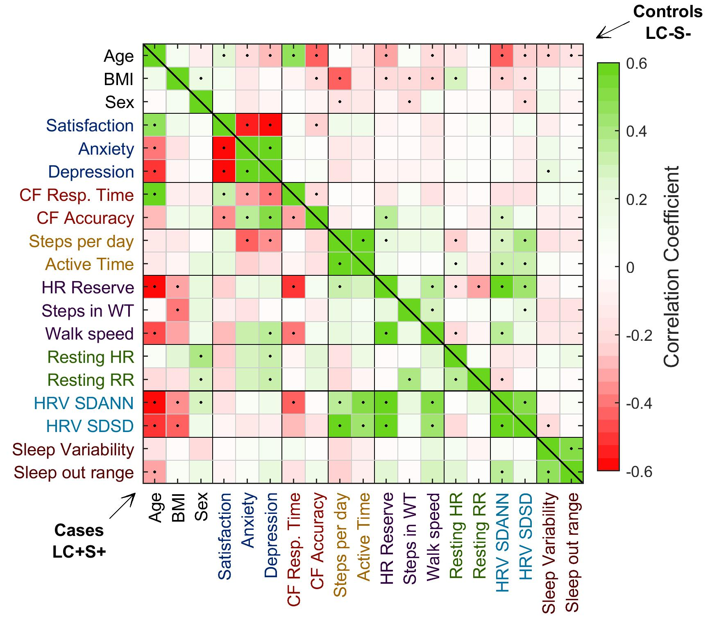

Supplementary Figure 2. Sensitivity analysis: Deficits in cases when compared to a control group matched for BMI.
Spider plots showing differences between cases (LC+S+) and a control group (LC-S-) matched for BMI. Each case was matched to one or more controls in an iterative process that stopped when the minimum difference in BMI between cases and controls was identified (P>0.98). Panels on the left and right show results of primary analysis and analysis after matching for BMI, respectively. Circles represent standardized β coefficients for the association between participant status and aggregate outcome measures at initial assessment (upper graphs). Shaded areas represent 95% confidence intervals. Models were adjusted for age, sex, education (cognitive function only) and mean heart rate (autonomic function only).

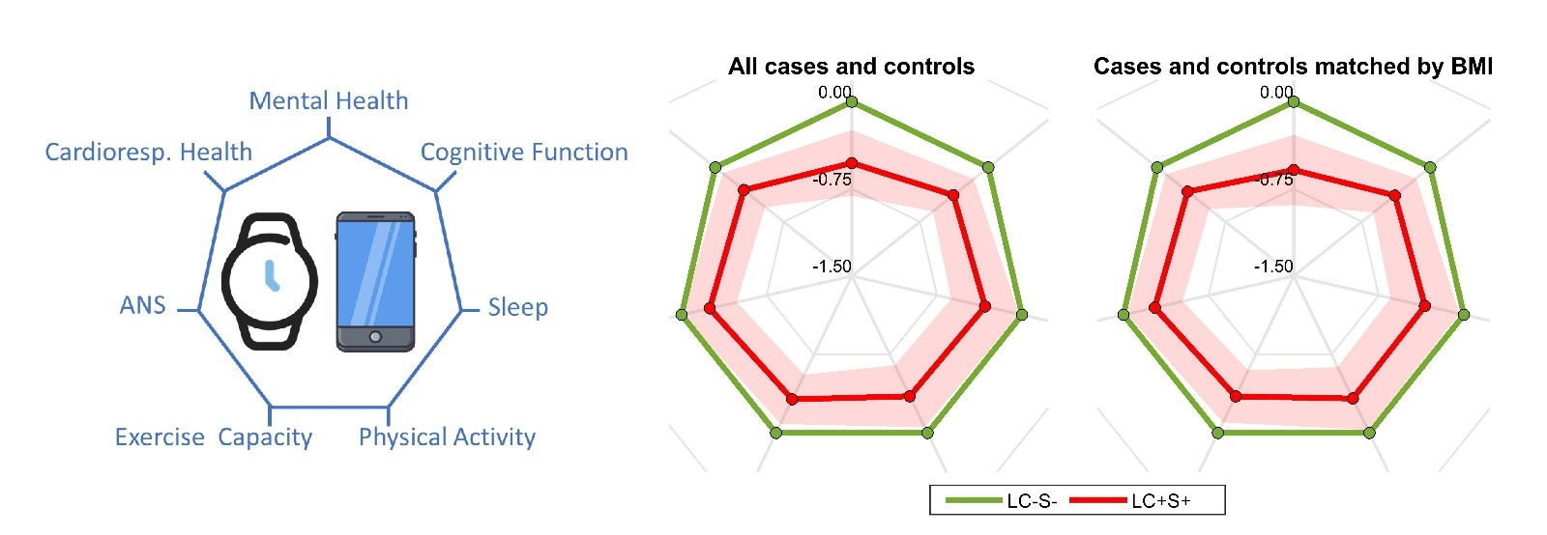

Supplementary Figure 3. Complete case analysis: Aggregate outcome measures
Spider plots showing differences between controls (LC-S-) and cases (LC+S+), and groups LC-S+ and LC+S-. Analysis was restricted to participants who were followed for ≥12 months. Circles represent standardized β coefficients for the association between participant status and aggregate system scores at baseline (upper graphs) and after 12 months (lower graphs). Shaded areas represent 95% confidence intervals. All models were adjusted for age, sex and body mass index. Models for cognitive function and autonomic function were further adjusted for education and mean heart rate.

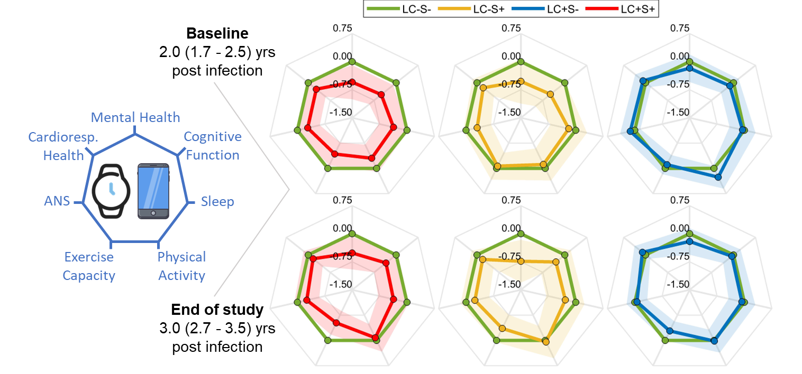

Supplementary Figure 4. Complete case analysis: single outcome measures.
Forest plots reporting standardized β coefficients and 95% confidence intervals describing the association between participant status (LC+S+, LC-S+, LC+S- compared to LC-S-) and single health parameters, grouped by physiological system. Analysis restricted to participants who were followed for 12 months. In each graph, the first 2 columns represent associations at baseline and after 12 months, while the third column reports the standardized coefficient describing the trajectory slope (interaction between time and status in mixed-effect models). Models were adjusted for age, sex and body mass index. Cognitive function and HRV models were further adjusted for education and mean HR, respectively. HR: Heart rate; HRV: HR variability; RR: Respiratory Rate; WT: Walk test

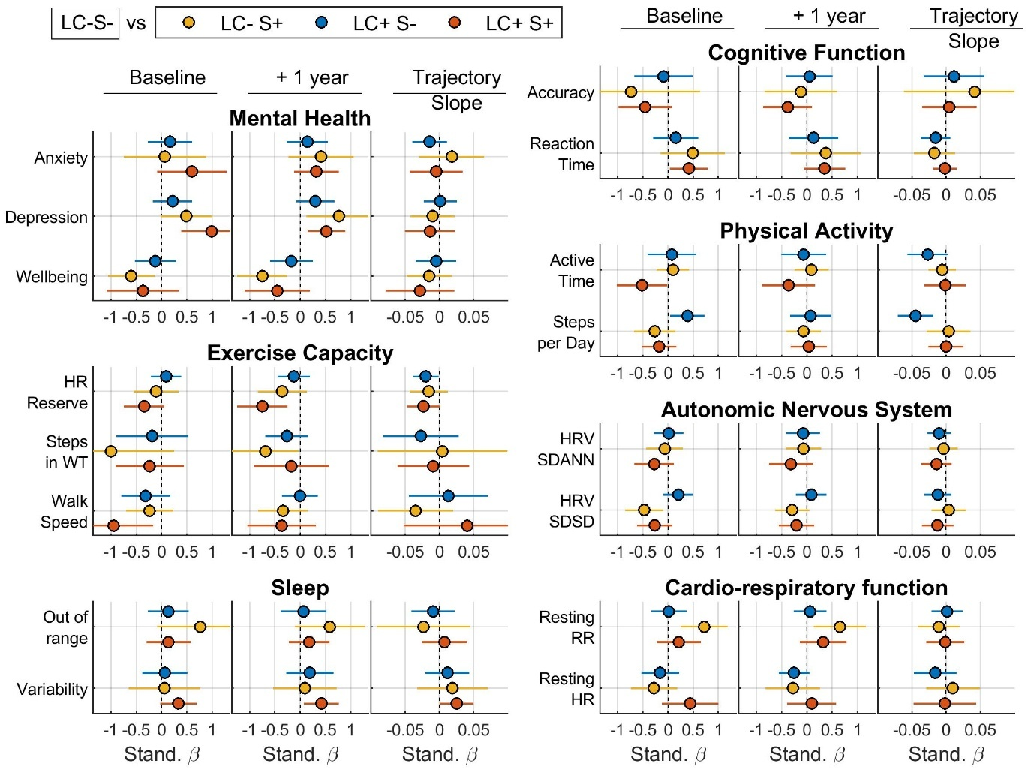

Supplementary Figure 5. Complete case analysis: Trajectories
Trajectory of aggregate system scores over time estimated from adjusted mixed-effect models. The lines and shaded area represent the predicted outcome and the 95% confidence interval. Models were adjusted for age, sex and body mass index at baseline. Cognitive function and HRV models were further adjusted for education and mean HR, respectively. To reduce the effect of learning, the trajectories of cognitive function have been corrected by subtracting the LC-S- slope.

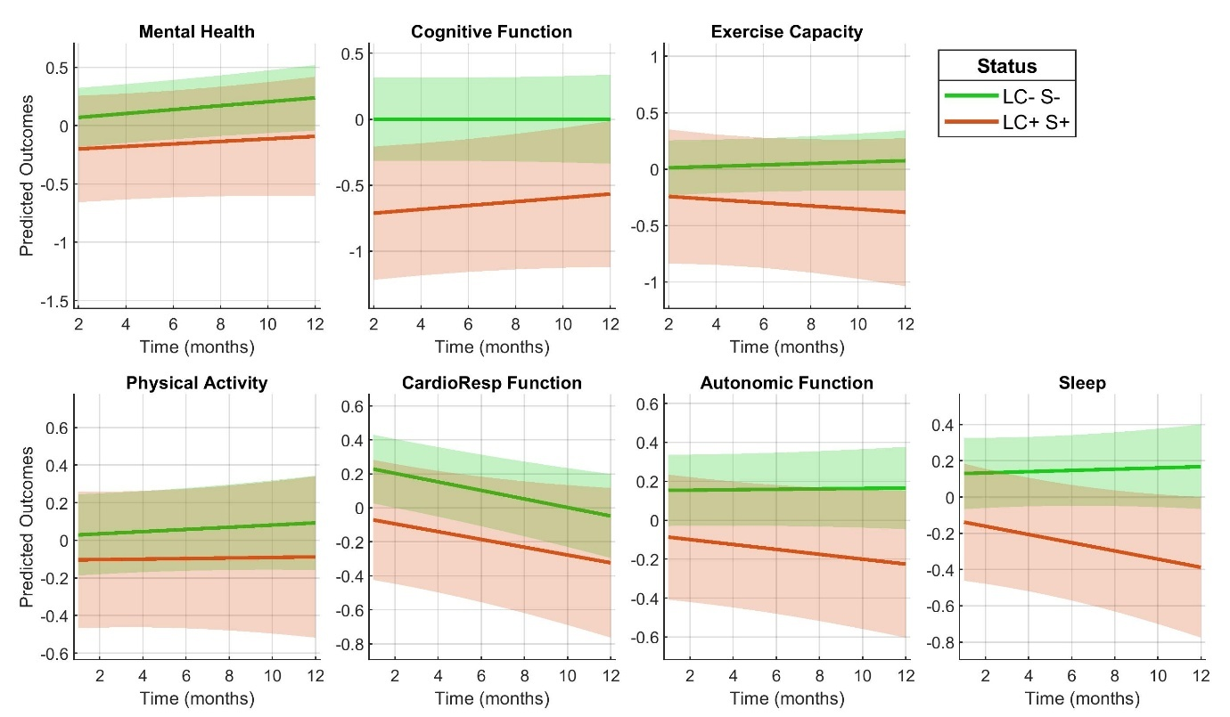

Supplementary Figure 6. Trajectories of health from time of infection
Trajectory of aggregate system scores over time estimated from adjusted linear mixed-effect models. The lines and shaded area represent the predicted outcome and the 95% confidence interval. Models were adjusted for age, sex and body mass index at baseline. Cognitive function and HRV models were further adjusted for education and mean HR, respectively. Time of infection is set as time zero. In case of no infection, a random time is allocated as time zero. To reduce the effect of learning, the trajectories of cognitive function have been corrected by subtracting the LC-S- slope.

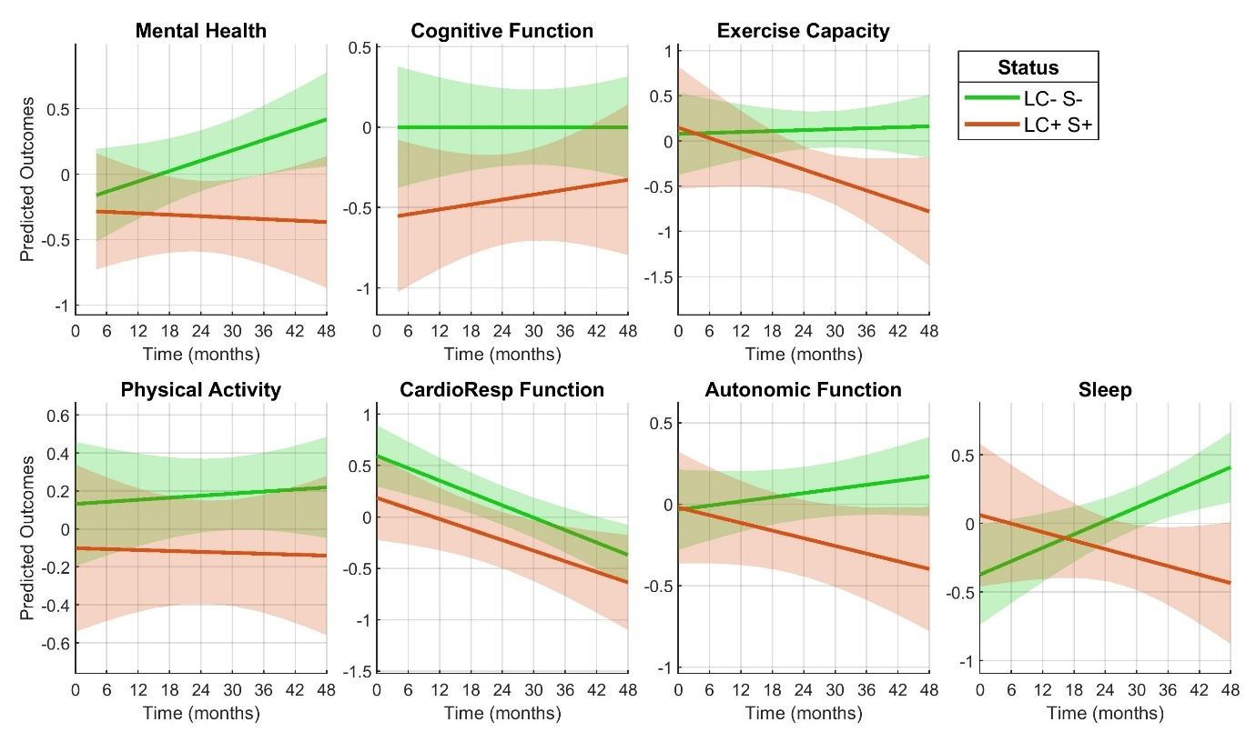

Supplementary Figure 7. Extended symptoms: Aggregate outcome measures.
Spider plots showing differences between controls (LC-S-) and cases (LC+S+), and groups LC-S+ and LC+S-. Here cases LC+S+ also include study participants who reported confusion and join pain. Circles represent standardized β coefficients for the association between participant status and aggregate system scores at baseline (upper graphs) and after 12 months (lower graphs). Shaded areas represent 95% confidence intervals. All models were adjusted for age, sex and body mass index. Models for cognitive function and autonomic function were further adjusted for education and mean heart rate.
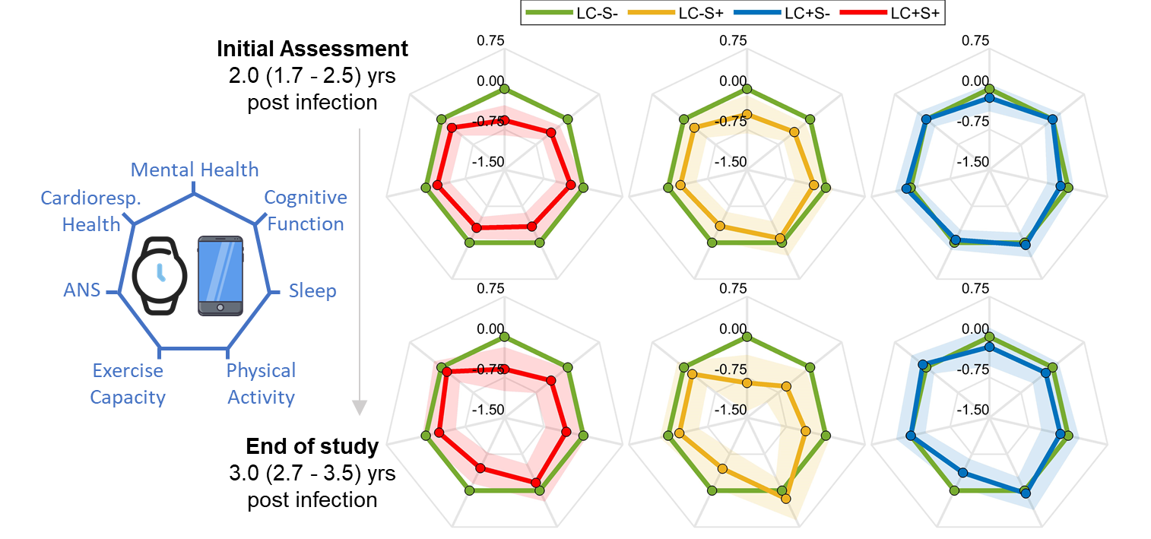

Supplementary Figure 8. Extended symptoms: Trajectories of health.
Trajectory of aggregate system scores over time estimated from adjusted mixed-effect models. The lines and shaded area represent the predicted outcome and the 95% confidence interval. Here cases LC+S+ also include study participants who reported confusion and join pain. Models were adjusted for age, sex and body mass index at baseline. Cognitive function and HRV models were further adjusted for education and mean HR, respectively. To reduce the effect of learning, the trajectories of cognitive function have been corrected by subtracting the LC-S- slope.

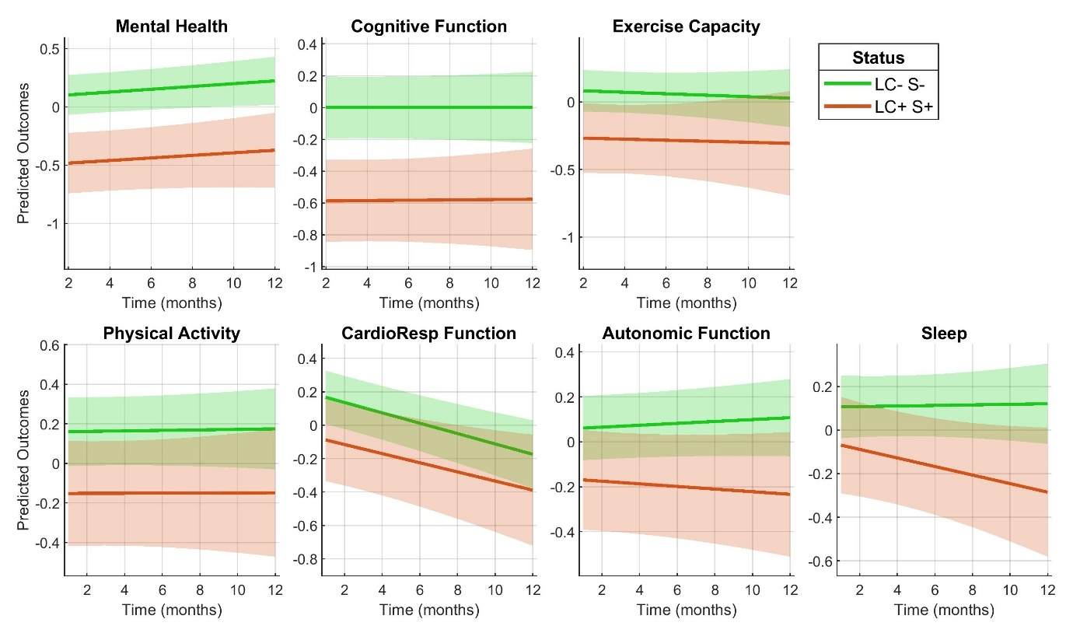

Supplementary Figure 9. Distribution of symptoms
Distribution of symptoms reported at the initial assessment in clinic. “x”: Symptoms reported by less than 5 participants. Fatigue cluster symptoms reported in this study are shown in red.
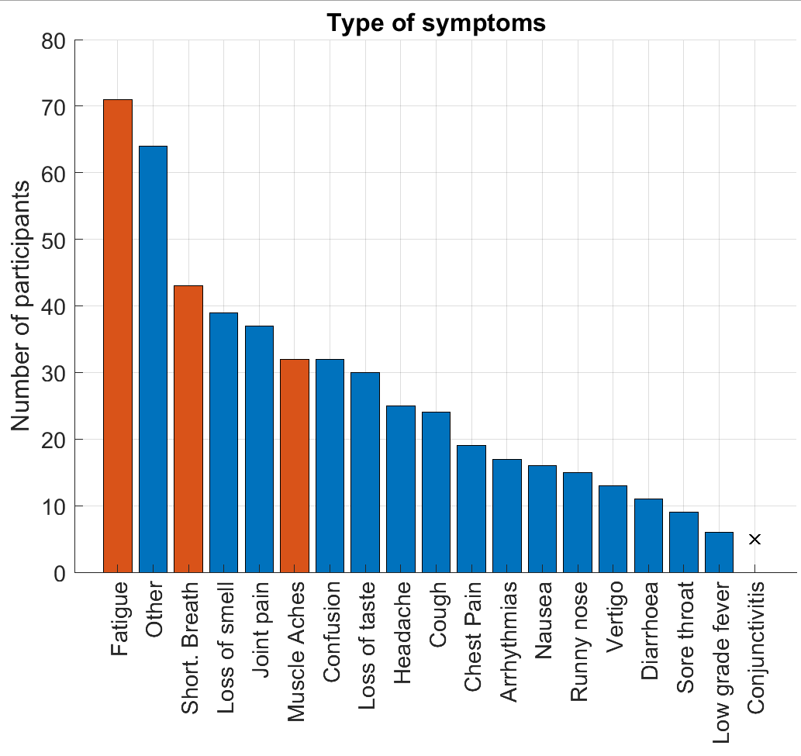

Supplementary Tables

Supplementary Table 1. Definition of outcome measures
HRV: Heart rate variability; Wear. T. Wearing time; CF: Cognitive function; bpm: Beat/Breath per minute.

Supplementary Table 2. Definition of aggregate outcome measures.
z( ) represents the z-score transformation (subtracting the mean value and dividing by the standard deviation)

Supplementary Table 3. Association between participant status and aggregate outcome measures.
Standardized β coefficients, 95% confidence intervals and p-values were estimated by regressing aggregate outcome measures on participant status (LC-S-, LC-S+, LC+S-, LC+S+), sex, age, body mass, education (cognitive function only) and mean heart rate (ANS only). Controls (LC-S-) are used as reference group. Continuous outcomes and exposures were standardized.

Supplementary Table 4. Association between participant status and single outcome measures.
Standardized β coefficients, 95% confidence intervals and p-values were estimated by regressing aggregate outcome measures on participant status (LC-S-, LC-S+, LC+S-, LC+S+), sex, age, body mass, education (cognitive function only) and mean heart rate (ANS only). Controls (LC-S-) are used as reference group. Continuous exposures were standardized, continuous outcomes were not standardized

Supplementary Table 5. Association between participant status and individual cognitive tasks.
Standardized β coefficients, 95% confidence intervals and p-values were estimated by regressing aggregate outcome measures on participant status (LC-S-, LC-S+, LC+S-, LC+S+), sex, age, body mass, and level of education. Controls (LC-S-) are used as reference group. Continuous exposures and outcomes were standardized.
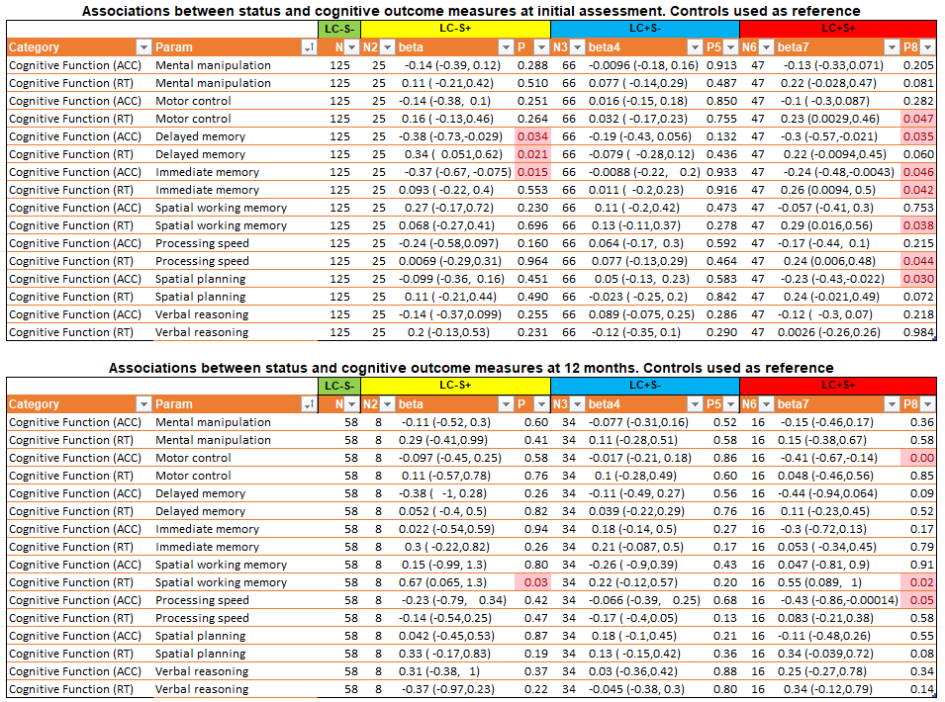

Supplementary Table 6. Monitoring duration and details.
Duration of monitoring (in months) and number of items received per participants during the monitoring period (count). Walk tests are 6-min walk tests. Walk speed is derived from all walk activities, irrespective of their duration. Surveys were collected to monitor mental health using the Radar Base app and Cognitive function was assessed using cognitive tests (Cognitron). P value by Kruskal Wallis.

Supplementary Table 7. Association between participant status and outcome measure temporal variability.
Standardized β coefficients and 95% confidence intervals were estimated by regressing the standard deviation of the conditional residuals of the mixed-effect model on status and number of data point.

Supplementary Table 8. Complete case analysis: Aggregate outcome measures
Standardized β coefficients and 95% confidence intervals were estimated using multivariable linear regression, with aggregate outcome measures as independent variable, status as exposure and age, sex and body mass index as confounding factors. Models of cognitive function and autonomic nervous systems were further adjusted for education and mean heart rate respectively. Analysis restricted to participants who were followed for 12 months.

Supplementary Table 9. Complete case analysis: single outcome measures
Standardized β coefficients and 95% confidence intervals were estimated using multivariable linear regression, with aggregate outcome measures as independent variable, status as exposure and age, sex and body mass index as confounding factors. Models of cognitive function and autonomic nervous systems were further adjusted for education and mean heart rate respectively. Analysis restricted to participants who were followed for 12 months.

Supplementary Table 10. Extended symptoms: Aggregate outcome measures.
Association between participant status and aggregate outcome measures (cases defined as showing fatigue cluster symptoms or joint pain or confusion). Standardized β coefficients, 95% confidence intervals and p-values were estimated by regressing aggregate outcome measures on participant status (LC-S-, LC-S+, LC+S-, LC+S+), sex, age, body mass, education (cognitive function only) and mean heart rate (ANS only). Controls (LC-S-) are used as reference group. Continuous outcomes and exposures were standardized

Supplementary Table 11. Extended symptoms: Single outcome measures
Association between participant status and single outcome measures (cases defined as showing fatigue cluster symptoms or joint pain or confusion). Standardized β coefficients and 95% confidence intervals were estimated using multivariable linear regression, with aggregate outcome measures as independent variable, status as exposure and age, sex and body mass index as confounding factors. Models of cognitive function and autonomic nervous systems were further adjusted for education and mean heart rate respectively.

Supplementary Text

ALSPAC cohort
Avon Longitudinal Study of Parents and Children ALSPAC is a multigenerational, population-based
prospective birth cohort study established in the early0 ‘90s. All pregnant women resident in Avon, UK with an expected date of delivery between 1 April 1991 and 31 December 1992 were invited to take part in the study. 13988 children from 14541 pregnancies were originally enrolled, and further recruitment phases included more eligible participants in following years. Mothers, partners and children from this recruitment have been followed up at multiple time points. The study website (http://www.bristol.ac.uk/alspac/researchers/our-data/) contains details of all available data through a fully searchable data dictionary and variable search tool. Data have also been collected on 12113 partners of the pregnant women who have been invited to take part since 2010. (Boyd et al., 2013; Fraser et al., 2013)
In April 2020, ALSPAC participants were first invited to complete a series of questionnaires focused on COVID19. A serology study was carried out in April 2021, in which SARS-CoV-2 infection status was defined based on measures of anti-N IgG and anti-S IgG. Participants from ALSPAC were recruited from those who responded positively (n=6988) to the following question in the fifth COVID-19 questionnaire (July–October 2021): ‘Would you be happy to be contacted about taking part in future studies, which may involve a trip to London (this applies regardless of whether or not you have had COVID-19)?’. Between July and December 2021, participants were asked to report the duration of their COVID-19 symptoms (less than 2 weeks, 2–3 weeks, 4–12 weeks, more than 12 weeks).
Ethical approval for the study was obtained from the ALSPAC Ethics and Law Committee and the Local Research Ethics Committees (ALSPAC; REC: 21/SC/0030). Informed consent for the use of all data collected was obtained from participants following the recommendations of the ALSPAC Ethics and Law Committee at the time. Participants can contact the study team at any time to retrospectively withdraw consent for their data to be used. Study participation is voluntary and during all data collection sweeps, information was provided on the intended use of data.
References
Boyd, A., Golding, J., Macleod, J., Lawlor, D. A., Fraser, A., Henderson, J., Molloy, L., Ness, A., Ring, S., & Smith, G. D. (2013). Cohort profile: The ’Children of the 90s’-The index offspring of the avon longitudinal study of parents and children. International Journal of Epidemiology, 42(1), 111–127. https://doi.org/10.1093/ije/dys064
Fraser, A., Macdonald-wallis, C., Tilling, K., Boyd, A., Golding, J., Davey smith, G., Henderson, J., Macleod, J., Molloy, L., Ness, A., Ring, S., Nelson, S. M., & Lawlor, D. A. (2013). Cohort profile: The avon longitudinal study of parents and children: ALSPAC mothers cohort. International Journal of Epidemiology, 42(1), 97–110. https://doi.org/10.1093/ije/dys066

