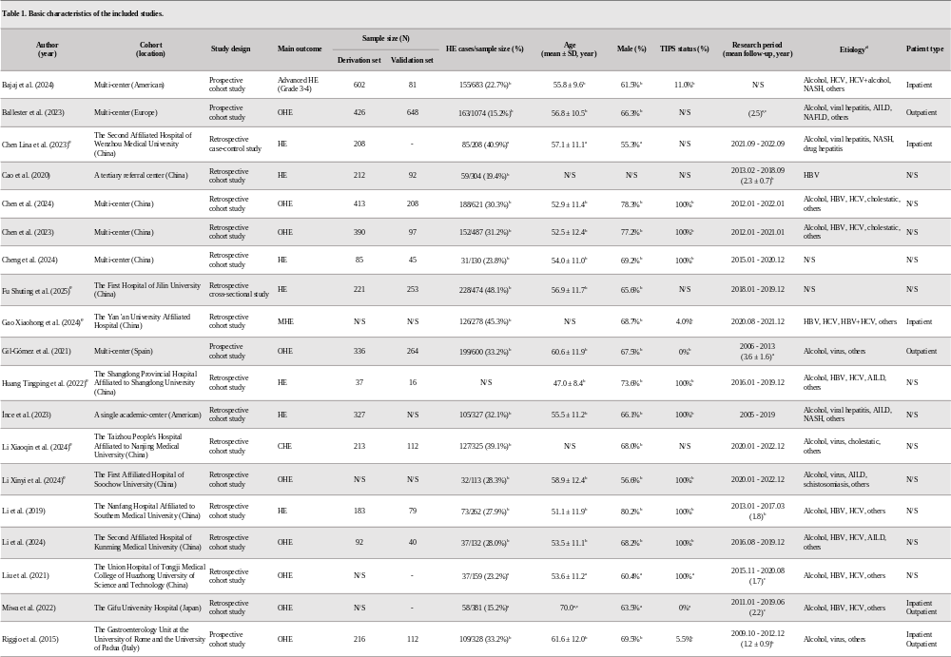
Table 1. Basic characteristics of the included studies.
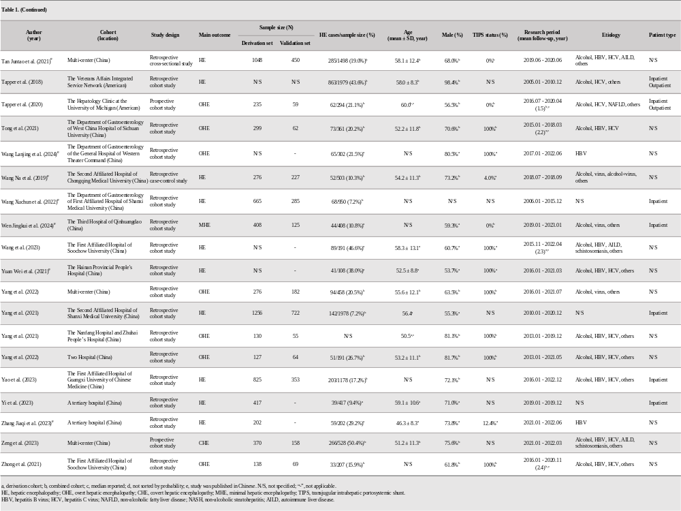
Table 1 (continued). Basic characteristics of the included studies.
Table 2. Basic information of the included prediction models.
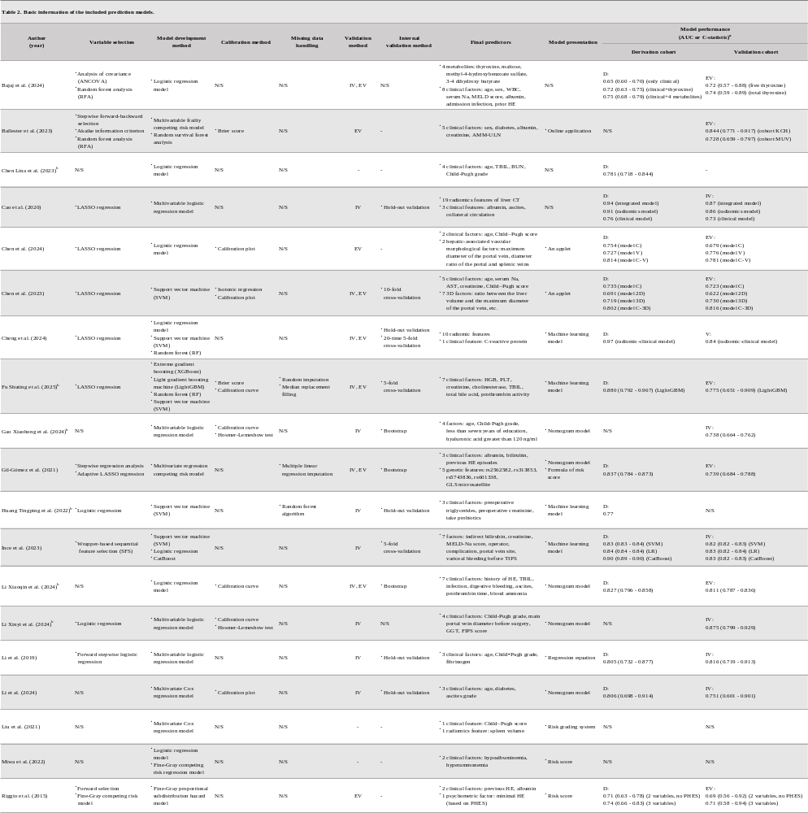
Table 2 (continued). Basic information of the included prediction models.
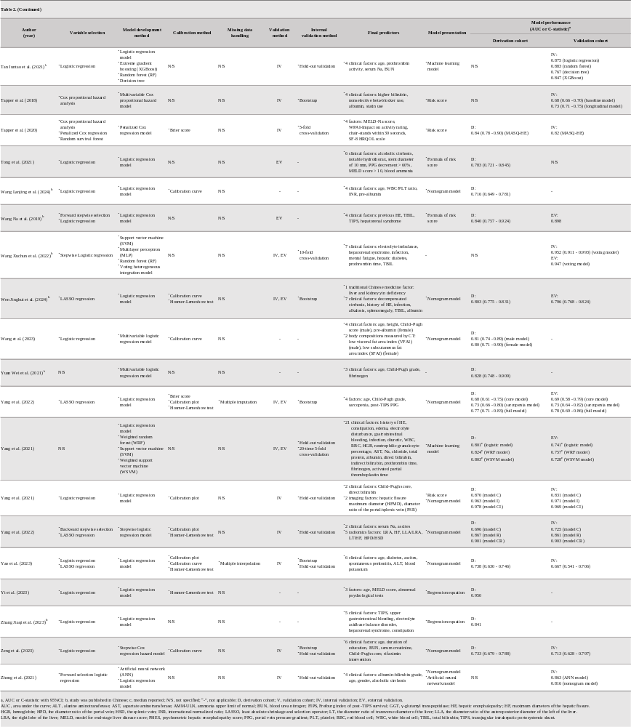
Table 3. PROBAST results of the included studies.
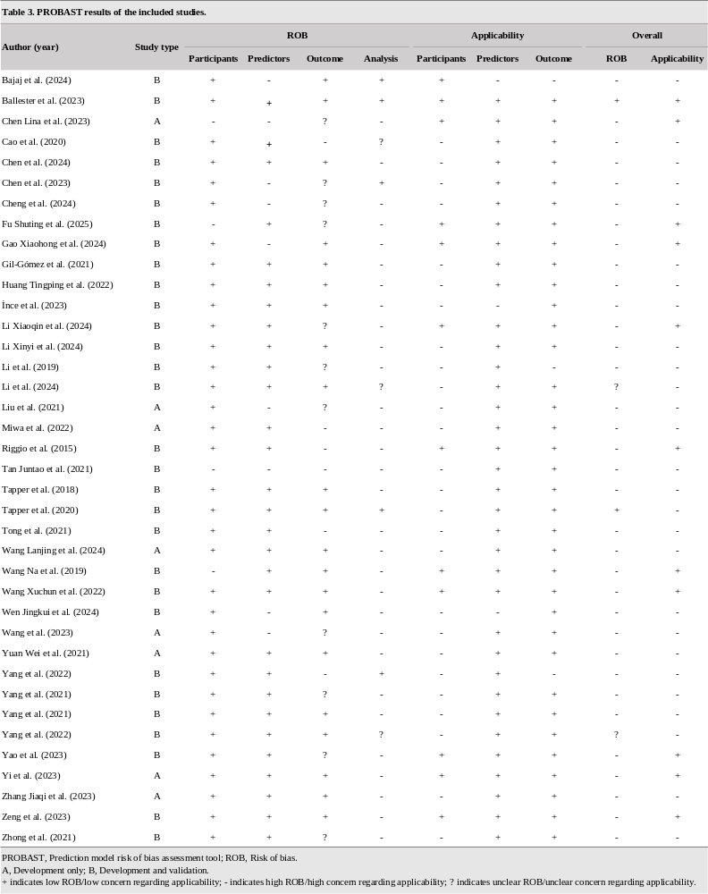

Table 4. Results of meta-analysis of predictors of HE in liver cirrhosis patients.
