Supporting Information
Isolation, characterization, anticancer and antioxidant activities of 2-methox mucic acid from Rhizophora apiculata: An in vitro and in silico studies
A. Parthibanª, V. Sachithanandam,^{a*}, P. Lalithaª, Jayaraman Muthukumaran^{b}, Monika Jain^{b}, Ranjita Misra^{c}, R. Sridharª, Ramachandran Purvajaª and Ramachandran Rameshª

^{a-}National Centre for Sustainable Coastal Management, Ministry of Environment, Forest and Climate Change, Anna University Campus, Chennai – 600 025, India.
^{b}Department of Biotechnology, School of Engineering and Technology, Sharda University, Greater Noida, India.

^{c-}Centre for Nanotechnology, International Research Centre, Sathyabama Institute of Science and Technology, Chennai – 600119, Tamil Nadu, India.

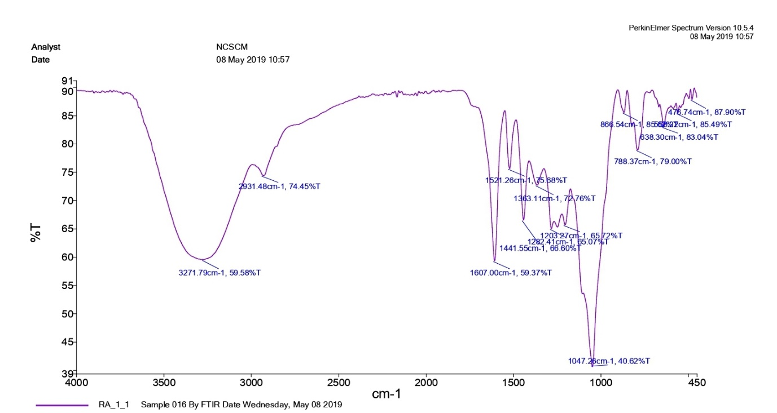
Fig. 1. FT-IR spectrum of 2-methoxy mucic acid (4).

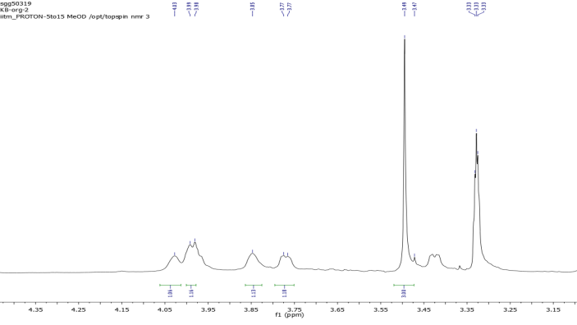
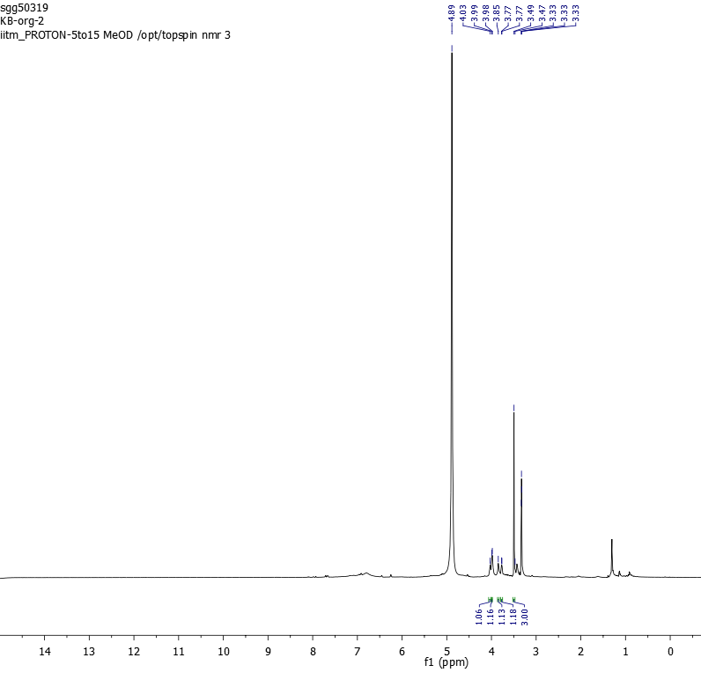
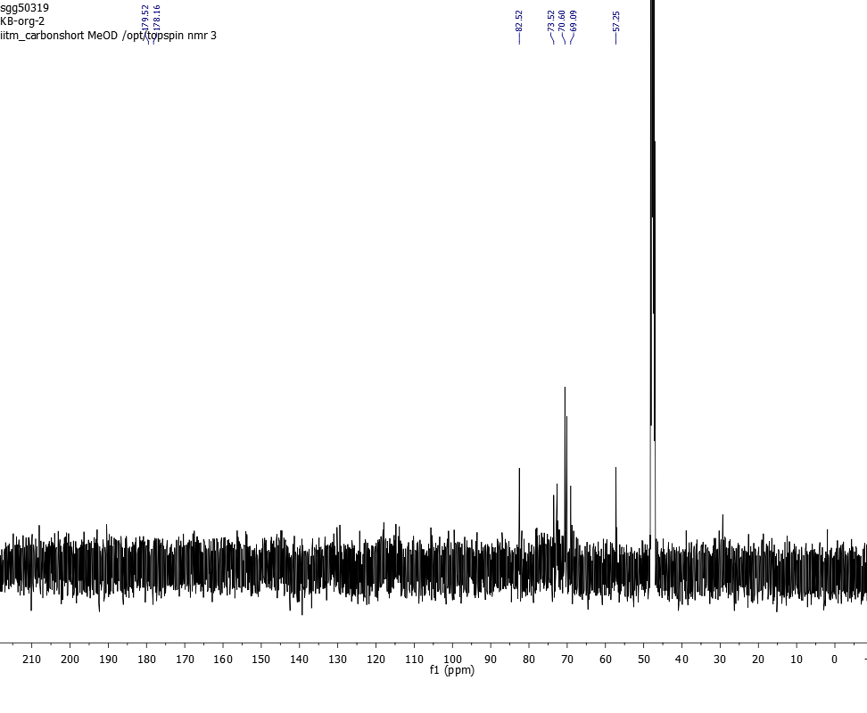
Fig. 2. 400 MHz (CD₃OD) ¹H NMR spectrum of 2-methoxy mucic acid (4).
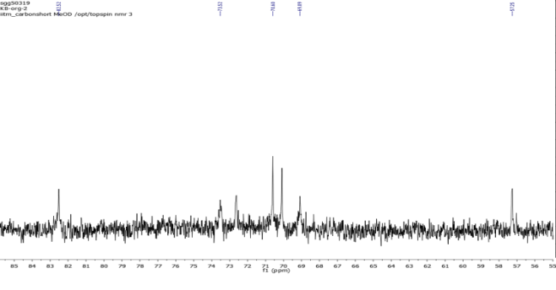

Fig. 3.100 MHz (CD₃OD) ¹³C NMR spectrum 2-methoxy mucic acid (4).

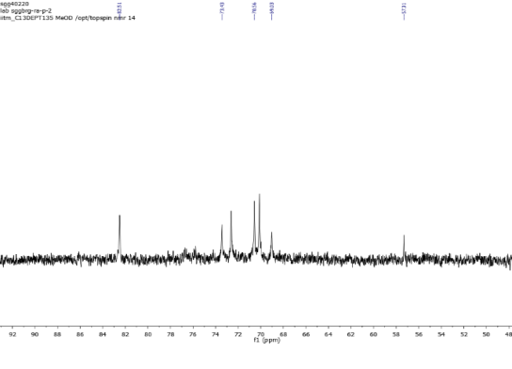
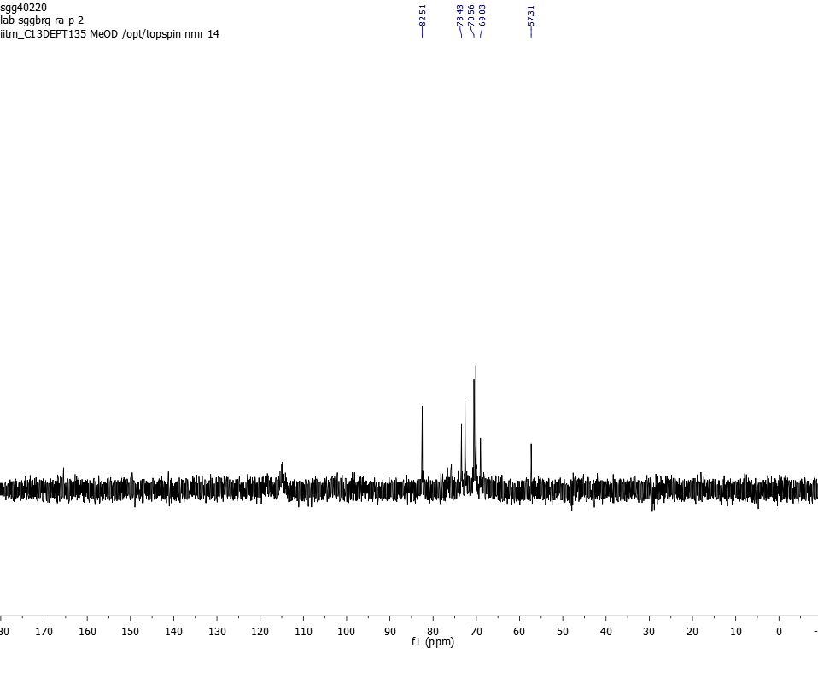

Fig. 4.100 MHz (CD₃OD) DEPT-135 spectrum of 2-methoxy mucic acid (4).

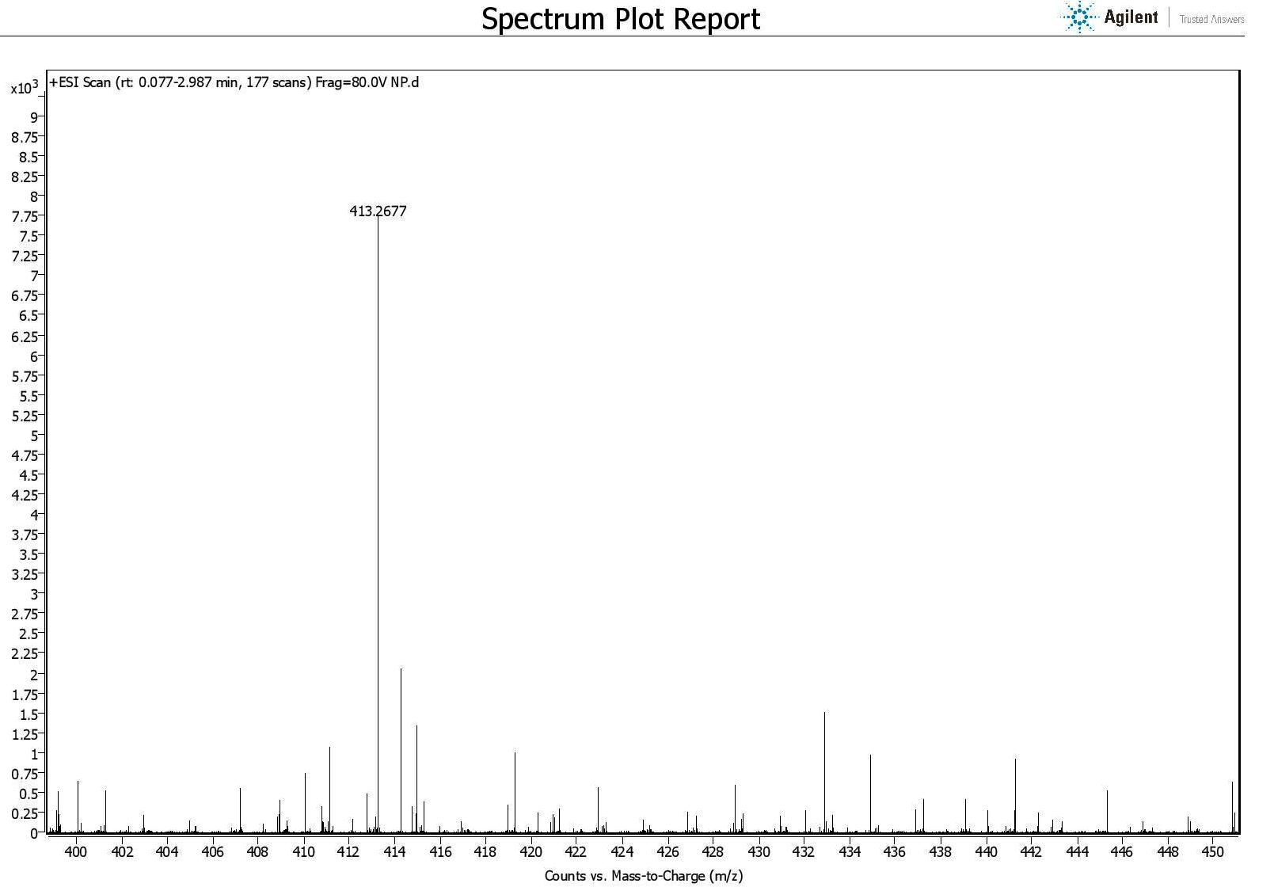
Fig. 5. HRMS (ESI) spectrum of 2-methoxy mucic acid (4).

