Supplementary Information for

Orientational Enhancement of Surface Phonon Polarity in Superconducting KTaO₃ Interfaces
Tongying Liu¹, Jiashi Li¹, Shiyu Zhang¹, Tao Zhou¹, Fanjin Lu¹, Xiaoyang Chen¹, Jia Liu², Long Cheng², Xinyi Liu¹, Wei Li¹, Yanwu Xie³, Xiaofang Zhai², Rui Peng¹, and Wei-Tao Liu¹*

* Corresponding author email: wtliu@fudan.edu.cn

This file includes:
Supplementary Note 1 to Note 3
Figs. S1 to S9
Tables S1 to S7
References 1 to 9

Supplementary Information Text
Supplementary Note 1. SFG basics
For the system we studied, the total nonlinear susceptibility comprises the surface and the bulk contributions, yielding the SF intensity as ¹
$$\begin{aligned}I\left(ω_{3}\right)=\frac{{ω_{3}}^{2}{\left|{}_{eff}^{\left(2\right)}\right|}^{2}I\left(ω_{1}\right)I\left(ω_{2}\right)}{8{}_{0}c^{3}\cos^{2}{}_{3}}\#\left(1\right)\end{aligned}$$
with I(ω_{i}) and β_{i} denoting the beam intensity at ω_{i} and the exit angle of SF beam with respect to the sample surface normal, respectively. Generally, we can we fit spectra using complex Lorentzian functions to extract the susceptibility tensor elements:
$$I {|{\overset{⃡}{}}_{NR}+{\overset{⃡}{}}_{R}|}^{2}={|{\overset{⃡}{}}_{NR}+\sum_{q}{\frac{{\overset{⃡}{A}}_{q}}{ω_{IR}−ω_{q}+i{}_{q}}}|}^{2}$$
where ${\overset{⃡}{}}_{NR}$is the non-resonant background, and ${\overset{⃡}{}}_{R}$is the resonant contribution, with ${\overset{⃡}{A}}_{q}$, $ω_{q}$, and ${}_{q}$ being the amplitude, frequency, and damping coefficient of the q^{th} resonance mode, respectively. The resonant part, i.e., effective nonlinear susceptibility is${}_{eff}^{\left(2\right)}={}_{eff, S}^{\left(2\right)}+{}_{eff, B}^{\left(2\right)}$ with ${}_{eff, S}^{\left(2\right)}$ and ${}_{eff, B}^{\left(2\right)}$ referring to the surface and bulk contributions to the effective nonlinear susceptibility, respectively. For the KTO-based heterojunction interface, assuming the built-in polar field exhibits an exponentially decaying profile $E=E_{Z}e^{−z/ξ}\hat{z}$ (ξ is the thickness that field extends), the effective nonlinear susceptibilities are ¹:
$${}_{eff, S}^{\left(2\right)}=\left[{\overset{⃡}{L}}_{3} {\vec{e}}_{3}\right] {\overset{⃡}{}}_{S}^{\left(2\right)}:\left[{\overset{⃡}{L}}_{1} {\vec{e}}_{1}\right]\left[{\overset{⃡}{L}}_{2} {\vec{e}}_{2}\right]$$
$$\begin{aligned}{}_{eff, B}^{\left(2\right)}=\left[{\overset{⃡}{L}}_{3} {\vec{e}}_{3}\right] \left[{\overset{⃡}{}}_{B}^{\left(3\right)}\frac{\left(E_{Z}ξ \right)}{1−ikξ}\right]:\left[{\overset{⃡}{L}}_{1} {\vec{e}}_{1}\right]\left[{\overset{⃡}{L}}_{2} {\vec{e}}_{2}\right]\#\left(2\right)\end{aligned}$$
where ${\overset{⃡}{}}_{S}^{\left(2\right)}$ and ${\overset{⃡}{}}_{B}^{\left(3\right)}$ are the second and third order nonlinear susceptibility tensors of the surface and bulk, ${\vec{e}}_{i}$ and ${\overset{⃡}{L}}_{i}$ are the unit polarization vector and corresponding transmission Fresnel coefficient (see in Supplementary Table. S6 for our systems), respectively. The wavevector mismatch ∆k is the reciprocal of the coherence length l_{c}, which for our setup is 30 nm ². The ARPES measurements reveal that the conductive layer thickness is 5.5 nm ³, resulting in $E_{Z}ξ/(1−ikξ)≈E_{Z}ξ$.

Supplementary Note 2. Susceptibility tensor of KTO heterostructures
For the $Pm\overline{3}m$ space group (O_{h} point group) that KTO belongs to, the third-order susceptibility has the 21 non-zero tensor elements ${}_{}^{(3)}$ in crystal coordinate $( \{a=\left[100\right]$, $b=\left[010\right]$, $c=\left[001\right]\})$, of which only four are independent, denoted as d₁, d₂, d₃, d₄.
$aaaa\left(={}_{aaaa}^{\left(3\right)}\right)=bbbb=cccc=d_{1}$,
$aabb=aacc=bbaa=bbcc=ccaa=ccbb=d_{2}$,
$abab=acac=baba=bcbc=caca=cbcb=d_{3}$,
$abba=acca=baab=bccb=caac=cbbc=d_{4}$.
We can use 3×3×3×3 matrix ( ${}_{}^{(3)}$ in $×××$ position ) to represent the susceptibility for clarity,
${\overset{⃡}{}}_{}^{\left(3\right)}=\left(\begin{matrix}\left(\begin{matrix}d_{1} & 0 & 0 \\ 0 & d_{2} & 0 \\ 0 & 0 & d_{2}\end{matrix}\right) & \left(\begin{matrix}0 & d_{3} & 0 \\ d_{4} & 0 & 0 \\ 0 & 0 & 0\end{matrix}\right) & \left(\begin{matrix}0 & 0 & d_{3} \\ 0 & 0 & 0 \\ d_{4} & 0 & 0\end{matrix}\right) \\ \left(\begin{matrix}0 & d_{4} & 0 \\ d_{3} & 0 & 0 \\ 0 & 0 & 0\end{matrix}\right) & \left(\begin{matrix}d_{2} & 0 & 0 \\ 0 & d_{1} & 0 \\ 0 & 0 & d_{2}\end{matrix}\right) & \left(\begin{matrix}0 & 0 & 0 \\ 0 & 0 & d_{3} \\ 0 & d_{4} & 0\end{matrix}\right) \\ \left(\begin{matrix}0 & 0 & d_{4} \\ 0 & 0 & 0 \\ d_{3} & 0 & 0\end{matrix}\right) & \left(\begin{matrix}0 & 0 & 0 \\ 0 & 0 & d_{4} \\ 0 & d_{3} & 0\end{matrix}\right) & \left(\begin{matrix}d_{2} & 0 & 0 \\ 0 & d_{2} & 0 \\ 0 & 0 & d_{1}\end{matrix}\right)\end{matrix}\right)$.
The transformation from the crystal coordinates (α, β, μ, ν ∈ {a, b, c}) to the lab coordinates (i, j, k, l ∈ {x, y, z}) follows:
$${}_{ijkl}^{(3)}=T_{iα}T_{jβ}T_{kμ}T_{l}{}_{αβμ}^{\left(3\right)}$$
where $T^{⊤}T=I$, $T^{−1}=T$, ${(T^{−1})}_{βj}=T_{jβ}$.
The subindices of ${}_{ijkl}^{(3)}$ from left to right represent the direction of SFG, NIR, IR and the field term, respectively. Given the close proximity of the SFG and NIR wavelengths, we further have $d_{3}≈d_{4}$. The coordinates used for the three crystal facets are shown in Supplementary Fig. S7, with z along the surface normal and zx being the beam incident plane.

(001)
For (001) surface, the crystal coordinate is defined with x'-axis along the a-axis and z' along the c-axis in sample coordinates. The transformation matrix from the crystal to the lab is
$T_{(001)}=\left(\begin{matrix}cos & −sin & 0 \\ sin & cos & 0 \\ 0 & 0 & 1\end{matrix}\right)\left(\begin{matrix}1 & 0 & 0 \\ 0 & 1 & 0 \\ 0 & 0 & 1\end{matrix}\right)$.
Since the field is along z direction, only l = z terms are permitted:
${\overset{⃡}{}}_{ijkl}^{\left(3\right)}=\left(\begin{matrix}\left(\begin{matrix}0 \\ 0 \\ d_{2}\end{matrix}\right) & \left(\begin{matrix}0 \\ 0 \\ 0\end{matrix}\right) & \left(\begin{matrix}d_{3} \\ 0 \\ 0\end{matrix}\right) \\ \left(\begin{matrix}0 \\ 0 \\ 0\end{matrix}\right) & \left(\begin{matrix}0 \\ 0 \\ d_{2}\end{matrix}\right) & \left(\begin{matrix}0 \\ d_{3} \\ 0\end{matrix}\right) \\ \left(\begin{matrix}d_{3} \\ 0 \\ 0\end{matrix}\right) & \left(\begin{matrix}0 \\ d_{3} \\ 0\end{matrix}\right) & \left(\begin{matrix}0 \\ 0 \\ d_{1}\end{matrix}\right)\end{matrix}\right)$.
Substitute it into Eq. (2) and for the SSP and PPP polarization combinations used in this study, the effective susceptibility can be expressed as
$$\begin{aligned}{}_{eff}^{\left(2\right)}\left(SSP\right)={}_{yyz}{}_{B,2}^{\left(2\right)} \\ {}_{eff}^{\left(2\right)}\left(PPP\right)={}_{zzz}{}_{B,1}^{\left(2\right)}−{}_{xxz}{}_{B,2}^{\left(2\right)}+\left({}_{zxx}−{}_{xzx}\right){}_{B,3}^{\left(2\right)}\#\left(3\right)\end{aligned}$$
where ${}_{ijk}$ are the dimensionless coefficients including Fresnel coefficients after projection to the polarization vector, for example, ${}_{yyz}$ represents $cos{}_{1}L_{yy}(ω_{3})L_{yy}(ω_{2})L_{zz}(ω_{1})$. All coefficients can be obtained from Kramers-Kronig relations ^{4,5} and listed in Supplementary Table. S6. Besides, the term ${}_{zxx}−{}_{xzx}=0.002$ is three orders of magnitude smaller than the other terms and can therefore be neglected.
Evidently, Eq. (3) implies that for the (001) plane, the SF intensity is azimuthally invariant, i.e., isotropic, as indeed depicted in Fig. 1e and 2e. By fitting the patterns (see Supplementary Table S2), we can deduce the susceptibility components as follow:
${}_{B,1}^{\left(2\right)}=(C_{iso}^{PPP}+{}_{xxz}C_{iso}^{SSP}/{}_{yyz}){}_{zzz}$,
${}_{B,2}^{\left(2\right)}=C_{iso}^{SSP}/{}_{yyz}$.
where the superscript denotes the polarization and the subscript represents the isotropic term coefficient.

(110)
For (110) surface, the coordinates are defined with x′-axis along c-axis and z'-axis along the [110] direction. The transformation matrix from the crystal to the lab and non-vanishing terms are:
$T_{(110)}=\left(\begin{matrix}cos & −sin & 0 \\ sin & cos & 0 \\ 0 & 0 & 1\end{matrix}\right)\left(\begin{matrix}0 & 0 & 1 \\ 1/\sqrt{2} & −1/\sqrt{2} & 0 \\ 1/\sqrt{2} & 1/\sqrt{2} & 0\end{matrix}\right)$.
${\overset{⃡}{}}_{ijkl}^{\left(3\right)}=\left(\begin{matrix}\left(\begin{matrix}0 \\ 0 \\ d_{2}−\frac{d'}{2}\sin^{2}\end{matrix}\right) & \left(\begin{matrix}0 \\ 0 \\ \frac{d'}{4}sin2\end{matrix}\right) & \left(\begin{matrix}d_{3}−\frac{d'}{2}\sin^{2} \\ \frac{d'}{4}sin2 \\ 0\end{matrix}\right) \\ \left(\begin{matrix}0 \\ 0 \\ \frac{d'}{4}sin2\end{matrix}\right) & \left(\begin{matrix}0 \\ 0 \\ d_{2}−\frac{d'}{2}\cos^{2}\end{matrix}\right) & \left(\begin{matrix}\frac{d'}{4}sin2 \\ d_{3}−\frac{d'}{2}\cos^{2} \\ 0\end{matrix}\right) \\ \left(\begin{matrix}d_{3}−\frac{d'}{2}\sin^{2} \\ \frac{d'}{4}sin2 \\ 0\end{matrix}\right) & \left(\begin{matrix}\frac{d'}{4}sin2 \\ d_{3}−\frac{d'}{2}\cos^{2} \\ 0\end{matrix}\right) & \left(\begin{matrix}0 \\ 0 \\ \frac{d'}{2}+d_{1}\end{matrix}\right)\end{matrix}\right)$.
Note that we define the terms $d^{'}≡−d_{1}+d_{2}+2d_{3}$ for clarity. Substitute it into Eq. (2) and for the SSP and PPP polarization combinations used in this study, the effective susceptibility can be expressed as
$${}_{eff}^{\left(2\right)}\left(SSP\right)=C_{ani}^{SSP}cos2+C_{iso}^{SSP}$$
$$\begin{aligned}{}_{eff}^{\left(2\right)}\left(PPP\right)=C_{ani}^{PPP}cos2+C_{iso}^{PPP}\#\left(4\right)\end{aligned}$$
where the $C_{ani}^{PPP}$ and $C_{ani}^{SSP}$are the anisotropic coefficients respectively. Here are the values:
$C_{ani}^{SSP}={}_{yyz}({}_{B,1}^{\left(2\right)}−{}_{B,2}^{\left(2\right)}−2{}_{B,3}^{\left(2\right)})/4$,
$C_{iso}^{SSP}={}_{yyz}({}_{B,1}^{\left(2\right)}+3{}_{B,2}^{\left(2\right)}−2{}_{B,3}^{\left(2\right)})/4$,
$C_{ani}^{PPP}=({}_{xxz}+{}_{xzx}−{}_{zxx})({}_{B,1}^{\left(2\right)}−{}_{B,2}^{\left(2\right)}−2{}_{B,3}^{\left(2\right)})/4$,
$$C_{iso}^{PPP}=[\left(−{}_{xxz}−{}_{xzx}+{}_{zxx}+2{}_{zzz}\right){}_{B,1}^{\left(2\right)}$$
$$+(−3{}_{xxz}+{}_{xzx}−{}_{zxx}+2{}_{zzz}) {}_{B,2}^{\left(2\right)}$$
$+2\left({}_{xxz}−{}_{xzx}+{}_{zxx}+2{}_{zzz}\right){}_{B,3}^{\left(2\right)}]/4$.
Obviously, the $cos2$ terms suggest the anisotropic pattern in the spectra, consisting with C_{2v} symmetry of the (110) plane.

(111)
For (111) surface, the coordinates are defined with x′-axis along the [1-10] direction z'-axis along the [111] direction. The transformation matrix from the crystal to the lab and non-vanishing terms are:
$T_{(111)}=\left(\begin{matrix}cos & −sin & 0 \\ sin & cos & 0 \\ 0 & 0 & 1\end{matrix}\right)\left(\begin{matrix}1/\sqrt{2} & −1/\sqrt{2} & 0 \\ 1/\sqrt{6} & 1/\sqrt{6} & −2/\sqrt{6} \\ 1/\sqrt{3} & 1/\sqrt{3} & 1/\sqrt{3}\end{matrix}\right)$.
${\overset{⃡}{}}_{ijkl}^{\left(3\right)}=\left(\begin{matrix}\left(\begin{matrix}\frac{\sqrt{2}}{6}d^{'}sin3 \\ \frac{−\sqrt{2}}{6}d^{'}cos3 \\ d_{2}−d^{'}/3\end{matrix}\right) & \left(\begin{matrix}\frac{−\sqrt{2}}{6}d^{'}cos3 \\ \frac{−\sqrt{2}}{6}d^{'}sin3 \\ 0\end{matrix}\right) & \left(\begin{matrix}d_{3}−d^{'}/3 \\ 0 \\ 0\end{matrix}\right) \\ \left(\begin{matrix}\frac{−\sqrt{2}}{6}d^{'}cos3 \\ \frac{−\sqrt{2}}{6}d^{'}sin3 \\ 0\end{matrix}\right) & \left(\begin{matrix}\frac{−\sqrt{2}}{6}d^{'}sin3 \\ \frac{\sqrt{2}}{6}d^{'}cos3 \\ d_{2}−d^{'}/3\end{matrix}\right) & \left(\begin{matrix}0 \\ d_{3}−d^{'}/3 \\ 0\end{matrix}\right) \\ \left(\begin{matrix}d_{3}−d^{'}/3 \\ 0 \\ 0\end{matrix}\right) & \left(\begin{matrix}0 \\ d_{3}−d^{'}/3 \\ 0\end{matrix}\right) & \left(\begin{matrix}0 \\ 0 \\ d_{1}−d^{'}/3\end{matrix}\right)\end{matrix}\right)$.
Substitute it into Eq. (2) and the effective susceptibility can be expressed as
$${}_{eff}^{\left(2\right)}\left(SSP\right)=C_{ani}^{SSP}sin3+C_{iso}^{SSP}$$
$$\begin{aligned}{}_{eff}^{\left(2\right)}\left(PPP\right)=C_{ani}^{PPP}sin3+C_{iso}^{PPP}\#\left(5\right)\end{aligned}$$
with the coefficients
$C_{ani}^{SSP}={\sqrt{2}}_{yyx}({}_{B,1}^{\left(2\right)}−{}_{B,2}^{\left(2\right)}−2{}_{B,3}^{\left(2\right)})/6$,
$C_{iso}^{SSP}={}_{yyz}({}_{B,1}^{\left(2\right)}+2{}_{B,2}^{\left(2\right)}−2{}_{B,3}^{\left(2\right)})/3$,
$C_{ani}^{PPP}=\sqrt{2}{}_{xxx}({}_{B,1}^{\left(2\right)}−{}_{B,2}^{\left(2\right)}−2{}_{B,3}^{\left(2\right)})/6$,
$$C_{iso}^{PPP}=[\left(−{}_{xxz}−{}_{xzx}+{}_{zxx}+{}_{zzz}\right){}_{B,1}^{\left(2\right)}$$
$$+(−2{}_{xxz}+{}_{xzx}−{}_{zxx}+2{}_{zzz}) {}_{B,2}^{\left(2\right)}$$
$+2\left({}_{xxz}−{}_{xzx}+{}_{zxx}+4{}_{zzz}\right){}_{B,3}^{\left(2\right)}]/3$.
Now we have obtained expressions for the effective susceptibility for all three orientations under SSP and PPP polarizations. With coefficients parameter fitted from experimental patterns in Supplementary Table S2, we can solve the system of equations (3)-(5) for the value of ${}_{B,1}^{\left(2\right)}$, ${}_{B,2}^{\left(2\right)}$and${}_{B,3}^{\left(2\right)}$, as tabled in Supplementary Table S3. The same analysis can be applied to the KTO substrate, which is primarily a surface signal, to obtain the value of ${}_{S, i}^{(2)}$, as listed in Supplementary Table S4. We note that the equations for $C_{ani}^{SSP}$ and $C_{ani}^{PPP}$ are equivalent. Taking either value yields comparable field enhancement factor, which validates the reliability of our findings. Since the lattice itself is not expected to change drastically with varying orientations, the discrepancies between LAO/KTO and substrates are mainly caused by the change in polar fields after the growth of the LAO. The polariyt enhancement factors are tabulated in Supplementary Table S5 and plotted in Fig. 3a of the main text. Although the reverse derivation process is highly complex, the results exhibit consistency across different crystal planes and align with the superconducting trend: (111) > (110) >> (001). While the experiments were conducted at room temperature, the interfacial properties probed by sum-frequency generation are intrinsic. A stronger polar field enhances spin-orbit coupling and electron-phonon interactions, thereby creating favorable conditions for superconductivity.

Supplementary Note 3. Dynamical polarization
The lab coordinate is chosen with the Ta atoms as the center. Assuming the charge q_{i} is located at position $\vec{r_{i}}$, the geometric center position is then determined to be $R=\sum{q_{i}{\vec{r}}_{i}}/\sum{q_{i}}$. After calculating the geometric centers of the positive R₊ and negative R₋ charges, the dipole moment can be obtained as $\vec{p}=(q_{+}+q_{−})(R_{+}−R_{−})/2$. We calculated both the nominal and the dynamical Born effective charges (BECs). In the nominal case, the K, Ta, and O ions have charges of +1, +5, and -2, respectively. It is an ill-defined quantity because artificially dividing the ground-state electronic density to different atoms is ambiguous ⁶. The dynamical born effective charge describes the effective charge of an ion in a crystal lattice when it is displaced from its equilibrium position. It is related to the change of polarization created by an atomic displacement. Typical values of born effective charges for K, Ta and O ions are 1.14, 8.86, and -6.64 C, respectively ^{7,8}.
The surfaces are depicted in Supplementary Fig. S9. The Ta ion is at the origin with a charge of q_{Ta}. Considering the (001) configuration, the coordinates of the four K ions are (±a/2, ±a/2, -a/2) with the charge q_{K} in one primitive cell, whereÅ is the lattice constant ⁹. There are five oxygen ions with a negative charge of q_{O} located at (±a/2, 0, 0), (0, ±a/2, 0) and (0, 0, -a/2), respectively. The positive and negative center are
$$R_{+}=(\sum{q_{K}{\vec{r}}_{K}}+q_{Ta}{\vec{r}}_{Ta})/(\sum{q_{K}}+q_{Ta})$$
$=(0, 0, −2aq_{K}/(\sum{q_{K}}+q_{Ta}))$,
$R_{−}=\sum{q_{O}{\vec{r}}_{O}}/\sum{q_{O}} =(0, 0, −aq_{O}/2\sum{q_{O}})$.
For the nominal case, we have q_{Ta} = 5 C, q_{K} = 0.125 C and q_{O} = 1 C. Note that in one primitive cell, the K ions on the corners count as one-eighth and the O ions on the faces count as one-half. Then, the dipole yields p_{z,nom} = 1.142 C/Å. For the BECs case, we have q_{Ta} = 8.86 C, q_{K} = 0.1425 Cand q_{O} = 3.32 C. The dipole is given by p_{z,BECs} = 3.622 C/Å.
With respect to (110) surface, the positive and negative center are
$R_{+}=(0, 0, −\sqrt{2}aq_{K}/\sum{q_{K}+}q_{Ta})$,
$R_{−}=(0, 0, −aq_{O}/\sum{q_{O}})$.
Similarly, we have p_{z,nom} = 4.263 C/Å and p_{z,BECs} = 10.512 C/Å.
Regarding the (111) surface, the positive and negative center are
$R_{+}=(0, 0, −\sqrt{3}aq_{K}/\sum{q_{K}+}q_{Ta})$,
$R_{−}=(0, 0, −\sqrt{3}aq_{O}/2\sum{q_{O}})$.
Likewise, we have p_{z,nom} = 4.226 C/Å and p_{z,BECs} = 10.149 C/Å.
The values of dipole moment in z direction p_{z} are tabulated in Supplementary Table S7. In the nominal case, the (110) and (111) surfaces are 3.7 times larger than the (001) surface. Under BECs conditions, the (110) and (111) surfaces are 2.9 and 2.8 times larger than the (001) surface, respectively. In both cases, the polarization of the (110) and (111) surfaces is stronger than that of the (001) surface.

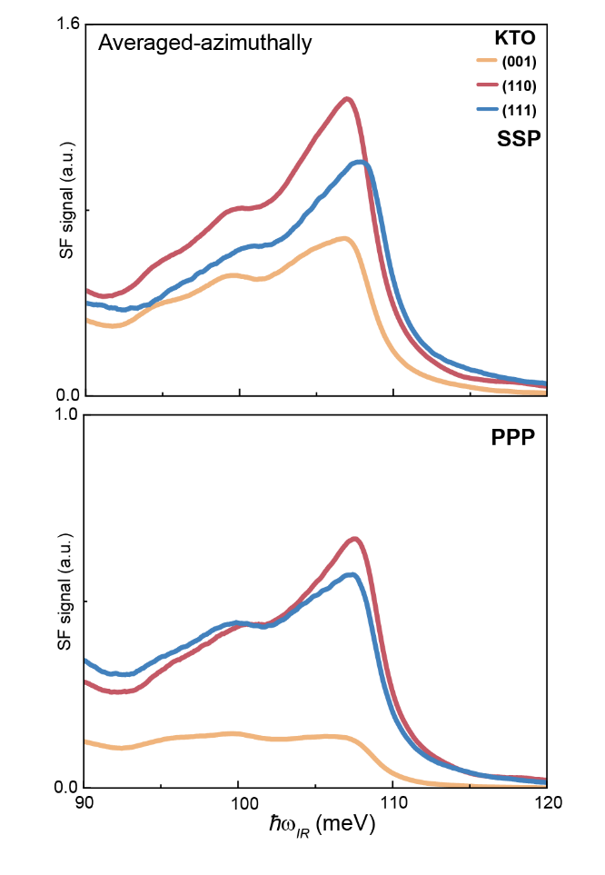
Supplementary Fig. S1 The averaged-azimuthally spectra of KTO substrate with (001), (110) and (111) orientation under SSP and PPP combination. All normalized to the signals from a non-resonant gold thin film.
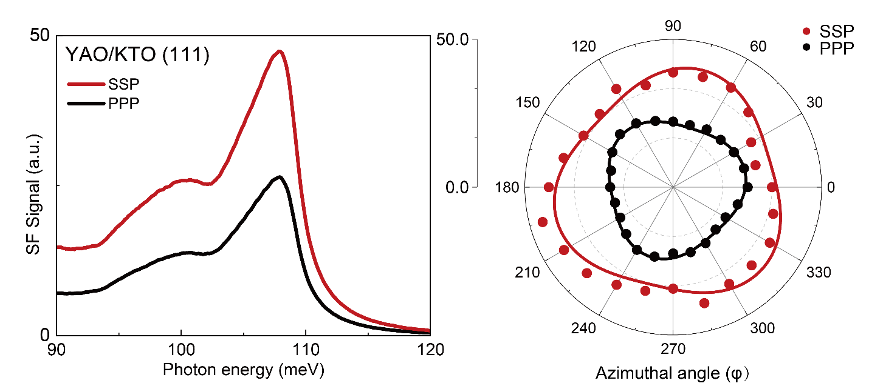
Supplementary Fig. S2 The SF spectra of YAO/KTO (111) and the azimuthal patterns (see fitting parameters in Supplementary Table 2)
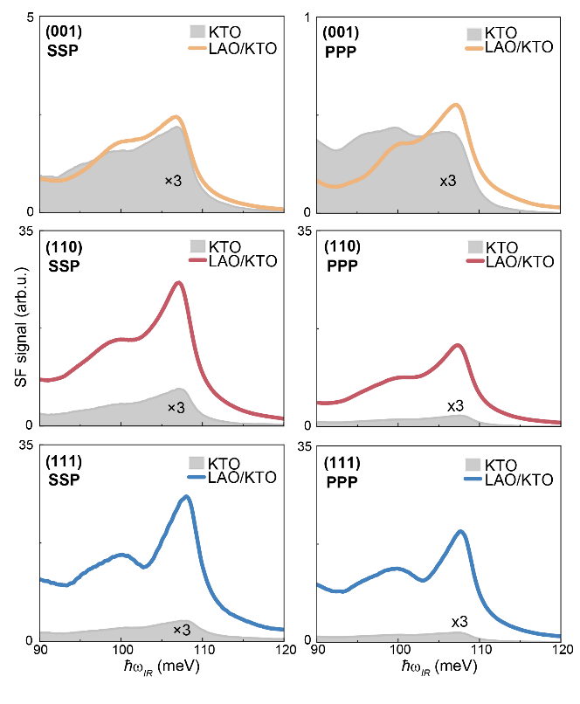
Supplementary Fig. S3 The azimuthally-averaged SSP and PPP spectra from LAO/KTO with (001), (110) and (111) orientations (colored) and corresponding substrate (gray filled, amplified by 3 times).
Supplementary Fig. S4 a Spectra of KTO (001) upon UV irradiation at 100 K, and after UV irradiation at elevated temperature. b Spectra of KTO (001) upon UV irradiation before (black) and after 120 minutes of UV irradiation (purple) at 295 K.
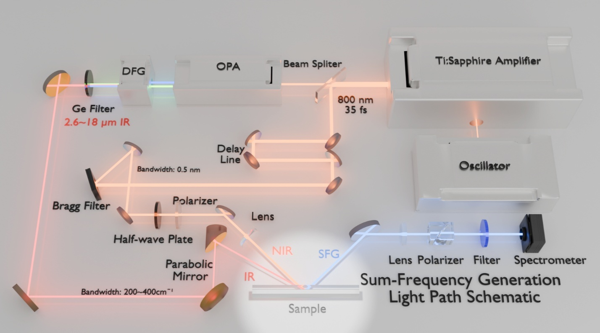
Supplementary Fig. S5 The schematic of femtosecond laser system.
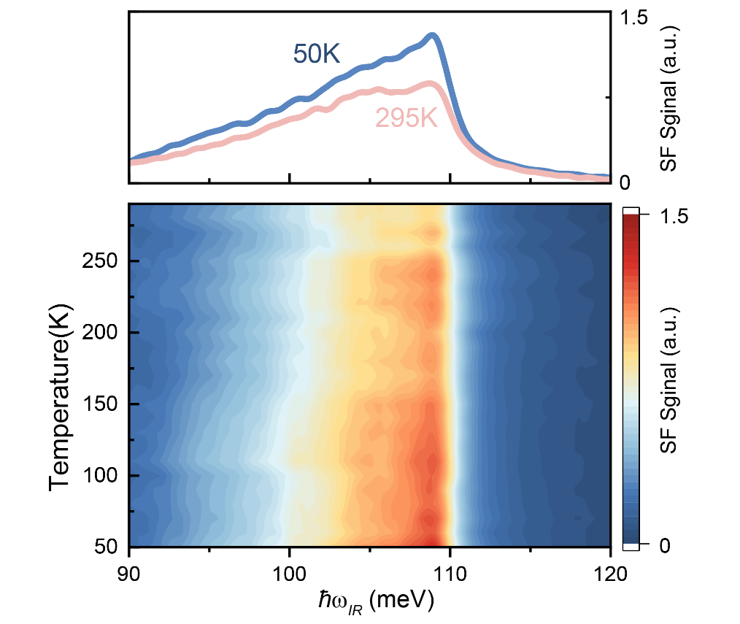
Supplementary Fig. S6 The temperature dependence of KTO (001) spectra.
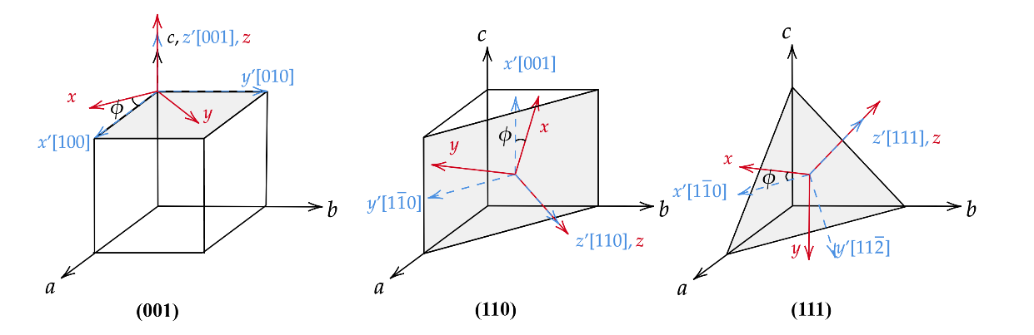
Supplementary Fig. S7 The sketch of the crystal {a, b, c} (black) and lab {x, y, z} (red) coordinates. The blue one {x’, y’, z’} denotes initial ϕ = 0° state.
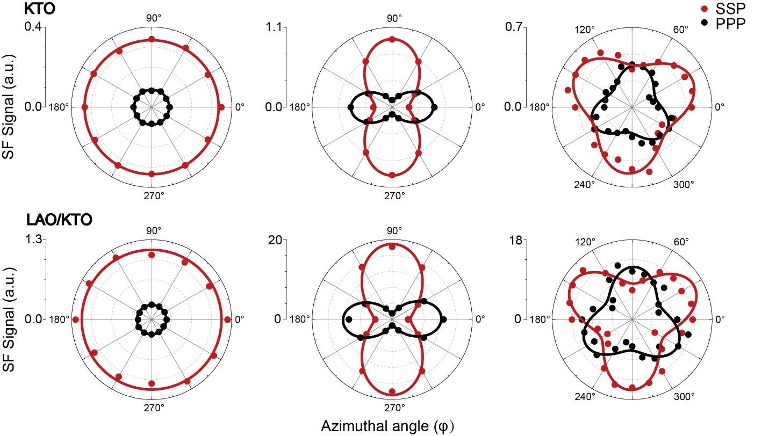
Supplementary Fig. S8 Anisotropy patterns of bare KTO substrates and LAO/KTO samples with signals averaged within range 90~120 meV, showing the same trends of those averaged between 106~108 meV as in Figs. 1 and 2 of the main text. The fitting parameters were listed in Supplementary Table 2.

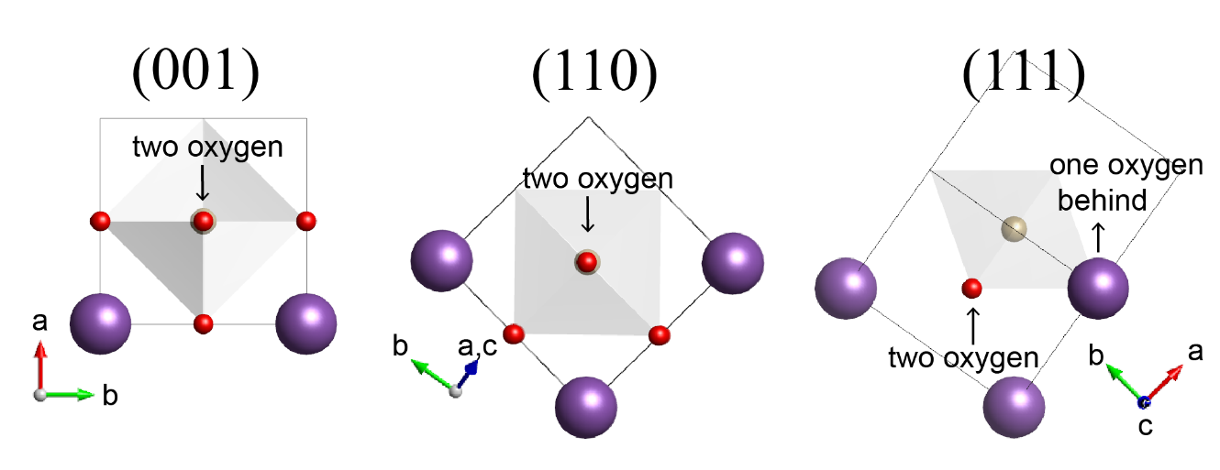
Supplementary Fig. S9 The sketch of semi-infinite model for three surfaces to estimate dipole moments.

Time | ω₂ (cm⁻¹) | A₁ | A₂
10 sec | 109.42±0.01 | 3.08±0.02 | 0.51±0.02
1 min | 109.82±0.02 | 2.44±0.01 | 0.71±0.02
2 min | 110.01±0.04 | 2.20±0.01 | 0.73±0.02
3 min | 110.18±0.03 | 2.01±0.01 | 0.73±0.02
5 min | 110.42±0.04 | 1.80±0.02 | 0.72±0.02
8 min | 110.72±0.06 | 1.59±0.02 | 0.71±0.02
10 min | 110.82±0.06 | 1.49±0.02 | 0.75±0.02
20 min | 111.47±0.10 | 1.13±0.02 | 0.79±0.02
30 min | 111.59±0.11 | 1.01±0.03 | 0.87±0.02
60 min | 111.87±0.14 | 0.68±0.04 | 0.90±0.02
120 min | 111.78±0.14 | 0.70±0.04 | 0.89±0.02

Supplementary Table S1 Fitting parameters of KTO (001) after UV illumination at 60K. The global fitting was employed to ensure the reliability with Re(χ_{NR}) = -0.23±0.01, Im(χ_{NR}) = -0.26±0.01, Γ₁= 2.43±0.01 cm⁻¹, ω₁= 101.76±0.02 cm⁻¹, Γ₂ = 2.83±0.05 cm⁻¹.
Integrated within 106~108 meV (Figure 1E and 2E)
Samples |  | SSP |  |  | PPP
 |  | C_{ani} | C_{iso} | φ₀ (°) | C_{ani} | C_{iso} | φ₀ (°)
KTO | (001) | / | 0.808±0.005 | / | / | 0.362±0.002 | /
KTO | (110) | 0.383±0.005 | 1.076±0.004 | 1.044±0.761 | 0.347±0.008 | 0.766±0.006 | -0.684±1.1.268
KTO | (111) | 0.076±0.012 | 0.986±0.009 | 7.984±8.847 | -0.064±0.015 | 0.743±0.011 | 30.877±13.435
LAO/  KTO | (001) | / | 1.523±0.005 | / | / | 0.733±0.002 | /
LAO/  KTO | (110) | -1.704±0.064 | 4.803±0.046 | 0.153±2.084 | 1.702±0.109 | 3.56±0.084 | -3.022±3.307
LAO/  KTO | (111) | 0.743±0.072 | 4.875±0.050 | -16.443±5.339 | -0.396±0.073 | 4.338±0.051 | 4.311±10.137
YAO/KTO | (111) | -0.290±0.066 | 6.100±0.047 | 40.774±13.06 | 0.209±0.022 | 4.755±0.0159 | 53.046±6.181

Integrated within 90~120 meV (Supplementary Fig. S8)
Samples |  | SSP |  |  | PPP
 |  | C_{ani} | C_{iso} | φ₀ (°) | C_{ani} | C_{iso} | φ₀ (°)
KTO | (001) | / | 0.578±0.002 | / | / | 0.295±0.001 | /
KTO | (110) | -0.243±0.003 | 0.726±0.002 | -0.232±0.719 | 0.225±0.005 | 0.528±0.004 | -1.717±1.211
KTO | (111) | 0.078±0.010 | 0.684±0.007 | 14.208±6.793 | -0.070±0.010 | 0.540±0.007 | 24.665±7.689
LAO/  KTO | (001) | / | 1.065±0.009 | / | / | 0.487±0.003 | /
LAO/  KTO | (110) | -1.099±0.038 | 3.245±0.028 | -0.193±1.956 | 1.128±0.056 | 2.377±0.043 | -2.651±2.561
LAO/  KTO | (111) | 0.566±0.064 | 3.414±0.045 | 3.952±6.131 | -0.401±0.073 | 3.043±0.050 | 6.736±9.900

Supplementary Table S2 Fitting parameters of the SSP and PPP patterns. The fitting formulas used for the (001), (110), and (111) crystal surfaces are as follows: y=| C_{iso} |² , y=| C_{ani} cos(2x+φ₀)+ C_{iso} |² and y=| C_{ani} sin(3x+φ₀)+ C_{iso} |².

Integrated within 106~108 meV (Figure 1E and 2E)
 | SSP |  |  |  | PPP
 | LAO/KTO |  |  | YAO/KTO | LAO/KTO |  |  | YAO/KTO
 | (001) | (110) | (111) | (111) | (001) | (110) | (111) | (111)
${}_{B,1}^{\left(2\right)}$ (a.u.) | 11.28 | 24.86 | 51.79 | 49.67 | 11.28 | 56.59 | 39.65 | 55.04
${}_{B,2}^{\left(2\right)}$ (a.u.) | 9.25 | 37.10 | 25.83 | 38.51 | 9.25 | 21.20 | 31.93 | 35.81
${}_{B,3}^{\left(2\right)}$ (a.u.) | / | 9.72 | 7.30 | 7.80 | / | 1.73 | 7.33 | 7.79

Integrated within 90~120 meV (Supplementary Fig. S8)
 | SSP |  |  | PPP
 | (001) | (110) | (111) | (001) | (110) | (111)
${}_{B,1}^{\left(2\right)}$ (a.u.) | 7.78 | 17.21 | 36.75 | 7.78 | 37.91 | 26.34
${}_{B,2}^{\left(2\right)}$ (a.u.) | 6.47 | 24.80 | 17.86 | 6.47 | 14.42 | 23.09
${}_{B,3}^{\left(2\right)}$ (a.u.) | / | 6.38 | 5.12 | / | 1.16 | 5.15

Supplementary Table S3 The susceptibility of LAO/KTO and YAO/KTO obtained through SSP and PPP patterns.
Integrated within 106~108 meV (Figure 1A and 2F)
 | SSP |  |  | PPP
 | (001) | (110) | (111) | (001) | (110) | (111)
${}_{S,1}^{\left(2\right)}$ (a.u.) | 5.87 | 5.39 | 9.17 | 5.87 | 12.23 | 7.65
${}_{S,2}^{\left(2\right)}$ (a.u.) | 4.91 | 8.33 | 5.60 | 4.91 | 4.91 | 6.36
${}_{S,3}^{\left(2\right)}$ (a.u.) | / | 2.12 | 1.20 | / | 0.40 | 1.20

Integrated within 90~120 meV (Supplementary Fig. S8)
 | SSP |  |  | PPP
 | (001) | (110) | (111) | (001) | (110) | (111)
${}_{S,1}^{\left(2\right)}$ (a.u.) | 4.35 | 3.86 | 6.71 | 4.35 | 8.20 | 5.13
${}_{S,2}^{\left(2\right)}$ (a.u.) | 3.51 | 5.53 | 3.75 | 3.51 | 3.36 | 4.55
${}_{S,3}^{\left(2\right)}$ (a.u.) | / | 1.41 | 0.89 | / | 0.32 | 0.89

Supplementary Table S4 The susceptibility of KTO obtained through SSP and PPP patterns.
Integrated within 106~108 meV (Figure 1E and 2E)
 | SSP |  |  |  | PPP
 | LAO/KTO |  |  | YAO/KTO | LAO/KTO |  |  | YAO/KTO
 | (001) | (110) | (111) | (111) | (001) | (110) | (111) | (111)
f₁ (a.u.) | 1.9 | 4.6 | 5.7 | 5.4 | 1.9 | 4.6 | 5.2 | 7.2
f₂ (a.u.) | 1.9 | 4.5 | 4.6 | 6.9 | 1.9 | 4.3 | 5.0 | 5.6
f₃ (a.u.) | / | 4.6 | 6.1 | 6.5 | / | 4.5 | 6.1 | 6.5

Integrated within 90~120 meV (Supplementary Fig. S8)
 | SSP |  |  | PPP
 | (001) | (110) | (111) | (001) | (110) | (111)
f₁ (a.u.) | 1.8 | 4.5 | 5.5 | 1.8 | 4.6 | 5.1
f₂ (a.u.) | 1.8 | 4.5 | 4.8 | 1.8 | 4.3 | 5.1
f₃ (a.u.) |  | 4.5 | 5.8 |  | 3.7

Supplementary Table S5 The polarity enhancement factor.

Photon energey | $${}_{yyx}$$ | $${}_{yyz}$$ | $${}_{xxz}$$ | $${}_{zxx}$$ | $${}_{xzx}$$ | $${}_{xxx}$$ | $${}_{zzz}$$
107 meV | 0.2779 | 0.1645 | 0.2153 | 0.1806 | 0.1784 | 0.2420 | 0.1185
104 meV | 0.3139 | 0.0414 | 0.0542 | 0.2040 | 0.2015 | 0.2733 | 0.0298

Supplementary Table S6 Dimensionless coefficients including Fresnel coefficients after projection to the polarization vector.

 | (001) | (110) | (111)
nominal | 1.142 | 4.263 | 4.226
BECs | 3.622 | 10.512 | 10.149

Supplementary Table S7 Dipole moments along the surface normal for different surfaces.

References
1. Shen, Y. R. Fundamentals of sum-frequency spectroscopy. (Cambridge University Press, 2016).
2. Liu, X. et al. Nonlinear optical phonon spectroscopy revealing polaronic signatures of the LaAlO₃/SrTiO₃ interface. Sci. Adv. 9, eadg7037 (2023).
3. Chen, X. et al. Orientation-dependent electronic structure in interfacial superconductors LaAlO₃/KTaO₃. Nat. Commun. 15, (2024).
4. Shi, H. et al. Surface and bulk contributions to the second-harmonic generation in Bi₂Se₃. Phys. Rev. B. 94, (2016).
5. Miller, R. C. & Spitzer, W. G. Far Infrared Dielectric Dispersion in KTaO₃. Physical Review. 129, 94-98 (1963).
6. Ghosez, P., Michenaud, J. P. & Gonze, X. Dynamical atomic charges: The case of ABO₃ compounds. Phys. Rev. B. 58, 6224-6240 (1998).
7. Geilhufe, R. M., Juričić, V., Bonetti, S., Zhu, J. & Balatsky, A. V. Dynamically induced magnetism in KTaO₃. Phys. Rev. Res. 3, L022011 (2021).
8. Cabuk, S. Ab initio volume-dependent elastic and lattice dynamics properties of KTaO₃. Physica Status Solidi (B). 247, 93-97 (2010).
9. Gupta, A. et al. KTaO₃ —The New Kid on the Spintronics Block. Adv. Mater. 34, (2022).

