Design, Synthesis, Biological Evaluation, and In Silico Studies of Novel Phenylthiazole Derivatives as Multifunctional Skin-Whitening Agents
Yang Xu ¹, Xuhui Liang¹ and Chang-Gu Hyun ^{1,2*}
¹ Jeju Inside Agency and Cosmetic Science Center, Jeju National University, Jeju 63243, Korea
² Department of Beauty and Cosmetology, Jeju National University, Jeju 63243, Korea
* Correspondence: cghyun@jejunu.ac.kr; Tel.: +82-64-754-1803
Supplementary materials
Table S1. Gradient elution of the mobile phase for the synthetic compounds using HPLC 5
Table S2. The stability of the synthesized compounds in aqueous solution 5
Figure S1. 1H NMR of the 4-phenyl-2-(2-(propan-2-ylidene)hydrazineyl)thiazole (3a) 6
Figure S2. ¹³C NMR of the 4-phenyl-2-(2-(propan-2-ylidene)hydrazineyl)thiazole (3a) 6
Figure S3. HRMS of the 4-phenyl-2-(2-(propan-2-ylidene)hydrazineyl)thiazole (3a) 7
Figure S4. ¹H NMR of the 4-(4-methoxyphenyl)-2-(2-(propan-2-ylidene)hydrazineyl)thiazole (3b) 7
Figure S5. ¹³C NMR of the 4-(4-methoxyphenyl)-2-(2-(propan-2-ylidene)hydrazineyl)thiazole (3b) 8
Figure S6. HRMS of the 4-(4-methoxyphenyl)-2-(2-(propan-2-ylidene)hydrazineyl)thiazole (3b) 8
Figure S7. ¹H NMR of the 4-(2-(2-(propan-2-ylidene)hydrazineyl)thiazol-4-yl)phenol (3c) 9
Figure S8. ¹³C NMR of the 4-(2-(2-(propan-2-ylidene)hydrazineyl)thiazol-4-yl)phenol (3c) 9
Figure S9. HRMS of the 4-(2-(2-(propan-2-ylidene)hydrazineyl)thiazol-4-yl)phenol (3c) 10
Figure S10. 1H NMR of the 3-(2-(2-(propan-2-ylidene)hydrazineyl)thiazol-4-yl)phenol (3d) 10
Figure S11. ¹³C NMR of the 3-(2-(2-(propan-2-ylidene)hydrazineyl)thiazol-4-yl)phenol (3d) 11
Figure S12. HRMS of the 3-(2-(2-(propan-2-ylidene)hydrazineyl)thiazol-4-yl)phenol (3d) 11
Figure S13. ¹H NMR of the 2-(2-(2-(propan-2-ylidene)hydrazineyl)thiazol-4-yl)phenol (3e) 12
Figure S14. ¹³C NMR of the 2-(2-(2-(propan-2-ylidene)hydrazineyl)thiazol-4-yl)phenol (3e) 12
Figure S15. HRMS of the 2-(2-(2-(propan-2-ylidene)hydrazineyl)thiazol-4-yl)phenol (3e) 13
Figure S16. 1H NMR of the 4-(4-fluorophenyl)-2-(2-(propan-2-ylidene)hydrazineyl)thiazole (3f) 13
Figure S17. ¹³C NMR of the 4-(4-fluorophenyl)-2-(2-(propan-2-ylidene)hydrazineyl)thiazole (3f) 14
Figure S18. HRMS of the 4-(4-fluorophenyl)-2-(2-(propan-2-ylidene)hydrazineyl)thiazole (3f) 14
Figure S19. ¹H NMR of the 4-fluoro-2-(2-(2-(propan-2-ylidene)hydrazineyl)thiazol-4-yl)phenol (3g) 15
Figure S20. ¹³C NMR of the 4-fluoro-2-(2-(2-(propan-2-ylidene)hydrazineyl)thiazol-4-yl)phenol (3g) 15
Figure S21. HRMS of the 4-fluoro-2-(2-(2-(propan-2-ylidene)hydrazineyl)thiazol-4-yl)phenol (3g) 16
Figure S22. ¹H NMR of the 4-(3,4-dimethoxyphenyl)-2-(2-(propan-2-ylidene)hydrazineyl)thiazole (3h) 16
Figure S23. ¹³C NMR of the 4-(3,4-dimethoxyphenyl)-2-(2-(propan-2-ylidene)hydrazineyl)thiazole (3h) 17
Figure S24. HRMS of the 4-(3,4-dimethoxyphenyl)-2-(2-(propan-2-ylidene)hydrazineyl)thiazole (3h) 17
Figure S25. Antimelanogenic effects of compounds in B16F10 melanoma cells. 18
Figure S26. Synthesis compounds 3a-3h on NO producton and cell viability in LPS-induced RAW 264.7macrophage cells. 18
Figure S27. The inhibition percentage of DPPH by the synthesized compounds 18
Figure S28. HPLC chromatograms for stability evaluation of the synthesized compounds 19

Table S1. Gradient elution of the mobile phase for the synthetic compounds using HPLC
The mobile phase consisted of solvent A (0.1% acetic acid in water) and solvent B (acetonitrile). Gradient elution was performed at a flow rate of 1.0 mL/min.

Time | Solution (A) % | Solution (B) %
0 to 10 min | 90 | 10
10 to 20 min | 60 | 40
20 to 28 min | 30 | 70
28 to 30 min | 5 | 95
30 to 40 min | 90 | 10

Table S2. The stability of the synthesized compounds in aqueous solution
Each compound was dissolved in an acetonitrile–water (1:1, v/v) mixture, followed by sonication and filtration through a 0.22 μm membrane filter prior to analysis. The detection wavelength was set at 248 nm. Peak areas were quantified using the minimum area integration method.

Compounds | 0 day |  | 1 month |  | Degradation  (%)
Compounds | RT (min) | Area (%) | RT (min) | Area (%) | Degradation  (%)
3a | 30.837 | 95.60 | 30.862 | 87.50 | 8.10
3b | 30.462 | 95.36 | 30.482 | 85.48 | 9.88
3c | 26.237 | 96.93 | 26.205 | 87.31 | 9.62
3d | 31.912 | 97.44 | 31.875 | 85.36 | 12.08
3e | 26.813 | 96.73 | 26.780 | 85.21 | 11.52
3f | 31.265 | 95.59 | 31.213 | 88.81 | 6.78
3g | 32.185 | 96.68 | 32.184 | 84.32 | 12.36
3h | 28.815 | 94.80 | 28.775 | 88.46 | 6.36

Figure S1. 1H NMR of the 4-phenyl-2-(2-(propan-2-ylidene)hydrazineyl)thiazole (3a)
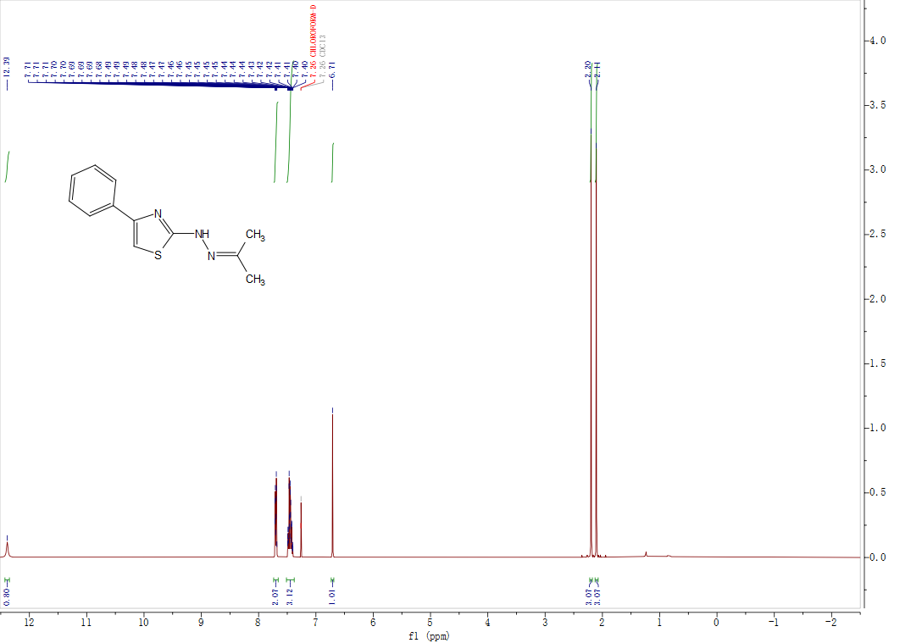

Figure S2. ¹³C NMR of the 4-phenyl-2-(2-(propan-2-ylidene)hydrazineyl)thiazole (3a)

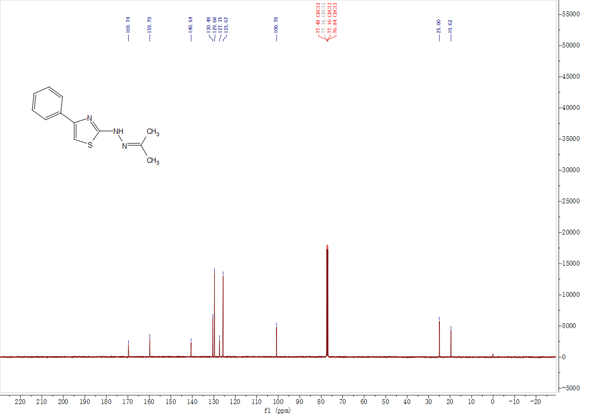

Figure S3. HRMS of the 4-phenyl-2-(2-(propan-2-ylidene)hydrazineyl)thiazole (3a)

Figure S4. ¹H NMR of the 4-(4-methoxyphenyl)-2-(2-(propan-2-ylidene)hydrazineyl)thiazole (3b)

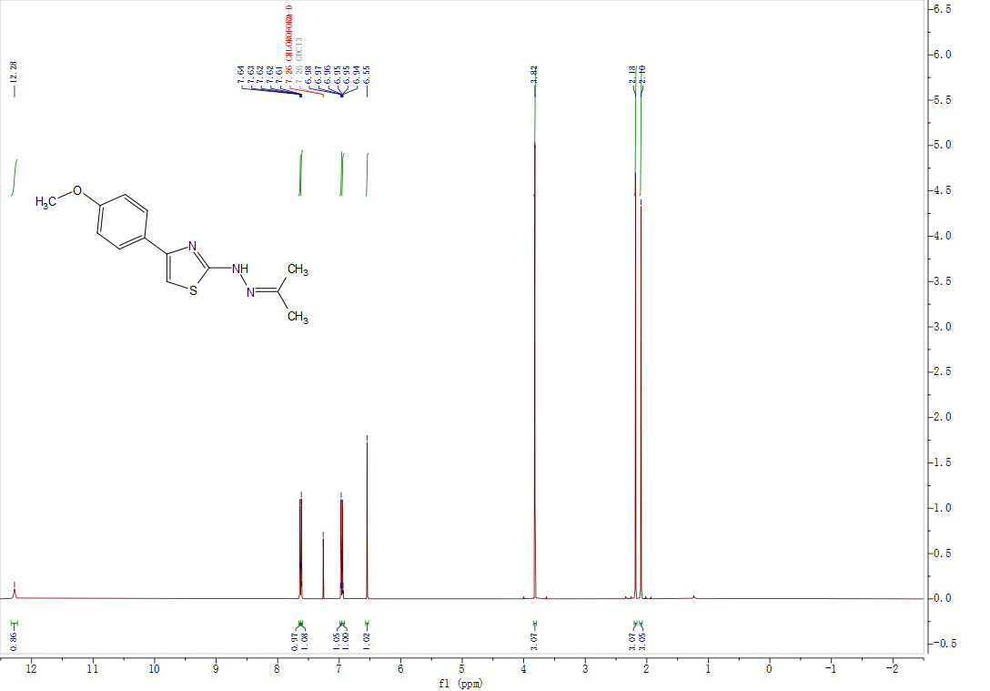

Figure S5. ¹³C NMR of the 4-(4-methoxyphenyl)-2-(2-(propan-2-ylidene)hydrazineyl)thiazole (3b)
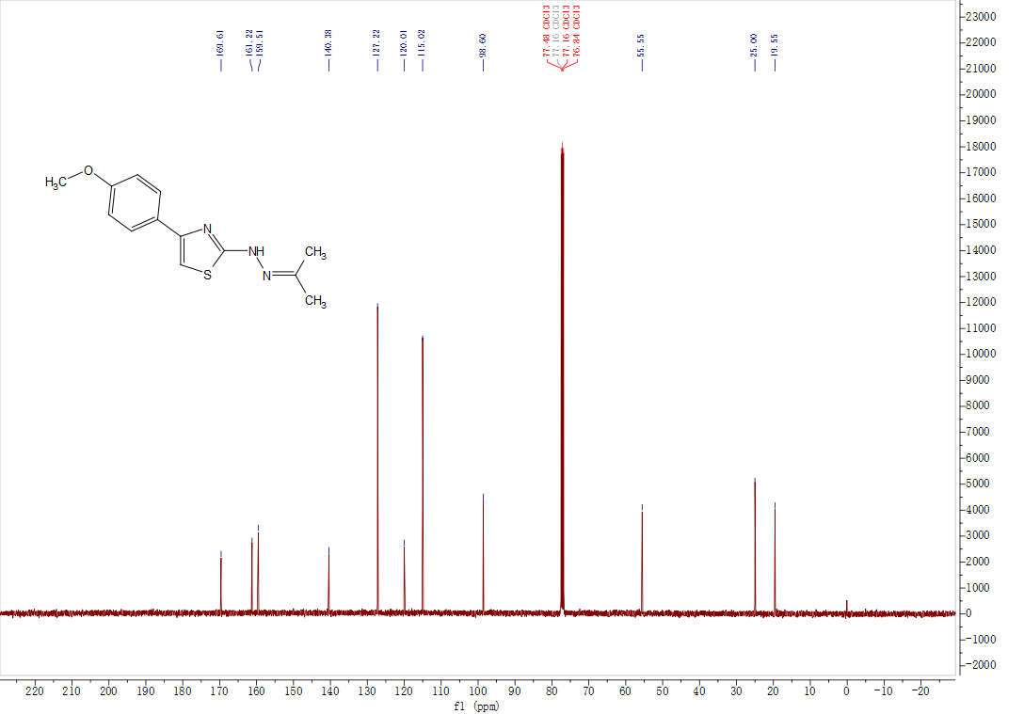

Figure S6. HRMS of the 4-(4-methoxyphenyl)-2-(2-(propan-2-ylidene)hydrazineyl)thiazole (3b)

Figure S7. ¹H NMR of the 4-(2-(2-(propan-2-ylidene)hydrazineyl)thiazol-4-yl)phenol (3c)

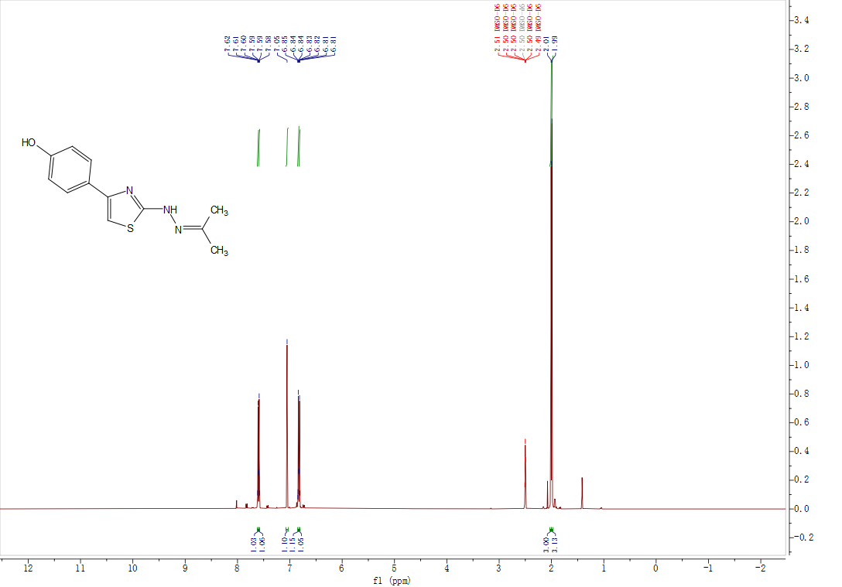

Figure S8. ¹³C NMR of the 4-(2-(2-(propan-2-ylidene)hydrazineyl)thiazol-4-yl)phenol (3c)
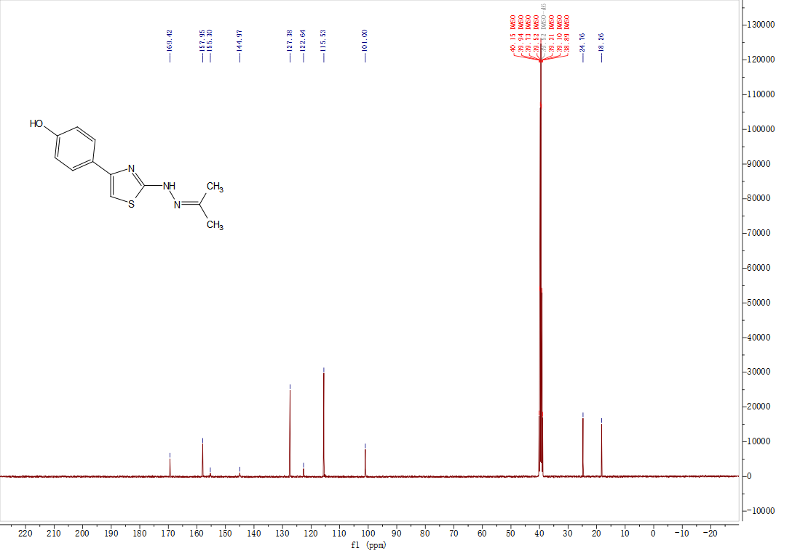

Figure S9. HRMS of the 4-(2-(2-(propan-2-ylidene)hydrazineyl)thiazol-4-yl)phenol (3c)

Figure S10. 1H NMR of the 3-(2-(2-(propan-2-ylidene)hydrazineyl)thiazol-4-yl)phenol (3d)

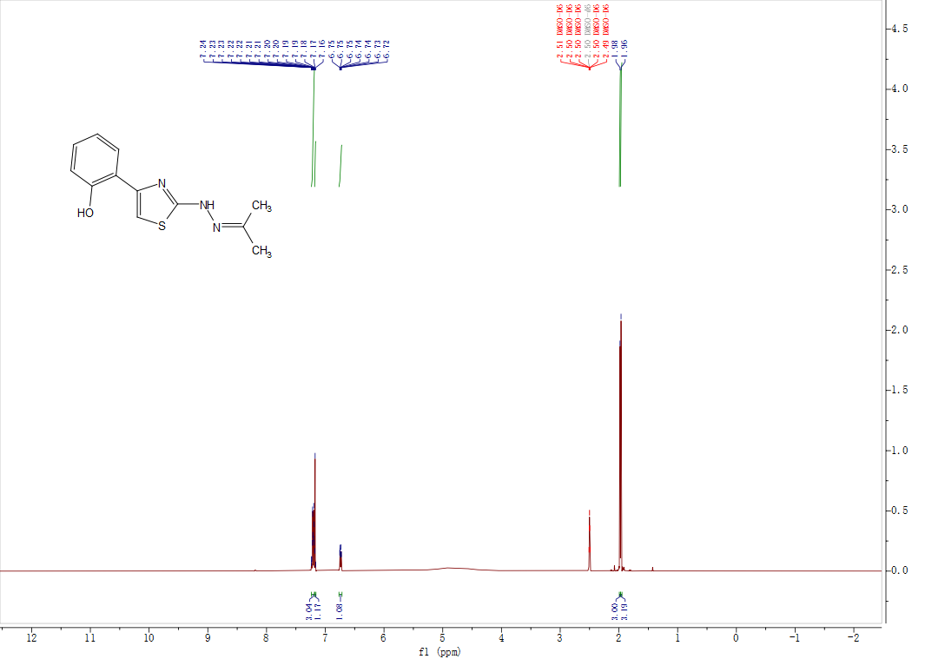

Figure S11. ¹³C NMR of the 3-(2-(2-(propan-2-ylidene)hydrazineyl)thiazol-4-yl)phenol (3d)
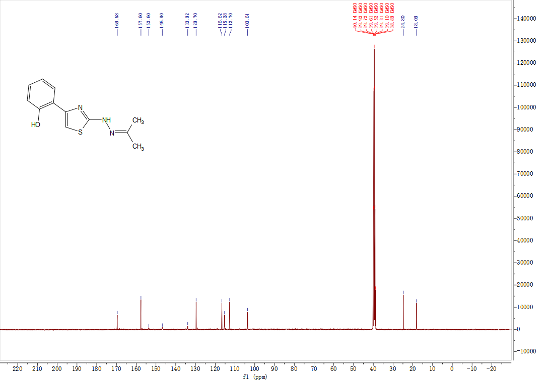

Figure S12. HRMS of the 3-(2-(2-(propan-2-ylidene)hydrazineyl)thiazol-4-yl)phenol (3d)

Figure S13. ¹H NMR of the 2-(2-(2-(propan-2-ylidene)hydrazineyl)thiazol-4-yl)phenol (3e)
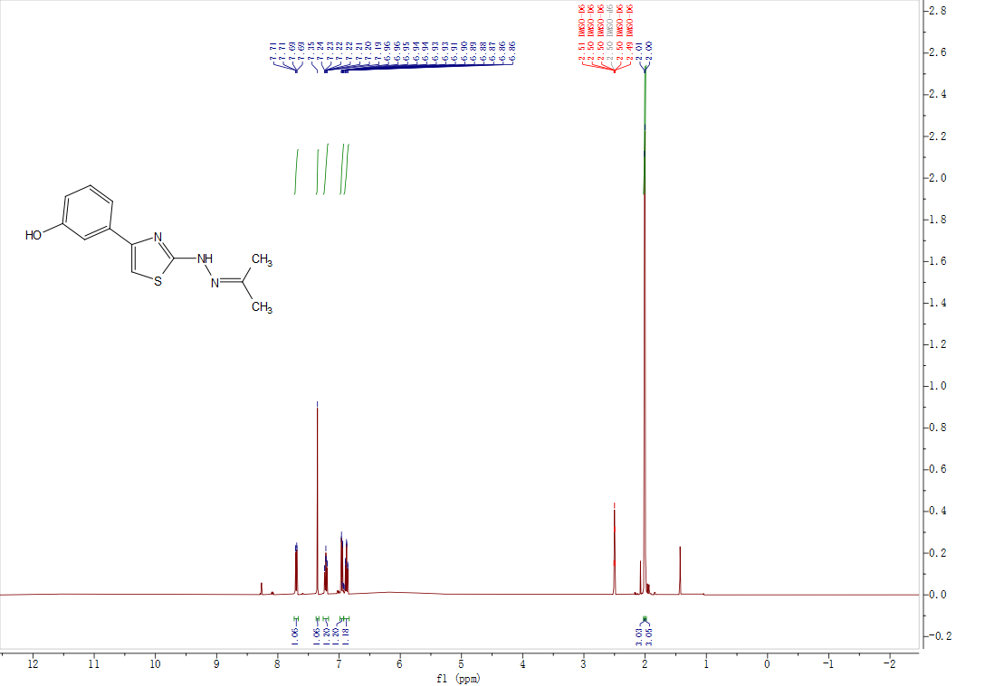

Figure S14. ¹³C NMR of the 2-(2-(2-(propan-2-ylidene)hydrazineyl)thiazol-4-yl)phenol (3e)
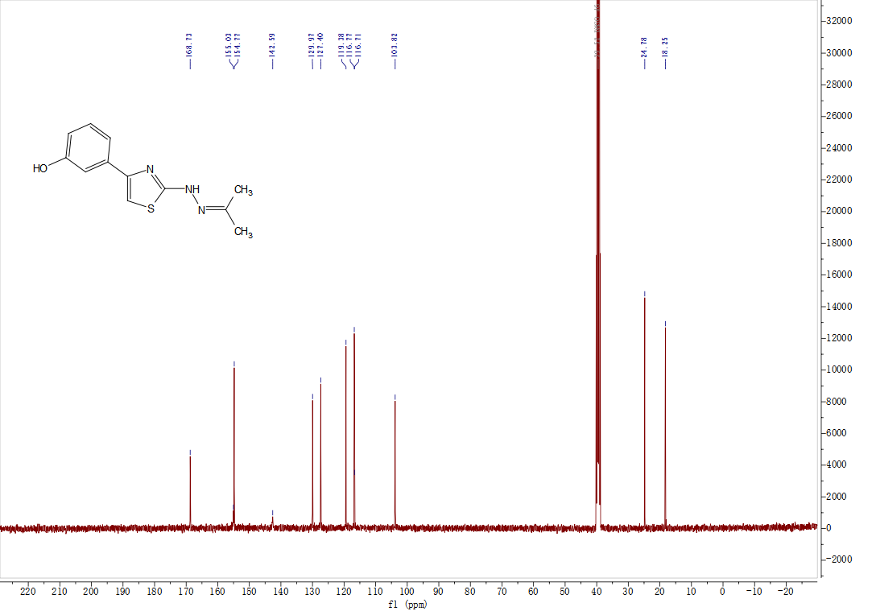

Figure S15. HRMS of the 2-(2-(2-(propan-2-ylidene)hydrazineyl)thiazol-4-yl)phenol (3e)

Figure S16. 1H NMR of the 4-(4-fluorophenyl)-2-(2-(propan-2-ylidene)hydrazineyl)thiazole (3f)

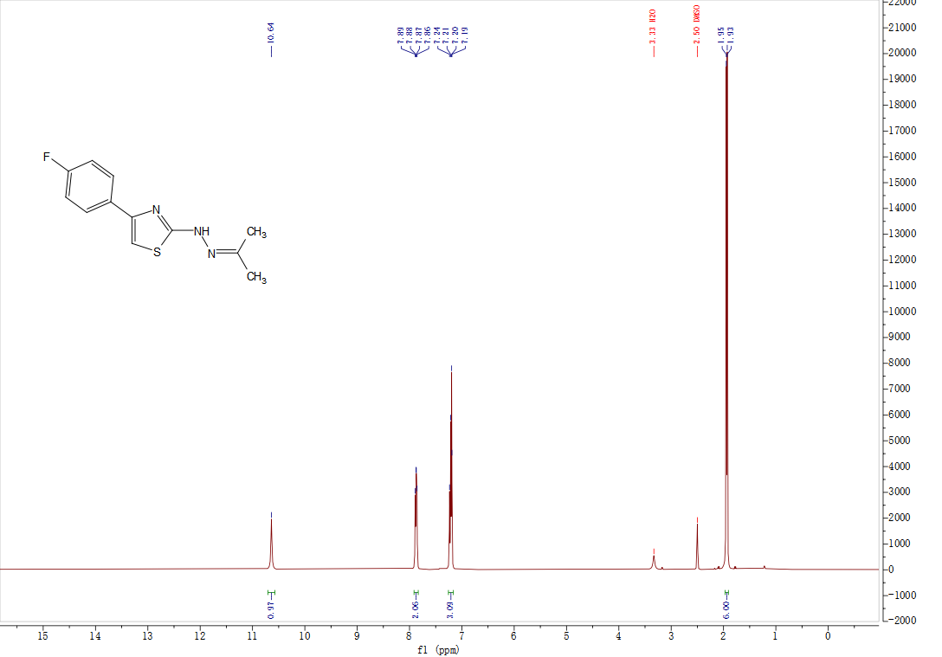

Figure S17. ¹³C NMR of the 4-(4-fluorophenyl)-2-(2-(propan-2-ylidene)hydrazineyl)thiazole (3f)
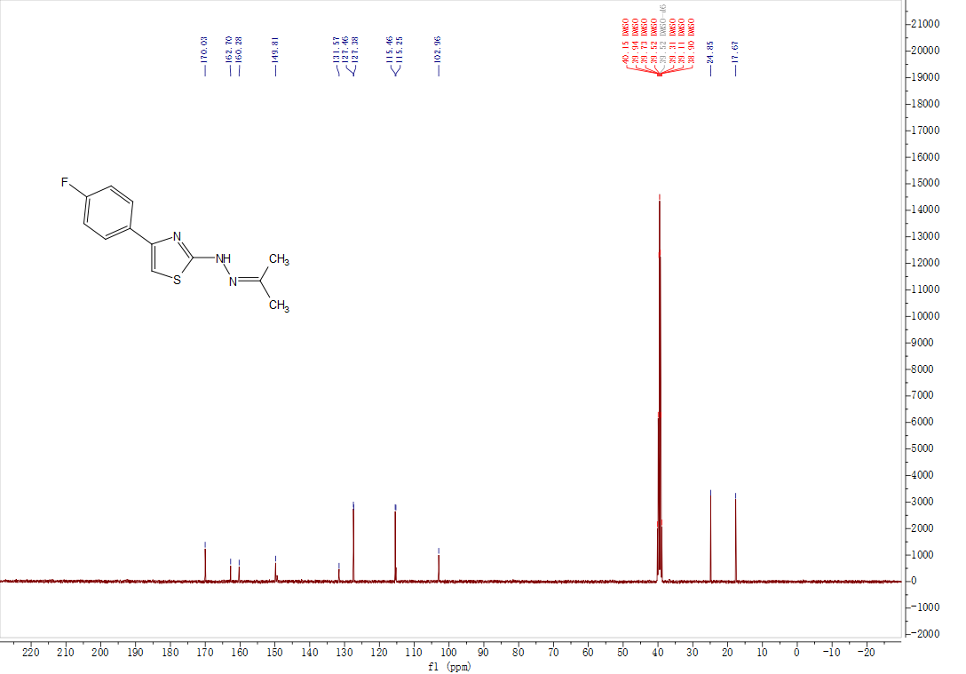

Figure S18. HRMS of the 4-(4-fluorophenyl)-2-(2-(propan-2-ylidene)hydrazineyl)thiazole (3f)

Figure S19. ¹H NMR of the 4-fluoro-2-(2-(2-(propan-2-ylidene)hydrazineyl)thiazol-4-yl)phenol (3g)
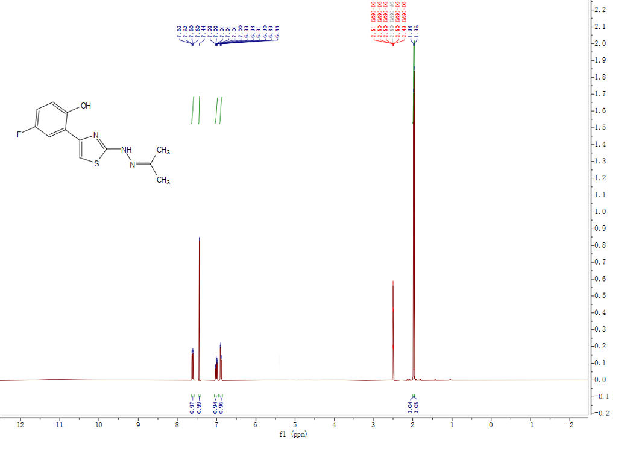

Figure S20. ¹³C NMR of the 4-fluoro-2-(2-(2-(propan-2-ylidene)hydrazineyl)thiazol-4-yl)phenol (3g)
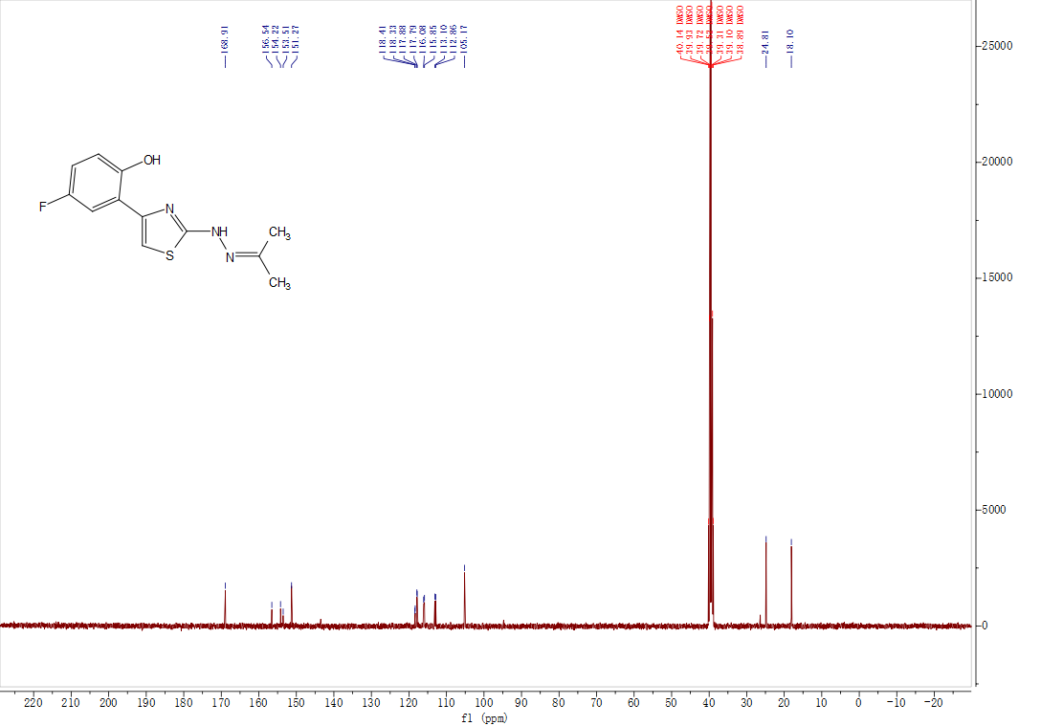

Figure S21. HRMS of the 4-fluoro-2-(2-(2-(propan-2-ylidene)hydrazineyl)thiazol-4-yl)phenol (3g)

Figure S22. ¹H NMR of the 4-(3,4-dimethoxyphenyl)-2-(2-(propan-2-ylidene)hydrazineyl)thiazole (3h)

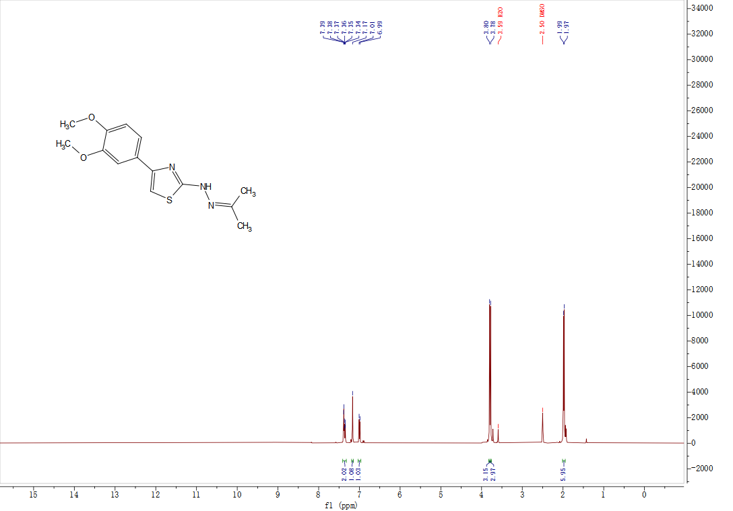

Figure S23. ¹³C NMR of the 4-(3,4-dimethoxyphenyl)-2-(2-(propan-2-ylidene)hydrazineyl)thiazole (3h)
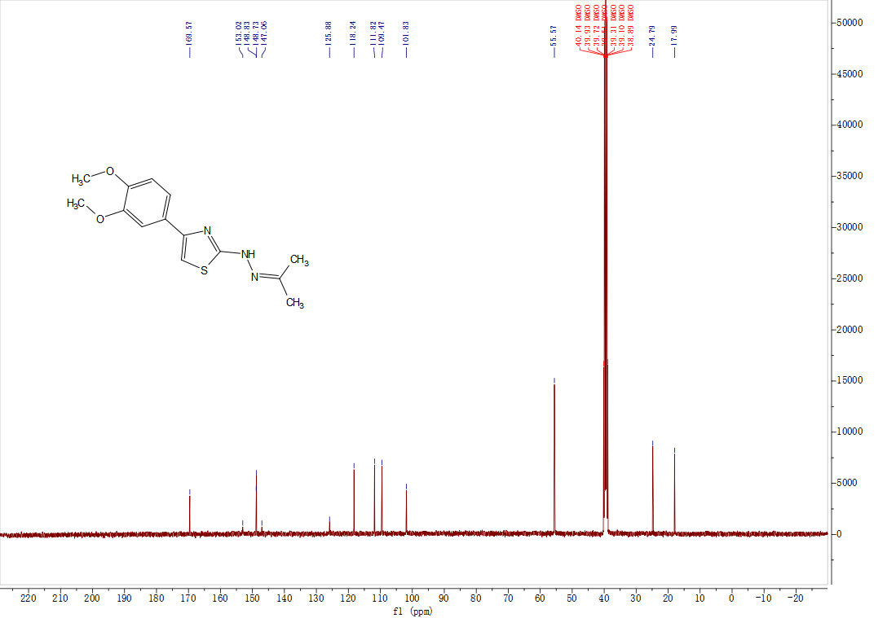

Figure S24. HRMS of the 4-(3,4-dimethoxyphenyl)-2-(2-(propan-2-ylidene)hydrazineyl)thiazole (3h)
Figure S25. Antimelanogenic effects of compounds in B16F10 melanoma cells. (A) 3a; (B) 3b; (C) 3e; (D) 3g; (E) 3h. Cells were stimulated with 100 nM α-MSH, and arbutin (100 μM) served as the positive control. Data are presented as mean ± SD from three independent experiments. Values are the mean SEM of triplicate experiments. *p < 0.05; **p < 0.01.
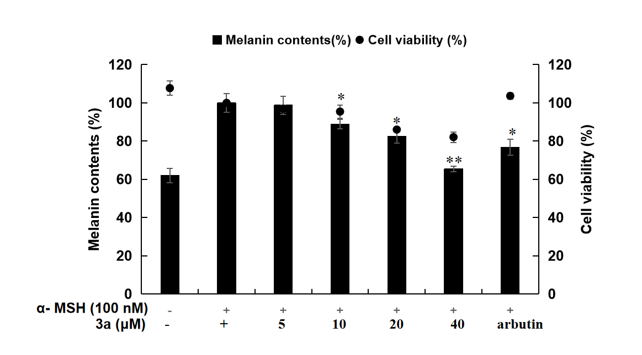 | 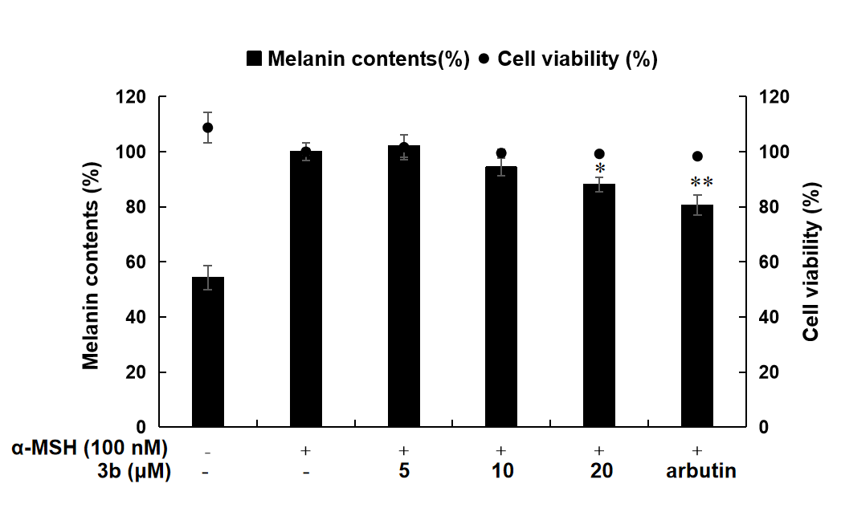 | 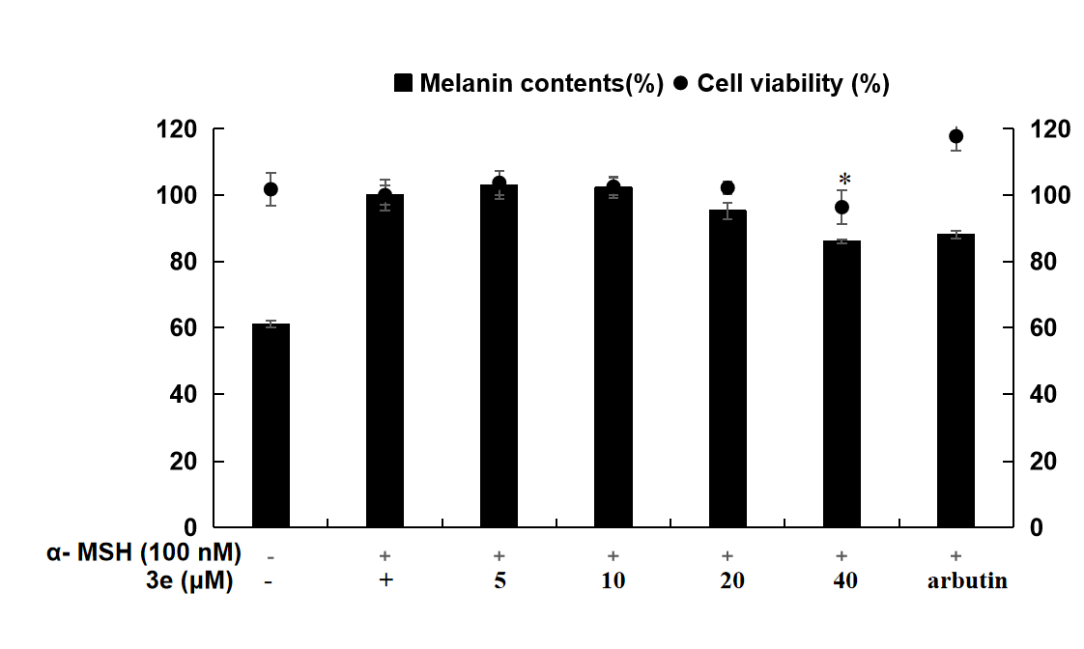
A | B | C
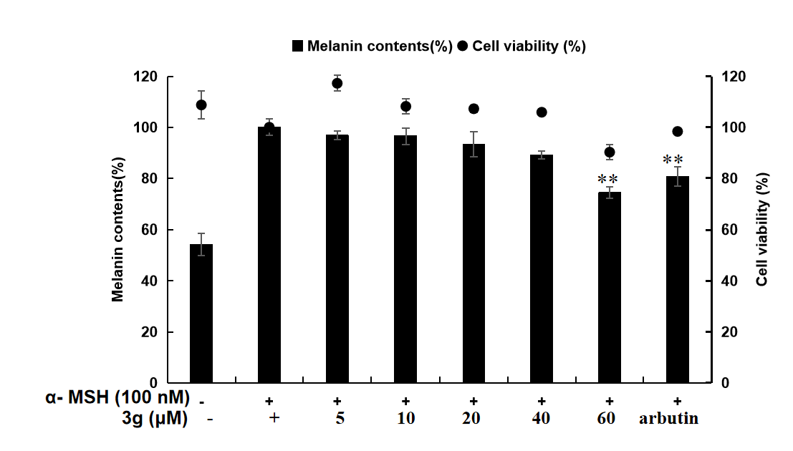 | 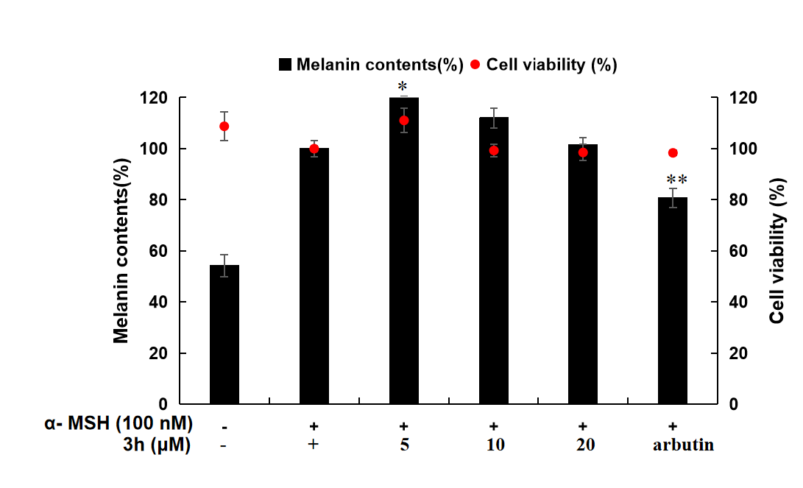
D | E

Figure S26. Synthesis compounds 3a-3h on NO producton and cell viability in LPS-induced RAW 264.7macrophage cells. The cells were stimulated with 1 μg /mL of LPS only, or with LPS plus 3a-3h and L-NIL (positive control, 40 μM) for 24 h. The data represent the mean ±SD of triplicate experiments. Values are the mean SEM of triplicate experiments. *p < 0.05; **p < 0.01
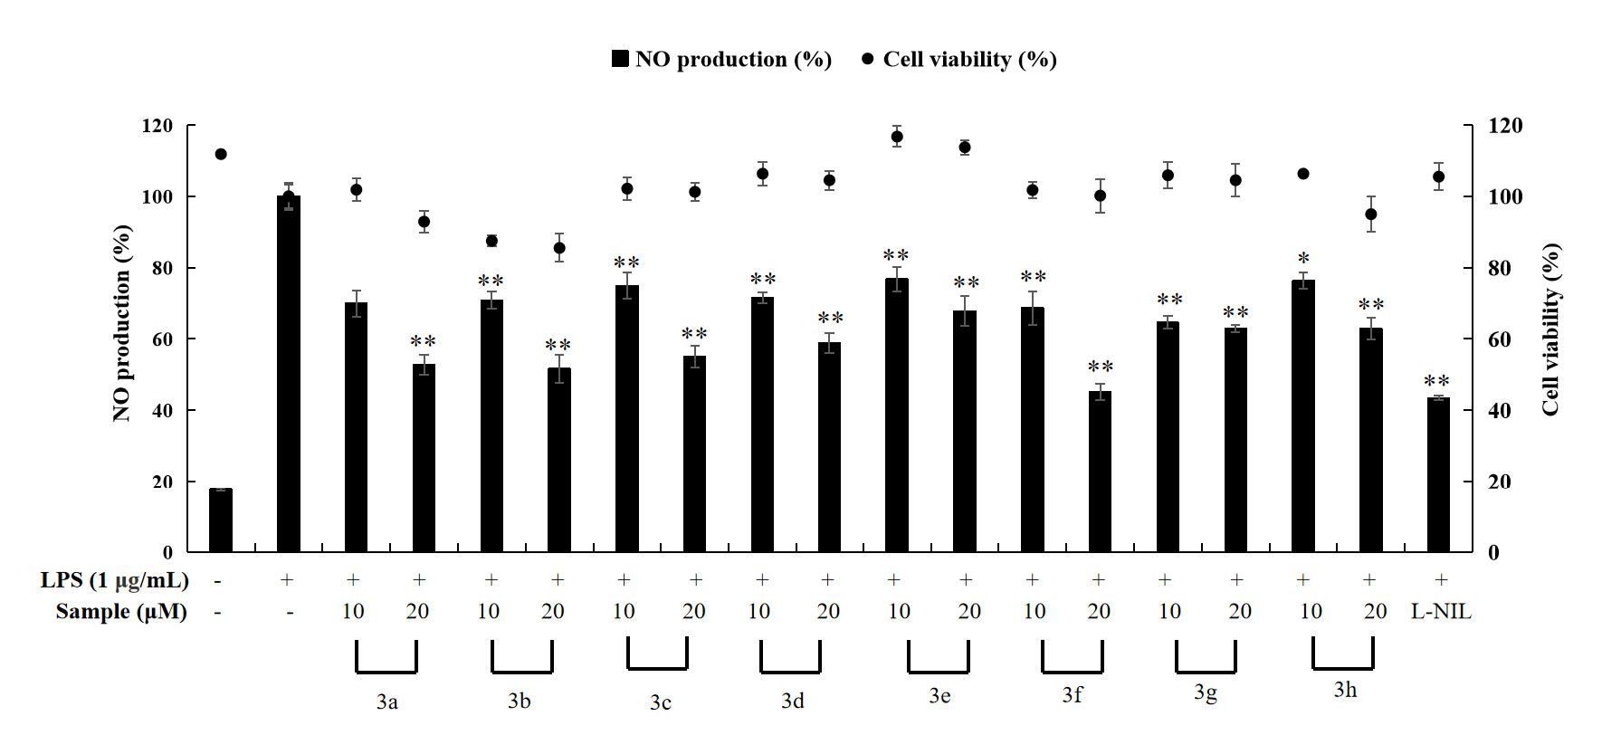

Figure S27. The inhibition percentage of DPPH by the synthesized compounds
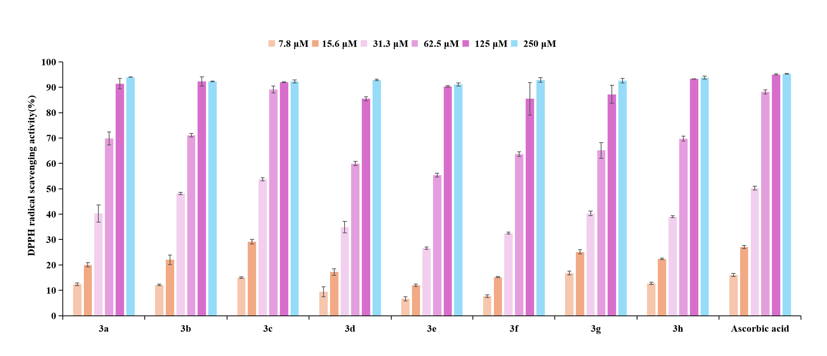

Figure S28. HPLC chromatograms for stability evaluation of the synthesized compounds

