Supplementary Table 1. Comprehensive table reporting all variables acquired per patient.
Patient ID | Gender (f/m) | Age (y) | Circulating PCs (%) | Light chain type CPCs | BM-PCs (%) | Light chain type BM-PCs | Different markers | CD138 | CD45 | CD56 | CD19 | CD81 | CD20 | CD27 | CD117 | WBC (xµl) | Neutrophils (%) | Lymphocytes (%) | Monocytes (%) | Platelets (x10*9) | Calcium (mg/dL) | Albumin (g/L) | LDH (IU/L) | Tot proteins (g/dL) | CRP (mg/dL) | M-protein (%) | κ/λ | β2M (mg/L)
MPC_1185 | m | 76 | 0.100000 | KAPPA | 2.000 | KAPPA | CD56 | dim | neg | pos | neg | neg | neg | pos | neg | 17650 | 68.1 | 22.4 | 9.3 | 229 | 9.1 | 39.4 | 219 | 6.9 | 0.35 | 12.8 | 83.23 | n/a
MPC_3301 | f | 57 | 0.009000 | LAMBDA | 35.500 | LAMBDA | CD56 | high | neg | pos | neg | pos | neg | neg | neg | 37970 | n/a | n/a | n/a | n/a | n/a | n/a | n/a | n/a | n/a | n/a | n/a | n/a
MPC_332 | m | 60 | 0.900000 | KAPPA | 1.500 | KAPPA | n/a | high | neg | pos | neg | pos | neg | neg | neg | 7970 | 44.6 | 47.1 | 6.5 | 173 | 9.4 | 40.5 | 155 | 9.2 | 0.11 | 29.1 | 445.4 | n/a
MPC_3334 | f | 75 | 0.002000 | LAMBDA | 3.500 | LAMBDA | CD27 | high | neg | pos | neg | neg | neg | pos | pos | 15080 | 33.9 | 58.2 | 7 | 168 | 9.6 | 43.6 | 169 | 6.7 | 0.25 | 1.4 | 0.01 | 4.2
MPC_3513 | f | 36 | 0.033000 | KAPPA | 15.000 | KAPPA | CD56, CD19 | dim | neg | pos | pos | pos | pos | neg | pos | 11860 | n/a | n/a | n/a | n/a | n/a | n/a | n/a | n/a | n/a | n/a | n/a | n/a
MPC_3520 | m | 79 | 0.007000 | KAPPA | 6.200 | KAPPA | n/a | high | neg | pos | neg | neg | neg | neg | neg | 12640 | 70.1 | 19.5 | 6.5 | 207 | 9.4 | 34.6 | 167 | 8.8 | 0.77 | 26.9 | 24.23 | n/a
MPC_3521 | f | 63 | 0.100000 | KAPPA | 22.000 | KAPPA | CD56, CD117 | dim | neg | neg | neg | neg | neg | neg | neg | 4180 | n/a | n/a | n/a | n/a | n/a | n/a | n/a | n/a | n/a | n/a | n/a | n/a
MPC_3569 | m | 74 | 0.020000 | KAPPA | 11.000 | KAPPA | CD81 | high | neg | pos | neg | pos | neg | neg | pos | 8660 | 41.3 | 45.6 | 8.9 | 143 | 9.9 | n/a | 146 | 8 | 0.14 | 18.7 | 174.69 | 10
MPC_3570 | m | 79 | 0.100000 | LAMBDA | 12.000 | LAMBDA | n/a | high | neg | pos | neg | neg | neg | neg | neg | 29820 | n/a | n/a | n/a | n/a | n/a | n/a | n/a | n/a | n/a | n/a | n/a | n/a
MPC_3572 | m | 71 | 0.300000 | LAMBDA | 0.000 | n/a | n/a | dim | neg | pos | neg | pos | neg | neg | neg | 13860 | n/a | n/a | n/a | n/a | n/a | n/a | n/a | n/a | n/a | n/a | n/a | n/a
MPC_3578 | f | 81 | 0.030000 | LAMBDA | 7.000 | LAMBDA | n/a | high | neg | pos | neg | neg | neg | neg | pos | 17920 | 37.3 | 53.5 | 8.1 | 188 | 9.1 | 36.34 | 205 | 7.8 | 0.43 | 23.2 | 0.04 | 2.2
MPC_3601 | f | 61 | 0.200000 | KAPPA | 19.000 | KAPPA | CD56 | dim | neg | dim | neg | neg | neg | dim | neg | 19670 | n/a | n/a | n/a | n/a | n/a | n/a | n/a | n/a | n/a | n/a | n/a | n/a
MPC_3602 | m | 66 | 0.010000 | KAPPA | 1.600 | KAPPA | CD81, CD27, CD117 | high | neg | pos | pos | pos | neg | neg | neg | 10640 | 62.9 | 26.3 | 6.9 | 325 | 9.6 | 40.1 | 206 | 9.2 | 1.45 | 28.5 | 14.01 | 2.5
MPC_3608 | m | 71 | 0.000000 | n/a | 0.400 | KAPPA | n/a | n/a | n/a | n/a | n/a | n/a | n/a | n/a | n/a | 6020 | n/a | n/a | n/a | n/a | n/a | n/a | n/a | n/a | n/a | n/a | n/a | n/a
MPC_3609 | f | 57 | 0.100000 | KAPPA | 2.200 | KAPPA | CD81 | dim | neg | pos | neg | pos | neg | neg | neg | 15430 | 45.5 | 41 | 4.7 | 225 | 9.7 | 36.9 | 175 | 7.6 | 1.34 | n/a | n/a | n/a
MPC_3610 | m | 65 | 0.008200 | KAPPA | 16.200 | KAPPA | n/a | high | neg | pos | neg | neg | neg | neg | neg | 15570 | 61 | 27.5 | 7.7 | 226 | 8.6 | 32.5 | 225 | 8.4 | 0.43 | 34 | 1.12 | n/a
MPC_3612 | m | 81 | 0.001100 | KAPPA | 0.900 | KAPPA | CD56 | high | neg | pos | neg | pos | partial | neg | neg | 22970 | 46.8 | 45.3 | 5.3 | 128 | 9.3 | n/a | 167 | 6.6 | 0.05 | 10.8 | 6.45 | 2.8
MPC_3614 | f | 55 | 0.007000 | KAPPA | 14.000 | KAPPA | CD56 | high | neg | pos | neg | neg | neg | neg | neg | 14040 | 56.1 | 37.6 | 3.9 | 237 | 9.6 | 36.9 | 383 | 6.4 | 2.57 | n/a | n/a | n/a
MPC_3619 | f | 53 | 0.000300 | KAPPA | 16.000 | KAPPA | n/a | high | neg | pos | neg | neg | neg | neg | pos | 11170 | 56.4 | 33.1 | 9.2 | 332 | 8.9 | 40.9 | 141 | 13.5 | 0.04 | 47.6 | 2475.43 | 8.4
MPC_3620 | m | 51 | 0.001000 | LAMBDA | 13.000 | LAMBDA | n/a | high | neg | pos | neg | neg | neg | neg | neg | 16780 | 55.1 | 37.5 | 5.6 | 50.5 | 10.1 | 27.9 | 141 | 9.9 | 1.75 | 29.2 | 0.1 | 4.6
MPC_3685 | f | 59 | 0.100000 | KAPPA | 0.400 | KAPPA | CD56 | high | neg | pos | neg | neg | pos | pos | pos | 22070 | n/a | n/a | n/a | n/a | n/a | n/a | n/a | n/a | n/a | n/a | n/a | n/a
MPC_3687 | m | 75 | 0.009000 | LAMBDA | 52.000 | LAMBDA | n/a | high | neg | pos | neg | neg | neg | neg | neg | 17440 | n/a | n/a | n/a | n/a | n/a | n/a | n/a | n/a | n/a | n/a | n/a | n/a
MPC_3690 | m | 77 | 0.200000 | LAMBDA | 27.000 | LAMBDA | CD27 | high | neg | pos | neg | neg | neg | pos | neg | 14780 | 71.2 | 20.5 | 6.6 | 222 | 11.7 | 31.02 | 213 | 9.4 | 9.41 | 29.9 | 0.01 | 13.5
MPC_3697 | m | 58 | 0.200000 | KAPPA | 2.000 | KAPPA | CD56 | high | neg | dim | neg | neg | neg | neg | neg | 37150 | 58.3 | 31 | 9.1 | 225 | 9.2 | 28.5 | 401 | 9.8 | 0.39 | 35.1 | 802.85 | 5.6
MPC_3698 | f | 79 | 1.600000 | LAMBDA | 7.400 | LAMBDA | n/a | high | neg | pos | neg | neg | neg | neg | neg | 17970 | 64.6 | 22.4 | 12 | 249 | 10.74 | 29.59 | 209.1 | 10.58 | 0.64 | 36 | 0.01 | 5.41
MPC_3713 | m | 62 | 5.300000 | KAPPA | 4.000 | KAPPA | CD56 | high | neg | dim | neg | neg | neg | pos | pos | 17570 | 26.9 | 59.8 | 11.4 | 176 | 10.03 | 30.65 | 158.4 | 8.67 | 2.3 | 25.8 | 174.4 | 2.87
MPC_3742 | f | 68 | 0.100000 | KAPPA | 7.500 | KAPPA | CD117 | high | neg | pos | neg | neg | neg | neg | pos | 19420 | n/a | n/a | n/a | n/a | n/a | n/a | n/a | n/a | n/a | n/a | n/a | n/a
MPC_3745 | m | 77 | 0.002100 | LAMBDA | 3.600 | LAMBDA | n/a | dim | dim | pos | neg | pos | neg | neg | neg | 17910 | 64.2 | 25.3 | 7.3 | 129 | 9.2 | 37.3 | 176 | 7.6 | 0.44 | 21.9 | 0.01 | 3.8
MPC_3749 | m | 55 | 0.006650 | LAMBDA | 8.600 | LAMBDA | CD81 | high | dim | pos | neg | neg | neg | neg | partial | 8990 | 74.4 | 16.6 | 6.2 | 222 | 8.4 | 27.9 | 170 | 7.7 | 0.78 | n/a | n/a | n/a
MPC_3750 | m | 65 | 0.011000 | LAMBDA | 0.500 | LAMBDA | n/a | high | neg | pos | neg | neg | neg | neg | neg | 22420 | 73.2 | 20.5 | 5.2 | 327 | 10 | 39.3 | 312 | 6.7 | 1.34 | 2.4 | 0.04 | n/a
MPC_3757 | m | 66 | 0.020000 | normal | n/a | n/a | n/a | dim | pos | neg | pos | neg | neg | pos | neg | 20960 | 72.9 | 21.5 | 4.3 | 263 | 9.6 | 40.3 | 177 | 6.7 | 3.68 | 9.1 | 90.33 | n/a
MPC_3759 | m | 72 | 0.021700 | KAPPA | 22.000 | KAPPA | CD56 | high | neg | pos | neg | neg | neg | neg | neg | 27710 | 46.3 | 31.2 | 10.3 | 259 | 9.9 | 39 | 162 | 6.4 | 0.07 | x | 48.56 | n/a
MPC_3769 | f | 75 | 0.013200 | LAMBDA | 6.700 | LAMBDA | n/a | dim | neg | pos | neg | neg | neg | neg | pos | 19600 | 57.2 | 35.7 | 6.7 | 293 | 10.2 | 41.75 | 189 | 7.3 | n/a | 14.3 | 0.04 | n/a
MPC_3781 | f | 61 | 0.003500 | KAPPA | 4.300 | KAPPA | n/a | high | neg | pos | neg | partial | neg | neg | partial | 26370 | 45.7 | 45.8 | 6.4 | 268 | 8.8 | 41.1 | 274 | 8.6 | 0.57 | 22.8 | 136.78 | 2.48
MPC_3799 | f | 69 | 0.000600 | LAMBDA | 0.300 | LAMBDA | CD56, CD81, CD20, CD117 | high | dim | pos | neg | pos | neg | pos | neg | 37170 | 59.8 | 30.2 | 8.6 | 261 | 10 | 34.91 | 173 | 7.9 | n/a | 25 | 0.01 | 5.3
MPC_3800 | f | 53 | 0.200000 | KAPPA | 31.500 | KAPPA | CD56 | dim | neg | dim | neg | neg | neg | neg | neg | 35400 | 75.6 | 18.8 | 5.2 | 115 | 12.8 | 26 | 141 | 13.3 | 0.28 | 53.4 | 54.6 | 5
MPC_3801 | m | 64 | 0.001400 | normal | 2.300 | LAMBDA | n/a | high | dim | pos | neg | pos | pos | pos | neg | 14840 | 68.4 | 23.9 | 5 | 155 | 8.8 | 33.85 | 181 | 9.1 | 0.14 | 29.4 | 1 | 3
MPC_3803 | f | 58 | 1.300000 | LAMBDA | n/a | n/a | n/a | high | neg | pos | neg | neg | neg | pos | neg | 16120 | 68.6 | 20.4 | 9.8 | 117 | 8.1 | 29 | 118 | 13 | 0.13 | 41.7 | 0.01 | 77.3
MPC_3808 | f | 62 | 0.037800 | normal | 0.200 | KAPPA | n/a | high | pos | pos | pos | pos | neg | pos | neg | 52528 | 86 | 7.4 | 3.8 | 177 | 8 | 29.2 | 312 | 5.4 | 1.84 | n/a | n/a | n/a
MPC_3811 | m | 62 | 0.001700 | normal | 0.800 | KAPPA | n/a | dim | dim | dim | neg | dim | neg | neg | neg | 28650 | 78.8 | 17.1 | 3.5 | 209 | 10 | 46.27 | 236 | 7.7 | 0.07 | 11.1 | 3.1 | 3.4
MPC_3812 | m | 21 | 2.300000 | KAPPA | 9.700 | KAPPA | CD56 | high | dim | pos | neg | pos | neg | pos | neg | n/a | 47.6 | 35.7 | 14.8 | 140 | 8.1 | 25.5 | 700 | 10.6 | 0.92 | 45.2 | 23.25 | n/a
MPC_3815 | f | 63 | 0.045000 | KAPPA | 1.200 | KAPPA | CD56, CD81, CD117 | high | neg | pos | neg | neg | neg | neg | pos | 18360 | n/a | n/a | n/a | n/a | n/a | n/a | n/a | n/a | n/a | n/a | n/a | n/a
MPC_3816 | m | 69 | 0.000100 | KAPPA | 5.000 | KAPPA | CD117 | dim | dim | pos | neg | neg | neg | neg | neg | 9920 | n/a | n/a | n/a | n/a | n/a | n/a | n/a | n/a | n/a | n/a | n/a | n/a
MPC_3817 | m | 52 | 0.003000 | normal | 2.600 | LAMBDA | n/a | dim | pos | dim | neg | pos | neg | pos | neg | 29520 | 59.1 | 34.1 | 5.6 | 363 | 9.8 | 43.7 | 163 | 8.2 | 0.13 | 17.9 | 0.07 | 1.6
MPC_3819 | f | 54 | 0.002000 | normal | 15.700 | KAPPA | n/a | high | pos | pos | pos | pos | pos | pos | neg | 23860 | 69.9 | 27.8 | 2.1 | 319 | 8.6 | 42.15 | 94 | 10.7 | 2.47 | 38.3 | 4.8 | 3.2
MPC_3820 | m | 65 | 0.100000 | LAMBDA | n/a | n/a | n/a | high | neg | dim | neg | neg | neg | neg | dim | 15740 | 45.1 | 29.6 | 17.9 | 132 | 9.2 | 35.8 | 163 | 5.8 | 0.58 | 11.8 | 0.01 | n/a
MPC_3824 | m | 76 | 0.034700 | LAMBDA | 0.700 | LAMBDA | CD27 | high | dim | pos | neg | pos | neg | neg | neg | 23950 | 63.3 | 27.8 | 5.3 | 147 | 9.22 | n/a | 142.6 | n/a | 0.45 | 23.8 | 0.1 | 4.89
MPC_3846 | m | 79 | 2.000000 | LAMBDA | 43.000 | LAMBDA | CD56 | dim | neg | pos | neg | neg | neg | neg | neg | 20080 | 42.5 | 42.2 | 7.8 | 166 | 10.1 | 41.7 | 180 | 6 | 0.15 | 3 | 0.01 | 4
MPC_3882 | f | 73 | 0.200000 | LAMBDA | 56.000 | LAMBDA | CD81 | high | neg | pos | neg | pos | neg | neg | neg | 18990 | 42.5 | 51.4 | 3.9 | 135 | 11.1 | 36.07 | 109 | 10.8 | 0.61 | 47 | 0.38 | 2.9
MPC_3884 | f | 80 | 0.010500 | KAPPA | 2.300 | KAPPA | CD27 | dim | dim | pos | neg | neg | pos | neg | neg | 13680 | n/a | n/a | n/a | n/a | n/a | n/a | n/a | n/a | n/a | n/a | n/a | n/a
MPC_3910 | m | 72 | 0.000000 | n/a | n/a | n/a | n/a | n/a | n/a | n/a | n/a | n/a | n/a | n/a | n/a | 22500 | 81 | 10.8 | 6.8 | 224 | 8.6 | n/a | 215 | 6.4 | 0.43 | 5.3 | 0.02 | n/a
MPC_3915 | f | 62 | 1.700000 | KAPPA | 20 | KAPPA | n/a | dim | neg | neg | neg | neg | neg | neg | pos | 13420 | 37.7 | 57.7 | 2.9 | 225 | 10 | 46.4 | 221 | 7 | 1.96 | 0.6 | 1194 | 4
MPC_3917 | m | 71 | 0.010000 | KAPPA | n/a | n/a | n/a | dim | dim | pos | neg | neg | neg | neg | neg | 23170 | 67.1 | 19.9 | 11.1 | 130 | 11.7 | 32.1 | 193 | 10.4 | 0.05 | 34.2 | 5.23 | 10
MPC_3919 | m | 71 | 0.000000 | n/a | 0.700 | KAPPA | n/a | n/a | n/a | n/a | n/a | n/a | n/a | n/a | n/a | 18420 | 69.7 | 14.9 | 8 | 203 | 9.4 | 40.6 | 204 | 7.8 | 0.26 | 14.6 | 22.54 | n/a
MPC_3921 | m | 70 | 0.011750 | KAPPA | 7.000 | KAPPA | CD20 | high | neg | pos | neg | neg | neg | neg | pos | 18610 | n/a | n/a | n/a | n/a | n/a | n/a | n/a | n/a | n/a | n/a | n/a | n/a
MPC_3924 | m | 69 | 0.000800 | LAMBDA | 0.100 | LAMBDA | n/a | dim | dim | neg | neg | neg | neg | neg | neg | 14970 | 51.8 | 36.4 | 10.3 | 221 | 9 | 35 | 182 | 6 | 2.08 | 3.3 | 0 | 4
MPC_3925 | f | 58 | 0.180000 | KAPPA | 28.000 | KAPPA | CD81 | dim | neg | pos | neg | neg | neg | neg | neg | 28210 | 69.3 | 22.9 | 6.4 | 399 | 13.2 | 26.1 | 79 | 11.4 | 6.03 | 31 | 355.84 | 7.9
MPC_3928 | m | 74 | 0.000200 | LAMBDA | 1.900 | LAMBDA | n/a | dim | neg | neg | neg | neg | neg | neg | pos | 15780 | 57 | 34.2 | 7.4 | 244 | 8.8 | 40.5 | 139 | 6.4 | 0.2 | x | 0.04 | 5.1
MPC_3930 | m | 67 | 0.000000 | n/a | 1.800 | KAPPA | n/a | n/a | n/a | n/a | n/a | n/a | n/a | n/a | n/a | 14770 | 58.8 | 34.8 | 5.4 | 166 | 8.9 | 46.3 | 167 | 7.7 | 0.06 | 15.3 | 19.11 | 2.2
MPC_3938 | f | 64 | 0.000000 | n/a | 12.000 | n/a | n/a | n/a | n/a | n/a | n/a | n/a | n/a | n/a | n/a | 27230 | 59.8 | 33.9 | 6.1 | 273 | 9.8 | 44.61 | 183 | 7.8 | 0.31 | 15.6 | 258.69 | 1.8
MPC_3939 | m | 55 | 0.001500 | LAMBDA | 0.500 | KAPPA | Light chain | dim | dim | neg | neg | neg | neg | neg | pos | 18370 | 62.6 | 23.9 | 10.4 | 222 | 10.3 | 40.32 | 220 | 7.2 | 0.87 | 10.7 | 32.13 | 2.7
MPC_3940 | m | 73 | 0.000300 | LAMBDA | 2.300 | KAPPA | Light chain | high | neg | pos | neg | neg | neg | neg | pos | 23810 | n/a | n/a | n/a | n/a | n/a | n/a | n/a | n/a | n/a | n/a | n/a | n/a
MPC_3943 | f | 78 | 0.020000 | normal | 4.800 | LAMBDA | n/a | dim | pos | neg | pos | pos | pos | pos | neg | 35650 | 48.7 | 37 | 11.7 | 247 | 9.3 | 37.67 | 95 | 13.7 | 0.45 | 50.8 | 0.01 | 3.3
MPC_3944 | m | 41 | 0.005900 | KAPPA | 2.000 | KAPPA | n/a | dim | pos | neg | pos | pos | pos | pos | neg | 28690 | 81 | 17.9 | 1 | 130 | 9.4 | 37.6 | 179 | 4.9 | 0.83 | n/a | 988.65 | 15.5
MPC_3945 | m | 78 | 0.100000 | KAPPA | 12.600 | KAPPA | n/a | high | neg | pos | neg | neg | neg | partial | neg | 28020 | 62.8 | 25.6 | 7.6 | 194 | 9.4 | 42.6 | 145 | 6 | 0.38 | 1 | 1018.17 | 5.2
MPC_3948 | f | 71 | 0.006000 | KAPPA | 3.700 | KAPPA | n/a | high | neg | n/a | neg | n/a | n/a | neg | n/a | 9570 | 34.5 | 54.5 | 6.6 | 215 | 9.4 | 32.1 | 89 | 9.8 | 0.12 | 43.8 | 235.89 | 5.6
MPC_3952 | f | 67 | 0.007300 | KAPPA | 7.700 | KAPPA | n/a | high | neg | n/a | neg | n/a | n/a | pos | n/a | 23680 | 54.5 | 37.6 | 6.9 | 284 | 10.7 | 42.7 | 227 | 6.9 | 0.92 | x | 70.36 | n/a
MPC_3960 | f | 69 | 0.150000 | LAMBDA | 23.000 | LAMBDA | n/a | high | neg | neg | neg | neg | neg | neg | neg | 14110 | 62.9 | 23.8 | 12.4 | 214 | 9.6 | 44.8 | 133 | 9.8 | 0.05 | 37 | 0.01 | 7
MPC_3964 | f | 53 | 0.000000 | n/a | 1.000 | KAPPA | n/a | n/a | n/a | n/a | n/a | n/a | n/a | n/a | n/a | 5630 | n/a | n/a | n/a | n/a | n/a | 40.8 | n/a | 8.9 | n/a | 30.2 | 118.45 | 2.1
MPC_3966 | m | 80 | 0.000400 | normal | 0.200 | KAPPA | n/a | dim | dim | n/a | neg | n/a | n/a | pos | n/a | 19160 | 75.8 | 14 | 8.9 | 619 | 9.1 | 43.3 | 224 | 7.7 | 0.08 | 5.3 | 64.51 | 4.3
MPC_3968 | f | 53 | 0.000000 | n/a | 2.000 | LAMBDA | n/a | n/a | n/a | n/a | n/a | n/a | n/a | n/a | n/a | 15150 | 52.6 | 40.9 | 5.7 | 203 | 10.6 | 30.1 | 104 | 9.7 | 0.43 | 25.8 | 0.01 | 3.5
MPC_3969 | m | 50 | 0.000100 | LAMBDA | 3.700 | KAPPA | Light chain, CD27, CD56 | dim | neg | pos | neg | pos | neg | pos | neg | 19900 | 54.2 | 37 | 5.8 | 238 | 9.8 | 42.63 | n/a | 7 | n/a | X | 16.72 | n/a
MPC_3974 | m | 50 | 0.260000 | LAMBDA | 30.000 | LAMBDA | n/a | dim | neg | neg | neg | neg | neg | neg | neg | 25010 | 58.2 | 24.4 | 5.4 | 184 | 11.3 | 55.5 | 144 | 7.8 | 0.34 | 7.3 | 0.01 | 2.2
MPC_3985 | m | 60 | 0.000000 | n/a | 1.500 | KAPPA | n/a | n/a | n/a | n/a | n/a | n/a | n/a | n/a | n/a | 29570 | n/a | n/a | n/a | n/a | n/a | n/a | n/a | n/a | n/a | n/a | n/a | n/a
MPC_3986 | f | 66 | 0.120000 | KAPPA | 14.000 | KAPPA | n/a | high | neg | pos | neg | neg | neg | neg | neg | 8980 | 54.7 | 34.5 | 10 | 268 | 9.2 | 39.4 | 145 | 8.7 | 0.11 | 31 | 28.95 | 4.8
MPC_3989 | m | 77 | 0.030000 | KAPPA | 20.000 | KAPPA | CD81 | dim | neg | pos | neg | neg | pos | neg | pos | 13720 | 51.9 | 42.3 | 5.6 | 195 | 9.6 | 25 | 103 | 16.4 | 1.76 | 52.6 | 36.18 | 11.9
MPC_3998 | m | 71 | 0.008400 | KAPPA | 28.000 | KAPPA | n/a | high | neg | neg | neg | neg | pos | neg | pos | 15080 | 64 | 29.9 | 4.5 | 316 | n/a | n/a | n/a | n/a | n/a | n/a | n/a | n/a
MPC_4008 | f | 75 | 0.800000 | KAPPA | 1.400 | KAPPA | CD117, CD20 | high | dim | pos | neg | neg | neg | neg | neg | 23690 | 80.7 | 8.6 | 8.4 | 311 | 8.4 | 32 | 264 | 6.1 | 4.45 | 15.3 | 33.59 | 4.2
MPC_4010 | m | 59 | 0.003300 | normal | 0.300 | LAMBDA | n/a | dim | pos | n/a | neg | n/a | n/a | neg | n/a | 11950 | 62.4 | 25.2 | 6.9 | 281 | 8.8 | 39.9 | 195 | 6.9 | 0.84 | 1.7 | 0.84 | n/a
MPC_4014 | m | 67 | 0.021000 | KAPPA | 10.7 | KAPPA | n/a | high | neg | pos | neg | neg | neg | neg | neg | 25200 | 66.5 | 26.4 | 4.9 | 238 | 9.8 | 31.6 | 113 | 8.7 | 1.52 | 32.4 | 49.89 | n/a
MPC_4015 | f | 58 | 0.100000 | KAPPA | 1.400 | KAPPA | CD117 | dim | dim | neg | neg | neg | neg | neg | dim | 38210 | 80 | 10.5 | 8.6 | 262 | 8.5 | 34.4 | n/a | n/a | 0.37 | n/a | 297.72 | 9.9
MPC_4018 | f | 47 | 0.340000 | normal | 3.600 | KAPPA | n/a | dim | dim | neg | dim | neg | neg | pos | neg | 21970 | 49.3 | 38.9 | 6 | 538 | 9.5 | 35.26 | 161 | 8.2 | 0.67 | 26.7 | 1.37 | 2.3
MPC_4019 | f | 58 | 0.700000 | KAPPA | 6.500 | KAPPA | n/a | high | neg | neg | neg | pos | partial | pos | neg | 12310 | 60.3 | 31.3 | 7.7 | 162 | 10.8 | 32.8 | 137 | 11.5 | 0.06 | 42.9 | 619.39 | 3.9
MPC_4022 | f | 64 | 0.001500 | LAMBDA | 0.700 | LAMBDA | CD27 | high | neg | pos | neg | neg | neg | neg | neg | 22100 | 78.2 | 16.7 | 4.3 | 242 | 9.5 | 42.9 | n/a | 6.9 | 0.21 | 4 | 0.01 | n/a
MPC_4025 | m | 50 | 0.002800 | LAMBDA | 10.500 | LAMBDA | n/a | high | neg | pos | neg | neg | neg | neg | pos | 16400 | 56.5 | 35 | 6.3 | 168 | 10.5 | 45.86 | 145 | 8.4 | 0.31 | 20.7 | 0.01 | 2.1
MPC_4028 | m | 67 | 0.065000 | LAMBDA | 1.200 | KAPPA | Light chain | dim | pos | pos | neg | pos | neg | pos | neg | 28830 | 55.5 | 34.5 | 7.1 | 314 | 9.7 | 41.3 | 190 | 7 | 0.08 | 1.5 | 1.6 | n/a
MPC_4031 | f | 63 | 0.000000 | n/a | 0.800 | KAPPA | n/a | n/a | n/a | n/a | n/a | n/a | n/a | n/a | n/a | 42060 | 71.6 | 22.1 | 3.4 | 248 | 9 | 42.18 | 137 | 7.9 | 0.16 | 9.2 | 1.88 | 2.4
MPC_4033 | m | 60 | 0.002000 | normal | 0.100 | KAPPA | n/a | dim | pos | n/a | pos | n/a | n/a | pos | n/a | 46520 | 83.1 | 13.1 | 3.1 | 364 | 9.4 | 40.81 | 186 | 7.7 | 0.62 | 13.9 | 16.34 | 2.9
MPC_4034 | m | 54 | 0.300000 | KAPPA | 0.084 | KAPPA | n/a | high | pos | neg | partial | neg | neg | pos | neg | 17110 | 50 | 34.2 | 5.3 | 53 | 8.7 | 31 | 313 | 5.4 | 2.42 | n/a | n/a | n/a
MPC_4035 | f | 57 | 0.012000 | KAPPA | 12.000 | KAPPA | CD27, CD20, CD117 | high | neg | pos | neg | neg | neg | neg | neg | 32600 | 74.9 | 19.1 | 5.7 | 411 | 9.5 | 28.7 | 100 | 11.6 | 6.21 | 32.4 | 36 | 3.1
MPC_4038 | f | 43 | 0.020000 | normal | 0.040 | KAPPA | n/a | dim | pos | neg | pos | neg | neg | pos | neg | 9070 | 66.1 | 24 | 4.8 | 196 | 10.8 | 49.3 | 146 | 7.6 | 0.11 | x | 14.08 | 1.6
MPC_4049 | f | 73 | 0.220000 | LAMBDA | 13.500 | LAMBDA | n/a | high | neg | pos | neg | neg | partial | neg | pos | 15170 | 74 | 17.5 | 7.9 | 295 | 9.8 | 36.9 | 210 | 9.5 | 1.13 | n/a | n/a | 6.8
MPC_4050 | f | 70 | 3.300000 | KAPPA | 24.600 | KAPPA | n/a | high | neg | pos | neg | neg | neg | neg | neg | 16230 | 85.8 | 9.5 | 4.4 | 241 | 8.1 | 27.5 | 185 | 14.1 | 7.5 | 39.5 | 941.07 | 2.89
MPC_4055 | f | 73 | 0.010100 | normal | 0.500 | normal | n/a | high | pos | neg | pos | pos | pos | pos | neg | 27120 | 57.5 | 30.1 | 10.4 | 311 | 9.7 | 36.18 | 203 | 6.7 | 1.81 | 3.2 | 0.2 | 2.8
MPC_4058 | f | 44 | 0.025000 | normal | 6.500 | LAMBDA | n/a | high | pos | neg | pos | pos | pos | pos | neg | 19520 | 60.3 | 27.4 | 9.4 | 374 | 8.5 | 30.4 | 103 | 15.1 | 0.21 | 40.7 | 0.02 | 4.21
MPC_4059 | m | 61 | 0.006000 | LAMBDA | 23.1 | LAMBDA | n/a | high | neg | pos | neg | neg | neg | neg | neg | 24700 | 54.3 | 36.8 | 6.9 | 314 | 10 | 39.5 | 216 | 9 | n/a | 33.1 | 0.01 | 2.94
MPC_4061 | m | 78 | 0.002700 | KAPPA | 1.500 | KAPPA | n/a | high | neg | pos | neg | pos | neg | pos | neg | 17670 | 68.5 | 23.4 | 6.3 | 216 | n/a | n/a | n/a | n/a | 0.03 | n/a | n/a | n/a
MPC_4062 | f | 51 | 9.000000 | LAMBDA | 9.000 | LAMBDA | n/a | high | neg | pos | neg | neg | neg | neg | neg | 24310 | 51.8 | 40.4 | 7.4 | 120 | 8.3 | n/a | n/a | 11.6 | 0.22 | 55.8 | n/a | n/a
MPC_4063 | m | 70 | 0.007000 | normal | 4.500 | KAPPA | n/a | dim | pos | neg | pos | neg | neg | pos | neg | 34320 | 81.3 | 12.6 | 5.3 | 546 | 9.2 | 37.66 | 218 | 7.3 | 0.11 | 5.3 | 1.96 | 2.24
MPC_4066 | m | 77 | 0.008000 | KAPPA | 20.300 | KAPPA | CD56, CD27 | high | neg | neg | neg | neg | pos | neg | pos | 11040 | 61.2 | 31.1 | 4.3 | 167 | 9.9 | n/a | 208 | 10.2 | 0.37 | n/a | 37.23 | 4.49
MPC_4067 | f | 68 | 0.091000 | LAMBDA | 25.000 | LAMBDA | CD117 | dim | neg | pos | neg | neg | pos | neg | pos | 19340 | 46.6 | 44.9 | 5.8 | 141 | 10.3 | 29.04 | 123.5 | 11.3 | 0.12 | 42.5 | 0.16 | 7.86
MPC_4068 | f | 50 | 0.013000 | normal | 0.500 | KAPPA | n/a | dim | pos | neg | pos | pos | pos | pos | neg | 9810 | 58.4 | 30 | 9.5 | 196 | 8.7 | 40.2 | 148.2 | 6 | 0.25 | 8.7 | 145.68 | 1.98
MPC_450 | m | 67 | 0.004600 | LAMBDA | n/a | n/a | n/a | high | neg | pos | neg | neg | pos | pos | neg | 21930 | 55.5 | 22.5 | 5.3 | 116 | 9.6 | 45.2 | 184 | 6.5 | 0.32 | x | 0.01 | 2
MPC_505 | m | 67 | 0.013000 | LAMBDA | 0.200 | KAPPA | Light chain, CD45, CD20, CD117 | dim | pos | neg | neg | pos | neg | pos | neg | 44200 | n/a | n/a | n/a | n/a | n/a | n/a | n/a | n/a | n/a | n/a | n/a | n/a
MPC_666 | m | 76 | 0.005700 | LAMBDA | n/a | n/a | n/a | high | neg | pos | neg | neg | neg | neg | neg | 41550 | 75.2 | 14.9 | 9.1 | 176 | 8.2 | 30.6 | n/a | 4.8 | n/a | n/a | 0.01 | n/a
MPC_940 | m | 80 | 0.001900 | LAMBDA | 2.600 | LAMBDA | n/a | dim | pos | n/a | neg | n/a | n/a | pos | n/a | 12110 | 64.9 | 24.4 | 5.5 | 150 | 10.3 | 46.9 | 236 | 7 | 0.08 | 1.3 | 0.01 | n/a
MPC_978 | f | 77 | 0.024000 | LAMBDA | 13.500 | LAMBDA | n/a | high | dim | pos | neg | neg | neg | neg | pos | 29260 | n/a | n/a | n/a | n/a | n/a | n/a | n/a | n/a | n/a | n/a | n/a | n/a
MPC_978 | f | 75 | 0.500000 | LAMBDA | 6.000 | LAMBDA | n/a | high | dim | pos | neg | neg | neg | neg | pos | 21180 | n/a | n/a | n/a | n/a | n/a | n/a | n/a | n/a | n/a | n/a | n/a | n/a

Supplementary Table 2. Genomic variables relations with expression of MM markers expressed on CPCs. Analyses were performed with Fisher's exact test between categorical variables, divided for each marker categorized for negative, positive or dim expression.
 | Variable | p-value
CD138 | 3p | 0.038
CD138 | 3q | 0.038
CD138 | CUL4B | 0.06
CD138 | RLP10 | 0.013
CD45 | CD138 | 0.020
CD45 | CD81 | 0.029
CD45 | t vs. hd | 0.010
CD45 | 3p | 0.079
CD45 | 3q | 0.079
CD19 | mCPCs | 0.020
CD81 | CD45 | 0.019
CD81 | CD27 | 0.028
CD81 | t vs. hd | 0.034
CD27 | CD81 | 0.028
CD27 | 15q | 0.070
CD27 | 19p | 0.013
CD27 | 19q | 0.013
CD27 | BAX | 0.038
CD27 | IDH2 | 0.038
CD27 | MYD88 | 0.054
CD27 | PRKD2 | 0.054
CD27 | TNFSF12 | 0.054
CD117 | 6p | 0.029
CD117 | 6q | 0.059
CD117 | 8p | 0.038
CD117 | 11p | 0.028
CD117 | 11q | 0.005
CD56 (CPCs) | IDH2 | 0.043
CD56 (BM-PCs) | mCPCs | 0.043
CD56 (BM-PCs) | 3p | 0.038
CD56 (BM-PCs) | 3q | 0.038
CD56 (BM-PCs) | 19p | 0.066
CD56 (BM-PCs) | 19q | 0.066
t=translocated; hd=hyperdiploid

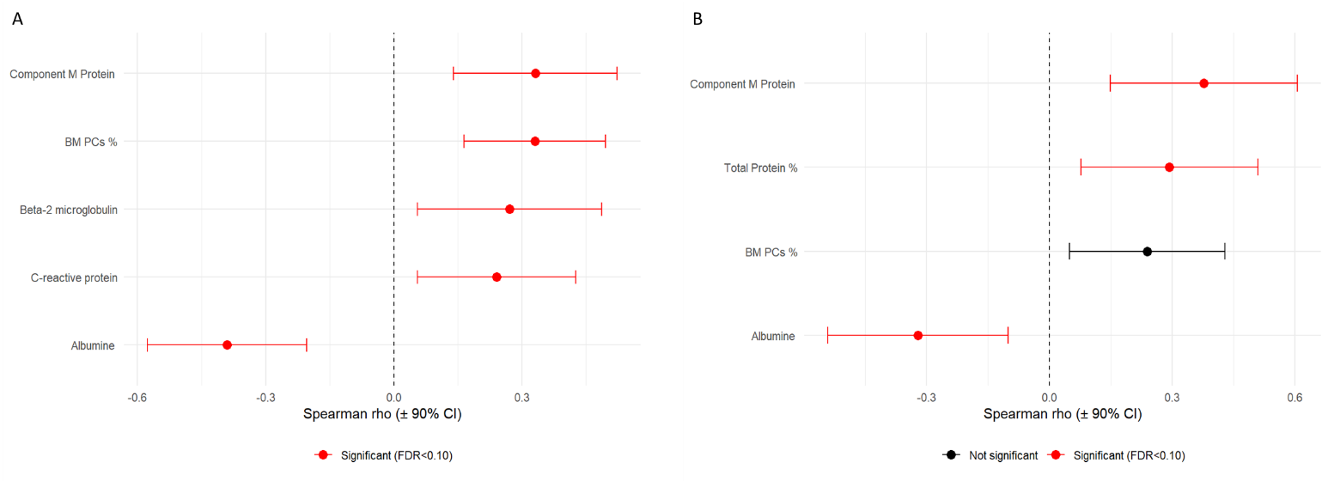
Supplementary Figure 1. BH forest plot where significance was determined at a false discovery rate (FDR) threshold of 0.10. A) Biochemical values correlated with CPCs, and B) Correlations with mCPCs, with significant associations (FDR < 0.10) shown in red and non-significant associations shown in black.

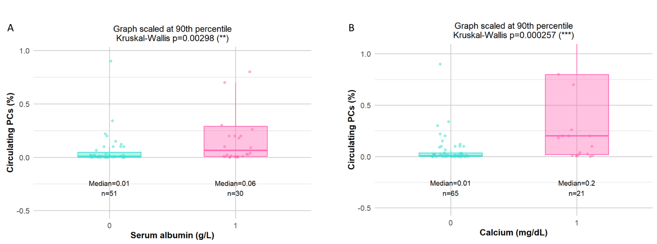
Supplementary Figure 2. Kruskal-Wallis test for A) Median of Circulating PCs vs. Serum Albumin (p=0.00298), and B) Median of CPCs vs. Calcium (p=0.00026). Graphs are scaled at 90th percentile.

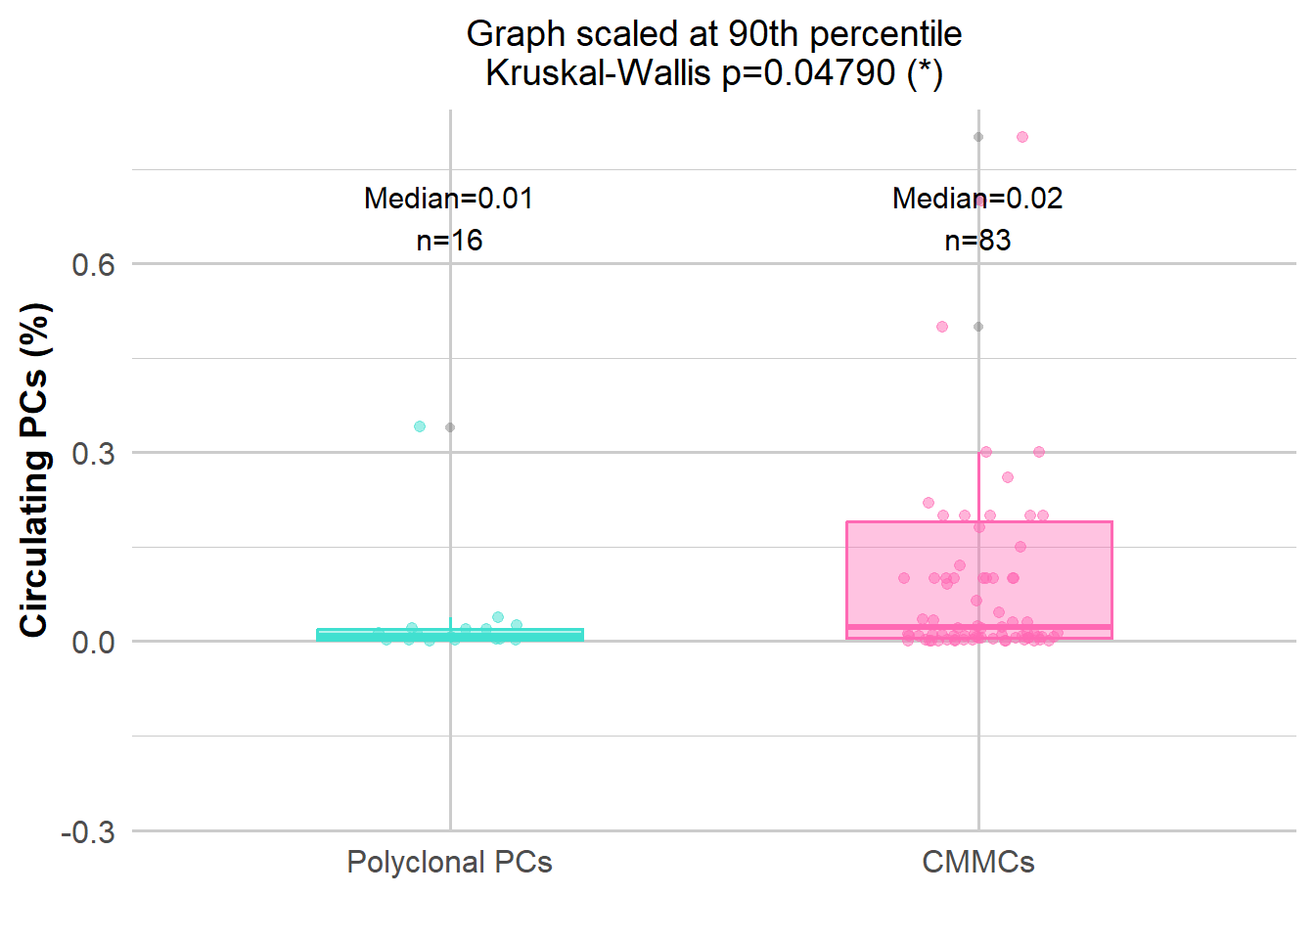
Supplementary Figure 3. Polyclonal PCs (16 patients) vs. mCPCs (83 patients) in terms of median (p=0.048). Median polyclonal PCs=0.00855% vs. Median mCPCs=0.02%. Graphs are scaled at 90th percentile.

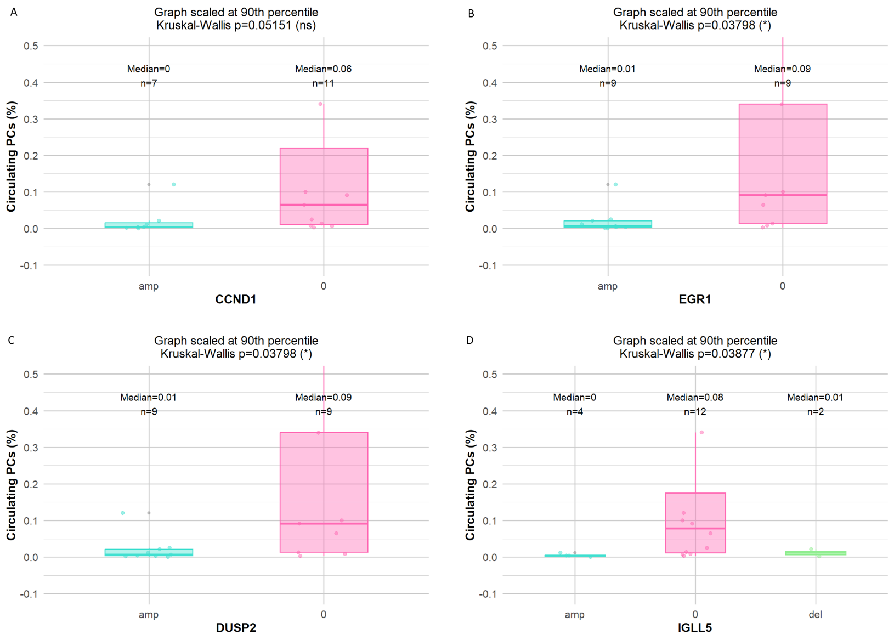
Supplementary Figure 4. Focal aberrations (in term of amplifications (amp, turquoise), or deletions (del, green), or none of the above (0, pink)) involving: A) CCDN1, B) EGR1, C) DUSP2, D) IGLL5. Graphs are scaled at 90th percentile.

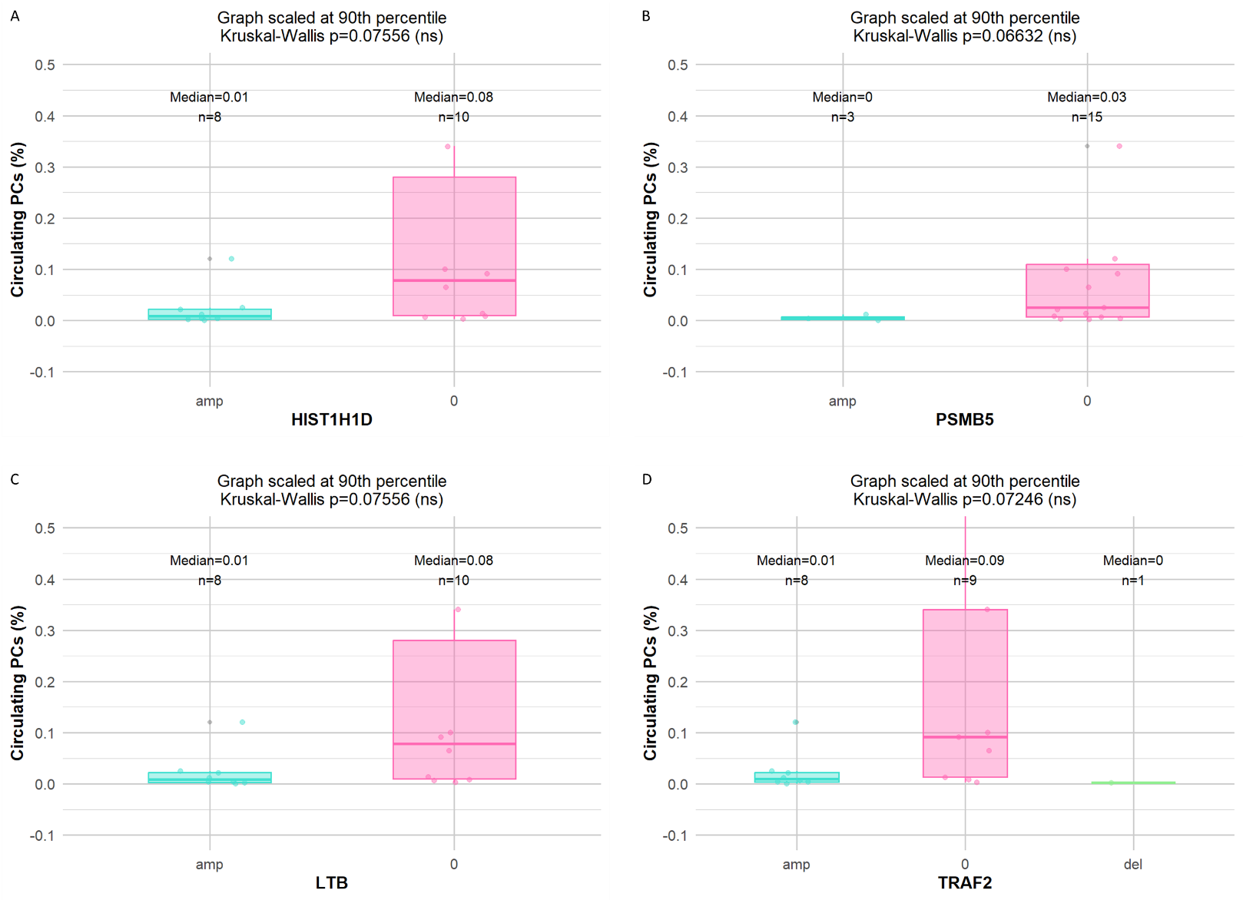
Supplementary Figure 5. Focal aberrations (in term of amplifications (amp, turquoise), deletions (del, green) or none (0, pink)) involving: A) HIST1H1D, B) PSMB5, C) LTB, D) TRAF2. Graphs are scaled at 90th percentile.

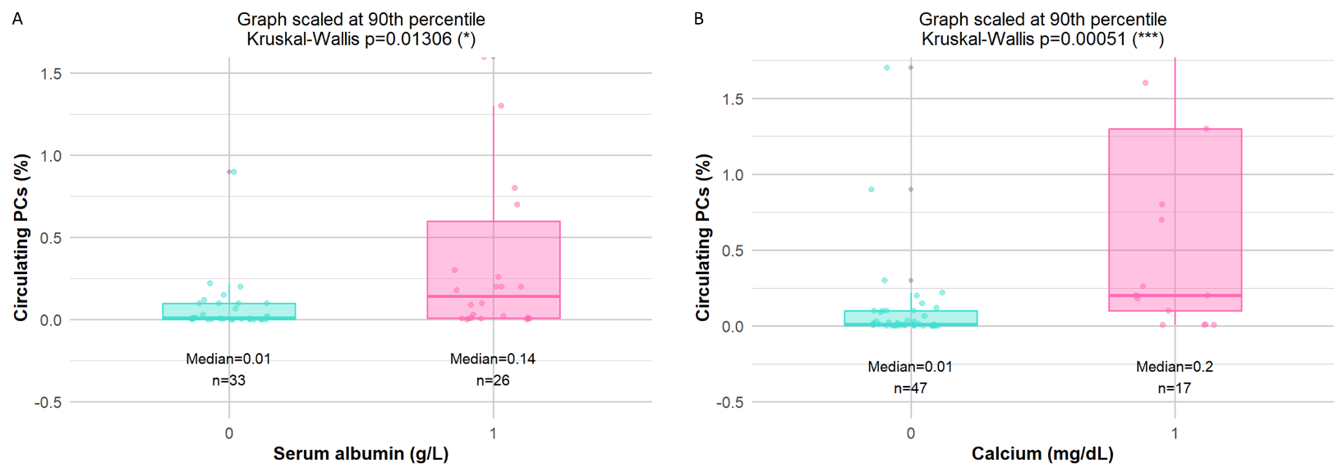
Supplementary Figure 6. Kruskal-Wallis test. A) Median of mCPCs vs. Serum Albumin (p=0.01306). B) Median of mCPCs vs. Calcium (p=0.00051). Graphs are scaled at 90th percentile.

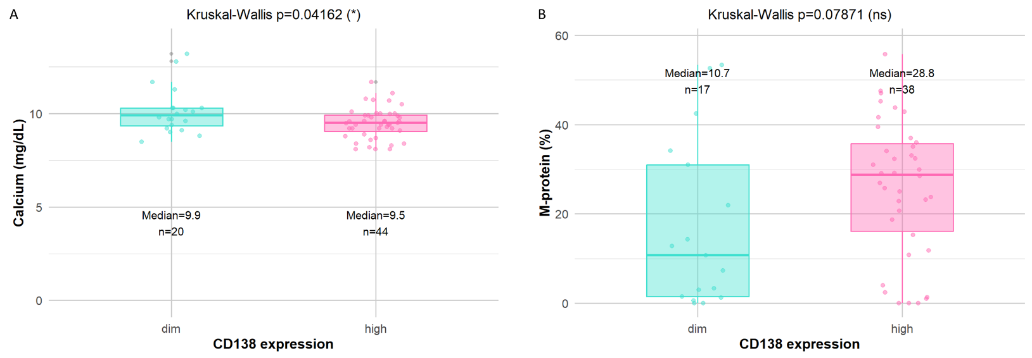
Supplementary Figure 7. A) Differential expression of CD138 (either high, in pink, or dim, in turquoise) on mCPCs vs. Calcium (p=0.04162). B) Differential expression of CD138 vs. M-protein (p=0.07871).

