Network polymers containing disulfide bond prepared by addition reactions of multi-functional epoxy, aziridine, or isocyanate with dicarboxylic acid or diol compounds: structure, mechanical properties, and reductive degradation

Naofumi Naga^{1,2}*, Kazumasa Moriyama², Kazuma Hasegawa², Toshiki Tajima^{1,2}, Tamaki Nakano^{3,4}

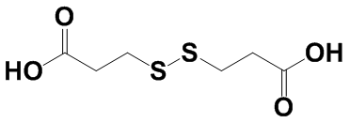
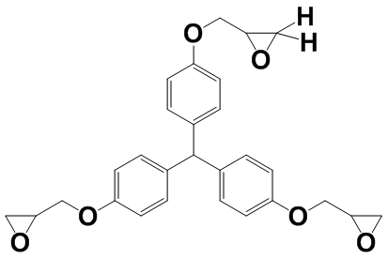
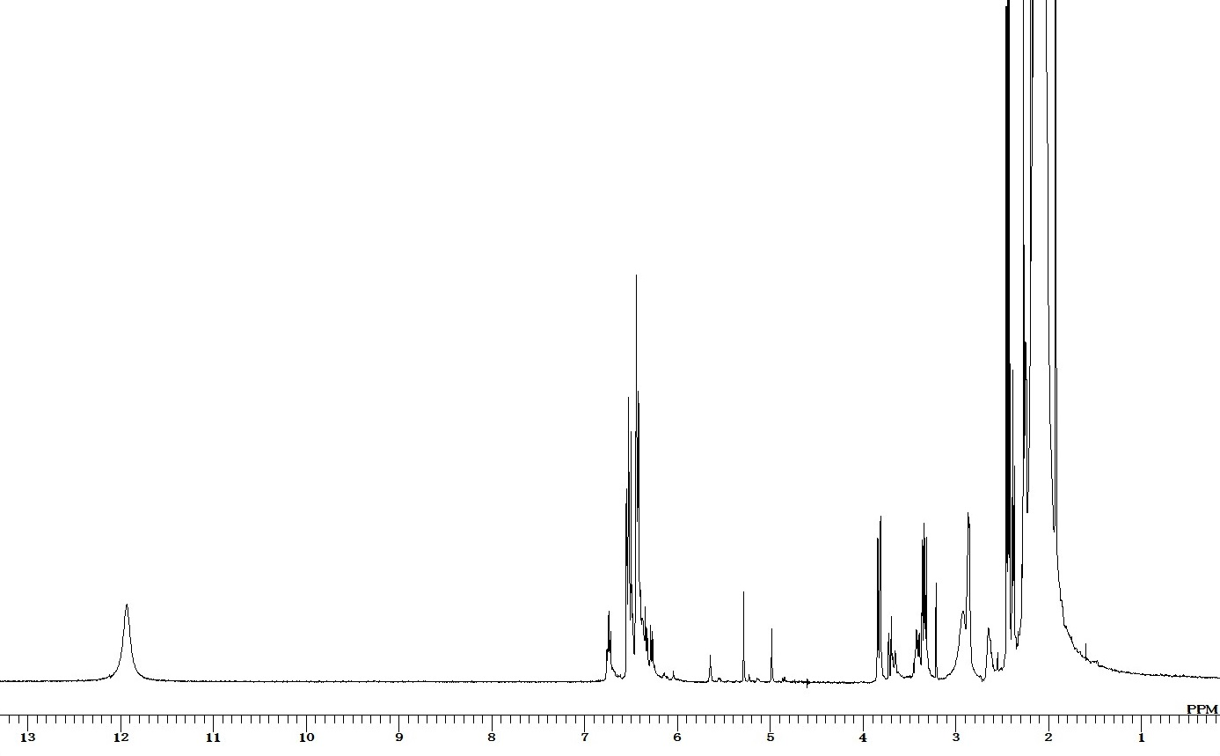
a
b
a
c
c
b
(i)
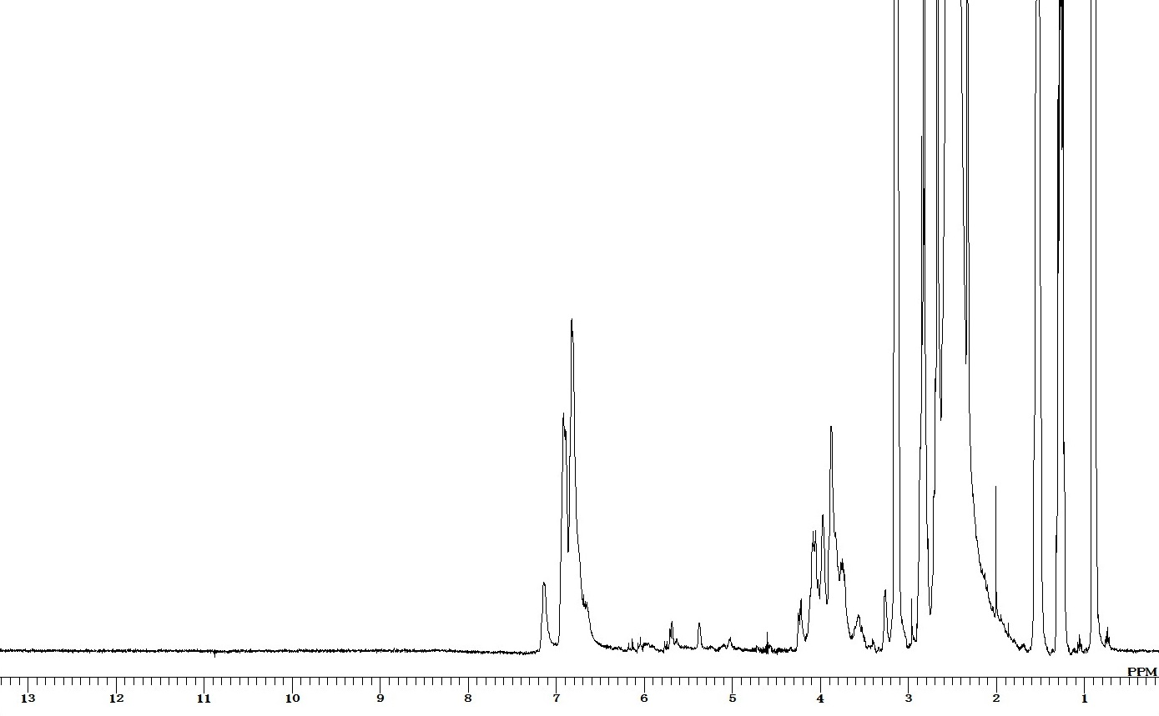
c
a
b
c
b
(ii)
Fig. S1 ¹H NMR spectra of TME-DTPA system, (i) before reaction, (ii) after reaction in DMSO containing 10 vol.% of DMSO-d6, monomer concentration: 4 wt%.

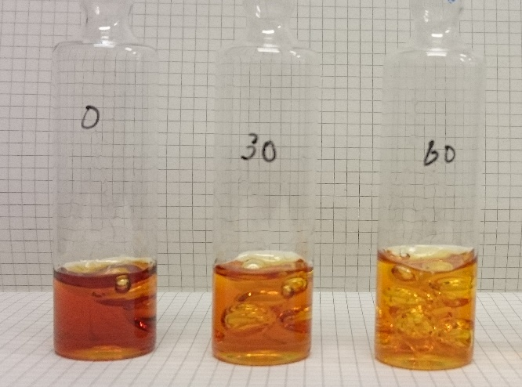
(a) (b) (c)
Fig. S2 Photos of TME-DTGA gel, monomer concentration 30 wt%, (a): just after gelation, (b): 30 min after gelation, (b): 60 min after gelation.

Fig. S3 Stress-strain curves of TME-DTBA or TPE-DTBA gels, monomer concentration: 20, 30, and 40 wt%.

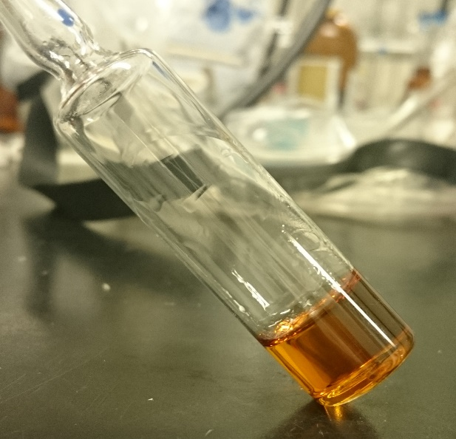
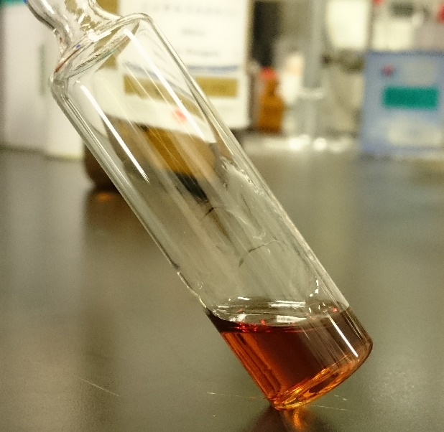

(d)
(c)

Fig. S4 Photos of the solution obtained after reduction of TME-DTPA gel (monomer concentration: 30 wt%) with DTT (c) and after re-oxidation at 85 ºC for 8 h (d).

(a)

(b)
Fig. S5 FT-IR spectra of (a) 3AZ- DTPA (run 14) and (b) 3AZ-DTBA (run 17) porous polymers.

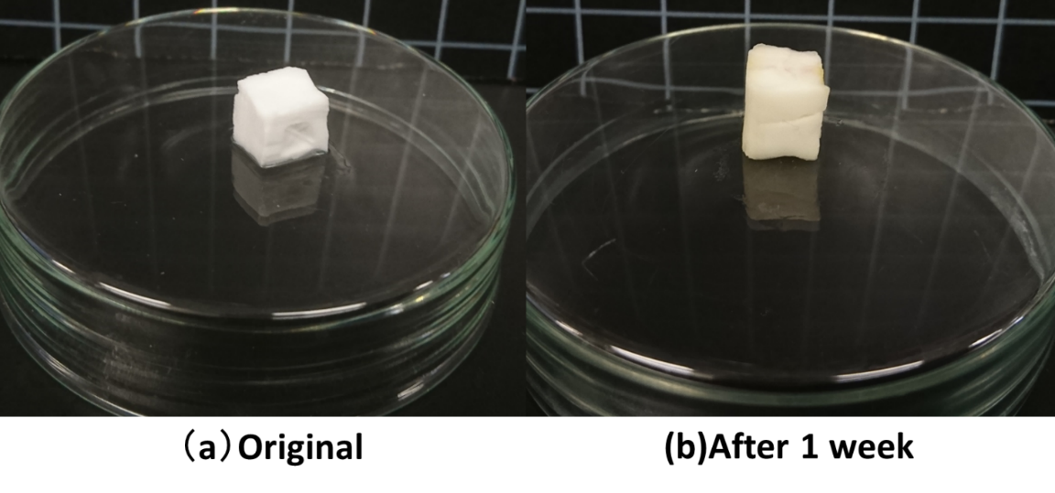
Fig. S6 Photos of reduction process of 3AZ-DTGA porous polymer (run 11).
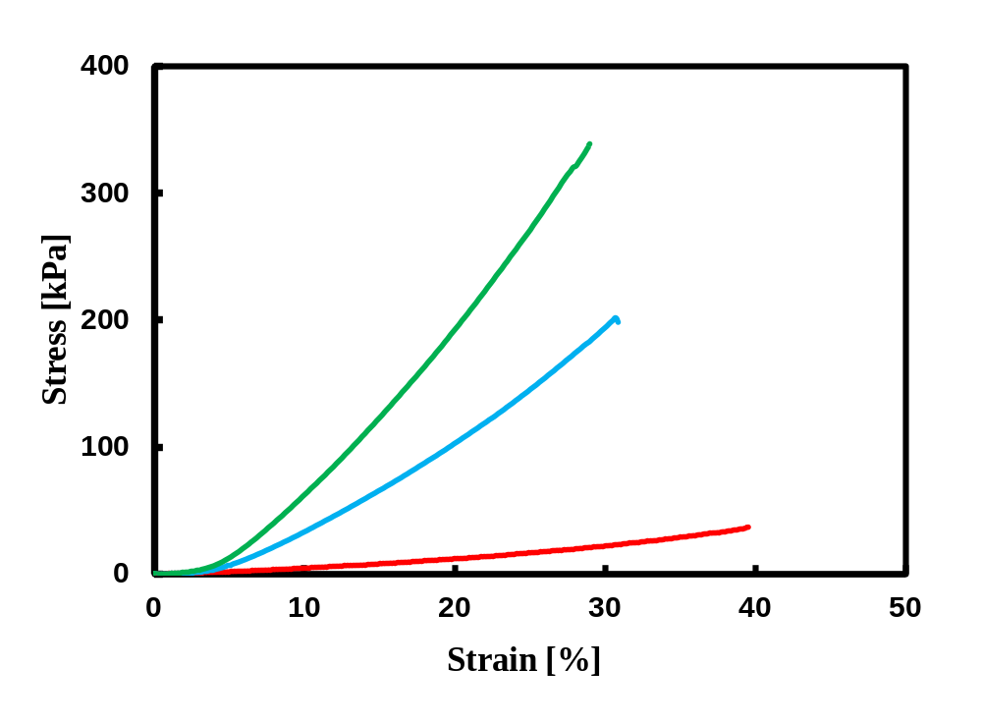
Fig. S7 Stress-strain curves of 3I-HEDS/DMSO gels, monomer concentration: (a) 15 wt%, (b) 25 wt%, and (c) 35 wt%.

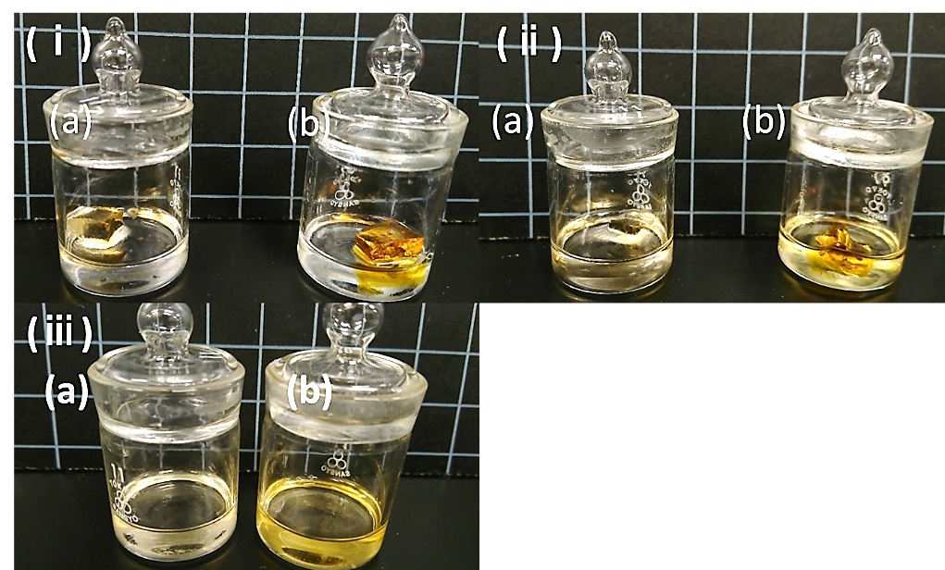
Fig. S8 Photos of reduction process of (a) 3I-HEDS (run 21), (b) 3I-DTGA (run 23)/DMSO gels, immersed in DMSO solution of DTT for (i) 0 h, (ii) 3 h, and (iii) 7 h.
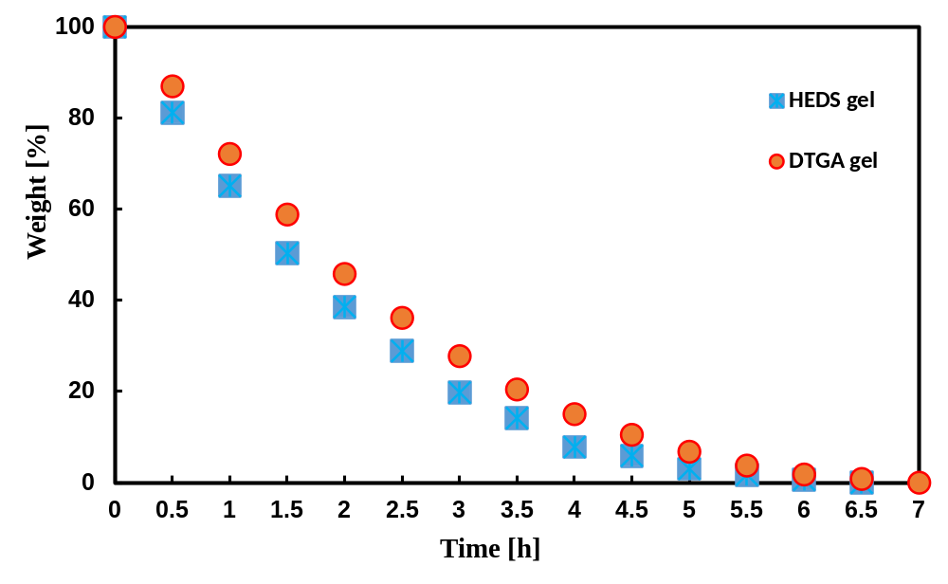
Fig. S9 Time evolution of weight of 3I-HEDS (run 21) and 3I-DTGA (run 23)/DMSO gels immersed in DTT/DMSO solution (0.04 g/mL).

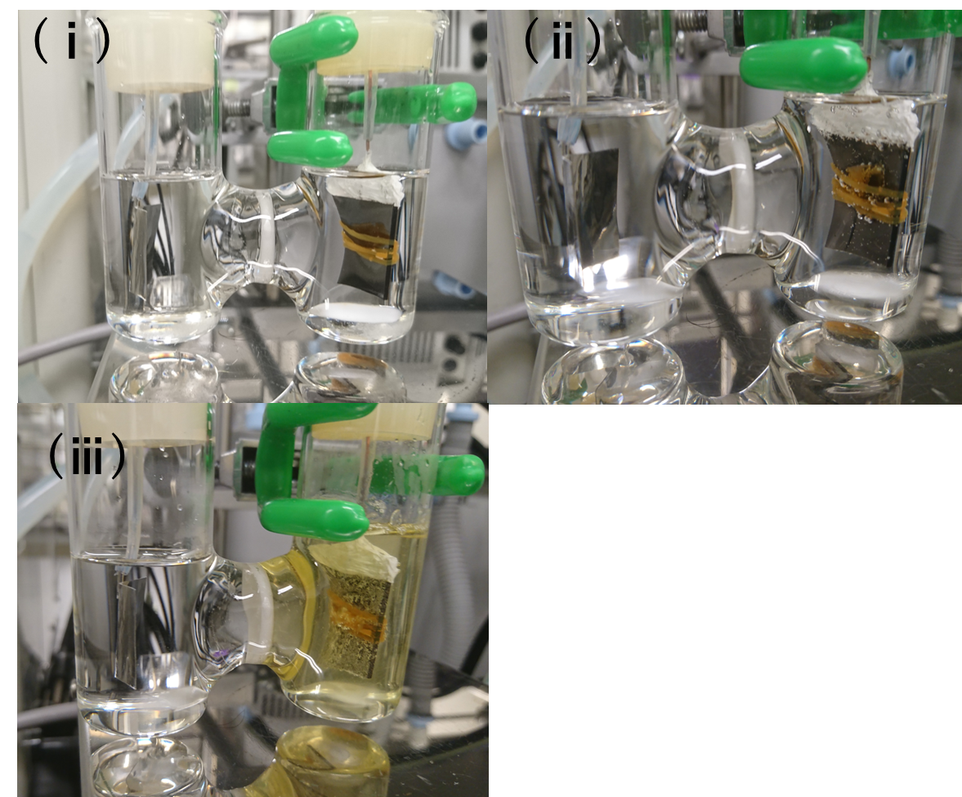
Fig. S10 Photos of electrolysis process of 3I-HEDS/DMSO gel (run 21) in a DMSO solution of NaClO₄ (3.0 wt %), (i) before electrolysis, (ii) after 1 min, and (iii) after 2

