Suplementary Material:
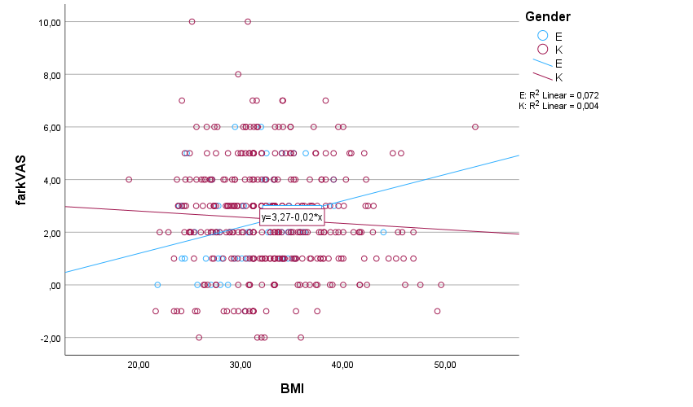
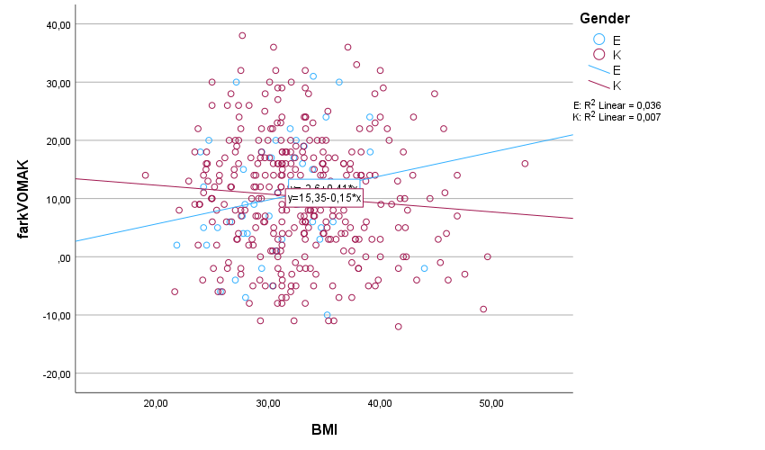
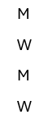
Change in VAS

M: R² Linear = 0.072
W: R² Linear = 0.004

Although not statistically significant, the relationship between BMI and changes in VAS scores differed by sex. In men, higher BMI was associated with greater improvement in VAS scores, whereas in women, higher BMI was associated with smaller improvements.

M: R² Linear = 0.036
W: R² Linear = 0.007

Change in WOMAC

Although not statistically significant, the relationship between BMI and changes in WOMAC scores differed by sex. In men, higher BMI was associated with greater improvement in WOMAC scores, whereas in women, higher BMI was associated with smaller improvements.

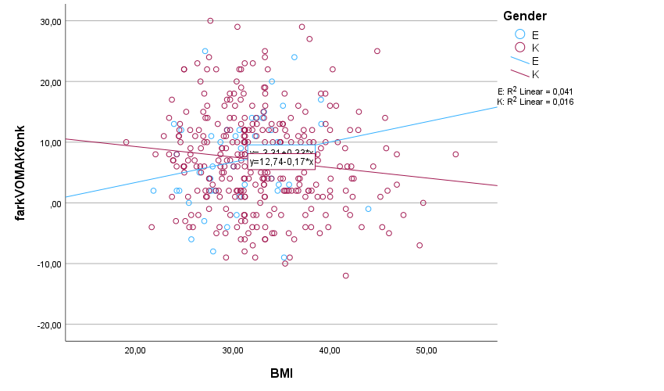
Change in WOMAC Function

M: R² Linear = 0.041
W: R² Linear = 0.016

Although not statistically significant, the relationship between BMI and changes in WOMAC Function scores differed by sex. In men, higher BMI was associated with greater improvement in WOMAC Function scores, whereas in women, higher BMI was associated with smaller improvements.

 | Baseline score | 12 months | Mean difference | 95% CI of the difference
 |  |  |  | Lower | Upper
VAS
40–54 years | 7.57(1.16)  N=23 | 5.13(1.84)  N=23 | 2.43 | 1.66 | 3.20
55–64 years | 7.52(1.11)  N=104 | 4.67(1.90)  N=104 | 2.85 | 2.47 | 3.24
65–74 years | 7.60(1.17)  N=168 | 5.19(2.06)  N=168 | 2.41 | 2.08 | 2.75
≥75 years | 7.72(1.01)  N=92 | 5.55(1.82)  N=92 | 2.17 | 1.77 | 2.57
WOMAC Function
40–54 years | 41.86(6.86)  N=23 | 35.00(10.79)  N=23 | 6.86 | 3.28 | 10.45
55–64 years | 39.71(6.89)  N=103 | 32.18(9.46)  N=103 | 7.53 | 6.01 | 9.05
65–74 years | 41.06(7.59)  N=168 | 34.26(10.37)  N=168 | 6.80 | 5.58 | 8.02
≥75 years | 42.63(7.33)  N=92 | 35.74(10.12)  N=92 | 6.89 | 5.50 | 8.27
WOMAC Total
40–54 years | 59.04(9.02)  N=23 | 48.83(14.56)  N=23 | 10.21 | 5.43 | 14.99
55–64 years | 56.02(9.64)  N=104 | 44.68(12.49)  N=104 | 11.34 | 9.42 | 13.27
65–74 years | 58.22(10.59)  N=168 | 48.10(13.93)  N=168 | 10.12 | 8.49 | 11.75
≥75 years | 59.65(9.75)  N=92 | 50.33(12.74)  N=92 | 9.32 | 7.51 | 11.13
Table. Changes in VAS and WOMAC (function and total) scores from baseline to 12 months after intra-articular PAAG hydrogel injection, stratified by age categories (40–54, 55–64, 65–74, and ≥75 years). Data are expressed as mean ± SD, along with mean differences and 95% CI.

 | Baseline score | 12 months | Mean difference | 95% CI of the difference
 |  |  |  | Lower | Upper
VAS
≤24.9 kg/m² | 7.16(1.05)  N=27 | 4.90(1.75)  N=27 | 2.26 | 1.32. | 3.19
25.0–29.9 kg/m² | 7.35(1.06)  N=92 | 4.97(1.83)  N=92 | 2.38 | 1.93 | 2.83
≥30.0 kg/m² | 7.75(1.12)  N=268 | 5.28(2.02)  N=268 | 2.47 | 2.22 | 2.72
WOMAC Function
≤24.9 kg/m² | 38.91(6.92)  N=27 | 31.18(8.77)  N=27 | 7.73 | 5.36 | 10.10
25.0–29.9 kg/m² | 39.59(7.60)  N=92 | 32.92(9.43)  N=92 | 6.67 | 5.02 | 8.33
≥30.0 kg/m² | 41.70(7.02)  N=268 | 34.90(10.34)  N=268 | 6.80 | 5.87 | 7.73
WOMAC Total
≤24.9 kg/m² | 54.50(9.16)  N=27 | 43.90(11.87)  N=27 | 10.60 | 7.34 | 13.87
25.0–29.9 kg/m² | 55.20(10.35)  N=92 | 45.73(12.35)  N=92 | 9.47 | 7.33 | 11.61
≥30.0 kg/m² | 59.20(9.58)  N=268 | 49.03(13.65)  N=268 | 10.17 | 8.93 | 11.41
Table . Changes in VAS and WOMAC (function and total) scores from baseline to 12 months after intra-articular PAAG hydrogel injection according to body mass index (BMI) categories. Data are shown as mean ± SD, together with mean differences and 95% CI for each group.

