Supplementary Materials: Detailed Correlation Analysis
Purpose
The main manuscript focuses on not only time-lagged relationships identified through cross-correlation analysis but also predictive relationships revealed by Granger causality testing. These analyses are essential to understand temporal dynamics and establish potential causal relationships between biomarkers, mental health, and athletic performance. Moreover, examining the overall pattern of linear relationships among all measured variables provides important context for interpreting these temporal findings. Cross-sectional correlation analysis characterizes the strength and direction of associations between training load indicators, hair hormone biomarkers, physiological measures, mental health indices, competitive stressors, and athletic performance. This comprehensive correlation matrix helps identify the variables that are closely related within the same time period, providing a foundation for understanding the more complex temporal relationships examined in the main results. The purpose of this supplementary analysis is to present detailed correlation patterns among all measured variables—organized by thematic categories—to complement the temporal analyses presented in the main manuscript.

Methods
Pearson correlation coefficients were calculated for all pairs of measured variables using R software (version 4.4.2). Given the single-subject repeated measures design (N=1 participant with 10–22 monthly measurements depending on the variable), these correlation coefficients represent the strength and direction of linear relationships within this individual athlete, not statistical inferences to a population. Correlation coefficients were interpreted based on established criteria, with r values of 0–0.3, 0.3–0.5, 0.5–0.7, and 0.7–1.0 indicating weak, weak-to-moderate, moderate, and strong linear relationships, respectively (Ratner, 2009). The number of available data points varied across variable pairs depending on missing data, particularly for hair oxytocin concentration and cortisol/oxytocin ratio, where insufficient hair samples prevented measurement during certain months. Sample sizes for each correlation are reported alongside the correlation coefficient. The complete correlation matrix is presented in Table 2 of the main manuscript. Fig. S1 displays scatter plots with linear regression lines for all variable pairs showing correlation coefficients with absolute values of 0.5 or greater.

Results Overview
Of all possible variable pairs, 76 pairs revealed correlations with absolute values of 0.3 or greater (weak-to-moderate or strong linear relationships), and 21 pairs revealed correlations with absolute values of 0.5 or greater (moderate or strong linear relationships), as visualized in Fig. S1. Six pairs exhibited strong correlations with absolute values of 0.7 or greater. Waking resting heart rate revealed a strong negative linear relationship with waking standing root mean square of successive differences (RMSSD; r = -.814, 21 measurements), reflecting the expected inverse relationship between resting heart rate and parasympathetic activity during orthostatic challenge. Hair cortisol concentration revealed a strong positive linear relationship with training volume (r = .756, 21 measurements), consistent with previous findings associating intensive aerobic training with elevated cumulative cortisol exposure (Sato et al., 2024; Skoluda et al., 2012). Waking standing heart rate revealed a strong negative linear relationship with waking standing RMSSD (r = -.752, 21 measurements), again reflecting the expected inverse relationship between heart rate and parasympathetic modulation. Training time revealed a strong positive linear relationship with training volume (r = .739, 21 measurements), validating the consistency between different objective training load measures. Waking resting and standing heart rates revealed a strong positive linear relationship (r = .732, 21 measurements), indicating heart rate stability across different postural conditions. POMS2 vigor-activity and World Athletics points revealed a strong positive linear relationship (r = .728, 10 measurements), suggesting the association of higher vigor with better athletic performance. Fifteen additional pairs revealed moderate correlations with absolute values between 0.5 and 0.7, including relationships between training load indicators, hair hormones, physiological measures, competitive stressors, and mental health outcomes. The detailed patterns of these relationships are organized by thematic categories below.

Training Load Relationships
Training time, distance, and volume revealed strong positive linear relationships with each other. While training time was strongly correlated with training volume (r = .739, 21 measurements), training distance revealed strong and moderate positive linear relationships with training volume (r = .704, 21 measurements) and training time (r = .682, 21 measurements), respectively. Self-reported training load revealed moderate and weak-to-moderate positive relationships with training distance (r = .577, 21 measurements) and training volume (r = .419, 21 measurements), respectively. These findings validate the consistency between subjective training load assessment and objective heart rate-based monitoring.

Hair Hormone Biomarkers
The relationship between hair cortisol and oxytocin revealed distinct patterns. Hair cortisol and oxytocin concentrations revealed a weak positive relationship (r = .120, 16 measurements). However, hair cortisol concentration revealed a strong positive linear relationship with cortisol/oxytocin ratio (r = .701, 16 measurements), while hair oxytocin concentration revealed a moderate negative linear relationship with cortisol/oxytocin ratio (r = -.610, 16 measurements).

Hair Hormones and Training Load
Hair cortisol concentration revealed strong positive relationships with training volume (r = .756, 21 measurements), weak-to-moderate positive relationships with training time (r = .450, 21 measurements), and weak positive relationships with training distance (r = .336, 21 measurements) and self-reported training load (r = .116, 22 measurements). Hair oxytocin concentration revealed moderate positive relationships with self-reported training load (r = .516, 16 measurements) and training volume (r = .504, 16 measurements), and weak positive relationships with training time (r = .267, 16 measurements) and training distance (r = .274, 16 measurements). Cortisol/oxytocin ratio revealed a weak-to-moderate positive relationship with training distance (r = .374, 16 measurements) and weak positive relationships with training time (r = .282, 16 measurements), training volume (r = .264, 16 measurements), and self-reported training load (r = .107, 16 measurements).

Waking Heart Rate and Heart Rate Variability
Waking heart rate and RMSSD revealed distinct patterns. Waking resting heart rate had a strong negative linear relationship with waking standing RMSSD (r = -.814, 21 measurements) and a strong positive linear relationship with waking standing heart rate (r = .732, 21 measurements). Waking standing heart rate revealed a strong negative linear relationship with waking standing RMSSD (r = -.752, 21 measurements). Waking resting and standing RMSSD revealed a moderate positive linear relationship (r = .539, 21 measurements). Waking resting heart rate revealed a weak-to-moderate negative linear relationship with waking resting RMSSD (r = -.459, 21 measurements), which in turn revealed a weak-to-moderate negative linear relationship with waking standing heart rate (r = -.426, 21 measurements).

Hair Hormones and Physiological Indicators
Hair cortisol concentration revealed a moderate negative relationship with waking standing heart rate (r = -.500, 21 measurements), weak negative relationships with waking resting heart rate (r = -.370, 21 measurements) and waking resting RMSSD (r = -.257, 21 measurements), and weak positive relationships with waking standing RMSSD (r = .300, 21 measurements). Hair oxytocin concentration revealed weak negative relationships with waking standing (r = -.416, 16 measurements) and waking resting (r = -.245, 16 measurements) heart rates, and weak-to-moderate positive relationships with waking standing (r = .340, 16 measurements) and waking resting (r = .255, 16 measurements) RMSSD. Cortisol/oxytocin ratio revealed a moderate negative relationship with waking resting RMSSD (r = -.640, 16 measurements) and very weak relationships with waking resting heart rate (r = -.056, 16 measurements), waking standing heart rate (r = -.021, 16 measurements), and waking standing RMSSD (r = -.039, 16 measurements).

Mental Health Indicators
POMS2 vigor-activity revealed a strong positive relationship with athletic performance (r = .728, 10 measurements), moderate positive relationship with self-reported training load (r = .657, 22 measurements), weak-to-moderate positive relationship with training distance (r = .491, 21 measurements), and weak positive relationships with training volume (r = .335, 21 measurements) and training time (r = .111, 21 measurements). K6 revealed a weak-to-moderate positive relationship with POMS2 fatigue-inertia (r = .465, 22 measurements), weak-to-moderate negative relationships with POMS2 vigor-activity (r = -.435, 22 measurements) and athletic performance (r = -.367, 10 measurements), a moderate negative relationship with training distance (r = -.511, 21 measurements), weak negative relationships with self-reported training load (r = -.289, 22 measurements) and training time (r = -.207, 21 measurements), and a very weak negative relationship with training volume (r = -.044, 21 measurements). POMS2 fatigue-inertia revealed weak-to-moderate negative relationships with POMS2 vigor-activity (r = -.448, 22 measurements), training distance (r = -.488, 21 measurements), training volume (r = -.444, 21 measurements), and training time (r = -.439, 21 measurements), a weak negative relationship with athletic performance (r = -.244, 10 measurements), and a very weak negative relationship with self-reported training load (r = -.088, 22 measurements). Athletic performance revealed moderate positive relationships with training volume (r = .580, 10 measurements) and self-reported training load (r = .484, 10 measurements), a weak-to-moderate positive relationship with training distance (r = .379, 10 measurements), and a very weak positive relationship with training time (r = .028, 10 measurements).

Mental Health and Physiological Indicators
Waking standing RMSSD revealed weak negative relationships with K6 (r = -.191, 21 measurements), POMS2 fatigue-inertia (r = -.195, 21 measurements), and athletic performance (r = -.494, 10 measurements), as well as a weak positive relationship with POMS2 vigor-activity (r = .142, 21 measurements). Waking resting RMSSD revealed weak negative relationships with K6 (r = -.172, 21 measurements), POMS2 vigor-activity (r = -.148, 21 measurements), and athletic performance (r = -.459, 10 measurements), as well as a very weak negative relationship with POMS2 fatigue-inertia (r = -.104, 21 measurements). Waking resting heart rate revealed a weak negative relationship with K6 (r = -.326, 21 measurements), very weak negative relationship with POMS2 fatigue-inertia (r = -.069, 21 measurements), weak positive relationship with POMS2 vigor-activity (r = .091, 21 measurements), and very weak positive relationship with athletic performance (r = .022, 10 measurements). Waking standing heart rate revealed very weak relationships with K6 (r = .019, 21 measurements), POMS2 fatigue-inertia (r = .142, 21 measurements), POMS2 vigor-activity (r = .049, 21 measurements), and athletic performance (r = -.060, 10 measurements).

Hair Hormones and Mental Health
Hair cortisol concentration revealed weak positive relationships with K6 (r = .304, 22 measurements) and World Athletics points (r = .318, 10 measurements), a weak negative relationship with POMS2 fatigue-inertia (r = -.284, 22 measurements), and a weak positive relationship with POMS2 vigor-activity (r = .131, 22 measurements). Hair oxytocin concentration revealed weak negative relationships with K6 (r = -.175, 16 measurements) and POMS2 fatigue-inertia (r = -.206, 16 measurements) and weak positive relationships with POMS2 vigor-activity (r = .119, 16 measurements) and World Athletics points (r = .327, 8 measurements). Cortisol/oxytocin ratio revealed weak negative relationships with K6 (r = -.088, 16 measurements) and POMS2 fatigue-inertia (r = -.230, 16 measurements) and weak positive relationships with POMS2 vigor-activity (r = .272, 16 measurements) and World Athletics points (r = .175, 8 measurements).

Competitive Stressors
Performance stressor revealed moderate negative relationships with training distance (r = -.624, 21 measurements) and POMS2 vigor-activity (r = -.604, 22 measurements); moderate positive relationships with K6 (r = .559, 22 measurements) and evaluation stressor (r = .598, 22 measurements); a weak-to-moderate positive relationship with POMS2 fatigue-inertia (r = .431, 22 measurements); weak negative relationships with self-reported training load (r = -.344, 22 measurements), training time (r = -.243, 21 measurements), and training volume (r = -.230, 21 measurements); and a weak positive relationship with hair cortisol concentration (r = .185, 22 measurements). Motivation loss stressor revealed moderate negative relationships with training volume (r = -.695, 21 measurements), training distance (r = -.529, 21 measurements), training time (r = -.524, 21 measurements), and World Athletics points (r = -.510, 10 measurements); weak-to-moderate negative relationships with hair cortisol concentration (r = -.424, 22 measurements) and hair oxytocin concentration (r = -.418, 16 measurements); and a weak negative relationship with self-reported training load (r = -.306, 22 measurements). Evaluation stressor revealed a weak-to-moderate positive relationship with hair cortisol concentration (r = .420, 22 measurements), weak-to-moderate negative relationship with POMS2 vigor-activity (r = -.417, 22 measurements), and weak positive relationship with training time (r = .155, 21 measurements). Interpersonal stressor revealed weak-to-moderate negative relationships with World Athletics points (r = -.447, 10 measurements) and evaluation stressor (r = -.438, 22 measurements); a weak-to-moderate positive relationship with motivation loss stressor (r = .362, 22 measurements); weak negative relationships with hair cortisol concentration (r = -.376, 22 measurements), hair oxytocin concentration (r = -.311, 16 measurements), and training volume (r = -.351, 21 measurements); and weak negative relationships with training time (r = -.334, 21 measurements). Expectation stressor revealed weak-to-moderate negative relationships with hair cortisol concentration (r = -.439, 22 measurements), hair oxytocin concentration (r = -.446, 16 measurements), and K6 (r = -.354, 22 measurements) and a weak positive relationship with POMS2 vigor-activity (r = .320, 22 measurements).

Figures
Fig. S1 displays scatter plots with linear regression lines for all 21 variable pairs showing correlation coefficients with absolute values of 0.5 or greater (moderate or strong relationships). Each scatter plot includes the correlation coefficient (r) and the number of available measurements for that specific variable pair. This visualization allows readers to examine the patterns of these moderate-to-strong relationships and assess the consistency of the linear trends. The scatter plots reveal relatively consistent linear patterns for most of these relationships across the 22-month study period, although some variability is evident because of the longitudinal nature of the data and missing values for certain variables (particularly hair oxytocin concentration and cortisol/oxytocin ratio).
Fig. S2 presents the complete correlation matrix as a heatmap for all measured variables. This visualization provides Pearson correlation coefficients for all possible variable pairs, allowing readers to examine the strength and direction of linear relationships across the entire dataset. According to the heatmap’s color gradient, blue indicates negative correlations, white indicates no correlation, and red indicates positive correlations. Each cell displays the numerical correlation coefficient, with the color intensity reflecting the strength of the relationship. Fig. S2 serves as a comprehensive visual reference to identify which variables show weak, moderate, or strong correlations within this single-subject longitudinal study.
Together, Fig. S1 and Fig. S2 provide complementary perspectives on the correlation patterns observed in this study. Fig. S1 offers detailed scatter plots for the strongest relationships allowing assessment of linearity assumptions and potential outliers or influential observations, while Fig. S2 provides a complete overview of all correlation patterns with numerical precision and comprehensive coverage of all variable pairs.

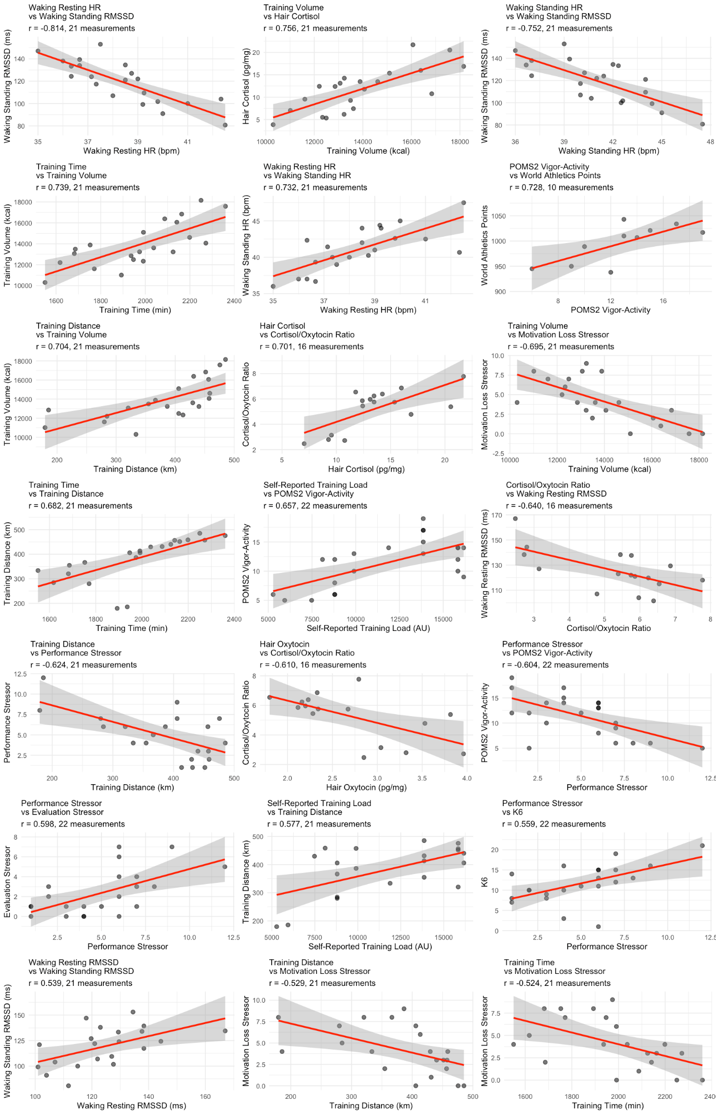
Fig. S1 Scatter Plots of Moderate-to-Strong Correlations
Scatter plots with linear regression lines for all variable pairs revealing correlation coefficients with |r| ≥ 0.5 (21 pairs). Each plot displays the correlation coefficient (r) and number of measurements. The 21 pairs include: (1) waking resting heart rate (HR) and waking standing RMSSD (r = -.814, 21 measurements), (2) hair cortisol concentration and training volume (r = .756, 21 measurements), (3) waking standing HR and waking standing RMSSD (r = -.752, 21 measurements), (4) training time and training volume (r = .739, 21 measurements), (5) waking resting HR and waking standing HR (r = .732, 21 measurements), (6) POMS2 vigor-activity and World Athletics points (r = .728, 10 measurements), (7) training distance and training volume (r = .704, 21 measurements), (8) hair cortisol concentration and cortisol/oxytocin ratio (r = .701, 16 measurements), (9) training volume and motivation loss stressor (r = -.695, 21 measurements), (10) training time and training distance (r = .682, 21 measurements), (11) POMS2 vigor-activity and self-reported training load (r = .657, 22 measurements), (12) cortisol/oxytocin ratio and waking resting RMSSD (r = -.640, 16 measurements), (13) training distance and performance stressor (r = -.624, 21 measurements), (14) hair oxytocin concentration and cortisol/oxytocin ratio (r = -.610, 16 measurements), (15) POMS2 vigor-activity and performance stressor (r = -.604, 22 measurements), (16) performance stressor and evaluation stressor (r = .598, 22 measurements), (17) self-reported training load and training distance (r = .577, 21 measurements), (18) K6 and performance stressor (r = .559, 22 measurements), (19) waking resting RMSSD and waking standing RMSSD (r = .539, 21 measurements), (20) training distance and motivation loss stressor (r = -.529, 21 measurements), and (21) training time and motivation loss stressor (r = -.524, 21 measurements). Scatter plots reveal relatively consistent linear patterns across the 22-month study period, with some variability because of missing values for hair oxytocin concentration and cortisol/oxytocin ratio.

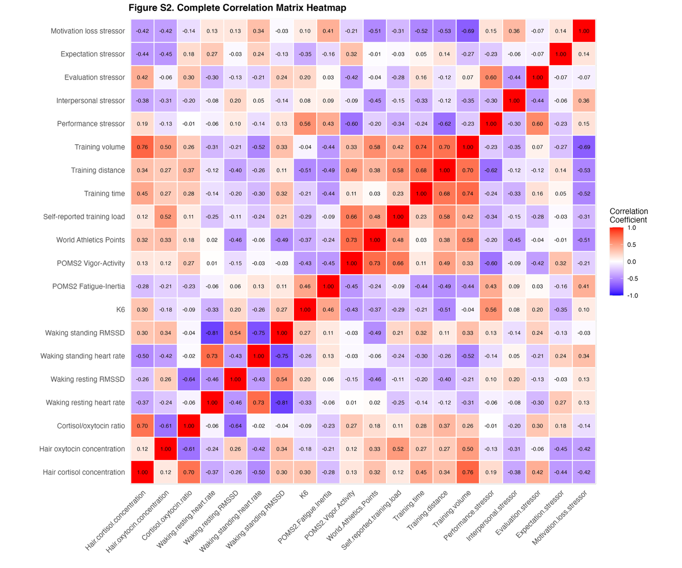
Fig. S2 Complete Correlation Matrix Heatmap
Heatmap visualization of Pearson correlation coefficients for all measured variable pairs across the 22-month study period. The matrix includes training load indicators (self-reported training load, training time, training distance, training volume), hair hormone biomarkers (hair cortisol concentration, hair oxytocin concentration, cortisol/oxytocin ratio), waking physiological indicators (waking resting heart rate and RMSSD, waking standing heart rate and RMSSD), mental health indices (K6, POMS2 fatigue-inertia, POMS2 vigor-activity, World Athletics points), and competitive stressors (performance, interpersonal, evaluation, expectation, and motivation loss stressors). The color gradient represents correlation strength and direction: blue indicates negative correlations, white indicates no correlation (r = 0), and red indicates positive correlations. Each cell displays the numerical correlation coefficient (rounded to two decimal places). Sample sizes vary by variable pair (10–22 measurements) because of missing data for hair oxytocin concentration and cortisol/oxytocin ratio. Correlation coefficients with absolute values ≥ 0.3 indicate weak-to-moderate or strong relationships, while those with absolute values ≥ 0.5 indicate moderate or strong relationships (Ratner, 2009).
Reference
Ratner, B. (2009). The correlation coefficient: Its values range between +1/−1, or do they? Journal of Targeting, Measurement and Analysis for Marketing, 17(2), 139–142. https://doi.org/10.1057/jt.2009.5
Sato, M., Sasaki, M., Shima, T., Ikegami, R., Sato, D., & Ochi, G. (2024). Hair cortisol is a physiological indicator of training stress for female footballers. European Journal of Applied Physiology, 124(12), 3719–3728. https://doi.org/10.1007/s00421-024-05571-7
Skoluda, N., Dettenborn, L., Stalder, T., & Kirschbaum, C. (2012). Elevated hair cortisol concentrations in endurance athletes. Psychoneuroendocrinology, 37(5), 611–617. https://doi.org/10.1016/j.psyneuen.2011.09.001

